Building and Validating a Basic
Machine Learning Model
Week 4 — Machine Learning Fundamentals in Python
Dataset: Wisconsin Breast Cancer Diagnostic Dataset (scikit-learn)
Task type: Binary Classification

1. Introduction and Objective
The objective of this exercise is to walk through the complete lifecycle of a basic machine learning model: data preparation, algorithm selection, training, evaluation, and critical reflection on performance. The chosen problem is a binary classification task — predicting whether a breast tumor is malignant or benign from a set of digitized cell-nuclei measurements.
The dataset used is the Wisconsin Breast Cancer Diagnostic dataset, a well-known, publicly available dataset bundled directly with scikit-learn (sklearn.datasets.load_breast_cancer). It was chosen because it is clean, realistic, appropriately sized (569 samples, 30 numeric features), and widely used as a benchmark for introductory classification exercises, which keeps the focus on process rather than data-sourcing overhead.

1.1 Dataset Overview
- Samples: 569 (212 malignant, 357 benign) — a moderate class imbalance of roughly 37% / 63%.
- Features: 30 numeric predictors describing cell nuclei characteristics (radius, texture, perimeter, area, smoothness, compactness, concavity, symmetry, fractal dimension — each summarized by mean, standard error, and "worst" value).
- Target: diagnosis — 0 = malignant, 1 = benign.
- No missing values were present in the raw data.

2. Data Preparation
Even though this dataset arrives pre-cleaned, the pipeline below follows the same defensive steps that would be required on a real-world, messier dataset, so the process generalizes.

2.1 Steps Performed
- Missing-value check: df.isna().sum() confirmed zero missing values; a dropna() safeguard was kept in the pipeline for robustness.
- Duplicate removal: drop_duplicates() was applied (0 duplicates found in this dataset).
- Feature / target separation: the 30 measurement columns were separated from the diagnosis label.
- Train/test split: an 80/20 stratified split (train_test_split(..., stratify=y)) was used so both sets preserve the original malignant/benign ratio.
- Feature scaling: StandardScaler was fit only on the training set and then applied to both sets, preventing data leakage from the test set into the scaling parameters. Scaling matters here because logistic regression is sensitive to feature magnitude — raw "area" values are on a completely different scale than "smoothness" values.

2.2 Code Snippet — Data Preparation
from sklearn.datasets import load_breast_cancer
from sklearn.model_selection import train_test_split
from sklearn.preprocessing import StandardScaler

data = load_breast_cancer(as_frame=True)
df = data.frame.rename(columns={'target': 'diagnosis'})
df = df.dropna().drop_duplicates()

X = df.drop(columns=['diagnosis'])
y = df['diagnosis']

X_train, X_test, y_train, y_test = train_test_split(
X, y, test_size=0.2, random_state=42, stratify=y)

scaler = StandardScaler()
X_train_scaled = scaler.fit_transform(X_train) # fit on TRAIN only
X_test_scaled = scaler.transform(X_test) # reuse train stats

3. Model Selection and Training
Two models were trained so that the primary choice could be evaluated against a meaningfully different alternative rather than in isolation.

3.1 Primary Model: Logistic Regression
Logistic Regression was selected as the primary algorithm because: (1) the task is binary classification on continuous, largely linearly-separable features after scaling; (2) it produces interpretable coefficients, which is valuable in a medical-adjacent context where understanding which features drive a prediction matters; (3) it trains quickly and is a strong, well-understood baseline that is hard to badly misconfigure.

3.2 Comparison Model: Decision Tree
A Decision Tree (max_depth = 4, to limit overfitting) was trained as a comparison point. Trees can capture non-linear feature interactions without scaling, but are more prone to overfitting and higher variance, which this report uses as a teaching contrast against the logistic regression baseline.

3.3 Code Snippet — Training
from sklearn.linear_model import LogisticRegression
from sklearn.tree import DecisionTreeClassifier
from sklearn.model_selection import cross_val_score

log_reg = LogisticRegression(max_iter=5000, random_state=42)
log_reg.fit(X_train_scaled, y_train)

tree = DecisionTreeClassifier(max_depth=4, random_state=42)
tree.fit(X_train, y_train) # trees do not require scaling

cv_scores = cross_val_score(log_reg, X_train_scaled, y_train, cv=5)
Five-fold cross-validation on the training set gave a mean accuracy of 98.02% (± 1.28%) for logistic regression versus 93.85% (± 1.79%) for the decision tree, confirming the logistic regression result is stable across folds rather than a lucky single split.

4. Evaluation

4.1 Metrics Summary
Metric | Logistic Regression | Decision Tree
Train accuracy | 0.989 | 0.9868
Test accuracy | 0.9825 | 0.9386
Precision (benign) | 0.9861 | 0.9577
Recall (benign) | 0.9861 | 0.9444
F1-score | 0.9861 | 0.951
ROC-AUC | 0.9954 | 0.9342
5-fold CV mean accuracy | 0.9802 | 0.9385

Logistic Regression outperforms the Decision Tree on every held-out metric, most notably ROC-AUC (0.995 vs 0.934) and test accuracy (98.2% vs 93.9%), while both models show similar training accuracy. This gap between comparable training performance but divergent test performance is itself diagnostic (see Section 5).

4.2 Confusion Matrix
The confusion matrix below shows the Logistic Regression model's predictions on the 114 held-out test samples. Only 2 of 114 samples were misclassified: 1 malignant case predicted benign (a false negative) and 1 benign case predicted malignant (a false positive).
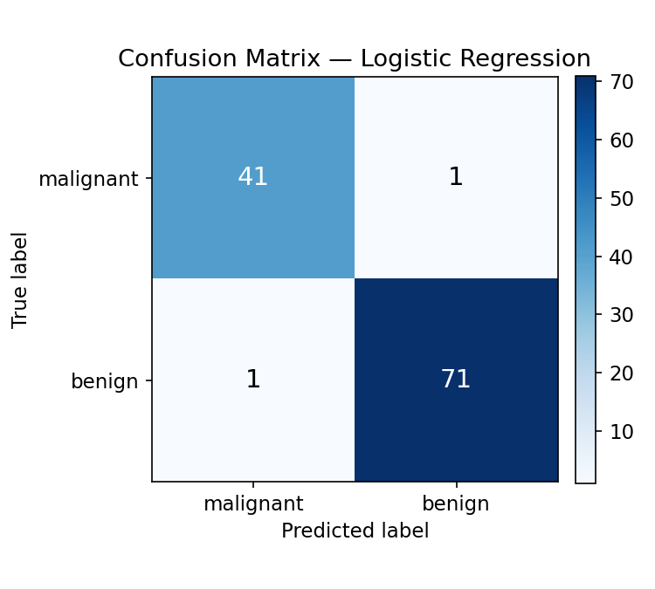
Figure 1. Confusion matrix — Logistic Regression on the test set.

4.3 ROC Curve
The ROC curve plots the true-positive rate against the false-positive rate across all classification thresholds. Logistic Regression's curve hugs the top-left corner far more tightly than the Decision Tree's, reflected in its higher AUC (area under curve).
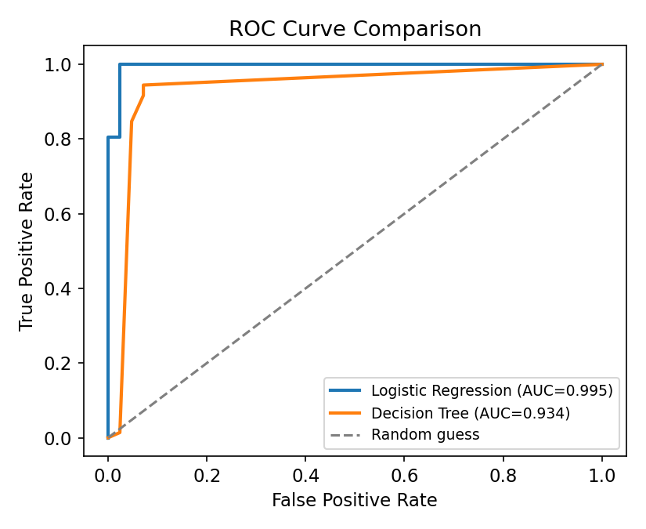
Figure 2. ROC curve comparison between Logistic Regression and Decision Tree.

4.4 Train vs Test Accuracy (Overfitting Check)
Comparing training accuracy to test accuracy is a simple but effective overfitting diagnostic: a large gap indicates the model has memorized training-set patterns that do not generalize.
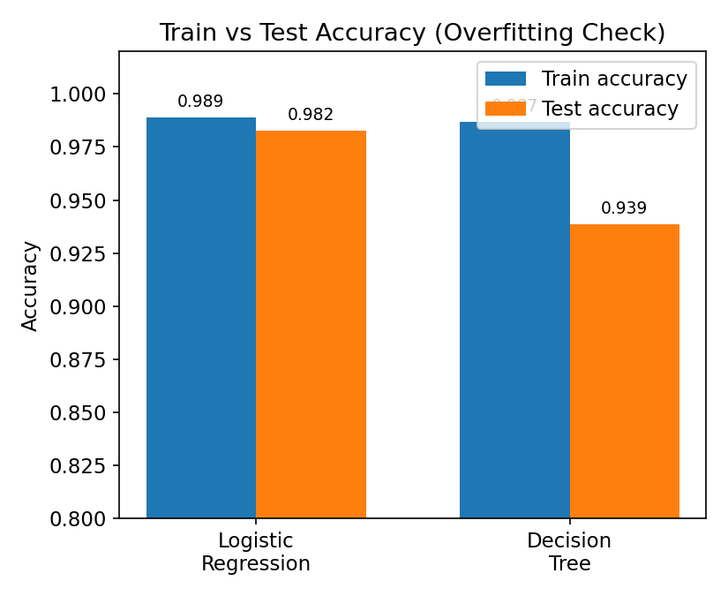
Figure 3. Train vs test accuracy for both models.

4.5 Feature Influence
Standardized logistic regression coefficients indicate which features most strongly push a prediction toward malignant (negative, red) or benign (positive, blue) in this encoding.
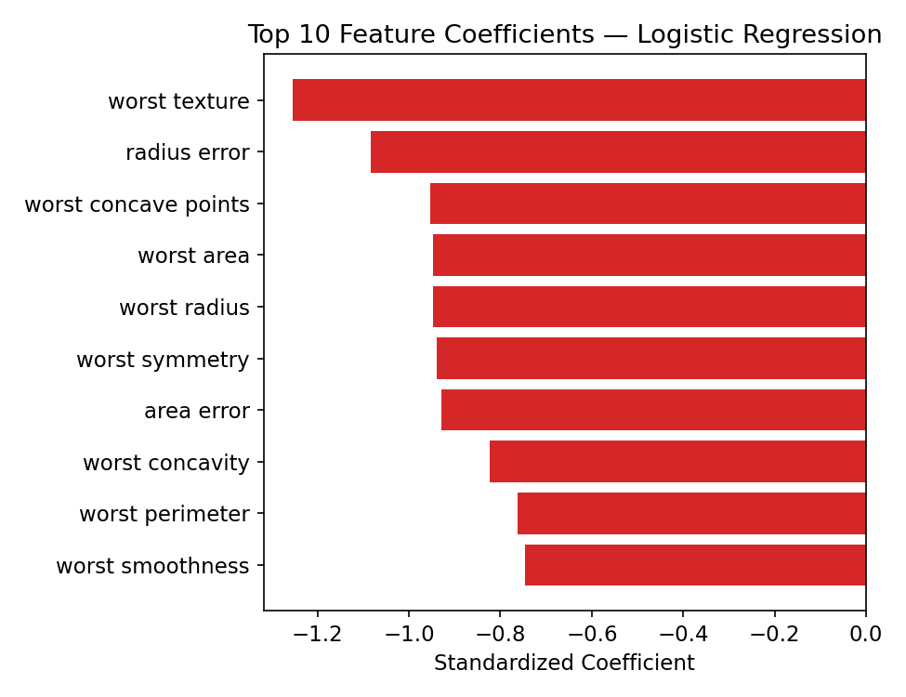
Figure 4. Top 10 logistic regression coefficients by magnitude.

4.6 Code Snippet — Evaluation
from sklearn.metrics import (accuracy_score, precision_score,
recall_score, f1_score, confusion_matrix, roc_curve, roc_auc_score)

y_pred = log_reg.predict(X_test_scaled)
y_proba = log_reg.predict_proba(X_test_scaled)[:, 1]

acc = accuracy_score(y_test, y_pred)
prec = precision_score(y_test, y_pred)
rec = recall_score(y_test, y_pred)
f1 = f1_score(y_test, y_pred)
auc = roc_auc_score(y_test, y_proba)
cm = confusion_matrix(y_test, y_pred)
fpr, tpr, thresholds = roc_curve(y_test, y_proba)

5. Critical Discussion: Sources of Error and Improvement

5.1 Overfitting vs Underfitting
Logistic Regression shows train accuracy of 98.9% against test accuracy of 98.3% — a gap of under 1 point, indicating the model generalizes well and is neither meaningfully overfitting nor underfitting. The Decision Tree, by contrast, shows train accuracy of 98.7% but test accuracy of only 93.9% — a gap of roughly 5 points even with depth capped at 4. This is a classic signature of overfitting: the tree partitions the training data more aggressively than the underlying signal warrants, capturing some noise along with real structure. An unconstrained tree (no max_depth) would show this effect far more severely.

5.2 Potential Sources of Error
- Sample size and single-split variance: 569 total samples (114 in the test set) is small enough that a single train/test split can be somewhat lucky or unlucky. Cross-validation partially mitigates this, but a fully robust estimate would use repeated stratified k-fold or nested cross-validation.
- Class imbalance: benign cases outnumber malignant cases roughly 3:2. Although accuracy remains meaningful here because the imbalance is mild, in a more imbalanced or higher-stakes clinical setting accuracy alone would be misleading, and recall on the malignant class (avoiding false negatives) should be weighted more heavily than overall accuracy.
- Feature correlation / multicollinearity: several features (e.g., radius, perimeter, area) are near-redundant measurements of tumor size. This can inflate or destabilize individual logistic regression coefficients even when overall predictive performance remains strong, which limits how literally the coefficient plot (Figure 4) should be interpreted as "feature importance."
- Threshold sensitivity: the default 0.5 probability threshold was used for the confusion matrix. In a screening context, that threshold might be deliberately lowered to reduce false negatives (missed malignant cases) at the cost of more false positives, which the ROC curve makes possible to reason about.
- Generalization to new populations: the dataset originates from a single imaging source and patient population; performance on this held-out split does not guarantee equivalent performance on data collected with different instruments or from different demographics.

5.3 Suggestions for Improvement
- Use repeated stratified k-fold cross-validation (rather than a single split) to obtain a more robust estimate of generalization performance and its variance.
- Apply regularization tuning (grid search over the logistic regression C parameter, and L1 vs L2 penalty) to further stabilize coefficients in the presence of correlated features.
- Address class imbalance explicitly with class_weight='balanced' or resampling (e.g., SMOTE), and report recall/precision per class rather than relying on accuracy alone.
- Perform dimensionality reduction or feature selection (e.g., PCA, or dropping redundant size-related features) to reduce multicollinearity and improve interpretability.
- Try additional model families (e.g., Random Forest, Gradient Boosting, SVM with an RBF kernel) and compare via nested cross-validation before finalizing a production model.
- Calibrate the decision threshold to the clinical cost of false negatives vs false positives rather than defaulting to 0.5.

6. Conclusion
This exercise implemented a complete, reproducible machine learning workflow: loading and cleaning data, preventing data leakage through correct train/test/scaling order, training and comparing two classification algorithms, and evaluating them with multiple complementary metrics and visualizations rather than accuracy alone. Logistic Regression proved to be the stronger and more reliable model for this dataset, achieving 98.2% test accuracy and a 0.995 ROC-AUC with minimal train/test gap, while the Decision Tree comparison usefully illustrated what overfitting looks like in practice. The critical discussion above outlines concrete, prioritized next steps — cross-validation, imbalance handling, regularization tuning, and broader model comparison — that would be the natural continuation of this work beyond the scope of this introductory exercise.

