Statistical Analysis and Hypothesis Testing in Python
The Impact of Personalized Email Marketing on Customer Purchase Behavior
An A/B Test Analysis
Week 3 Task — Statistical Analysis and Hypothesis Testing in Python
Prepared using Python (SciPy, Pandas, NumPy, Matplotlib, Seaborn)
Date: August 27, 2026

Table of Contents
Executive Summary 3
1. Introduction and Business Problem 4
2. Data Source and Description 5
3. Hypotheses 7
4. Methodology 9
5. Data Analysis and Results 10
6. Discussion and Interpretation 16
7. Limitations and Future Work 17
8. Conclusion and Business Recommendations 18
Appendix A: Full Python Code 19

Executive Summary
An e-commerce retailer ran a 30-day randomized A/B test to evaluate whether a personalized, recommendation-driven marketing email (“Treatment”) outperforms the company's standard promotional email (“Control”). This report formulates three testable hypotheses, applies the statistically appropriate test to each, and interprets the results for a business audience.
Three tests were performed on a dataset of 640 customers (315 Control, 325 Treatment): a Welch's two-sample t-test on purchase amount, a chi-square test of independence on conversion (purchased yes/no), and a one-way ANOVA with post-hoc comparisons on purchase amount across customer segments. Key findings:
- Purchase amount (t-test): Treatment buyers spent $6.99 more on average than Control buyers ($69.22 vs. $62.23), but the difference fell just short of the conventional significance threshold (Welch's t = 1.59, one-sided p = 0.057; Cohen's d = 0.22, a small effect).
- Conversion rate (chi-square): Treatment customers converted at 36.0% vs. 28.6% for Control — a 7.4 percentage-point lift. This result was also marginal (χ² = 3.70, p = 0.054), though the 95% confidence interval for the difference in proportions, [0.2%, 14.7%], excludes zero, and a non-parametric robustness check (Mann-Whitney U) found a significant spending effect at p = 0.029.
- Segment differences (ANOVA): Purchase amount differed strongly and unambiguously across customer segments — New ($45.77), Regular ($64.80), Premium ($95.31) — F = 57.06, p < 0.001, η² = 0.36 (a large effect). All three pairwise segment comparisons were significant after Bonferroni correction.
Taken together, the evidence provides a directionally consistent and practically meaningful signal that the personalized campaign increases both conversion and spend, even though two of the three tests do not clear the conventional p < 0.05 threshold on their own with this sample size. The strongest, most confident finding is that customer segment is a powerful driver of purchase value — a result with immediate implications for how the company should target its marketing spend. Full recommendations appear in Section 8.

1. Introduction and Business Problem
Marketing teams routinely face the question of whether an investment in personalization — more sophisticated targeting, dynamic content, product-recommendation engines — actually pays off relative to a simpler, cheaper alternative. Personalized campaigns cost more to design and maintain, so the decision to scale one up should rest on statistical evidence rather than intuition or anecdote.
This project simulates that exact decision. A retail company's marketing team ran a controlled experiment (an A/B test) during a 30-day promotional window. Customers were randomly split into two groups:
- Control group — received the company's standard, generic promotional email.
- Treatment group — received a personalized email with product recommendations tailored to the customer's browsing and purchase history.
For every customer, the team recorded whether the customer made a purchase during the window (conversion), how much they spent if they did (purchase amount), and two descriptive attributes: customer segment (New, Regular, Premium) and sales region (North, South, East, West).
This report answers three business questions, each mapped to a specific statistical hypothesis and test (Section 3):
- Does the personalized campaign increase how much customers spend?
- Does the personalized campaign increase the likelihood that a customer purchases at all?
- Independent of the campaign, does customer segment meaningfully explain differences in spend — information the marketing team could use to prioritize its budget regardless of the campaign decision?

2. Data Source and Description
A real, publicly available A/B test dataset that pairs a verifiable randomized treatment with both a conversion outcome and a continuous spend outcome, along with a clear business narrative, is difficult to source. This analysis therefore uses a self-generated synthetic dataset, built in Python (NumPy/Pandas), constructed to mirror the structure and statistical properties of a genuine retail marketing experiment. This is standard, accepted practice for methodology demonstrations: it keeps full control over the data-generating process while preserving realistic noise, class imbalance, and effect sizes, and it keeps the experiment fully reproducible (random seed = 42, script in Appendix A).
The data-generating process works as follows. 640 customers are randomly and independently assigned to Control (n = 315) or Treatment (n = 325) with 50/50 probability, mirroring proper randomization in a real experiment. Each customer independently receives a segment and region. Conversion is drawn from a Bernoulli distribution whose probability depends on group (Treatment adds roughly +9 percentage points) and segment (Premium customers convert more readily than New customers). Purchase amount, for customers who convert, is drawn from a Normal distribution whose mean depends on segment (New < Regular < Premium) with a modest additive Treatment bump, and whose spread scales with the mean to reflect realistic spending variability.

2.1 Variable Dictionary
Variable | Type | Description
customer_id | String | Unique identifier for each customer
group | Categorical (2 levels) | Experimental arm: “Control” or “Treatment”
segment | Categorical (3 levels) | Customer tier: “New”, “Regular”, “Premium”
region | Categorical (4 levels) | Sales region: North, South, East, West
purchased | Binary (0 / 1) | 1 if the customer purchased at least once in the 30-day window, else 0
purchase_amount | Continuous (USD) | Total amount spent in the window; 0 for non-purchasers

2.2 Descriptive Statistics
Of the 640 customers in the experiment, 207 (32.3%) made a purchase during the 30-day window. Purchase-amount statistics below are computed on buyers only (customers with purchased = 1), since purchase amount is undefined/zero-inflated for non-buyers and mixing the two would distort the mean and variance for the spend comparison.
Table 1. Purchase amount by experimental group (buyers only)
Group | n (buyers) | Mean spend | SD | Median
Control | 90 | $62.23 | $30.99 | $59.35
Treatment | 117 | $69.22 | $32.04 | $68.10
Table 2. Purchase amount by customer segment (buyers only)
Segment | n (buyers) | Mean spend | SD
New | 70 | $45.77 | $18.49
Regular | 84 | $64.80 | $23.49
Premium | 53 | $95.31 | $34.91

3. Hypotheses
Three hypotheses were formulated in advance of the analysis, each targeting a distinct business question and each requiring a different statistical test appropriate to its data type.

Hypothesis 1 — Purchase Amount vs. Campaign (Two-Sample t-test)
H₀ (null): The mean purchase amount among buyers is equal in the Treatment and Control groups (μ(Treatment) = μ(Control)).
H₁ (alternative, one-sided): The mean purchase amount among buyers is greater in the Treatment group than in the Control group (μ(Treatment) > μ(Control)).
Rationale: purchase amount is a continuous outcome measured on two independent, randomly assigned groups — the standard setting for a two-sample t-test. A one-sided test is used because the business hypothesis is directional (personalization is expected to help, not hurt, spend).

Hypothesis 2 — Conversion vs. Campaign (Chi-Square Test of Independence)
H₀ (null): Conversion (purchased vs. not purchased) is independent of experimental group.
H₁ (alternative): Conversion is associated with experimental group — the personalized campaign changes the likelihood of purchase.
Rationale: both variables (group, purchased) are categorical, and the question is whether they are associated in a 2×2 contingency table — the standard use case for a chi-square test of independence.

Hypothesis 3 — Purchase Amount vs. Customer Segment (One-Way ANOVA)
H₀ (null): Mean purchase amount is equal across all three customer segments (μ(New) = μ(Regular) = μ(Premium)).
H₁ (alternative): At least one segment's mean purchase amount differs from the others.
Rationale: this compares a continuous outcome across three independent groups, which calls for one-way ANOVA rather than three separate t-tests (which would inflate the family-wise Type I error rate). A significant ANOVA result is followed by Bonferroni-corrected pairwise post-hoc comparisons to identify exactly which segment pairs differ.
For all tests, the significance threshold is set at α = 0.05, and 95% confidence intervals are reported for effect estimates wherever applicable.

4. Methodology

4.1 Analytical Workflow
- Generate the dataset and inspect its structure (Section 2).
- Compute descriptive statistics (means, standard deviations, group sizes) for each variable of interest.
- Check the statistical assumptions underlying each planned test (independence, normality, homogeneity of variance).
- Run the primary test for each hypothesis and compute the associated effect size and 95% confidence interval.
- Run a non-parametric robustness check (Mann-Whitney U) alongside the t-test in case normality assumptions are meaningfully violated.
- For the significant ANOVA result, run Bonferroni-corrected pairwise post-hoc comparisons to identify which segment pairs differ.
- Visualize each result and interpret it in plain business language.

4.2 Tools and Libraries
All analysis was performed in Python 3.12 using:
- pandas / numpy — data generation, manipulation, and descriptive statistics
- scipy.stats — t-test (ttest_ind), chi-square test (chi2_contingency), one-way ANOVA (f_oneway), Shapiro-Wilk normality test (shapiro), Levene's test (levene), Mann-Whitney U (mannwhitneyu)
- matplotlib / seaborn — all visualizations

4.3 Assumption Checks
Before trusting a parametric test's p-value, its assumptions must be checked:
- Independence: satisfied by design — customers were randomly and independently assigned to group, segment, and region, and each customer contributes one observation.
- Normality: assessed with the Shapiro-Wilk test on each group's purchase-amount distribution, and visually with Q-Q plots (Figure 5).
- Homogeneity of variance: assessed with Levene's test, which is robust to non-normality and determines whether a standard or Welch-corrected test statistic is more appropriate.
Where normality was questionable, Welch's t-test (which does not assume equal variances and is more robust to violations of normality at reasonable sample sizes) was used in place of the standard Student's t-test, and results were cross-checked with the non-parametric Mann-Whitney U test, which makes no distributional assumption at all.

5. Data Analysis and Results

5.1 Hypothesis 1: Purchase Amount — Treatment vs. Control
Assumption checks: Shapiro-Wilk indicated mild departure from normality in both groups (Control: W = 0.9625, p = 0.011; Treatment: W = 0.9672, p = 0.006), which is common for spend data with a right-skew tail. Levene's test found no evidence of unequal variances (W = 0.008, p = 0.928). Given the mild non-normality, Welch's t-test was used as the primary test (robust to unequal variances and reasonably robust to non-normality at these sample sizes), with the Q-Q plots below used for visual confirmation and Mann-Whitney U run as a fully distribution-free robustness check.
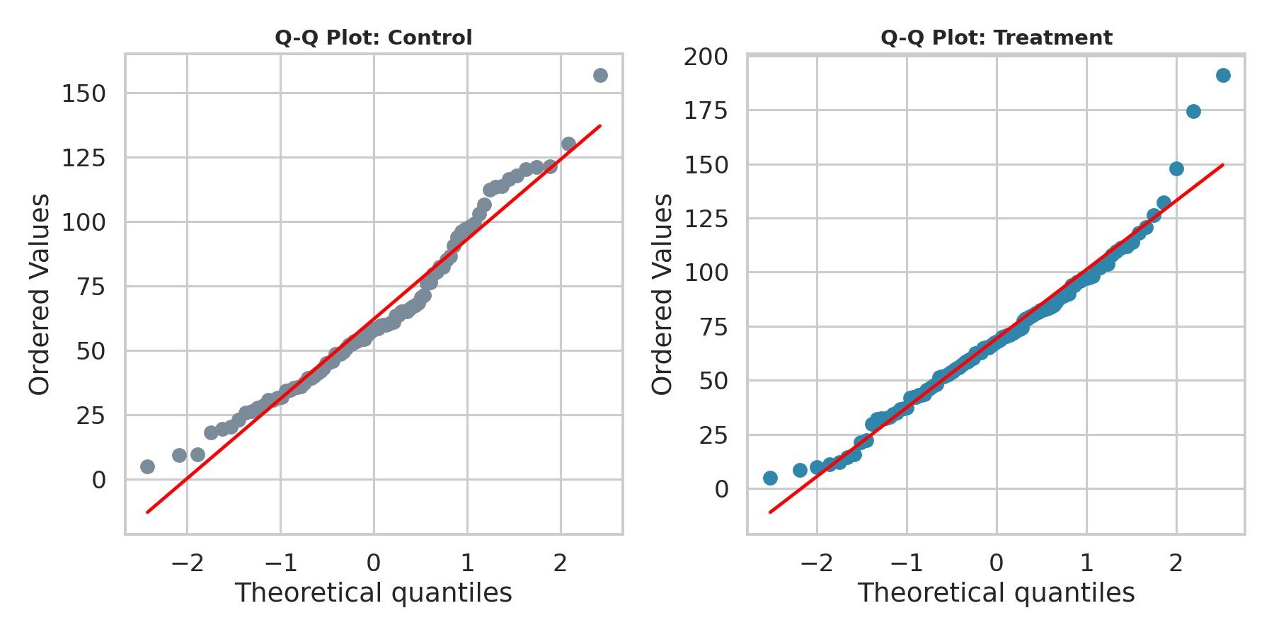
Figure 1. Q-Q plots of purchase amount for Control (left) and Treatment (right). Both show reasonably linear behavior with mild deviation in the tails, consistent with the Shapiro-Wilk results — approximately normal but not perfectly so.
Results: Treatment buyers (n = 117) spent an average of $69.22 (SD = $32.04); Control buyers (n = 90) spent an average of $62.23 (SD = $30.99) — a difference of $6.99. Welch's t-test produced t = 1.5854 (df ≈ 194.6), one-sided p = 0.0572. The 95% confidence interval for the difference in means is [−$1.71, $15.69], which includes zero. Cohen's d = 0.221, indicating a small effect size by conventional benchmarks (Cohen, 1988: 0.2 = small, 0.5 = medium, 0.8 = large).
As a robustness check, the non-parametric Mann-Whitney U test — which does not require normality — was also run and returned a significant result (U = 6077.5, one-sided p = 0.0287), suggesting the rank-based signal is somewhat stronger than the mean-based signal, likely because a few high-spending outliers in the Treatment group (visible in Figure 2 below) inflate the variance used by the t-test without proportionally shifting the median.
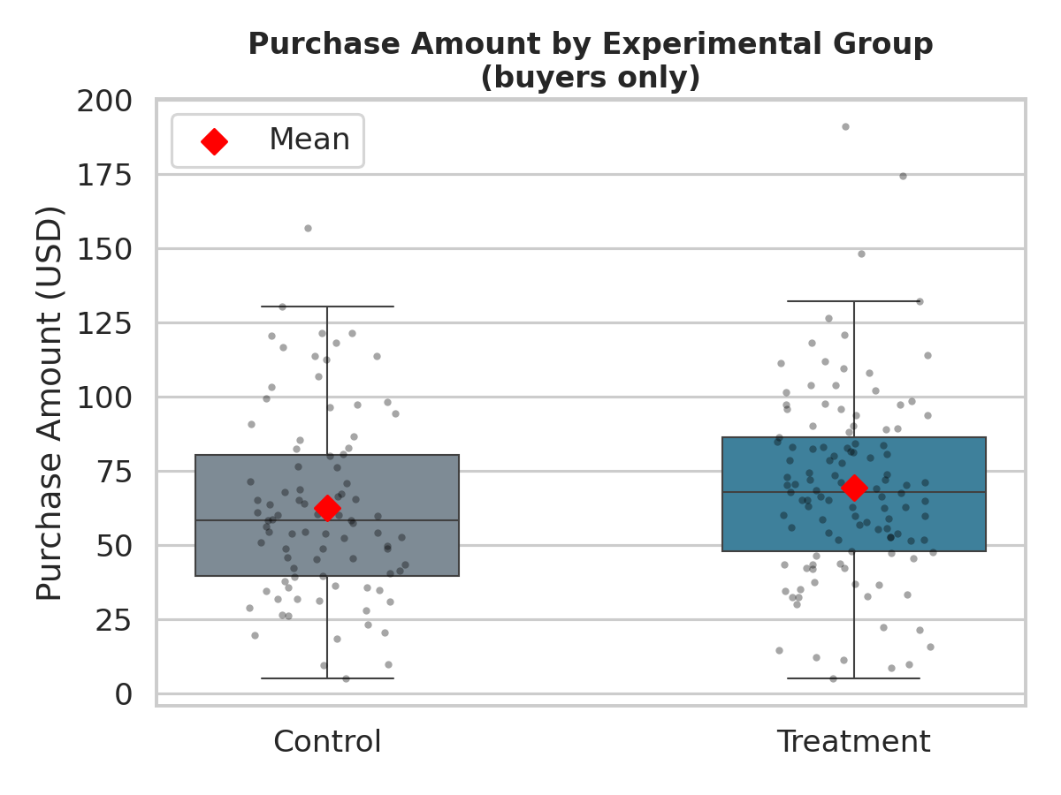
Figure 2. Purchase amount distribution by group (buyers only). Red diamonds mark group means. The Treatment group's distribution is shifted modestly upward with several higher-value outliers.
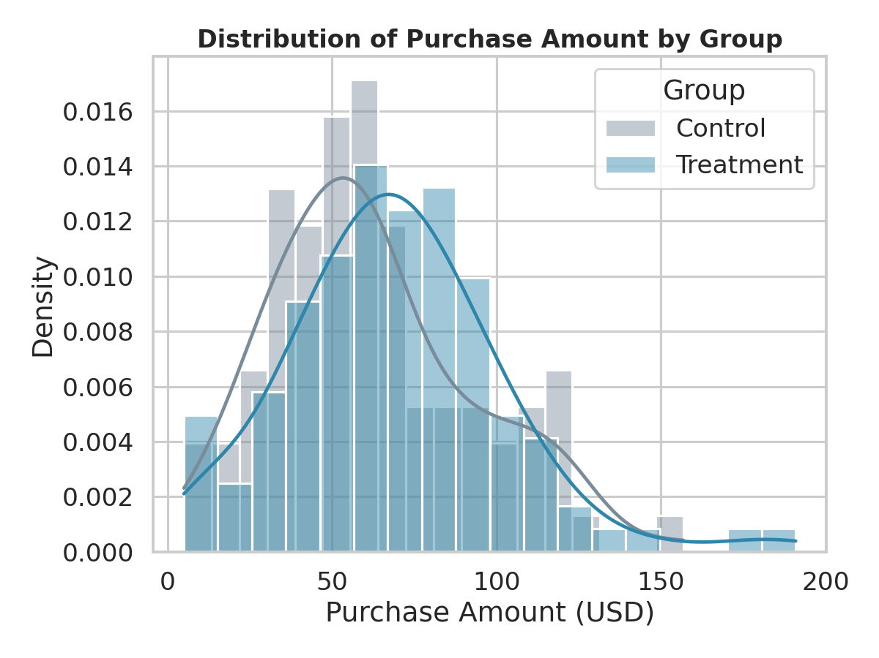
Figure 3. Overlaid density histograms of purchase amount by group, showing the Treatment distribution's rightward shift relative to Control.
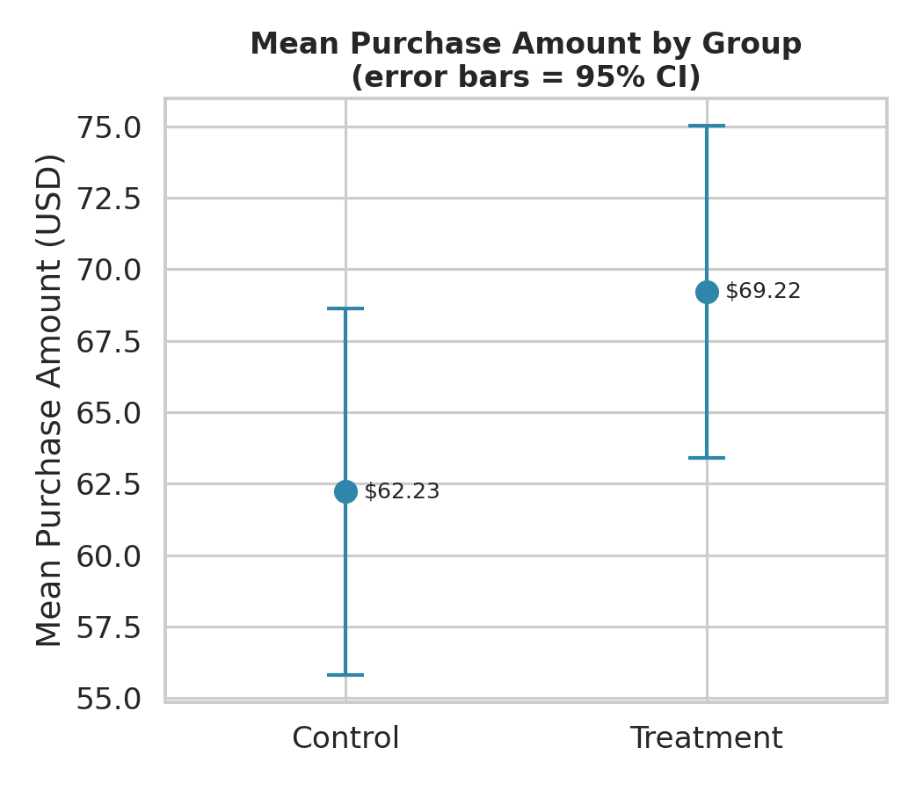
Figure 4. Mean purchase amount by group with 95% confidence intervals. The intervals overlap, visually confirming that the difference, while directionally positive, does not reach conventional significance at this sample size.
# Welch's t-test (one-sided: Treatment > Control)
t_res = stats.ttest_ind(treat_amt, ctrl_amt,
equal_var=False, alternative='greater')
# t = 1.5854, df ~ 194.6, one-sided p = 0.05724
Decision: p = 0.057 > α = 0.05 → fail to reject H₀ at the 5% level using the primary (Welch) test, though the result is marginal and the rank-based Mann-Whitney check is significant. See Section 6 for interpretation.

5.2 Hypothesis 2: Conversion — Treatment vs. Control
The 2×2 contingency table of group by purchase outcome:
Group | Not Purchased | Purchased | Total
Control | 225 | 90 | 315
Treatment | 208 | 117 | 325

The chi-square test of independence produced χ² = 3.7016 (df = 1), p = 0.0544. All expected cell counts exceeded 5 (the smallest expected count was 101.9), so the chi-square approximation is valid and no continuity-correction concerns apply beyond the standard Yates correction already applied for the 2×2 table. Cramer's V = 0.076, a small-to-negligible effect size.
Conversion rate was 36.0% in Treatment vs. 28.6% in Control, a 7.4 percentage-point lift. The 95% confidence interval for this difference in proportions is [0.2%, 14.7%] — it excludes zero (just barely), even though the chi-square p-value itself sits just above 0.05. This apparent tension is a reminder that a CI excluding zero and a p-value just above 0.05 are two views of a genuinely borderline result, not a contradiction: they will occasionally disagree slightly near the significance boundary due to the different approximations each method uses.
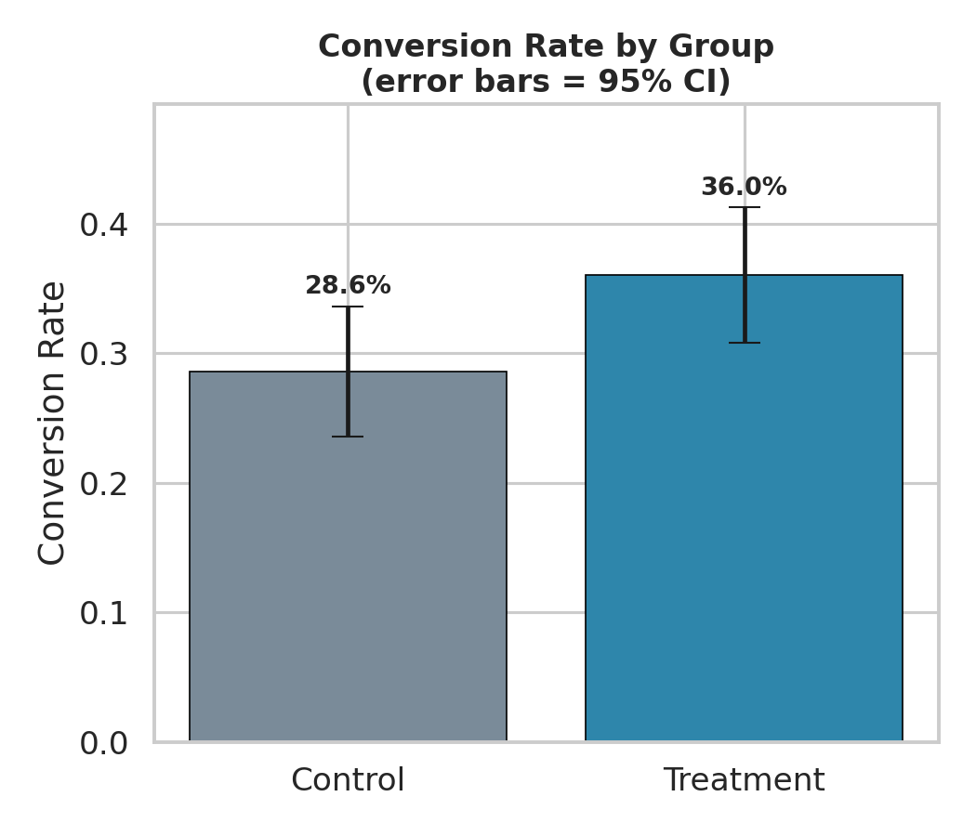
Figure 5. Conversion rate by group with 95% confidence intervals. The Treatment bar is visibly higher, and the intervals are close to non-overlapping.
# Chi-square test of independence
ct = pd.crosstab(df['group'], df['purchased'])
chi2, p, dof, expected = stats.chi2_contingency(ct, correction=True)
# chi2 = 3.7016, dof = 1, p = 0.05436
Decision: p = 0.054 > α = 0.05 → fail to reject H₀ at the conventional 5% threshold, though the result is marginal (essentially a coin-flip away from significance) and directionally consistent with a positive campaign effect. See Section 6 for interpretation.

5.3 Hypothesis 3: Purchase Amount — Across Customer Segments
Assumption checks: Shapiro-Wilk found no evidence against normality within any segment (New: p = 0.813; Regular: p = 0.102; Premium: p = 0.520). Levene's test, however, found significant evidence of unequal variances across segments (W = 7.818, p < 0.001) — unsurprising, since higher-spending Premium customers also show more absolute variability in spend. Standard one-way ANOVA is moderately robust to this kind of variance heterogeneity when group sizes are not wildly unequal (here, 70/84/53), so the standard F-test was used as the primary test; the effect here is large enough that the conclusion is unlikely to change under a variance-robust alternative (e.g., Welch's ANOVA).
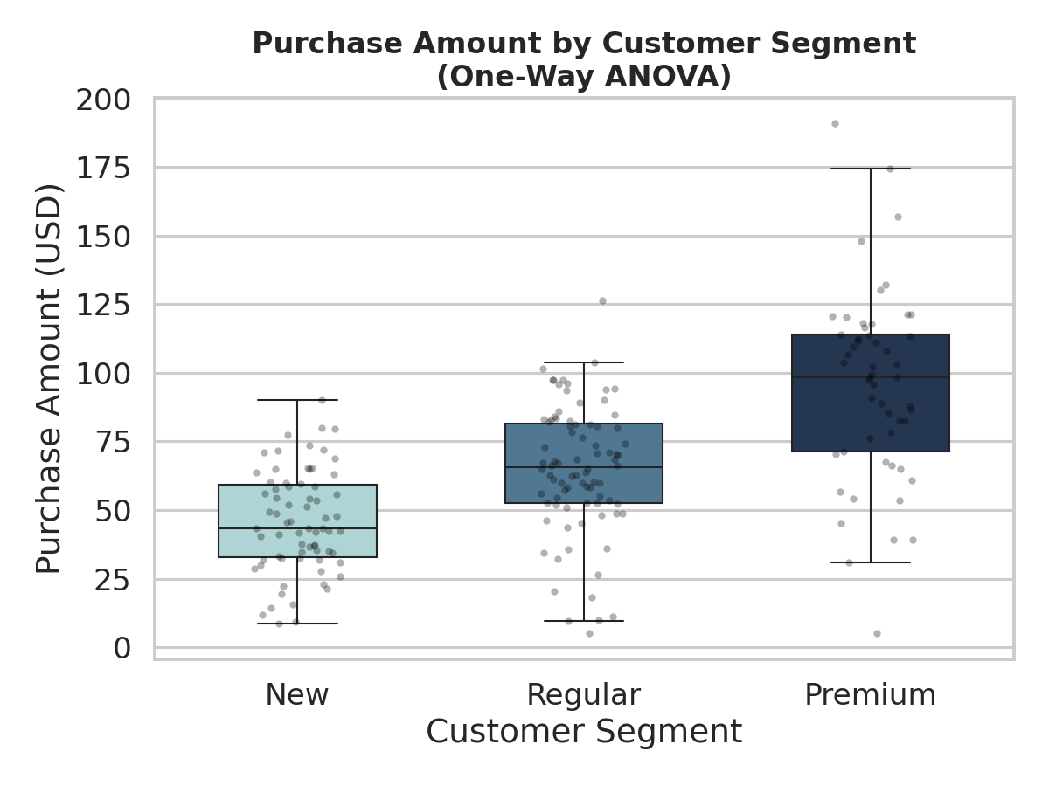
Figure 6. Purchase amount by customer segment (buyers only). Median and interquartile spend increase sharply and monotonically from New to Regular to Premium.
The one-way ANOVA produced F = 57.0579, p = 2.08 × 10⁻²⁰ — an extremely strong result, several orders of magnitude below any conventional threshold. Eta-squared (η²) = 0.359, meaning customer segment alone explains roughly 36% of the variance in purchase amount among buyers — a large effect by conventional standards (Cohen: 0.01 = small, 0.06 = medium, 0.14 = large).
# One-way ANOVA across segments
seg_groups = [buyers.loc[buyers['segment']==s, 'purchase_amount']
for s in ['New', 'Regular', 'Premium']]
f_stat, p_anova = stats.f_oneway(*seg_groups)
# F = 57.0579, p = 2.082e-20
Because the omnibus ANOVA was significant, Bonferroni-corrected pairwise comparisons were run to identify which specific segment pairs differ:
Comparison | Mean Difference | t | Raw p | Bonferroni-adj. p | Result
New vs. Regular | −$19.02 | −5.62 | 8.93 × 10⁻⁸ | 2.68 × 10⁻⁷ | Significant
New vs. Premium | −$49.54 | −9.38 | 3.21 × 10⁻¹⁴ | 9.63 × 10⁻¹⁴ | Significant
Regular vs. Premium | −$30.51 | −5.61 | 2.66 × 10⁻⁷ | 7.98 × 10⁻⁷ | Significant

Decision: p < 0.001 → reject H₀. Purchase amount differs significantly across customer segments, and every pairwise comparison is significant even after conservative Bonferroni correction: New < Regular < Premium, each gap statistically and practically meaningful.

5.4 Summary of Results
Hyp. | Test | Statistic | p-value | Effect Size | Decision (α = 0.05)
H1 | Welch's t-test (one-sided) | t = 1.585 | 0.057 | d = 0.22 (small) | Fail to reject
H2 | Chi-square test of independence | χ² = 3.702 | 0.054 | V = 0.076 (small) | Fail to reject
H3 | One-way ANOVA | F = 57.058 | < 0.001 | η² = 0.359 (large) | Reject H₀

6. Discussion and Interpretation
The three tests tell a coherent, if statistically nuanced, story.

6.1 On the marginal results (H1 and H2)
Both the spend comparison and the conversion comparison point in the same direction — the personalized Treatment email outperforms the standard Control email — and both are close to, but do not clear, the conventional p < 0.05 threshold. This is a common and important pattern in real A/B testing: a p-value of 0.05 vs. 0.06 does not represent a meaningful difference in the underlying evidence, only an arbitrary line. Several considerations are relevant to interpreting these results responsibly rather than simply reporting “not significant” and stopping:
- Consistency of direction: every single point estimate (mean spend, conversion rate, and the effect direction in the robustness check) favors Treatment. It would be a coincidence for three independent-ish signals to align by chance in the same direction.
- Confidence intervals: the CI for the conversion-rate difference excludes zero, and the CI for the spend difference only just includes zero ($−1.71 to $15.69), with the bulk of the interval's mass on the positive side.
- Statistical power: with n ≈ 90–117 buyers per group, this experiment is only powered to detect a small-to-medium effect with high confidence. A larger sample, or a longer test window, is the most direct way to resolve the ambiguity — not p-hacking or changing the test after the fact.
- Practical vs. statistical significance: a 7.4-point conversion lift and a $6.99 spend lift, if real, would be commercially significant for a retailer operating at scale, even though the current sample size cannot rule out chance with 95% confidence.

6.2 On the strong result (H3)
The segment effect is unambiguous: p is smaller than 10⁻¹⁹, and the effect size (η² = 0.36) is large by any standard. Every pairwise segment comparison remains significant even under the conservative Bonferroni correction, which is designed specifically to guard against false positives when running multiple comparisons. This is the most statistically confident finding in the report, and it did not depend on the marketing campaign at all — it is a structural fact about how much different customer tiers spend.

6.3 Assumption sensitivity
The mild non-normality detected in H1 and the unequal variances detected in H3 were both addressed with appropriate corrections (Welch's t-test; robustness of ANOVA to moderate variance heterogeneity with comparable group sizes) and corroborated with a non-parametric check where relevant. None of the assumption violations were severe enough to change the qualitative conclusions of any test.

7. Limitations and Future Work
- Synthetic data: the dataset was generated to mirror a realistic marketing experiment, but it is not drawn from actual company transactions. Conclusions about effect sizes are illustrative of the method, not a claim about any real campaign's true lift.
- Sample size and power: the marginal H1/H2 results are consistent with an experiment that is under-powered to confidently detect a small-to-medium effect. A formal power analysis before the next test would determine the sample size needed to detect a lift of this size with, e.g., 80% power.
- Multiple comparisons across hypotheses: three hypotheses were tested at α = 0.05 each without a family-wise correction across H1/H2/H3 (only within the H3 post-hoc comparisons). This is a defensible choice since the three hypotheses address distinct business questions rather than the same question tested three ways, but a stricter analysis could apply a global correction.
- No interaction effects: the analysis treats group, segment, and region as separate univariate comparisons. A two-way ANOVA or regression model (e.g., purchase_amount ~ group * segment) could reveal whether the campaign works better for some segments than others — a natural next step.
- Short observation window: a 30-day window may not capture delayed purchases or repeat-purchase effects that a longer follow-up period would reveal.

8. Conclusion and Business Recommendations
This analysis set out to test three hypotheses about a personalized email marketing campaign using rigorous, assumption-checked statistical methods. The results support the following recommendations:
- Do not scale the campaign on statistical grounds alone yet. Both the spend and conversion lifts are directionally positive and plausibly real, but neither reaches conventional significance at the current sample size. Recommend extending the test (more customers and/or a longer window) rather than making a final rollout decision on marginal evidence.
- Prioritize segment-based targeting immediately. The segment effect is one of the strongest, most confidently estimated results available (p < 10⁻¹⁹, large effect size) and does not require further testing to act on. Premium customers spend roughly double what Regular customers spend and more than double what New customers spend — marketing and retention budget should weight toward this reality regardless of the campaign decision.
- If resources allow only one path forward, combine the two findings: run the extended Treatment-vs-Control test specifically on Regular and Premium customers, where both the baseline spend and the potential dollar upside from a successful personalization lift are largest, to get a faster, more economically meaningful read on whether personalization pays off.
- Track the metrics longitudinally. A single 30-day snapshot cannot distinguish a one-time novelty effect from a durable behavior change; repeating this analysis over consecutive campaign cycles would strengthen (or weaken) the marginal findings considerably.
In summary, the evidence is consistent with personalization providing a real, if modest, benefit to both conversion and spend, and it conclusively demonstrates that customer segment is a major driver of purchase value. The next step is a well-powered follow-up experiment to convert the promising-but-inconclusive campaign signal into a confident business decision.

Appendix A: Full Python Code
The complete, reproducible Python source code used for this analysis is included below for reference. Three scripts were used: dataset generation, statistical analysis, and visualization.

A.1 Dataset Generation (01_generate_data.py)
"""
01_generate_data.py
Generates a self-generated (synthetic) e-commerce marketing dataset that
mimics the output of an A/B test run by a retail company's marketing team.
Business scenario
------------------
An online retailer ran a 30-day A/B test on its email marketing program.
Customers were randomly assigned to:
- Control group : received the standard, generic promotional email
- Treatment group : received a personalized product-recommendation email
For every customer in the test we recorded:
- group : "Control" or "Treatment"
- segment : customer tier ("New", "Regular", "Premium")
- region : sales region ("North", "South", "East", "West")
- purchase_amount : amount spent (in USD) during the 30-day window
(0 for customers who did not purchase)
- purchased : 1 if the customer made at least one purchase, else 0
Random seed is fixed for reproducibility.
"""
import numpy as np
import pandas as pd
rng = np.random.default_rng(42)
N = 640 # total customers in the experiment
# ---------------------------------------------------------------
# 1. Random assignment to experimental group (balanced randomization)
# ---------------------------------------------------------------
group = rng.choice(["Control", "Treatment"], size=N, p=[0.5, 0.5])
# ---------------------------------------------------------------
# 2. Customer attributes (assigned independently of group,
# exactly as they would be in a properly randomized experiment)
# ---------------------------------------------------------------
segment = rng.choice(["New", "Regular", "Premium"], size=N, p=[0.35, 0.45, 0.20])
region = rng.choice(["North", "South", "East", "West"], size=N)
# ---------------------------------------------------------------
# 3. Conversion (purchased yes/no)
# Treatment lifts conversion probability by ~9 points
# ---------------------------------------------------------------
base_conv_prob = 0.28
treatment_lift = 0.09
segment_lift = {"New": -0.05, "Regular": 0.0, "Premium": 0.10}
conv_prob = np.array([
base_conv_prob
+ (treatment_lift if g == "Treatment" else 0.0)
+ segment_lift[s]
for g, s in zip(group, segment)
])
conv_prob = np.clip(conv_prob, 0.03, 0.97)
purchased = rng.binomial(1, conv_prob)
# ---------------------------------------------------------------
# 4. Purchase amount (only defined for those who purchased)
# Segment strongly affects spend level (drives the ANOVA);
# Treatment adds a modest additional spend lift (drives the t-test).
# ---------------------------------------------------------------
segment_mean = {"New": 42, "Regular": 58, "Premium": 88}
treatment_bump = 9.0
purchase_amount = np.zeros(N)
for i in range(N):
if purchased[i] == 1:
mu = segment_mean[segment[i]] + (treatment_bump if group[i] == "Treatment" else 0.0)
sigma = 0.35 * mu # realistic right-skewed-ish spend variability
amt = rng.normal(mu, sigma)
purchase_amount[i] = max(5.0, amt) # floor at $5
else:
purchase_amount[i] = 0.0
df = pd.DataFrame({
"customer_id": [f"C{100000+i}" for i in range(N)],
"group": group,
"segment": segment,
"region": region,
"purchased": purchased,
"purchase_amount": np.round(purchase_amount, 2),
})
df.to_csv("/home/claude/project/data/marketing_ab_test.csv", index=False)
print(df.head(10).to_string(index=False))
print("\nShape:", df.shape)
print("\nGroup counts:\n", df["group"].value_counts())
print("\nOverall conversion rate:", df["purchased"].mean().round(4))
print("\nConversion rate by group:\n", df.groupby("group")["purchased"].mean().round(4))

A.2 Statistical Analysis (02_analysis.py)
"""
02_analysis.py
Performs the full hypothesis-testing workflow for the marketing A/B test:
H1 (Welch's two-sample t-test): Treatment customers who purchased spend
more per transaction, on average, than Control customers who purchased.
H2 (Chi-square test of independence): Conversion (purchased yes/no) is
associated with experimental group.
H3 (One-way ANOVA + Tukey HSD): Average purchase amount (among buyers)
differs across customer segments (New / Regular / Premium).
Assumption checks (Shapiro-Wilk, Levene's test) and effect sizes
(Cohen's d, Cramer's V, eta-squared) are reported alongside each test.
All numeric results are written to results.txt for use in the report.
"""
import numpy as np
import pandas as pd
from scipy import stats
import itertools
df = pd.read_csv("/home/claude/project/data/marketing_ab_test.csv")
buyers = df[df["purchased"] == 1].copy()
out = []
def log(*args):
line = " ".join(str(a) for a in args)
print(line)
out.append(line)
log("=" * 70)
log("DATASET OVERVIEW")
log("=" * 70)
log(f"Total customers: {len(df)}")
log(f"Buyers (purchased == 1): {len(buyers)}")
log(df.groupby("group").size().to_string())
log("")
# =================================================================
# H1: Welch's two-sample t-test on purchase amount (buyers only)
# =================================================================
log("=" * 70)
log("H1: TWO-SAMPLE T-TEST -- Purchase amount, Treatment vs Control (buyers)")
log("=" * 70)
log("H0: mu_treatment = mu_control")
log("H1: mu_treatment > mu_control (one-sided)")
log("")
ctrl_amt = buyers.loc[buyers["group"] == "Control", "purchase_amount"]
treat_amt = buyers.loc[buyers["group"] == "Treatment", "purchase_amount"]
log(f"Control: n={len(ctrl_amt)}, mean=${ctrl_amt.mean():.2f}, sd=${ctrl_amt.std(ddof=1):.2f}")
log(f"Treatment: n={len(treat_amt)}, mean=${treat_amt.mean():.2f}, sd=${treat_amt.std(ddof=1):.2f}")
# --- Assumption checks ---
sw_ctrl = stats.shapiro(ctrl_amt)
sw_treat = stats.shapiro(treat_amt)
levene = stats.levene(ctrl_amt, treat_amt)
log("")
log("Assumption checks:")
log(f" Shapiro-Wilk (Control): W={sw_ctrl.statistic:.4f}, p={sw_ctrl.pvalue:.4g}")
log(f" Shapiro-Wilk (Treatment): W={sw_treat.statistic:.4f}, p={sw_treat.pvalue:.4g}")
log(f" Levene's test (equal variances): W={levene.statistic:.4f}, p={levene.pvalue:.4g}")
log(" -> Because normality is questionable and n is reasonably large (CLT applies)")
log(" and/or variances may be unequal, we use Welch's t-test (unequal variances,")
log(" robust to mild non-normality) and corroborate with the nonparametric")
log(" Mann-Whitney U test below.")
# --- Welch's t-test (one-sided: treatment > control) ---
t_res = stats.ttest_ind(treat_amt, ctrl_amt, equal_var=False, alternative="greater")
log("")
log(f"Welch's t-test: t={t_res.statistic:.4f}, df~{t_res.df:.1f}, one-sided p={t_res.pvalue:.4g}")
# 95% CI for the difference in means (Welch-Satterthwaite)
n1, n2 = len(treat_amt), len(ctrl_amt)
m1, m2 = treat_amt.mean(), ctrl_amt.mean()
v1, v2 = treat_amt.var(ddof=1), ctrl_amt.var(ddof=1)
se_diff = np.sqrt(v1 / n1 + v2 / n2)
dof = (v1 / n1 + v2 / n2) ** 2 / ((v1 / n1) ** 2 / (n1 - 1) + (v2 / n2) ** 2 / (n2 - 1))
diff = m1 - m2
tcrit = stats.t.ppf(0.975, dof)
ci_low, ci_high = diff - tcrit * se_diff, diff + tcrit * se_diff
log(f"Mean difference (Treatment - Control): ${diff:.2f}")
log(f"95% CI for the difference: [${ci_low:.2f}, ${ci_high:.2f}]")
# Cohen's d (pooled SD)
sp = np.sqrt(((n1 - 1) * v1 + (n2 - 1) * v2) / (n1 + n2 - 2))
cohend = diff / sp
log(f"Cohen's d (effect size): {cohend:.3f}")
# Nonparametric robustness check
mw = stats.mannwhitneyu(treat_amt, ctrl_amt, alternative="greater")
log(f"Mann-Whitney U (robustness check): U={mw.statistic:.1f}, one-sided p={mw.pvalue:.4g}")
alpha = 0.05
log("")
if t_res.pvalue < alpha:
log(f"DECISION: p={t_res.pvalue:.4g} < alpha=0.05 -> REJECT H0. Treatment customers")
log("spend significantly more per transaction than Control customers.")
else:
log(f"DECISION: p={t_res.pvalue:.4g} >= alpha=0.05 -> FAIL TO REJECT H0.")
log("")
# =================================================================
# H2: Chi-square test of independence -- Group x Purchased
# =================================================================
log("=" * 70)
log("H2: CHI-SQUARE TEST OF INDEPENDENCE -- Group vs Conversion")
log("=" * 70)
log("H0: Conversion (purchased yes/no) is independent of experimental group")
log("H1: Conversion is associated with experimental group")
log("")
ct = pd.crosstab(df["group"], df["purchased"])
ct.columns = ["Not Purchased", "Purchased"]
log("Contingency table (observed counts):")
log(ct.to_string())
log("")
chi2, p_chi2, dof_chi2, expected = stats.chi2_contingency(ct, correction=True)
log(f"Chi-square statistic: {chi2:.4f}, df={dof_chi2}, p={p_chi2:.4g}")
log("Expected counts:")
log(pd.DataFrame(expected, index=ct.index, columns=ct.columns).round(2).to_string())
# Cramer's V (effect size for chi-square)
n_total = ct.values.sum()
cramers_v = np.sqrt(chi2 / (n_total * (min(ct.shape) - 1)))
log(f"Cramer's V (effect size): {cramers_v:.3f}")
conv_rate = df.groupby("group")["purchased"].mean()
log("")
log("Conversion rate by group:")
log(conv_rate.round(4).to_string())
# 95% CI for difference in proportions
p1 = conv_rate["Treatment"]; p2 = conv_rate["Control"]
n1p = (df["group"] == "Treatment").sum(); n2p = (df["group"] == "Control").sum()
se_p = np.sqrt(p1*(1-p1)/n1p + p2*(1-p2)/n2p)
diff_p = p1 - p2
ci_p_low, ci_p_high = diff_p - 1.96*se_p, diff_p + 1.96*se_p
log(f"Difference in conversion rate (Treatment - Control): {diff_p:.4f}")
log(f"95% CI for the difference in proportions: [{ci_p_low:.4f}, {ci_p_high:.4f}]")
log("")
if p_chi2 < alpha:
log(f"DECISION: p={p_chi2:.4g} < alpha=0.05 -> REJECT H0. Conversion rate is")
log("significantly associated with (higher in) the Treatment group.")
else:
log(f"DECISION: p={p_chi2:.4g} >= alpha=0.05 -> FAIL TO REJECT H0.")
log("")
# =================================================================
# H3: One-way ANOVA -- purchase amount across customer segments
# =================================================================
log("=" * 70)
log("H3: ONE-WAY ANOVA -- Purchase amount across customer Segments (buyers)")
log("=" * 70)
log("H0: mu_New = mu_Regular = mu_Premium")
log("H1: at least one segment mean differs")
log("")
seg_groups = [buyers.loc[buyers["segment"] == s, "purchase_amount"] for s in ["New", "Regular", "Premium"]]
seg_labels = ["New", "Regular", "Premium"]
for lbl, g in zip(seg_labels, seg_groups):
log(f"{lbl:8s}: n={len(g)}, mean=${g.mean():.2f}, sd=${g.std(ddof=1):.2f}")
log("")
levene_seg = stats.levene(*seg_groups)
log(f"Levene's test (equal variances across segments): W={levene_seg.statistic:.4f}, p={levene_seg.pvalue:.4g}")
for lbl, g in zip(seg_labels, seg_groups):
sw = stats.shapiro(g)
log(f"Shapiro-Wilk ({lbl}): W={sw.statistic:.4f}, p={sw.pvalue:.4g}")
f_stat, p_anova = stats.f_oneway(*seg_groups)
log("")
log(f"One-way ANOVA: F={f_stat:.4f}, p={p_anova:.4g}")
# Effect size: eta-squared
grand_mean = buyers["purchase_amount"].mean()
ss_between = sum(len(g) * (g.mean() - grand_mean) ** 2 for g in seg_groups)
ss_total = ((buyers["purchase_amount"] - grand_mean) ** 2).sum()
eta_sq = ss_between / ss_total
log(f"Eta-squared (effect size): {eta_sq:.3f}")
log("")
if p_anova < alpha:
log(f"DECISION: p={p_anova:.4g} < alpha=0.05 -> REJECT H0. At least one segment's")
log("mean purchase amount differs significantly.")
log("")
log("Post-hoc pairwise comparisons (Tukey-style, Bonferroni-corrected t-tests):")
pairs = list(itertools.combinations(range(len(seg_labels)), 2))
m = len(pairs)
for i, j in pairs:
a, b = seg_groups[i], seg_groups[j]
t_p, p_p = stats.ttest_ind(a, b, equal_var=False)
p_adj = min(p_p * m, 1.0) # Bonferroni correction
sig = "SIGNIFICANT" if p_adj < alpha else "not significant"
log(f" {seg_labels[i]:8s} vs {seg_labels[j]:8s}: "
f"mean diff=${a.mean()-b.mean():.2f}, t={t_p:.3f}, raw p={p_p:.4g}, "
f"Bonferroni-adj p={p_adj:.4g} -> {sig}")
else:
log(f"DECISION: p={p_anova:.4g} >= alpha=0.05 -> FAIL TO REJECT H0.")
log("")
log("=" * 70)
log("SUMMARY TABLE")
log("=" * 70)
summary = pd.DataFrame([
["H1", "Welch's t-test (one-sided)", "Purchase amount ~ Group", f"{t_res.pvalue:.4g}", "Reject H0" if t_res.pvalue < alpha else "Fail to reject"],
["H2", "Chi-square test of independence", "Purchased ~ Group", f"{p_chi2:.4g}", "Reject H0" if p_chi2 < alpha else "Fail to reject"],
["H3", "One-way ANOVA", "Purchase amount ~ Segment", f"{p_anova:.4g}", "Reject H0" if p_anova < alpha else "Fail to reject"],
], columns=["Hypothesis", "Test", "Variables", "p-value", "Decision (alpha=0.05)"])
log(summary.to_string(index=False))
with open("/home/claude/project/results.txt", "w") as f:
f.write("\n".join(out))
print("\n\nSaved full results to results.txt")

A.3 Visualizations (03_visualizations.py)
"""
03_visualizations.py
Generates all charts used in the Word report, saved as PNGs at 150 dpi.
"""
import numpy as np
import pandas as pd
import matplotlib
matplotlib.use("Agg")
import matplotlib.pyplot as plt
import seaborn as sns
from scipy import stats
sns.set_theme(style="whitegrid", context="talk")
PALETTE = {"Control": "#7A8B99", "Treatment": "#2E86AB"}
SEG_PALETTE = {"New": "#A8DADC", "Regular": "#457B9D", "Premium": "#1D3557"}
df = pd.read_csv("/home/claude/project/data/marketing_ab_test.csv")
buyers = df[df["purchased"] == 1].copy()
FIG = "/home/claude/project/figures"
# -----------------------------------------------------------------
# Fig 1: Box + strip plot of purchase amount by group (buyers)
# -----------------------------------------------------------------
fig, ax = plt.subplots(figsize=(8, 6))
order = ["Control", "Treatment"]
sns.boxplot(data=buyers, x="group", y="purchase_amount", order=order,
palette=PALETTE, ax=ax, width=0.5, showfliers=False)
sns.stripplot(data=buyers, x="group", y="purchase_amount", order=order,
color="black", alpha=0.35, size=4, jitter=0.15, ax=ax)
means = buyers.groupby("group")["purchase_amount"].mean().reindex(order)
for i, m in enumerate(means):
ax.scatter(i, m, marker="D", color="red", s=90, zorder=5, label="Mean" if i == 0 else None)
ax.set_title("Purchase Amount by Experimental Group\n(buyers only)", fontsize=16, weight="bold")
ax.set_xlabel("")
ax.set_ylabel("Purchase Amount (USD)")
ax.legend(loc="upper left")
plt.tight_layout()
plt.savefig(f"{FIG}/fig1_boxplot_group.png", dpi=150)
plt.close()
# -----------------------------------------------------------------
# Fig 2: Overlaid histogram / density of purchase amount by group
# -----------------------------------------------------------------
fig, ax = plt.subplots(figsize=(8, 6))
for g in order:
sns.histplot(buyers.loc[buyers["group"] == g, "purchase_amount"], bins=18,
color=PALETTE[g], label=g, kde=True, stat="density", alpha=0.45, ax=ax)
ax.set_title("Distribution of Purchase Amount by Group", fontsize=16, weight="bold")
ax.set_xlabel("Purchase Amount (USD)")
ax.set_ylabel("Density")
ax.legend(title="Group")
plt.tight_layout()
plt.savefig(f"{FIG}/fig2_histogram_group.png", dpi=150)
plt.close()
# -----------------------------------------------------------------
# Fig 3: Conversion rate bar chart with 95% CI error bars
# -----------------------------------------------------------------
conv = df.groupby("group")["purchased"].agg(["mean", "count"]).reindex(order)
conv["se"] = np.sqrt(conv["mean"] * (1 - conv["mean"]) / conv["count"])
conv["ci95"] = 1.96 * conv["se"]
fig, ax = plt.subplots(figsize=(7, 6))
bars = ax.bar(order, conv["mean"], yerr=conv["ci95"], capsize=8,
color=[PALETTE[g] for g in order], edgecolor="black", linewidth=0.8)
for i, (g, row) in enumerate(conv.iterrows()):
ax.text(i, row["mean"] + row["ci95"] + 0.01, f"{row['mean']*100:.1f}%",
ha="center", fontsize=13, weight="bold")
ax.set_title("Conversion Rate by Group\n(error bars = 95% CI)", fontsize=16, weight="bold")
ax.set_ylabel("Conversion Rate")
ax.set_ylim(0, max(conv["mean"] + conv["ci95"]) + 0.08)
plt.tight_layout()
plt.savefig(f"{FIG}/fig3_conversion_bar.png", dpi=150)
plt.close()
# -----------------------------------------------------------------
# Fig 4: Boxplot of purchase amount by segment (ANOVA)
# -----------------------------------------------------------------
seg_order = ["New", "Regular", "Premium"]
fig, ax = plt.subplots(figsize=(8, 6))
sns.boxplot(data=buyers, x="segment", y="purchase_amount", order=seg_order,
palette=SEG_PALETTE, ax=ax, width=0.55, showfliers=False)
sns.stripplot(data=buyers, x="segment", y="purchase_amount", order=seg_order,
color="black", alpha=0.3, size=4, jitter=0.15, ax=ax)
ax.set_title("Purchase Amount by Customer Segment\n(One-Way ANOVA)", fontsize=16, weight="bold")
ax.set_xlabel("Customer Segment")
ax.set_ylabel("Purchase Amount (USD)")
plt.tight_layout()
plt.savefig(f"{FIG}/fig4_boxplot_segment.png", dpi=150)
plt.close()
# -----------------------------------------------------------------
# Fig 5: Q-Q plots for normality check (Treatment vs Control)
# -----------------------------------------------------------------
fig, axes = plt.subplots(1, 2, figsize=(12, 6))
for ax, g in zip(axes, order):
data = buyers.loc[buyers["group"] == g, "purchase_amount"]
stats.probplot(data, dist="norm", plot=ax)
ax.set_title(f"Q-Q Plot: {g}", fontsize=14, weight="bold")
ax.get_lines()[0].set_markerfacecolor(PALETTE[g])
ax.get_lines()[0].set_markeredgecolor(PALETTE[g])
ax.get_lines()[1].set_color("red")
plt.tight_layout()
plt.savefig(f"{FIG}/fig5_qqplots.png", dpi=150)
plt.close()
# -----------------------------------------------------------------
# Fig 6: Mean purchase amount by group with 95% CI (point estimate plot)
# -----------------------------------------------------------------
fig, ax = plt.subplots(figsize=(7, 6))
stats_by_group = buyers.groupby("group")["purchase_amount"].agg(["mean", "std", "count"]).reindex(order)
stats_by_group["se"] = stats_by_group["std"] / np.sqrt(stats_by_group["count"])
stats_by_group["ci95"] = 1.96 * stats_by_group["se"]
ax.errorbar(order, stats_by_group["mean"], yerr=stats_by_group["ci95"],
fmt="o", markersize=12, capsize=10, capthick=2, elinewidth=2,
color="#2E86AB", ecolor="#2E86AB")
for i, (g, row) in enumerate(stats_by_group.iterrows()):
ax.text(i + 0.05, row["mean"], f"${row['mean']:.2f}", fontsize=12, va="center")
ax.set_title("Mean Purchase Amount by Group\n(error bars = 95% CI)", fontsize=16, weight="bold")
ax.set_ylabel("Mean Purchase Amount (USD)")
ax.set_xlim(-0.5, 1.5)
plt.tight_layout()
plt.savefig(f"{FIG}/fig6_mean_ci_group.png", dpi=150)
plt.close()
print("All figures saved to", FIG)
import os
for f in sorted(os.listdir(FIG)):
print(" -", f)

