What the Hack AI Model and Training Brief
Judge and team reference for the network attack forecasting system
This reference explains what the deployed AI model does, what data it was trained on, what the visible risk forecast means, and which claims should and should not be made in a judging conversation. The demonstrated system is an end to end forecasting prototype: it ingests traffic, creates one minute behavioural windows, forecasts risk for the next five minutes, predicts a coarse MITRE aligned stage, explains the strongest signals, and stores analyst alerts.

Executive summary
Question | Answer
What does it forecast | The probability that attack risk will persist or escalate over the next five one minute windows.
What does it observe | The previous 10 one minute windows, each represented by 37 network behaviour features.
What is the model | A PyTorch next state world model with a two layer LSTM and a separate risk and stage prediction head.
What does the stage mean | A transparent coarse CICIDS to MITRE aligned progression category, not proof of an exact ATT and CK technique.
What is safe to claim today | A complete reproducible local forecasting demo with a trained checkpoint and explicit evaluation limitations.

Model architecture
The model is a small world model. Instead of only labelling the current traffic as safe or unsafe, it first learns how the 37 feature network state changes from one minute to the next. The risk and stage head then evaluates each predicted future state.
Component | Configuration | Purpose
Input sequence | 10 windows by 37 features | Represents approximately the previous 10 minutes of network behaviour.
Dynamics model | 2 layer LSTM, 64 hidden units, dropout 0.1 | Predicts the next 60 second feature vector.
Next state head | Linear 64 to 37 | Returns the predicted next behavioural state.
Risk and stage trunk | 37 to 32 ReLU to 32 ReLU | Creates a compact representation of each real or forecast state.
Risk output | Linear 32 to 1 plus sigmoid | Produces a risk probability from 0 to 1.
Stage output | Linear 32 to 6 logits | Chooses one coarse stage class.

The full input tensor is 10 times 37, or 370 observed values per prediction sequence. The system rolls the dynamics model forward five times, yielding a five minute risk projection.

Stage classes and interpretation
Model class | Dataset family used for training | Judge safe interpretation
Benign | BENIGN | No attack family label in the source window.
Reconnaissance | PortScan | Scanning or discovery style behaviour.
Initial Access | FTP SSH Patator, web brute force, Heartbleed | Credential or exposed service entry behaviour.
Lateral Movement | Infiltration | Potential internal movement pattern requiring validation.
Command and Control | Botnet | Botnet or remote control style traffic pattern.
Exfiltration and Impact | DoS and DDoS | Late stage harmful impact bucket. It is not proof of data exfiltration.

Training dataset and preparation
The committed demo replay is a 105000 row CICIDS2017 derived, labelled traffic dataset. It is included in the repository so a fresh clone can train pipeline mechanics, upload traffic, and run the dashboard without downloading the original archive. Its public archive variant does not retain complete capture timestamps, so the cleaner constructs a deterministic source order timeline.
Training item | Value
Dataset file | ai datasets cleaned cicids2017 archive clean csv
Rows | 105000 normalized labelled flows
Window size | 60 seconds
Windows created | 143 feature windows
Sequence length | 10 windows
Forecast horizon | 5 windows or 5 minutes
Usable teacher forced sequences | 133 windows minus 10 history windows
Feature schema | 37 features version v1
Checkpoint | ai models world model pt

Feature groups
Group | Examples and meaning
Traffic volume | flow count, packet count, byte count, average packets and bytes per flow
Packet shape | average duration, packet length mean, packet length standard deviation
Host and port diversity | unique source IPs, destination IPs, source ports, destination ports, entropy
Protocol mix | TCP, UDP, and ICMP traffic ratios
TCP handshake health | SYN, ACK, FIN, RST, SYN ACK, and failed connection ratios
Connection behaviour | short flow ratio, inbound outbound ratio, retry rate
Rates and momentum | packet byte flow rates, packet burst score, SYN burst score
Change signals | deltas in packet rate, byte rate, SYN ratio, failures, destination ports, and bursts

Ten helpful features to name in a presentation are flow count, packet count, byte count, average duration, packet length standard deviation, unique destination ports, destination port entropy, UDP ratio, ACK ratio, and packet burst score.

Training configuration
Parameter | Value | Reason
Framework | PyTorch | Supports the LSTM dynamics model and multi output head.
Epochs | 15 | Small reproducible demo training run.
Batch size | 64 | Balances stable updates with the small sequence count.
Optimizer | Adam | Standard adaptive optimizer for neural networks.
Learning rate | 0.001 | Training step size used by both model components.
Dynamics loss | Mean squared error | Measures predicted versus observed next feature state.
Risk loss | Binary cross entropy | Measures attack risk probability error.
Stage loss | Cross entropy | Measures six class stage prediction error.
Combined risk stage loss | Binary cross entropy plus cross entropy | Optimizes risk and stage together.

Training verification loss graph
The original checkpoint run printed terminal losses but did not save a complete epoch log. To provide an auditable graph, this figure is a verification rerun with the same committed dataset, 15 epoch configuration, architecture, optimizer, and loss functions. Neural network training is stochastic, so it should not be described as the exact historical curve of the committed checkpoint.
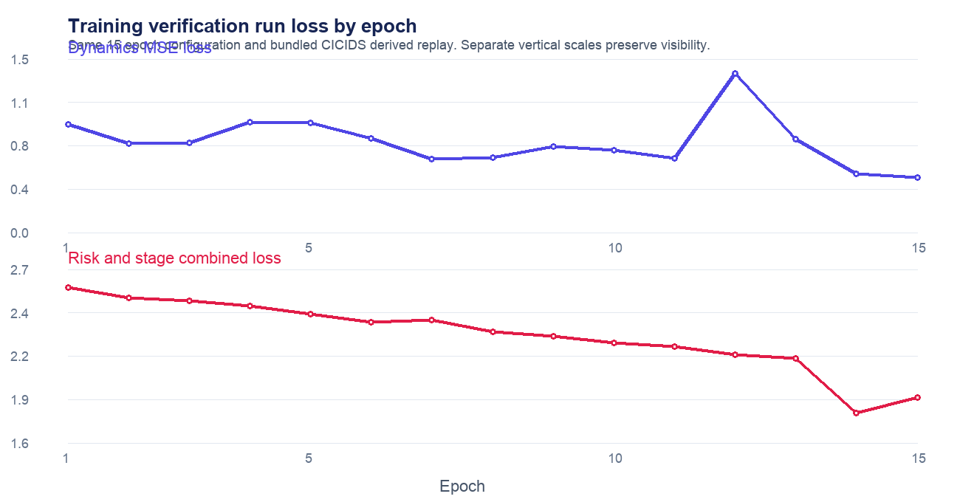
Figure 1 Training verification run using the bundled CICIDS derived replay. The two curves use separate vertical scales because their losses have different ranges.

How to interpret the graph
- Dynamics MSE ended at 0.4784 in the verification run. It is somewhat noisy because the replay yields only 133 training sequences.
- Combined risk and stage loss fell from 2.5852 to 1.8861. It improved overall but did not fully plateau by epoch 15.
- The dashboard risk line can look flat when five predicted risk scores differ by less than one percentage point. That describes a sustained forecast, not a training failure.
- The earlier checkpoint run recorded final terminal values near 0.568 for dynamics and 1.6953 for risk and stage. Do not mix those with the verification rerun values above.

Metrics and evidence boundary
The system has demonstrated that the full pipeline runs: it builds windows, loads a checkpoint, forecasts five future states, returns a stage verdict, explains feature influence, and saves alerts. That is the supported product claim.
Metric or claim | Current status | How to present it
Pipeline outcome | Verified | End to end local replay and forecast demo works.
Bundled split binary F1 | 100 percent smoke test observed | Do not present as final accuracy because the chronological holdout is class skewed.
Final benchmark accuracy | Not claimed | Use original timestamped CICIDS files and balanced chronological folds.
Recommended final metrics | Precision recall F1 false positive rate lead time and per stage F1 | Accuracy alone is misleading for imbalanced cyberattack data.

Judge ready answer: We do not claim a production accuracy percentage from the bundled replay. It is a reproducible functional demo. A rigorous benchmark requires original timestamped captures, class balanced chronological test folds, and per stage evaluation.

Likely questions and concise answers
Question | Answer
Is this detection or forecasting | Forecasting. The model observes the prior 10 windows and projects the next five one minute windows.
Why does the stage remain the same | A stable stage means the model sees the same high risk pattern continuing. It is not five independent alerts.
Can it use another dataset | Yes after normalizing the required fields and retraining and evaluating on that dataset. The architecture is portable but weights are dataset dependent.
What should happen next | Use original timestamped multi dataset training, measure balanced held out performance, then add live Zeek Suricata or NetFlow ingestion.

