**Traffic Management System**

**Phase 5 : Project Documentation & Submission**

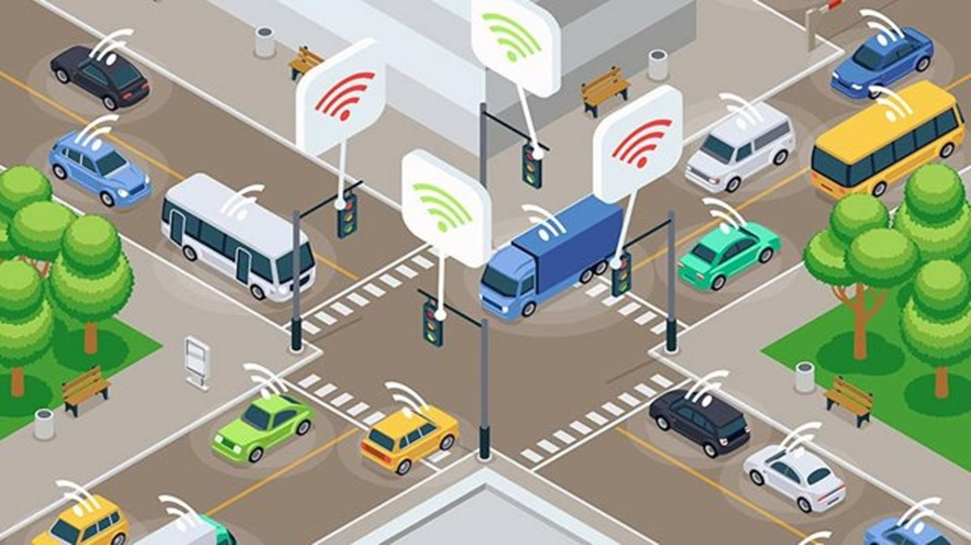

TEAM MEMBER:

DIVYAPRASHANTH M

ECE-III YEAR,

IOT (IBM ITERNET OF THINKS GROUP 3)

MENTOR NAME : MR.MANISANKAR

KARPAGAM INSTITUTE OF TECHNOLOGY, COIMBATORE

***Introduction***

In today's fast-paced world, traffic congestion has become a common challenge faced by commuters in urban areas. The need for efficient and data-driven traffic management solutions is more critical than ever. Our Traffic Management System project aims to address this issue by providing a comprehensive solution that leverages IoT technology, real-time data analysis, and mobile app accessibility to enable commuters to make optimal route decisions and improve traffic flow.

**Project Objectives**

***IoT Sensor Setup***

In this section, we will discuss the deployment and setup of the IoT sensors used in the Traffic Management System. These sensors play a critical role in collecting real-time traffic data, and their accurate installation is essential for the system's functionality.

**Required Hardware**

List the specific IoT sensors and hardware components you are using for traffic data collection.

* **Sensor Type 1:** Describe the first sensor type, including its specifications.
* **Sensor Type 2:** Describe the second sensor type, including its specifications.

**Setting Up IoT Sensors**

1. **Mounting and Placement:**
   * Explain the ideal mounting and placement locations for each sensor.
   * Include considerations like height, angle, and orientation for optimal data collection.
2. **Wiring and Connectivity:**
   * Provide instructions for connecting the sensors to microcontrollers or IoT devices.
   * Include the pin configurations and wiring diagrams, if applicable.

**Calibration and Configuration**

To ensure accurate data collection, IoT sensors may require calibration and configuration. Please follow these steps for each sensor:

Sensor Type 1 Calibration:

* Describe the calibration process, such as calibrating the sensor for traffic speed or volume.
* Include calibration code or commands, if available.

Sensor Type 2 Configuration:

* Explain the configuration settings needed for Sensor Type 2.
* Provide sample code or configuration files for setting up the sensor's parameters.

**Sample Code for Sensor Setup (Python)**

For reference, here's sample Python code to initialize and read data from an IoT sensor (adjust this code according to your specific sensor's library and API):

python code

# Import the sensor library (replace 'sensor_library' with the actual library name)

import sensor_library

# Initialize the sensor

sensor = sensor_library.Sensor()

# Configure the sensor (if applicable)

sensor.configure(some_parameter=1, another_parameter=2)

# Start data collection

data = sensor.start_collection()

# Process and send data to the central platform

send_data_to_platform(data)

In the above template, you have a structure for documenting your IoT sensor setup, including details on the required hardware, sensor placement, calibration, and sample Python code to get you started. Be sure to replace placeholders with your actual sensor information and code.

***Mobile App Development***

In this section, we will discuss the development of the mobile app for the Traffic Management System. The mobile app serves as the user interface for accessing real-time traffic data and making informed route decisions.

**Development Tools and Environment**

List the development tools, programming languages, and platforms used for the mobile app development.

* **Development Platform:** Specify the mobile app development platform (e.g., Android, iOS, cross-platform).
* **Programming Language:** Mention the programming language used for app development (e.g., Java, Kotlin, Swift, React Native).
* **Integrated Development Environment (IDE):** Name the IDE used for app coding and testing.

**User Interface and Features**

Describe the design and features of the mobile app. Include details about the app's layout, user interactions, and key functionality.

* **User Interface Design:** Explain the layout, color schemes, and visual elements used in the app.
* **Features:** List and describe the main features offered by the app, such as real-time traffic data display, route recommendations, and user account management.

**Sample Code for Mobile App (Simplified)**

Below is a simplified sample code snippet for a basic mobile app feature. This example demonstrates how to fetch real-time traffic data from a hypothetical API and display it to the user:

Kotlin Code

// Import the necessary libraries

import android.os.AsyncTask

import android.widget.TextView

import org.json.JSONObject

import java.io.InputStreamReader

import java.net.HttpURLConnection

import java.net.URL

class TrafficAppActivity : AppCompatActivity() {

// Reference to the traffic data display element

private val trafficDataTextView: TextView = findViewById(R.id.trafficDataTextView)

// Fetch and display real-time traffic data

fun fetchTrafficData() {

val apiUrl = "https://example.com/api/traffic"

val connection = URL(apiUrl).openConnection() as HttpURLConnection

val inputStreamReader = InputStreamReader(connection.inputStream)

val jsonData = inputStreamReader.readText()

val trafficInfo = JSONObject(jsonData)

val trafficStatus = trafficInfo.getString("status")

val trafficDetails = trafficInfo.getString("details")

trafficDataTextView.text = "Traffic Status: $trafficStatus\nDetails: $trafficDetails"

}

}

This simplified code fetches traffic data from a hypothetical API and displays it on the app's user interface. In your actual app development, you will need to adapt this code to your specific app architecture, UI design, and API integration.

***Raspberry Pi Integration***

In this section, we will discuss the integration of Raspberry Pi into the Traffic Management System. The Raspberry Pi serves as a key component for collecting data from IoT sensors and transmitting it to the central platform.

**Raspberry Pi Setup**

Detail the specific Raspberry Pi models and components used for integration.

* **Raspberry Pi Model:** Specify the Raspberry Pi model used (e.g., Raspberry Pi 3, Raspberry Pi 4).
* **Additional Components:** List any additional components, such as power supplies or connectivity modules.

**Operating System Installation**

Explain how to install the operating system on the Raspberry Pi to prepare it for integration.

* **Operating System:** Specify the chosen operating system (e.g., Raspbian, Raspberry Pi OS).
* **Installation Steps:** Provide instructions for downloading and installing the operating system on the Raspberry Pi.

**Integration and Data Collection**

Explain how the Raspberry Pi is integrated with IoT sensors for data collection. Provide sample Python code for data collection and transmission.

Sample Python Code for Data Collection and Transmission

Below is a simplified sample Python code snippet for Raspberry Pi integration. This code demonstrates how to collect data from IoT sensors and send it to a central platform:

python code

# Import necessary libraries for sensor communication (replace 'sensor_library' with your actual library)

import sensor_library

import requests

# Initialize the sensor

sensor = sensor_library.Sensor()

# Start data collection

data = sensor.start_collection()

# Define the central platform's API endpoint

api_endpoint = "https://example.com/api/traffic_data"

# Send data to the central platform

response = requests.post(api_endpoint, json=data)

# Check the response

if response.status_code == 200:

print("Data successfully transmitted to the central platform.")

else:

print("Failed to transmit data. Check the connection.")

This simplified code collects data from IoT sensors and sends it to a central platform using the Python **requests** library. In your actual integration, adapt this code to your specific sensor libraries and API endpoints.

1. **Integration with Raspberry Pi:** The project integrates Raspberry Pi devices to gather data from IoT sensors, process it, and transmit it to the central platform.
2. **Open-Source Collaboration:** To encourage innovation and collaboration, our project code and documentation will be made open-source and accessible to the developer community.

***Real-Time Traffic Monitoring***

In this section, we will explain how the Traffic Management System enables real-time traffic data monitoring, assisting commuters in making optimal route decisions and improving traffic flow.

**Real-Time Traffic Data Sources**

Detail the data sources that your system collects traffic information from. This may include IoT sensors, traffic cameras, or external APIs.

* **Data Source 1:** Describe the first data source, including how it contributes to real-time traffic monitoring.
* **Data Source 2:** Describe additional data sources, if applicable.

**Data Processing and Analysis**

Explain how the collected data is processed and analyzed to provide real-time traffic information.

* **Data Processing Pipeline:** Describe the steps involved in processing incoming traffic data.
* **Data Analysis Algorithms:** Explain the algorithms used to detect traffic conditions, congestion, or incidents.

**Sample Code for Real-Time Traffic Monitoring (Simplified)**

Below is a simplified sample code snippet for real-time traffic monitoring. This code demonstrates how to fetch data from a hypothetical API and analyze it for traffic conditions:

python code

import requests

# Define the API endpoint for traffic data (replace with your actual API endpoint)

traffic_api = "https://example.com/api/traffic_data"

# Fetch real-time traffic data from the API

response = requests.get(traffic_api)

if response.status_code == 200:

traffic_data = response.json()

# Analyze traffic data

traffic_status = analyze_traffic_data(traffic_data)

# Display the traffic status

print("Real-Time Traffic Status: " + traffic_status)

else:

print("Failed to fetch traffic data. Check the connection.")

This code is a simplified example of how your system can fetch and analyze traffic data. In practice, you'll need to adapt this code to your specific data sources, processing algorithms, and API endpoints.

**How It Works**

Our Traffic Management System operates by collecting data from various IoT sensors strategically placed at key traffic points. These sensors continuously monitor traffic conditions, including vehicle counts, speed, and environmental factors. The data is then transmitted to Raspberry Pi devices, which act as data hubs.

The Raspberry Pi devices process and analyze the incoming data, identifying traffic congestion, accidents, and other incidents. This processed data is then made accessible to commuters through our mobile app. Using this app, users can check real-time traffic status, receive route recommendations, and make informed decisions about their daily commute.

Our system does not only assist commuters but also contributes to traffic management by providing authorities with valuable insights into traffic patterns and helping them make data-driven decisions to improve overall traffic flow.

**Conclusion**

The Traffic Management System project is a multi-faceted approach to tackle the challenges of urban traffic congestion. By leveraging the power of IoT, real-time data analysis, and mobile app technology, we aim to empower commuters and enhance the efficiency of traffic management in our cities. This documentation will guide you through the key aspects of our project, including IoT sensor setup, mobile app development, Raspberry Pi integration, and real-time traffic monitoring, allowing you to replicate and expand upon our solution for the benefit of your own communities.