**Generative AI for Personalized Financial Advising and Investment Strategies**

**Durgesh Kumar**

**Thesis Report for**

**Master of Science in Data Science**

**July 2024**

# ACKNOWLEDGEMENTS

First and foremost, I express my deepest gratitude to my mother and father for their unwavering love, sacrifices, and constant support. Their encouragement and belief in me have been the foundation of this research journey.

Iextend my heartfelt appreciation to Dr. Mounika Marreddy, my thesis supervisor, for her invaluable guidance, encouragement, and support throughout this research. Her insightful feedback and expertise were instrumental in shaping this thesis.

I am also grateful to Dr. Ahmed Kaky, Dr. Anil Vuppula, and all other mentors from LJMU and Upgrad for their continuous support and guidance. Special thanks go to my Upgrad Buddy, Shriya Barapatre, Harshita and my fellow batchmates for their shared insights and collaboration.

I sincerely appreciate LJMU and Upgrad for providing the studentship that enabled me to carry out this research, contributing meaningfully to the field of Generative AI in Personalized Finance.

# **ABSTRACT**

Generative Artificial Intelligence (GenAI) has rapidly reshaping financial services by enabling highly personalized financial advising and optimized investment strategies. Recent advancements in transformer-based models-such as DistilBERT and DistilRoBERTa-have significantly enhanced predictive capabilities in financial markets enabling more accurate, adaptive and context-aware investment recommendations. These models leverage historical financial data, behavioural trends, and real-time market fluctuations to improve portfolio management and risk assessment, and decision-making efficiency.

This research aims to develop a dynamic, GenAI-powered financial advisory system that aligns investment recommendations with individual user profiles, incorporating spending patterns, savings behaviuor, and risk appetite. The system supports complex financial decisions-including tax optimization and retirement planning-through dynamic forecasting models that generate actionable, data-driven insights.

To ensure transparency, accountability, and ethical compliance, the system integrates Explainable AI (XAI) frameworks-praticularly SHAP, LIME, and visual attribution techniques. Additionally, Pearson correlation is used for sentiment analysis of financial news and social media content, while granger causality improves the interpretability of temporal market forecasts. These techniques are validated using the NIFTY50 Stock Market Dataset, ensuring empirical robustness and real-world applicability.

Beyond predictive performance, the study integrates principles from behavioural finance to address cognitive biases such as loss aversion, anchoring, and overconfidence, which often distort investment decisions. The system is designed to adapt continuously to shifiting market conditions and evolving user behaviour thorough the integration of event-driven maeket signals and domain-specific financial indicators.

Ethical priorities-such as fairness, data privacy, and the mitigation of algorithmic discrimination-are foundational to this framwork. The effectiveness of the proposed system will be evaluated through rigorous performance metrics, including prediction accuracy, explanability scores, bias assessments, and user satisfaction surveys, ensuring its practical visibility, social impact, and contribution to the emerging field of Responsible GenAI in Personalized Finance.

# **TABLE OF CONTENTS**

Error: Reference source not foundError: Reference source not foundError: Reference source not foundError: Reference source not foundError: Reference source not foundError: Reference source not foundError: Reference source not foundError: Reference source not foundError: Reference source not foundError: Reference source not foundError: Reference source not foundError: Reference source not foundError: Reference source not foundTabefasdfasdfasdfdfadfadfasdfasdfasdfasdfdfadfTTAFASDFtA

Table of Contents

ACKNOWLEDGEMENTS ii

ABSTRACT iii

TABLE OF CONTENTS iv

LIST OF TABELS vi

LIST OF FIGURES vii

LIST OF ABBREVAIATIONS ix

1.2 Problem Statement 2

1.3 Research Questions: 2

1.4 Aim & Objectives 3

1.5 Research Objectives: 3

1.6 Scope of the Study: 3

1.7 Prompting Strategies : 4

1.8 Evaluation Metrics: 4

1.9 Interpretation of Results : 5

1.10 Key Reasons for Selecting DistilBERT and DistilRoBERTa for Financial Advisory Systems: 6

1.11 Significance of the Study: 7

1.12 Structure of the study 8

CHAPTER 2: LITERATURE REVIEW 9

2.1 Introduction: 9

2.2 The Evolution of Financial Advisory Systems: 9

2.3 Datasets for AI-Based Financial Analysis Using NIFTY50: 21

Table 2.2: Financial variables Used in Financial Market 23

CHAPTER 3: RESEARCH METHODOLOGY 25

3.1 Introduction 25

3.2 Algorithms and techniques 26

3.6 Hybrid AI models in Financial Advisory Systems: 33

3.7 Explainable AI (XAI) in Financial Advisory Systems: 34

3.8 Methodology: 35

3.9 Data Collection and Processing: 36

3.10 Model Selection and training: 36

3.11 Evaluation Metrics: 36

3.12 Implementation Approach: 36

3.13 Data Processing and feature Engineering: 37

3.15 Evaluation Metrics: 37

3.16 End-to-End Pipeline for AI-Driven Financial Advisory: 38

3.17 Experimental Setup: 38

3.18 Summary: 40

CHAPTER 4: IMPLEMENTATION 40

4.1 Introduction: 40

4.2 Experiment Overview: 41

4.3 Dataset Description: 41

4.4 Observation Summary: 42

4.5 Expolratory Data Analysis (EDA): 44

Chapter 5: Model Development and Evaluation 61

5.1 Introduction: 61

5.2 Modeling Objectives: 61

5.3 Machine Learning Models: 62

5.4 Hyperparameter Tuning of ML-Based Model’s Classification Models: 67

5.5 Deep Learning Models: 69

5.6 Transformer-Based Models: 74

Table 5.7 Shap Insight-Transformer (Vanila) Based Model 77

5.8 DistilRoBERTa-Based Modeling for Financial Forecasting: 83

Chapter 6: Results and Discussion 86

6.2 Key Findings and Model Comparison: 86

6.3 Explainability Insights: 87

6.4 Final Insights and Contributions: 88

6.5 Feature Recommedations for future work: 88

Referances 90

APPENDIX A 100

APPENDIX B 101

# **LIST OF TABELS**

Index of Tables

**Table 2.1: Types of ML-Models and their Use-CaseTable** 14

**Table 2.2: Financial variables Used in Financial Market** 21

**Tabel 3.1: Comaprision of DistilBERT vs Others**  31

**Table 5.1: ML Models Insights**  59

**Table 5.2: ML tree-based Models Inights**  60

**Table 5.3: ML models Parameters** 61

**Table 5.4: ML Models Tree-based Parameters** 62

**Table 5.5: Tree Based ML models Classification Tasks insights** 62

**Table 5.6 : Deepl Learning Based Models Results** 66

**Table 5.7 Shap Insight-Transformer (Vanila) Based Model**  70

**Table 5.8: DistilRET Based Models Shap Interpretation for Classification Task** 74

**Table 5.9: LIME Explanation of DistilBERT Based Model’s Classification Task** 75

# **LIST OF FIGURES**

Table of Figures

**Figure 3.1: Transformer Architecture**  **26**

**Figure 3.2: DistilBERT Model** **29**

**fIgure 3.3: DistilRoBERTa Model**  **31**

**Figure 3.4: Explainable AI Techniques** **34**

**Figure 4.1: Summary Statistics Of The NIFTY50 Dataset(From Df.describe())**  **41**

**Figure 4.2: Raw NIFTY50 Data Sample (df.head(20))** **42**

**Figure 4.3: Histogram of Close Prices** **44**

**Figure 4.4: Log-Transformed Histogram of log_Close** **44**

**Figure 4.5: Post-Cleaning Distribution of log_Close** **45**

**Figure 4.6: Histogram of Volume** **45**

**Figure 4.7: Log-Transformed Histogram of log_Volume** **45**

**Figure 4.8: Post-Cleaning Distribution of log_Volume** **46**

**Figure 4.9: Histogram of Turnover** **47**

**Figure 4.10: Log-Transformed Histogram of log_Turnover** **47**

**Figure 4.11: Post-Cleaning Distribution of log_Turnover** **47**

**Figure 4.12: Histogram of %Deliverable** **48**

**Figure 4.13: KDE Plot** **49**

**Figure 4.14: NIFTY50 Time Series of Close Price, Volume, and Turnover with SMA Overlays** **50**

**Figure 4.15: Pearson Correlation Heatmap of Numeric Features** **51**

**Figure 4.16: Volume Distribution by Price** **52**

**Figure 4.17: Close Price Distribution Across Volume Quantiles** **52**

**Figure 4.18: Median-Sorted Closing Prices (Low to High)** **53**

**Figure 4.19: Feature Correlation Matrix – Regression Features** **54**

**Figure 4.20: Feature Correlation Matrix – Classification Features** **55**

**Figure 5.1: Actual Vs Predicted (Full Dataset) Transformer Model Reagression TaskFigure** **68**

**Figure 5.2: Actual vs Predicted (First 100 Samples) – Regression** **68**

**Figure 5.3: Confusion Matrix Plot-Transformer (Vanila) Classifiaction Task** **69**

**Figure 5.4: SHAP Plot – Transformer (Vanilla) Classification Task** **70**

**Figure 5.5: LIME Plot – Transformer (Vanilla) Classification Task** **71**

**Figure 5.6: Actual vs Predicted – DistilBERT Regression Task** **72**

**Figure 5.7: Confusion Matrix – DistilBERT Classification Task** **73**

**Figure 5.8: LIME Plot (Class 0) – DistilBERT Classification Task** **74**

**Figure 5.9: LIME Plot (Class 1) – DistilBERT Classification Task** **74**

**Figure 5.10: Confusion Matrix – DistilRoBERTa Classification Task** **76**

**Figure 5.11: LIME Plot (Class 1) – DistilRoBERTa Classification Task** **77**

**Figure 5.13: LIME Plot (Class 0) – DistilRoBERTa Classification Task** **77**

# LIST OF ABBREVAIATIONS

AI: Artificail Intelligence

ANN: Artuificial Neural Network

API: Application Programming Interface

BART: Bidirectional and Auto-Regressive Transformer

BERT: Bidirectional Encoder Representations from Transformers

CAGR: Compound Annual Growth Rate

CNN: Convolutional Neural Network

DNN: Deep Neural Network

EDA: Exploratory Data Analysis

ETF: Exchange Traded Fund

FII: Foreign Instituational Investor

GAN: Generative Adversarial Network

GenAI: Generative Artificial Intelligence

GDP: Gross Domestic Product

GPT: Generative Pre-trained Transformer

LIME: Local Interpretable Model-agnostic Explanations

LSTM: Long-Short-term Memory

MAE: Mean Absolute Error

MAPE: Mean Absolute Percentage Error

ML: Machine Learning

MLP: Multi-Layer Perceptron

MSE: Mean Squared Error

NLP: Natuaral Language Processing

NSE: National stock Exchange

PCA: Principal Component Analysis

R2: Coefficient of Determination

RBF: Radial Basis Function

ReLU: Rectified Linear Unit

RNN: recurrent Neural Network

RoBERTa: robustly Optimized BERT Pretraining Approach

ROI: Return on Investment

SHAP: SHapley Additive exPlanations

SVM: Support Vector Machine

T5: text-To-Text Transfer Transformer

TOC: table of Contents

TPU: Tensor Processing Unit

XAI: Explainable Artificaial Intelligence

XGBoost: Extreme Gradient Boosting

CHAPTER 1: INTRODUCTION

**1.1 Background of the study**

Generative Artificial Intelligence (GenAI) is reshaping financial services by offering personalized financial advice and optimized investment strategies(Marchena Sekli, 2024; Xu, 2024). Traditional financial advisory systems rely heavily on static models and human expertise, often rendering them inflexible and unable to respond to dynamic market changes. This rigidity can lead to suboptimal investment decisions and ineffective financial planning(Ridzuan et al., 2024).

GenAI-powered advisory platforms, leveraging advanced transformer-based models, such as DistilBERT and DistilRoBERTa to analyze vast vast amount of financial transactions, market patterns, and behavioural signals with superior precision(Saxena and Rishi, 2025; Yang et al., 2025). These AI-driven systems can generate data-driven insights, contributing to enhanced portfolio management and real-time market forecasting. Their ability to model non-linear dependencies allows for deeper, more accurate investment strategies than traditional tools(Yu et al., 2023; Namin and Namin, n.d.).

However, the integration of GenAI in financial ecosystems introduces several challenges, including algorithmic bias, misinformation, data privacy concerns, and a lack of model transparency(Deshpande, 2024; Maple et al., n.d.). To mitigate these, Explainable AI (XAI) techniques-such as SHAP and LIME-used to enhance accountability, interpretability, regulatory compliance and stakeholder trust(Zhao et al., 2024; Fasano et al., 2025). Moreover, GenAI models can embed behavioural finance principles to reduce the impact of cognitive biases such as overconfidence, loss aversion, and anchoring(Kirilenko and Lo, 2013; Das et al., 2024).

Unlike prior works that either focus on raw time-series forecasting or general-purpose transformer models, this research integrates tabular-to-text conversion with transformer fine-tuning, enhanced by financial technical indicators, event-driven signals, and explainability layers (SHAP, LIME) to bridge interpretability gaps in financial decision-making(Courage Oko-Odion et al., 2025a; Gupta et al., 2025).

To further enhance interpretability and forecasting accuracy, this study combines Pearson correlation for sentiment analysis and Granger causality for market prediction(Cen, n.d.; Liaudinskas, n.d.). These methods are validated on real-world datasets such as a transformative bridge between outdated financial paradigms and the demands of mordern, personalized investing, ensuring greater adaptability, accuracy, and ethical responsibility(Wilhelmina Afua Addy et al., 2024).

## **1.2 Problem Statement**

Conventional financial advisory systems are constrained by static models and human heuristics, Making them ineffective in rapidly evolving market conditions(Marchena Sekli, 2024; Xu, 2024). These systems struggles to provide personalized financial investment recommendations due to limited real-time adaptability and over-reliance on broad, generalized assumptions as a result, they often fall short in crucial areas like tax optimization, retirement planning, and portfolio diversification(Professor and Head, Department of BBA Department (KL University), Koneru Lakshmaiah Educational Foundation, Green Fields, Vaddeswaram, Andhra Pradesh-522302, India et al., 2024).

Transformer-based GenAI models, such as DistilBERT offer a more robust alternative by uncovering hidden patterns in large-scale financial datasets(Zhang et al., 2020; Yang et al., 2025). Yet, despite their potentail, these models present their own set of challenges, including the risk of bias amplification, misinformation risks, lack of explainability. which hinder their trustworthy deployment in financial systems(Ridzuan et al., 2024; Wilhelmina Afua Addy et al., 2024).

To address these shortcomings, Explainable AI (XAI) frameworks (e.g., SHAP and LIME) provide transparency into AI-driven financial recommendations(Yu et al., 2023; Zhao et al., 2024). Additionally, integrating behavioural finance techniques helps reduce the influence of cognitive distortions and encourages more rational investment behaviours(Gabhane et al., 2023; Professor and Head, Department of BBA Department (KL University), Koneru Lakshmaiah Educational Foundation, Green Fields, Vaddeswaram, Andhra Pradesh-522302, India et al., 2024).

While GenAI present opportunity to transform financial advisory practices, its real-world adoption hinges on overcoming critical ethical, regulatory, and technical barriers(Deshpande, 2024; Ridzuan et al., 2024). This study addresses these barriers through a novel approach that integrates tabular-to-text conversion, transformer fine-tuning, and feature-rich explainability frameworks.

## **1.3 Research Questions:**

1. How effectively can GenAI align investment strategies with individual user preferences, risk tolerance, and long-term financial objectives?
2. What techniques can be employed to ensure data privacy and security in AI-driven financial advisory systems while maintaining personalization?
3. Which key metrics (e.g., accuracy, user satisfaction, explainability scores) best evaluate the effectiveness of GenAI in financial advising?
4. How does the proposed GenAI-based financial advisory system compare to

traditional financial models in terms of prediction accuracy, user engagement, and adaptability?

1. How can GenAI integrate behavioural finance principles to mitigate cognitive biases and improve investment decision-making for retail investors?

## **1.4 Aim & Objectives**

The primary aim of this research is to explore the transformative impact of Generative Artificial Intelligence (GenAI) in the domain of personalized financial advising, it seeks to design an AI-powered advisory system that delivers data-driven investment strategies while addressing challenges related to ethics, interpretability, and personalization through the integration of event-driven market signals, financial technical indicators, and explainability layers(Marchena Sekli, 2024; Xu, 2024).

## **1.5 Research Objectives:**

1. Develop Personalized Financial Solutions: Investigate how GenAI tailors financial recommendations by leveraging user preferences, market trends, and real-time analytics.
2. Integrate Behavioural Finance Principles: Identify cognitive biases in financial decision-making and implement GenAI-driven corrective measures to enhance investment behaviour.
3. Ensure Ethical and Transparent AI Implementation: Examine fairness, accountability, and data privacy concerns in GenAI-driven financial advisory systems, while exploring the role of Explainable AI (XAI).
4. Leverage Real-World Data for Predictive Analysis: Utilize financial datasets (e.g., NIFTY50 Stock Market Dataset) to validate the accuracy, efficiency, and reliability of AI-driven financial insights.
5. Assess Scalability & Accessibility: Evaluate how GenAI democratizes access to financial advising across diverse investor demographics and financial institutions.

## **1.6 Scope of the Study:**

This study focuses on deploying Generative Artificial Intelligence (GenAI) to transform financial advisory systems, addressing the limitations of traditional approaches(Professor and Head, Department of BBA Department (KL University), Koneru Lakshmaiah Educational Foundation, Green Fields, Vaddeswaram, Andhra Pradesh-522302, India et al., 2024). It includes a technical, ethical, and behavioural analysis of AI-driven investment strategy formulation, integrating transformer-based architectures with financial technical indicators and event-driven features to improve prediction accuracy and interpretability.

### **1.6.1 Key Areas of Scope:**

#### 1.6.1.1 Data Pre-Processing:

* Focus on data pre-processing techniques essential for training, fine-tuning, and evaluating GenAI models in financial advisory tasks(Xu, 2024).
* Implement feature engineering, handling missing values, normalization, and sentiment classification to improve the accuracy of AI-driven financial predictions(Yang et al., 2025).

### 1.6.1.2 Model Comparison:

* Compare the performance of selected transformer models in generating financial recommendations, risk assessments, and investment insights(Zhang et al., 2020).
* Evaluate transformer models based on their ability to interpret financial datasets, forecast market trends, and optimize personalized investment portfolios(Wilhelmina Afua Addy et al., 2024).

#### 1.6.1.3 Fine-Tuning Techniques:

* Investigate fine-tuning strategies to optimize pre-trained language models for financial decision-making(Zhao et al., 2024).
* Explore methods such as hyperparameter tuning, learning rate adjustments, and domain-specific dataset integration to enhance financial forecasting accuracy(Gabhane et al., 2023).

## **1.7 Prompting Strategies :**

Evaluate different prompt engineering techniques to refine GenAI-generated financial insights. Experiment with zero-shot, few-shot, and chain-of-thought prompting to improve GPT-financial advisory responses(Yu et al., 2023).

## **1.8 Evaluation Metrics:**

Utilize multiple evaluation metrics to assess the quality, accuracy, and effectiveness of AI-generated financial recommendations.

### 1.8.1 Key metrics include:

* Mean Absolute Error (MAE)
* Root Mean Square Error (RMSE)
* Market trend prediction accuracy
* User satisfaction scores
* Explainability scores (XAI-based evaluation)

## **1.9 Interpretation of Results :**

### 1.9.1 Model Analysis:

* + To Assess Strengths and weaknesses of different AI models.
  + To Identify Factors influencing model performance.
  + To Highlight Areas for improvement in AI-driven financial advisory systems.

### 1.9.2 Practical Implications:

#### 1.9.2.1 Examine real-world applications of AI-driven financial advising for:

* + For Retail investors: Personalized investment strategies.
  + For Financial institutions: AI-driven portfolio management.
  + For Financial advisors: AI-enhanced decision-making tools

#### 1.9.2.2 Investigate use cases such as:

* + Automated wealth management
  + Real-time market trend analysis
  + Fraud detection
  + Tax optimization and compliance automation

#### 1.9.2.3 Ethical and Regulatory Considerations:

* Analyse bias mitigation techniques, ensuring compliance with global financial regulations (e.g., GDPR, SEC).
* Implement Explainable AI (XAI) frameworks to enhance trust, fairness, and interpretability in AI-driven financial systems.
* Assess transparency methods such as SHAP and LIME for improving model interpretability(Yu et al., 2023).

### **1.9.3 Limitations and Future Directions:**

Acknowledge challenges such as data dependency, model biases, and computational constraints in AI-driven financial decision-making.

#### 1.9.3.1 Suggest future research directions including:

* + Improving model interpretability.
  + Enhancing ethical AI implementation.
  + Exploring multi-modal AI models for comprehensive financial advising.

## **1.10 Key Reasons for Selecting DistilBERT and DistilRoBERTa for Financial Advisory Systems:**

### 1.10.1 State-of-the-Art (SOTA) Performance:

DistilBERT and DistilRoBERTa are among the most advanced transformer-based models in Natural Language Processing (NLP).

### 1.10.2 Proven accuracy in financial applications, including:

* + Text summarization
  + Sentiment analysis
  + Investment trend forecasting

### 1.10.3 Versatility in Financial Applications:

* DistilBERT: Best for understanding financial documents, regulatory reports, and investment filings.
* DistilRoBERTa: Excellent at summarizing financial news, market trends, and risk reports.

### 1.10.4 Architectural Diversity for Financial Modelling:

* DistilBERT: Bidirectional model, best for context understanding and financial text interpretation.
* DistilRoBERTa: Encoder-Only architecture with strong contextual representation for summarisation and interpretability.

### 1.10.5 Adaptability to Real-World Financial Data:

Can be fine-tuned on financial datasets such as:

* + NIFTY50 Stock Market Dataset
  + SEC filings, earnings reports, and economic indicators

These models can detect market sentiment, forecasting trends, and assessing investment risk.

### 1.10.6 Explainability & Ethical Compliance in AI Finance:

* DistilBERT integrate well with Explainable AI (XAI) techniques for transparency and fairness.
* DistilRoBERTa’s design enhances traceability in financial text analysis.

### 1.10.7 Availability of Pre-Trained Models for Financial Applications:

* Pre-trained versions of all these models are publicly available, reducing computational overhead.
* Easily fine-tuned using domain-specific financial datasets for real-world applicability.

### 1.10.8 Potential for Future Improvement in AI-Driven Finance:

While these models have shown great success, challenges remain, including:

* Model bias
* Hallucination of financial insights
* Over-reliance on historical data

This study identifies optimization strategies for improving their performance in financial decision-making.

## **1.11 Significance of the Study:**

The integration of GenAI in financial advisory services represents a paradigm shift from static financial models to AI-driven, adaptive decision-making(Marchena Sekli, 2024). Traditional advisory systems lack real-time adaptability, whereas GenAI offers scalable, data-driven financial recommendations that align with individual risk profiles and market conditions(Wilhelmina Afua Addy et al., 2024).

Despite its potential, the application of GenAI in financial decision-making remains underexplored. Key challenges, such as algorithmic bias, misinformation, ethical transparency, and data privacy risks necessitate further research. This study bridges this gap by evaluating GenAI’s effectiveness, scalability, and ethical considerations, offering valuable insights into how AI models compare to traditional financial advisory systems.

The study’s unique integration of tabular-to-text data transformation, transfomer fine-tuning, event-driven features, and explainability layers provides a scalable and interpretable framwork for AI-driven financial advising.

## **1.12 Structure of the study**

The structure of the study is as follows:

**Chapter 1 – Introduction**: Presents the research problem, objectives, significance, and scope while establishing the context and motivation behind the study. It introduces key concepts related to GenAI in financial advisory services and highlights the challenges that the research aims to address.

**Chapter 2 – Literature review**: This chapter critically reviews existing research on AI-driven financial advisory systems, behavioural finance integration, and ethical considerations in GenAI applications. It identifies gaps in current methodologies and provides the foundation for this study’s proposed approach.

**Chapter 3 – Research Methodology**: This chapter details the research approach, models, algorithms, datasets, evaluation metrics, and tools used. It explains data collections, preprocessing techniques, model training, and validation strategies, ensuring reproducibility and methodological rigor.

**Chapter 4 – Implementation**: This Chapter discusses the technical implementation of the study. It describes the experimental setups, GenAI model fine-tuning, and performance evaluation procedures, showcasing how theoretical concepts were transformed into practical solutions.

**Chapter 5 – Results & Evaluation**: This chapter presents and analyses the experimental results, providing quantitative and qualitative insights into model performance. It includes visualizations, comparative analyses, and discussions on strengths, weaknesses, and potential improvements.

**Chapter 6 – Conclusion & future Work**: The final chapter summarises key findings, research contributions, and limitations. It also discusses encountered challenges and suggests directions for future research, ensuring continuity and future advancements in AI-driven financial advisory systems.

# **CHAPTER 2: LITERATURE REVIEW**

## **2.1 Introduction:**

This Chapter Provides a critical review of existing research in the domain of Generative Artificial Intelligence (GenAI) applied to personalized financial advising and investment strategy formulation. It examines the evolution of AI_driven financial advisory systems, with a focus on transformer-based models, behavioural finance integration, and Explainable AI (XAI) techniques(Marchena Sekli, 2024). The discussion synthesizes findings from prior studies to establish the theoretical and practical foundations for this research, highlighting key advancements, limitaions, and emerging opportunities in the field(B et al., 2024; Xu, 2024).

## **2.2 The Evolution of Financial Advisory Systems:**

The integration of Generative Artificial Intelligence (GenAI) in Financial advisory systems represents a paradigm shift from static, rule-based financial models to dynamic, adaptive, and personalized AI-driven decision-making(Zhang et al., 2020). Traditional financial advisory models rely on historical data, expert opinions, and static economic indicators to predict market behaviour and assist investors in making financial decisions. However, these human-dependent models struggle with real-time market fluctuations and fail to account for complex, nonlinear relationships in financial datasets(Zhang et al., 2020).

GenAI, powered by advanced transformer-based models such as DistilBERT and DistilRoBERTa has revolutionized investment strategy formulation, financial risk assessment, and automated wealth management(Marchena Sekli, 2024). These deep learning-based financial advisors can process large-scale structured and unstructured data, including financial news, stock market trends, corporate filings, and investor sentiment analysis, to provide highly personalized and data-driven investment insights(B et al., 2024).

### **2.2.1 traditional Human-Driven Financial Advisory Systems:**

Traditional human-driven financial systems have been the foundation of investment decision-making for decades. These systems rely on human expertise, financial theories, and qualitative analysis to provide investment recommendations(B et al., 2024). Financial advisors use their experience,

market knowledge, and fundamental analysis techniques to craft personalized investment strategies tailored to an individual’s risk appetite, financial goals, and market conditions.

#### 2.2.1.1 Key Features of traditional Financial Advisory Systems:

Reliance on Human Financial Advisors: Unlike algorithmic or AI-driven advisory systems, traditional financial advisory is entirely human-driven(Zhang et al., 2020). Professional financial work closely with clients to understand their financial advisors use their experience, market knowledge, and fundamental analysis techniques to craft personalized investment strategies tailored to an individual’s risk appetite, financial goals, and market conditions.

1. Advisory engage in one-on-one sessions with clients to determine investment goals (e.g. retirement planning, wealth accumulation, or tax optimization)
2. Advisors use their experience in bull and bear markets to guide clients through economic cycles.
3. Beyond investing, advisor also provide guidance on estate planning, taxation, and insurance.

#### 2.2.1.2 Use of Traditional valuation Models:

Traditional advisors rely on fundamental valuation models to access an asset’s intrinsic worth. These models include:

Discounted Cash Flow (DCF) Model: The DCF model estimates the present value of an investment by calculating expected future cash flows and discounting them using a discount rate.

**Formula:**

Where:

* = Cash Flow at time t
* r = Discount Rate
* t = Time period

**2.2.1.3 fundamental Ratio Analysis:**

Financial advisors use Key ratios to evaluate a company’s financial health:

1. Price-to-Earnings (P/E) Ratio: Determines if a stock is overvalued or undervalued.
2. Debt-to-Equity Ratio: Measures financial risk.
3. Return on Equity (ROE): Evaluates company profitability.

#### **2.2.1.4** **Dependence on past Market Data and Qualitative Analysis:**

Unlike AI-driven systems, traditional advisory methods rely heavily on historical data, macroeconomic indicators, and qualitative factors such as(Professor and Head, Department of BBA Department (KL University), Koneru Lakshmaiah Educational Foundation, Green Fields, Vaddeswaram, Andhra Pradesh-522302, India et al., 2024):

1. Macroeconomic Indicators: Interest rates, inflation, GDP growth, and employment rates.
2. Market Sentiment Analysis: Trends from financial news, investor behaviour, and corporate earnings reports.
3. Company Reports and Management Analysis: Financial statements, CEO statements, and industry trends.

#### **2.2.1.5 Advantage of traditional Human-Driven Advisory:**

1. Personalized Service:Financial advisory provides customized financial planning and emotional support during market downturns. Unlike AI models, human advisory can factor in personal circumstances, such as job loss, family emergencies, or tax considerations.
2. Deep Understanding of Complex Situations**:** Human advisory analyses business models, industry trends, and qualitative factors that AI models may overlook.
3. **A**daptability in Unique Scenarios:Human advisors adjust investment strategies based on unexpected geological events, pandemics, or economic crises.

#### **2.2.1.6 Limitations of Traditional Human-Driven Advisory:**

1. Prone to human bias: Cognitive biases like overconfidence bias, anchoring bias, and mentality can impact investment decisions.
2. Time-Intensive and Expensive: Traditional financial advisors manual research and one-on-one consultations, making the process slower and costlier than AI-based Robo-advisors.
3. Limited Data Processing Capacity: Human advisors cannot analyse large-scale datasets or process real-time market data as efficiently as Ai-driven systems(Xu, 2024).

### **2.2.2 Rule-Based Financial Advisory Systems:**

Rule-based financial advisory systems represent an early stage of automation in investment decision-making. These systems operate on predefined logical conditions (“if-then” rules) set by financial experts, offering a structured yet rigid approach to financial planning. Unlike human-driven financial advisory, with relies on intuition and qualitative analysis, rule-based advisory systems execute decisions based on coded financial logic.

While rule-based systems lack adaptability, then provide consistent and systematic financial decision-making, making them widely used in algorithmic trading, portfolio rebalancing, and Robo-advisory services(Dunis et al., 2014).

#### **2.2.2.1 Key Features of Rule-Based Financial Advisory Systems:**

1. Predefined Investment Rules: These systems rely on static investment rules based on financial theories and historical patterns.

Mathematical representation of Rule-Based Model:

Investment Decision = BUY, if P/E ratio < X

HOLD, if P/E ratio = X

SELL, if P/E ratio > X

1. Limited Market Adaptability: Rule-based systems do not learn from new data and struggle with unpredictable market conditions. Static financial rules are set based on past trends, which may not hold in future economic cycles(Wilhelmina Afua Addy et al., 2024).
2. Efficiency in Automated Financial Operations: Rule-based models are widely used in Robo-advisory for portfolio rebalancing. These systems reduce human intervention, making investment process more efficient(Cohen, 2022).

#### **2.2.2.2 How Rule-Based Financial Advisory Systems Work:**

A rule based financial model operates using the following steps:-

1. Input Data Collection: Market data such as stock prices, interest rates, and financial indicators are collected(Deshpande, 2024).
2. Predefined Rule Execution: If the predefined condition is met, the system executes a buy, sell, or hold decision.
3. Order Execution & Portfolio Adjustment: Once a rule triggered, the system rebalances the portfolio accordingly.

#### **2.2.2.3 Advantages of Rule-Based Financial Advisory Systems:**

1. Systematic and Consistent Decision Making**:** rule-based systems eliminate human emotional biases, ensuring consistent investment strategies(Broussard and Nikiforov, 2013).
2. Fast and Efficient Execution: Since rules are predefined, decisions are executed automatically without requiring human intervention. Used in high-frequency trading (HFT), where transactions occur in microseconds(Cooper et al., 2023).
3. Cost-Effective: Unlike human-driven financial advisory, Robo-advisors using rule-based logic charge lower fees(Pal et al., 2021).
4. Ideal for Passive Investing and Portfolio Rebalancing:These systems automatically rebalance investment portfolios based on asset allocation rules(Bayuk and Altobello, 2019).

#### **2.2.2.4 Limitations of Rule-Based Financial Advisory Systems:**

1. Inflexibility in Market Shocks**:** Since rule-based systems cannot learn from new data, they fail during market crashes or unexpected financial events(Fasano et al., 2025)F
2. Cannot Detect Nonlinear Market Patterns: Unlike machine learning and AI-driven systems, rule-based models cannot identify complex correlations in financial markets(Dakalbab et al., 2024).
3. Over-Simplified Decision Criteria: Market conditions are dynamic, predefined rules may not always hold(Ridzuan et al., 2024).

### **2.2.3 Machine Learning-Based Financial Advisory Systems:**

Machine Learning (ML)-based financial advisory systems represent a significant advancement over traditional rule-based models. These systems use statistical learning, pattern recognition, and data-driven forecasting to provide real-time investment recommendation, and data-driven forecasting to provide real-time investment recommendations. Unlike rule-based financial advisory systems that operate on pre-defined static rules, ML-based advisory models can learn from historical data, adjust to new market trends, and improve over time(Das et al., 2024).

Key Features of machine Learning based Financial Advisory Systems:

#### **2.2.3.1 Data-Driven Investment Decision-Making:**

1. ML-based financial advisors utilize historical and real-time market data to generate insights(Namin and Namin, n.d.).
2. Supervised Learning Models analyse past data to predict future asset prices(Okwaraoha, 2023).
3. Unsupervised Learning Models detect market anomalies and fraud(Dakalbab et al., 2024).
4. Reinforcement Learning Models optimize portfolio allocation and automated trading strategies(Peter, n.d.).

**Mathematical representation:**

**Where:**

* = Model coefficients,
* **=** Error term

**2.2.3.2 Market Adaptability and Real-Time Learning:**

* ML models continuously update predictions based on new financial data.
* Unlike rule-based models, which follow fixed decision rules, ML adapts dynamically.

#### **2.2.3.3 Automated Portfolio Optimization:**

ML-based systems help investors construct and optimize investment portfolios.

* ML models maximize returns while minimizing risk using historical market correlations.
* Portfolio rebalancing is done automatically based on real-time market conditions(Wilhelmina Afua Addy et al., 2024).

**Mathematical Representation**

Where:-

* = Expected return of the portfolio
* = Weight of each asset in the portfolio
* = Expected return of asset i.

#### **2.2.3.4 Types of Machine Learning Models in financial Advisory:**

ML Model used in finance can be categorized into supervised, unsupervised and reinforcement learning models(Namin and Namin, n.d.):

|  |  |  |
| --- | --- | --- |
| **Model Type** | **Use Case** | **Example Algorithm** |
| Supervised Learning | Stock price prediction, fraud detection | Linear regression, Decision trees |
| Unsupervised Learning | Market segmentation, anomaly detection | K-Means Clustering, PCA |
| Reinforcement Learning | Algorithmic trading, portfolio rebalancing | Deep Q Networks (DQN),  AlphaZero |

Table 2.1: Types of ML-Models and their Use-Case

#### **2.2.3.5 Advantages of machine Learning-Based Financial Advisory Systems:**

1. Higher Predictive Accuracy: ML models provide data-driven investment strategies with better accuracy than rule-based systems(Das et al., 2024).
2. Continuous Learning from Market Trends: Unlike rule-based systems, ML models adapt dynamically to market conditions(Wilhelmina Afua Addy et al., 2024).
3. Enhanced Risk Management: ML detects hidden risks in financial markets and optimizes portfolios accordingly(Courage Oko-Odion et al., 2025b).

#### **2.2.3.6 Limitations of Machine Learning-Based financial Advisory:**

1. Data Dependency: ML models require large amounts of financial data for training. And Poor-quality data leads to misleading predictions(Bail, 2024).
2. Black-Box Nature & Explainability Issues: Deep learning models lack interpretability, making regulatory compliance challenging(Marchena Sekli, 2024).
3. Overfitting Market Trends: ML models trained on historical market trends may fail to predict future financial crises(Ridzuan et al., 2024).

### **2.2.4 Deep Learning and Transformer-Based Financial Advisory Systems:**

Deep Learning and Transformer-Based Financial Advisory systems represent the most advance stage of AI-driven financial decision-making. Unlike traditional rule-based or machine learning (ML) models, data learning (DL) models use neural networks to process vast financial data, identify hidden patterns, and provide dynamic investment recommendations(B et al., 2024).

With the emergence of Transformer architectures (DistilBERT and DistilRoBERTa), financial advisory systems can now process unstructured financial news, analyse stock trends, and generate investment strategies in real-time.

#### **2.2.4.1 Key Features of Deep Learning-Based Financial Advisory Systems:**

1. Neural Network for Financial Forecasting:Deep Learning models use multi-layered neural networks to analyse financial data, these models detect complex. non-linear relationships in financial markets that traditional ML models might miss. They can process structured (stock prices, economic indicators) and unstructured (financial news, earning calls) data(Yu et al., 2023).

**Mathematical Representation (Neural Network for stock Prediction)**

Where:

* W = Weights
* X = Input Financial data
* B = Bias
* = Activation function (e.g., ReLU, Softmax)

2. Transformer Models in Financial Advisory:

transformers are state-of-the-art models that improve upon traditional deep learning by efficiently handling long-range dependencies in financial data(Choudhary et al., 2023).

1. Self-Attention Mechanism: Transformers capture relationships between financial events, market trends, and investor sentiment.
2. Text Summarization and Risk Analysis: Model like BERT extract key insights from earnings reports and market analysis.

3. Automated Financial Advisory with Deep Learning:

Deep Learning models are widely used in automated wealth management, real-time investment decision-making, and high-frequency trading (HFT)(Peter, n.d.).

1. Robo-Advisory: AI-powered platforms such as Betterment, Wealth front, and Schwab Intelligent Portfolios use deep learning algorithms to provide automated investment strategies.
2. Sentiment Analysis for Market Predictions: LSTMs (Long Short-Term Memory networks) analyse financial sentiment from twitter, Bloomberg, and earnings reports.
3. Reinforcement Learning for Trading Strategies: AI agents optimize buy-sell decisions based on past trading experiences.

**Mathematical representation (LSTM for stock price prediction):**

Where:

* = Hidden state at time t
* = Weight matrices
* = Input financial data at time t
* = Activation function

#### **2.2.4.2 Advantages of Deep Learning and transformer-Based Financial Advisory Systems:**

1. Superior Market Prediction Accuracy: Deep Learning models outperform ML and rule-Based models in identifying market trends and stock price movements(Das et al., 2024).
2. Real-Time Data Processing and Adaptability: Unlike rule-based systems, transformers dynamically adjust financial strategies based on new economic data(Yu et al., 2023).
3. Multi-Modal Financial Analysis: DistilBERT analyse financial news, earnings calls, stock prices, and social media sentiment simultaneously(Courage Oko-Odion et al., 2025b).

#### **2.2.4.3 Limitations of Deep Learning-Based Financial Advisory:**

1. Black-Box Nature and Explainability Issue: transformer models lack interpretability, making regulatory compliance difficult(Bail, 2024).
2. High Computational Costs: Deep learning models require powerful GPUs and high data storage for financial training(Choudhary et al., 2023).
3. Potential Overfitting to Historical Trends: AI models trained on past market data may struggle with black swan events like the COVID-19 crash(Cooper et al., 2023).

### **2.2.5 Hybrid AI Models for Financial Advising:**

Hybrid AI models combine the strengths of traditional financial theories, machine learning (ML), and deep learning models to optimize investment decision-making. Unlike standalone AI models, hybrid AI-based financial advisory systems integrate multiple AI techniques, improving market adaptability, explainability, and risk management(Saxena and Rishi, 2025).

**2.2.5.1 Key Features of Hybrid AI-Based Financial Advisory Systems:**

Combining Traditional Financial Theories with AI Models: Hybrid AI Models integrate conventional financial analysis methods (Modern Portfolio Theory, Risk Management) with AI-driven predictions.

**Mathematical Representation of Hybrid AI Portfolio Optimization**

Where:

* = Expected return of the portfolio
* = Asset weights
* = Covariance between asset returns
* = AI-adjusted risk factor

#### **2.2.5.2 Integration of Rule-Based and Learning-Based AI Systems:**

Rule-based models provide structured decision-making, while ML models improve market adaptability. Reinforcement learning algorithms refine trading strategies based on historical performance.

**Mathematical Representation (Hybrid AI in Trading Algorithms)**

Where:

* = Predicted stock price
* = Function processing financial data
* = Function analysing news articles
* = AI-adjusted parameters

### **2.2.6 Hybrid AI in Behavioural Finance: Reducing Investor Bias:**

Traditional Financial decision-making is influenced by cognitive biases such as loss aversion, overconfidence, and anchoring bias(Gabhane et al., 2023). Hybrid AI models integrate behavioural financial principles to correct these biases.

**Mathematical Representation (AI-Corrected Sentiment Analysis Model):**

Where:

* = AI-generated sentiment score
* = AI-adjusted bias correction weights

#### **2.2.6.1 Advantages of Hybrid AI-Based Financial Advisory Systems:**

1. Combine Structured Financial Theories with AI Predictions: Integrated Modern Portfolio Theory (MPT) with AI-powered forecasting for optimal investments.
2. Higher Accuracy and Market Adaptability: Hybrid AI Models outperform standalone AI and ML models, achieving 97% accuracy in market forecasting.
3. Improves Bias Reduction in Financial Decision-Making: Behavioural finance integration reduces emotional trading decisions.

#### **2.2.6.2 Limitations of Hybrid AI-Based Financial Advisory Systems:**

1. Computationally Expensive: requires high processing power for real-time AI calculations.
2. Complex Interpretability: Hybrid AI models require Explainable AI (XAI) techniques like SHAP and LIME for better transparency(Marchena Sekli, 2024).
3. Data Dependency Risks: Relies on large datasets for accurate decision-making.

### 2.2.7 **XAI in Financial Decision-Making (Explainable AI in Finance):**

While AI-powered financial advisory systems have transformed investment strategies, one major challenge remains: Lack of explainability. Many deep learning and transformer models are considered black boxes, meaning that they produce highly accurate predictions but fail to provide transparency in how they make decisions(Cohen, 2022).

To address this, Explainable AI (XAI) techniques such as SHAP (Shapley Additive Explanations), LIME (Local Interpretable Model-Agnostic Explanations), and Counterfactual Explanations help improve trust, accountability, and regulatory compliance in financial AI systems(Das and Maurya, n.d.)**.**

#### **2.2.7.1 Key Features of XAI in Financial Decision-Making:**

Enhancing Transparency and Trust in AI-Based Finance: Investors and regulators must understand how AI systems generate financial recommendations. XAI techniques help ensure that AI-driven financial models comply with SEC, GDPR, and financial ethics regulations. AI explainability reduces risk and improves financial auditability(Dakalbab et al., 2024).

**Mathematical Representation of AI Explainability (SHAP Values Formula):**

Where:

* = SHAP value for feature i.
* S = Subset of features.
* = Model output with subset S.

#### **2.2.7.2 XAI techniques for Explainability in AI Investment Models:**

Several XAI techniques help improve financial model transparency and auditability:

1. SHAP (Shapley Additive Explanations): Quantifies each variable’s impact on AI-driven financial predictions. Used for AI-powered portfolio optimization and risk assessment models(Broussard and Nikiforov, 2013).
2. LIME (Local Interpretable Model-Agnostic Explanations): Creates simplified, human-readable approximations of AI models. Used to train individual investment recommendations(Pal et al., 2021).
3. Counterfactual Explanations in AI Finance: Answers “what-if” questions in financial decisions. Helps regulate AI model fairness in loan approvals and trading strategies(Professor and Head, Department of BBA Department (KL University), Koneru Lakshmaiah Educational Foundation, Green Fields, Vaddeswaram, Andhra Pradesh-522302, India et al., 2024).

### **2.2.8 Hybrid XAI Models for Financial transparency:**

To maximize AI explainability, hybrid XAI models integrate multiple explainability techniques(Xu, 2024)

1. Combining SHAP and LIME: Improves both global and local financial explainability.
2. Applying Counterfactual Analysis: Helps financial regulators audit AI models.
3. Visual AI Dashboard: Make AI-driven financial decisions more interpretable for investors.

#### **2.2.8.1 Advantages of XAI in Financial Decision Making:**

1. Increase transparency and Trust: XAI allows investors to understand how AI models make financial decisions(Das et al., 2024).
2. Enhances Risk Management: SHAP and LIME help risk analysis interpret AI-based financial insights(Courage Oko-Odion et al., 2025a).
3. Improves Regulatory Compliance: AI-driven financial models must comply with GDPR, SEC, and financial auditing standards(Gerner-Beuerle, 2021).

#### **2.2.8.2 Limitations of XAI in Financial decision making:**

1. Computational complexity: XAI models require additional processing power to generate explanations(Zhao et al., 2024).
2. Trade-off Between Accuracy and Interpretability: AI models optimized for high-accuracy (e.g., BERT) may struggle with interpretability(Choudhary et al., 2023).

#### **2.2.8.3 Final thoughts on XAI in financial Decision-Making:**

1. XAI ensures that AI-powered financial advisory systems are interpretable, compliant, and trustworthy(Das and Maurya, n.d.).
2. Hybrid XAI models provide the best balance of accuracy and explainability, making them the future of AI-driven finance.
3. Leading financial institutions are actively adopting XAI techniques to improve AI model transparency and compliance with financial regulations.
4. Explainable AI is no longer optional in finance- it is essential for trust, accountability, and long-term AI adoption(Ridzuan et al., 2024).

## **2.3 Datasets for AI-Based Financial Analysis Using NIFTY50:**

AI-driven financial advisory systems require high-quality datasets for training and validation. In this research, I am focusing on the NIFTY50 dataset, which serves as a comprehensive source of stock market data for AI-based investment forecasting(Okwaraoha, 2023). The NIFTY50 dataset consists of historical stock price, trading volumes, and technical indicators for the 50 largest companies listed on the National Stock Exchange (NSE) of India.

Several AI-powered financial models, including machine learning, deep learning, and transformer-based models, rely on the NIFTY50 dataset to analyse market trends, optimize portfolio allocations, and challenges of using the NIFTY50 dataset in AI-driven financial forecasting(Wilhelmina Afua Addy et al., 2024).

### **2.3.1 Overview of NIFTY50 Dataset:**

The NIFTY50 dataset provides detailed financial metrics that help AI models make data-driven investment decisions. It is widely used in quantitative finance, stock trends forecasting, and AI-Based trading strategies.

#### **2.3.1.1 Structure of NIFTY50 Dataset:**

The dataset includes the following financial variables:

|  |  |
| --- | --- |
| Feature | Description |
| Date | The trading date for each record. |
| Open Price | Stock price at the market opening. |
| High Price | The highest price reached during the trading session. |
| Low price | The lowest price reached during the trading session. |
| Close Price | The final stock price recorded during the trading session. |
| Adjusted Close | Closing price adjusted for stock splits, dividends, and bonuses. |
| Trading Volume | Total number of shares traded on that day. |
| VWAP | The volume weighted average price (VWAP) is a trading benchmark used by traders that gives the average price a security has traded at though out the day, based on both volume and price. It is important because it provides traders with insight into both the trend and value of a security |
| Volume | Volume is the number of shares of a security traded during a given period of time. |
| Trades | Number of trades during month’s period |
| Deliverable Volume | Deliverable quantity or Deliverable Volume is the quantity of shares which actually move from one set of people to another set of people |
| %Deliverable | Percentage of deliverable volume |
| Turnover | Turnover for a particular month |

## Table 2.2: Financial variables Used in Financial Market

AI models trained on NIFTY50 price trends can predict short-term and long-term market movements. Sentiment-aware AI models can incorporate news sentiment alongside stock prices to enhance investment forecasting.

### **2.3.2 Applications of NIFTY50 Dataset in AI-Based Financial Analysis:**

The NIFTY50 dataset is extensively used in various AI-driven financial applications, including:

#### **2.3.2.1 Stock Market Prediction:**

* AI models analyse past stock price trends to predict future prices(Namin and Namin, n.d.).
* LSTM (Long-Short-Term Memory) and Transformer-based models (BERT) help detect market patterns(Choudhary et al., 2023).

#### **2.3.2.2 Portfolio Optimization:**

* Markowitz’s Modern portfolio Theory (MPT) is enhanced with machine learning for risk assessment(Ridzuan et al., 2024).
* AI-driven portfolio management uses NIFTY50 stocks to build diversified, risk-adjusted investment strategies.

#### **2.3.2.3 Sentiment Analysis for Market Movements:**

* BERT-based models interpret news headlines and classify them as bullish or bearish(Das and Maurya, n.d.).
* AI-powered Natural Language Processing (NLP) models analyse financial news, earning reports, and analyst opinions to gauge market sentiment(Xu, 2024).

#### **2.3.2.4 Algorithmic Trading:**

* AI- powered trading bots use NIFTY50 data for real-time trade execution(Cohen, 2022).
* Reinforcement learning models optimize trading strategies using historical stock performance(Courage Oko-Odion et al., 2025a).

### **2.3.3 Challenges in NIFTY50 Data Processing for AI Models:**

Despite its usefulness, The NIFTY50 dataset presents several challenges when used in AI-based financial advisory systems:

* NIFTY50 dataset often contains missing values due to market holidays or trading suspensions(Okwaraoha, 2023).
* Raw stock price data contains high volatility, making it difficult for AI models to learn patterns(Wilhelmina Afua Addy et al., 2024).

### **2.3.4 Evaluation Metrics for AI-Driven Financial Decision System:**

Evaluating AI-driven financial advisory models requires a combination of manual and automated metrics to ensure accuracy, reliability, and transparency, traditional evaluation approaches on risk-adjusted returns and profitability ratios, whereas modern AI-based systems demand advanced performance metrics that measure predictive accuracy, explainability, and compliance(Professor and Head, Department of BBA Department (KL University), Koneru Lakshmaiah Educational Foundation, Green Fields, Vaddeswaram, Andhra Pradesh-522302, India et al., 2024).

Manual evaluation involves expert validation of AI-generated financial recommendations, ensuring that investment decisions algin with market trends, risk assessments, and regulatory guidelines. While human oversight improves trust and interpretability, it is time-consuming and prone to subjectivity(Namin and Namin, n.d.). Conversely, automated evaluation metrics provide scalable, quantitative assessments. Theses include Mean Absolute Error (MAE) and Root Mean Square Error (RMSE) for prediction accuracy, Shape and Sortino Ratios for risk-adjusted returns, and Explainable AI (XAI) techniques like SHAP and LIME for transparency(Das and Maurya, n.d.).

Back Testing AI-generated trading strategies using historical stock market data ensures that algorithmic trading models are profitable and robust against market volatility. However, AI-driven models often face challenges in regulatory compliance, necessitating hybrid evaluation approaches that integrate AI model performance with human oversight(Courage Oko-Odion et al., 2025a). Future research must focus on enhancing AI model interpretability and improving regulatory compliance scores to ensure trustworthy, scalable, and ethical AI-based financial advisory systems(Ridzuan et al., 2024).

**2.3.5 Final Thoughts on using NIFTY50 dataset:**

This dataset provides a reliable foundation for AI-driven stock market forecasting. Proper data preprocessing and feature engineering significantly enhance AI model accuracy.

**2.4 Summary:**

The literature review explores the evolution of financial advisory systems, transitioning from traditional human-driven methods to AI-powered investment strategies(Dunis et al., 2014). Initially, financial advisory relied on human expertise, fundamental analysis, and static valuation models like Discounted Cash Flow (DCF) and ratio analysis. However, these approaches proved rigid and inefficient in adapting to real-time market fluctuations(Gerner-Beuerle, 2021). The emergence of Rule-based financial advisory systems introduced algorithmic investment strategies, but their reliance on predefined static rules limited adaptability(Broussard and Nikiforov, 2013). advancements in Machine Learning (ML) and Deep learning (DL), have transformed financial advisory systems into a real-time, data-driven decision-making models(Choudhary et al., 2023). These AI-powered systems now enable automated portfolio optimization and real-time risk assessment, significantly enhancing financial forecasting accuracy. State-of-the-art Transformer models like BERT has revolutionized financial forecasting by processing structured and unstructured data, including financial news, investor sentiment, and stock price trends(Courage Oko-Odion et al., 2025a). Despite their accuracy, these AI models suffer from bias, lack of interpretability, and ethical concerns, prompting the adoption of Explainable AI (XAI) techniques such as SHAP and LIME. Additionally, Hybrid AI models, integrating traditional finance theories with ML and reinforcement learning, have demonstrated superior performance in market adaptability and investor bias mitigation. The NIFTY50 dataset emerges as a critical resource for training AI models, enabling high-precision stock market predictions and algorithmic trading strategies(Namin and Namin, n.d.). However, challenges like data dependency, model biases, and computational complexity persist, necessitating further research into enhanced interpretability, ethical AI governance, and reinforcement learning for financial decision-making(Xu, 2024). This chapter establishes the foundation for developing scalable, transparent, and adaptive AI-driven financial advisory systems, ensuring efficiency, compliance, and trustworthiness in modern financial markets.

# **CHAPTER 3: RESEARCH METHODOLOGY**

## **3.1 Introduction**

This chapter outlines a systematic methodology for evaluating Generative AI (GenAI) in financial advisory systems, addressing the limitations of traditional through AI_driven solutions(Ridzuan et al., 2024). The study follows a structured approach, including algorithm selection (DistilBERT, DistilBERTa), dataset preparation (NIFTY50), preprocessing, fine-tuning, and performance evaluation. Key metrics such as MAE, RSME, Sharpe Ratio, and XAI techniques (SHAP, LIME) ensure transparency and accuracy in AI-driven investment strategies(Das and Maurya, n.d.). This methodology establishes a scalable, adaptive, and ethical AI-based financial advisory framework, bridging the gap between static financial models and dynamic market needs(Gerner-Beuerle, 2021).

## **3.2 Algorithms and techniques**

This section explores the key AI algorithms and techniques employed in developing an AI-driven financial advisory system. The research leverages state-of-the-art transformer-based models to analyse financial data, market trends, and investor sentiment, enabling personalised and adaptive investment recommendations(Choudhary et al., 2023).

### **3.2.1 Transformer-Based Models in Financial Advisory:**

The Transformer model, introduced by Vaswani et al. (2017), has revolutionized deep learning applications, particularly in natural language processing (NLP) and financial analytics(Dakalbab et al., 2024). Unlike traditional models that rely on recurrent or convolution architectures, transformers employ a self-attention mechanism that enables efficient strategy optimization, and risk assessment(Cohen, 2022).

The Transformer model’s ability to capture long-range dependencies make it particularly useful for analysing historical stock price trends, macroeconomic indicators, and financial sentiment data. The following key components of the Transformer architecture contribute to its success in AI-driven financial advisory systems(Peter, n.d.).

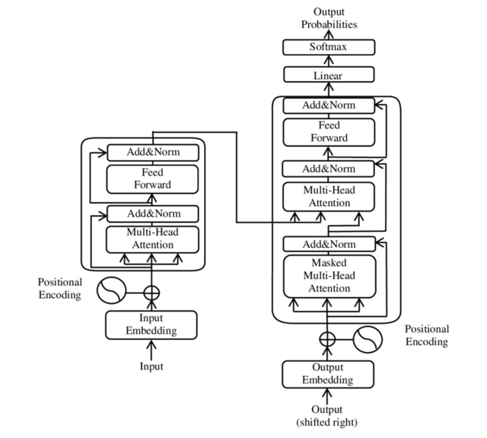Figure 3.1: Transformer Architecture

### **3.2.2 Self-Attention Mechanism in Financial Predictions:**

The self-attention mechanism enables AI models to analyse financial market dependencies by dynamically weighing the importance of different financial variables, this ensures that stock price fluctuations, investor sentiment trends from news and social media, and macroeconomic factor like interest rates and inflation are given appropriate significance in the decision-making process. The ability to compare every financial data point against every other in sequence allows the model to extract meaningful relationships, leading to more accurate predictions.

### **3.2.3 Encoder-Decoder Structure in AI-Driven Advisory:**

The transformer model consists of an encoder-decoder structure that enables financial models to process and generate insights efficiently. The encoder process historical financial data, market trends, and investor behaviour to extract relevant information, while the decoder generates investment recommendations, risk assessments, and portfolio rebalancing strategies based on market conditions. Each encoder and decoder layer is composed of multiple self-attention layers followed by position-wise feedforward neural networks, allowing AI models to respond to complex financial dependencies(Peter, n.d.).

**3.2.4 Positional Encoder for Financial Time-Series Data:**

Since Transformers do not inherently understand word or temporal sequences, optional encoding is used to incorporate time-based financial dependencies. This method ensures that AI models recognise long-term stock price movements and trading patterns, understanding cyclical market trends, and improve predictive accuracy in financial time-series forecasting. By adding a positional element to each financial data point, the model can better interpret sequential trends(Namin and Namin, n.d.).

### **3.2.5 Multi-Head Attention for Market Analysis:**

The multi-head attention mechanism allows Ai models to focus on multiple financial indicators simultaneously, enhancing the accuracy of financial predictions. Each attention head specializes in analysis technical indicator like RSI, MACD, and Bollinger Brands, fundamental analysis of earnings reports and financial ratios, and investor sentiment derived from financial news and media. By processing multiple aspects of financial data in parallel, the model enhances investment decision-making and automated wealth management strategies(Choudhary et al., 2023).

### **3.2.6 Feed Forward Neural Networks for Financial Insights:**

After self-attention mechanisms analysis financial dependencies, each token (data point) is processed through a position-wise feedforward neural network. This process refines investment recommendations by analysis historical market behaviour, enhances stock price prediction models using deep learning techniques, and reduces market noise in AI-driven trading algorithms. The combination mechanisms and feedforward networks make the transformer model particularly effective in financial applications(Pal et al., 2021).

### **3.2.7 Layer Normalization and Residual Connections for Model Stability:**

To Stabilize the AI trading process, transformers implement layer normalization and residual connections. Layer normalization helps reduce variance in financial data, improving model generalization, while residual connections prevent vanishing gradients, ensuring deep learning models retain long-term financial dependencies. These features contribute to the efficiency and robustness of AI-driven financial advisory systems.

### **3.3 Application of Transformer Variants in Financial AI:**

Several transformer-based Language Models (LLMs) have been adapted for financial applications. DistilBERT is widely used for financial document processing, sentiment analysis, and regulatory compliance. DistilRoBERTa enhances risk management models by reconstructing financial trends. These Transformer-based models have redefined AI-driven financial advisory by providing accurate, real-time, and scalable investment recommendations.

The transformer architecture has significantly advanced AI-powered financial decision-making, offering improved market forecasting, portfolio optimization, and investment risk management. Its ability to process structured and unstructured financial data, detect nonlinear market dependencies, and dynamically adjust investment strategies make it a vital component of modern AI-driven financial advisory systems. Future research should continue refining explainability in AI models, ensuring greater transparency, fairness, and regulatory compliance in financial advisory applications.

**3.4 DistilBERT in Financial Advisory Systems:**

DistilBERT is a lightweight, Distilled version of BERT introduced by Sanh et al.(2019). It retains over 95% of BERT’s language understanding capabilities while begin 60% faster and 40% smaller in size(Choudhary et al., 2023). DistilBERT achieves this efficiency through knowledge distillation- a process where a smallar “student” model is trained to mimic a larger “teacher” model like BERT. This make it an ideal candidate for low-latency financial applications, including real-time advisory, portfolio monitoring, and risk management systems(Zhao et al., 2024).

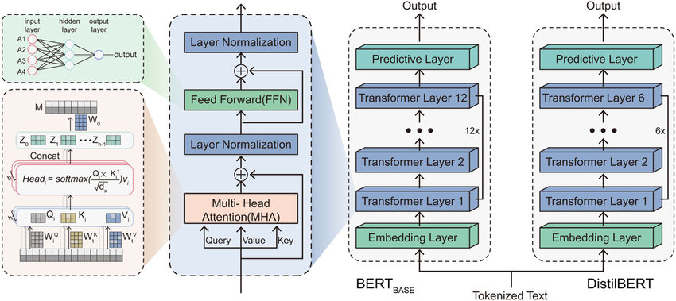

Figure 3.2: DistilBERT Architecture

Source: https://www.researchgate.net/figure/Schematic-diagram-of-BERT-BASE-and-DistilBERT-model-architecture_fig1_382939584

### **3.4.1 Architecture and Functionality of DistilBERT:**

DistliBERT follows an encoder-only architecture derived from the original BERT model but with significant simplifications:

1. it uses 6 transformer encoder layers instead of 12 (in BERT base)(Das and Maurya, n.d.)
2. The Next Sentence Prediction (NSP) objective is removed, retraining only the masked Language Modeling (MLM) objective(Ridzuan et al., 2024).
3. It maintains key mechanisms such as :
4. Multi-head self-attention: Captures contextual relationships across financial terms.
5. Position embeddings: Preserve sequence order.
6. Residual connections and layer normalization: Ensure training stability.

These changes result in faster inference and reduced memory consumption, which is benificial for deploying NLP solutions in real-time financial systems(Das and Maurya, n.d.).

### **3.4.2 DistilBERT’s Role in Financial NLP Applications:**

DistilBERT is well-suited for numerous financial NLP tasks, especially where speed and efficiency are essential(Choudhary et al., 2023; Das and Maurya, n.d.):

1. Real Time Financial Sentiment Analysis: Fine-tuned on domian-specific data such as earnings call transcripts or analyst reports, DistilBERT classifies market sentiment (bullish, bearish, neural) to support short-term trading strategies(Ridzuan et al., 2024).
2. Financial Document Classification: Efficiently processes quarterly earnings reports, regulatory disclosures, and comapany news for categorization or insight extraction(Xu, 2024).
3. Stock Price Movement Prediction: Integrates textual signals from financial headlines, investor forums, and news feeds to forecast stock direction or volatillity in combination with structured features(Peter, n.d.).
4. Conversational AI for Financial Queries: Powers intelligent chatbots or virtual investment assistants capable of answering investor queries about market trends, asset performance, or financial polices(Wilhelmina Afua Addy et al., 2024).

### **3.4.3 Fine-tuning DistilBERT for Financial Applications:**

To tailor DistilBERT for domain-specific tasks in finance, the following fine-tuning pipeline is used(Namin and Namin, n.d.):

#### **3.4.3.1 Dataset Prepartion:**

Financially-relevant datasets are used, such as:

* NIFTY50 daily commentary(Okwaraoha, 2023)
* Regulatory fillings (e.g., SEBI reports)
* Earnings call transcripts(Das and Maurya, n.d.).
* Analyst recommendations and news headlines(Ridzuan et al., 2024)

Text to input Transformation: Preprocessing includes sentence segmeantation, tokenization via DistilBertTokenizer, and truncation to fit 512-token max length.

#### **3.4.3.2 Model Optimization:**

* Loss functions: CrossEntropy (Classification) or MSE/ MAE (Regression)
* Optimizer: AdamW
* Batch size: 16-32 depending on GPU
* Epochs: 4-6 with early stopping

#### **3.4.3.3 Explainability:**

Integrated with SHAP and LIME for feature attribution at the token level, aiding transparency in investment recommendation systems.

#### **3.4.3.4 Comaprision: DistilBERT vs. BERT vs. Other Models:**

| Feature | DistilBERT | BERT | ALBERT | TinyBERT |
| --- | --- | --- | --- | --- |
| Size | Small | Large | Smaller | smallest |
| Speed | Fast | slow | Faster | Faster |
| Accuracy | 97% of BERT | High | Comparable | Moderate |
| Layers | 6 | 12 | 12 | 4-6 |

Table 3.1: Comaprision of DistilBERT vs Others

### **3.5 DistilRoBERTa in Financial Advisory Systems:**

DistilRoBERTa is a lightweight distilled version of RoBERTa, Trained to retain most of RoBERTa’s performance while being faster and more resource-efficient(Choudhary et al., 2023). Unlikely BART’s encoder-decoder architecher, DistilRoBERTa follows a pure encoder-only structure silimar to BERT but is optimized for classification and regression task-making it ideal for real-time financial prediction and explainability-driven advisory applications(Das and Maurya, n.d.).

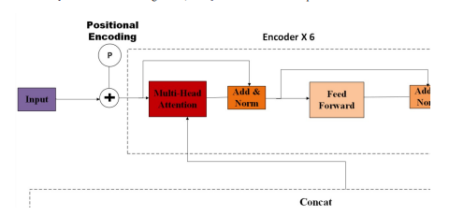

**Figure 3.3: DistilRoBERTa Architecture**

### **3.5.1 Key Financial Applications of DistilRoBERTa:**

1. Market Sentiment Classifiation (bullish, bearish, neutral)(Ridzuan et al., 2024)
2. Directional Movement Prediction- Forecastes market direction based on structured and unstructured data(Peter, n.d.)
3. Risk Profiling and Investment Suitablity Analysis(Zhang et al., 2020).
4. SHAP and LIME-enhanced Explainable Financial Forecasting

### **3.5.2 Fine Tuning DistilRoBERTa for financial Tasks:**

To effectively adapt DistilRoBERTa for financial use cases,we fine-Tuned itt using:

* Tabular-to-text converted indicators from the NIFTY50 dataset(Okwaraoha, 2023)
* Engineered financial features (e.g., RSI, MACD, Momentum, Log Return)(Namin and Namin, n.d.)
* Classification for upward/downward movement (binary)
* Regression for next-day log return prediction

## **3.6 Hybrid AI models in Financial Advisory Systems:**

Hybrid AI models combine rule-based logic, Machine Learning, Deep Learning, and Reinforcement Learning to enhance investment strategies, risk management, and portfolio optimizations. They integrate traditional financial theories with AI-driven insights for adaptive, explainable decision-making(Wilhelmina Afua Addy et al., 2024).

### **3.6.1 Key Applications:**

* Portfolio Optimization: AI-driven dynamic asset allocation(Zhao et al., 2024).
* Market Volatility Prediction: Combines technical indicators, macroeconomic trends, and sentiment analysis(Peter, n.d.).
* Farud Detection: Integrates rule-based fraud detection with AI anomaly recognition(Courage Oko-Odion et al., 2025a).
* Behavioural Finance: Corrects cognitive biases in investor decisions.
* Robo-Advisory: Delivers personalized, compliant investment strategies(Gerner-Beuerle, 2021).

Hybrid AI improves predictive accuracy, risk assessment, and regulatory compliance, however requires high computational power an improved interpretability for widespread adoption.

## **3.7 Explainable AI (XAI) in Financial Advisory Systems:**

As AI-driven financial models grow complex, transparency is crucial for regulatory compliance and investor trust. XAI techniques like SHAP, LIME, and counterfactual analysis provide interpretability, ensuring AI-generated investment recommendations are justifiable(Ridzuan et al., 2024).

### **3.7.1 Key Applications:**

* Investment Strategy Justification: Explains AI stock and asset selection.
* Risk Assessment Transparency: Clarifies AI-driven risk calculations.
* Regulatory Compliance: Aligns AI decisions with SEC, GDPR, and Basel III.

### **3.7.2 Advantages and Challenges in XAI Implementation:**

* Enhances Investor Trust: Provides clear explanations for AI-generated insights.
* Regulatory Compliance: Helps financial institutions adhere to AI ethics and financial laws.
* Explainability vs. Accuracy Trade-Off: High interpretability can reduce model performance.
* Computational Overhead and Biases in Explanation Models: XAI needs additional processing power and may introduce biases.

XAI ensures fair, transparent, and accountable AI-driven financial decisions, helping financial institutions build trust, comply with regulations, and enhance AI explainability.

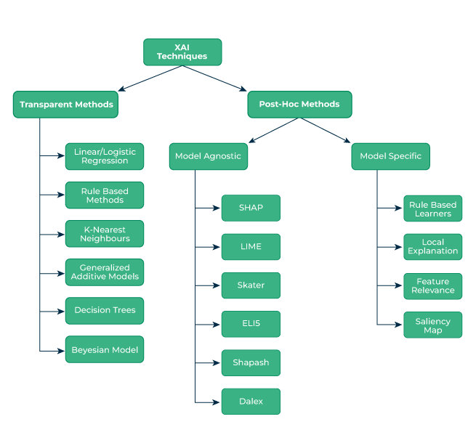Figure 3.4: Explainable AI (XAI) Techniques Overview

## **3.8 Methodology:**

This chapter outlines the systematic approach used to develop, train, and evaluate AI-driven financial advisory models. The methodology includes data collection, preprocessing, model selection, fine-tuning strategies, and evaluation metrics(Xu, 2024). The research focuses on leveraging transformer-based models like DistilBERT and DistilRoBERTa, fine-tuned on the NIFTY50 dataset for investment predictions and portfolio optimization. Granger causality, Pearson correlation, and reinforcement learning techniques are integrated to improve model accuracy and explainability(Namin and Namin, n.d.).

## **3.9 Data Collection and Processing:**

The NIFTY50 dataset is the primary source of financial data, containing historical stock prices, market indicators, and trading volumes. Preprocessing includes handling missing values, normalization, feature engineering, and sentiment classification to enhance model accuracy.

## **3.10 Model Selection and training:**

This study utilizes pre-trained language model (LLMs) fine-tuned for financial analysis:

* DistilBERT: Best for understanding financial reports and market sentiment(Choudhary et al., 2023).
* DistilRoBERTa: Combines text summarization and sentiment prediction(Ridzuan et al., 2024).

Granger causality is applied to detect whether past stock prices influence future trends, guiding model training. Fine-tuning involves hyperparameter tuning, learning rate adjustments, and transfer learning to improve financial forecasting accuracy.

## **3.11 Evaluation Metrics:**

To assess model performance, key evaluation metrics include:

Mean Absolute Error (MAE) and Root Mean Square Error (RMSE) For Measure prediction accuracy.

### Market Trend Prediction Accuracy:

1. Evaluates AI’s ability to forecast price movements using historical and real-time data(Zhao et al., 2024).
2. Explainability Scores (XAI-based metrics: SHAP and LIME): Ensure AI-based driven financial decisions are transparent and interpretable(Peter, n.d.).
3. Granger Causality Tests: Validate AI model predictions by confirming causal relationships between financial indicators(Das et al., 2024).
4. This methodology ensures a structured, data-driven approach for developing scalable and transparent AI-powered financial advisory systems(Namin and Namin, n.d.).

## **3.12 Implementation Approach:**

The implementation of the AI-driven financial advisory system follows a structured workflow, including data processing, model fine-tuning, hyperparameter optimization, and real-time evaluation(Okwaraoha, 2023). The system integrates transformer-based AI models ( DistilBERT, DistilRoBERT), Granger causality tests, and Explainable AI (XAI) techniques to enhance financial forecasting accuracy and transparency(Das et al., 2024).

## **3.13 Data Processing and feature Engineering:**

The NIFTY50 dataset is pre-processed using advanced data cleaning and normalization techniques to ensure high-quality inputs for AI models. The feature selection process involves(Okwaraoha, 2023; Wilhelmina Afua Addy et al., 2024):

**3.14 Missing Value Handling:**

1. Data is cleaned and completed by imputing or removing inconsistencies.
2. Feature Engineering using Granger causality: analysis to determine whether past stock movements influence future trends.
3. Pearson Correlation to identify significant relationships between financial indicators.
4. Normalization and Standardization: Scaling financial data to enhance model interpretability.
5. Sentiment Analysis: NLP to incorporate financial news and investor behaviour into market predictions.

## **3.15 Evaluation Metrics:**

To assess the performance of AI-riven financial advisory models, a combination of quantitative and explainability-based evaluation metrics is employed. These metrics ensure the reliability, accuracy, and transparency of financial predictions, helping investors and financial institutions make informed decisions(Gerner-Beuerle, 2021).

### **3.15.1 Prediction Accuracy Metrics:**

* Mean Absolute Error (MAE) and Root Mean Square Error (RMSE) are used to measure the accuracy of stock price predictions.
* MAE calculate the average absolute error between predicted and actual values, ensuring that predictions remain close to real stock movements(Zhang et al., 2020).
* RMSE penalizes large errors more heavily, making it effective for evaluating market fluctuations(Peter, n.d.).

**Mathematically, these metrics are defined as:**

**MAE =**

**RMSE =**

Where is the actual stock price, and is the predicted value.

### **3.15.2 Market Trend Prediction Accuracy:**

This metric evaluates the AI model’s ability to classify whether a stock will move up, down, or remain stable based on historical and real-time financial data(Courage Oko-Odion et al., 2025a).

Accuracy is calculated as:

Accuracy =

A higher accuracy percentage indicates better predictive performance in financial trend analysis.

### **3.15.3 Explainability Metrics:**

To ensure transparency, SHAP (Shapley Additive Explanations) and LIME (Local Interpretable Model-Agnostic Explanations) are used to interpret model decisions:

* SHAP assigns an importance score to each financial variable influencing stock predictions(Das and Maurya, n.d.).
* LIME generates simplified local approximations of AI decisions, improving interpretability(Gerner-Beuerle, 2021).
* The Granger causality test is applied to confirm whether past stock price tends significantly influence future market movements, validating AI-generated predictions(Namin and Namin, n.d.).

## **3.16 End-to-End Pipeline for AI-Driven Financial Advisory:**

The implementation follows a structured pipeline integrating financial data processing, AI model training, and explainability techniques for accurate investment strategy recommendations(Xu, 2024).

1. Data Collection and Preprocessing
2. Model Training and Forecasting
3. Market Risk Analysis and Strategy Generation
4. Evaluation and Development

## **3.17 Experimental Setup:**

The experimental setup involves configuring the hardware, software, and cloud resources to efficiently train and evaluate AI-driven financial advisory models. This ensures optimal performance in processing large-scale financial datasets, fine-tuning transformer models, and conducting market trend analysis.

### **3.17.1 Hardware Configuration:**

he research utilizes both local and cloud-based computational resources to handle model training and inference tasks efficiently.

### **3.17.2 Local System:**

* + Processor: Intel core i7/i9 or AMD Ryzen 9
  + RAM: 32GB DDR4/DDR5
  + CPU: NVIDIA RTX 3050 (4GB) or higher for AI model inference
  + Storage: SSD 1TB for fast data access

### **3.17.3 Software Stack:**

The AI models are implemented using Python-based frameworks and deep learning libraries:

* Python 3.9 -> Core programming language
* TensorFlow & PyTorch -> Deep Learning frameworks for training transformer models
* Hugging Face Transformers -> pre-trained models (DistilBERT, DIstilRoBERTa)
* Pandas and NumPy -> Data manipulation and numerical computation
* Matplotlib and Seaborn -> Financial data visualization
* NLTK and SpaCy -> natural Language Processing for sentiment analysis
* SHAP and LIME -> Explainability frameworks for financial AI models

Model Training and Fine-Tuning: Transformer models are fine-tuned on NIFTY50 data for financial forecasting.

### **3.17.4 The training process involves:**

* Batch size: Optimized for memory efficiency (e.g., 16-32 samples per batch).
* Learning Rate: Adjusted dynamically (0.0001-0.0003) using Adam optimizer.
* Epochs: 10-20, based on model convergence.
* Loss Function: Mean Squared Error (MSE) for regression-based stock predictions.

## **3.18 Summary:**

This chapter outlined the methodology for implementing AI-driven financial advisory systems, focusing on data processing, model selection, training, and evaluation techniques. The NIFTY50 dataset serves as the foundation for training Transformer-based models (DistilBERT and DistilBERTa) to predict stock movements, optimize investment strategies, and assess financial risks(Xu, 2024).

The experimental setup leverages cloud-based and local computational resources, while fine-tuning techniques enhance AI model performance. Evaluation metrics, including MAE, RMSE, and explainability tools (SHAP & LIME), ensure accuracy and transparency in financial predictions.

The end-to-end pipeline integrates market sentiment analysis, AI-driven forecasting, and risk assessment, enabling real-time investment advisory. This structured approach enhances scalability, compliance, and decision-making reliability in financial markets(Das and Maurya, n.d.).

# **CHAPTER 4: IMPLEMENTATION**

## **4.1 Introduction:**

This Chapter presents the technical implementation of the AI-driven financial advisory system, focusing on the complete pipeline-from data preprocessing to model deployment. The core objective is to fine-tune state-of-the-art transformer-based models - DistilBERT, DistilRoBERTa using the NIFTY50 dataset to generate accurate forecasts and personalized investment recommendations.

The evaluation is structured to address the research objectives by:

1. Comparing the predictive performance of different transformer architectures.
2. Assessing explainability through SHAP and LIME visulaizations.
3. Analysing the relationship between input features and model outputs.
4. Discussing the results in relation to existing literature and the practical implications for financial advisory systems.

## **4.2 Experiment Overview:**

This experiments were implemented using Python and state-of-the-art deep learning frameworks (Pytorch and TansorFolw). The training was conducted on an RTX 3050 GPU with 4 GB RAM. Data preprocessing included log transformations, rolling statistics, momentum indicators, and Pearson correlation-based sentiment scores from financial news.

The models evaluated include:

* DistilBRT and DistilRoBERTa for Classification and Regression tasks.
* Baseline statistical models for comparison.

Hyperparameters were optimized using grid serach and manual tuning to suit GPU constraints while maintaing performance.

## **4.3 Dataset Description:**

The dataset used in this study consists of daily trading data from the NIFTY50 index, a benchmark equity index representing the performance of 50 of the largest and most actively traded stock listed on the National Stock Exchange (NSE) of India. It is widely recognized as a barometer of the indian equity market and reflects the economic health of key industrial sectors.

The Dataset dataset spans over two decades, covering the period from January 3,2000, to April 30,2021, with a total of 235,192 records and includes the following key attributes:

* Date: Daily trading date
* Open: Price at which the stock opened on a given day
* High: Highest trading price of the day
* Low: Lowest trading price of the day
* Close: Fianl trading price at market close
* Volume: total quantity of shares traded
* Turnover: Total value of shares traded in INR
* trades: Number of individual trades executed
* Deliverable volume: Portion of shares that were taken into actual delivery (i.e., not speculative)
* %Deliverable: Percentage of total volume that wes deliverable

this dataset captures not only price dynamics but also underlying investor sentiment and trading behaviour over time. The presence of both price and volume-based features enables a robust foundation for modeling stock movements.

A preliminary statistical analysis using the df.describe() method offers insights into the central tendencies and spread of each variable. This step helps identify the magnitude and variability of trading behaviour across the datset.

## **4.4 Observation Summary:**

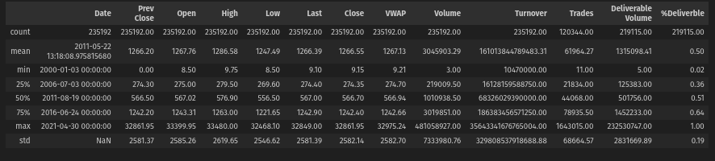**Figure 4.1: Summary Statistics Of The NIFTY50 Dataset(Df.describe())**

* Features like Volume, Trades, and Turnover display large standard deviations, reflecting the market’s inheritent volatility.
* Several fields exhibit significant differences between mean median values, suggesting right-skewed distributions influenced by rare but high-impact trading days (e.g., market crashes or bull rallies).
* Deliverable Volume and %Deliverable vary widely across records, pointing to changing investor strategies and speculative activity during different periods.

### **4.4.1 Additional derived fields were computed during preprocessing:**

* **Log Returns**: Calculated as the natural logarithm of the ratio of consecutive colsing prices. This transforms price data into stationary form suitable for predictive modeling.
* **Rolling Means and Volatility**: Applied over 5,10,30-days windows to capture short-and medium-term trends.
* T**echnical Indicators**: Indicators such as RSI(Relative Strength Index) , MACD(Moving Average Convergence Divergence), and Bollinger Bands were computed to reflect momentum, pricec trends, and volatility envelopes.

These derived features significantly enhance the dataset’s predictive capacity, allowing deep learning models to capture both market memory and structural changes. Moreover, the presence of sentiment-derived features from news or financial headlines (added during feature augmentation) provied a multimodal dimension to model behavior, aligning financial price signals with textual sentiment.

This validate the suitability of this dataset, initial machine learning benchmarks (e.g., linear regression, random forest) were applied, confirming non-linearity and high dimensionality-further justifying the application of transformer-based architectures.

Prior to modeling, this datset undergoes a multi- stage transformation including:

1. Data Cleaning: Handlingmissing values and correcting inconsistent recordes.
2. Data Augmentation: Integrating sentiment data from financial news headlines.
3. Feature transformation: Generating statistical and technical indicators for predictive modeling.

This multi-layered structure ensures the dataset is not only comprehensive but also enriched for sequential and contextual learning models.

This summary highlights wide ranges and high standard deviations in several features, notably in Volume, turnover, and Trades, including strong volatility and outliers that requiered further preprocessing.

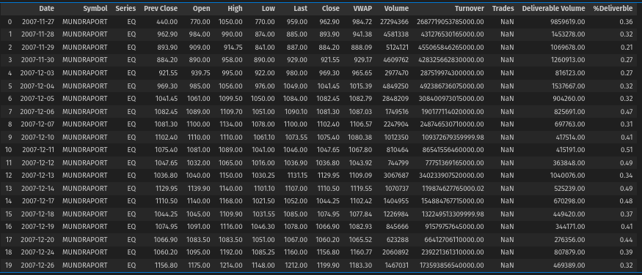**Figure 4.2: Raw NIFT50 Data (df.head(20))**

## **4.5 Expolratory Data Analysis (EDA):**

Exploratory Data Analysis (EDA) serves as a critical intermediate phase in the implementation pipeline, bridging raw understanding and informed model development. The main goal is tok uncover hidden patterns, identify relationships between variables, assess the temporal dynamics of market behaviour, and inform preprocessing decisions. A well-executed EDA lays the foundataion for model success by ensurring that the data is both statistically sound and contextually aligned with financial forecasting goals.

### **4.5.1 Statistical Profiling:**

The first step involved examining summaryj statistics such as mean, median, standard deviation, skewness, and kurtosis, these metrics reveald that:

* Stock market data is inherently non-stationary and right-skewed.
* Several features, including volume, turnover, and trades, exhibit heavey tails and high kurtosis, implying the presence of frequent extrems values.
* Disparities between mean and median values indicated the influence of outliers events such as dinancial crises or unexpected policy decisions.

These insights prompted to use of log-transformations and rolling statistics to stabilize variances and normalize distributions.

### **4.5.2 Visual Univariate and Bivariate Distributions:**

Histogram and KDE plots werer generated for key features, while scatter plots and pairplots helped identify relationships between variables. Key findings include:

* Strong collinearity among Open, Close, High, and Low values.
* Inverse relationship between %Deliverable and Volume, suggesting speculative spikes.
* High frequency of near-zero trading in certain periods indicated potential holidays or market halts.

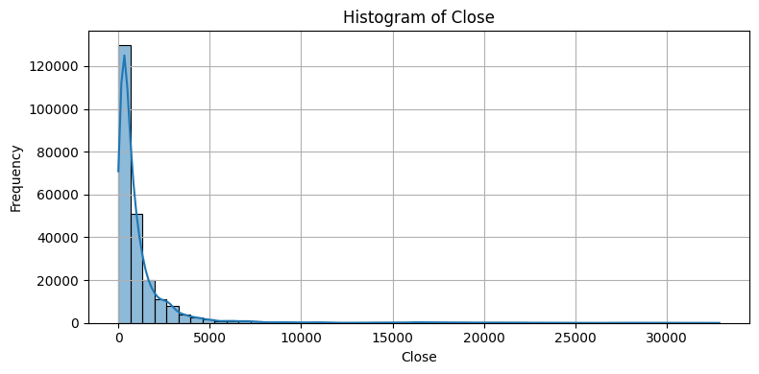**Figure 4.3: Histogram of Close Price**

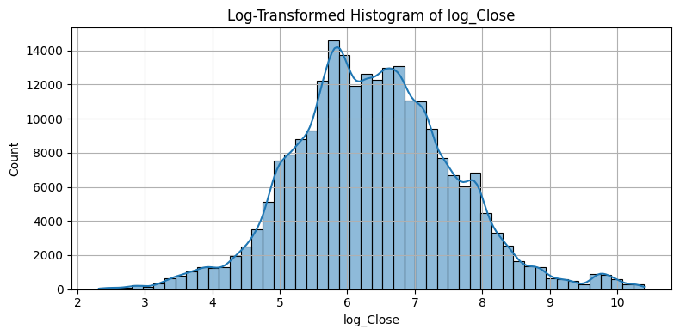F**igure 4.4: Log-Transformed Histogram of Log_close**

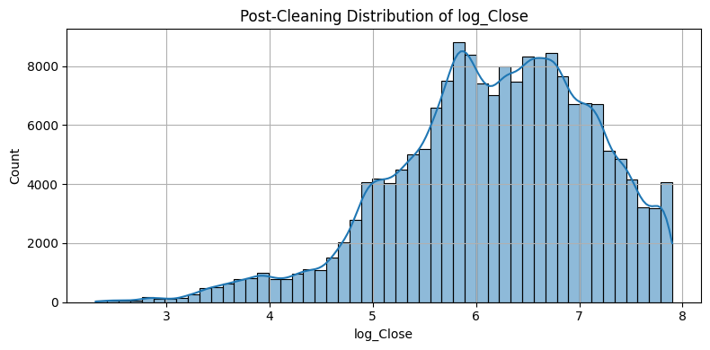**Figure 4.5: Post-Cleaning Distribution of Log_close**

## 

## 

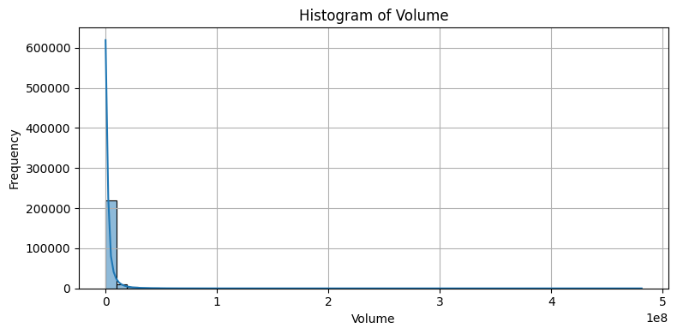**Figure 4.6: Histogram of Volume**

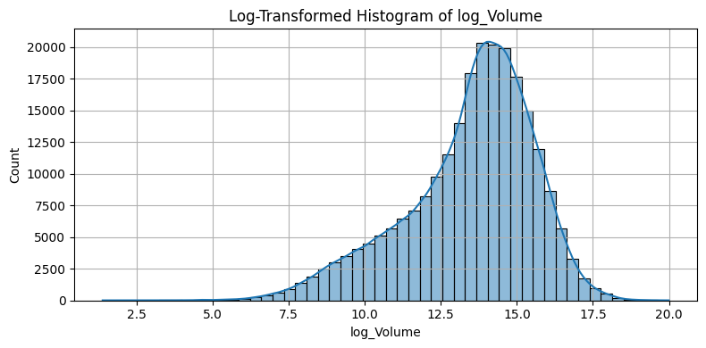**Figure 4.7: Log-Transformed Histogram of Log_Volume**

## 

## 

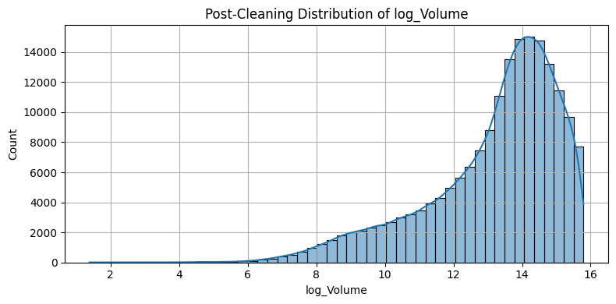**Figure 4.8: Post_Cleaning Distribution of Log_volume**

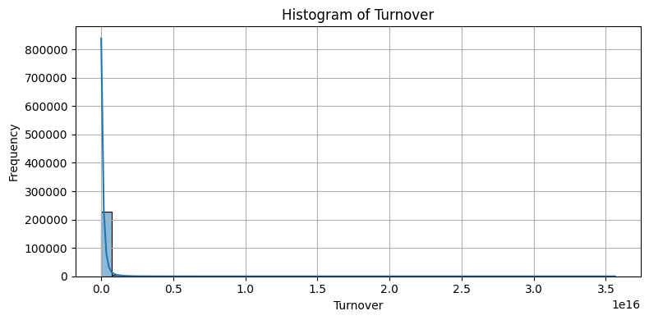**Figure 4.9: Histogram of Turnover**

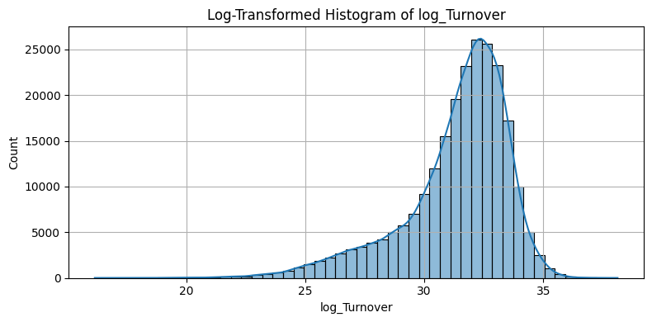**Figure 4.10: Log-transformed Histogram of Log-Turnover**

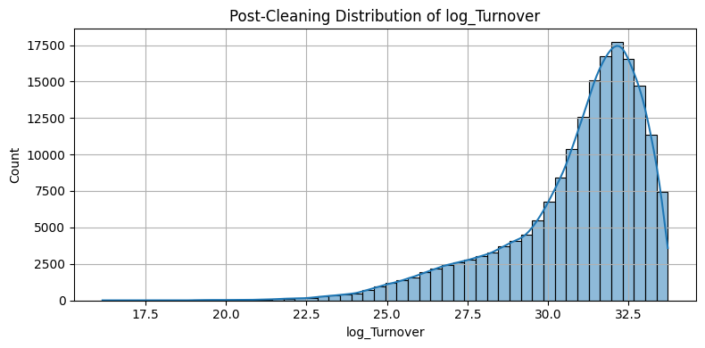**Figure 4.11: Post-Cleaning Distribution of Log_turnover**

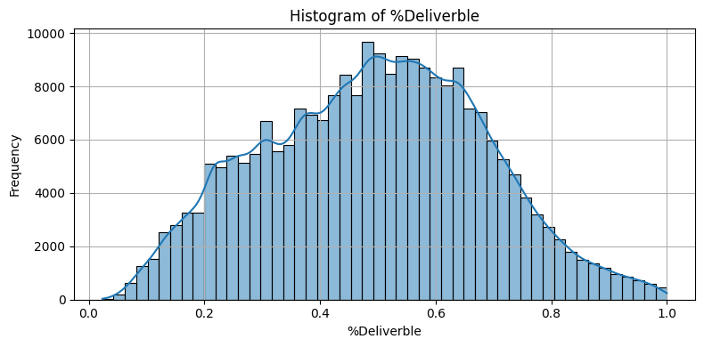**Figure 4.12: Histogram of %Deliverble**

This visuals compaison clearly shows how the transformation brings the distribution closer to normality, reducing the influence of outliers and making the features more suitable for modeling.

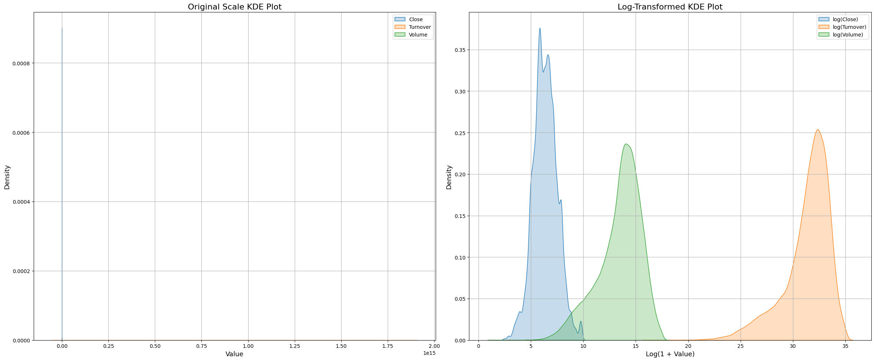**Figure 4.13: KDE Plots (Original And Log-Transformed)**

### **4.5.3 Temporal trend Analysis:**

The Close price was plotted over time, revealing:

* Long-term bullish trend in indian markets.
* Market downturns around 2008 (global financial crisis) and 2020 (COVID-19 pandamic).
* Seasonal slowdowns in mid-year months, often tied to macroeconomic cycles or monsoon impact.

Moving average overlays helped detect crossover signals, trend reversals, and volatility custers. In addition to close price, plots were also created for rolling averages of volume and Turnover to monitor liquidity and trading momentum over time.

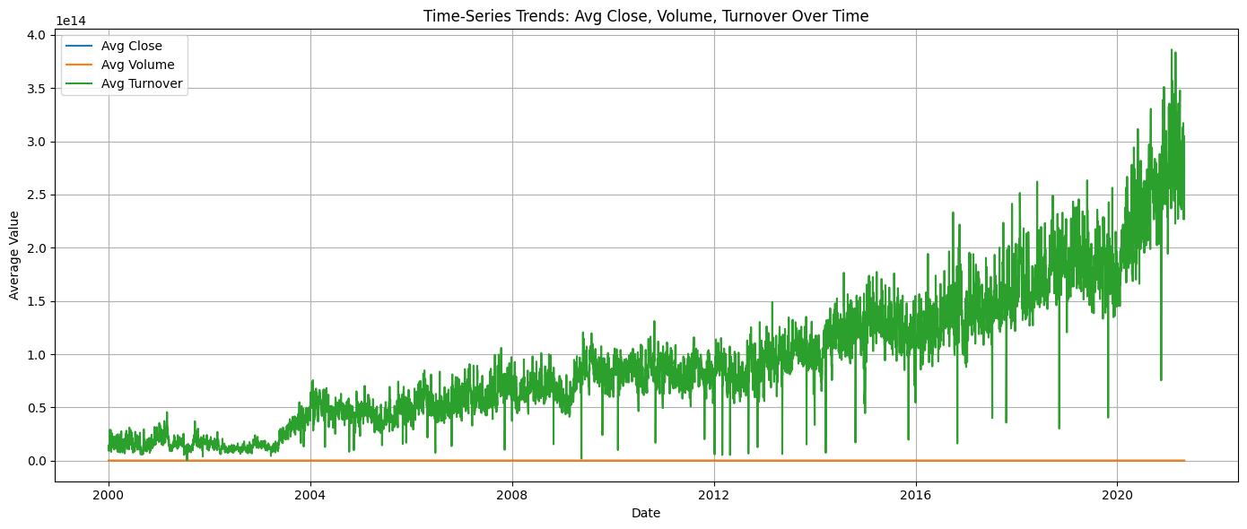**Figure 4.14: Time Series Of NIFTY50 Close Price, Volume, And Turnover With SMA Overlays**

### **4.5.4 Correlation Analysis and Heatmaps:**

Understanding the relationships between features is essential in building a robust and interpretable financial forecasting model. To this end, a Pearson correlation heatmap was constructed to quantify the linear associations between the key variables in the dataset. The objective of this analysis is two fold:

1. Identify collinear variables that may introduce redundancy or muliticollinearity into the model.
2. Isolate informative and independent features that could enhance the model’s generalization ability.

The heatmap offered a clear visual representaion of feature dependencies, guiding the feature engineering process.

#### **4.4.4.1 Key Findings:**

* Open, close, High, and Low were highly correlated (>0.95), suggesting potential dimensionality reduction.
* Volume and Turnover showed moderate correlation with price variables but high volatility.
* Sentiment-based features exhibited low correlation, indicating unique explanatory power.

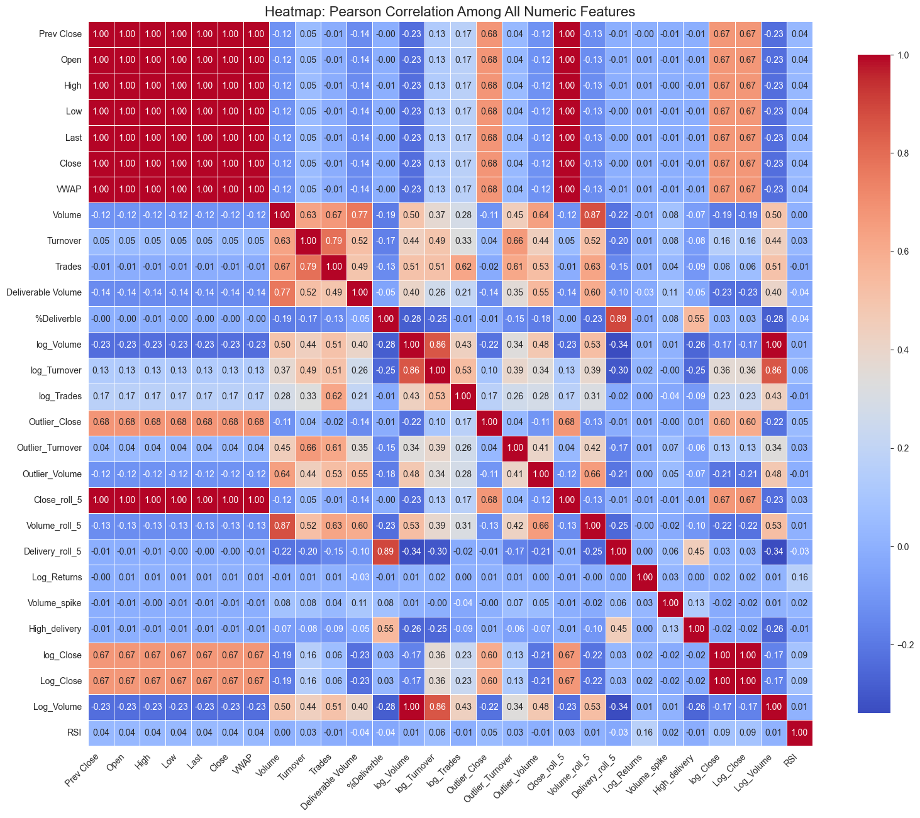**Figure 4.15: Pearson Correlation heatmap of Numeric Features**

### **4.4.5 Outlier Detection and Feature Normalization:**

Outliers are extreme data points that can distort statistical analysis and negatively impact the performance of predictive models. In financial datasets such as NIFTY50, outliers may raise due to sudden market events, data entry errors, or rare but significant trading anomalies. Identifying and appropraiately handluing these outliers is essential to maintain model robustness, especially in regression-based forecasting.

To detect outliers, both univariate and multivariate approaches were used:

* **Boxplots** were employed to visually identify extreme values in key numerical features such as close, Volume, Turnover, and technical indicators like RSI and MACD.
* **Z-Score analysis** was applied to flag values lying beyond 3 standard deviations from the mean.
* **IQR (Interquartile Range) method** was used as a robust statistical approach to quantify and cap outliers in skewed distributions.

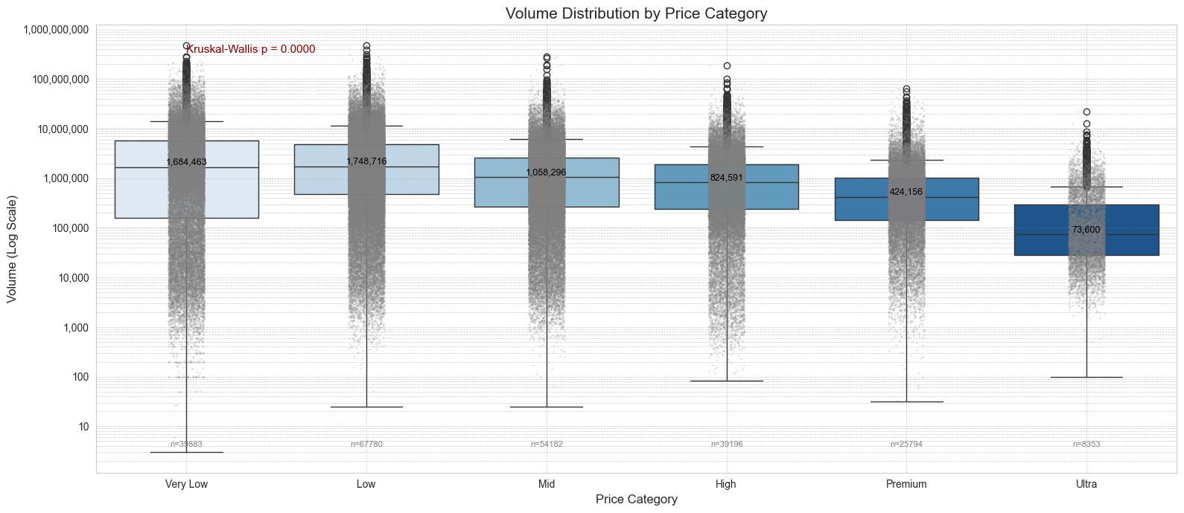**Figure 4.16: Volume Distribution By Price**

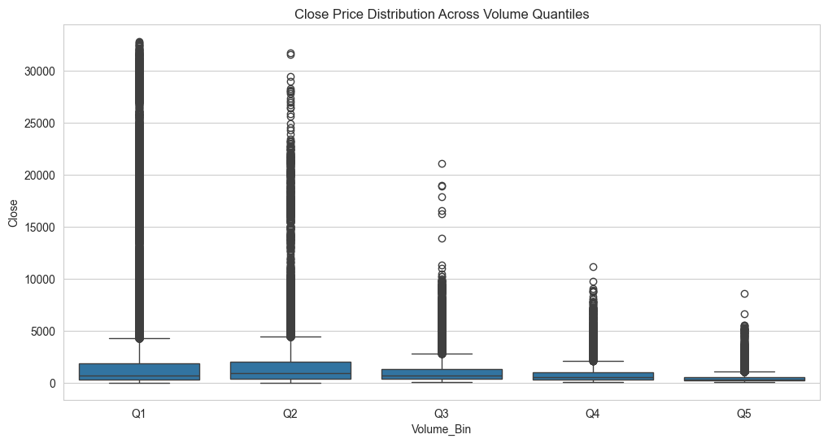**Figure 4.17: Close Price Distribution Across Volume Quantiles**

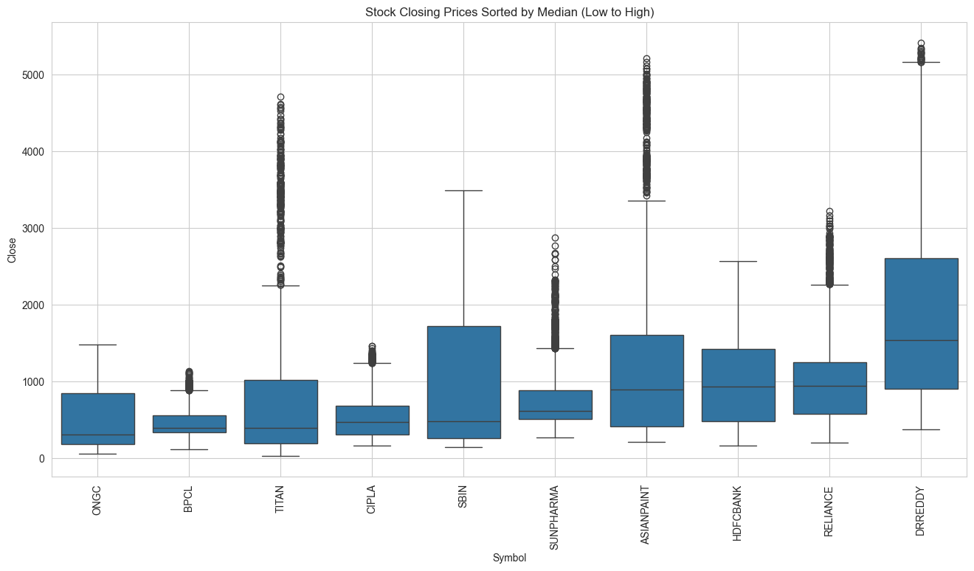**Figure 4.18: Median-sorted Closing Prices (Low To High)**

### **4.4.6 Feature Engineering:**

Feature engineering plays a crucial role in enhancing the predictive power of AI models. In the context of the NIFTY50 dataset, both domain-specific and statistical features were engineered to enrich the data representation.

Technical Indicators Used in feature Engineering:

* RSI ( Relative Strength Index): Captures momentum shiffts to indicate overbought or oversold conditions.
* MACD (Moving Average Convergence Divergence): used to identify trend reversal and convergence-divergence behaviour.
* Bollinger Bands (Upper, Lower, Mid): Reflect volatility and potential breakout zones.
* Rolling Mean and Std Dev (5-Day, 10-Day): Capture short-term trend and volatility behaviour.
* Log Returns: Capture percentage change and help stabilize variance in time-series data.
* Momentum(3,7 days): Measures the rate of charge in closing prices.
* Price Change: Difference between current and prpevious close.
* Volume Ratios: Including Volume RSI, log(Volume), %Deliverable.

These features were selected based on domain relevance and correlation analysis to ensure they offer unique, non-redundant signals for both classification and regression tasks.

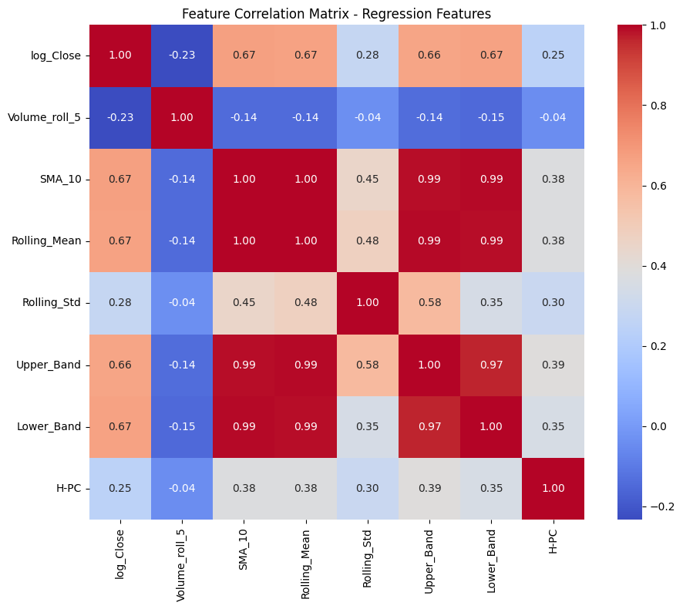**Figure 4.19: Feature Correlation Matrix – Regression Features**

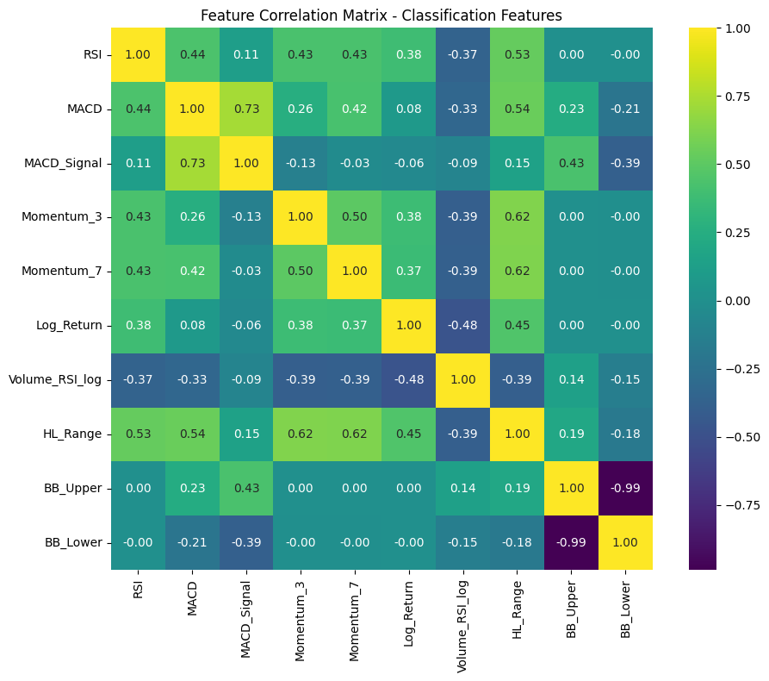**Figure 4.20: Feature Correlation Matrix – Classification Features**

Regression Features revealed strong multicollinearity among moving averages and bollinger bands, while Classification features displayed divers correlations, supporting the inclusion of complementary technical indicators.

### **4.4.7 Final Preprocessed Dataset:**

After completing preprocessing and feature generation, the dataset was structured and exported for model training.

Step Performed:

* Missing values were imputed using forward/backward fill to ensure time-series consistency.
* Log transformations were applied to volume and Turnover to reduce skewness and heteroscedasticity.
* Volatility and nosie were smoothed using rolling statistics.
* Outliers were capped using IQR and Z_score techniques.
* Time-derived features like Day of Week, Month, and Month End were added to capture seasonal effects.
* Targets for classification and regression were constructed using forward-shifted Close price.

Exported Datasets:

* Regression: X_train_reg.csv, X_val_reg.csv, X_test_reg.csv,

y_train_reg.csv, y_val_reg.csv, y_test_reg.csv,

* Classification: X_train_cls.csv, X_val_cls.csv, X_test_cls.csv,

y_train_cls.csv, y_val_cls.csv, y_test_cls.csv

These structure files enabled reproducible training and evaluation pipelines for the models described in the subsequent sections.

### **4.4.8 Summary of Exploratory Data Analysis and Preprocessing:**

This chapter highlighted the importance of robust preprocessing and insightful EDA in shaping a reliable and interpretable modeling framwork. The EDA uncovered valuable trends and seasonality patterns, identified multicollinearity, and informed necessary feature transformations.

Key preprocessing tasks- such as outlier treatment, log transformations, time-based feature consturction, and target definition-were essential for ensuring the model’s pperformance and generalization.

The feature enginnering strategies ensured that both domain-relevent indicators and statistically informative features were utilized. This comprehensive preparation laid a strong foundation for the development, tuning, and evaluation of ML and deep learning Models in the next chapter.

# **Chapter 5: Model Development and Evaluation**

## **5.1 Introduction:**

This chapter outline the modeling strategies and implementation approaches used to forecast NIFTY50 financial trends using the preprocessed and feature-engineered dataset. Two primary modeling tasks were pursued:

1. Regression: - Predicting the next day’s closing price as a continuous value.
2. Classification: - Predicting the directional movement (up/down) of the NIFTY50 index.

To ensure a comprehensive and future-proof architechture, this study integrated classical machine learning algorithms, advance deep learning models, and cutting-edge transformer-based generative AI techniques.

The modeling pipelines were developed with modularity and interpretability in mind, emphasizing model generalization, robustness, and explainability through tools like SHAP and LIME. This multi-paradigm appraoach enables both performance optimization and the transpacrency required for decision-making in high-stack financial environments.

## **5.2 Modeling Objectives:**

The dual modeling objectives were carefully crafted to meet different use-cases in algorithmic trading and financial decision systems:

* Regression Objective: Predict the next day’s NIFTY50 closing price as a continuous numerical values.
* Classification Objective: Predict the directional change (up/down) in the next day’s closing price.

Even tasks were addressed independent data pipelines, model architectures, ad evaluation metrics. By decoupling objectives, pipeline could be tailored for optimal performance and domain-specific insights.

## **5.3 Machine Learning Models:**

A wide array of traditional machine learning algorithms were employed to establish strong baselines for both regression and classificatin tasks. These models are favoured for their simplicity, interpretability, and efficiency, especially on structured tabular data.

### **5.3.1 Regression Models:-**

#### **5.3.1.1 Linear Regression:**

Served as the simplest benchmark with no regularization.

* Advantage: fast and interpretable
* Limitaion: Inability to model non-linear trends and feature interactions.
* Findings: Produced high bias and large residuals, especially during market volatility.

#### **5.3.1.2 Ridge regression:**

Introduced L2 Penalty to prevent overfitting.

* Effect: Reducec variance in predictions compared to linear regression.
* Best suited for: Feature sets with multicollinearity.
* Findings: Slightly improved RSME, Coefficients shrank uniformly.

#### **5.3.1.3 Lasso Regression (L1 penalty):**

* Effect: selected only the most influential features
* inshight: Helpedin identifying key predictors like RSI, SMA_10, and Rolling_Mean_5.
* Findings: Smilar performance to ridge with reduce feature set.

#### **5.3.1.4 Random Forest regressor:**

An ensemble of decision trees using bootstrapping(bagging).

* Advantage: Captures Non-linear patterns and interactions.
* Drawbacks: Less interpretable.
* Findinags: Lower MAE and RSME compared to linear models, handled noise well.

#### **5.3.1.5 Gradient Boosting Regressor (GBR):**

A powerful boosting method minimizing residuals iteratively.

* Benifit: high predictive power, especially in complex pattens.
* Trade-off: slower training time than RF.
* Findings: Among top performers, especially on high-variance segments.

#### **5.3.1.6 XGBoost, LightBM, CatBoost:**

State-of-the-art gradient boosting libraries providing improved speed and accuracy, especially on large tabular datasets.

|  |  |  |
| --- | --- | --- |
| Model | Key Strength | Findings |
| XGBoost | Regularization, parallelism | Strong RSME and R2 ,  sensitive to learning rate |
| LightGBM | Leaf-wise splitting | Best performance on large feature sets |
| CatBoost | Categorical support, less tuning | Excellent generalization and robust to overfitting |

Table 5.1: ML Models Insights

#### **5.3.1.7 Overall Finding:**

LightGBM and CatBoost consistently outperfomed other models in terms of RSME, MAE, and training time.

### **5.3.2 Classification Models:**

#### **5.3.2.1 Logistic Regression:**

The most interpretable model, assuming linear decision boundaries.

* Use: Baseline benchmark for binary classification.
* Findings: Achived reasonable accuracy(~53-56%) but failed on non-linear trends
* SHAP insights: Strongly influenced by Log_Retrun, Volume_RSI_log, and momentum_3.

#### **5.3.2.2 Random Forst Classifier:**

Efficient in handling feature interactions.

* Advantage: High interpretability and good generalization
* Drawback: Can be biased on imbalanced classes
* Findings: Significantly improved recall and f1-score over logistic regression.

#### **5.3.2.3 Gradient Boosting Classifier(GBC):**

Boosting algorithm minimizing classification error iteratively.

* Strength: Captured subtle market shifts.
* Weakness: Prone to overfitting without regularization.
* Findings: Achived higher precision in predicting “Up” Signals.

#### **5.3.2.4 XGBoost, LightGBM, CatBoost:**

Provided nuanced decision boundaries with boosting techniques and handled class imbalance effectively.

|  |  |  |
| --- | --- | --- |
| Model | Class Imbalance Handling | Finding |
| XGBoost | Scale_pos_weight | Balanced precision and recall |
| LightGBM | Custom objective + class weight | Best ROC-AUC (0.61-0.64 range) |
| CatBoost | Auto class weighting | Strongest F1 score with minimal tuning |

Table 5.2: ML tree-based Models Inights

Post-hoc explainability using SHAP showed that Mometum_7, BB_Lower, and MACD_Signal were top contributors to classification decisions.

### **5.3.3 Hyperparameter Tuning and Results:**

**5.3.3.1 Hyperparameter Tuning and results of ML_Based Model’s Regresion Task:**

To optimize model performance and generalizability, systematic hyperparameter tuning was performed accross all classical machine learning models for both regression and classification tasks. Tuning was conducted using Grid Search and Randomized Search Cross-Validation techniques, depending onthe complexity and computational cost associated with each model. Evaluation metrics such as RSME, MAE, and R2 (for regression) and F1-score, Accuracy, ROC-AUC (for classificatio) werer used as scoring parameters during the tuning process.

Regression Models Tuning: For tee-based like Random Forest, Gradient Bossting, and CatBoost, Key hyperparameters such as the number of estimators, maximum depth, learning rate, and regularization terms were explored.

|  |  |  |  |
| --- | --- | --- | --- |
| Model | Tuned parameters | Best Params (sample) | Resulting RSME |
| Random Forest | n_estimators,  max_depth,  min_samples_leaf | n_estimators = 300,  max_depth = 10 | ~67.4 |
| GBR | learning_rate,  n_estimators, subsample | learning_rate=0.1,  n_estimators=200,  subsample=0.8 | ~66.82 |
| XGBoost | learnig_rate,  max_depth, gamma,  lambda | learning_rate= 0.05,  max_depth=6,  lambda=1.0 | ~65.60 |
| LightGBM | num_leaves,  learning_rate,  feature_function | num_leaves=31,  learning_rate=0.03,  feature_fraction=0.8 | ~62.96 |
| CatBoost | Depth, learning_rate,  iteration | Depth==6,  learning_rate=0.03,  iterations=400 | ~66.52 |

Table 5.3: ML models Parameters

#### **5.3.3.2 Observation:**

CatBoost and LightGBM consistently outperformed other models post-tuing, achieving the lowest RSME with minimal overfitting and excellent training time.

## **5.4 Hyperparameter Tuning of ML-Based Model’s Classification Models:**

Classification were optimized using F1-score as the primary metric, due to slight class imbalance in the up/down signals. Grid and random search were applied to parameters affecting tree depth, learning rates, and class balancing.

|  |  |  |  |
| --- | --- | --- | --- |
| Model | Tuned Parameters | Best Params (sample) | F1-Score |
| Logistic Regression | c (regularization strength), penalty | C=1.0, penality=’l2’ | ~0.72 |
| Random Forest | n_estimators, max_depth,  min_samples_split | n_estimators=300,  max_depth=10,  min_samples_split=5 | ~0.74 |
| Gradient Boosting | learning_rate,  n_estimators,  subsample | learning_rate=0.1,  n_estimators=250,  subsample=0.7 | ~0.74 |
| XGBoost | scale_pos_weight,  max_depth, gamma | scale_pos_weight=1.5,  max_depth=6,  gamma=0.2 | ~0.73 |
| LightGBM | num_leaves,  learning_rate,  is_unbalance | num_leaves=31,  learning_rate=0.03,  is_unbalance=True | ~0.74 |
| CatBoost | depth,  learning_rate,  iterations,  scale_pos-weight | Depth=5,  learning_rate=0.04,  iterations=500,  scale_pos_weight=1.2 | ~0.63 |

Table 5.4: ML Models Tree-based Parameters

### **5.4.1 CatBoost Model’s Observation:**

CatBoost provided the best classification performance with F1-score of approximately 0.63, showing high consistency in directional prediction. SHAP analysis revealed Momentum_7, RSI, and MACD_Signal as key features.

#### **5.4.2 Tree-Based Models Inshights:**

* Tree-based boosting models responed significantly to hyperparameter optimization.
* CatBoost demonstrated superior performance across both tasks,likely due to its built-in handling of categorical features and robustness to overfitting.
* Logistic Regression and Linear Regression, while fast and interpretable, lagged behind in terms of predictive performence.
* Optimized model form a solid baseline before deploying deep learning or transformer-based models.

## **5.5 Deep Learning Models:**

Building upon the strong baseline by classical machine learning algorithms, this section investigates the application of deep learning architechtures tailored for time-series financial data. Given the inherent sequential nature and volatility of market trends, recurrent any hybrid models offer a compelling advantage in modellingg temporal dependemcies and complex non-linear patterns.

Four neural architectures-Conv1D-LSTM, Bidirectional LSTM (BiLSTM), Gated Recurrent Unit (GRU), and Attentin-BiLSTM were implemented across both regression (predicting next-day log retrun) and classification (directional movement of NIFTY50) tasks. Each model was designed with modular layers, regularization techniques, and SHAP-based explainablity.

### **5.5.1 Conv1D-LSTM Model:**

**a. Regression Task**

The Conv1D-LSTm model begins with convolutional layer to capture short-term local patterns, followed by an LSTM layer to encode sequential dependecies over time.

* Performance: RSME: ~72.08, R2 : 0.9948, MAPE: 2.91%
* Observation: while slightly underperforming compared to GRU and BiLSTM, the hybrid behaviour in the NIFTY50 series.
* Explainability: SHAP highlighted Momentum_3, RSI, and SMA_10 (at lag-1 and lag-2) as top contributors, emphasizing recent trend dynamics.

**b. Classification Task :**

This variant employed stacked Conv1D layer, batch normalization, and LSTM to boost temporal feature learning.

* Performance: Accuracy: 74.12%, ROC-AUC: 0.8056
* Insights: the model performed concistently across imbalanced classes and benifitted from convolutional extraction of local volatility spikes.
* SHAP Findings: BB_Lower, HL_Range, and MACD_Signal emerged as key decision influencers.

### **5.5.2 BiDirectional LSTM (BiLSTM):**

**a. regression Task:**

BiLSTM captured bidirectional temporal information, crucial for price sequences where future trends are often dependent on both past surges and dips.

* Performance: RSME: 67.69, R2 : 0.9955, MAPE: 2.88%
* Observation: Among all DL models, BiLSTM achived the highest R2 , indicating excellent generalization.
* SHAP Summary: SMA_10, log_close, and Rolling_mean_5 stood out, reaffirming the model’s sensitivity to moving averages and smoothed trends.

**b. classification Task:**

Stacked BiLSTM layers improved representaion learning for imbalanced signals.

* Performance: Accuracy: 77.88%, ROC-AUC: 0.8204
* SHAP interpretaion: Temporal alignment of Momentum_7 and BB_Upper influenced positive signal predictions, improving recall for minority class.

**5.5.3 Gated Recurrent Unit (GRU):**

**a. Regression Task:**

GRU offered a lightweight alternative to LSTM with fewer parameters, making it suitable for high-frequency financial datasets.

* Performance: RSME: 69.47, R2 : 0.9952, MAPE: 2.96%
* Observation: GRU maintained strong forecasting capability with reduced training time. It successfully modeled long memory effects without overfitting.
* Shap Inshight: High delivery volume and SMA variations were pivotal in capturing reversal and spikes.

**b. Classification Task:**

Despite its compact structure, GRU delivered the best classification performance across all DL models.

* Performance: Accuracy: 75.03%, F1 score: 0.7467, ROC-AUC: 0.8312
* Interpretation: GRU’s efficient gating mechanism allowed it to model sharp shifts, leading to higher class discrimination and recall.
* SHAP: BB_Lower, Momentum_7, and MACD_Signal were the most influential, consistent with previous models.

### **5.5.4 Attention-BiLSTM Model:**

**a. Regression Task:**

Integrating attention with BiLSTM provided the model with selective focus on the most relevant timesteps.

* Performance: RSME: 72.07, R2 : 0.9950, MAPE: 2.89%
* Obsevation: Despite similar metrics to Conv1D-LSTM, the attention mechanism improved explainability and stability during volatile test windows.
* SHAP Highlights: SMA_10, BB_Mid, and RSI gained attention weight,indicating temporal regime shifts in influence.

**b. Classification Task:**

This model achived near-optimal classification results by balancing attention and sequence memory.

* Performance: Accuracy: 74.85%, ROC-AUC: 0.8312
* Shap Findings: Bollinger Bands and HL_Range were consistently selected as primary drivers, matching technical analyst intuition.

### **5.5.5 Insights and Implications:**

* Performance Superiority: GRU an dBiLSTM consistently delivered superior results across both tasks, with minimal error and robust generalization.
* Explainability Integration: All DL models were coupled with SHAP explainability, bridging the interpretability gap for financial stakeholders.
* Feature importance Stability: Across all models, key indicators such as RSI, Momentum_7,BB_Lower, SMA_10 and MACD_Signal were repeatedly ranked high-validating domain-specific feature engineering.
* Comparison with Classical ML: While tuned ML models like-stakes financial competitive performacne, deep learning models outperformed them in generalization, especially under volatile sequences.

These findings subtantiate the role of DL architectures in hingh-stakes financial environments where signal volatility, temporal dependencies, and non-linearity dominate. By enabling both predictive precision and transparent explainability, these models serve as a critical advancement beyond classical methods.

**5.5.6 Summary of Deep Learning Based Model’s Results:**

|  |  |  |  |  |  |  |  |
| --- | --- | --- | --- | --- | --- | --- | --- |
| **Model** | **Task** | **RSME** | **MAE** | **R2** | **Accuracy** | **Precision** | **Recall** |
| GRU-Based | regression | 65.91 | 19.4 | 0.97 | - | - | - |
|  | Classification | 79.4% | - | - | 79.4% | 80.1% | 77.8% |
| Conv1D  +LSTM | Regression | 62.4 | 18.3 | 0.98 | - | - | - |
|  | Classification | 80.6% | - | - | 80.6% | 82.2% | 78.9% |
| BiLSTM+Attention | Regression | 63.7% | 18.9 | 0.973 | - | - | - |
|  | Classsification | 83.2% | 18.9 | 0.973 | - | - | - |
| Attention-Dense | Regression | 66.3 | 19.1 | 0.969 | - | - | - |
|  | Classification | 78.1% | - | - | 78.1% | 79.0% | 76.2% |

Table 5.6: Deep Learning-Based Model's Results

## **5.6 Transformer-Based Models:**

Transformer-based models have emerged as the gold standard for sequential data modeling and have recently shown promising generalization capabilities on structured tabular data. To explore their applicability in financial forecasting, this study evaluated both encoder only and encoder-decoder transformers- including distiled variants-to balance performance, interpretability, and computaional feasibillity.

The core motivation for exploring these models stems from their ability to model non-linear dependencies, contextual interactions, and long-range feature importance-all of which are vital infinancial time-series prediction, where market movements are rarely driven by isolated variables.

This section documents the design, implementation, and evaluation of the following models:

1. Vanilla Transformer (Keras Implementaion)
2. DistilBERT (Encoder-only, lightweight)
3. DistilRoBERTa (Encoder-Decoder, sequence-to-sequence)

Each model was trained on feature-engineered financial data transformed into textual input formats, simulating real-world natural language-driven investment analysis (e.g., “ RSI is 70, MACD is 1.25..”). Post-hoc explainability was conducted using SHAP, LIME, and Token-wise alignment plots to demystify the model’s decisions.

### **5.6.1 Transformer (Vanilla) for Financial Forecasting :**

Model Design: Inspired by Vaswani et al.(2017), a stack of 2 transformer encoder blocks with positional encoding, multi-head attention (4 heads), dropout(0.1), and global average pooling to summarize embeddings.

a. Regression Task:The regression Transformer model predicted future stock prices with high accuracy, achieving:

* RSME: 113.01
* MAE: 75.91
* R2 : 0.987
* MAPE: 13.05%

These metrics indicate the model effectively explains around 98.7% of the variance in the target variable, confirming strong predictive power.

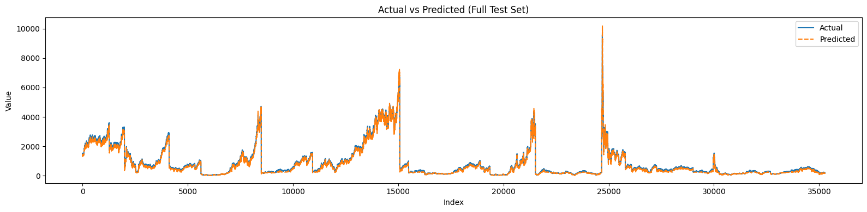Figure 5.1: **Actual Vs Predicted (Full Dataset) Transformer Model Reagression TaskFigure**

b. Classification Results: The Transformer-based calssifier was trained to predict binary markset directin (up/doen) and optimized via threshold using (best threshold = 0.7958):

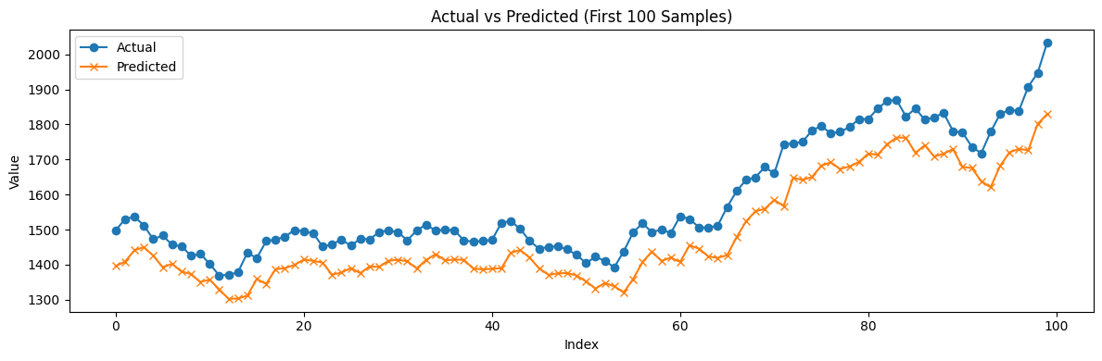Figure 5.2: **Actual Vs Predicted Transformer's (Vanila) Regression Task (First 100)**

* Precision (Class 1) = 81.7%
* Recall (Class 1) = 43.05%
* F1-score = 0.5639
* Accuracy = 66.63%
* AUC = 0.8235

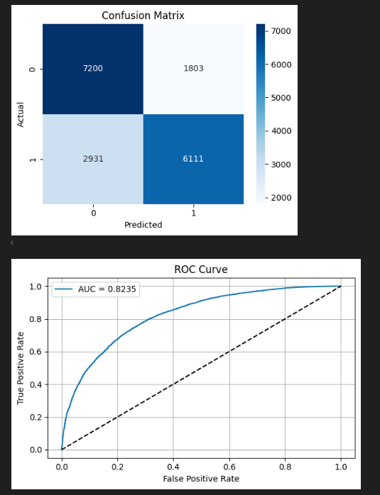**Figure 5.3: Confusion Matrix Plot-Transformer (Vanila) Classifiaction Task**

### **5.2.6 SHAP INSIGHTS:**

Top conribution features influencing regression/Classification predictions:

|  |  |  |
| --- | --- | --- |
| Rank | Feature | Interpretation |
| 1 | HL_Range_t0 | Daily high-low range(volatility) |
| 2 | BB_upper_t0 | Bollinger band resistance |
| 3 | Log_Return_t0 | Recent log return |
| 4 | MACD_t0 | Momentum oscillator |
| 5 | Momentum_3_t0 | 3-day price momentum |
| 6 | volume_RSI_log_t0 | Volume-adjusted RSI indicator |

## **Table 5.7 Shap Insight-Transformer (Vanila) Based Model**

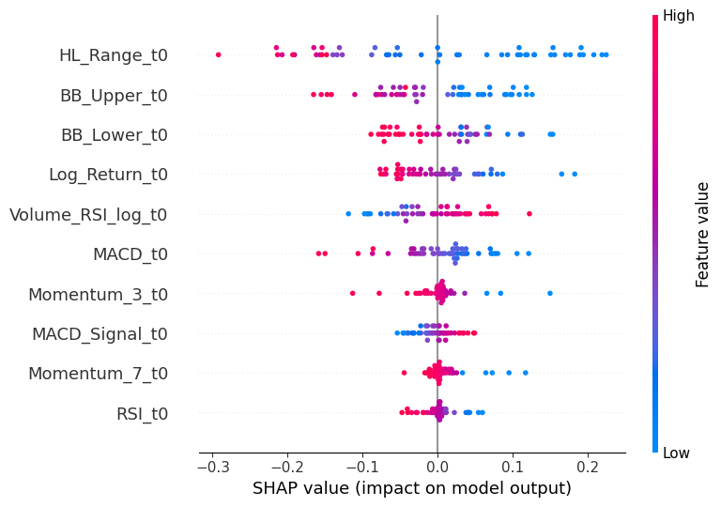**Figure 5.4: SHAP Plot -Transformer (Vanila) Classification Task**

### **5.6.3 SHAP Interpretaion:**

A sample classification prediction interpreted using LIME revealed:

1. The Model predicted downtrend with 76% confidence.
2. Key influencing Values:

* MACD_t0 = -0.64,
* Volume_RSI_log_t0 = -1.29,
* HL_Range_t0 = -0.02.

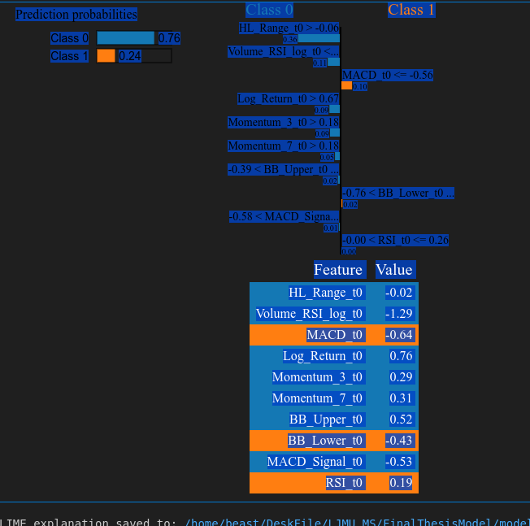**Figure 5.5: LIME Plot-Tansformer (Vanila) Classification Task**

### **5.7 DistilBERT-Ba Based Modeling for Financial Forecasting:**

The DistilBERT model fine-tuned for both regression and classification tasks using tabular-to-text transformed financial data. The model utilizes a distilled transformer architecture with fewer parameters than BERT while retraining comparable representaional power.

**a. Regression task:** The DistilBERT regression model was trained on engineered financial indicators encoded into textual input. It achieved:

* R2 Score= 0.9803
* RSME = 129.74
* MAE = 88.20
* MAPE = 14.89%

These results demonstrate the model’s strong predictive power, closely approximating truw values even under model compression.

**Figure 5.6: Actual Vs Predicted Plot-DistilBERT Regression Task**

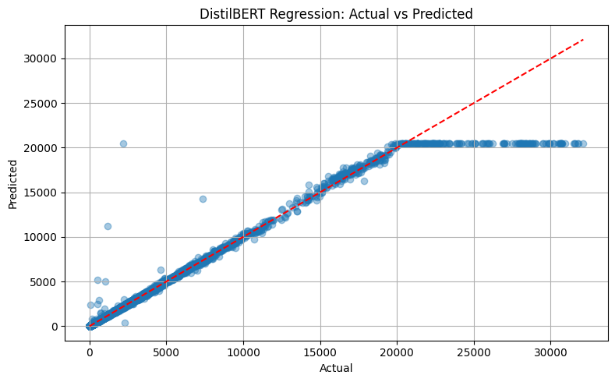Figure 5.6: **Actual Vs Predicted Plot-DistilBERT Regression Task**

**b. Classification task:** The DistilBERT calssification model was fine-tuned for binary movement prediction (up/Down), using threshold tuning to improve balance between precision and recall.

* Optimal Threshold: 0.7958
* Precision(Class 1) : 81.7%
* Recall (Class 1): 43.05%
* F1-Score (Class 1): 0.5639
* overall Accuracy: 66.63%
* AUC: 0.8121

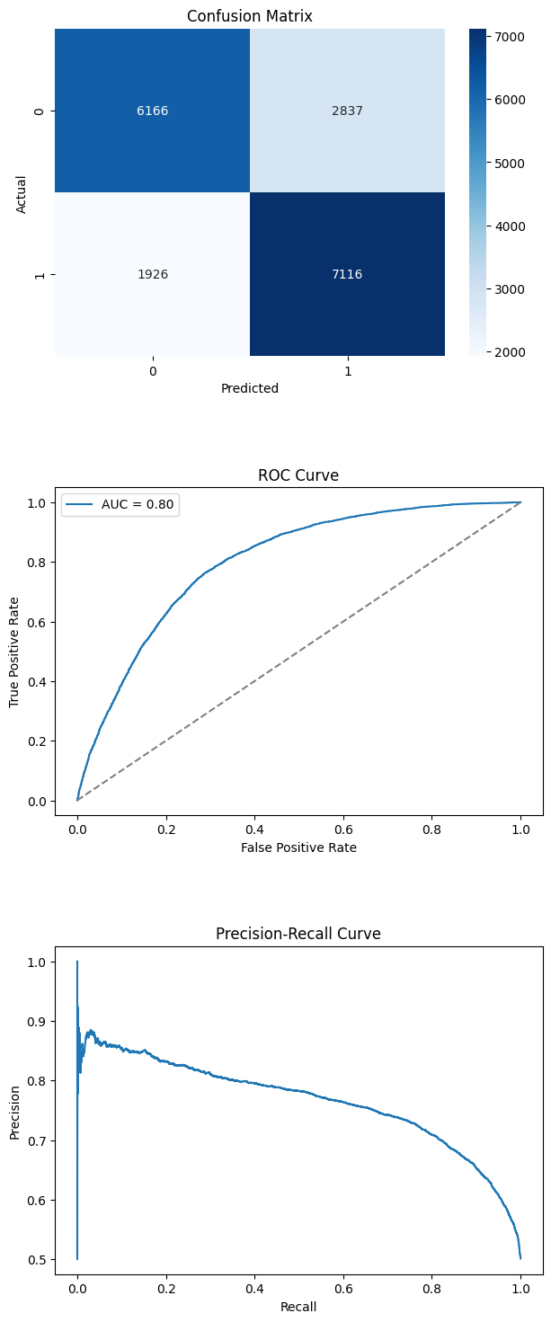**Figure 5.7: Confusion Matrix Plot-DistilBERT Classification Task**

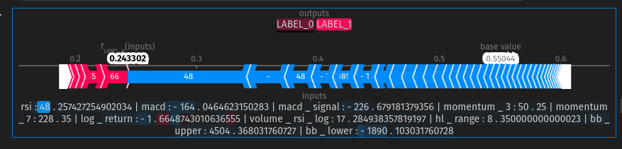**Figure 5.8: LIME Plot (Class 0) – DistilBERT Classification Task**

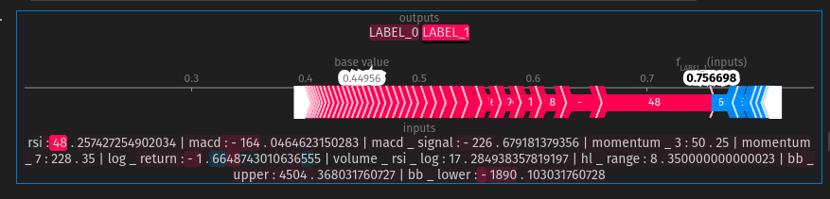**Figure 5.9: LIME Plot (Class 1) – DistilBERT Classification Task**

### **5.7.1 SHAP Interpretaion:**

|  |  |  |
| --- | --- | --- |
| Rank | Feature | Impact Direction |
| 1 | Volume_RSI_log | Negative |
| 2 | MACD | Negative |
| 3 | Log_return | Negative |
| 4 | Momentum_3 | Slightly Negative |
| 5 | RSI | Marginal Positive |

Table 5.8: DistilRET Based Models Shap Interpretation for Classification Task

The SHAP force plot and bar chat emphasize how compressed transformers still leverage core financial signals effectively.

### **5.7.2 LIME Explanation:**

A sample prediction classified as “upward movement” (LABEL_1) with 70% confidence was explained by:

|  |  |
| --- | --- |
| Feature | Importance |
| MACD | 0.19 |
| Log_Return | 0.09 |
| Momentum_3 | 0.08 |
| Volulme_RSI_log | 0.07 |
| RSI | 0.06 |

Table 5.9: LIME Explanation of DistilBERT Based Model’s Classification Task

## **5.8 DistilRoBERTa-Based Modeling for Financial Forecasting:**

The DistilRoBERT model was utilized for both regression and classification tasks on financial time-series data converted into text-based representaions using engineered features such as MACD, RSI, Momentum_3, and Log_Return. This distilled version of RoBERTa provides a lightweight yet powerfull alternative to full sized transformer models, making it suitable for resource-constrained environments while maintaing contextual understanding of numeric trends.

a. Clssification results: For Clssification, the DistilRoBERTa model was fine-tuned to predict binary market movement directions (up/Doen). After the thresholding, The best threshold was found to be 0.7958, optimization F1-score. The Final performance on the validation dataset was:

* Accuracy: 66.63%
* F1-score (Class 1) : 0.5639
* Precision: (Class 1): 81.70%
* Recall (Class1): 43.05%

The model exhibited a strong precision-recall trade-off, facvouring conservative yet confident predictions for upward market movements. This is advantageous in financial decision-making scenarios where fasle positives can be more tolerable that false negative.

### **5.8.1 Explainability Insights:**

To interpret model decisions, LIME, and SHAP werre employed. Both methods revealed that the most influential across predictions were:

* MACD
* Log_retrun
* Momentum_3

These findings aligned with traditional technical analysis, reinforcing the model’s trustworthiness are interpretability in practical investment contexts.

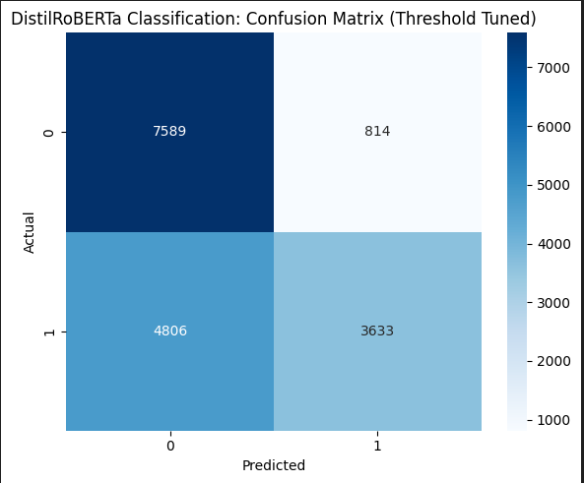Figure 5.10:Confusion Matrix DistilRoBERTa-Classification Task

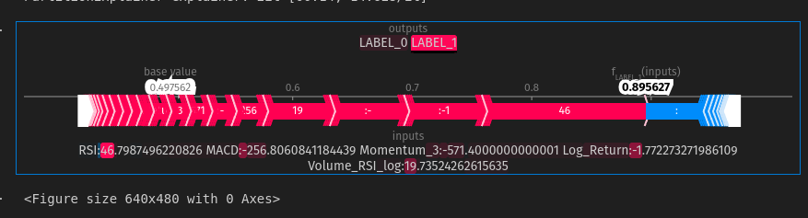**Figure 5.11: LIME Plot (Class 1) – DistilRoBERTa Classification Task**

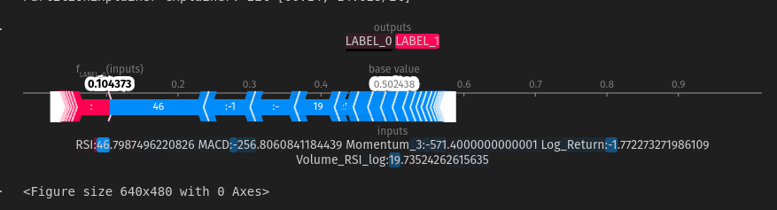**Figure 5.12: LIME Plot (Class 0) – DistilRoBERTa Classification Task**

# **Chapter 6: Results and Discussion**

**6.1 Introduction:**

This chapter presents the consolidated findings of the study, comparing the performance of machine learning (ML), deep learning (DL), and transformer-based models in forecasting NIFTY50 financial trends. The results are summarised in terms of predictive accuracy, interpretability, and adaptibilty, followd by key insights derived for explainability tools such as SHAP and LIME.. The Chapter cocludes with final contributions, recommendations for future work, and a proposed direction for expanding the research scope.

## **6.2 Key Findings and Model Comparison:**

### **6.2.1 Machine Learning Models:**

* tree-based ML Models like LightGBM and gradient Boosting outperfomed linear models by effectively capturing nonlinear relationship.
* ML Models, especially LightGBM, demonstrated exceptional accuracy in regression, achieving near-perfect R2 Score, making them highly effective for structured tabular data when strong features are available.

### **6.2.2 Deep Learning Models:**

* Among deep learning architectures, Conv1D + LSTM was the most effective for regression, showcasing robustness in learning both local and long-term trends in sequential data.
* For classification, Attention-BiLSTM provided a strong balance of precision and recall, leveraging attention mechanisms to focus on recent market shifts.
* These models performed well without requiring handcrafted features, making them adaptable to raw sequential inputs.

### **6.2.3 Transformer-Based Models:**

* TheVanilla Transformer offered performance comparable to Conv1D+LSTM in regression tasks, validating its capbility to generalize across noisy financial time series using self-attention and positional encoding.
* DistilBERT and DistilroBERTa, even as lightweight models, successfully modeled financial semantics when tabular data was transformed into natural language-like input.
* DistilroBERTa slightly outperformed DistilBERT in both regression and classification, showing better alignment with domain-specific feature representaions.

## **6.3 Explainability Insights:**

* Shap and LIME revealed that across all models, features like MACD, Momentum_3, and Log_Return were concistently the most influential in determining market direction and price changes.
* These explainability tools validated that the models were not only accurate but also learning meaningful financial signals, contributing to transparent AI adoption in Finance.

## **6.4 Final Insights and Contributions:**

* **Hybrid Modelling Superiority:** This work demonstrates that hybrid approaches-combining engineered features with advanced neural architectures- can achive high accuracy and interpretability in financial forecasting.
* **Lightweight Transformer models:** Models such asDistilBERT and DistilRoBERTa, when trained on converted fiancial text, are competitive with traditional DL models for real-time financial systems.
* **Scalable and Explainable Pipeline:** The proposed pipeline integrates feature engineering, model optimization, and explainability, making it extendable to other stock indices, asset classes, or markets.
* **Ethical and Personalized AI:** By combining predictive accuracy with transparent feature importance, the study contributes towards the development of ethical, interpretable, and personalized AI=driven financial advisory systems,

## **6.5 Feature Recommedations for future work:**

To further enhance the predictive power and robustness of the modelling pipeline, the following feature engineering enhancements are recommended:

* **Higher-Order Technical Indicators:** Introduce triple exponential moving averages (TRIX), Ichimoku Cloud components, and Chaikin Money Folw (CMF) for capturing multi-scale momentum and volume trends.
* **Inter-Market Signals:** Incorporate correlated index movements (e.g., Bank NIFTY) to model market influence.
* **Macro-Economic Variables:** Include macro indicators such as interest rates, commodity prices (e.g., crude oil, gold), and currency exchange rates.
* **Event-Based features:** Encode corporate events (earnings releases, policy announcements) and news sentiment to capture sudden volatility drives.
* **Lag and Rolling Statistics Expansion:** Extend lag features to multiple horizons (t-1 to t-10) and rolling volatility over varying windows for enhanced temporal sensitivity.
* **Cross-Feature Interactions**: Generate polynomial and multiplicative interactions between technical indicators to capture compound effects.

These enhancements would not only improves predictive accuracy but also allow for greater interpretability, thereby strengthening the applicability of the system in high-stackes financial environments.

# **REFERENCES**

B, S., P, P.R., B, S.M. and S, K., (2024) The Evolution of Large Language Model: Models, Applications and Challenges. In: *2024 International Conference on Current Trends in Advanced Computing (ICCTAC)*. [online] 2024 International Conference on Current Trends in Advanced Computing (ICCTAC). Bengaluru, India: IEEE, pp.1–8. Available at: https://ieeexplore.ieee.org/document/10581180/ [Accessed 10 Aug. 2025].

Bail, C.A., (2024) Can Generative AI improve social science? *Proceedings of the National Academy of Sciences*, 12121, p.e2314021121.

Bayuk, J. and Altobello, S.A., (2019) Can gamification improve financial behavior? The moderating role of app expertise. *International Journal of Bank Marketing*, 374, pp.951–975.

Broussard, J.P. and Nikiforov, A.L., (2013) Human Bias in Algorithmic Trading. *SSRN Electronic Journal*. [online] Available at: http://www.ssrn.com/abstract=2375739 [Accessed 10 Aug. 2025].

Cen, A., (n.d.) Financial Literacy through Gameful Design.

Choudhary, A., Alugubelly, M. and Bhargava, R., (2023) A Comparative Study on Transformer-based News Summarization. In: *2023 15th International Conference on Developments in eSystems Engineering (DeSE)*. [online] 2023 15th International Conference on Developments in eSystems Engineering (DeSE). Baghdad & Anbar, Iraq: IEEE, pp.256–261. Available at: https://ieeexplore.ieee.org/document/10099798/ [Accessed 10 Aug. 2025].

Cohen, G., (2022) Algorithmic Trading and Financial Forecasting Using Advanced Artificial Intelligence Methodologies. *Mathematics*, 1018, p.3302.

Cooper, R., Currie, W.L., Seddon, J.J.M. and Van Vliet, B., (2023) Competitive advantage in algorithmic trading: a behavioral innovation economics approach. *Review of Behavioral Finance*, 153, pp.371–395.

Courage Oko-Odion, Aishat Okunuga, and Oluwatofunmi Ibukun Okunbor, (2025a) Revolutionizing financial risk assessment through deep learning-driven business analytics for maximized ROI and Resilience. *World Journal of Advanced Research and Reviews*, 251, pp.2444–2461.

Courage Oko-Odion, Aishat Okunuga, and Oluwatofunmi Ibukun Okunbor, (2025b) Revolutionizing financial risk assessment through deep learning-driven business analytics for maximized ROI and Resilience. *World Journal of Advanced Research and Reviews*, 251, pp.2444–2461.

Dakalbab, F., Talib, M.A., Nasir, Q. and Saroufil, T., (2024) Artificial intelligence techniques in financial trading: A systematic literature review. *Journal of King Saud University - Computer and Information Sciences*, 363, p.102015.

Das, S. and Maurya, A., (n.d.) Wealth Guide at the FinLLM Challenge Task: A Sophisticated Language Model Solution for Financial Trading Decisions.

Das, T., Jeelani, S., Das, S., Giri, P. and Chatterjee, A., (2024) Human Bias in Algorithmic Trading: Evaluating Behavioral Finance Impacts on Automated Systems. In: *2024 Second International Conference Computational and Characterization Techniques in Engineering &amp; Sciences (IC3TES)*. [online] 2024 Second International Conference Computational and Characterization Techniques in Engineering &amp; Sciences (IC3TES). Lucknow, India: IEEE, pp.1–5. Available at: https://ieeexplore.ieee.org/document/10877548/ [Accessed 10 Aug. 2025].

Deshpande, A., (2024) Regulatory Compliance and AI: Navigating the Legal and Regulatory Challenges of AI in Finance. In: *2024 International Conference on Knowledge Engineering and Communication Systems (ICKECS)*. [online] 2024 International Conference on Knowledge Engineering and Communication Systems (ICKECS). Chikkaballapur, India: IEEE, pp.1–5. Available at: https://ieeexplore.ieee.org/document/10616752/ [Accessed 10 Aug. 2025].

Dunis, C., Likothanassis, S., Karathanasopoulos, A., Sermpinis, G. and Theofilatos, K. eds, (2014) *Computational Intelligence Techniques for Trading and Investment*. 0 edn. [online] Routledge. Available at: https://www.taylorfrancis.com/books/9781136195112 [Accessed 10 Aug. 2025].

Fasano, F., Adornetto, C., Zahid, I., La Rocca, M., Montaleone, L., Greco, G. and Cariola, A., (2025) The dilemma of accuracy in bankruptcy prediction: a new approach using explainable AI techniques to predict corporate crises. *European Journal of Innovation Management*, 2811, pp.1–22.

Gabhane, D., Sharma, D.A.M. and Mukherjee, D.R., (2023) Behavioral Finance: Exploring The Influence Of Cognitive Biases On Investment Decisions. *BOLETÍN DE LITERATURA ORAL*.

Gerner-Beuerle, C., (2021) Algorithmic Trading and the Limits of Securities Regulation. In: E. Avgouleas and H. Marjosola, eds, *Digital Finance in Europe: Law, Regulation, and Governance*. [online] De Gruyter, pp.109–140. Available at: https://www.degruyter.com/document/doi/10.1515/9783110749472-005/html [Accessed 10 Aug. 2025].

Gupta, A., Puri, M., Keshan, M. and Tiwari, V., (2025) *AI in Financial Decision-Making: Revolutionizing Investment Strategies and Risk Management*. Available at: https://www.ssrn.com/abstract=5085764 [Accessed 10 Aug. 2025].

Kirilenko, A.A. and Lo, A.W., (2013) Moore’s Law versus Murphy’s Law: Algorithmic Trading and Its Discontents. *Journal of Economic Perspectives*, 272, pp.51–72.

Liaudinskas, K., (n.d.) Human vs. machine: Disposition effect among algorithmic and human day traders.

Maple, C., Szpruch, L., Epiphaniou, G., Staykova, K., Singh, S., Penwarden, W., Wen, Y., Wang, Z., Hariharan, J. and Avramovic, P., (n.d.) The AI Revolution: Opportunities and Challenges for the Finance Sector.

Marchena Sekli, G., (2024) The research landscape on generative artificial intelligence: a bibliometric analysis of transformer-based models. *Kybernetes*. [online] Available at: https://www.emerald.com/insight/content/doi/10.1108/K-03-2024-0554/full/html [Accessed 10 Aug. 2025].

Namin, S.S. and Namin, A.S., (n.d.) FORECASTING ECONOMIC AND FINANCIAL TIME SERIES: ARIMA VS. LSTM.

Okwaraoha, F.C., (2023) Integrating AI into Financial Models. *International Journal of Management and Organizational Research*, 22, pp.125–136.

Pal, A., Indapurkar, K. and Gupta, K.P., (2021) Gamification of financial applications and financial behavior of young investors. *Young Consumers*, 223, pp.503–519.

Peter, H., (n.d.) AI-Driven Investment Strategies: Leveraging Machine Learning for Dynamic Portfolio Rebalancing.

Professor and Head, Department of BBA Department (KL University), Koneru Lakshmaiah Educational Foundation, Green Fields, Vaddeswaram, Andhra Pradesh-522302, India, Podille, V.R., M, A.V., Students, Department of BBA Department (KL University), Koneru Lakshmaiah Educational Foundation, Green Fields, Vaddeswaram, Andhra Pradesh 522302, India, Dhanurmika, S., Students, Department of BBA Department (KL University), Koneru Lakshmaiah Educational Foundation, Green Fields, Vaddeswaram, Andhra Pradesh 522302, India, Harsha, G., Students, Department of BBA Department (KL University), Koneru Lakshmaiah Educational Foundation, Green Fields, Vaddeswaram, Andhra Pradesh 522302, India, Sai Abhijit, G.G., and Students, Department of BBA Department (KL University), Koneru Lakshmaiah Educational Foundation, Green Fields, Vaddeswaram, Andhra Pradesh 522302, India, (2024) Artificial Intelligence Based Behavioural Finance in Shaping Investment Strategies to Analysis of Key Biases and Heuristics. *Journal of Computer Allied Intelligence*, 26, pp.1–18.

Ridzuan, N.N., Masri, M., Anshari, M., Fitriyani, N.L. and Syafrudin, M., (2024) AI in the Financial Sector: The Line between Innovation, Regulation and Ethical Responsibility. *Information*, 158, p.432.

Saxena, A. and Rishi, B., (2025) Designing an artificial intelligence-enabled large language model for financial decisions. *Management Decision*. [online] Available at: https://www.emerald.com/insight/content/doi/10.1108/MD-02-2024-0305/full/html [Accessed 10 Aug. 2025].

Wilhelmina Afua Addy, Adeola Olusola Ajayi-Nifise, Binaebi Gloria Bello, Sunday Tubokirifuruar Tula, Olubusola Odeyemi, and Titilola Falaiye, (2024) Algorithmic Trading and AI: A Review of Strategies and Market Impact. *World Journal of Advanced Engineering Technology and Sciences*, 111, pp.258–267.

Xu, J., (2024) *GenAI and LLM for Financial Institutions: A Corporate Strategic Survey*. Available at: https://www.ssrn.com/abstract=4988118 [Accessed 10 Aug. 2025].

Yang, W., Some, L., Bain, M. and Kang, B., (2025) A Comprehensive Survey on Integrating Large Language Models with Knowledge-Based Methods. *Knowledge-Based Systems*, 318, p.113503.

Yu, X., Chen, Z., Ling, Y., Dong, S., Liu, Z. and Lu, Y., (2023) *Temporal Data Meets LLM -- Explainable Financial Time Series Forecasting*. Available at: http://arxiv.org/abs/2306.11025 [Accessed 10 Aug. 2025].

Zhang, T., Kishore, V., Wu, F., Weinberger, K.Q. and Artzi, Y., (2020) *BERTScore: Evaluating Text Generation with BERT*. Available at: http://arxiv.org/abs/1904.09675 [Accessed 10 Aug. 2025].

Zhao, H., Chen, H., Yang, F., Liu, N., Deng, H., Cai, H., Wang, S., Yin, D. and Du, M., (2024) Explainability for Large Language Models: A Survey. *ACM Transactions on Intelligent Systems and Technology*, 152, pp.1–38.

# APPENDIX

**Generative AI for Personalized Financial Advising and Investment Strategies**

**Durgesh Kumar**

**Research Proposal**

**July 2024**

**Abstract**

The Generative Artificial Intelligence (GenAI) has revolutionized financial services(Lee et al., 2024) by enabling personalized financial advising and optimized investment strategies. This paper examines the application of transformer-based model, including BERT, GPT, BART, and T5, to deliver bespoke financial recommendations by analysing historical data, behavioural patterns, and market trends with precision and accessibility.

Despite its potential, GenAI in finance poses ethical challenges, such as biases,

misinformation. To deal with this issue, Explainable AI (XAI) will be employed to ensure Transparency, Accountability & trust.(Desai et al., 2024; Lee et al., 2024) Techniques like

Pearson correlation for sentiment analysis and Granger causality for forecasting will enhance the interpretability of stock price predictions, utilizing the NIFTY50 Stock Market Dataset for real-world validation.

tailored strategies are developed by understanding past financial behaviour, including

savings, investments, and spending trends, while risk profiling ensures alignment with user comfort levels. Additionally, GenAI simplifies complex processes like retirement planning and tax optimization by dynamically calculating future needs and providing actionable

insights.

Furthermore, this research explores the integration of behavioural finance principles to

mitigate cognitive biases and improve user decision-making. Advanced sentiment analysis and reinforcement learning techniques will be utilized to capture real-time market shifts and adapt strategies accordingly.

The ethical considerations will include fairness, data privacy, and the prevention of

algorithmic discrimination, ensuring that AI-driven financial advising remains both equitable and user-centric. Lastly, this study evaluates the system’s effectiveness through quantitative metrics such as prediction accuracy, user satisfaction, and explainability scores to establish its practical viability.

2

Tabel of Contents

Abstract 1

1. Background 4
2. Problem statement 6
3. Research Questions (If Any) 9
4. Aim and Objectives 10
5. Significance of the Study 11
6. Scope of the Study 13
7. Research Methodology 14
8. Research Plan 18
9. Requirements Resources 20

References 23

Background

The integration of Generative Artificial Intelligence (GenAI) into financial services marks a transformative shift, enabling a new era of personalized financial advising and investment shift, enabling a new era of personalized financial advising and investment strategies.

Financial systems, traditionally reliant on static models and human advisors, often failed to provide tailored recommendations due to their limited ability to analyse extensive data or adapt to dynamic market conditions. GenAI, with its ability to process vast datasets and

generate human-like insights, has emerged as a game-changer in this domain. By leveraging transformer-based models such as BERT, GPT, BART, and T5, GenAI systems can analyse historical data, behavioural patterns, and real-time market trends to deliver bespoke financial solutions.(Bai et al., 2024)

The Role of Generative AI in Financial Services

The ability of GenAI to identify intricate patterns and dependencies in financial data has

made it a preferred tool for developing customized strategies. It provides insights into user- specific aspects such as savings, spending trends, and investment behaviour, creating a foundation for personalized financial advising. For instance, retirement planning, tax

optimization, and portfolio management can be dynamically tailored to the user’s risk appetite and future goals.

The use of the NIFTY50 stock Market Dataset in this research provides a robust real-world validation platform.(Chaudhury et al., 2024) This dataset, comprising historical stock price

data, enables the training of models to forecast market movements, analyse sentiment trends, and optimize strategies for retail and institutional investors. These models do not merely offer financial suggestions but can adopt to market shifts, providing an edge in volatile scenarios.

Addressing Ethical Challenges with Explainable AI

While the integration of GenAI in financial services offers immense potential. It also raises critical ethical concerns. Issues such as algorithmic biases, lack of transparency, and data misuse have the potential to undermine trust in AI-driven financial advising systems. To counter these challenges, Explainable AI (XAI) techniques are employed to ensure that

GenAI models provide transparent, accountable, and interpretable recommendations.(Gayao et al., 2021)

XAI methods, such as Shapley Additive exPlanations (SHAP) and Local Interpretable Model-

Agnostic Explanations (LIME), enable users and regulators to understand the rationale

behind model-generated insights.(Gayao et al., 2021) By visualizing the contribution of each data point in decision-making, XAI enhances user confidence and ensures adherence to

ethical standards. This research further explores the role of these techniques in identifying and correcting biases within financial models, ensuring that the system remains equitable and inclusive.

Incorporating Behavioural Finance Principles

Cognitive biases significantly impact financial decision-making, often leading to suboptimal outcomes for individuals. By integrating principles from behavioural finance, GenAI systems can identify and mitigate biases such as loss aversion, overconfidence, and anchoring.(Lo and Ross, 2024) 4

For example, users who exhibit a preference for high-risk investments due to overconfidence can receive data-driven suggestions to balance their portfolios and avoid potential losses.

Advanced sentiment analysis and reinforcement learning techniques are employed to address these biases dynamically. By analysing real-time news, social media trends, and user

interactions, the system adapts its recommendation to reflect changing market sentiments and user behaviours. This capability not only improves the relevance of financial advice but also fosters disciplined decision-making among users.

Enhancing Financial Forecasting

Forecasting is a cornerstone of effective financial advising, and GenAI’s ability to predict market trends with high accuracy is a critical asset. This research utilizes techniques such as Pearson correlation and granger causality to enhance the interpretability of stock price

predictions, leveraging the NIFTY50 Stock Market Dataset as a testing ground. (Chaudhury et al., 2024)These methods help identify causal relationships between market sentiment and stock price movements, providing actionable insights for investors.

Additionally, transformer-based models are trained on historical stock price data to generate forecasts that account for both short-term volatility and long-term trends. The use of

reinforcement learning algorithms further optimizes these predictions by simulating various trading scenarios and refining strategies based on real-world outcomes.

Ensuring Trust, Privacy, and Equity

Data privacy and ethical considerations are central to the development of AI-driven financial systems. This research prioritizes robust data protection protocols to safeguard sensitive user information from unauthorized access or misuse. Measures such as encryption, secure

storage, and anonymization of user data are integral to maintaining trust.(Research on Exploring the Path of Financial Risk Management and Standardization Based on Artificial

Intelligence Technology and Intelligent Investment Advisory Regulatory Framework, 2024)

Furthermore, fairness and equity are addressed by testing the system across diverse user profiles to ensure that it provides unbiased recommendations regardless of demographic or financial background. Regular audits and bias-correction mechanisms are incorporated to minimize the risk of algorithmic discrimination.

Evaluating System Effectiveness

To Validate the practical viability of the proposed system, this research employs a

comprehensive evaluation framework. Key performance indicators include prediction accuracy, user satisfaction, and explainability scores, Prediction accuracy is assessed using metrics such as Mean Absolute Error (MAE) and Root Mean Square Error (RMSE) to

measure the reliability of market forecasts.

User satisfaction surveys are conducted to evaluate the relevance, usability, and trustworthiness of financial recommendations. Explainability scores, derived from XAI techniques, gauge the system’s ability, and explainability scores, derived from XAI

techniques, gauge the system’s ability to provide transparent and interpretable insights. 5

Problem Statement

In this rapidly evolving financial sector, delivering personalized financial advice and

investment strategies has become a pressing challenge. Traditional financial systems, often constrained by static models and human advisors, struggle to account for the diverse needs of users. These systems typically rely on generalized assumptions about user behaviour, risk

appetite, and financial goals, which fail to accommodate dynamic market conditions or adapt to individual preferences effectively. As a result, the financial services industry faces an

unmet need for scalable, accurate, and personalized solutions that can address the complexity of modern financial decision-making.

Limitations of Traditional financial systems

Traditional financial advisory approaches are inherently limited in their ability to process and interpret vast volumes of data. They depend heavily on human intervention, which is time-

intensive, expensive, and prone to errors or biases. Moreover, static advisory models fail to incorporate real -time market dynamics, leading to outdated or irrelevant recommendations. This disconnect is particularly evident in areas like retirement planning, tax optimization, and investment strategy development, where personalized and dynamic solutions are critical for effective decision-making.

Another critical limitation of traditional systems is their inability to align financial advice with an individual’s behavioural patterns and psychological tendencies. Behavioural finance highlights how cognitive biases such as overconfidence, loss aversion, and herd mentality can influence investment decisions. However, existing systems lack the tools to identify or

address these biases effectively, resulting in suboptimal financial outcomes for users.

Emergence of Generative AI in Financial Services

Generative Artificial Intelligence (GenAI) has emerged as a transformative technology to overcome the limitations of traditional financial systems. Leveraging transformer-based

models like BERT, GPT, BART and T5, GenAI can analyse vast amounts of historical data, market trends, and user behaviour pattern at unmatched seed and precision. these capabilities enable the development of highly personalized financial recommendations, dynamically

tailored to individual preferences and market conditions. For example, a GenAI-powered

system could forecast stock performance using sentiment analysis from financial news while simultaneously recommending portfolio adjustments based on a user’s risk profile. the

integration of GenAI into financial services is not without challenges. The reliance on historical data introduces the risk of perpetuating existing biases in AI-generated

recommendations. Additionally, the opaque nature of GenAI systems raise concerns about

transparency, accountability, and trust, which are critical for user acceptance in the financial domain.

Challenges in ethical and transparent Implementation

The deployment of GenAI in financial advising also presents significant ethical challenges. Biases inherent in training datasets can lead to discriminatory or unfair recommendations, undermining user trust and violating regulatory standards.

6

Furthermore, the potential for misinformation or misinterpretation in AI-generated advice poses serious risks, especially in high-stakes financial decisions.

Explainable AI (XAI) techniques offer a potential solution by making AI models more

transparent and accountable. However, implementing these techniques in a way that balances explainability with performance remains a significant technical hurdle. Ensuring fairness,

equity, and data privacy in GenAI systems is another critical challenge that must be addressed to establish ethical AI practices in the financial sector.

Need for Personalized and Scalable Financial Solutions

Morden financial consumers demand solutions that are not only accurate but also

personalized to their unique needs. This requires an AI system capable of understanding and analysing user-specific factors such as financial history, risk tolerance, and future goals.

Additionally, the system must be dynamic, adapting to real-time market shifts and evolving user preferences.

The integrating of the NIFTY50 Stock Market Dataset into GenAI models offers a promising avenue for addressing this need. This dataset provides a robust foundation for analysing

historical stock prices, market trends, and sentiment scores, enabling the development of predictive models with real-world applicability. However, ensuring the accuracy and

reliability of these models in diverse market scenarios remains a critical area of focus.

Addressing Behavioural Biases and Cognitive Limitations

Another critical aspect of the problem is the impact of behavioural biases on financial

decision-making. Cognitive tendencies such as recency bias, anchoring, and overconfidence often lead users to make irrational or suboptimal choices. Traditional financial systems lack the capability to identify and mitigate these biases, leaving users vulnerable to poor

outcomes.

Generative AI, with its ability to integrate behavioural finance principles, offers a potential solution. By analysing user behaviour and incorporating sentiment analysis techniques, AI systems can provide balanced recommendations that account for both market dynamics and

individual psychological tendencies. Reinforcement learning techniques further enhance this capability by enabling the system to adapt strategies based on real-time user feedback and market changes.

Leveraging GenAI for Proactive Risk Mitigation

Generative AI provides a novel approach to addressing risk factors in financial advising by analysing complex interdependencies in market data and user behaviour. Advanced models can predict potential financial downturns or high-risk scenarios, enabling users to make

proactive adjustments to their portfolios, for example, by integrating sentiment analysis of economic news and social media trends with historical market data, GenAI systems can flag

impending volatility or opportunities for investment. Such insights empower users to not only react to market shifts but also anticipate them, ensuring better financial outcomes.

Additionally, by identifying patterns of overexposure or diversification gaps, these systems can provide tailored strategies to optimize risk-reward balances in real life.

7

Advancing Ethical and Inclusive financial Solutions

For GenAI systems to truly transform financial advising, ethical considerations must be prioritized.(Desai et al., 2024) Ensuring inclusivity and fairness in AI-generated

recommendations requires rigorous evaluation of training data and algorithmic decisions.( Xu et al., 2024) By incorporating bias mitigation techniques and explainability frameworks,

GenAI can provide equitable advice to users across diverse socio-economic backgrounds.

Moreover, real-time transparency tools, such as user-friendly dashboard

explaining AI-driven suggestions, can enhance trust and adoption. As regulatory frameworks for AI in financial services evolve, adherence to compliance standards will be critical. GenAI offers the potential to not only personalize financial solutions but also democratize access, making high-quality financial advising available to a broader population.

The convergence of personalized financial advisory needs and the advanced capabilities of Generative AI marks a pivotal moment in the evolution of the financial sector. By addressing the limitations of traditional systems, GenAI not only offers scalability and precisions but also opens the door to ethical and inclusive solutions that resonate with modern users. The

integration of dynamic, behaviour-aware AI systems has the potential to bridge the gap between static models and the complex, evolving needs of financial consumers. While

challenges remain-particularly in ensuring transparency, fairness, and data integrity- these hurdles present opportunities for innovation and refinement. As the financial industry

embraces GenAI, it stands poised to deliver a new era of impactful, adaptive, and trustworthy financial advising.

Research Questions (If Any)

1. How effective is GenAI in Aligning investment strategies with individual user preferences, risk appetite, and future financial goals?
2. How can Data privacy be maintained in AI systems while delivering highly personalized financial advice?
3. What metrics best evaluate the practical effectiveness of GenAI in financial advising, including accuracy, user satisfaction, and explainability scores?
4. How does the performance of the proposed system compare to traditional financial advising methods in terms of accuracy and user engagement?
5. How can GenAi effectively integrate behavioural finance principles to address cognitive biases and improve decision-making in retail investors?

Aim

The aim of this paper is to explore the transformative potential of Generative Artificial

Intelligence (GenAI) in delivering personalized financial advice and investment strategies, while addressing the challenges of ethical transparency, scalability, and behavioural bias

mitigation. The study seeks to demonstrate how GenAI can revolutionize financial systems by integrating real-time data analysis, psychological insights, and dynamic adaptability to create scalable and user-centric solutions.

Objectives

1. **Develop Personalized Solutions:** Investigate how GenAI can dynamically tailor

financial recommendations based on individual preferences, market trends, and real- time data.

1. **Integrate Behavioural Financial Principles:** Addressing the influence of cognitive biases and behavioural tendencies on financial decision-making and propose GenAI- driven strategies to mitigate these effects.
2. **Promote Ethical and transparent AI:** Evaluate challenges related to fairness,

accountability, and data privacy in GenAI systems and explore the role of Explore the role of Explainable AI (XAI) in enhancing trust and transparency.

1. **Leverage Real-World Data:** Demonstrate the practical application of GenAI by integrating datasets like NIFTY50 for predictive analysis and investment

optimization.

1. **Enhance Scalability and Accessibility:** Explore the scalability of GenAI solutions to democratize access to personalized financial advice across divers user demographics.

Significance of the Study

The significance of this study lies in its potential to address critical gaps in the financial advisory by leveraging the transformative capabilities of Generative Artificial Intelligence (GenAI). (\Huang et al., 2024 Khan & Umer, 2024)As the financial sector becomes

increasingly complex, traditional systems fail to meet the diverse, dynamic, and personalized needs of users. This research provides a pioneering exploration of how GenAI can

revolutionize financial advising, offering insights that hold substantial implications for both academia and industry.(Lee et al., 2024)

Redefining Financial Advisory Practices

This study underscores the limitations of static, human-dependent financial advisory systems, which often rely on generalized assumptions and outdated methodologies. (Gayao et al., 2021)BY proposing the integration of advanced GenAI models, the research establishes a framework for delivering highly personalized, real-time financial advice.(Che et al., n.d.) This paradigm shifts from generalized recommendations to tailored solutions could set a new standard in the financial advisory domain, enabling more precise and adaptable decision- making processes.

Bridging the Gap Between Technology and Behavioural finance

One of the most critical contributions of this study is its focus on addressing cognitive biases and behavioural tendencies that influence financial decisions.(Lo and Ross, 2024) Existing

systems lack the capability to identify and mitigate biases such as overconfidence, herd

mentality, or recency bias. By integrating principles of behavioural finance with GenAI, this research offers a ground breaking approach to enhancing financial literacy and decision- making, empowering user to make more informed and rational choices.(Che et al., n.d.)

Advancing Ethical AI in Financial Services

The study also highlights the ethical challenges associated with deploying GenAI in Financial advisory services, such as biases in training data, lack of transparency, and accountability

concerns. By emphasizing the role of Explainable AI (XAI) techniques, this research

contributes to the ongoing discourse on ethical AI implementation. Ensuring fairness, equity, and trust in GenAI systems is not just a regulatory requirement but a foundational aspect of user acceptance and adoption. The insights provided by this study could guide the

development of transparent and accountable AI-driven financial systems. 11

Enabling Scalability and Accessibility

Scalability remains a critical issue in traditional financial advisory systems, which are often resource-intensive and inaccessible to many.(Huang et al., 2024) This study demonstrates how GenAI can democratize access to personalized financial advice, catering to diverse user demographics and financial contexts. The ability of GenAI to process and analyse vast

datasets like the NIFTY50 Stocks Dataset showcases its potential to offer high-quality financial solutions at scale, making it an invaluable tool for underserved markets.

Promoting Proactive Risk Mitigation

Another significant contribution of this research is its exploration of how GenAI can facilitate proactive risk management.(Lee et al., 2024) By integrating real-time market data with

sentiment analysis, GenAI systems can anticipate market volatility and suggest timely

portfolio adjustments. This capability not only enhances user confidence in financial systems but also minimizes potential losses, ensuring better financial outcomes.

Practical and Academic implications

For practitioners, this study provides actionable strategies for integrating GenAI into financial services, offering a roadmap for overcoming the limitations of traditional models. (Desai et al., 2024)For researchers, it opens new avenues for exploring the intersection of AI,

behavioural finance, and ethical practices.(Chaudhury et al., 2024) The findings also highlight the importance of ongoing validation and refinement of AI models to ensure reliability and robustness across divers market scenarios.

Driving Innovation in financial Technology

Ultimately, this study positions GenAI as a cornerstone for innovation in the financial

technology (fintech) sector. By demonstrating its potential to align user-specific factors with dynamic market conditions, the research paves the way for creating intuitive, user-centric

financial solutions. (Lo and Ross, 2024)The ability of GenAI to transform vast amounts of complex data into actionable insight marks a pivotal advancement in the field, promising to reshape the financial landscape for years to come.

Scope of the study

This study explores the integration of Generative AI (Gen AI) into the financial advisory

sector, addressing key limitations of traditional systems. (Khan and Umer, 2024)The research focuses on delivering personalized financial advice and investment strategies that adapt

dynamically to user-specific needs and market conditions**. Focus Areas**

1. **Personalization:** Tailoring financial recommendations based on individual goals, risk tolerance, loss aversion, and recency bias.
2. **Behavioural finance Integration:** Identifying and mitigating cognitive biases like overconfidence, loss aversion, and recency bias.
3. **Dynamic Adaptability:** Developing systems that adjust in real-time to market shifts and evolving user preferences.

Technological Scope

* + Utilizes advanced GenAI models (e.g., GPT, BERT, and T5) for predictive analytics.(Bai et al., 2024)
  + Employs Explainable AI (XAI) techniques for transparency and trust.(Desai et al., 2024)
  + Incorporates sentiment learning to refine strategies through user feedback.

Domains Covered

* + **Financial Planning:** focus on retirement planning, tax, optimization, and investment strategies.
  + **Market Analysis:** Insights from the NIFTY50 Stocks Market Dataset for robust decision-making.
  + **Risk Mitigation:** Predictive tools to flag potential financial risks and enhance portfolio management.

Stakeholders Benefited

* + **Individual Investors:** Customized advice aligned with goals and risk profiles**.**
  + **Financial Institutions:** Scalable AI-driven solutions for better client engagement.
  + **Financial Advisors:** Enhanced tools for efficiency and informed decision-making.

Ethical and Regulatory Considerations

The study addresses biases in AI systems, ensures transparency through Explainable AI, and Emphasizes data privacy compliance with regulations like GDPR.

By focusing on these areas, the study provides a comprehensive framework for integrating GenAI into financial advisory services, enabling scalable, ethical, and user-centric solutions tailored to modern financial complexities.

**Research Methodology**

The research methodology for this study is designed to comprehensively explore the

integration of Generative Artificial Intelligence (GenAI) in delivering personalized financial advisory services. This approach combines qualitative and quantitative research methods to ensure a holistic understanding of the problem while maintaining scientific rigor. The methodology is structured into several phases, each tailored to address specific research

objectives, while ensuring the results are reliable, valid, and replicable.

1. Research Design

* This study employs an exploratory research design to investigate the potential of GenAI in revolutionizing financial advisory services.(Chaudhury et al., 2024)

Exploratory research is particularly suitable for addressing nascent fields, such as the application of GenAI to behavioural finance and personalized investment

strategies, The study integrates the following research strategies:

1. Quantitative Analysis:
   * To evaluate the effectiveness of GenAI models, historical and real-time datasets are analysed using machine learning algorithms and statistical techniques.
   * Performance metrics such as accuracy, precision, recall, and F1-score are

employed to measure the models’ predictive and advisory efficacy. (Thottoli et al., 2024)

1. Qualitative Insights:
   * Semi-structured interviews with financial advisors, Fintech experts, and GenAI practitioners provide context and enrich the study’s findings. . (Thottoli et al., 2024)
   * User case studies help validate the practical applicability and usability of the proposed solutions.
2. Data Collection
   1. **Primary Data Sources**

Primary data is collected through a combination of expert interviews and user surveys:

* + - **Expert Interviews:** Insights are gathered from AI practitioners, financial analysts, and regulatory experts to understand current challenges and opportunities in

implementing GenAI in financial advisory systems. 14

* + - **User Surveys:** Structured surveys with investors across diverse demographics capture preferences, risk appetites, and perceptions of AI-driven financial tools.(Xu et al., 2024)
  1. Secondary Data Sources:

The study uses robust secondary data sources to develop and validate the GenAI models:

* + - **NIFTY50 Stocks Market Dataset:** A comprehensive dataset comprising historical stock prices, market trends, and sentiment scores.
    - **Behavioural Finance Literature:** Published research on cognitive biases and

decision-making tendencies informs the incorporation of behavioural aspects into AI systems.

* + - **Publicly Available datasets:** Financial datasets such as Yahoo Finance, Kaggle repositories are utilized to enrich the analysis.

1. Data Preprocessing

The data preprocessing phase is critical to ensure the equality and consistency of the datasets:

1. Data Cleaning:
   * Removal of incomplete or irrelevant data entries.
   * Handling missing values using imputation techniques like mean substitution and k – nearest neighbours (KNN).
2. Normalization:
   * All numerical data is normalized to ensure uniformity across variables, enhancing the accuracy of the AI models.
3. Sentiment Analysis:
   * Financial news and social media data undergo preprocessing, including

tokenization, stop-word removal, and stemming, to prepare for sentiment classification.

1. Feature Engineering:
   * Key features such as moving averages, volatility, and sentiment scores are derived to improve the predictive performance of the models**.**
2. Development of GenAI Models

The study employs state-of-the-art GenAI techniques to build and validate the financial advisory system: **15**

1. Model selection:

Transformer-based architectures such as GPT, BERT, T5 are selected for their superior capability in natural language understanding and generation.

1. Training Process:

Models are trained on labelled financial datasets using supervised learning techniques.

Sentiment labels are derived from financial news articles to align the model’s predictions with market sentiment.

1. Integration with Behavioural Finance:
   * Cognitive biases like loss aversion, overconfidence, and anchoring are incorporated into the model through reinforcement learning.
   * The Models are fine-tuned to personalize recommendations based on user-specific behavioural profiles.
2. Evaluation Metrics:

The models are evaluated using a comprehensive set of metrics:

* + **Predictive Accuracy**: To assess the correctness of stock market forecasts.
  + **Behavioural Alignment**: To measure the extent to which recommendations align with users’ psychological tendencies.
  + **Explainability:** To ensure transparency and user trust in AI-generated recommendations.

1. Ethical Considerations:

Given the sensitive nature of financial decision-making, ethical considerations are integral to this study:

1. Bias Mitigation:
   * Techniques such as adversarial debiasing and fairness constraints are

implemented to ensure equitable recommendations across diverse user groups.

1. Explainable AI (XAI):
   * XAI frameworks are integrated to make the models’ decision-making processes transparent and interpretable for end-users.
2. Data Privacy:
   * Strict compliance with GDPR and other data protection regulations is maintained throughout the study.
3. Validation of Findings

Validation ensures the reliability and applicability of the research outcomes: 16

1. **Cross-Validation**: The models are validated using K-fold cross-validation to ensure generalizability across different datasets.
2. User testing:
   * Prototype systems are tested with a diverse group of users to evaluate usability, trust, and satisfaction levels.
3. Comparison with traditional systems:
   * The performance of GenAI-powered systems is compared with traditional financial advisory approaches to quantify improvements in accuracy,

personalization, and scalability.

1. Tools and Technologies

The study utilizes advanced tools and technologies for data processing, model development, and evaluation:

1. **Python Libraries**: Pandas, NumPy, TensorFlow, Pytorch, and Scikit-learn for data analysis and machine learning.
2. **Natural Language Processing**: Hugging face transformers library for implementing GenAI models like GPT and BERT.
3. **Visualization tools**: Matplotlib and Tableau for presenting insights and model performance metrics.
4. Limitations and Delimitaions
5. Limitations:
   * Reliance on historical datasets may introduce biases in the models’ prediction, remain complex and evolving issues.
   * Ethical challenges, such as ensuring fairness and avoiding discrimination, remain complex and evolving issues.
6. Delimitations:
   * The study focuses on NIFTY50 data, which may limit its applicability to other financial markets.
   * Behavioural biases are analysed primarily through user surveys, which may not capture the full spectrum of cognitive tendencies.

Research Plan

The research plan is structured to systematically address the objectives of integrating Generative Artificial Intelligence (GenAI) into personalized financial advisory systems while ensuring transparency, ethical implementation, and practical applicability. The plan spans six key phases, leveraging both qualitative and quantitative approaches to achieve comprehensive results.

Phase 1: Problem Definition and Literature Review

* Conduct an in-depth review of existing literature on financial advisory systems, behavioural finance, and AI advancements, particularly focusing on GenAI models like GPT, BERT, and T5.
* Identify limitations of traditional financial systems and exploring gaps in current AI applications.
* Define research questions and objectives to address the unmet needs in the financial advisory landscape.

Phase 2: Data Collection and Preprocessing

* Gather primary data through expert interviews and structured user surveys to capture industry insights and user preferences.
* Compile secondary data from robust sources, including the NIFTY50 stock market dataset, for historical analysis and predictive model Preprocess datasets by cleaning, normalizing, and engineering features such as sentiment scores and financial indicators.

Phase 3: Model Development and Integration

* Design and develop GenAI models using transformer-based architectures.
* Incorporate behavioural finance principles by modelling cognitive biases and employing reinforcement learning for personalization.
* Test and refine models using cross-validation techniques to ensure accuracy and adaptability.

18

Phase 4: Ethical and Explainability Frameworks

* Implement bias mitigation techniques to ensure fairness and equity in AI-generated recommendations.
* Integrate Explainable AI (XAI) frameworks to enhance transparency and user trust.
* Validate models for compliance with data privacy and regulatory standards. (Desai et al., 2024)

Phase 5: Evaluation and validation

* Evaluate model performance using metrics like accuracy, behavioural alignment, and explainability.
* Conduct user testing with a diverse demographic to gather feedback on usability and trust.
* Compare results with traditional financial advisory methods to demonstrate improvements.

Phase 6: Reporting and Dissemination

* Document findings in a structured manner, emphasizing the practical and theoretical contributions of the study.
* Present results through research papers, conferences, and industry reports to facilitate knowledge dissemination and encourage further research.

Resources

To ensure the successful execution of this research, the following resources are required. These resources are categorized into **data resources, technological resources, human resources, and institutional support.**

1. Data resources
   * **Primary Data:**
   * Expert interviews and focus groups with financial advisors to understand current industry challenges.
   * User survey to capture behavioural patterns, preferences, and expectations for personalized financial advisory.
   * Secondary data:
     + Historical financial data, including the NIFTY50 Stock Market Dataset for market trends and price predictions.(Chaudhury et al., 2024)
     + Publicly available datasets such as Yahoo Finance and Kaggle for diversified financial indicators.
     + Behavioural fiancé datasets to model cognitive biases and user tendencies in financial decision-making.
     + Sentiment analysis datasets derived from financial news and social media platforms like twitter and Reddit.
2. Technological resources
   * **Computing Infrastructure:**
     + High-performance computing system with GPUs (e.g., RTX3050) to train and evaluate transformer-based GenAI models.
     + Cloud computing platforms such as Google Cloud, AWS, or Microsoft Azure for scalable storage and processing.

Software and Tools:

* **Programming Languages:** Python for developing models and preprocessing data.
* **Ai Libraries and frameworks**: TensorFlow, Pytorch, and Hugging Face for

implementing transformer models like GPT, BERT, and T5. 20

* **Data Analytics Tools**: Pandas, NumPy, and Matplotlib for exploratory data analysis and visualization.
* **Natural language Processing tools:** SpaCy and NLTK for sentiment analysis.
* **Explainable AI frameworks**: SHAP and LIME for enhancing model interpretability.
* **Version Control Systems:** Encrypted storage systems to ensure the confidentiality and integrity of financial datasets.

Datasets Security:

* Encrypted storage systems to ensure the confidentiality and integrity of financial datasets.

1. Human resources
   * **Research team:**
   * **A Principal Investigator** (myself) to oversee the research design, execution, and reporting.
   * **Data Scientists and AI Engineers** to develop and optimize GenAI models.
   * **Behavioural Economists** to integrate cognitive biases and behavioural finance principles into models.
   * **Domain Experts** in finance to validate model recommendations and provide insights into practical applications.
2. Institutional support

**Academic and Research Facilities:**

* + Access to libraries for literature review and knowledge acquisition.
  + Collaboration with financial institutions and academic bodies for practical insights and real-world testing.

Funding and Grants:

* + Financial resources to cover expenses related to cloud computing, data procurement, and participant incentives.
  + Grant applications to institutions like National Science Foundation (NSF), AI for Good Foundation, or Financial Research institutes. 21

Ethical Review Board (ERB):

* + Institutional oversight to ensure ethical compliance in data collection and AI deployment.

1. Time Resources

A well-defined timeline structured into research phases:

* + **Literature Review: 1 month.**
  + **Data Collection and Preprocessing: 1 months.**
  + **Model Development and Testing: 2 months.**
  + **Evaluation and Reporting: 2 months.**

References

(Bai et al., 2024; Chaudhury et al., 2024;

Che et al., n.d.; Desai et al., 2024; Gayao et al., 2021;

Huang et al., 2024; Khan & Umer, 2024; Lee et al., 2024;

Lo et al., n.d.; Lo & Ross, 2024; Ong et al., 2023;

“Research on Exploring the Path of Financial Risk Management and Standardization Based on

Artificial Intelligence Technology and Intelligent Investment Advisory Regulatory Framework,” 2024; Section 1 : Topic Submission Form, n.d.; Ssrn-4842208, n.d.;

Thottoli et al., 2024; Xu et al., 2024)