Student Management Database-Task2
Name: Durgeswari Nayak
Course: SQL Data Analytics

Query 1: List all students enrolled in each course

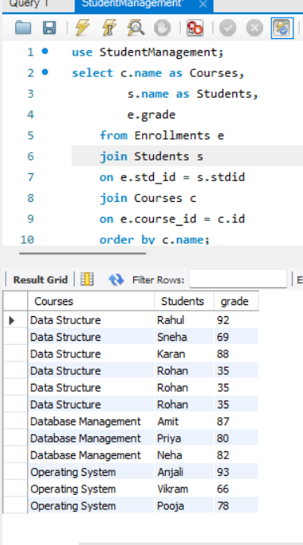
Query 2: Find average grade per Course

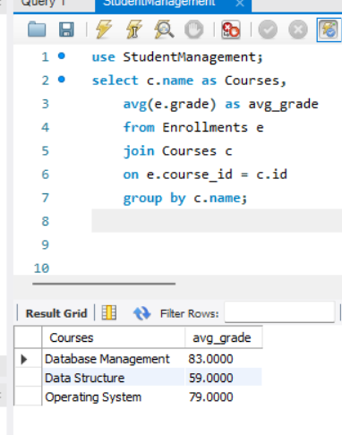

Query 3: Find Top 3 students overall

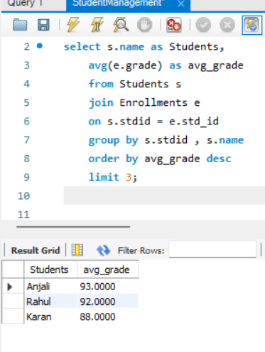
Query 4: Count students who failed (grade<40)

