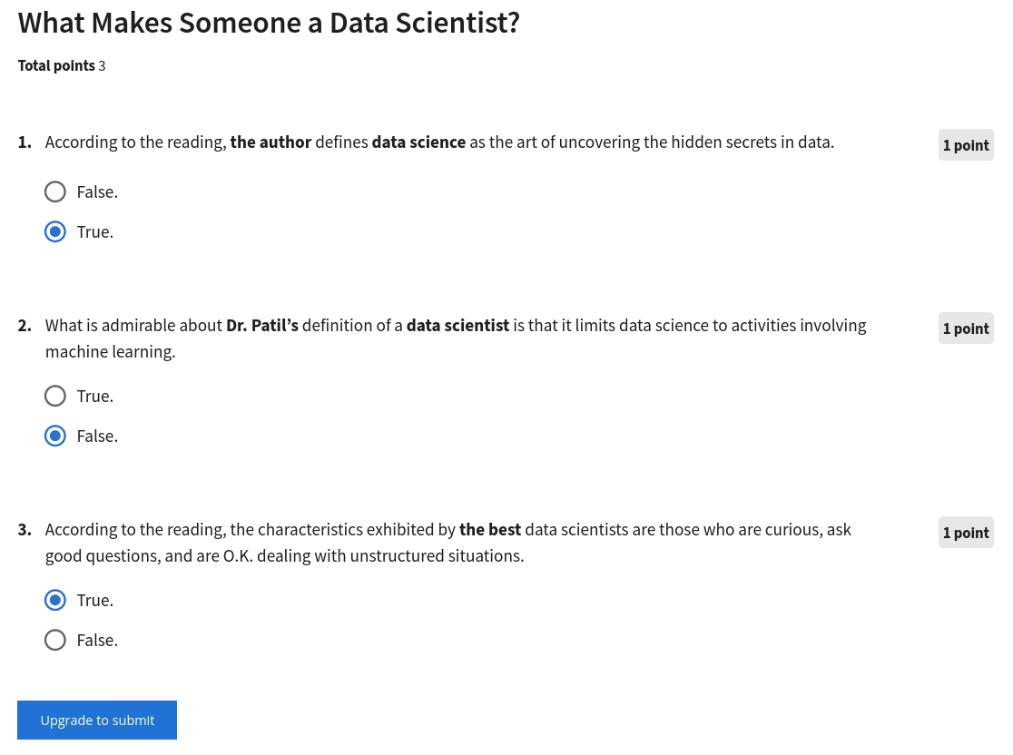https://www.coursera.org/learn/what-is-datascience/exam/fkzon/what-makes-someone-a-data-scientist/attempt

<https://www.coursera.org/learn/what-is-datascience/exam/GxhYX/data-science-the-sexiest-job-in-the-21st-century/attempt>

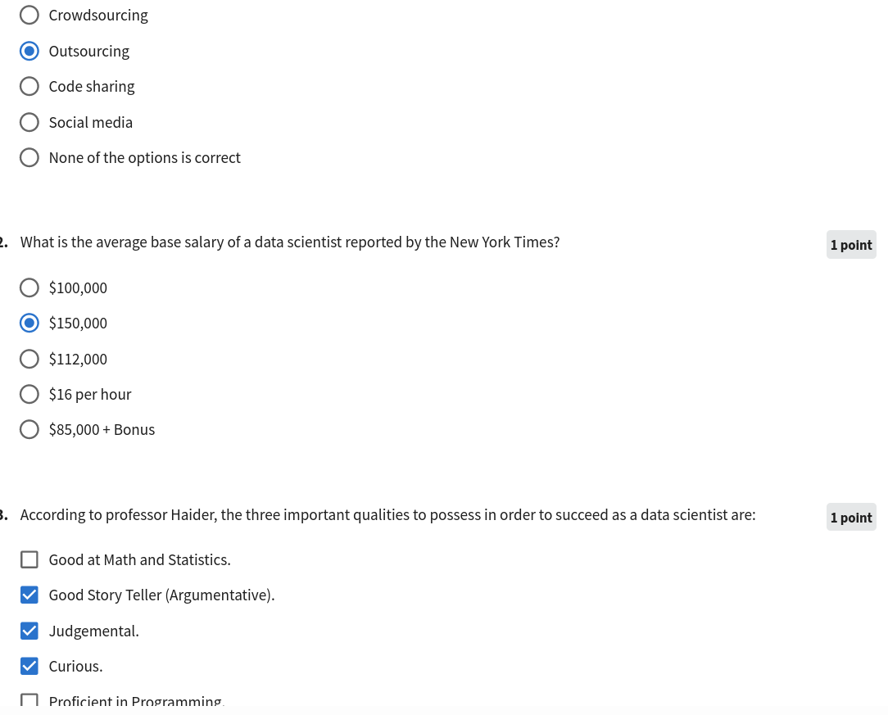

<https://www.coursera.org/learn/what-is-datascience/exam/wkBVE/data-mining/attempt>

[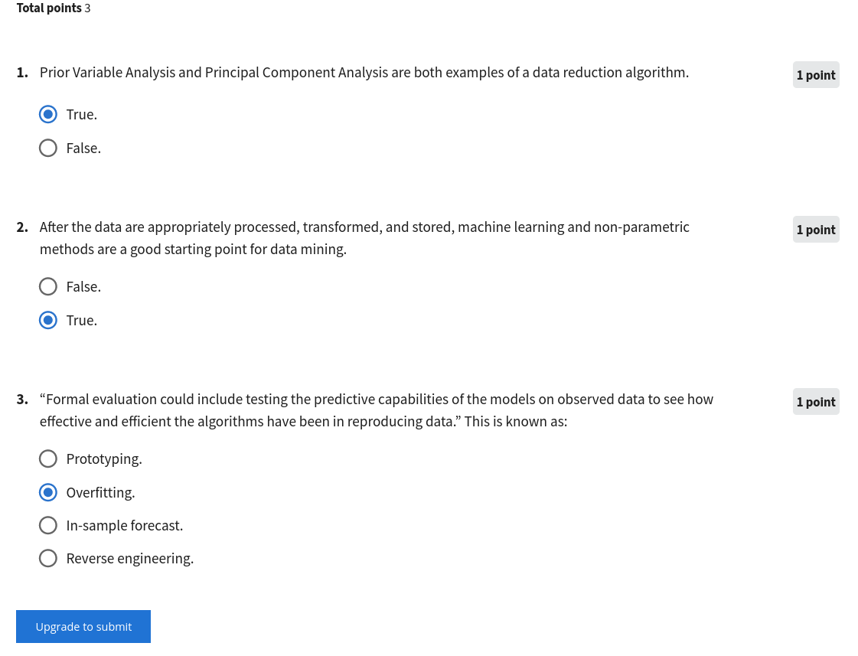](https://www.coursera.org/learn/what-is-datascience/exam/7QVlb/regression/attempt)https://www.coursera.org/learn/what-is-datascience/exam/7QVlb/regression/attempt

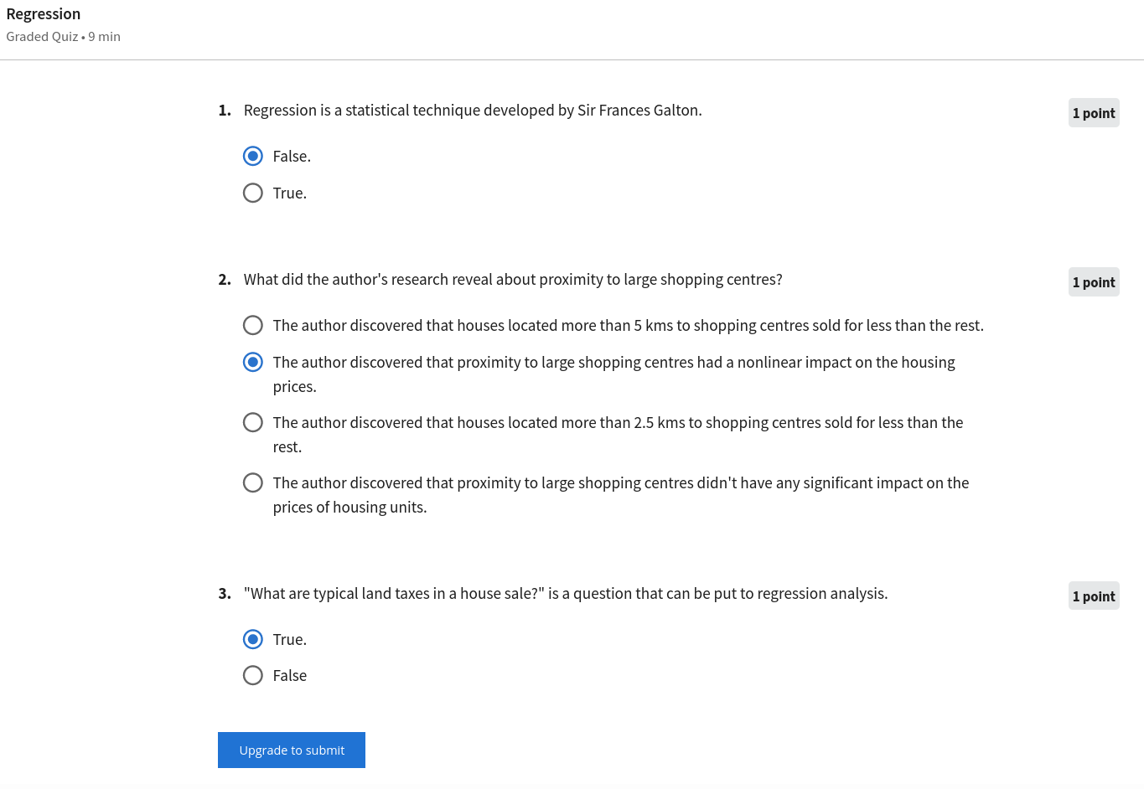

https://www.coursera.org/learn/what-is-datascience/exam/6ObIv/the-final-deliverable/attempt

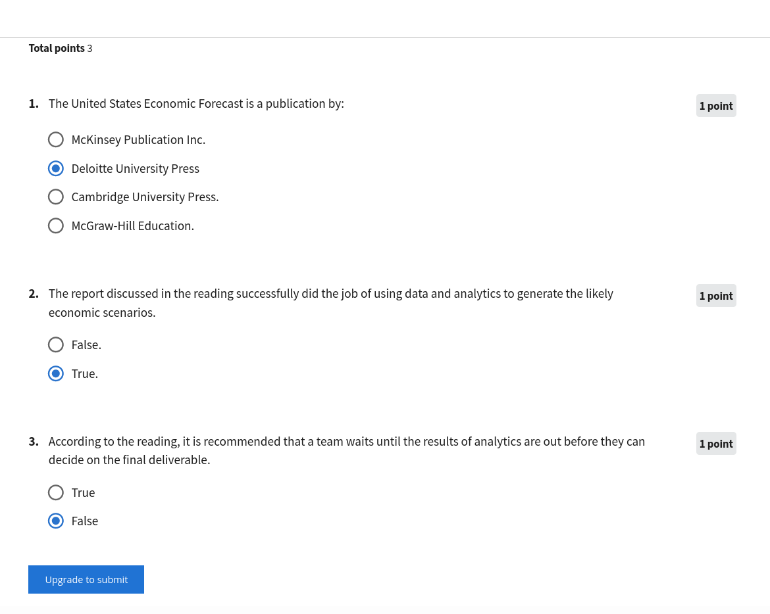

[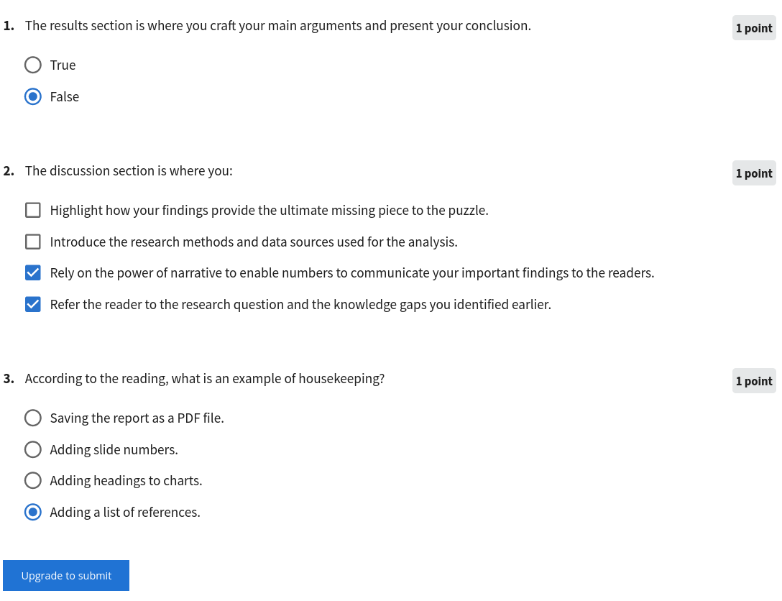](https://www.coursera.org/learn/what-is-datascience/exam/XJ8oh/the-report-structure/attempt)https://www.coursera.org/learn/what-is-datascience/exam/XJ8oh/the-report-structure/attempt

https://www.coursera.org/learn/what-is-datascience/peer/dgsjq/final-assignment/submit

*TYPE!!! DONT COPY PASTE!!!

**Project Title?**

What is Data Science ?

**Based on the videos and the reading material, how would you define a data scientist and data science?**

- Nowaday, in most organizations, data has been gradually generated to the point where statisticians, accountants, programmers and traditional analyst roles cannot sufficiently gain insight into it, so those jobs matured and combined in many ways to create a new role, Data Scientists, to try to make sense of large set of data and then present the results.

- Data Science includes methods and tools used by a data scientist to gain insights into large data set and communicate those insights to customers and viewers.

As discussed in the videos and the reading material, data science can be applied to problems across different industries. Give a brief explanation describing what industry you are passionate about and would like to pursue a data science career in?

I would like to improve healthcare system in Vietnam, my homeland, using my knowledge of data science and genomics.

**Based on the videos and the reading material, what are the ten main components of a report that would be delivered at the end of a data science project? (5 marks)**

Cover page, table of content, introduction, methodology, result, discussion, conclusion, references, acknowledgement.

<https://www.coursera.org/learn/what-is-datascience/exam/ZXaM0/final-exam/attempt>

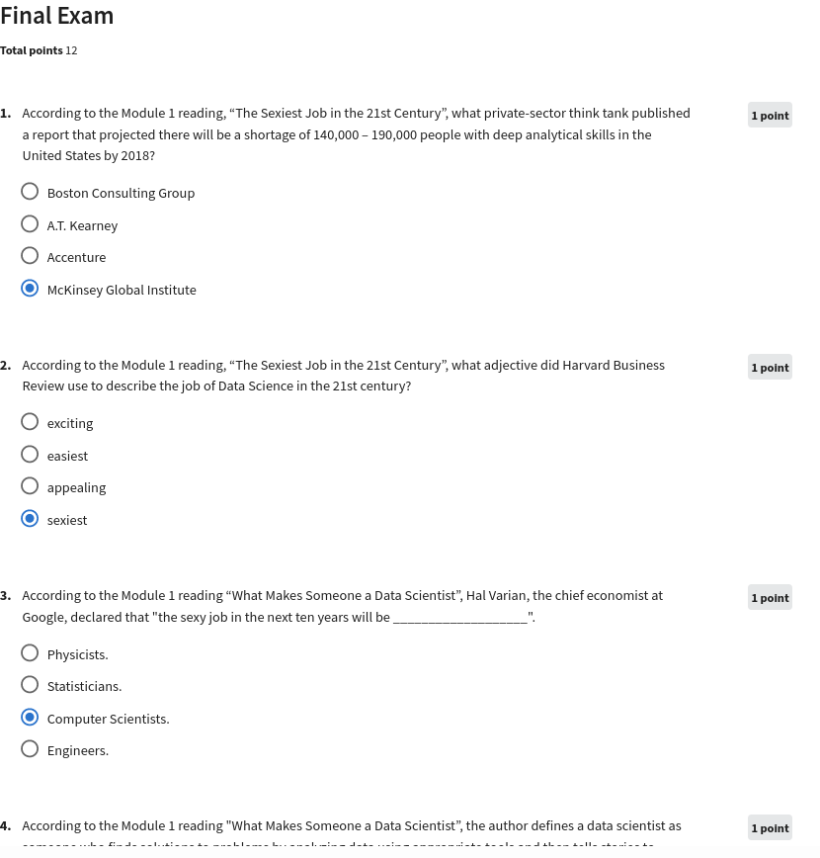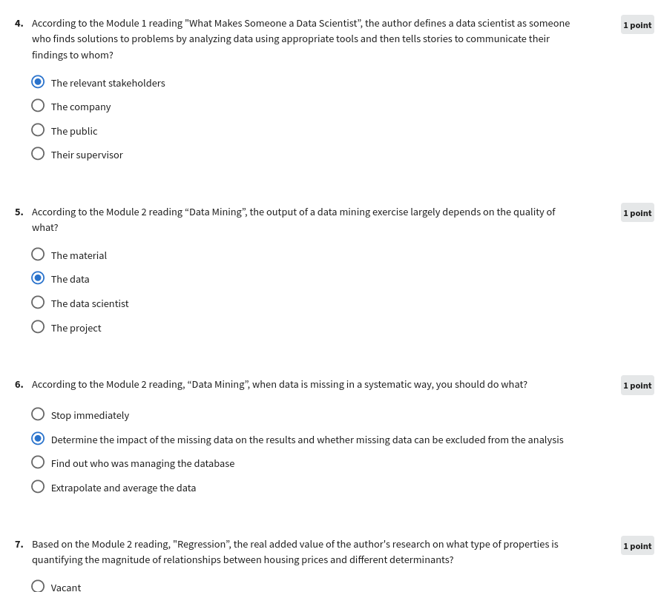

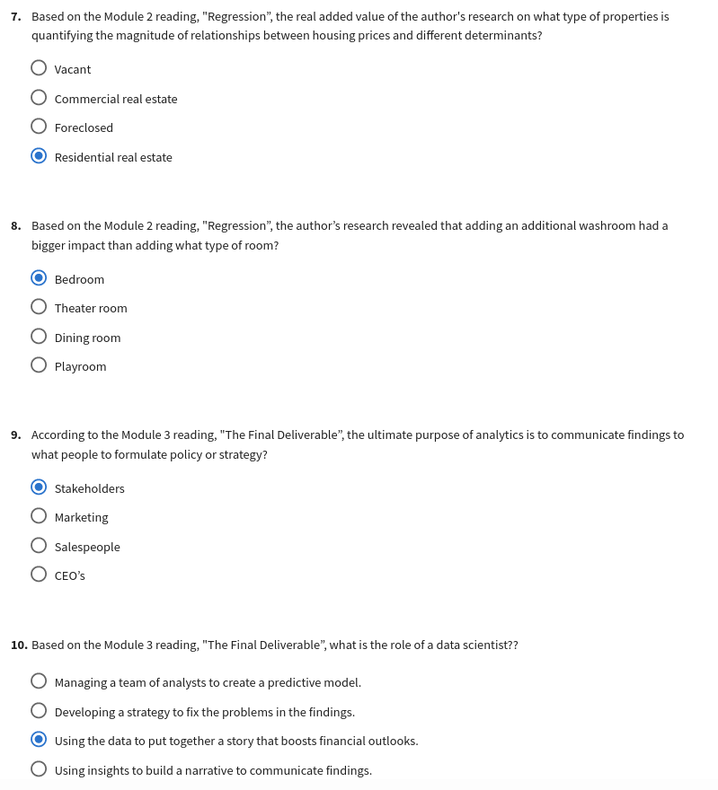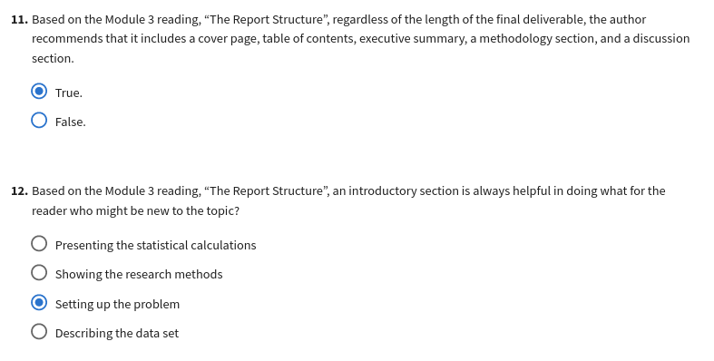

https://www.coursera.org/learn/open-source-tools-for-data-science/exam/YGD4N/graded-quiz/attempt

