https://www.coursera.org/learn/data-science-methodology/exam/7xWMh/from-problem-to-approach/attempt

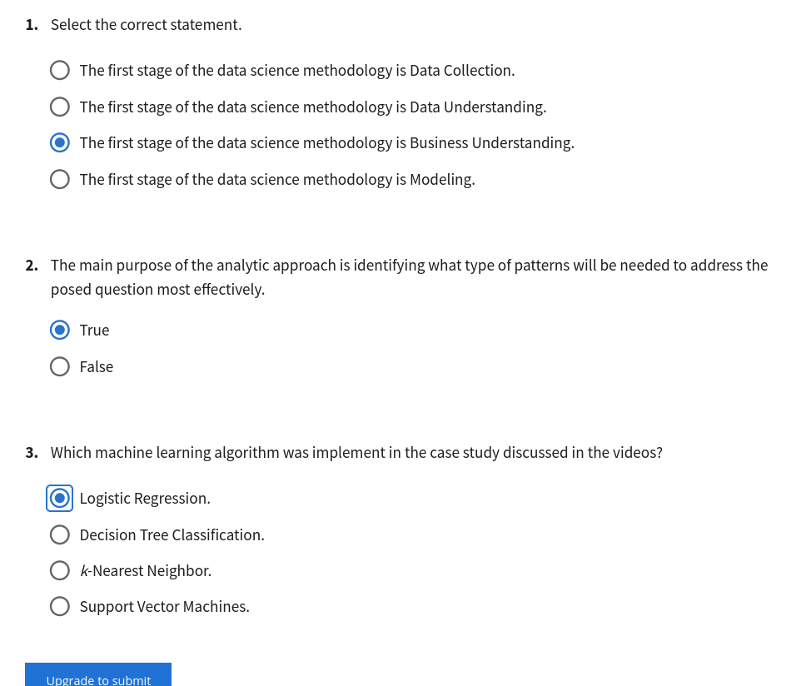

https://www.coursera.org/learn/data-science-methodology/exam/s1FFf/from-requirements-to-collection/attempt

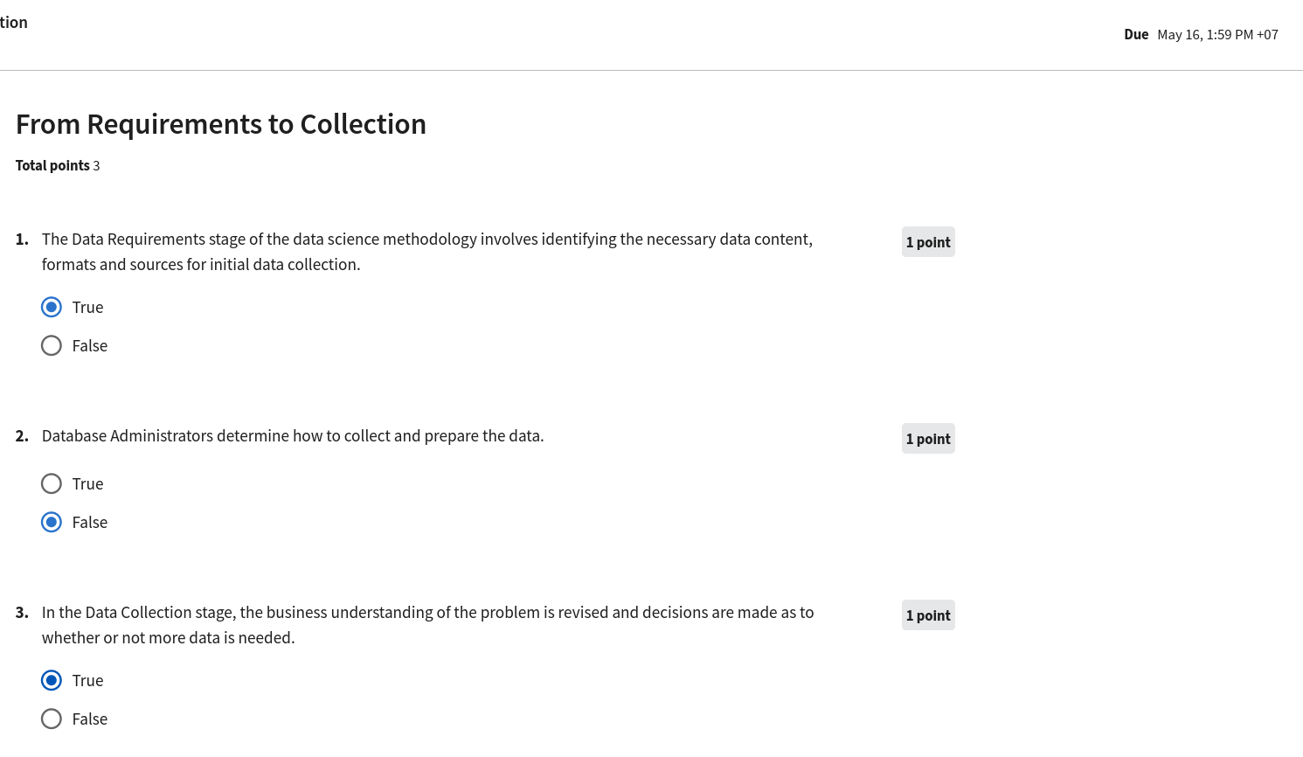

https://www.coursera.org/learn/data-science-methodology/exam/nIzQk/from-understanding-to-preparation/attempt

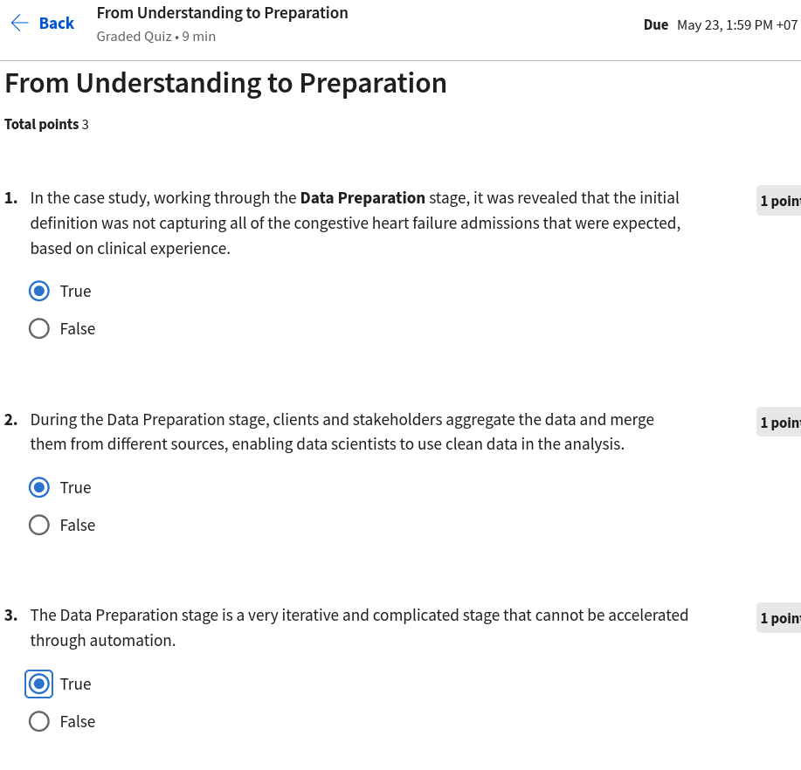

https://www.coursera.org/learn/data-science-methodology/exam/NMF0p/from-modeling-to-evaluation

