**1.** https://www.coursera.org/learn/sql-data-science/quiz/E55dI/practice-quiz/attempt

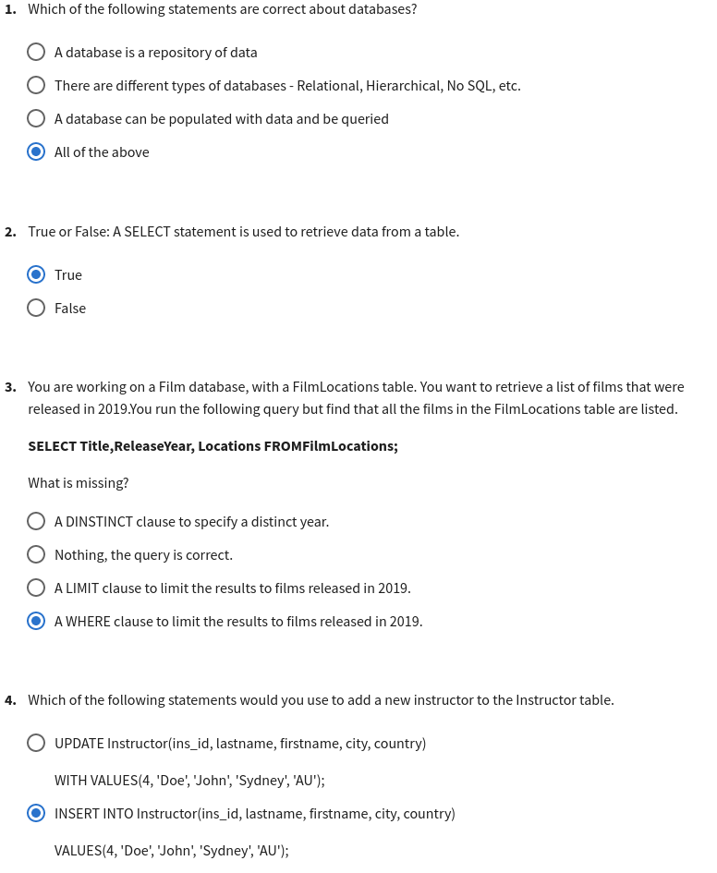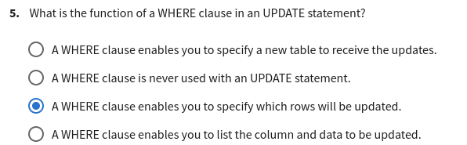

**2.** https://www.coursera.org/learn/sql-data-science/exam/jvanT/graded-quiz-basic-sql/attempt

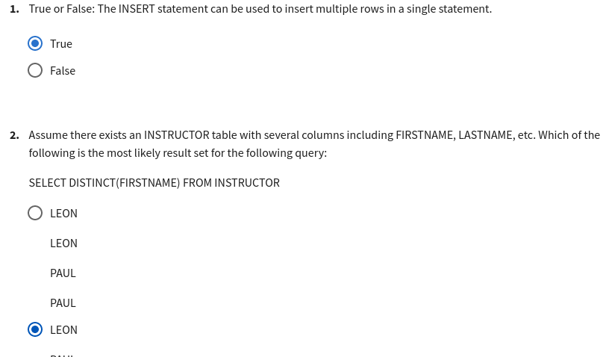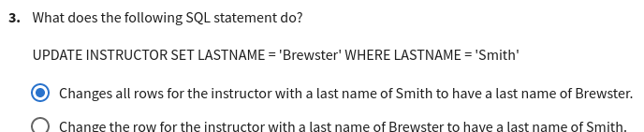

**3.** <https://www.coursera.org/learn/sql-data-science/quiz/tK1rz/practice-quiz/attempt>

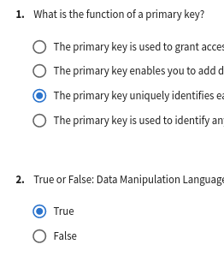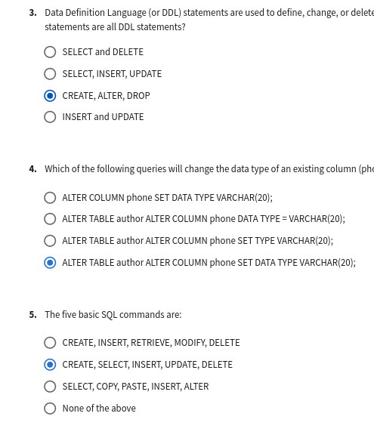

**4.** https://www.coursera.org/learn/sql-data-science/exam/ZJJgO/graded-quiz-relational-db-concepts-and-tables/attempt

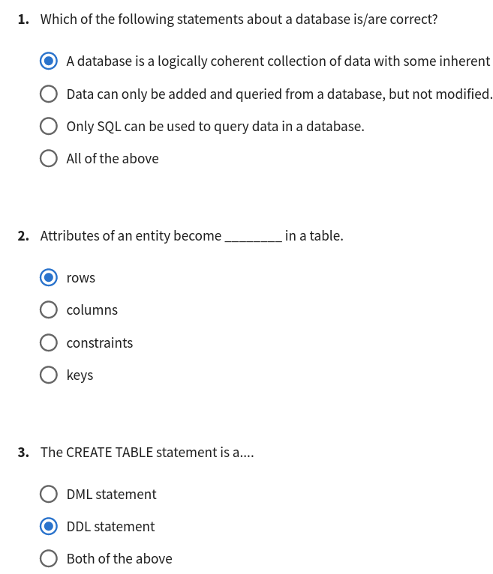

**5.** https://www.coursera.org/learn/sql-data-science/quiz/BsC6j/practice-quiz/attempt

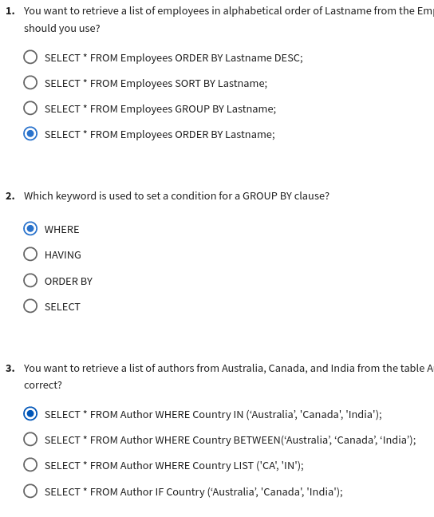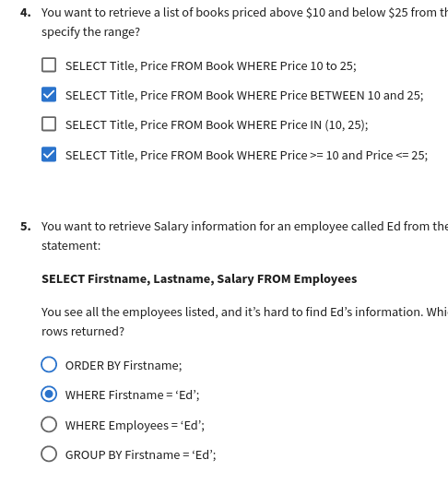

**6.** https://www.coursera.org/learn/sql-data-science/exam/yDeLh/graded-quiz-refining-your-results/attempt

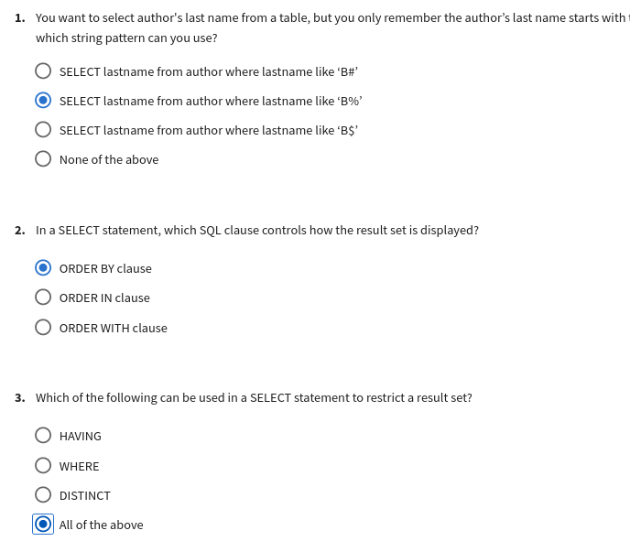

**7.** https://www.coursera.org/learn/sql-data-science/quiz/G9kof/practice-quiz/attempt

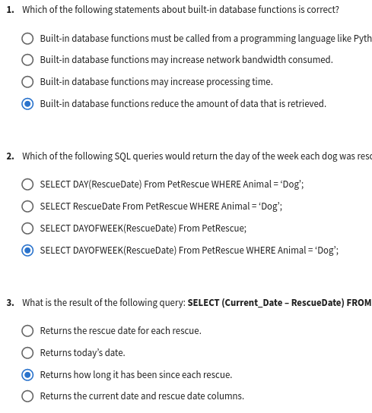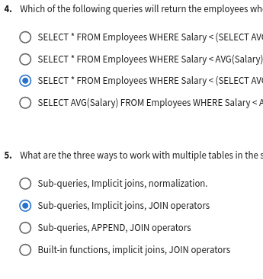

**8.** https://www.coursera.org/learn/sql-data-science/exam/D8qZH/graded-quiz-functions-sub-queries-multiple-tables/attempt

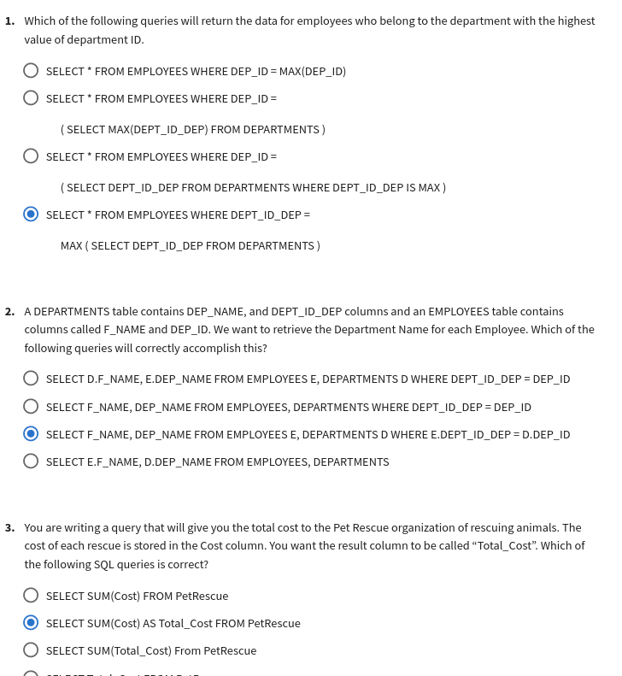

**9.** https://www.coursera.org/learn/sql-data-science/quiz/gWDiC/practice-quiz/attempt?redirectToCover=true

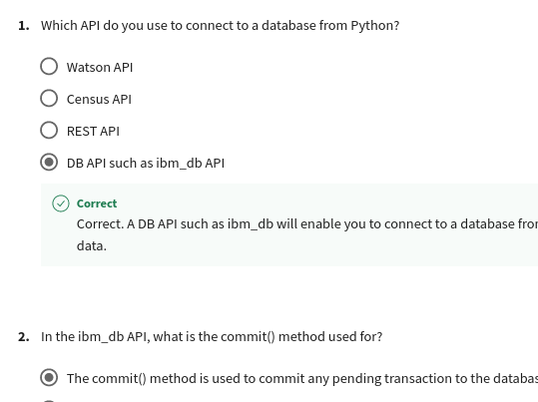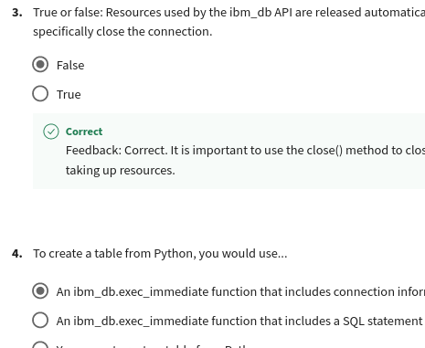

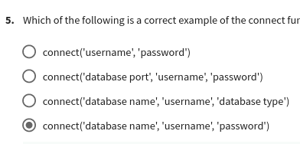

**10.** https://www.coursera.org/learn/sql-data-science/exam/ctpSf/graded-quiz-database-access-from-python/attempt

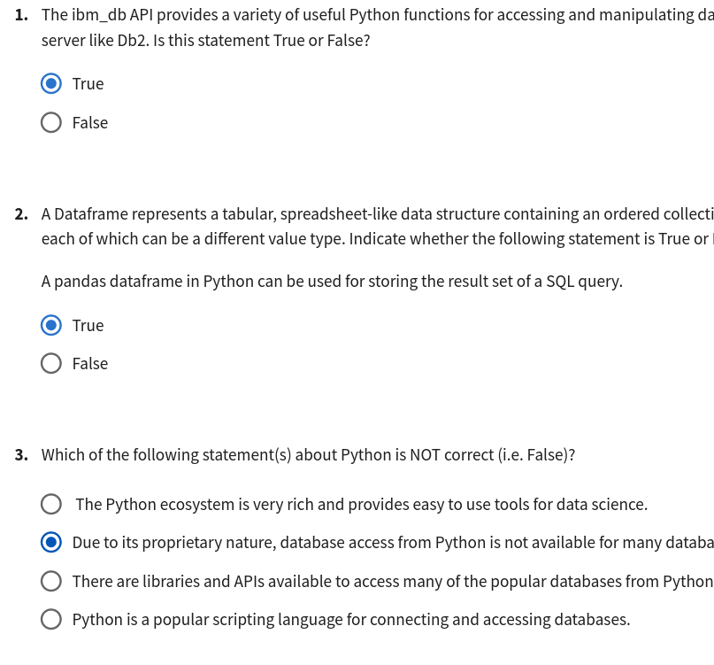

**11.** https://www.coursera.org/learn/sql-data-science/exam/WEJQF/final-exam/attempt

