**1.** https://www.coursera.org/learn/data-analysis-with-python/exam/20nd3/graded-quiz-importing-datasets/attempt

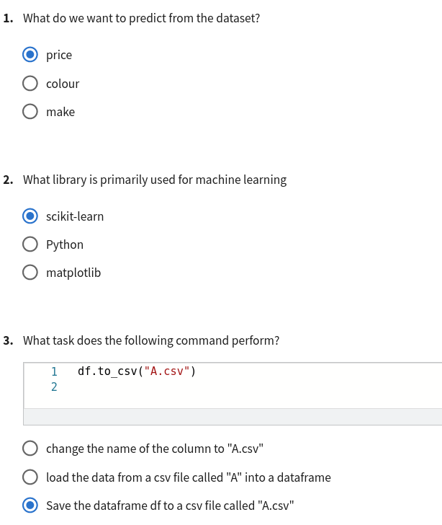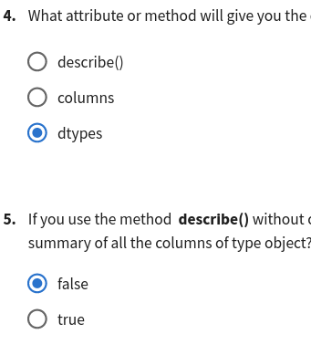

**2.** https://www.coursera.org/learn/data-analysis-with-python/exam/ytP0H/graded-quiz-exploratory-data-analysis/attempt

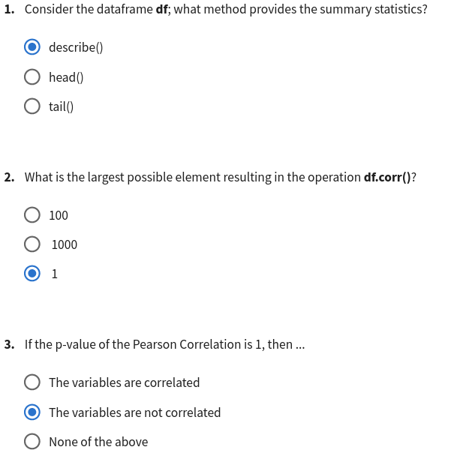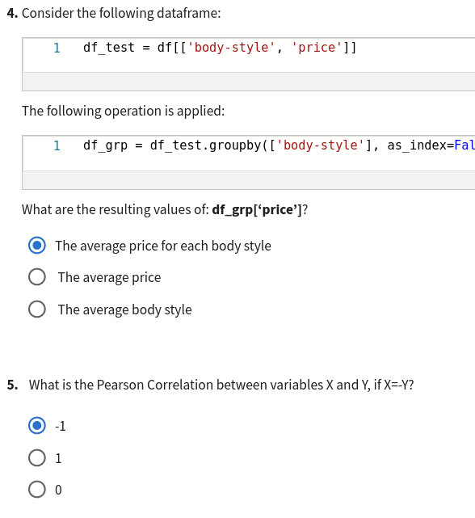

**3.** <https://www.coursera.org/learn/data-analysis-with-python/exam/hChji/graded-quiz-model-development/attempt>

