https://www.coursera.org/learn/open-source-tools-for-data-science/quiz/Zue9i/practice-quiz-languages/view-attempt

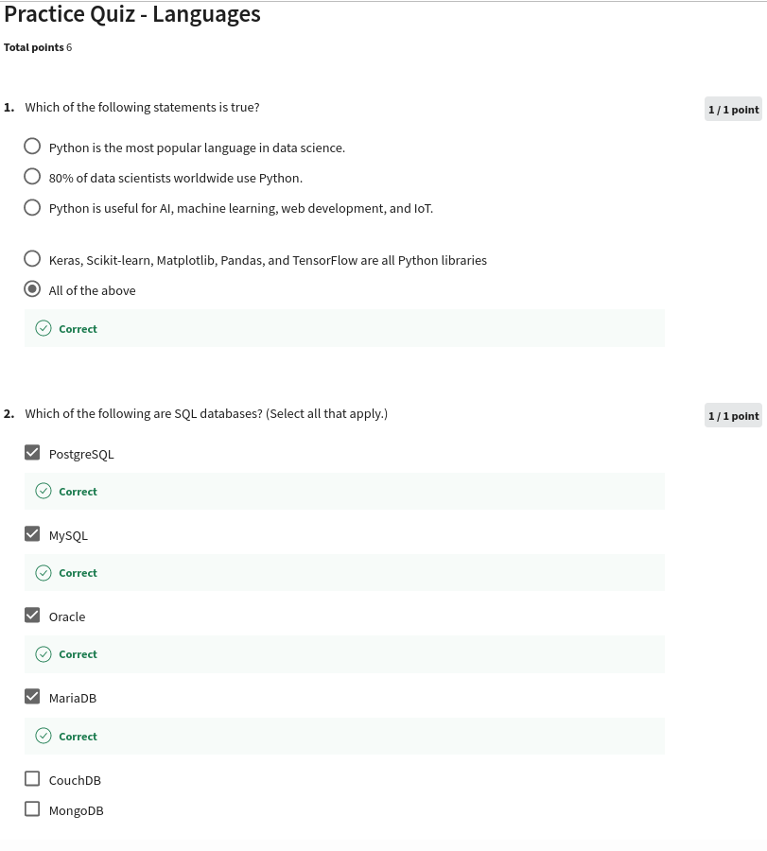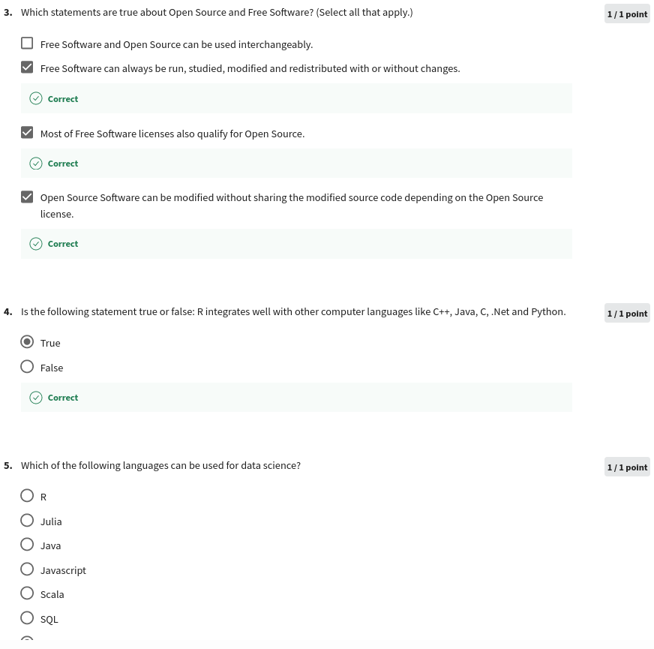

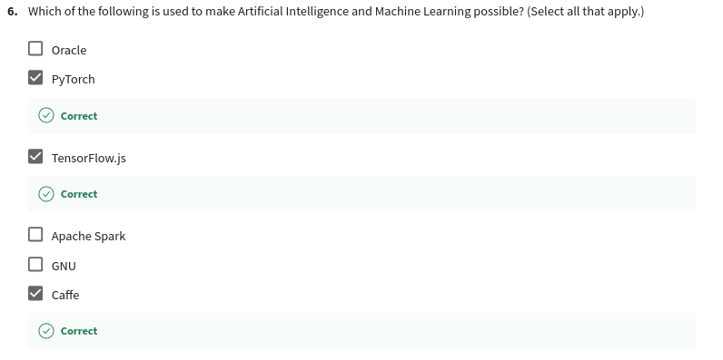

https://www.coursera.org/learn/open-source-tools-for-data-science/quiz/A8y9q/practice-quiz-tools/attempt

