Workforce Issues
Student Debt & Career Outcomes
Aisha Nomani • Sai Han Shan Pha • Mohammed Aljumai
Ahmed Alazzawi • Ngoc Phuong Tam Mai

Introduction
Over the past decade, student loan debt in the United States has become a significant economic and workforce concern. Higher education is often viewed as an investment in future success, with the expectation that earning a degree leads to higher income, improved job stability, and greater long-term financial security. However, as tuition costs continue to rise and borrowing becomes more common, questions have emerged about whether all degrees provide a return that justifies their cost.
One of the key challenges is that student debt and post-graduation outcomes are not evenly distributed. Earnings potential varies widely across majors, institutions and levels of education. It means that some students can repay their loans more easily than others. Fields such as engineering often lead to stronger financial outcomes while other areas of study may result in lower earnings despite similar levels of debt. These differences highlight the importance of evaluating education not just as a cost but as an investment with varying returns.
This project explores the relationship between student debt and career outcomes using multiple datasets, including Federal Reserve Economic Data (FRED), College Scorecard, IPEDS and the U.S. Bureau of Labor Statistics (BLS). Through a series of Tableau visualizations, the analysis examines trends in national student loan growth, the connection between debt and earnings after graduation, and how return on investment differs across majors. In addition, the project investigates how factors such as education level, household income, and type of institution influence both borrowing patterns and employment outcomes.
By answering the research questions below, the project aimed to provide a clearer understanding of how student debt impacts economic mobility and workforce outcomes. The findings can offer valuable insights for students making education decisions, as well as for policymakers and institutions seeking to improve the alignment between educational costs and labor market returns.
The research questions guiding this project include:
- How has the growth of national student loan debt per borrower changed over time?
- Is there a relationship between the level of student debt and earnings after graduation?
- Which majors show the strongest/ weakest wage-to-debt ratio?
- Is there a relationship between education level and unemployment rate in the United States?
- How do debt and earnings differ across institution types (public, private nonprofit, and for-profit)?
- Do popular majors provide stronger financial returns compared to less popular majors?
- Which fields of study have the top 5 highest and bottom 5 lowest wage-to-debt ratios (ROI)?

Methodology
To carry out this project, our team divided responsibilities to ensure the project was completed efficiently and cohesively. Aisha and Sai began by identifying and selecting the datasets used throughout the project, with Aisha refining the research questions to align with the available data, while Sai focused on cleaning and preparing the datasets for analysis.
For the visualization aspect of the project, tasks were assigned based on project requirements and individual strengths. Tam developed the four simple visualizations, while Aisha and Ahmed created two advanced visualizations each. Sai was responsible for designing two animated visualizations, and Mohammed developed the two dashboards that bring the analysis together.

Federal Reserve Economic Data (FRED)
Two datasets were used to analyze national student loan debt over time. It provides reliable macroeconomic indicators, including total outstanding student loan balances and student loans owned and securitized in the United States.
Source: Federal Reserve Bank of St. Louis (https://fred.stlouisfed.org)

College Scorecard (U.S. Department of Education)
This dataset contains institution-level and program-level data, including median debt, earnings after graduation, completion rates, and field of study (CIP codes). It was used to evaluate return on investment across majors and institutions.
Source: U.S. Department of Education (https://collegescorecard.ed.gov/data/)

Bureau of Labor Statistics (BLS)
This dataset includes unemployment rates by education level which was used to analyze how educational attainment relates to employment outcomes.
Source: U.S. Bureau of Labor Statistics (https://www.bls.gov)

IPEDS Completions Dataset
This dataset includes information on degrees awarded by field of study which was used to analyze popularity of majors and connect them with earnings and debt outcomes.
Source: National Center for Education Statistics (https://nces.ed.gov/ipeds/)

The datasets were cleaned and prepared using Tableau Prep Builder. Missing values such as "NA" and "PS" were removed to ensure accuracy. Relevant columns such as median debt, median earnings, completion counts, and institution type were retained. The datasets from College Scorecard and IPEDS were then joined using common fields such as CIP codes, degree level and institution names. After cleaning and integration, the data was visualized using Tableau through a combination of simple charts, advanced visualizations, and dashboards to address the research questions.

Analysis

Student Loan Debt Growth Over Time
Average student loan debt per borrower has increased steadily from 2007 to 2024. The average debt per borrower keeps rising, which shows that each borrower is taking on more debt over time. This means the financial burden per borrower is becoming heavier. Overall, average student debt per borrower has nearly doubled from 2007 to 2024.
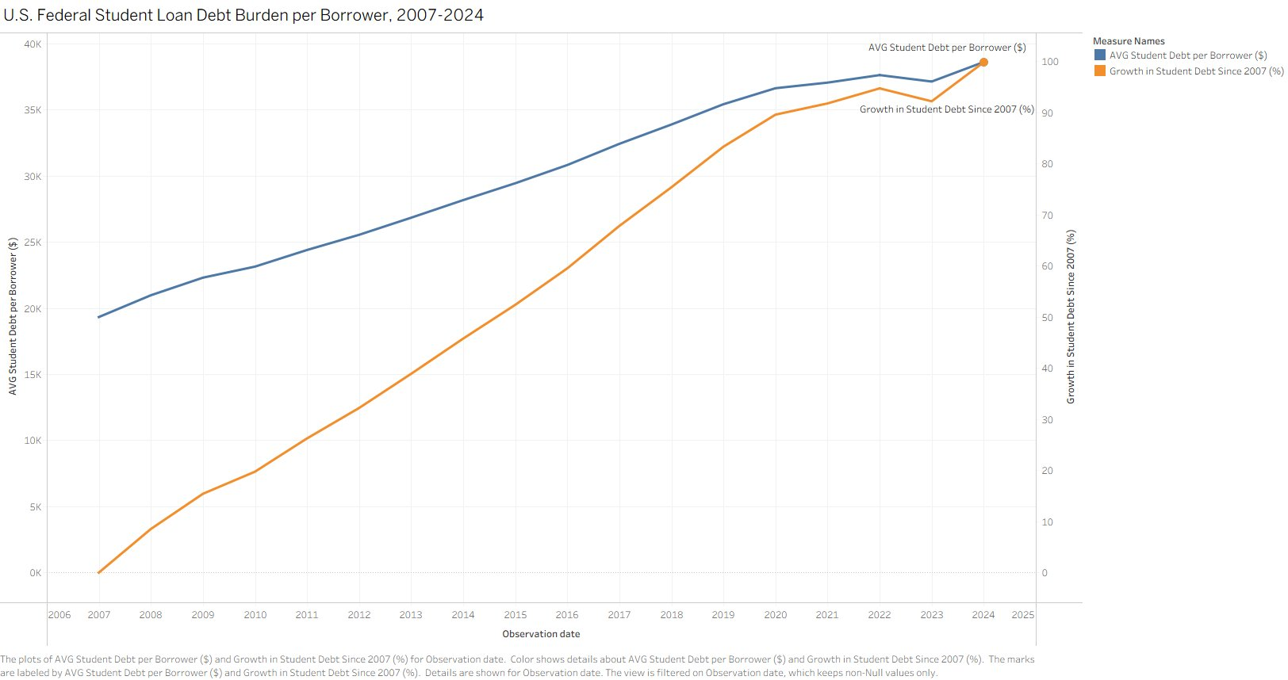
Figure 1: U.S. Federal Student Loan Debt Burden per Borrower, 2007–2024

Student Loan Growth vs. Graduate Unemployment
When comparing student loan growth with unemployment, we see that debt keeps increasing, but unemployment for graduates stays relatively low. This suggests that having a degree still helps people find jobs, even though debt is rising. The sharp spike in 2020 reflects the COVID-19 pandemic, but graduate unemployment quickly recovered, demonstrating the resilience of degree-holders in the labor market.
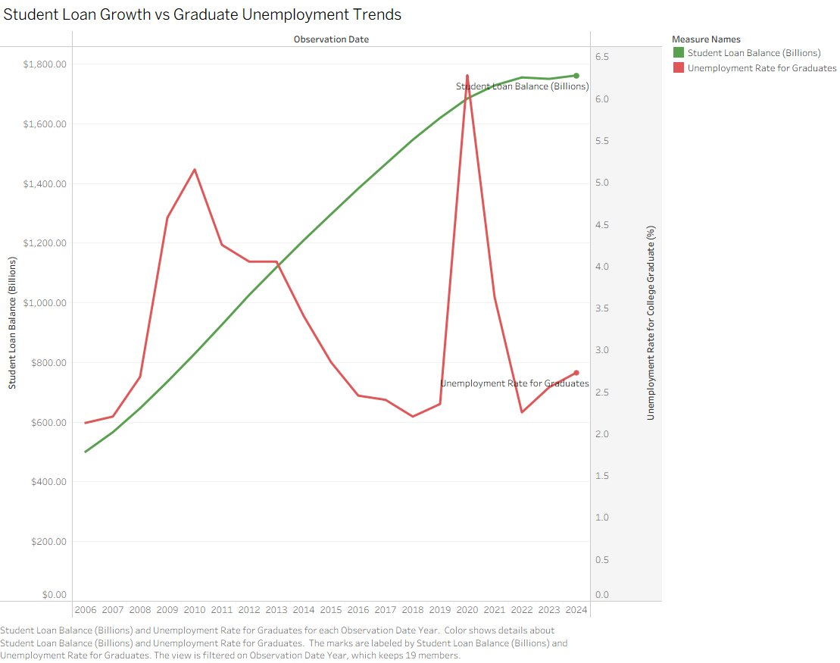
Figure 2: Student Loan Growth vs Graduate Unemployment Trends, 2006–2024

Median Debt vs. Median Earnings by Degree Level
Our analysis comparing debt and earnings shows a clear relationship between the two. In general, people with higher debt tend to have higher earnings.
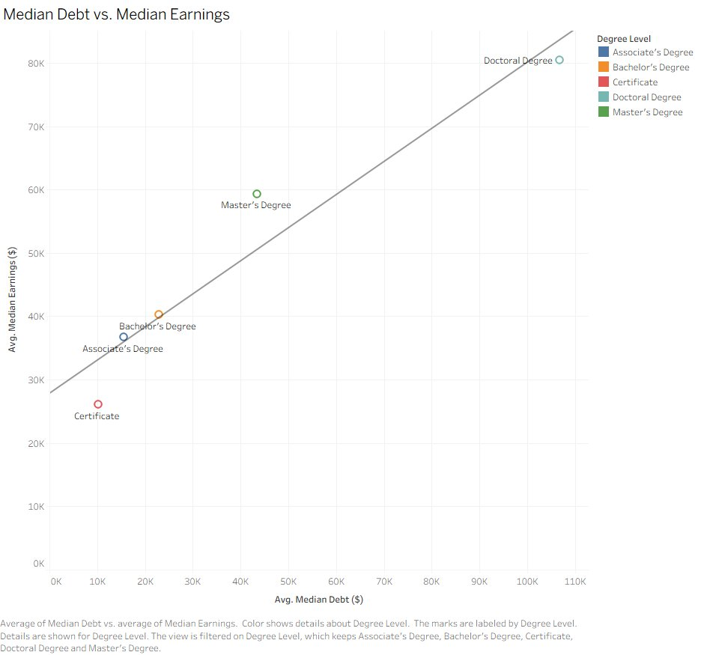
Figure 3: Average Median Debt vs. Average Median Earnings by Degree Level

Education Level, Earnings, and Unemployment
Education level has a strong impact on both unemployment and earnings. As education level increases, unemployment decreases, with higher degrees like bachelor's and master's having lower unemployment rates. At the same time, earnings increase with each level of education. Overall, both the level and type of degree matter, and higher education leads to better job stability and higher income.
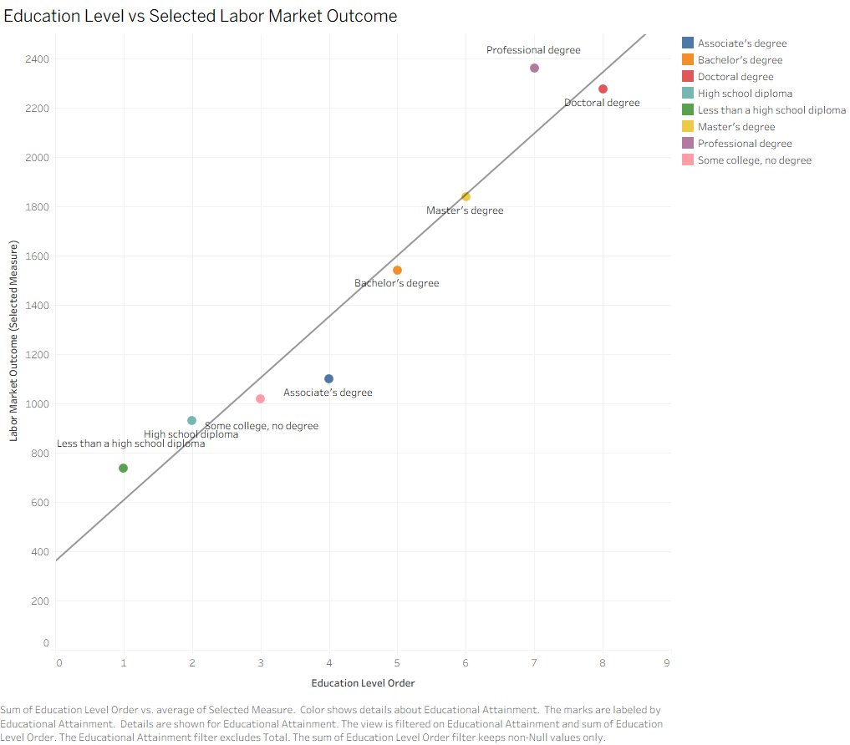
Figure 4: Education Level vs. Median Weekly Earnings
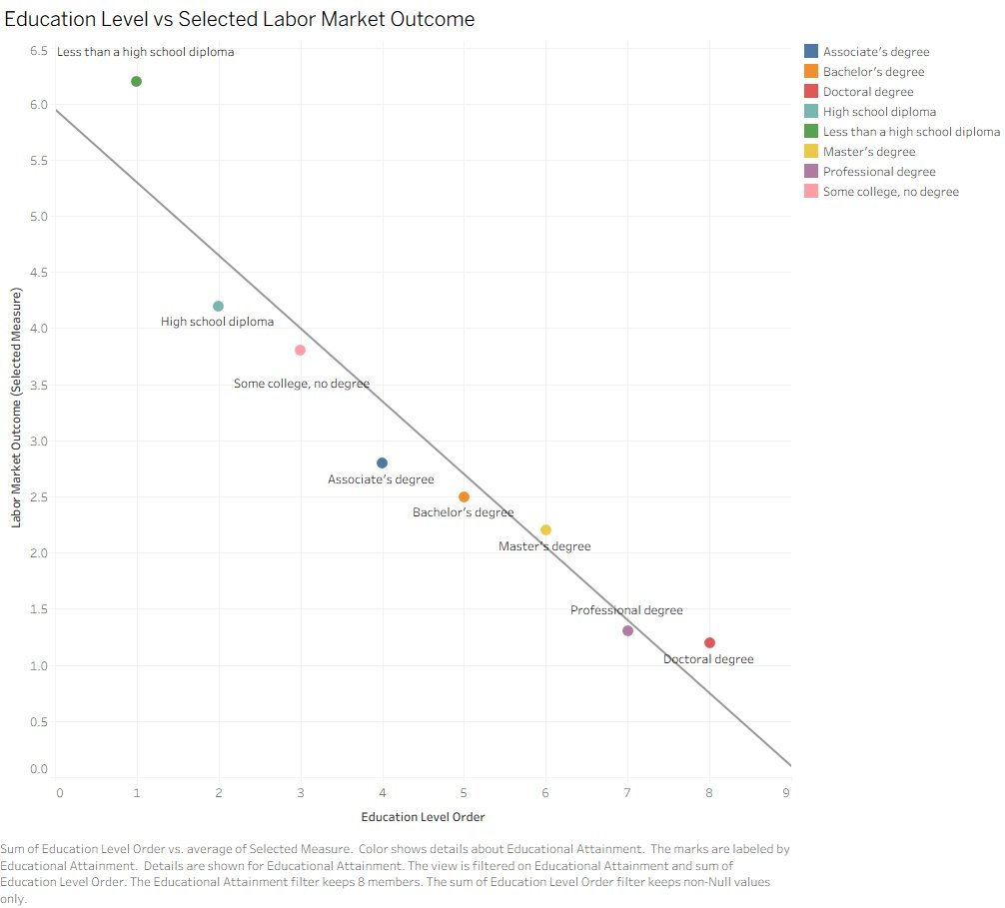
Figure 5: Education Level vs. Unemployment Rate

Debt and Earnings by Institution Type
When comparing institution types, public and private nonprofit schools tend to give better outcomes. For-profit private institutions often show lower returns compared to the level of debt. Nonprofit private institutions have high debt but also high returns. Public institutions carry a similar level of debt to for-profit private schools but produce greater earnings for graduates.
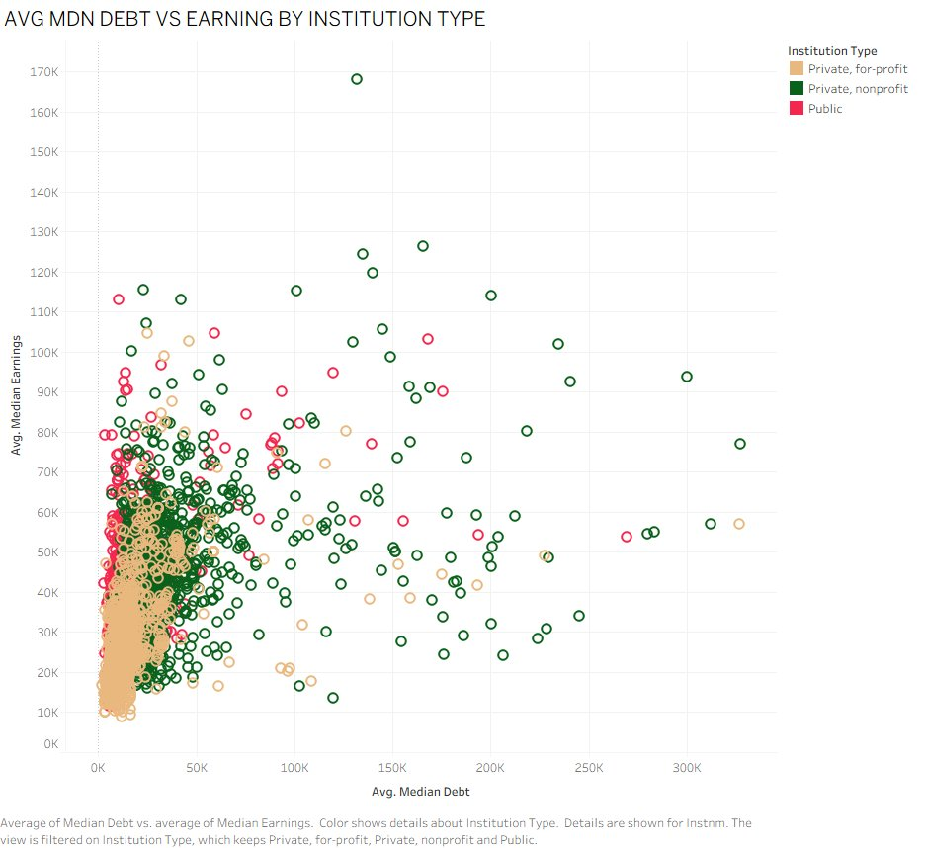
Figure 6: Average Median Debt vs. Earnings by Institution Type
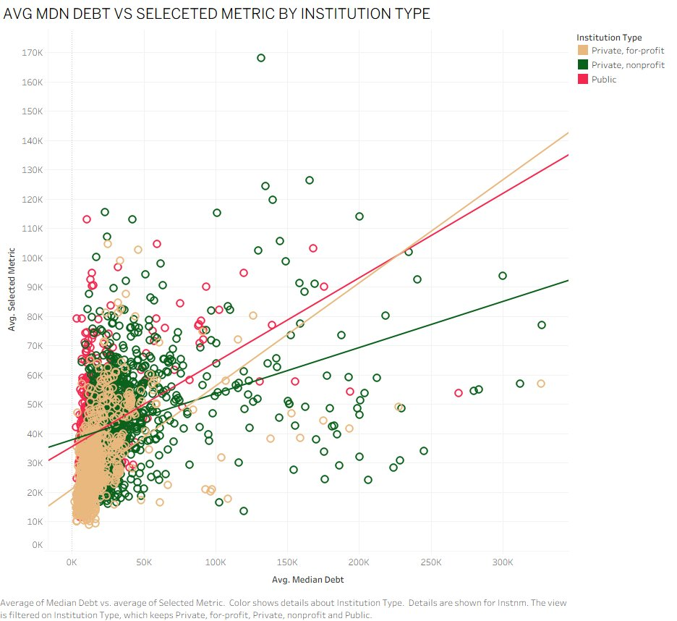
Figure 7: Average Median Debt vs. Selected Metric by Institution Type (with trend lines)
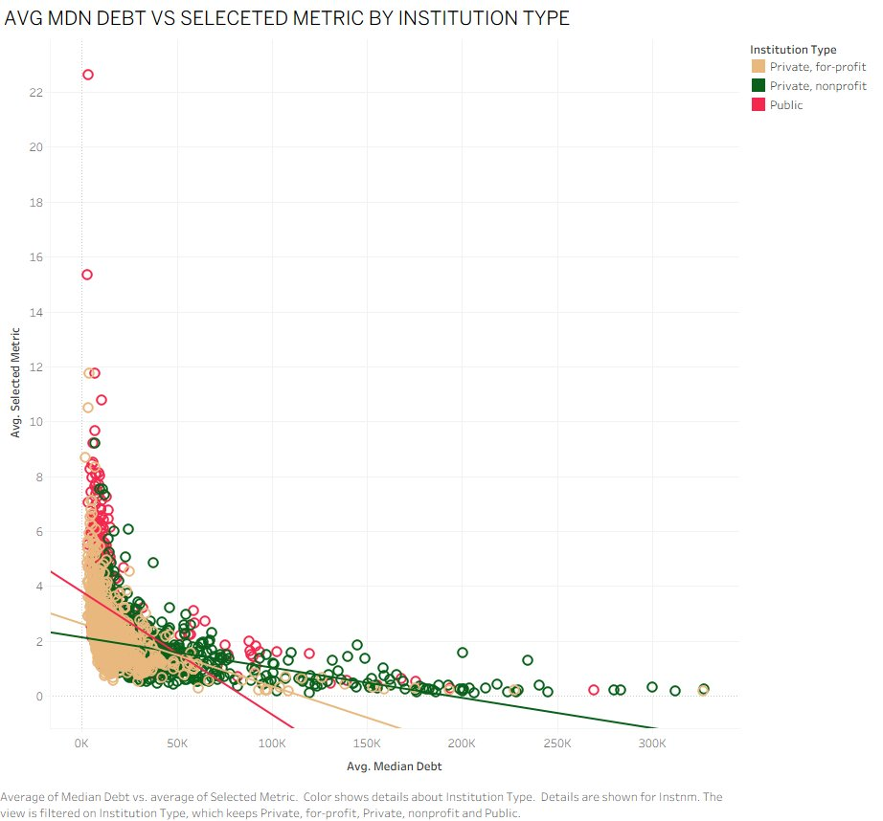
Figure 8: Average Median Debt vs. ROI by Institution Type

Top Majors by ROI Within Each Institution Type
Across all three institution types, technical and transportation-related fields consistently dominate the top ROI rankings. Nuclear Engineering Technology leads among private nonprofit institutions, while Ground Transportation ranks highly across all sectors. Public institutions perform strongly in electrical and nuclear fields.
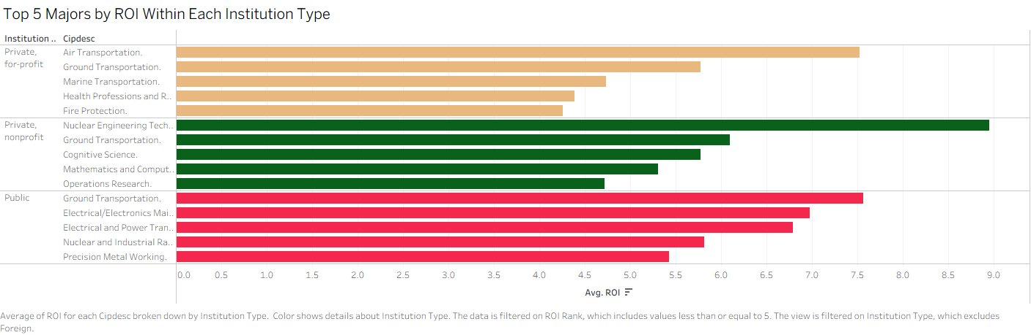
Figure 9: Top 5 Majors by ROI Within Each Institution Type

Popular vs. Less Popular Majors and ROI
The charts show that popular majors are not always the best financially. Some majors have a large number of graduates but only average returns. Registered Nursing leads among high-enrollment majors with an average ROI near 3.3. Meanwhile, Psychology and Liberal Arts show modest returns despite very large graduate populations. Less popular, specialized fields can offer surprisingly high ROI when debt remains low.
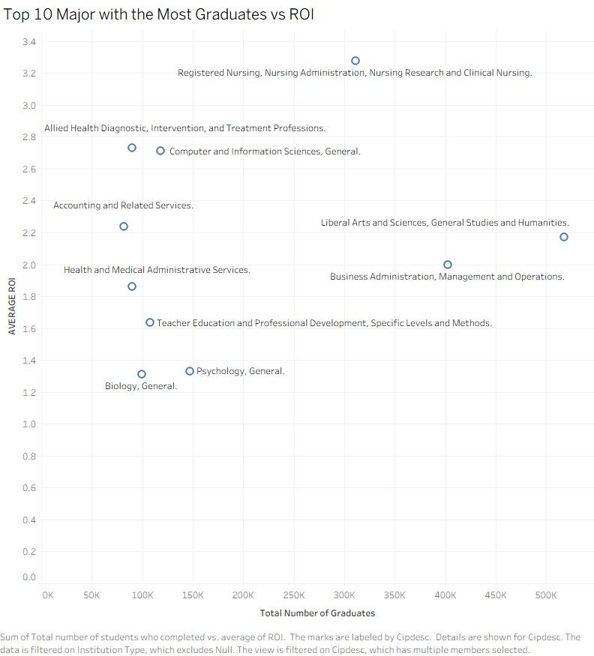
Figure 10: Top 10 Majors with the Most Graduates vs. ROI
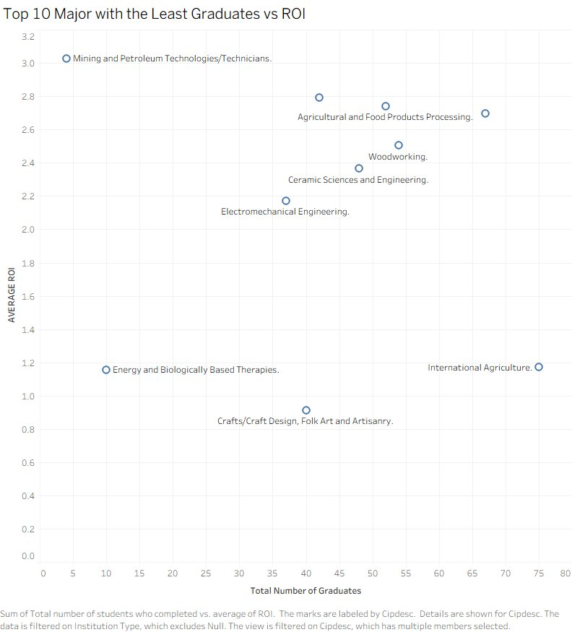
Figure 11: Top 10 Majors with the Least Graduates vs. ROI

Highest and Lowest ROI Fields of Study
Technical and engineering-related fields have the highest return on investment. Nuclear Engineering Technology leads with an average ROI near 9.0 and median debt of only $10,555 against median earnings of $94,408. Ground Transportation, Nuclear and Industrial Radiologic Technologies, Physical Science Technologies, and Electrical and Power Transmission also rank among the top five.
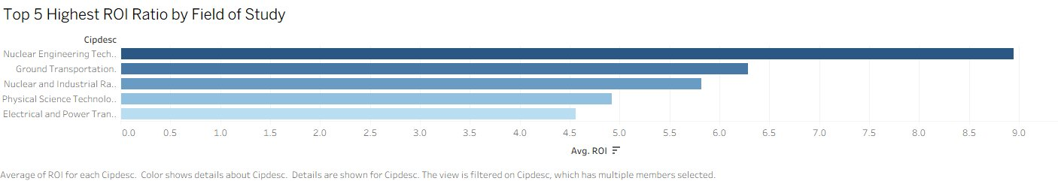
Figure 12: Top 5 Highest ROI Ratio by Field of Study
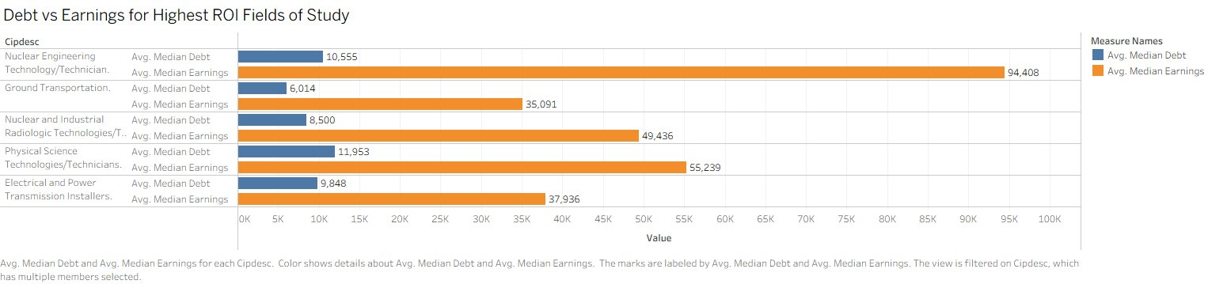
Figure 13: Debt vs. Earnings for Highest ROI Fields of Study

On the other hand, professional health fields including Optometry, Dentistry, Veterinary Medicine, Medicine, and Chiropractic have the lowest ROI ratios. This is not because their earnings are low, but because the debt required is extremely high. Dentistry graduates carry an average median debt of over $264,000 against earnings of approximately $108,000 resulting in an ROI ratio well below 0.5.
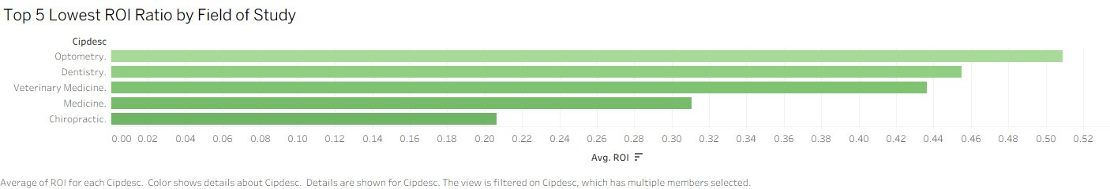
Figure 14: Top 5 Lowest ROI Ratio by Field of Study
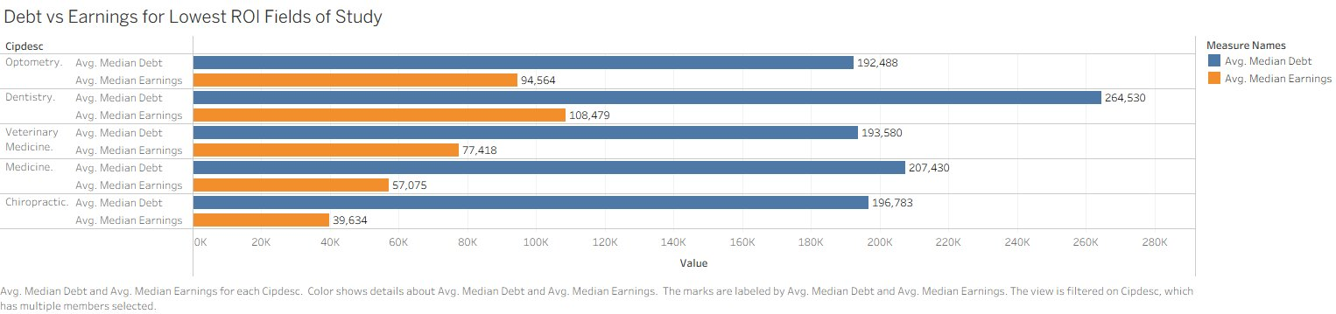
Figure 15: Debt vs. Earnings for Lowest ROI Fields of Study

Conclusion
The results show that student loan debt has been growing over time and is becoming a serious financial issue. While education still helps people get jobs and earn more, the value of a degree depends on several factors.
Higher education levels are linked to lower unemployment and higher earnings, confirming that education remains important and continues to provide measurable returns. However, the cost of education also matters, especially when students take on large amounts of debt. The field of study is one of the most critical factors: some majors, especially technical and engineering-related fields, provide strong financial returns. Other majors, particularly in the professional health fields, may require such heavy borrowing that the wage-to-debt ratio becomes unfavorable in the short term, even when absolute earnings are competitive.
Institution type also plays a role. Public and private nonprofit schools tend to offer better financial outcomes, while for-profit schools often show weaker ROI results. Students at for-profit institutions may face similar debt levels to those at public schools while earning comparatively less after graduation.
Overall, students should think carefully about what they study and how much they borrow. Choosing the right major and controlling debt can make a significant difference in long-term financial success. Popular majors do not always provide the strongest financial returns, and less common, specialized fields can offer surprisingly high ROI when debt is kept low.
For future research, it would be useful to study how students repay their loans over time, how geographic location affects earnings outcomes, and how student debt impacts broader measures of long-term financial stability such as homeownership rates, retirement savings, and wealth accumulation.

References
Federal Reserve Bank of St. Louis. (n.d.). Federal Reserve Economic Data (FRED). Retrieved from https://fred.stlouisfed.org
U.S. Department of Education. (n.d.). College Scorecard. Retrieved from https://collegescorecard.ed.gov/data/
U.S. Bureau of Labor Statistics. (n.d.). Labor Force Statistics. Retrieved from https://www.bls.gov
National Center for Education Statistics. (n.d.). IPEDS Completions Dataset. Retrieved from https://nces.ed.gov/ipeds/

