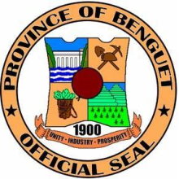
Republic of the Philippines
PROVINCE OF BENGUET
LA TRINIDAD
BIDS AND AWARDS COMMITTEE ON INFRASTRUCTURE
Cell no: 09108175538
Website: www.benguet.gov.ph

NOTICE

April 20, 2021

Marcos P. Bacoy
Manager/Babecor Builders
Ampucao Itogon Benguet

Dear Bacoy:

Please be informed that for project: IMPROVEMENT OF BANYOL-LUBAS FMR, ANSAGAN, TUBA, the quotation of SEPJR CONSTRUCTION & SUPPLIES TRADING, 1st LCRPC, has been found to be responsive and recommendation for award of the project was made in his favor under Resolution no. 04-20-2021d, dated April 20, 2021.

For your information.

Truly yours,

ATTY. SUNNY G. SACLA
BAC-Infra Chairperson-Presiding Officer

