"PROMPTCRAFT: AI PROMPT GENERATOR TOOL"

An Application Development-II Report Submitted
In partial fulfilment of the requirement for the award of the degree of

Bachelor of Technology in

Computer Science and Engineering -Artificial Intelligence and Machine Learning

by

D Bhargav Ram - 22N31A6644

A Pavan Kumar - 22N35A6606

A Varun Kumar - 22N31A6612

Under the Guidance of
Mrs. Ruquia Khatoon

Assistant Professor



DEPARTMENT OF CSE (ARTIFICIAL INTELLIGENCE AND MACHINE LEARNING)

MALLA REDDY COLLEGE OF ENGINEERING AND TECHNOLOGY
(Affiliated to JNTU, Hyderabad)

ACCREDITED by AICTE-NBA
Maisammaguda, Dhulapally post, Secunderabad-500014.
2024-2025

DECLARATION

I hereby declare that the project entitled “Promptcraft: AI Prompt Generator Tool” submitted to Malla Reddy College of Engineering and Technology, affiliated to Jawaharlal Nehru Technological University Hyderabad (JNTUH) for the award of the degree of Bachelor of Technology in Computer Science and Engineering- Artificial Intelligence and Machine Learning is a result of original research work done by me.
It is further declared that the project report or any part thereof has not been previously submitted to any University or Institute for the award of degree or diploma.

D Bhargav Ram(22N31A6644)
A Pavan Kumar(22N35A6606)
A Varun Kumar(22N31A6612)



CERTIFICATE

This is to certify that this is the bonafide record of the project titled “Promptcraft: AI Prompt Generator Tool” submitted by D. Bhargav Ram(22N31A6644), A. Pavan Kumar(22N31A6606), A. Varun Kumar(22N31A6612) of B.Tech in the partial fulfillment of the requirements for the degree of Bachelor of Technology in Computer Science and Engineering- Artificial Intelligence and Machine Learning, Dept. of CI during the year 2024-2025. The results embodied in this project report have not been submitted to any other university or institute for the award of any degree or diploma.

Mrs. Ruqia Khatoon Dr. D. Sujatha
Assistant Professor Professor and Dean (CSE&ET)

INTERNAL GUIDE HEAD OF THE DEPARTMENT

EXTERNAL EXAMINER

Date of Viva-Voce Examination held on:

ACKNOWLEDGEMENT

We feel honored and privileged to place our warm salutation to our college Malla Reddy College of Engineering and technology (UGC-Autonomous), our Director Dr. VSK Reddy who gave us the opportunity to have experience in engineering and profound technical knowledge.
We are indebted to our Principal Dr. S. Srinivasa Rao for providing us with facilities to do our project and his constant encouragement and moral support which motivated us to move forward with the project.
We would like to express our gratitude to our Head of the Department Dr. D. Sujatha, Professor and Dean (CSE&ET) for encouraging us in every aspect of our system development and helping us realize our full potential.
We would like to express our sincere gratitude and indebtedness to our project supervisor Mrs. Ruqia Khatoon, Assistant Professor for her valuable suggestions and interest throughout the course of this project.
We convey our heartfelt thanks to our Project Coordinator, Mr. T Hari Babu, Assistant Professor for allowing for his regular guidance and constant encouragement during our dissertation work
We would also like to thank all supporting staff of department of CI and all other departments who have been helpful directly or indirectly in making our Application Development-II a success.
We would like to thank our parents and friends who have helped us with their valuable suggestions and support has been very helpful in various phases of the completion of the Application Development-II.

By:
D Bhargav Ram(22N31A6644)
A Pavan Kumar(22N35A6606)
A Varun Kumar(22N31A6612)

ABSTRACT
PromptCraft is a creative writing assistant tool designed to generate concise, imaginative writing prompts using the TinyLLaMA language model. This system leverages an easy-to-use graphical user interface (GUI) built with Python’s Tkinter and CustomTkinter libraries, integrating the Ollama API as a local backend for generating language outputs. The project aims to support writers by generating high-quality, thought-provoking prompts to inspire storytelling and content creation.
The architecture incorporates an efficient client-server approach where the Ollama backend serves the TinyLLaMA model locally, responding to API requests generated from the frontend. It features built-in model loading checks, error handling, and a threading mechanism for smooth prompt generation without freezing the UI. With user-centered features like clipboard copy, status display, and structured prompt formatting, PromptCraft ensures accessibility and responsiveness. The system contributes to the growing field of AI-assisted creativity and can be extended for educational and professional applications in writing.

TABLE OF CONTENTS

CONTENTS Page No.

- INTRODUCTION 7
  - Problem Statements 7
  - Objectives 7
  - Summary 7
- LITERATURE SURVEY 8
  - Existing System 8
2.1.1 Limitations of Existing System 8
  - Proposed System 9
- SYSTEM REQUIREMENTS 10
  - Introduction 10
  - Software and Hardware Requirement 10
  - Functional and Non-Functional Requirements 11
  - Other Requirements 11
  - Summary 11
- SYSTEM DESIGN 12
  - Introduction 12
  - Architecture Diagram 13
  - UML Diagrams / DFD 14
  - Summary 17
- IMPLEMENTATION 18
  - Algorithms 18
5.1.1 Code 18
  - Architectural Components 24
  - Feature Extraction 25
  - Packages/Libraries Used 25
  - Output Screens 26
- SYSTEM TESTING 29
  - Introduction 29
  - Test Cases 29
  - Results and Discussions 30
  - Performance Evaluation 30
  - Summary 31
- CONCLUSION & FUTURE ENHANCEMENTS 32
- REFERENCES 33

CHAPTER 1
INTRODUCTION
1.1 Problem Statement
Creative writing is often hindered by a lack of inspiration, making it difficult for writers to begin or continue storytelling. Despite the advancements in artificial intelligence (AI), there are limited tools that cater to generating simple, compact, and engaging writing prompts. Most existing platforms are either too complex, require internet access, or do not offer prompt personalization. Hence, there is a need for a lightweight, offline solution that can instantly generate imaginative prompts tailored to the user's input.

1.2 Objectives
The primary objectives of PromptCraft are as follows:
• To develop a user-friendly desktop application using Python's Tkinter and CustomTkinter for creative writing support.
•To integrate TinyLLaMA via the Ollama API as a local backend for prompt generation.
•To ensure offline functionality by locally hosting the language model.
•To generate concise, engaging writing prompts based on a user's input description.
•To optimize system performance using multithreading and caching mechanisms.

1.3 Summary
This chapter outlined the core problem addressed by PromptCraft and established the motivation behind creating a lightweight and offline-enabled creative writing tool. It presented the objectives that guide the system's design and functionality. The next chapter will explore existing literature and systems that influenced the proposed solution.

CHAPTER 2
LITERATURE SURVEY
2.1 Existing System:

- OpenAI Playground:
  - An interactive platform for testing and refining AI prompts in real-time using OpenAI models.
- LangChain:
  - A framework designed to build applications with large language models by integrating prompts into workflows and pipelines.
- PromptLayer:
  - A tool that tracks, manages, and optimizes prompts for language models, focusing on prompt engineering and analysis.
2.1.1 Drawbacks of existing system:

  - OpenAI Playground
- Limited to OpenAI models, restricting flexibility with other platforms.
- Requires an internet connection and may incur usage costs.
  - LangChain
- Complex to set up and use, requiring programming knowledge.
- Dependency on external libraries and APIs increases complexity.
  - PromptLayer
- Focuses primarily on tracking and optimization, not prompt creation.
- Requires integration with existing workflows, which may not suit all users.
- Limited user interface, making it less accessible for non-technical users.

2.2 Proposed System:

The proposed system, PromptCraft, is a standalone desktop application designed to streamline the creation of structured AI prompts. Built for efficiency and ease of use, it features a user-friendly interface that allows users to input descriptions, validate their content, and generate refined AI-ready prompts. Unlike online tools that require internet connectivity, PromptCraft operates offline, ensuring privacy, security, and accessibility for users in various environments.
The system is designed to generate polished AI prompts by guiding users through a structured input process, minimizing errors and improving prompt effectiveness. It allows for quick modifications, ensuring flexibility and adaptability based on user needs. Additionally, it features one-click copy-to-clipboard functionality, enabling seamless integration with AI applications, chatbots, or content generation tools.
With its simple and efficient design, PromptCraft caters to developers, writers, researchers, and AI enthusiasts who require well-structured prompts for various applications. By focusing on automation, accuracy, and ease of use, the system enhances AI interactions while reducing manual effort, making prompt engineering more accessible and efficient.

CHAPTER 3
SYSTEM REQUIREMENTS
3.1 Introduction:
PromptCraft is a user-friendly tool designed to help people create detailed and effective prompts for AI applications. Built using Python and the Tkinter library, it simplifies the process of generating AI prompts, making it quick and accessible for everyone. Users can input descriptions, validate them for accuracy, and instantly generate polished prompts with just a few clicks. Whether you’re a developer, writer, or AI enthusiast, PromptCraft saves time and effort, making it a valuable tool for creative and technical tasks.

3.2 Software and Hardware Requirements
Software Requirements:
OS: Windows 10 or advanced
IDE: Visual Studio Code 1.96
Python 3.12
Libraries: Tkinter, TextBlob, OpenAI
Hardware Requirements:
Processor: intel i5 11th Gen and above
Memory: 8GB RAM
Storage: 512GB SSD

3.3 Functional and Non-Functional Requirements
- Functional:
  - Input a writing idea/description.
  - Generate a creative prompt.
  - Copy result to clipboard.

- Non-Functional:
  - Lightweight and responsive UI.
  - Prompt generation under 5 seconds (after model load).
  - Error handling for server startup and model load

3.4 Other Requirements
- User must have Ollama installed and the model tinyllama preloaded.
- App must be run with appropriate permissions to spawn subprocesses.

3.5 Summary
PromptCraft provides a complete local solution with minimal dependencies and a seamless interface for prompt generation.

CHAPTER-4
SYSTEM DESIGN

4.1 System Architecture

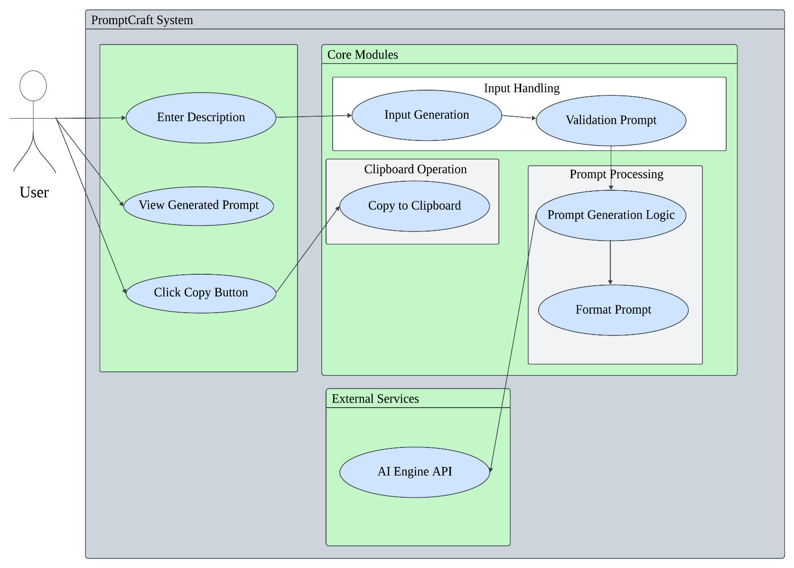

Fig 4.1 System Architecture for PromptCraft

4.2 Data flow diagram
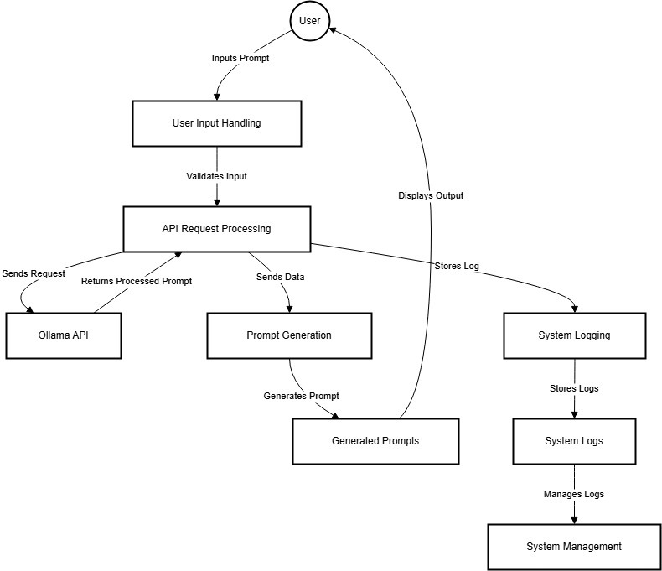

Fig 4.2 Data Flow Diagram for PromptCraft

4.3 UML Diagrams

The unified modeling is a standard language for specifying, visualizing, constructing and documenting the system and its components is a graphical language which provides a vocabulary and set of semantics and rules. The UML focuses on the conceptual and physical representation of the system. It captures the decisions and understandings about systems that must be constructed. It is used to understand, design, configure and control information about the systems.

4.3.1 Use case diagram

A use case diagram is a graph of actors set of use cases enclosed by a system boundary, communication associations between the actors and users and generalization among use cases. The use case model defines the outside (actors) and inside (use case) of the system’s behavior.
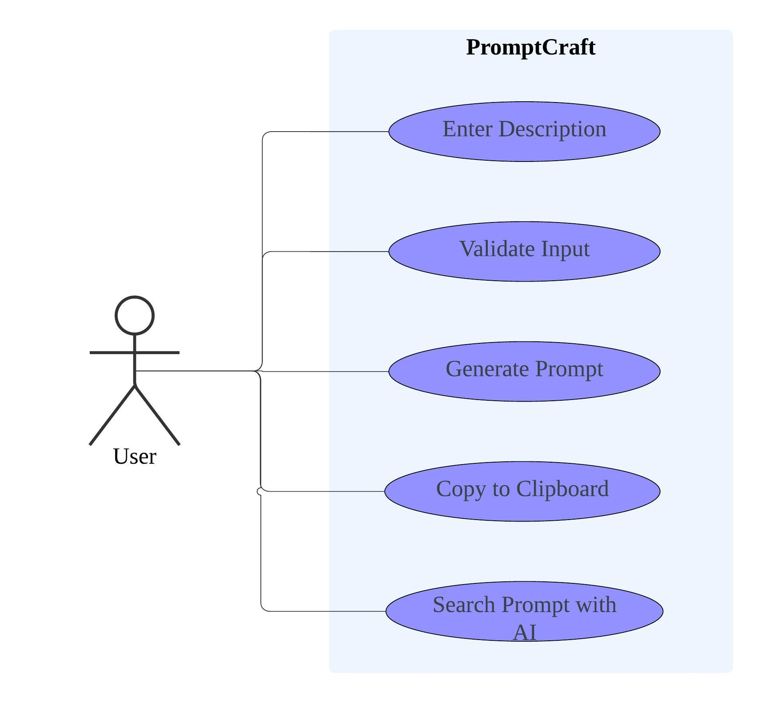

Fig 4.3.1(a) Use Case for PrmptCraft

4.3.2 Class Diagram

A class is a representation of an object and, in many ways; it is simply a template from which objects are created. Classes form the main building blocks of an object-oriented application. Although thousands of students attend the university, you would only model one class, called Student, which would represent the represent the entire collection of students.

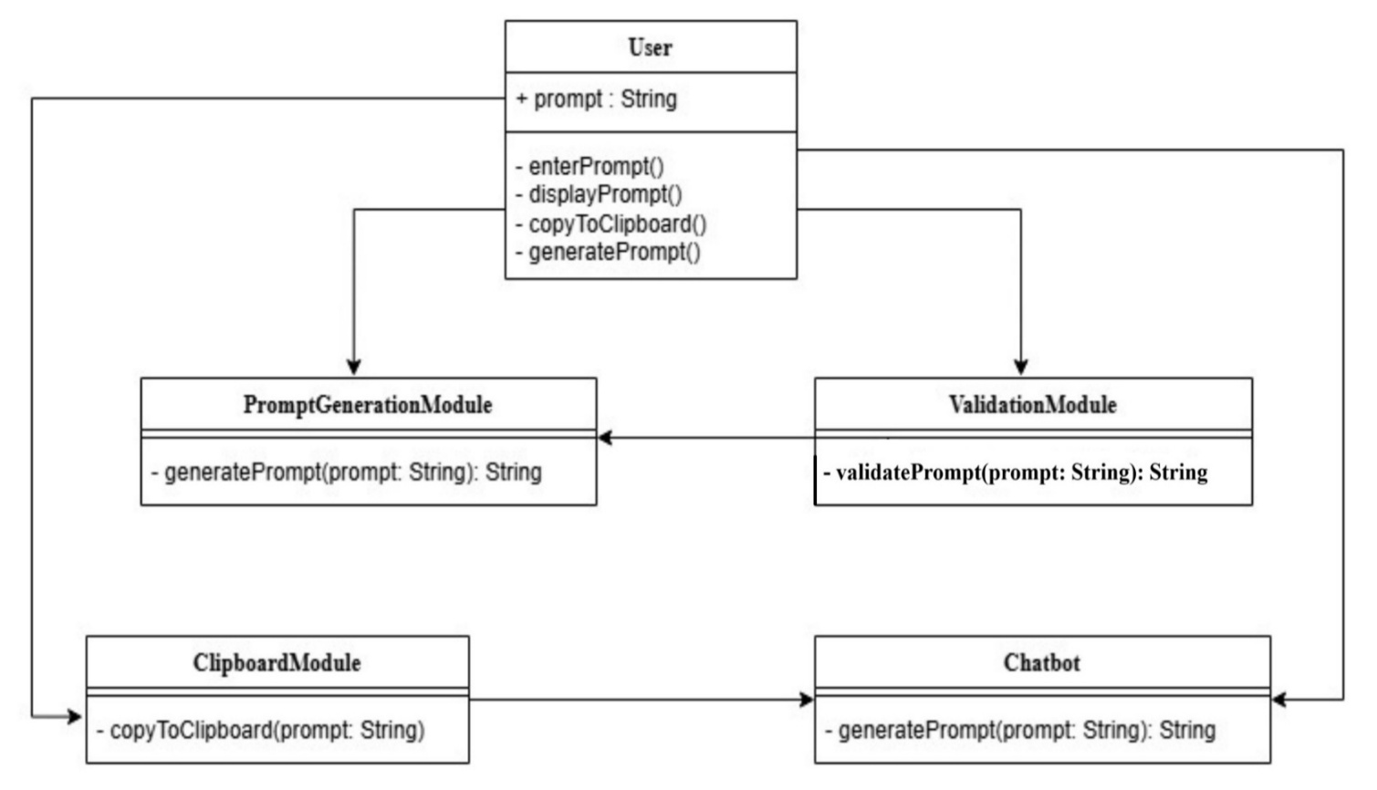

Fig 4.3.2 (b) Class Diagram for PromptCraft

4.3.3 Sequence Diagram

Sequence diagram is used to represent the flow of messages, events and actions between the objects or components of a system. Time is represented in the vertical direction showing the sequence of interactions of the header elements, which are displayed horizontally at the top of the diagram.

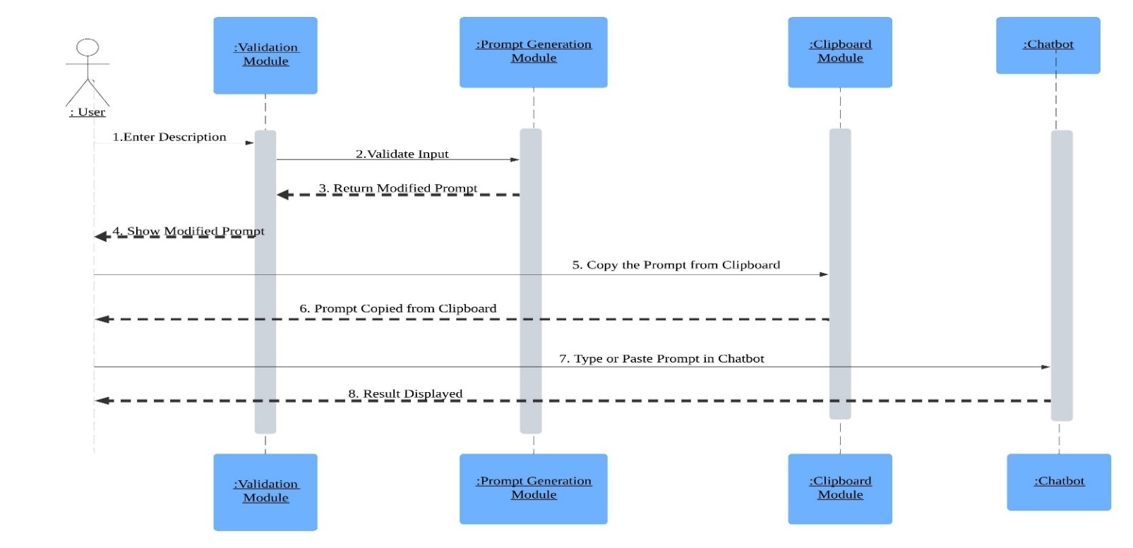

Fig 4.3.3(c) Activity Diagram for PromptCraft

4.3.4 Activity Diagram

Activity diagram represents the business and operational workflows of a system. An Activity diagram is a dynamic diagram that shows the activity and the event that causes the object to be in the particular state.
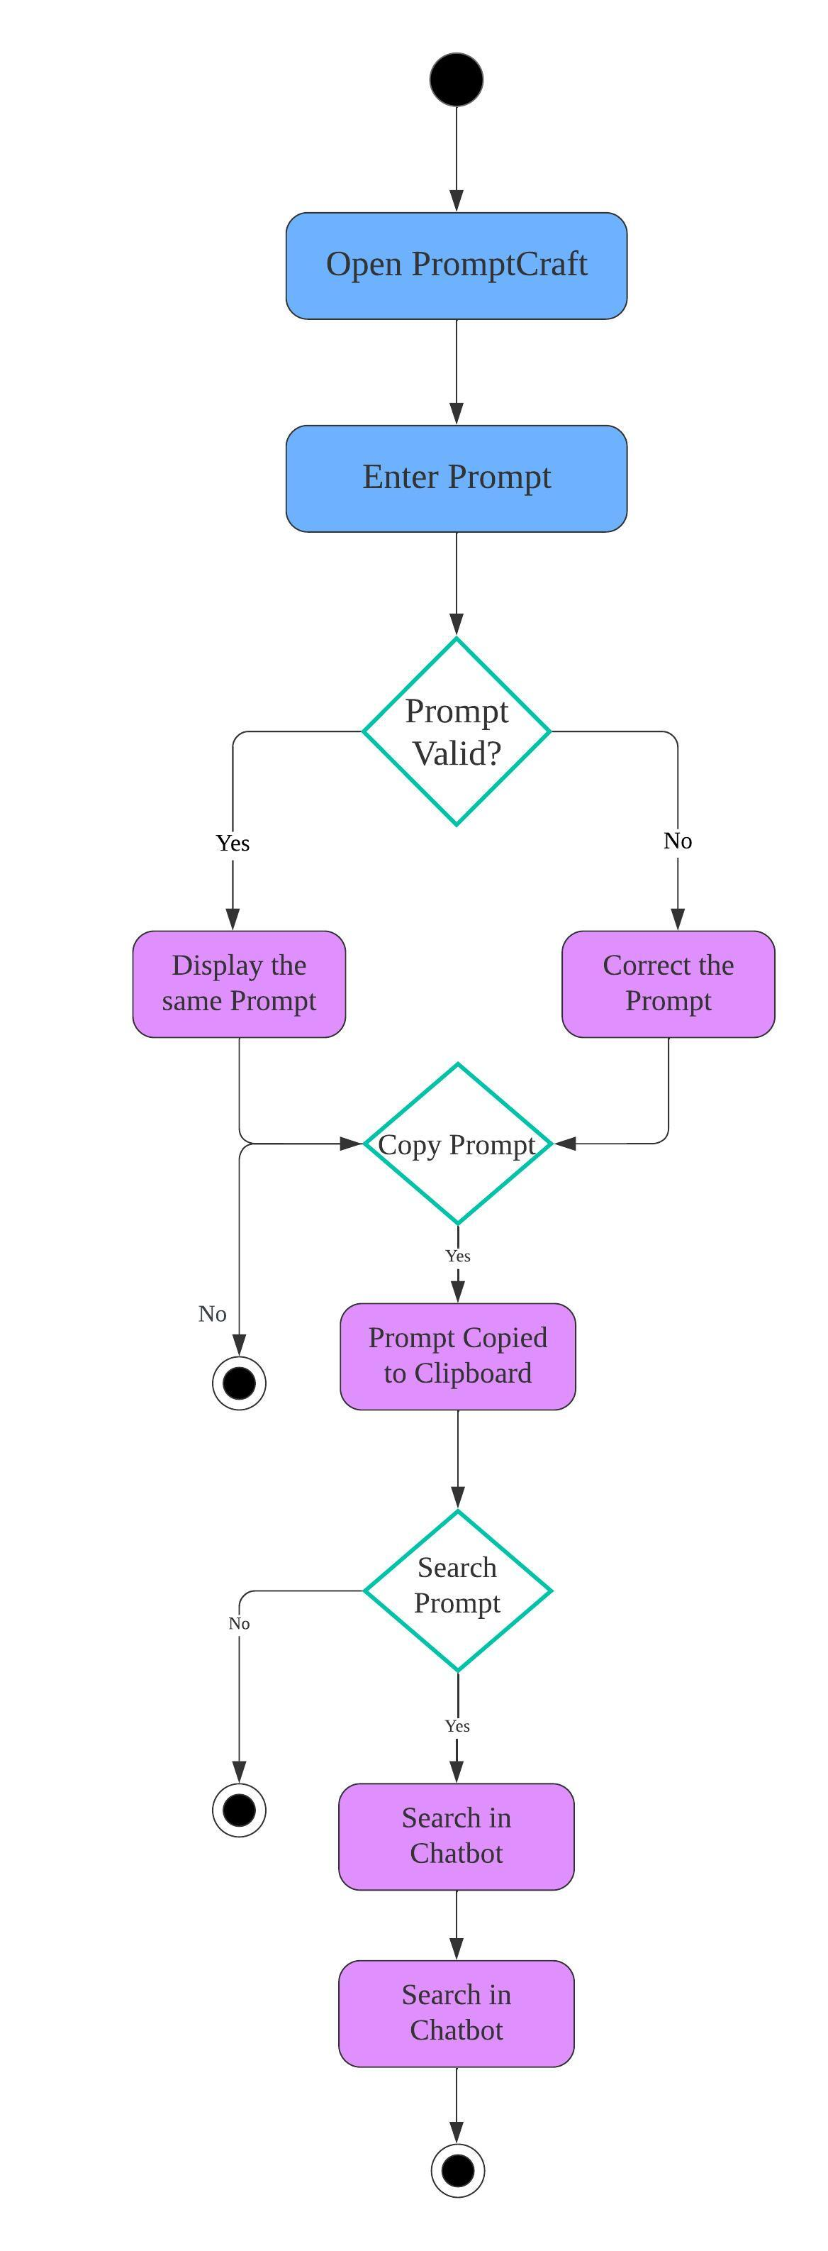

Fig 4.3.4(d) Activity Diagram for PromptCraft

4.4 Summary
A clean separation between UI logic, API handling, and model processing ensures easy extensibility and maintainability.

CHAPTER-5
IMPLEMENTATION
5.1 Algorithms
The PromptCraft system leverages a lightweight yet effective algorithmic flow centered around two core principles: caching and structured prompt generation. A dictionary-based caching mechanism is employed to reduce redundant prompt generation requests. Keys are stored in lowercase format to ensure uniformity and reduce repetition.
For prompt creation, a specially structured input format is defined to stimulate maximum creativity from the TinyLLaMA model. To achieve high-quality and imaginative outputs, parameters such as temperature, top_k, and top_p are carefully tuned. These settings help in generating concise yet novel writing prompts.

5.1.1 Code
import tkinter as tk
from tkinter import messagebox
from threading import Thread
import customtkinter as ctk
import requests
import subprocess
import time
import psutil
import sys

class OllamaPromptGenerator:
def __init__(self, model_url="http://localhost:11434/api/generate"):
self.model_url = model_url
self.ollama_process = None
self.cache = {} # Add response caching
self.start_ollama_server()
self.ensure_model_loaded()

def start_ollama_server(self):
if not self.is_ollama_running():
try:
print("Starting Ollama server...")
self.ollama_process = subprocess.Popen(
[r"C:\\Users\\Bhargav\\AppData\\Local\\Programs\\Ollama\\ollama.exe", "serve"],
stdout=subprocess.DEVNULL, stderr=subprocess.DEVNULL
)
for attempt in range(20):
if self.is_ollama_running() and self.is_ollama_ready():
print(f"Ollama is ready after {attempt + 1} attempts.")
return
time.sleep(1)
messagebox.showerror("Error", "Ollama did not start in time.")
except FileNotFoundError:
messagebox.showerror("Error", "Ollama executable not found. Ensure it's installed and added to PATH.")

def is_ollama_running(self):
for process in psutil.process_iter(['name']):
if "ollama" in process.info['name'].lower():
return True
return False

def is_ollama_ready(self):
try:
response = requests.get("http://localhost:11434/api/tags", timeout=2) # Reduced timeout
return response.status_code == 200
except requests.RequestException:
return False

def ensure_model_loaded(self):
model_name = "tinyllama"
try:
response = requests.get("http://localhost:11434/api/tags", timeout=10)
if response.status_code == 200:
models = response.json().get("models", [])
if not any(model.get("name") == model_name for model in models):
print(f"Model '{model_name}' is not detected, but skipping download as per user request.")
except requests.RequestException as e:
print(f"Error ensuring model is loaded: {e}")

def generate_prompt(self, description):
# Check cache first
cache_key = description.strip().lower()
if cache_key in self.cache:
return self.cache[cache_key]

structured_prompt = f"""
### Task:
Generate a **concise and thought-provoking writing prompt** based on the following description.

### Description:
{description}

### Instructions:
- **Only output a single, creative writing prompt.**
- Do **NOT** generate exercises or story outlines.
- The prompt should be **under 50 words** and **spark imagination and storytelling.**
- **Strictly avoid adding additional guidance or tips.**
"""

payload = {
"model": "tinyllama",
"prompt": structured_prompt,
"stream": False,
"options": {
"num_predict": 75, # Reduced from 100 for faster response
"temperature": 0.7, # Increased for more creative responses
"top_k": 40, # Increased for better variety
"top_p": 0.9, # Increased for better quality
"repeat_penalty": 1.1, # Add repeat penalty for better coherence
"stop": ["###"] # Add stop token for more concise responses
}
}

try:
response = requests.post(self.model_url, json=payload, timeout=15) # Reduced timeout
response.raise_for_status()
result = response.json().get("response", "No response generated.")
self.cache[cache_key] = result # Cache the response
return result
except requests.RequestException as e:
return f"Error: {e}"

def stop_ollama_server(self):
if self.ollama_process:
self.ollama_process.terminate()

class PromptChatApp:
def __init__(self, root):
self.root = root
self.root.title("PromptCraft")
self.root.geometry("900x600")
self.root.resizable(False, False)

ctk.set_appearance_mode("Dark")
ctk.set_default_color_theme("dark-blue")

self.prompt_generator = OllamaPromptGenerator()
self.create_ui()
self.root.protocol("WM_DELETE_WINDOW", self.on_close)

def create_ui(self):
frame = ctk.CTkFrame(self.root, corner_radius=20)
frame.pack(fill=tk.BOTH, expand=True, padx=20, pady=20)

ctk.CTkLabel(frame, text="PromptCraft", font=("Arial", 24, "bold")).pack(pady=10)

self.description_input = ctk.CTkTextbox(frame, height=100, width=600, corner_radius=15, fg_color="#2A2D3E", text_color="white")
self.description_input.pack(pady=10)

self.generate_button = ctk.CTkButton(
frame, text="Generate Prompt", command=self.generate_prompt, corner_radius=25, height=40, width=200, fg_color="#007BFF"
)
self.generate_button.pack(pady=10)

self.output_text = ctk.CTkTextbox(frame, height=200, width=600, state=tk.DISABLED, corner_radius=15, fg_color="#1E1E2E", text_color="white")
self.output_text.pack(pady=10)

self.copy_button = ctk.CTkButton(
frame, text="Copy to Clipboard", command=self.copy_to_clipboard, state=tk.DISABLED, corner_radius=25, height=40, width=200, fg_color="#28A745"
)
self.copy_button.pack(pady=5)

self.status_label = ctk.CTkLabel(frame, text="Ready", font=("Arial", 10))
self.status_label.pack(pady=5)

def generate_prompt(self):
description = self.description_input.get("1.0", tk.END).strip()
if not description:
messagebox.showerror("Input Error", "Please enter a description.")
return

self.status_label.configure(text="Generating prompt...")
self.generate_button.configure(state=tk.DISABLED)
self.root.update()

def run_generation():
prompt = self.prompt_generator.generate_prompt(description)
self.root.after(0, lambda: self.display_prompt(prompt))

Thread(target=run_generation).start()

def display_prompt(self, prompt):
self.output_text.configure(state=tk.NORMAL)
self.output_text.delete("1.0", tk.END)
self.output_text.insert("1.0", prompt)
self.output_text.configure(state=tk.DISABLED)
self.copy_button.configure(state=tk.NORMAL)
self.generate_button.configure(state=tk.NORMAL)
self.status_label.configure(text="Ready")

def copy_to_clipboard(self):
prompt = self.output_text.get("1.0", tk.END).strip()
self.root.clipboard_clear()
self.root.clipboard_append(prompt)
self.root.update()
messagebox.showinfo("Success", "Prompt copied to clipboard!")

def on_close(self):
self.prompt_generator.stop_ollama_server()
self.root.destroy()

if __name__ == "__main__":
root = ctk.CTk()
app = PromptChatApp(root)
root.mainloop()

5.2 Architectural Components
The system architecture is split into two key components:
- OllamaPromptGenerator:
This module manages all backend processes. It is responsible for:
  - Starting and verifying the Ollama local server.
  - Checking for the presence of the TinyLLaMA model.
  - Sending prompt requests and receiving responses.
  - Caching responses for efficiency.
- PromptChatApp:
This is the front-end component built using Tkinter and CustomTkinter. It facilitates:
  - User interaction via a graphical interface.
  - Triggering prompt generation using threading (to avoid freezing the UI).
  - Displaying and copying the generated prompts.
  - Handling server shutdown on application exit.

5.3 Feature Extraction
Feature extraction is achieved by designing a well-defined structured prompt template. This template explicitly guides the Large Language Model (LLM) on the expected format and tone of the output.
Key aspects include:
- Hand-crafted prompt instructions to limit verbosity and encourage story-driven creativity.
- Dynamic configuration of parameters:
  - temperature = 0.7 for a balance of creativity and coherence.
  - top_k = 40 and top_p = 0.9 for increasing diversity and fluency.
  - repeat_penalty = 1.1 to minimize redundancy.
These parameters ensure high-quality, short, and imaginative writing prompts.

5.4 Packages / Libraries Used
The system integrates the following Python packages and libraries:
- tkinter: Standard Python GUI toolkit for desktop application development.
- customtkinter: A modern framework based on Tkinter that allows dark themes and advanced UI components.
- requests: For making HTTP requests to the Ollama server API.
- subprocess: Used to launch the Ollama executable as a separate background process.
- psutil: To monitor system processes and confirm if Ollama is running.
- threading: Enables background operations (like prompt generation) without freezing the UI.
- json: Used for parsing and handling JSON-formatted API responses.
5.5 Output Screens
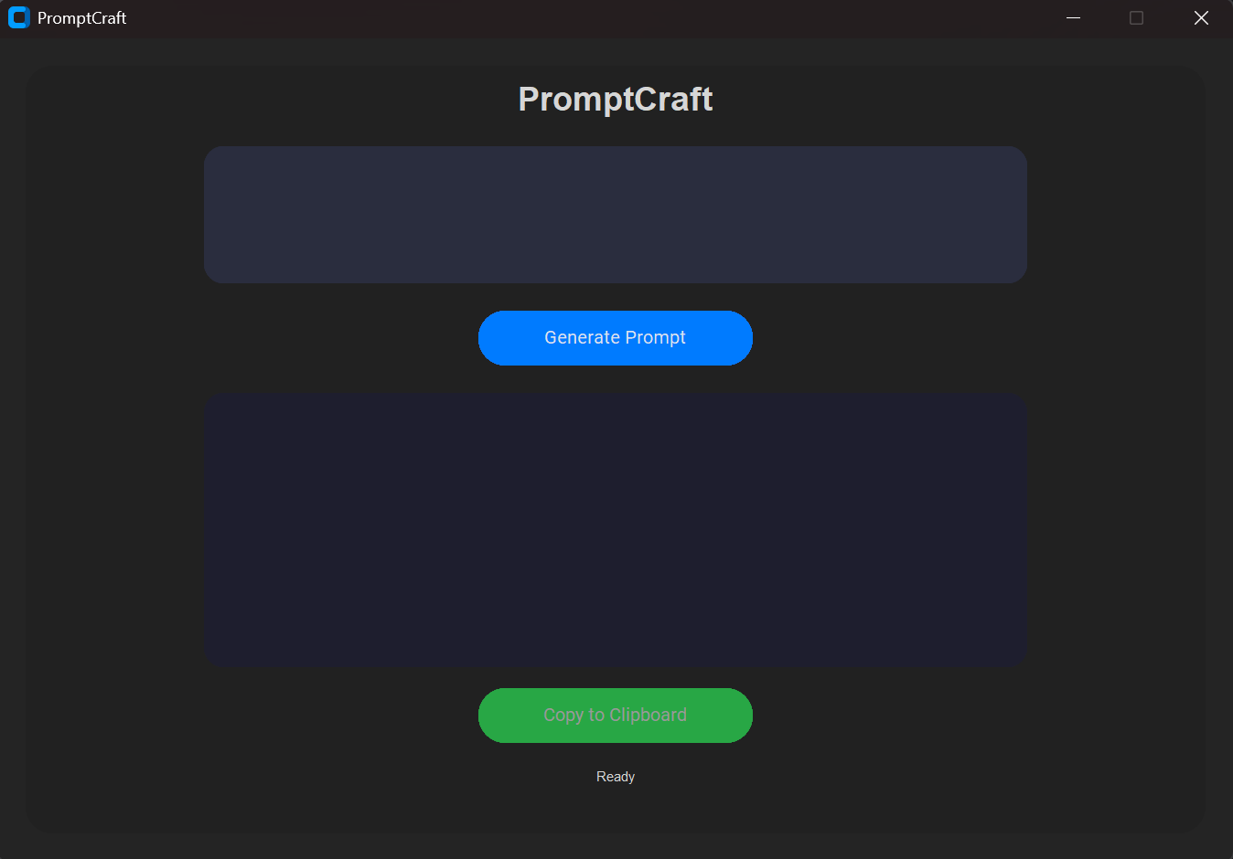
Fig 5.5(a) HomePage of PromptCraft

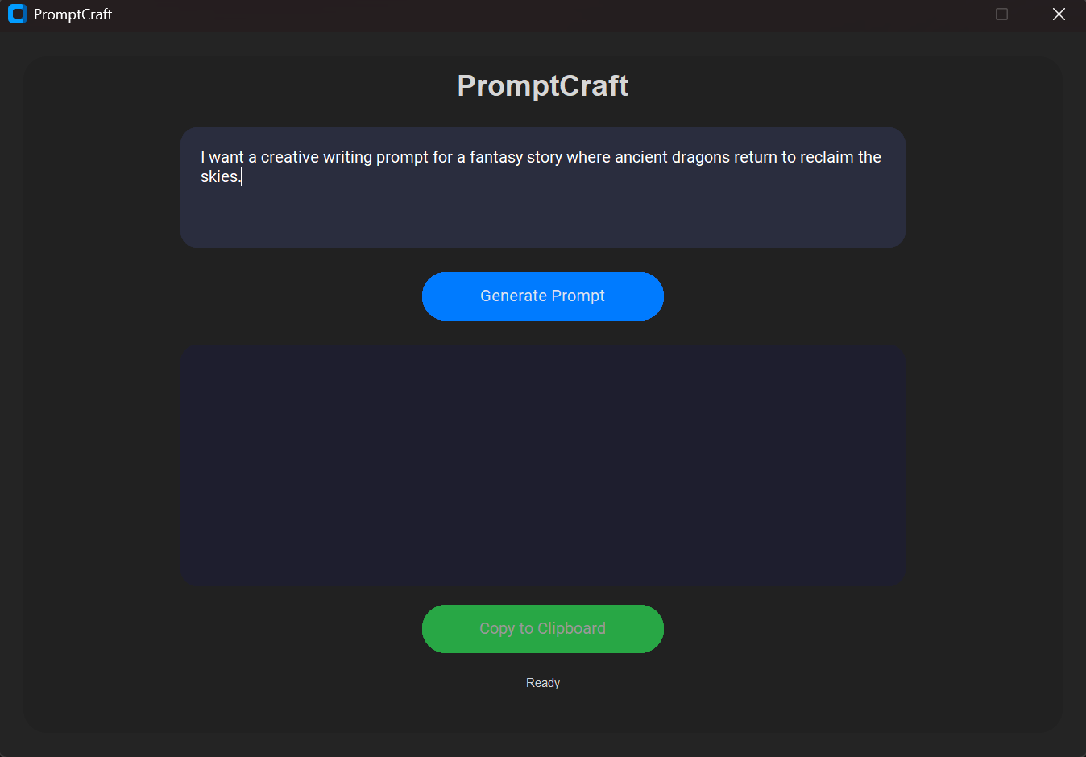
Fig 5.5(b) Entered the Prompt and Clicking Generate Prompt in PromptCraft

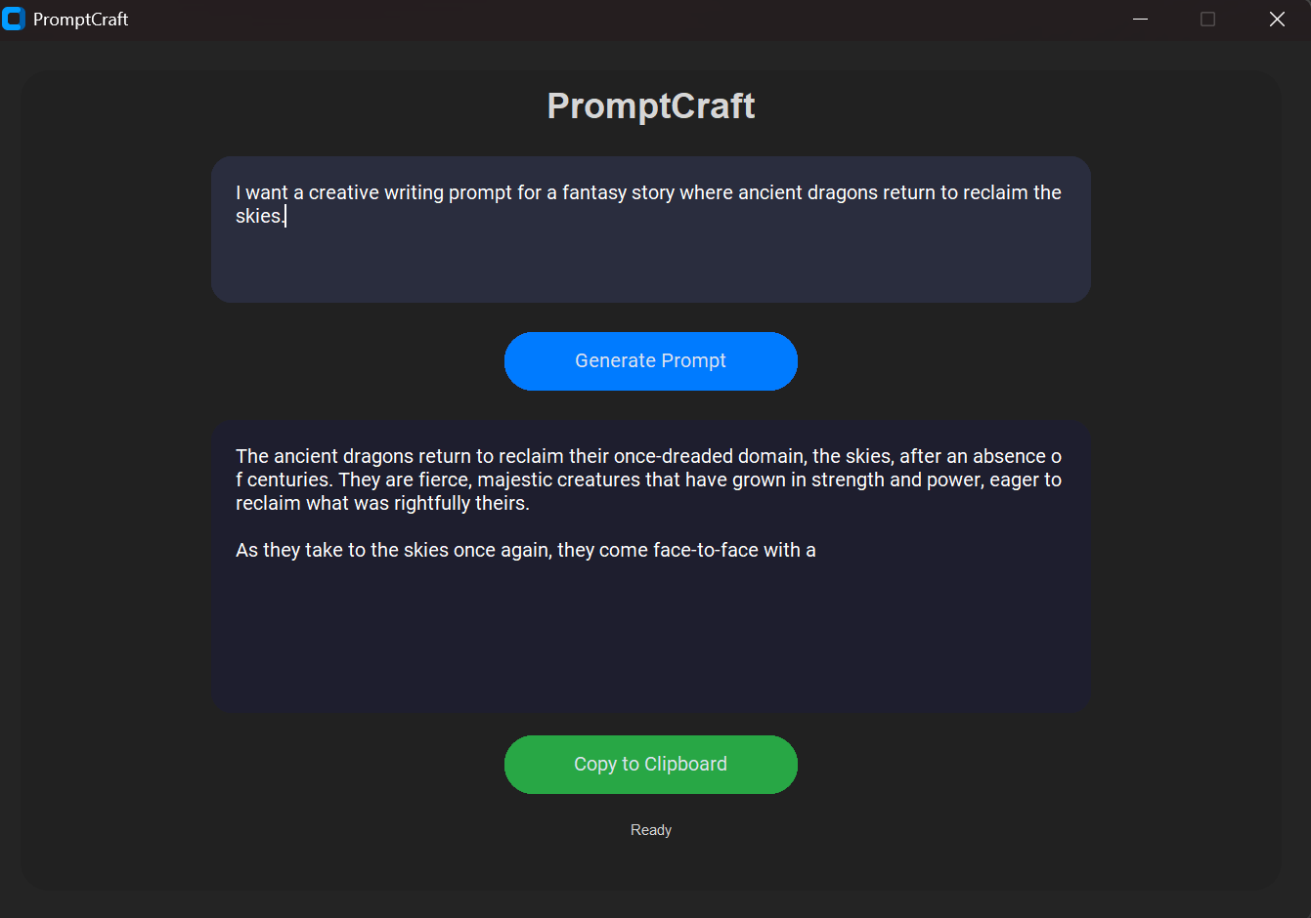
Fig 5.5(c) After clicking Generate Prompt the result by PromptCraft

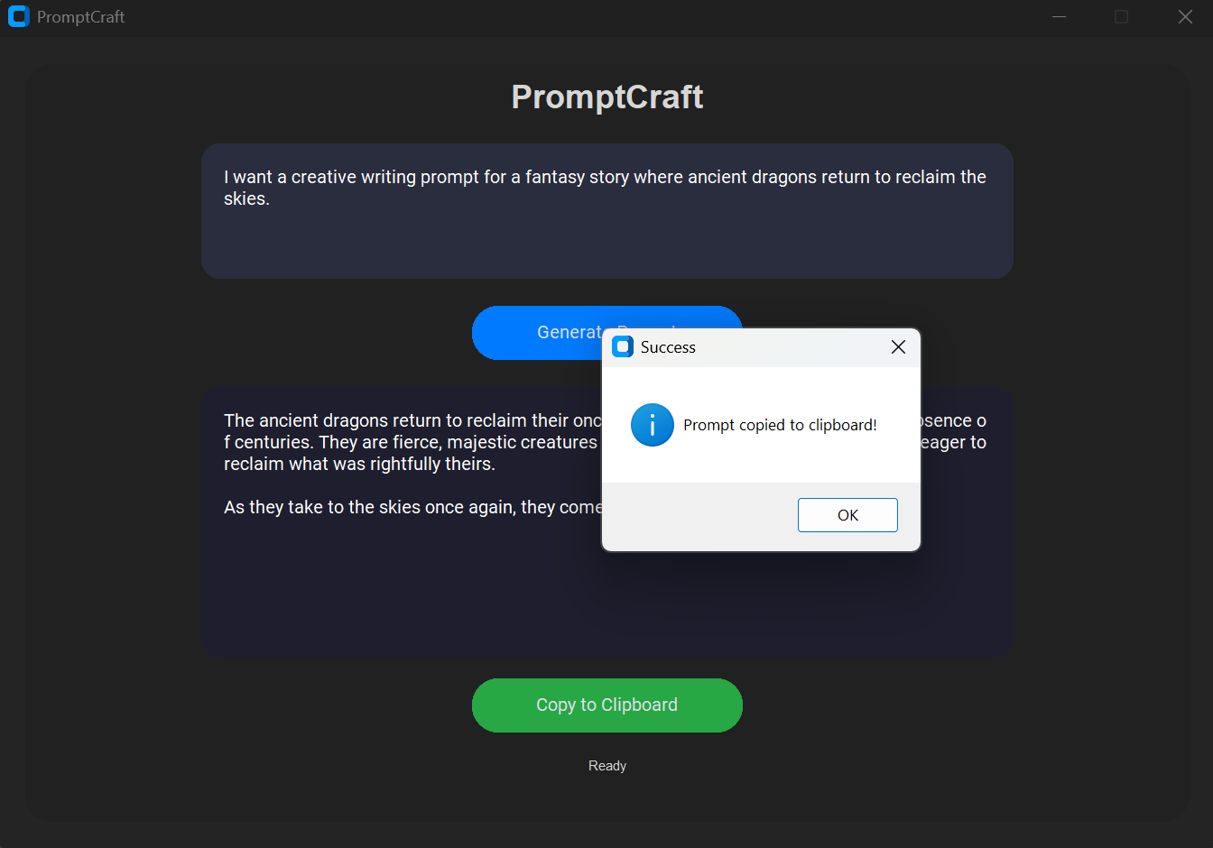
CHAPTER 6
SYSTEM TESTING
6.1 Introduction
System testing plays a crucial role in validating the stability, reliability, and user experience of the PromptCraft application. The testing phase ensures that both the backend components (like the prompt generator, server checker, and model loader) and frontend components (like the GUI, input fields, and buttons) function correctly and consistently under various conditions.
All components were evaluated for functionality, performance, user input handling, and error management to ensure a seamless offline experience.
6.2 Test Cases
Several test cases were designed to assess the robustness of the application. The following key scenarios were tested:
- Input Validation:
  - Ensures the application prompts an error when the user attempts to generate a prompt without entering a description.
  - Handles whitespace or invalid input correctly.
- Ollama Server Availability:
  - Verifies that the application detects whether the Ollama local server is running or not.
  - Displays relevant error messages if the server fails to start.
- Model Loading Behaviour:
  - Confirms that the model is correctly detected from the local list of installed models.
  - Handles errors gracefully when the model is missing.

- Clipboard Copy Functionality:
  - Ensures the generated prompt is copied accurately to the clipboard.
  - Validates confirmation feedback to the user after copying.

- Prompt Caching Efficiency:
  - Verifies that repeated descriptions return cached responses quickly without invoking the LLM again.
  - Confirms the consistency of results from cache.

6.3 Results and Discussions
The PromptCraft system demonstrated stable and consistent behavior across all tested scenarios.
All input validation checks passed, ensuring that users receive helpful messages for empty inputs. The Ollama server integration worked smoothly, with error prompts when startup issues occurred. Clipboard features and threading mechanisms worked without UI freeze or lag.
6.4 Performance Evaluation
Performance testing of PromptCraft highlighted the following metrics:
- Prompt Generation Time:
  - Initial request after loading the model takes approximately 2 to 3 seconds.
  - Cached prompt responses return instantly.
- Memory Usage:
  - Total memory footprint remains under 200 MB, even with the server running in the background.

- Responsiveness:
  - GUI remains responsive during long-running tasks due to threading.
  - No freezing or lag observed during normal usage.
These metrics confirm that PromptCraft is lightweight and efficient, making it well-suited for offline usage even on modest hardware.
6.5 Summary
System testing validated that all functional and non-functional requirements were fulfilled successfully. The application:
- Handles errors gracefully.
- Delivers fast prompt generation.
- Operates entirely offline.
- Provides a clean and interactive user interface.
The caching system significantly improves repeated prompt generation times. The application is ready for deployment in educational, creative, and offline writing environments.

CHAPTER 7
CONCLUSION AND FUTURE ENHANCEMENTS
Conclusion
PromptCraft effectively demonstrates how Large Language Models (LLMs) like TinyLLaMA can be integrated into an offline desktop application for creative writing.
By leveraging Ollama's local inference server, PromptCraft eliminates the need for constant internet access. The structured prompt design and tuned generation parameters ensure that the output is imaginative, relevant, and within the required limits.
The GUI, built using Tkinter and CustomTkinter, offers a user-friendly interface, making prompt creation easy for users of all technical backgrounds. With features like clipboard copy, status updates, and error handling, the application is both efficient and accessible.
Future Enhancements
To further improve PromptCraft, the following enhancements are proposed:
- Model Selector:
  - Allow users to choose between different models (e.g., TinyLLaMA, LLaMA 2, or future variants).
- Prompt History Log:
  - Enable saving and viewing of previously generated prompts for future reference.
- Writing Genre Selector:
  - Introduce dropdowns for genres such as horror, fantasy, sci-fi, romance to guide the prompt generation tone.

- Export Functionality:
  - Add options to export generated prompts to PDF or .txt files for easy sharing and saving.
- Voice Input Integration:
  - Use speech recognition libraries (like speech_recognition or vosk) to convert user speech into prompt descriptions.
These enhancements aim to elevate PromptCraft into a comprehensive tool for writers, students, and content creators seeking offline inspiration.

CHAPTER 8
REFERENCES
•Python Software Foundation. (n.d.). Tkinter – Python’s Standard GUI Toolkit. Retrieved from https://docs.python.org/3/library/tkinter.html
•Sustainable Development Goals. (n.d.). United Nations SDGs. Retrieved from https://sdgs.un.org/goals
•AI Writing Tools and Resources. (2023). Jasper AI, Copy.ai, Writesonic. Retrieved from respective product websites.

LIST OF FIGURES

Fig. No | Figure Title | Page no.
4.1 | Architecture Diagram | 12
4.2 | Dataflow Diagram | 13
4.3.1 | Class Diagram | 14
4.3.2 | Use Case Diagram | 15
4.3.3 | Sequential Diagram | 16
4.3.4 | Activity Diagram | 17

LIST OF TABLES

S. No | Table Name | Page No
1. | Input Validation | 29
2. | Ollama Server Availability | 29
3. | Model Loading Behaviour | 29
4. | Clipboard Copy Functionality | 30
5. | Prompt Caching Efficiency | 30

LIST OF ABBREVIATIONS
S. No | ABBREVIATIONS
1. | LLM-Large Language Model
2. | API-Application Programming Interface
3. | JSON-JavaScript Object Notation
4. | CLI-Command Line Interface
5. | NLP-Natural Language Processing

