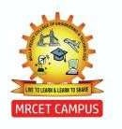
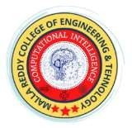
COMPUTATIONAL INTELLIGENCE | MRCET
(CSE – ARTIFICIAL INTELLIGENCE AND MACHINE LEARNING)
Email: mrcetsocse4@mrcet.ac.in
IV Year B. Tech-I Semester Mini Project Summary Sheet
Project Title: |  | Memora: Document-Aware AI for Goal-Centric Personal Assistance and Customized Task Scheduling
Project Code: |  | R22A6694 |  | Batch Size: |  |  | 03 | Batch: |  | 22CSMMP14
Domain / Area: |  | Generative AI |  | SDG Mapping |  | Industry, Innovation and Infrastructure
Abstract: |  | Memora is a local AI-powered scheduling assistant designed to redefine personal productivity by combining natural language interaction with intelligent calendar management. Unlike cloud-based tools, it ensures complete data privacy by running entirely on-device, leveraging FastAPI, Next.js, and Ollama with Qwen 2.5 7B for local LLM inference. The system introduces a conversational interface capable of handling complex scheduling requests, detecting conflicts, and integrating with personal documents through retrieval-augmented generation (RAG). With real-time synchronization across chat and calendar views, semantic search, and bulk task operations, Memora delivers an intuitive yet privacy-first productivity solution while laying the foundation for future collaborative and multi-modal AI assistants.
Technical (S/w & H/w) Specifications |  |  |  | Module(s) Specifications
 |  |  |  | Module 1: UI — Chat, calendar, documents.  Module 2: Chat — AI conversation I/O.  Module 3: Agent — Intent, context, conflict resolution,  planning.  Module 4: Vector Memory — ChromaDB embeddings +  document OCR/RAG.  Module 5: Task Store/API — JSON tasks CRUD + FastAPI  endpoints
  Software Requirements | Hardware Requirements:
  - Python 3.12  - Node.js 18  - Ollama (qwen2.5:7b)  - ChromaDB  - Poppler, Tesseract |  | - 16GB RAM  - Ryzen 7 5800H  - RTX 3050  - 10GB free space
Architecture Diagram |  |  |  | Methodology
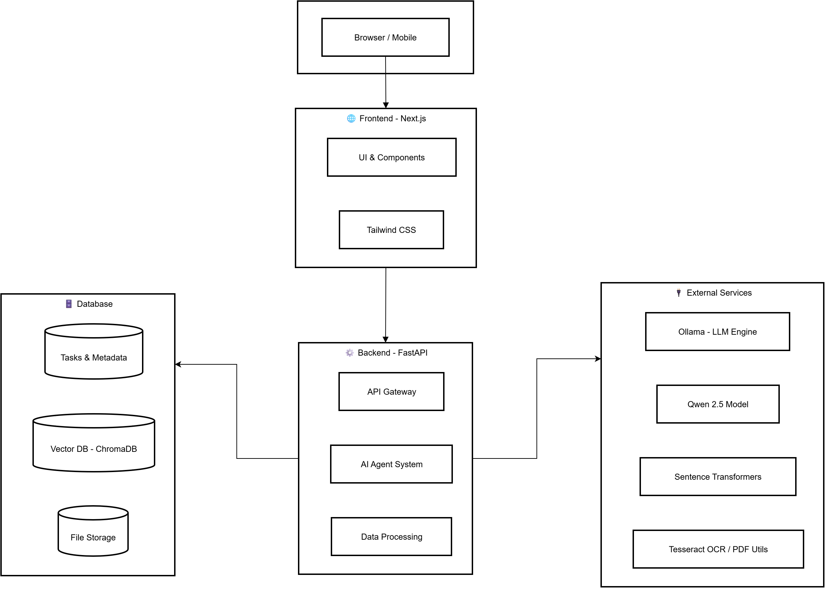 |  |  |  | - Chat → intent → task ops → response → UI sync.  - LangGraph agent: context + conflict handling.  - Qwen 2.5 via local Ollama (low temp, hybrid CPU/GPU).  - RAG: extract → OCR → chunk → embed → Chroma search.  - Storage: JSON tasks; SQLite‑backed Chroma vectors.  - Endpoints: /chat, /tasks, /tasks/today, /tasks/stats, /health.
Existing System |  |  |  | Proposed System
- Manual entries, forms.  - No AI intent/conflict handling.  - Cloud-tied, privacy risk.  - Fragmented chat/calendar/docs. |  |  |  | - ANL chat scheduling with AI.  - Auto conflict detection/resolution.  - Local-first, offline, private.  - Unified chat + calendar + docs.
Guide Details |  |  |  | Batch Members Details
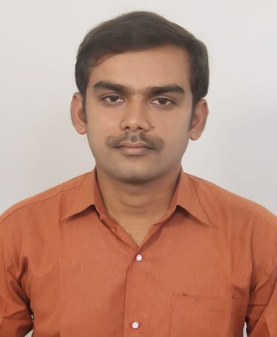 | Talluri Haribabu  Assistant professor in Department of CSM  MRCET Campus  UGC Autonomous Institution  -Govt. of India Hyderabad |  | 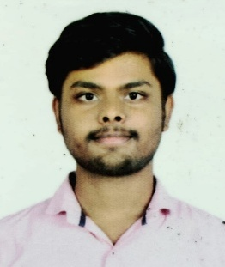 |  | 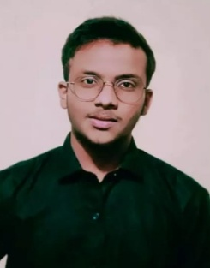 |  |  |  | 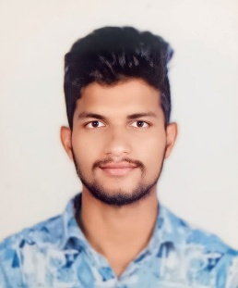
 |  |  | Durishetty Anirudh |  | Bonjuri Raghuvardhan |  |  |  | Arelli Karthikeya
 |  |  | 22N31A6648 |  | 22N31A6631 |  |  |  | 22N31A6611

