Tandem solar cell

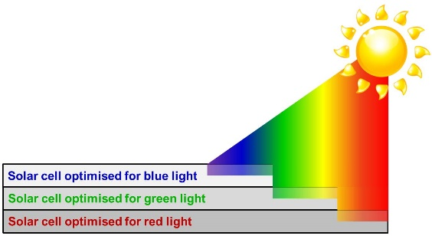[1]Tandem solar cell is another solar cell that is processed/produced by solution process. So, tandem cells are a stack of different solar cells on top one another. There is a reason on why is it arranged like this, it is because it can capture more energy from the sun. For an instance, a solar cell is designed to work really well when it absorbs blue light, we could put it next to one that absorbs green light well and one that absorbs red light well so that we can capture more energy from the sun. Tandem solar cells are invented to overcome theoretical limit, by using different solar cells which absorb different parts of the visible light spectrum, the value of theoretical limit can be increased, more than 33%. When stacking the cells, there is a certain order that need to be followed. Blue light has more energy than red and green, so the semiconductor(one of the components used in solar cells) material that absorbs it has a bigger band gap. Band gap simply means energy range which needs to be overcome before the semiconductor will conduct electricity. So to make use of the sunlight most efficiently, the light should reach blue absorber first.

Fig 2. The order of light that light /sun reaches first.

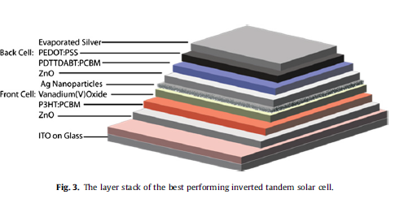[2]Tandem solar cells with normal and inverted geometries can be prepared by a solution process. We going to give a very brief explanation on how inverted tandem solar cell is it prepared. Before that, both device types were based on the use of zinc(ii)oxide as the electron transporting layer. The method that is used to prepare is fabrication process under ambient conditions. For the first layer, the glass/ITO substrate was spin-coated with Zn(OAc)22H2O, then dissolved in methanol, followed by annealing for 10 mins. For the second layer; P3HT(17 mg/ml):PCBM(15 mg/ml) was dissolved in chlorobenzene, was spin-coated at 1500 rpm for 30 s leading to an estimation the thickness of layer of 75 nm, followed by annealing and then cooling. Moreover for the third layer, a solution of vanadium(V)-oxiisopropoxide to be diluted with isopropanol to a concentration of 50 mg/ml were prepared, and applied by spin-coating and then followed by annealing. As for the fourth layer it was made by spin-coating Zn(OAc)2H2O/methanol solution at 1000 rpm for 30 s, followed by annealing. As for the fifth layer also known as the active layer of the back cell for all device types was prepared from a blend of 15 mg/ml of PDTTDABT or P3HT mixed with 15 mg/ml of PCBM and dissolved in cholorobenzene. The final metal back electrode was applied with evaporation through a shadow mask in a vacuum chamber under a certain pressure and the metal being Ag.