What's new
- Sentiment analysis has nice results for cryptocurrencies (bitcoin, ethereum, altcoins)!
- In often release OSS projects sentiment nicely follows release frequency
- Pairing – inverse approach shows almost 50% similarity but how can I find it?
  - Parsing github.com/project/issues/issue_id and getting issue description + then calculating similarity to reddit discussion
- Text & Framework structure
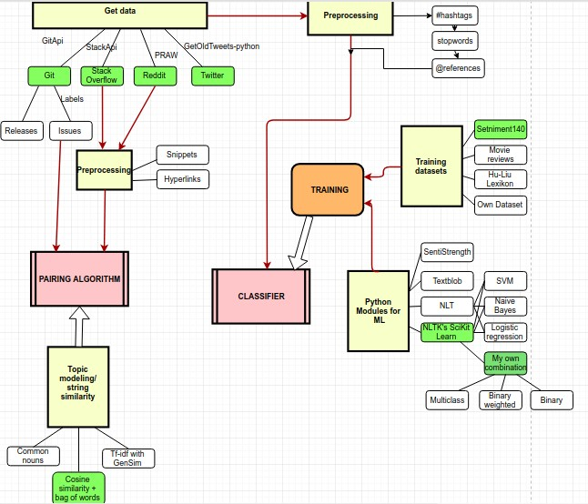

Questions:
- Is there some LateX form/guidelines I should follow in writing?
- Statistics seminar teacher: I know the items are there (similarity 0.5), but there's noise even with similarity 0.7 (maybe create buckets of similarity intervals and test percentage of containing matching item) – too much noise
- Statistics seminar teacher: How to narrow down so many parameters?
- Tangine about Toreador? (uses same classifier)
- Software for drawing flow diagrams? - Yed (https://www.yworks.com/products/yed)

To Do
- Sentiment reaction on weighted releases (number of commits – still can't get it)
- increase size of my own dataset and (now 180)
- pairing solution - buckets
- get the dataset from related paper

Discusse points:
- Framework in 2 separate points (pairing, sentiment)
- each point will have variation points (parameters like datasets, generic implementation)

