OSS projects
- jQuery
- Node.js
- Bootstrap
- Ruby on Rails
- Aurelia.js

- not just dev tools

Social Media
- Facebook – Graph API
- Twitter – Twitter API
- Reddit – Reddit API (30 requests/minute)
- (Stack OF)
- (Tumblr, Google+)

- Analyse the social media

Sentiment Analysis:
- Dataset
  - AFINN-111 (2477 words)
  - An English Word Database of EMOtional TErms (EMOTE - 1287 nouns and 985 adjectives)
  - Collaboration with Amy Warriner and Victor Kuperman (Amazon Mechanical Turk)
  - Affective Norms for English Words (ANEW - 1034 words..https://github.com/sbma44/begin_anew)
  - SentiWordNet
  - Hu and Liu's lexicon

- google play/appstore mining comments and ratings (sentiment analysis of appstore reviews)
Questions:
  - Do the OSS projects which release more often get general better sentiment score on social media?
  - Is there a difference in sentiment score of user response among various releases of different sizes
  - Is there a difference in volume of user response among various releases of different sizes
  - Is there a difference among social media response of dev tools vs end tools users (might be vs there is none)

Meeting 1

Twitter

- Rstudio with “twitteR” library (Udemy course)
- dendogram, histogram, frequent words, sentiment analysis
- Example: sentiment analysis with R on current week-old data
- Twitter API doesn't provide tweets older than 2 weeks
  - Twitter search is an option – but doesn't provide a flag to filter out the retweets (could be solved manualy by checking tweets content, but it's expensive)
  - https://github.com/Jefferson-Henrique/GetOldTweets-python
    - Example: Twitter search – lot of jquery post, but not many wihh jquery AND version
  - https://sifter.texifter.com – too expensive (money-wise)

Facebook
- access token set in
- Note that as of August 2014 and Graph API 2.0, Facebook has deprecated the post search functionality - Access to the Public Feed API is restricted to a limited set of media publishers and usage requires prior approval by Facebook. You cannot apply to use the API at this time (Feb 2017)
- '/v1.0/search' has been deprecated in 2.0 Version and your application can't use v1.0 API, if it was created after 30th April 2014
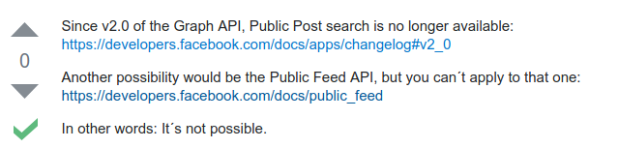
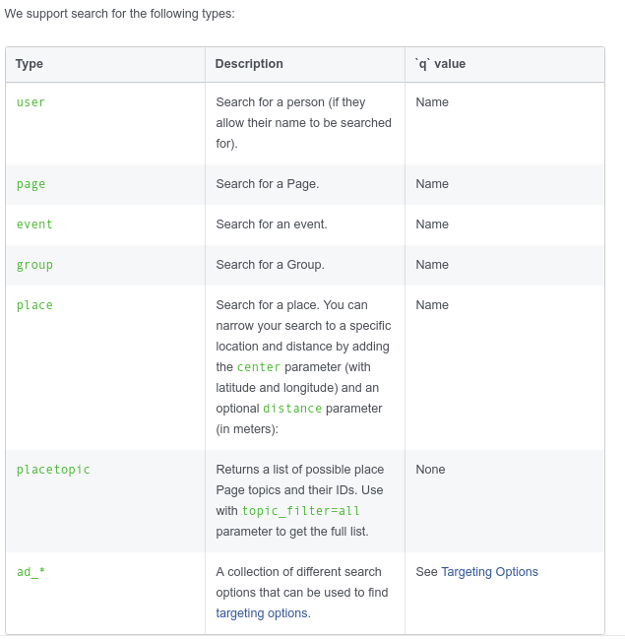
Example: Graph API Explorer (https://developers.facebook.com/tools/explorer/145634995501895/)

Reddit
- PRAW library
- data mining by keywords, hashtags and date possible but not enough data
- Example: getting all comments from specified subreddit in specified time interval

SO
- posts are more problem oriented, don't show any difference around release dates (cca 2 posts per release)
- option is to look for type of defects addressed on SO

GIT
- https://api.github.com/repos/django/django/git/refs/tags
- Example: parsing release versions and dates for given git repo urls

Data characteristics

Tweets around Release Dates - analysis
Audacity - no release response
Magento - big release response
GnuCash – no release response
LibreOffice – no release response
VLC player – no release response
ShotCut – not many tweets generally
Glassfish – not many tweets generally

Mozilla – too many releases
Apache httpd (http server) -too many releases (every couple of days)

Meeting 2
- is It possible to link SO items with their respective bug items in bugzilla (get bug → get version → get social media entries)
- risk based testing: - link tweets to software quality attributes (ISO 9126 external and internal quality)
- can we say something about quality properties/attributes (ISO 25000)
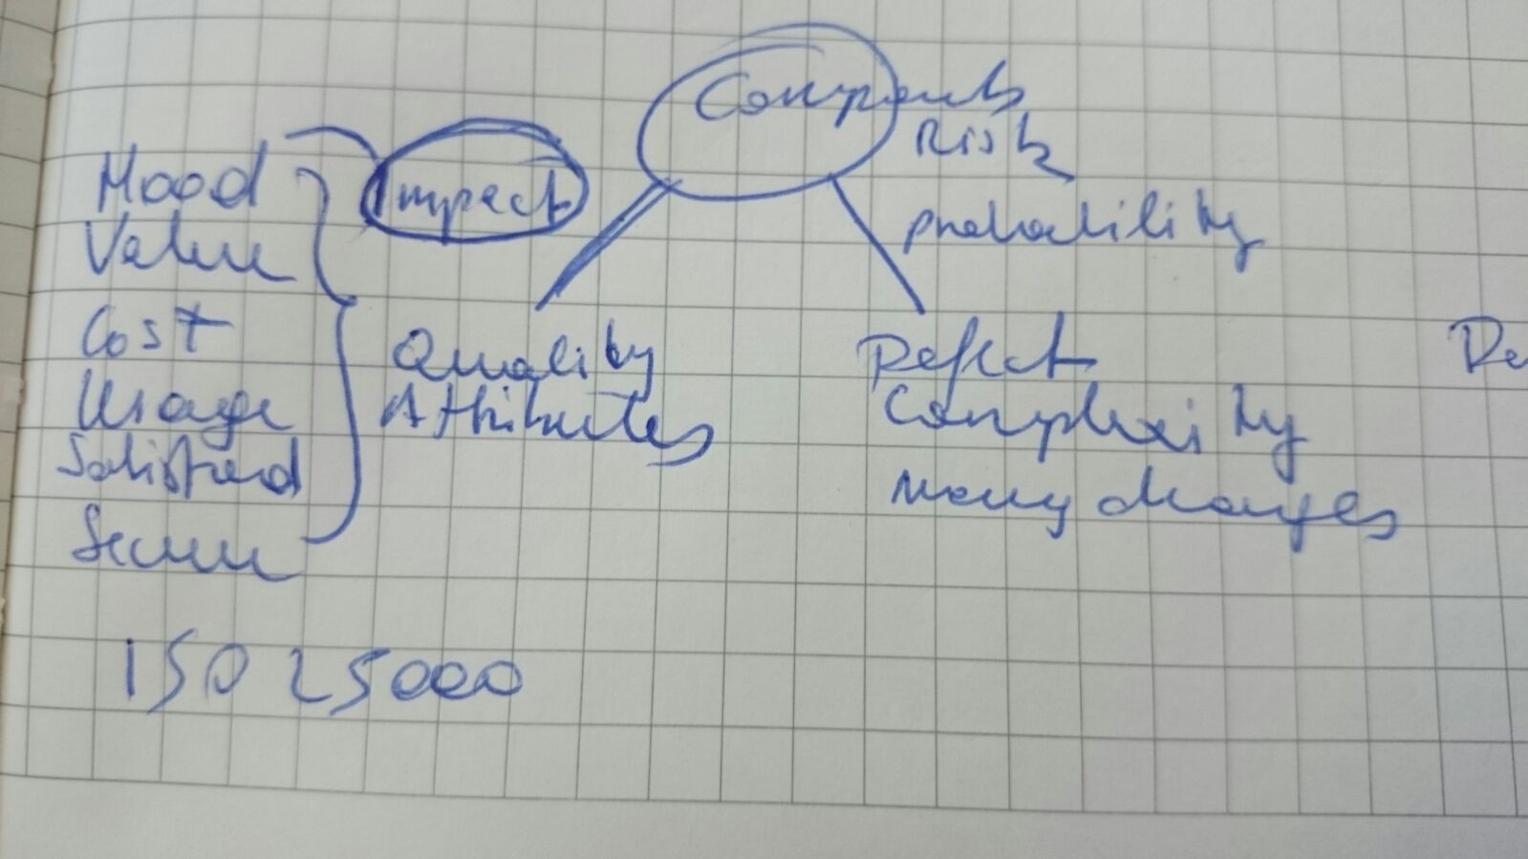

Meeting 3
Done in last 7 weeks
added several projects and cryptocurrencies to projects of choice

Release Dates (Git)

Twitter Data (Twitter):
- between releases
- continually every week between first and last release

Sentiment Analysis of tweets:
- Textblob
- Scikit learning module (SVN, 2 Naive Bayes algorithms, Logistic regression)
  - trained on tweets / movie reviews
  - vectorizer parameters tuning
  - data preprocessing

Bugs/Issues for projects (Git)

Stack overflow questions(Stack)

Pairing Items
- nouns extraction (word stemming)
- looking for specified ratio of shared nouns
- topic modeling

Problems
- sentiment is almost same for all projects (some popular cryptos show much less negative tweets though)
- not finding tweet – stack pairs (because tweets don't refer to bugs – I've inspected manually around 2000 of them)

Questions on professor
- does it make sense to continue with trying to find links between tweets and bugs?
- Would it be interesting from academical perspective to continue working with in cryptocurrency field (maybe shift more towards it? They are OSS projects)
- Other questions I could investigate

Tweets – are they about maintenability, security, usability (topic modeling)
- Real topic modeling not possible on such abstract similar topics
- Average maintainability score: 0.670160325966
Number of tweets: 42
Average usability score: 0.642389089497
Number of tweets: 65
Average security score: 0.648450042737
Number of tweets: 51
- there are around 8000 tweets for each project

Size of releases (backfired function points)
- Traversing through Git Api to get all commits and changes is problematic
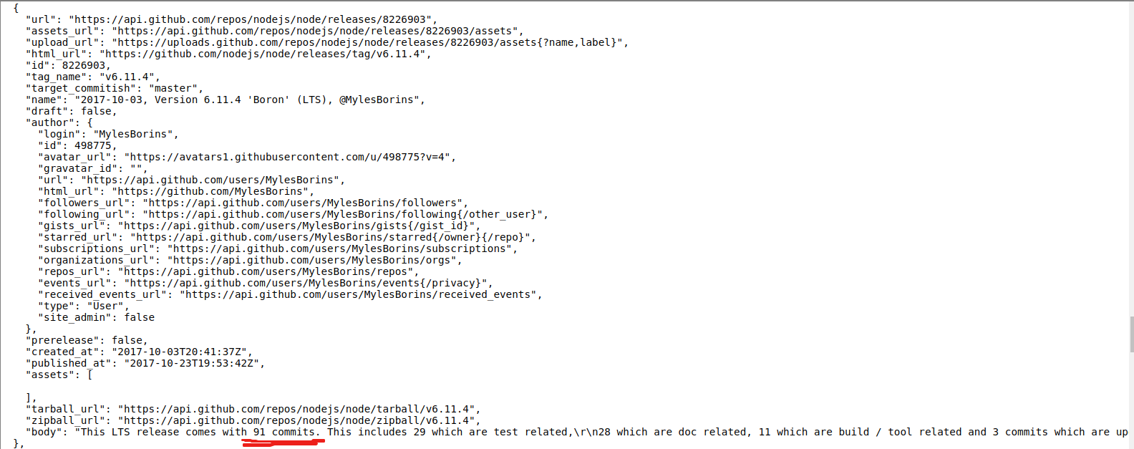

Function points:
- Number of user inputs
Number of user outputs
Number of user enquiries
Number of user files
Number of external interfaces
- http://groups.engin.umd.umich.edu/CIS/course.des/cis525/js/f00/artan/functionpoints.htm
- FP = k * SLOC (if written in the same language) – found in Carol Dekkers paper

Demographic analysis:
- you need an extra permission to authorize a user in order to get his hometown, and you can´t get the gender without authorization either.
- gender and age can be estimated from Social Security Administration name list as in e-cigarette paper
- if everything goes fine, I could have gender, name, age
- https://github.com/Jefferson-Henrique/GetOldTweets-python does not work right now (Twitter search limitations?)

- complementation with actual results from some other sentiment analysis
- topic maps
- on negative results of sentiment analysis tool for software engineerng results

