Conservation versus Trajectory Accuracy in Direct Gravitational N-Body Integration: A Benchmark of Euler, Velocity-Verlet, RK4, and Yoshida4
Daniel Durodola
Department of Physics, Faculty of Science, University of Lagos, Akoka, Lagos, Nigeria.
ORCID: 0009-0009-7171-4901 · danieldurodola02@gmail.com

Abstract
Numerical integration of gravitational N-body systems requires balancing trajectory accuracy, conservation, and computational cost. This study benchmarks direct Newtonian integration using forward Euler, velocity-Verlet, classical fourth-order Runge–Kutta (RK4), and Yoshida4. Experiments include analytical two-body validation, timestep convergence, long-duration eccentric motion, multi-year planetary configurations, binary dynamics, conservation diagnostics, direct-force scaling, and gravitational softening. For an eccentricity-0.9 Kepler orbit, an analytical solution of Kepler’s equation provides the reference for fixed-step methods. The measured global position-error orders over the finest usable grid levels are 1.93 for velocity-Verlet, 4.05 for RK4, and 4.00 for Yoshida4. Over 1,000 orbital periods at 10,000 steps per orbit, velocity-Verlet and Yoshida4 maintain bounded energy error while phase error accumulates; RK4 gives smaller phase drift than velocity-Verlet at this resolution but exhibits secular energy drift. A one-period figure-eight return test approaches a roughly 5×10⁻⁸ discrepancy floor associated with rounded initial conditions. The Pythagorean close-encounter test is not used to rank methods because the tested integration is under-resolved. The results illustrate that trajectory accuracy and invariant preservation are distinct criteria; they do not establish a new algorithm or superiority over established N-body packages.
Keywords: computational astrophysics; gravitational N-body problem; numerical integration; symplectic methods; conservation laws; work–precision; orbital dynamics

1. Introduction
The gravitational N-body problem describes the coupled motion of masses interacting through gravity. Numerical solutions support studies of planetary motion, asteroid and comet propagation, satellite trajectories, binary stars, and stellar systems. Even for Newtonian forces, the computed trajectory depends on the integration scheme, timestep, initial conditions, arithmetic precision, and diagnostic selected. A visually plausible orbit is not, by itself, evidence of numerical accuracy.
Direct summation evaluates every pairwise interaction and has O(N²) force-evaluation cost (Harfst et al., 2007; Aarseth, 2003). Its transparency makes it useful for small systems and validation studies, although the cost becomes prohibitive for large particle counts. Numerical integrators introduce a separate trade-off. Forward Euler is simple but generally poor for long conservative trajectories. Velocity-Verlet is second-order, time-reversible, and symplectic for the separable Hamiltonian systems considered here. Classical RK4 is not symplectic but can deliver high finite-time trajectory accuracy. Yoshida4 composes second-order symplectic maps to obtain fourth-order accuracy. Adaptive DOP853 provides a high-accuracy numerical baseline (Hairer, Nørsett, & Wanner, 1993), while an analytical Kepler solution offers a stronger reference for the two-body problem.
Energy error, angular-momentum error, and phase or position error are different quantities. A method may preserve energy within a bounded envelope yet accumulate phase error, and a close encounter can amplify small state discrepancies. This paper therefore combines analytical validation, convergence studies, invariant diagnostics, long-duration eccentric motion, work–precision analysis, and limited multi-body tests. The contribution is an inspectable benchmark for computational-physics education and method interpretation—not a new integration algorithm. External REBOUND and JPL Horizons comparisons are not claimed. The central questions are whether observed convergence orders match formal method orders, whether long-time energy behaviour tracks phase accuracy, and how much fixed-step accuracy is obtained per force evaluation. The experiments are chosen to answer these questions with analytical references where available, while explicitly separating finite-time accuracy from long-time geometric behaviour.

2. Related work
Geometric numerical integration explains why symplectic methods can preserve qualitative features of Hamiltonian systems over long integrations (Hairer, Lubich, & Wanner, 2006). Yoshida (1990) developed composition techniques for higher-order symplectic methods, while Wisdom and Holman (1991) introduced symplectic mappings tailored to long-term planetary dynamics. REBOUND is an open-source N-body framework (Rein & Liu, 2012); WHFast and IAS15 provide established symplectic and adaptive high-order alternatives (Rein & Tamayo, 2015; Rein & Spiegel, 2015). Brouwer’s (1937) analysis is relevant to the interpretation of long-run numerical error. Barnes and Hut (1986) introduced a hierarchical tree force approximation to reduce large-N cost. The present direct-force implementation is not intended to match the maturity, features, or performance of these packages.

3. Mathematical model
For body i with mass mᵢ, position rᵢ, and velocity vᵢ, the unsoftened Newtonian equations are
d²rᵢ/dt² = G Σⱼ≠ᵢ mⱼ (rⱼ − rᵢ) / |rⱼ − rᵢ|³
The total energy, angular momentum, linear momentum, and centre of mass are
E = Σᵢ ½mᵢ|vᵢ|² − Σᵢ<ⱼ Gmᵢmⱼ/|rᵢ − rⱼ|
L = Σᵢ mᵢ(rᵢ × vᵢ) ; P = Σᵢ mᵢvᵢ ; r_cm = (Σᵢmᵢrᵢ)/(Σᵢmᵢ)
Relative energy error is δE(t) = |E(t) − E(0)| / |E(0)|. Relative angular-momentum error is defined analogously when the initial angular momentum is nonzero. Position discrepancy is the Euclidean difference from a reference state at the same time, maximized over sampled times and bodies unless noted otherwise. The astronomical unit is exactly 149,597,870,700 m under IAU 2012 Resolution B2.
For softening length ε, the pair potential uses √(|rᵢ − rⱼ|² + ε²) in place of separation. Softening changes the physical force law; it is a modelling choice rather than an automatic accuracy improvement.

4. Numerical methods and experimental design
Forward Euler uses the beginning-of-step acceleration. Cached velocity-Verlet advances positions and then velocities using
rₙ₊₁ = rₙ + h vₙ + ½h²aₙ ; vₙ₊₁ = vₙ + ½h(aₙ + aₙ₊₁)
Classical RK4 applies four stages to the first-order state (r, v). Yoshida4 composes three Verlet maps with coefficients w₁ = 1/(2 − 2^(1/3)) and w₀ = −2^(1/3)/(2 − 2^(1/3)), using substeps w₁h, w₀h, and w₁h. With acceleration caching, the estimated new acceleration evaluations per macro-step are one for velocity-Verlet, four for RK4, and three for this Yoshida4 composition. DOP853 work is counted using the solver’s reported right-hand-side evaluations.
The circular Sun–Earth analogue is compared with its analytical two-body solution. A 1.0–0.8 solar-mass binary provides a second analytical check. Circular convergence uses timesteps of 4, 2, 1, 0.5, 0.25, and 0.125 days. The five-year integrator comparison uses a 2-day step; the ten-year circular radius-stability test uses velocity-Verlet at 0.5 day. The eccentric Kepler problem has semimajor axis a = 1, eccentricity e = 0.9, total mass parameter μ = 1, and periapsis r = 0.1a; the exact orbit is reconstructed by solving M = E − e sin E. The long-duration experiment integrates 1,000 periods with 10,000 fixed steps per period. The figure-eight return test uses the rounded published initial conditions and integrates one period. The Pythagorean problem is retained only as a qualitative close-encounter caution.
Table 1. Principal initial conditions and experiment scope
Problem | Initial conditions / units | Purpose and duration
Circular Sun–Earth | SI units; separation 1 au; barycentric circular state; relative speed √[G(M_sun + M_earth)/a] | Analytical validation; 1 year, Δt = 0.5 day
Eccentric Kepler | Dimensionless μ = 1, a = 1, e = 0.9; periapsis r = 0.1, tangential speed √19 | Analytical Kepler reference; 100–100,000 steps/orbit; long run 1,000 orbits at 10,000 steps/orbit
Figure-eight | Equal masses; r₁=(0.97000436,−0.24308753), r₂=−r₁, r₃=(0,0); v₁=v₂=(0.466203685,0.432365730), v₃=−2v₁ | One-period RK4 return error; published rounded initial conditions
Pythagorean | Dimensionless G=1; masses (3,4,5), positions (1,3), (−2,−1), (1,−1), initial velocities zero | Qualitative close-encounter example only; not used to rank methods
Sun–Earth–Mars / binary | Direct Newtonian point masses; barycentric states | Perturbation and second analytical validation
Scaling / softening | Direct summation; N scaling and ε sweep | Cost trend and sensitivity; limited exploratory tests

Software environment: Python 3.13.5, NumPy 2.3.5, SciPy 1.17.0, Matplotlib 3.10.8, Numba 0.65.1, and pandas 2.2.3 on Linux x86_64. The recorded CPU model was AMD EPYC 9V74 80-Core Processor; three logical CPUs were available to the process. Timings are exploratory and should not be generalized beyond this environment.

5. Results

5.1. Analytical Sun–Earth validation
At Δt = 0.5 day over one year, velocity-Verlet produced maximum Earth position error 1.619×10⁻⁴ au, maximum relative energy error 1.368×10⁻⁹, maximum relative angular-momentum error 1.635×10⁻¹⁵, and maximum centre-of-mass displacement 2.340×10⁻²⁰ au. This checks the force implementation and diagnostics for a comparatively benign orbit; it does not establish accuracy for arbitrary geometries.
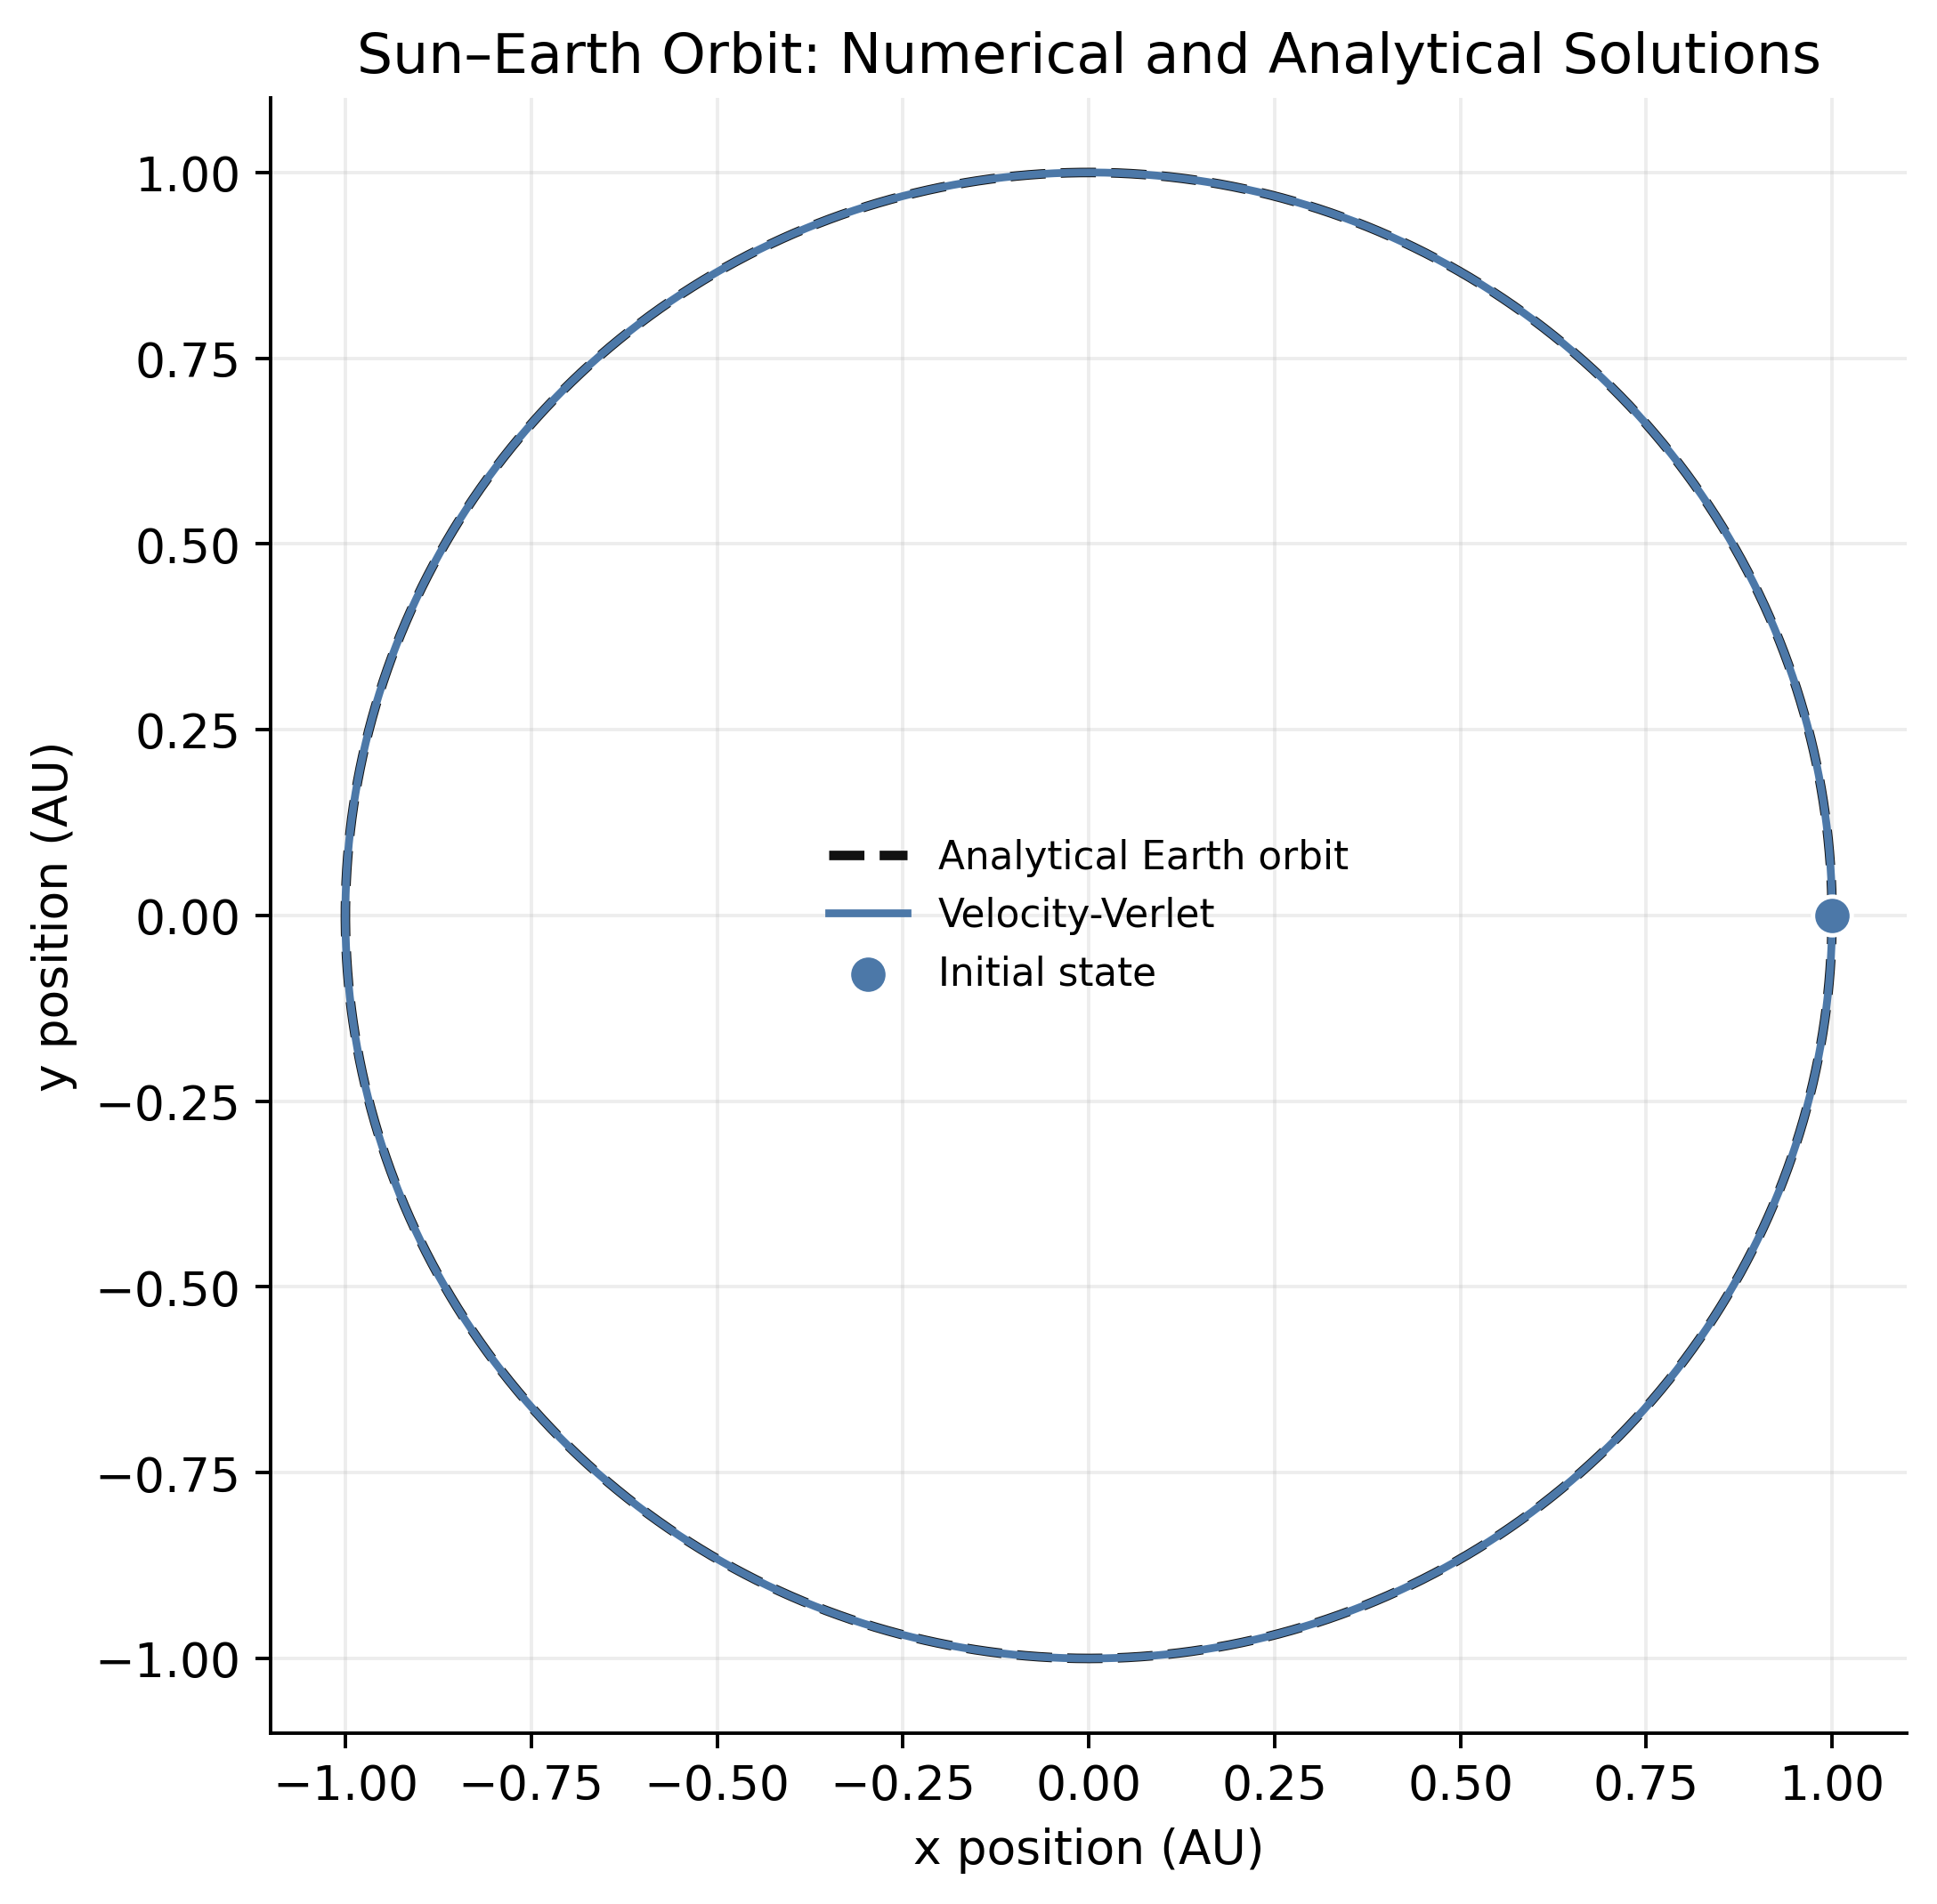
Figure 1. Numerical Sun–Earth orbit compared with the analytical circular two-body solution; spatial axes use equal scaling.

5.2. Five-year integrator comparison
At Δt = 2 days, all four methods were run over the same nominal five-year interval (913 steps; 1,826 days). Table 2 reports maximum errors over each run. RK4 has the smallest maximum Earth-position discrepancy, while Yoshida4 has the smallest energy error, and Verlet and Yoshida4 are both at machine precision for angular momentum. These values are from the five-year experiment; the separate one-year convergence results are not mixed into this comparison.
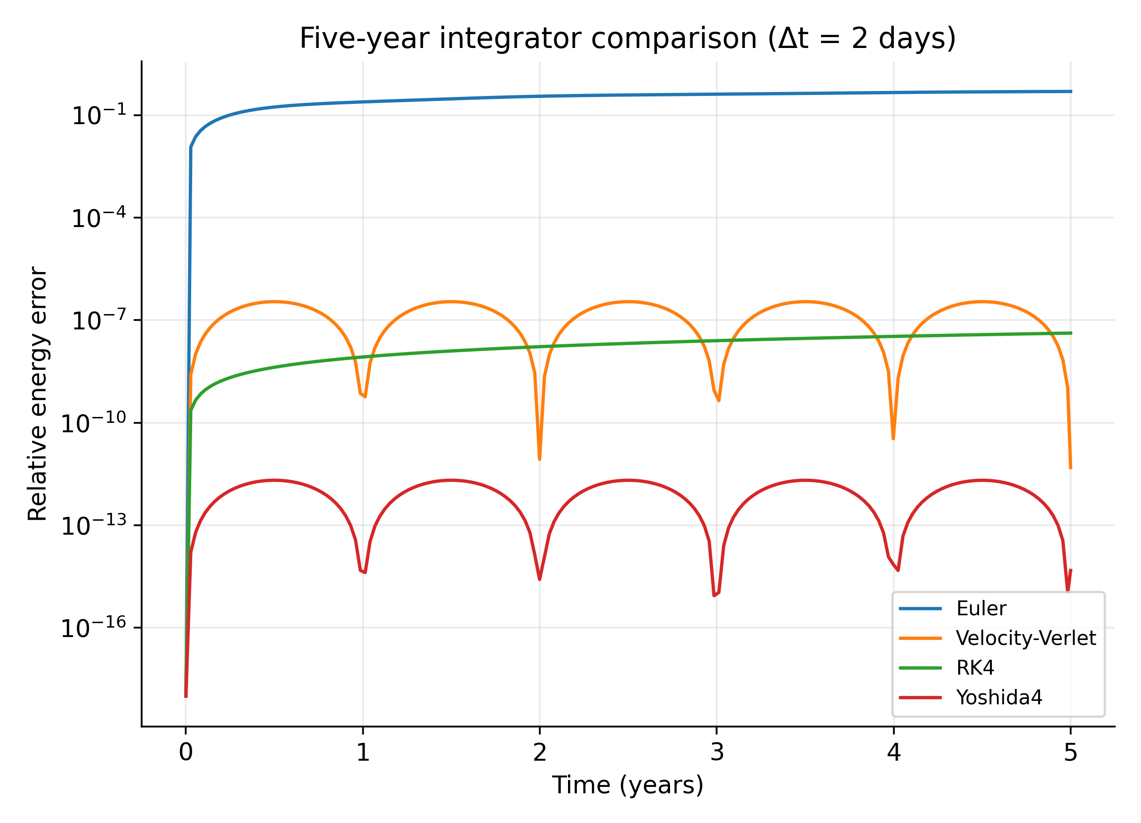  Figure 2. Relative energy error in the multi-year integrator comparison. | 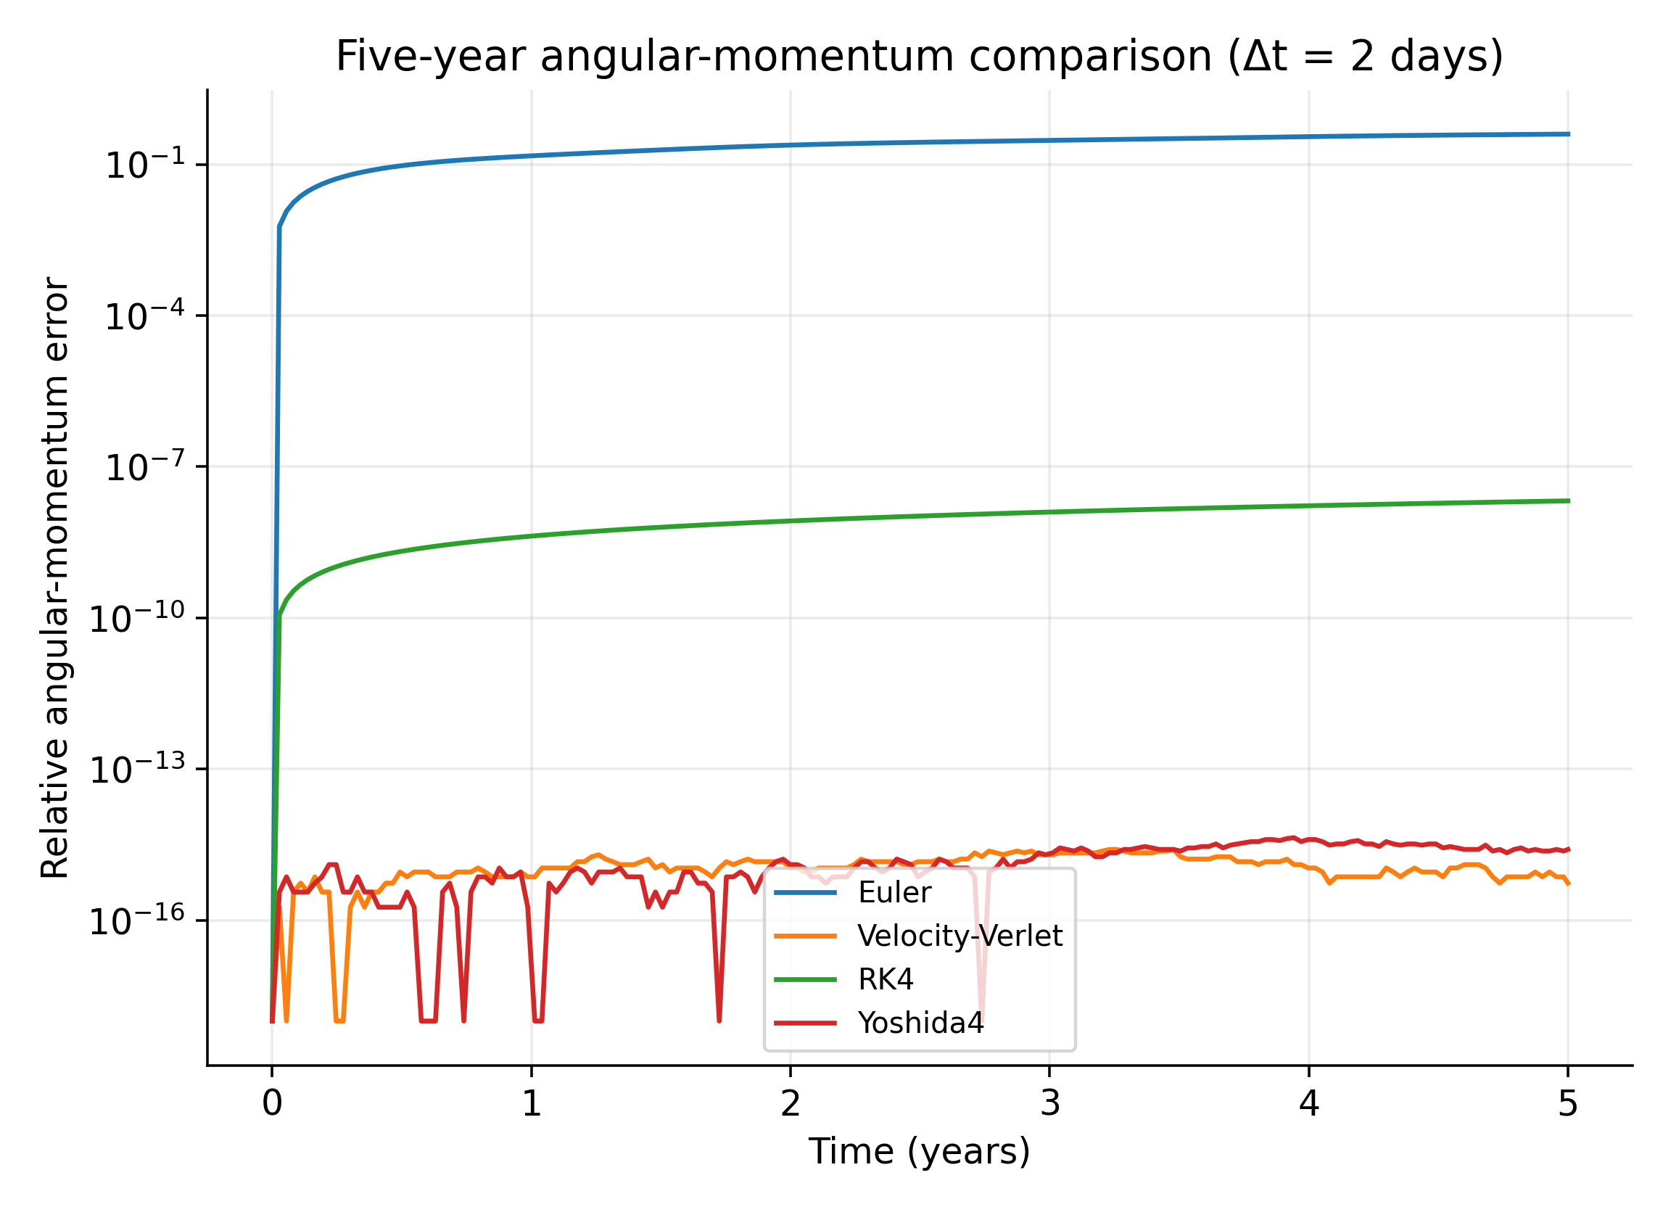  Figure 3. Relative angular-momentum error in the five-year integrator comparison.

Table 2. Five-year nominal comparison at Δt = 2 days (913 steps; 1,826 days).
Method | Max |ΔE/E₀| | Max |ΔL/L₀| | Max Earth position error (au)
Euler | 4.935×10⁻¹ | 3.991×10⁻¹ | 2.751
Velocity-Verlet | 3.497×10⁻⁷ | 2.726×10⁻¹⁵ | 1.250×10⁻²
RK4 | 4.207×10⁻⁸ | 2.104×10⁻⁸ | 1.999×10⁻⁶
Yoshida4 | 2.084×10⁻¹² | 3.634×10⁻¹⁵ | 4.082×10⁻⁵

5.3. Timestep convergence and the circular-orbit energy slope
The dedicated fine Euler sweep from 10³ to 10⁶ steps per year gives fitted position-error order 0.999 over the four finest points, recovering first-order behaviour after the coarser fit had saturated. The main circular convergence study shows second-order position convergence for velocity-Verlet and fourth-order convergence for RK4 and Yoshida4 before roundoff limits the smallest errors. For velocity-Verlet, the fitted energy-error slopes are 3.32 for the circular orbit and 2.04 for e = 0.9 over the selected fit windows. The eccentric slope is consistent with second-order behaviour. The circular slope is steeper but does not establish a general fourth-order law; a symmetry-related cancellation of a leading error contribution is a plausible, setup-specific interpretation, and the finest circular points approach the floating-point floor. Global trajectory order remains two.
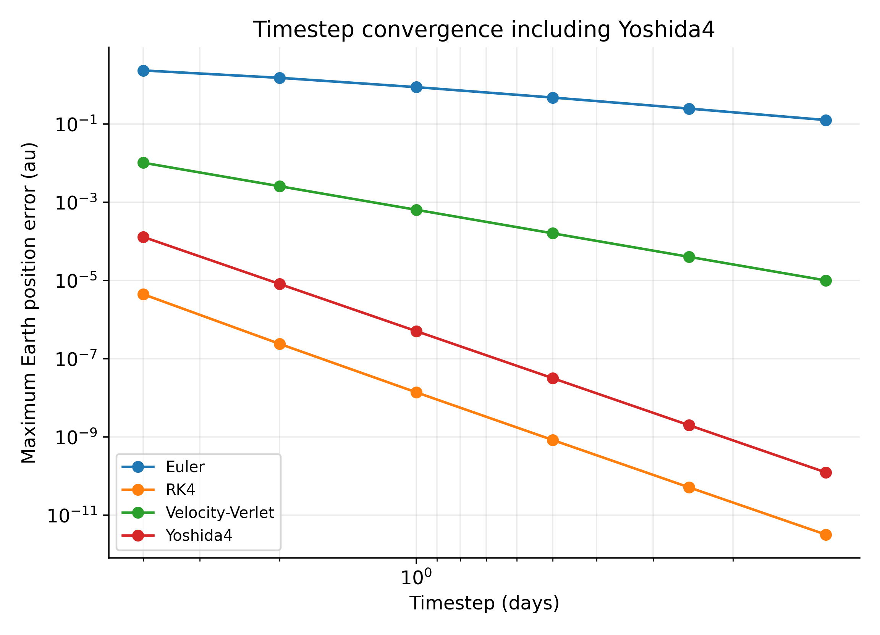  Figure 4. Maximum position error versus timestep for the main methods. | 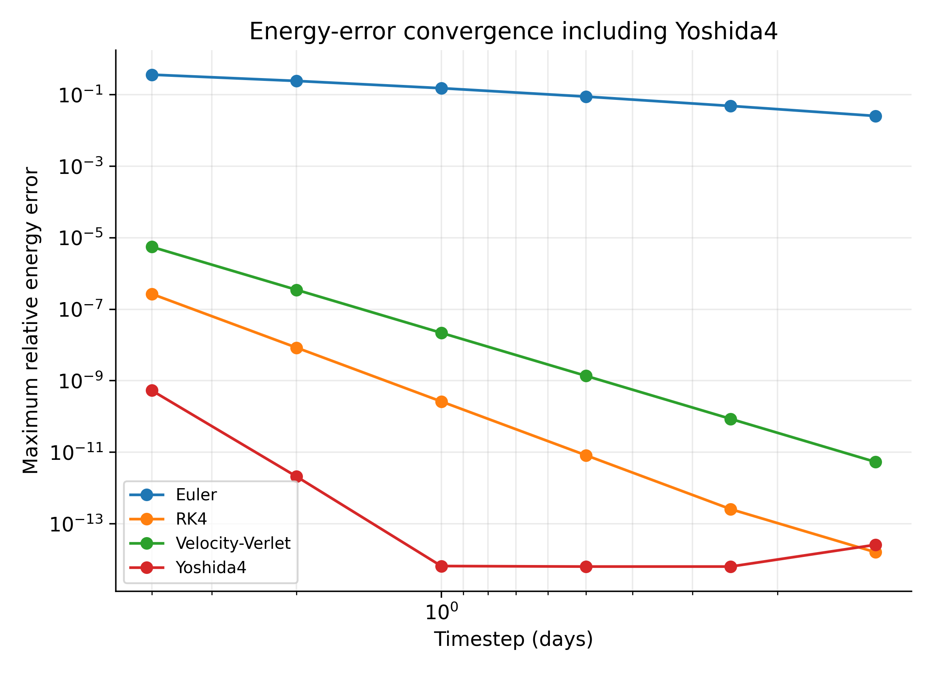  Figure 5. Maximum relative energy error versus timestep; the measured slope depends on quantity and orbit.

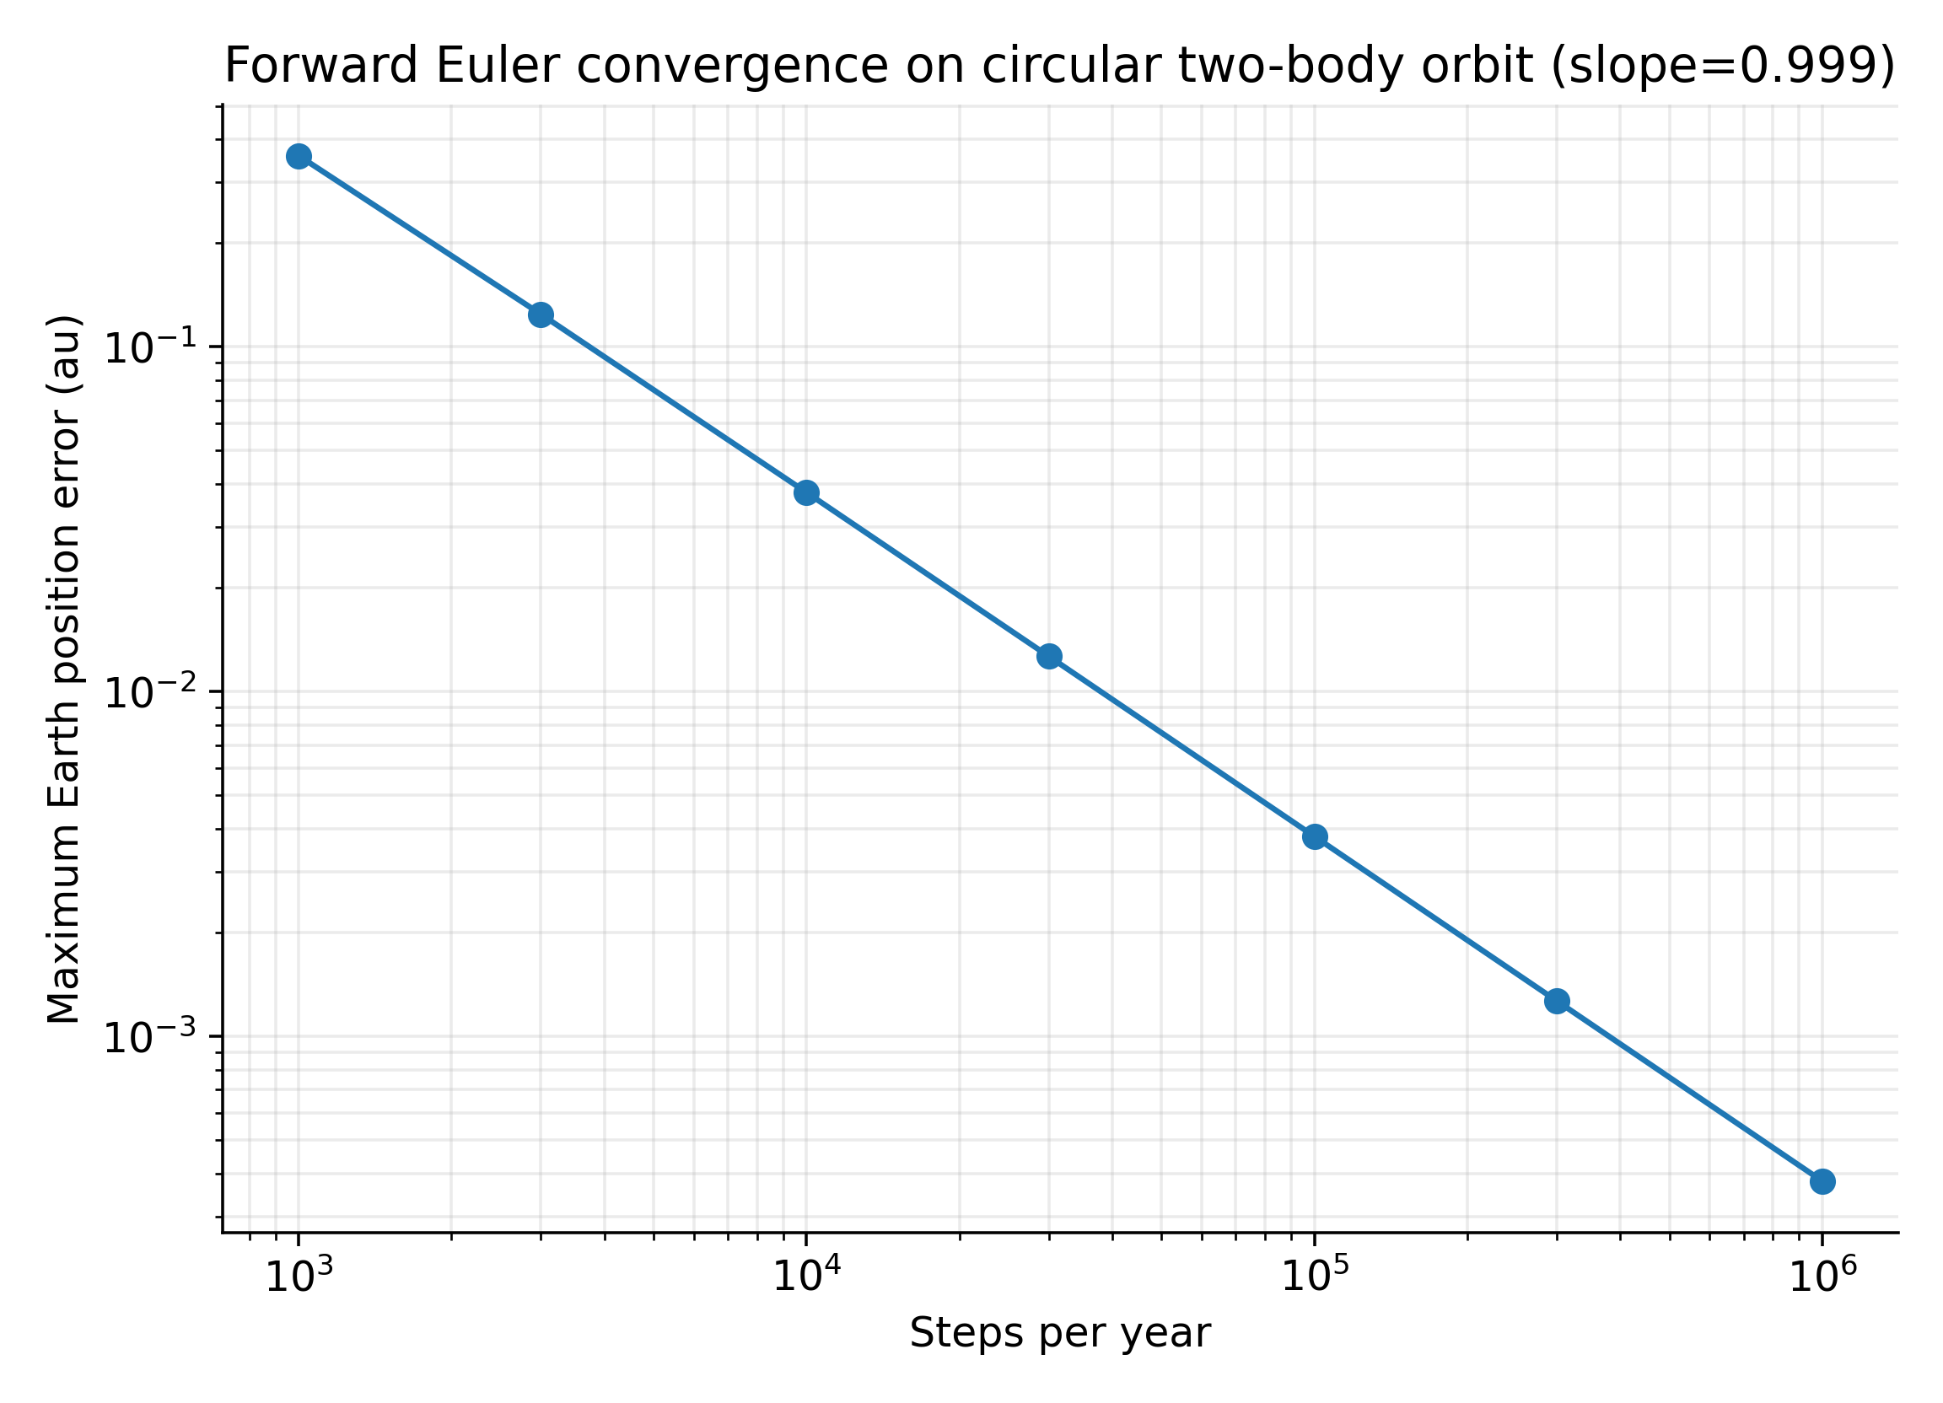  Figure 6. Fine-grid Euler convergence recovers the expected first-order trend. | 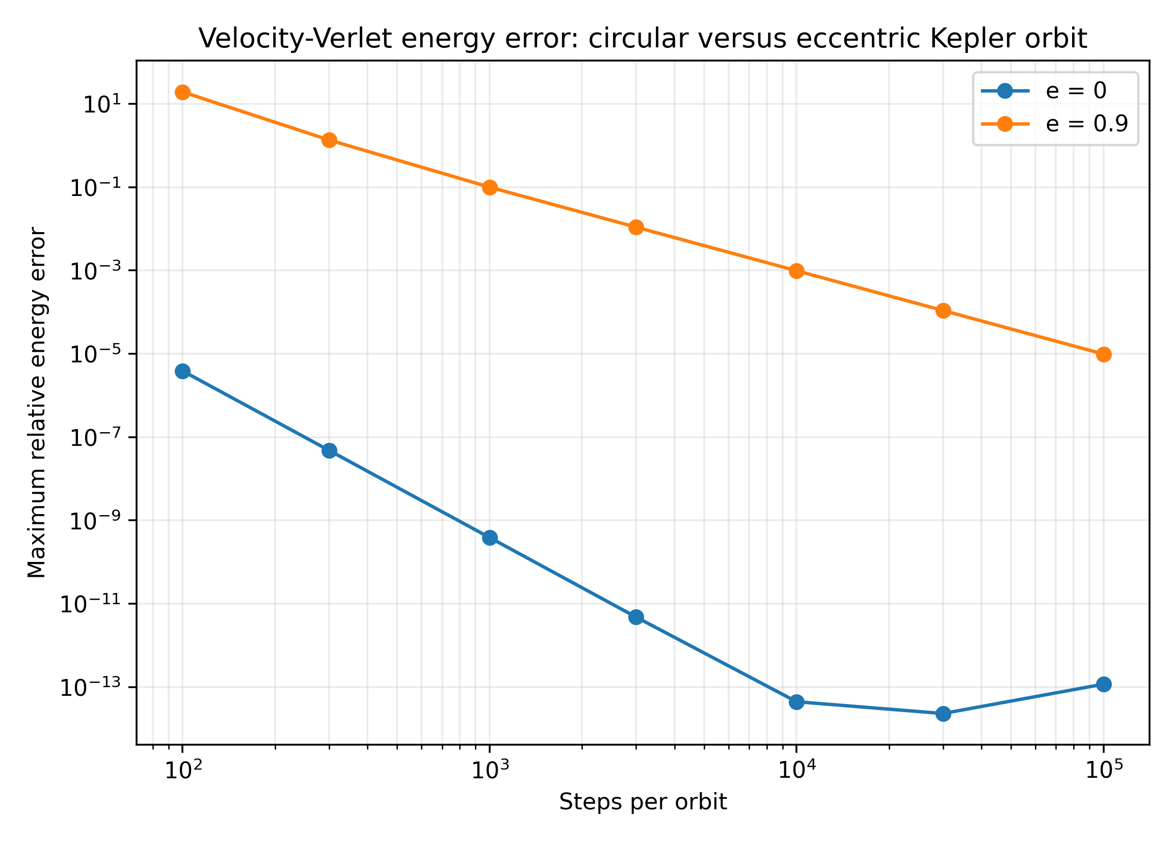  Figure 7. Velocity-Verlet energy-error slopes for circular and eccentric Kepler orbits.

5.4. Long-duration eccentric orbit: conservation versus phase accuracy
To test the central thesis over a longer interval than the one-orbit convergence study, the e = 0.9 Kepler problem was integrated for 1,000 orbital periods using 10,000 fixed steps per period (10 million macro-steps per method). Diagnostics were sampled 200 times per orbit against the analytical Kepler solution. Maximum relative energy error was 9.85×10⁻⁴ for velocity-Verlet, 3.58×10⁻⁶ for RK4, and 2.46×10⁻⁷ for Yoshida4. At the final sample, absolute unwrapped true-longitude discrepancies were approximately 9.44 rad, 0.685 rad, and 0.101 rad, respectively. Table 3 reports the two additional resolutions. The symplectic methods retain bounded energy error while phase error accumulates; this comparison is specific to the tested orbit and step sizes.
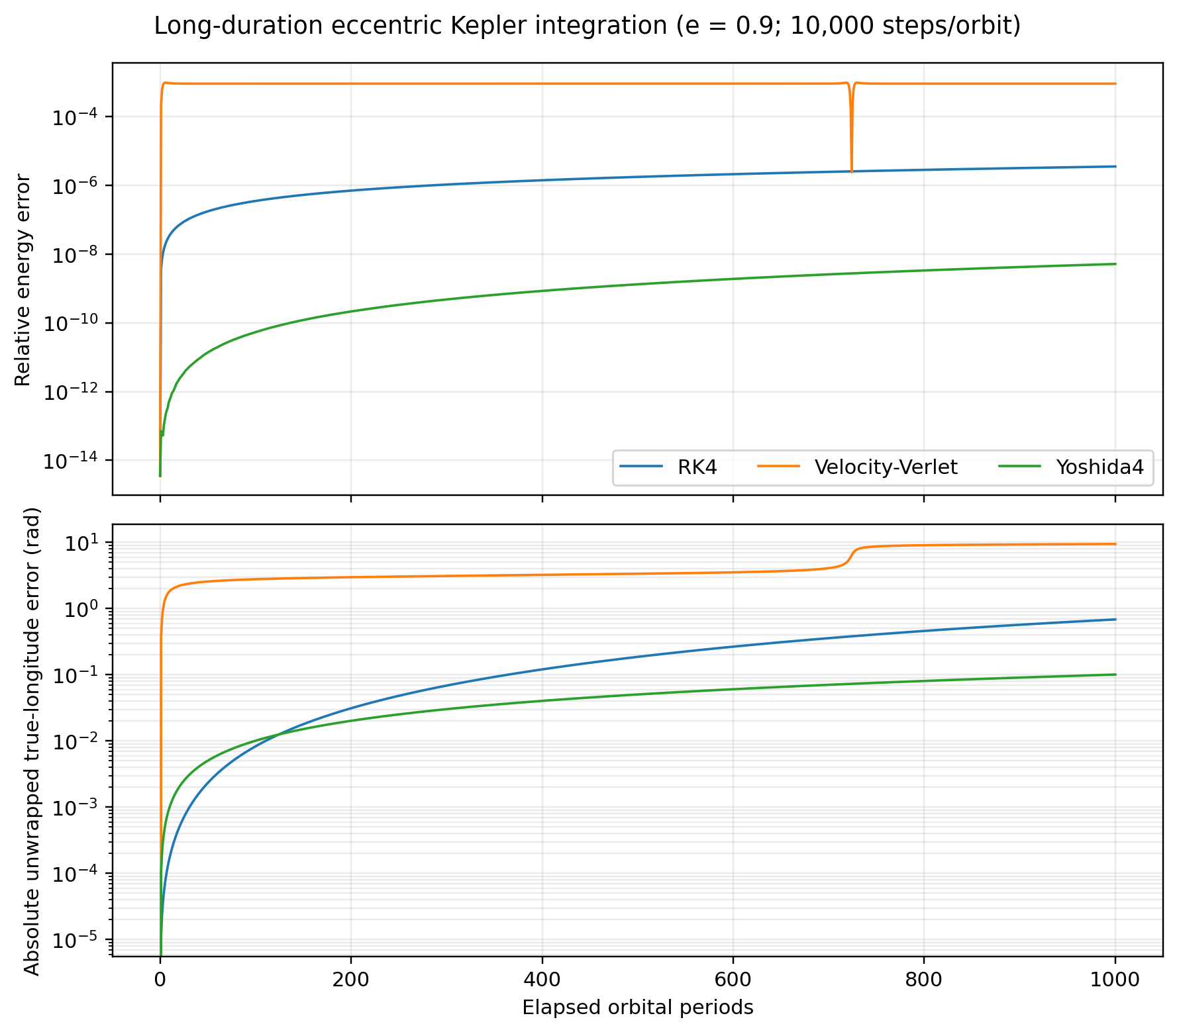
Figure 8. Once-per-orbit display of energy-error magnitude and true-longitude discrepancy for e = 0.9 over 1,000 periods at 10,000 steps/orbit. Tabulated maxima use 200 diagnostic samples per orbit.
The adaptive DOP853 result belongs to the separate one-orbit work–precision experiment and is not included in this long-run fixed-step comparison. Adaptive tolerances, step counts, and phase accumulation would need to be reported explicitly for a comparable long-duration adaptive run.
Table 3. Long-duration resolution sweep; maximum errors use 200 diagnostic samples per orbit.
Steps/orbit | Method | Max |ΔE/E₀| | Max |Δr|/a | Final |Δν| (rad)
5,000 | Velocity-Verlet | 3.942×10⁻³ | 2.015 | 35.008
5,000 | RK4 | 1.141×10⁻⁴ | 0.9658 | 2.625
5,000 | Yoshida4 | 3.915×10⁻⁶ | 0.1495 | 1.228
10,000 | Velocity-Verlet | 9.850×10⁻⁴ | 2.002 | 9.441
10,000 | RK4 | 3.576×10⁻⁶ | 0.07208 | 0.6851
10,000 | Yoshida4 | 2.456×10⁻⁷ | 0.01008 | 0.1007
20,000 | Velocity-Verlet | 2.462×10⁻⁴ | 1.880 | 3.046
20,000 | RK4 | 1.125×10⁻⁷ | 0.002345 | 0.02344
20,000 | Yoshida4 | 1.536×10⁻⁸ | 0.0006309 | 0.006309

The sharp velocity-Verlet energy-error dip near 724 periods is not a sudden loss of stability. Figure 8 displays once-per-orbit samples of the absolute, phase-dependent energy error; as the numerical orbit drifts in phase relative to the analytical orbit, one sample passes close to zero, which the logarithmic axis magnifies. The rapid change in true-longitude error is continuous and occurs as the two solutions become differently phased near periapsis, where angular motion is fastest.

5.5. Circular long-term behaviour
In the ten-year circular experiment, position discrepancy grows as phase differences accumulate while the Earth–Sun separation remains close to one au. This reinforces the distinction between qualitative orbital stability and pointwise trajectory agreement. A symplectic method does not eliminate phase error or guarantee high pointwise accuracy at arbitrary step sizes.
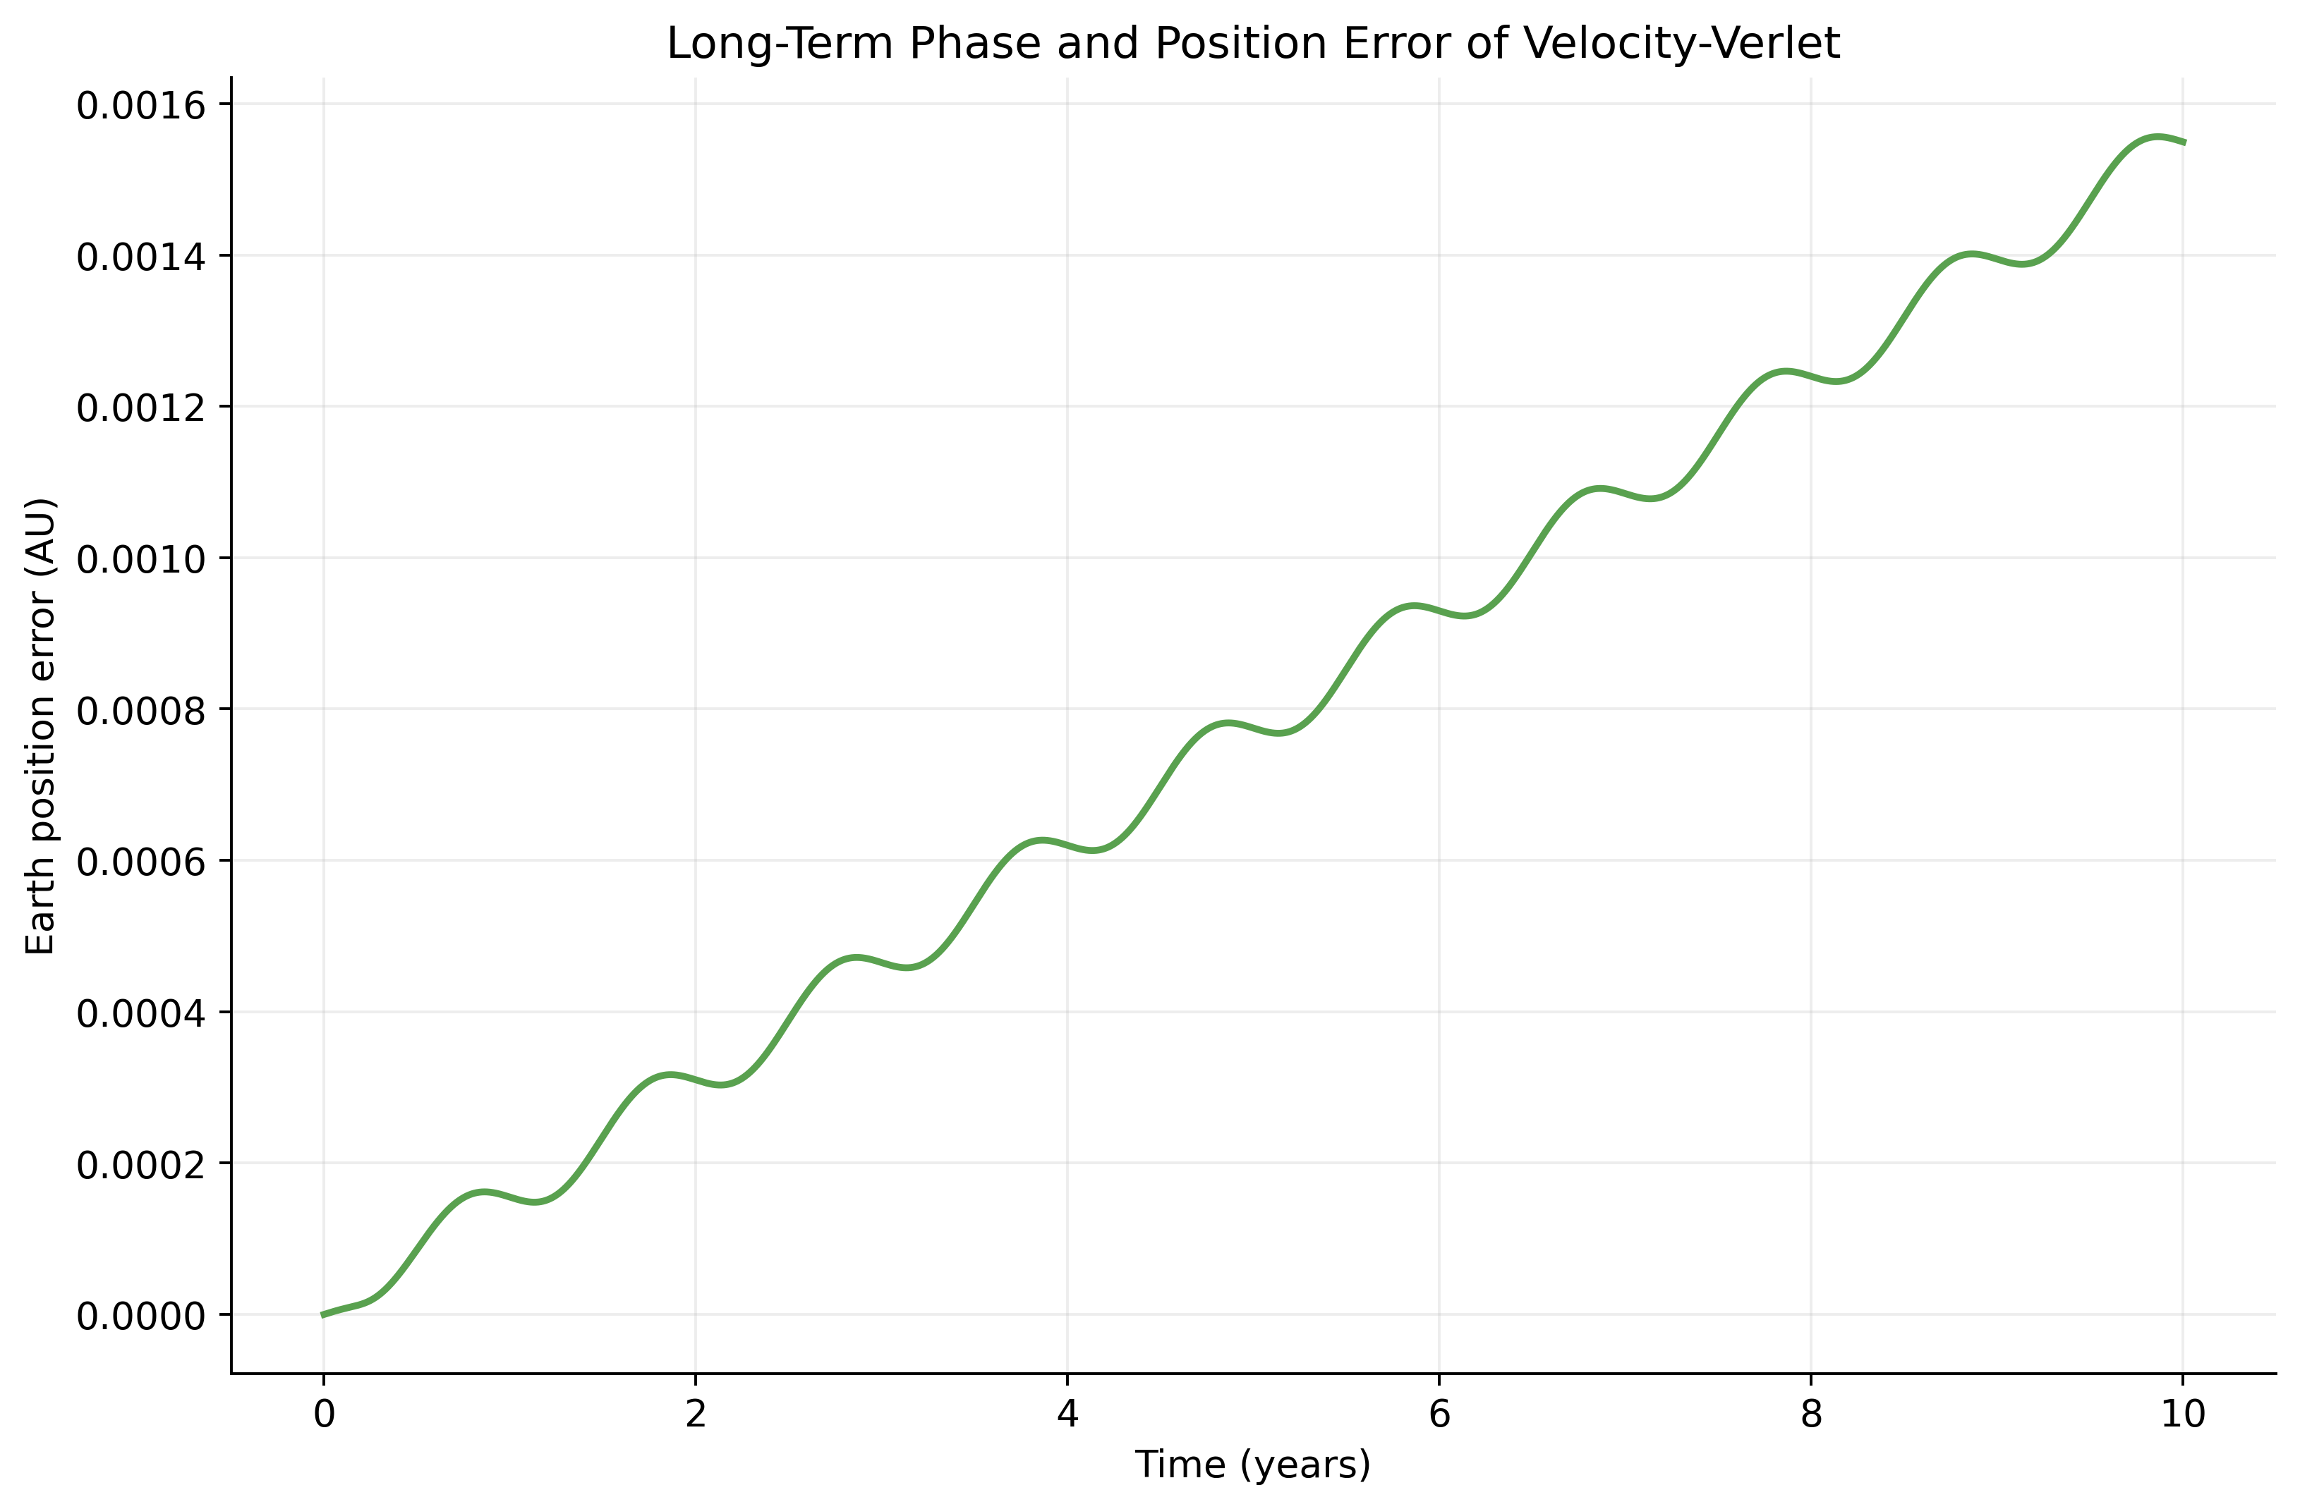  Figure 9. Position error relative to the analytical circular reference over ten years. | 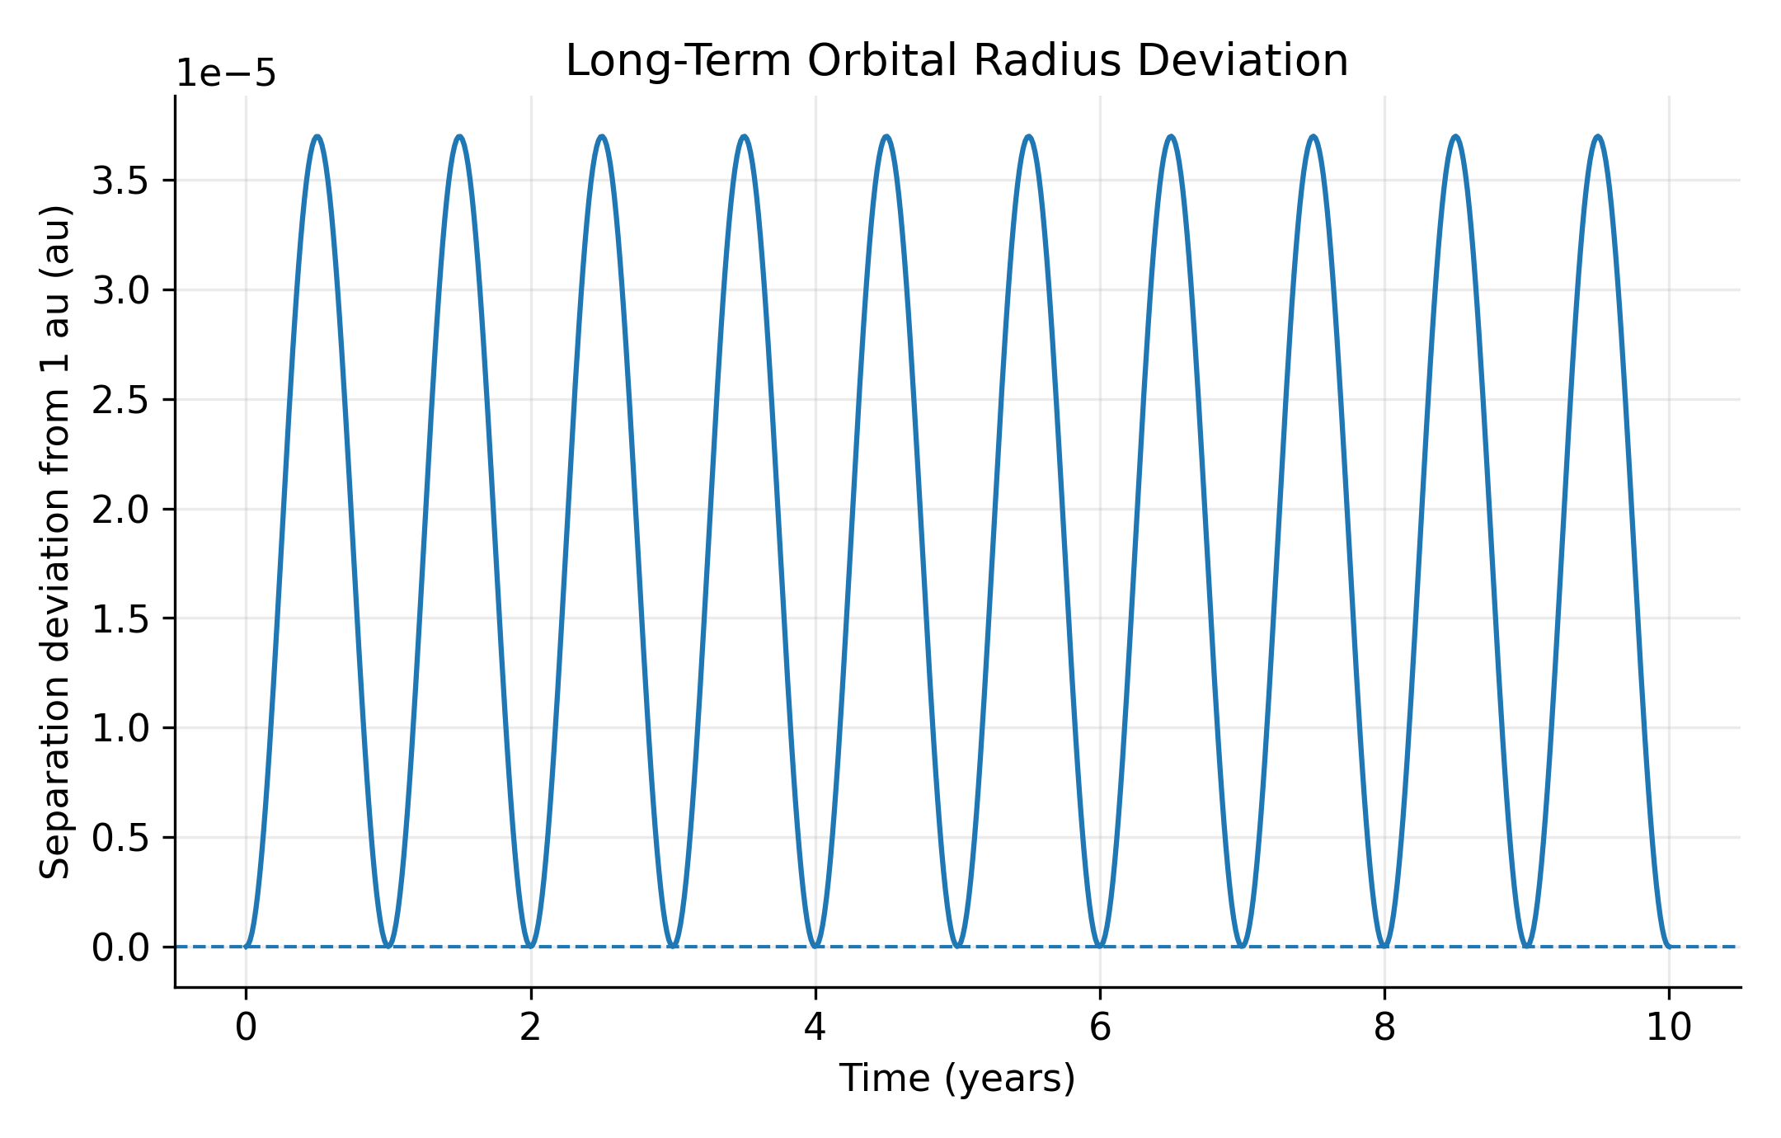  Figure 10. Earth–Sun separation over ten years; bounded radius is not exact phase agreement.

5.6. Third-body perturbation and binary validation
Adding Mars to the Sun–Earth model changed the Earth trajectory through the additional gravitational acceleration. At a 1-day step over five years, the maximum separation between the two Earth trajectories was 2.775×10⁻⁴ au and the final separation was 2.573×10⁻⁴ au. These are differences between idealized models, not errors against an observed ephemeris. For a circular binary with masses 1.0 and 0.8 solar masses and a 1-au separation, the maximum body-position discrepancy over five years at a 0.5-day step was 1.075×10⁻³ au.
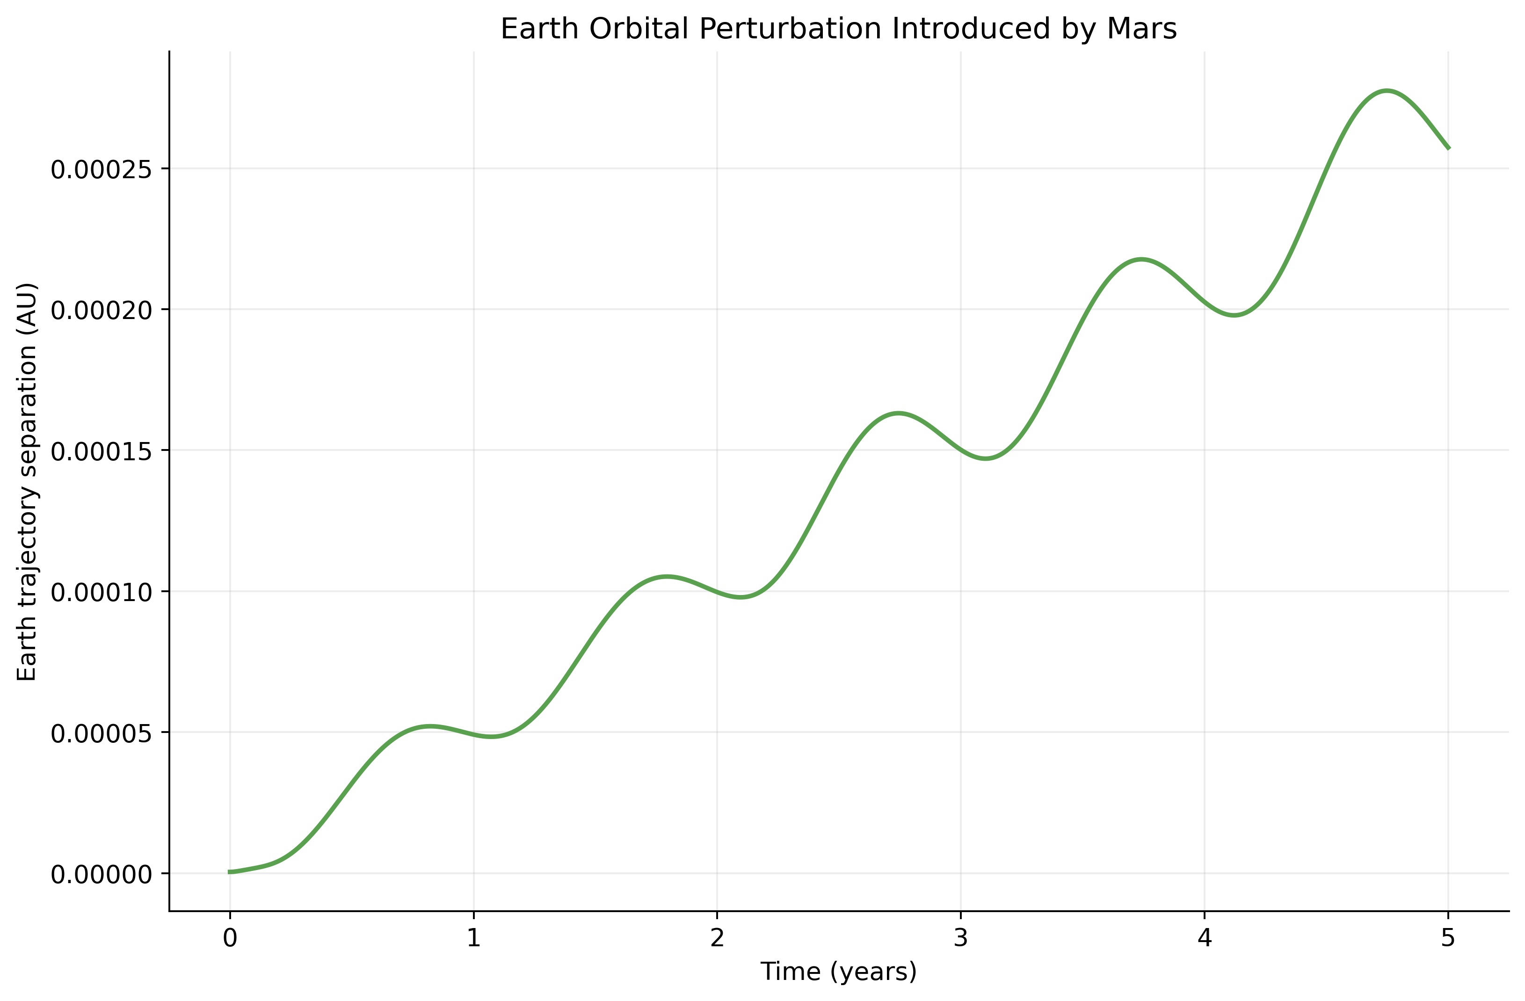  Figure 11. Earth trajectory separation with and without Mars over five years. | 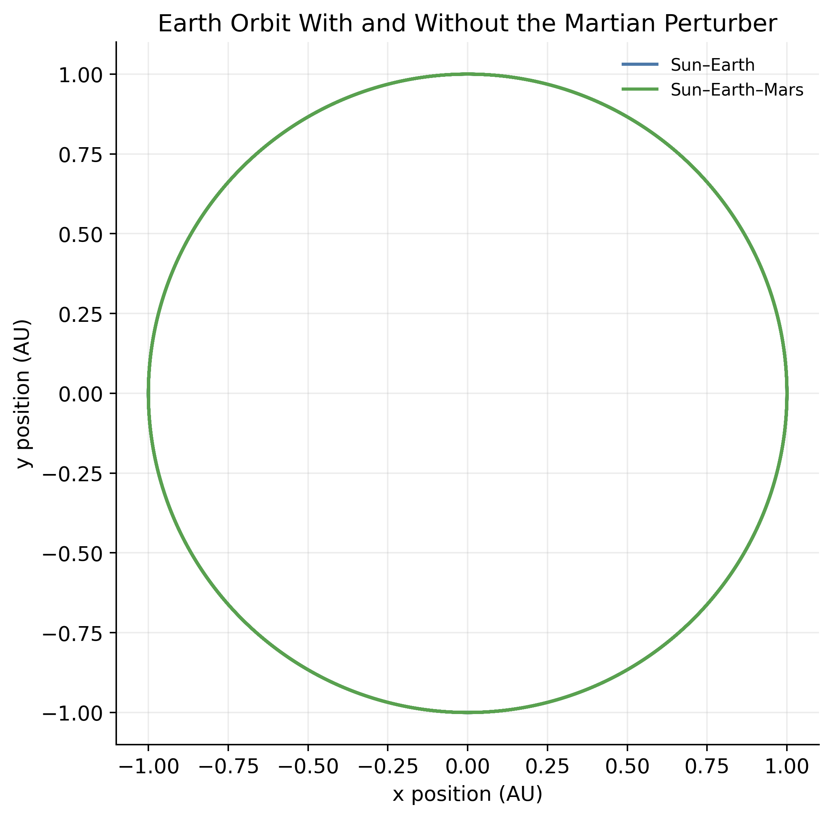  Figure 12. Two-body and three-body Earth trajectories, with equal aspect ratio.

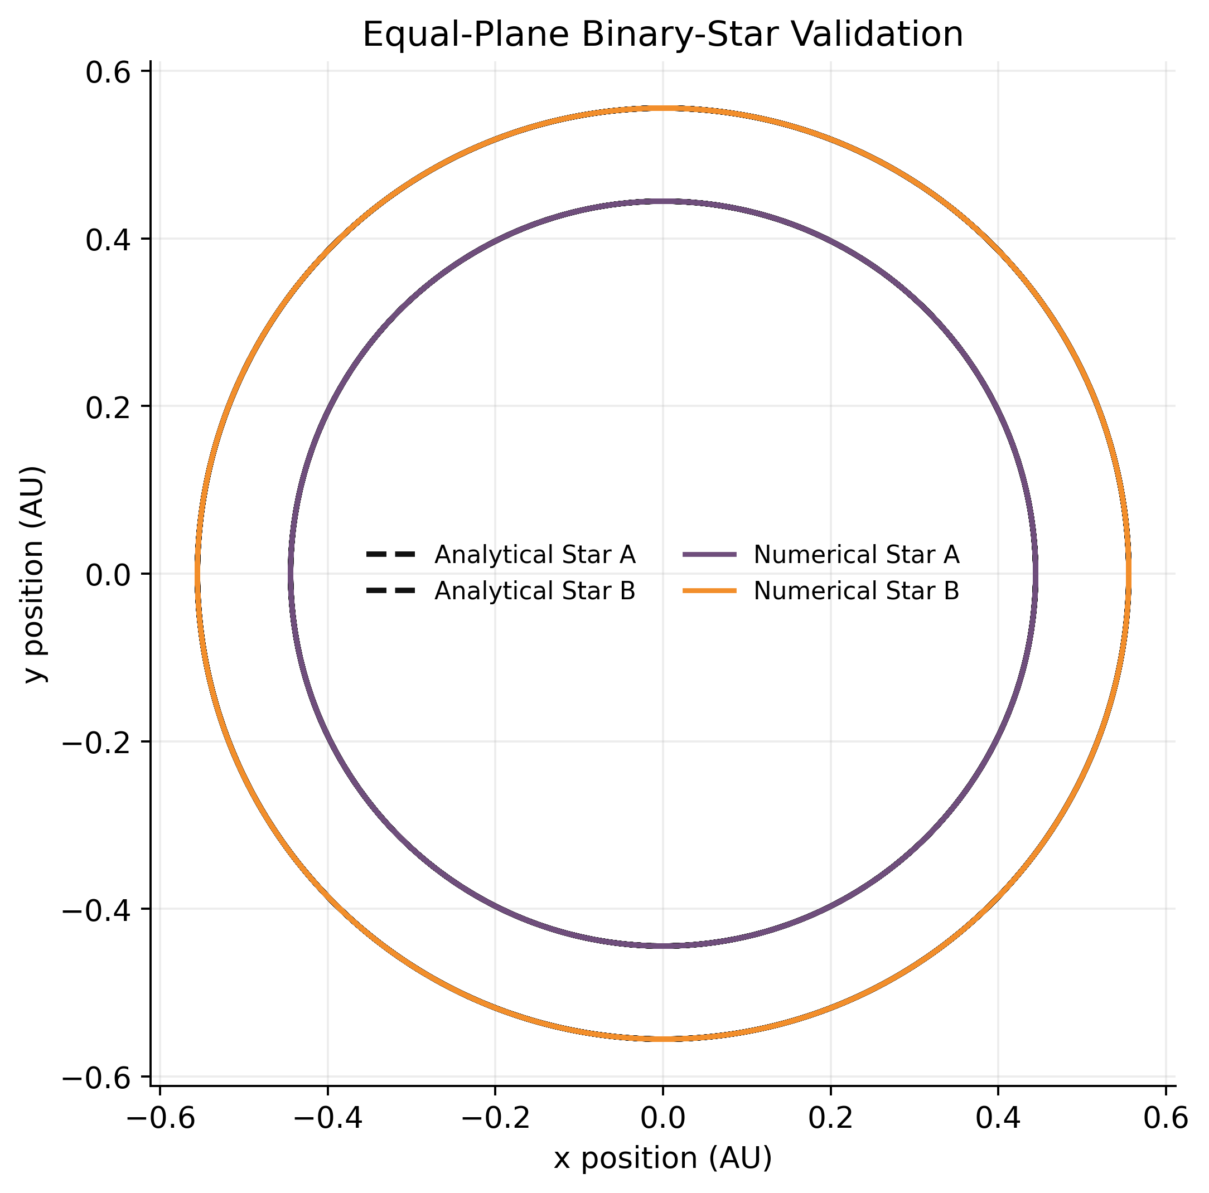
Figure 13. Numerical and analytical trajectories for the circular 1.0–0.8 solar-mass binary; axes use equal aspect ratio.

5.7. Momentum and centre-of-mass diagnostics
For an isolated system, pairwise Newtonian forces cancel in the total momentum balance. The computed centre-of-mass displacement and linear-momentum error remain near floating-point residual levels for the tested Sun–Earth–Mars configuration. These are implementation-level checks; values near roundoff should not be interpreted as meaningful relative accuracy beyond the normalization and precision of the calculation. The figures plot the computed positive values without replacing exact zeros by a plotting floor.
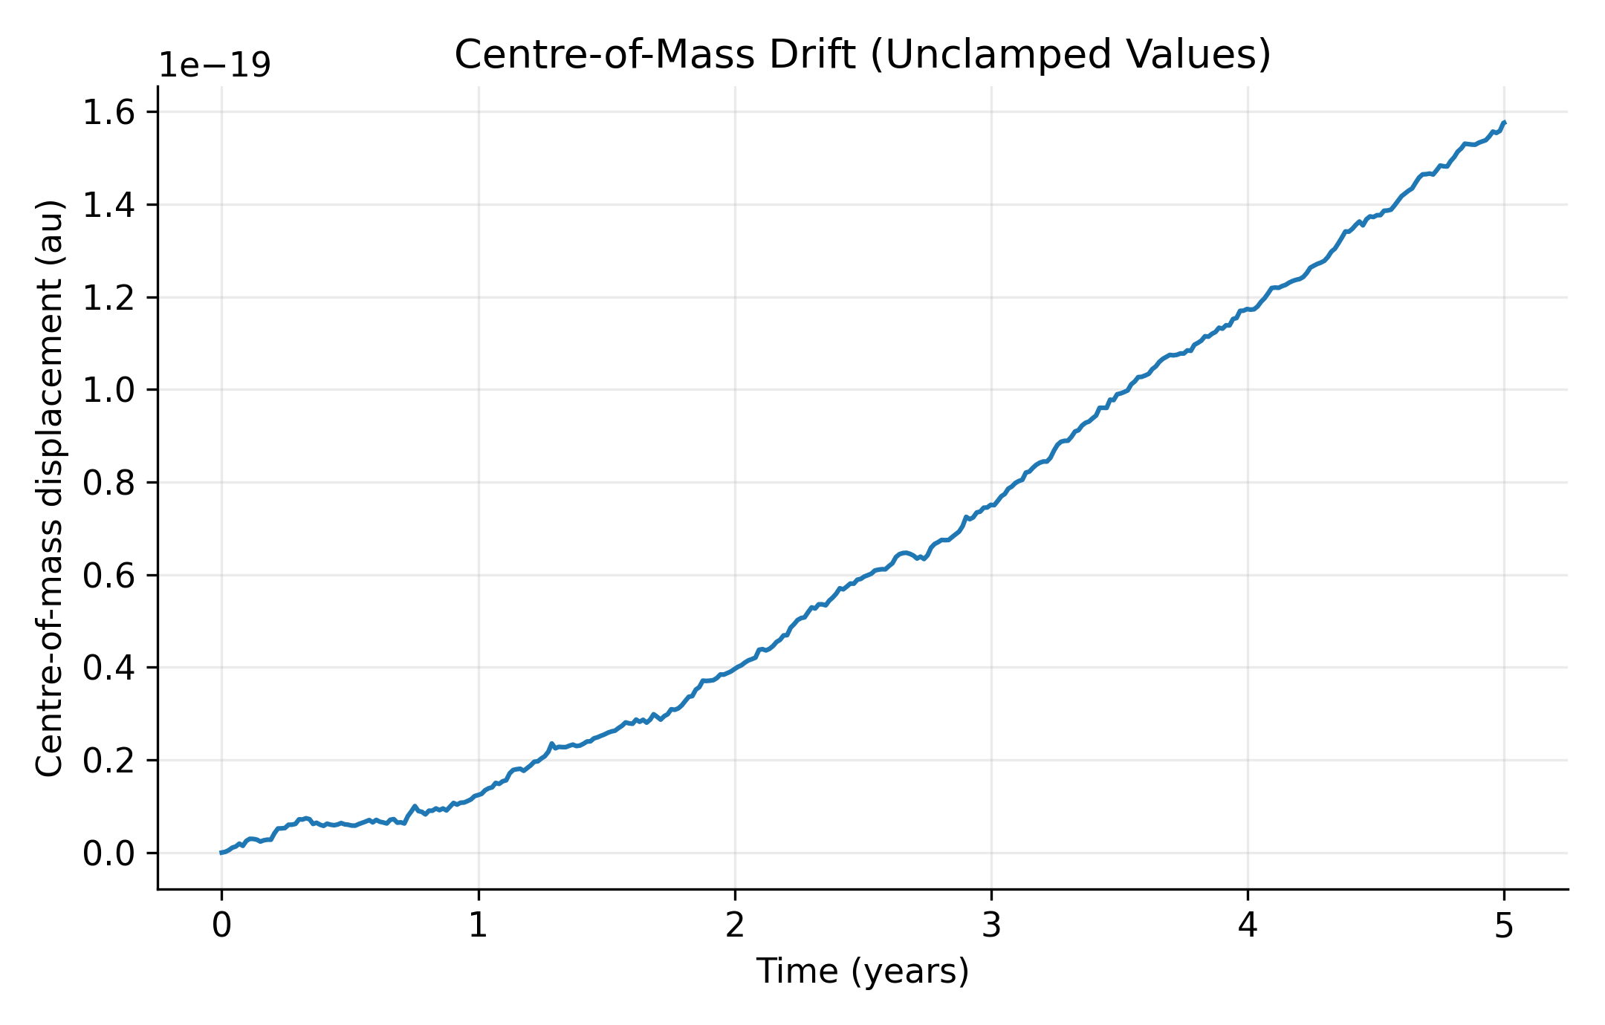  Figure 14. Computed centre-of-mass displacement; positive measured values only. | 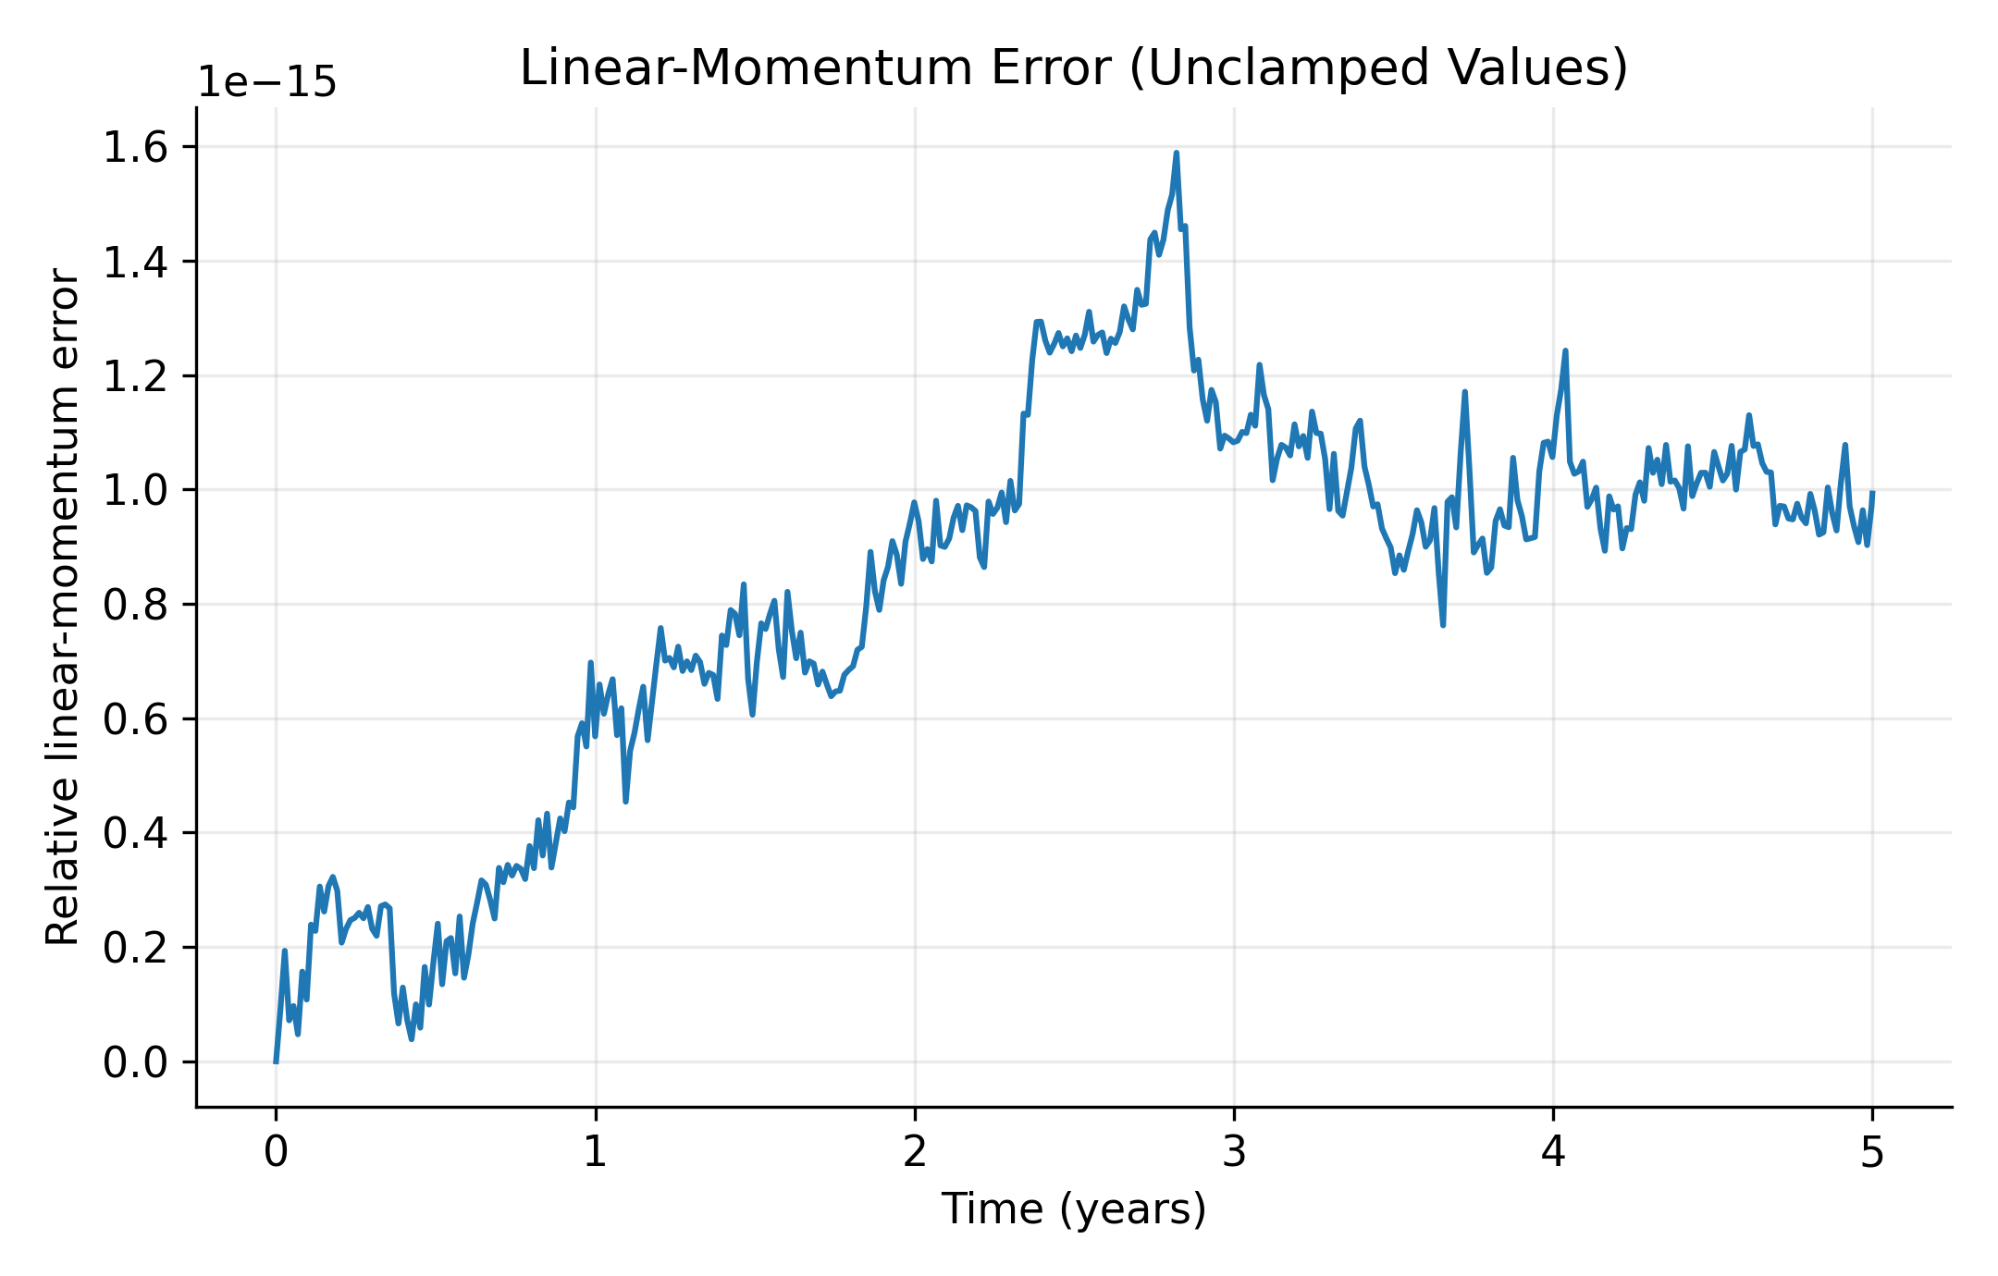  Figure 15. Relative linear-momentum error; positive measured values only.

5.8. Direct-force scaling
The timing protocol uses seven repeats of five velocity-Verlet steps for N = 16, 32, 64, 128, 256, and 512 bodies. The log–log fit is restricted to N ≥ 64 to reduce small-system overhead. The trend is consistent with the O(N²) cost of direct pairwise summation, but the workload is short and timings depend on implementation, hardware, and system load.
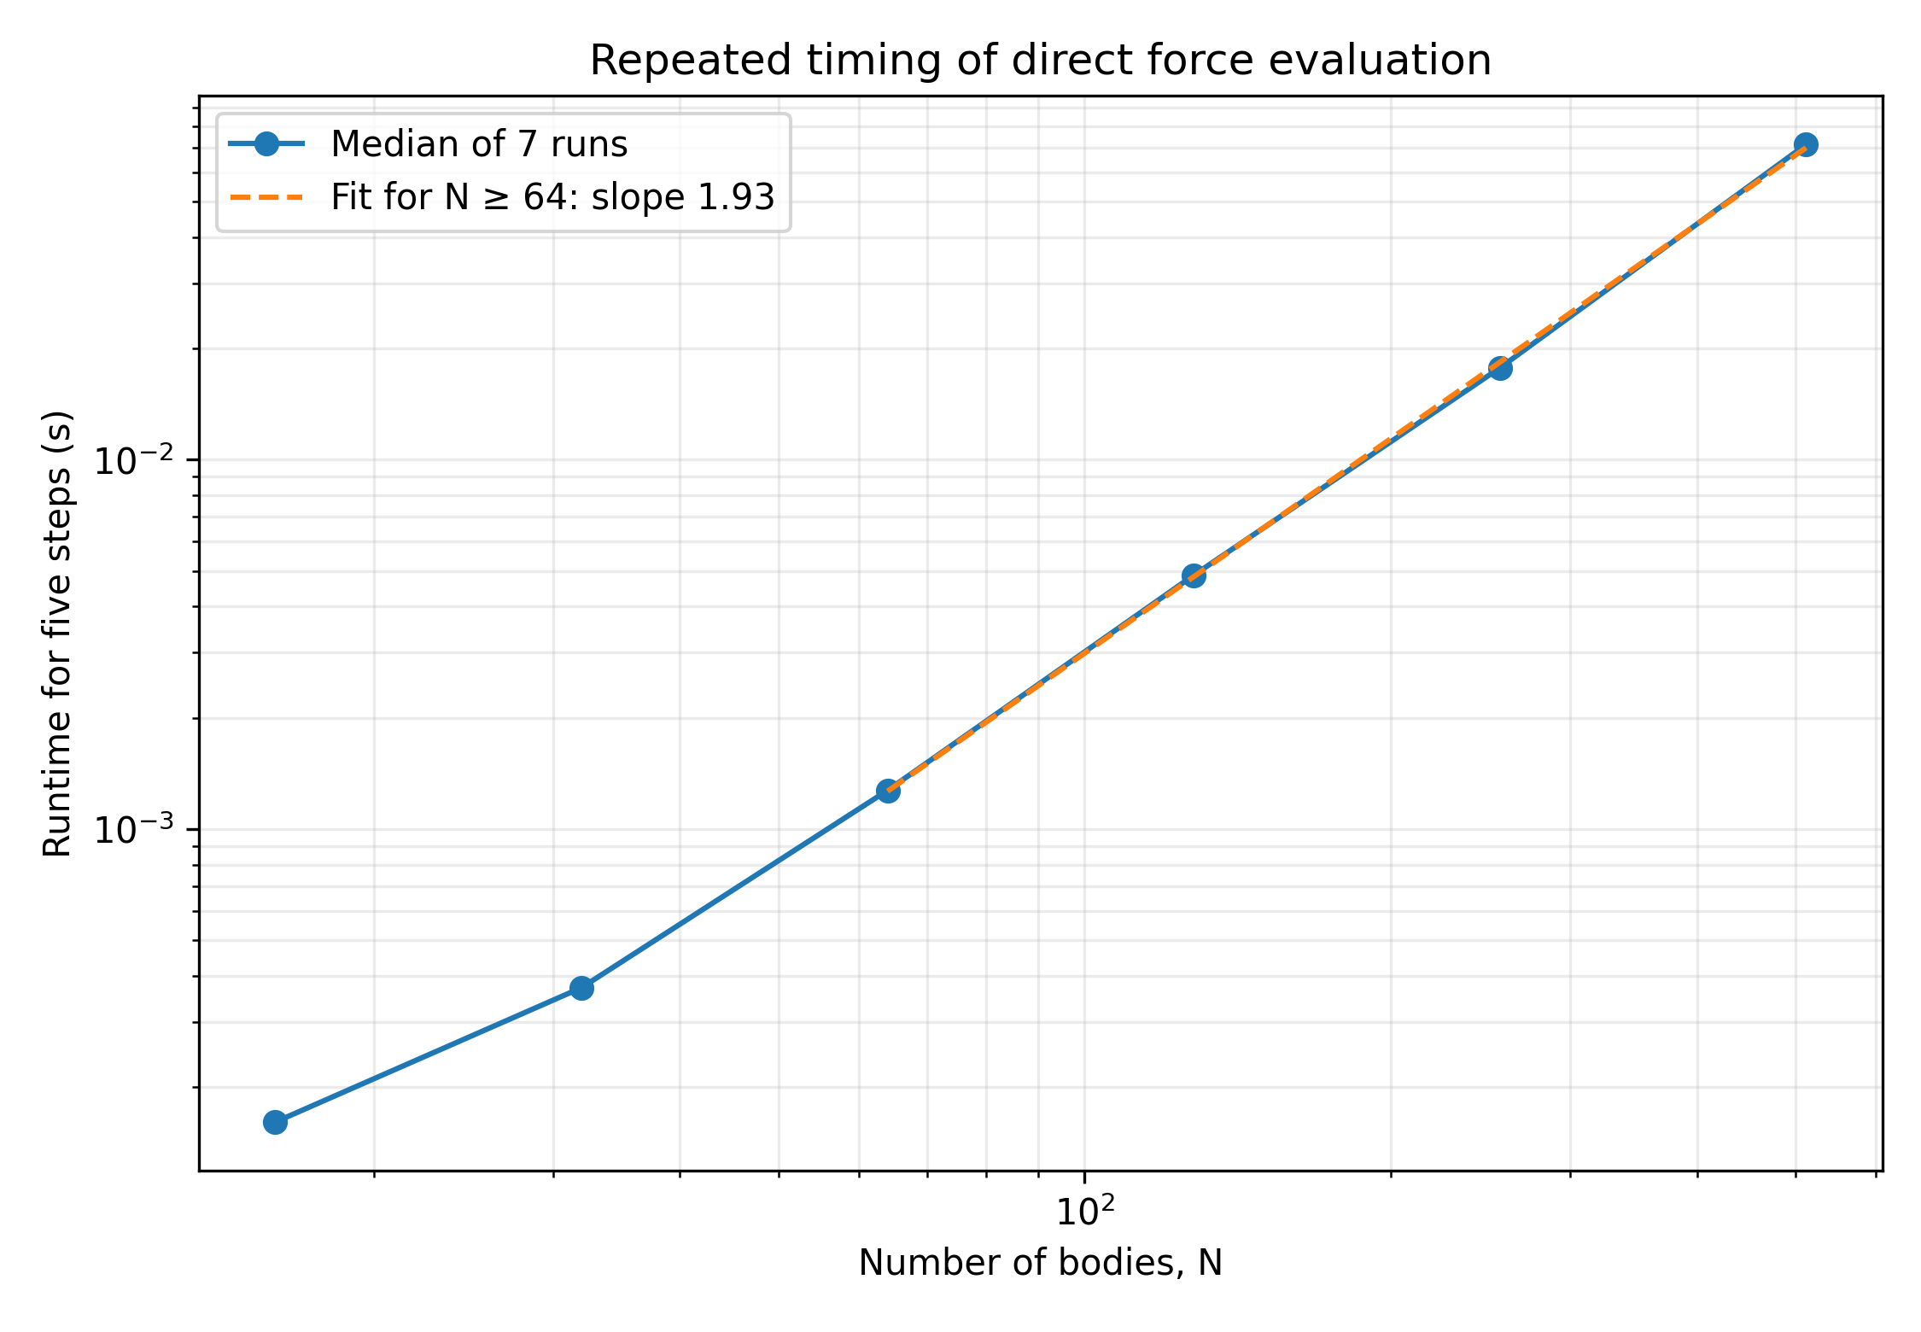
Figure 16. Repeated timing of five direct-force integration steps; points summarize repeated measurements and the fit uses the stated large-N subset.

5.9. Softening and work–precision
In the controlled binary experiment, softening values through ε = 0.001 au changed maximum relative energy error modestly, while ε = 0.005 au increased it to about 1.52×10⁻⁹. Because this binary has no close encounter, the result should not be generalized to encounter-dominated systems.
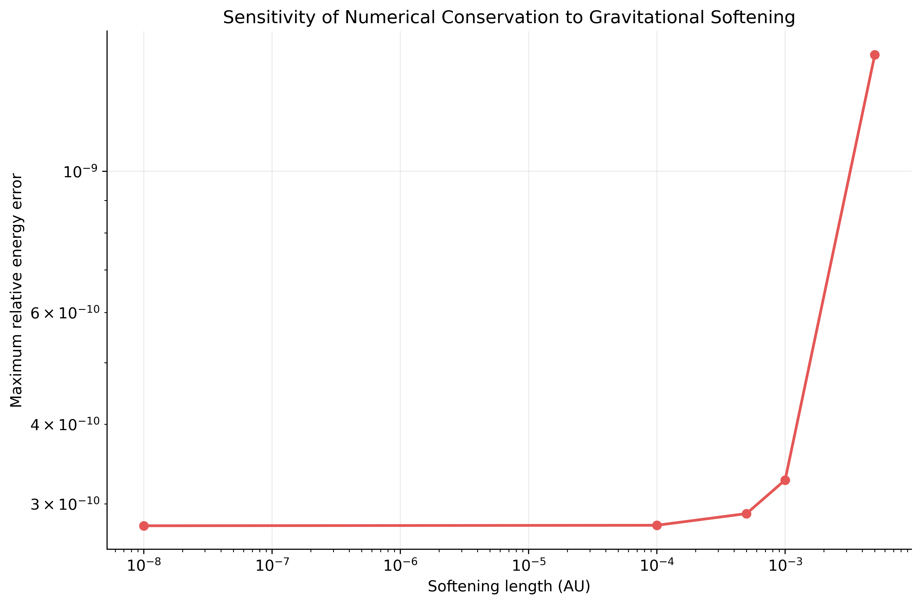  Figure 17. Maximum relative energy error versus softening length; zero softening is shown as the unsoftened reference. | 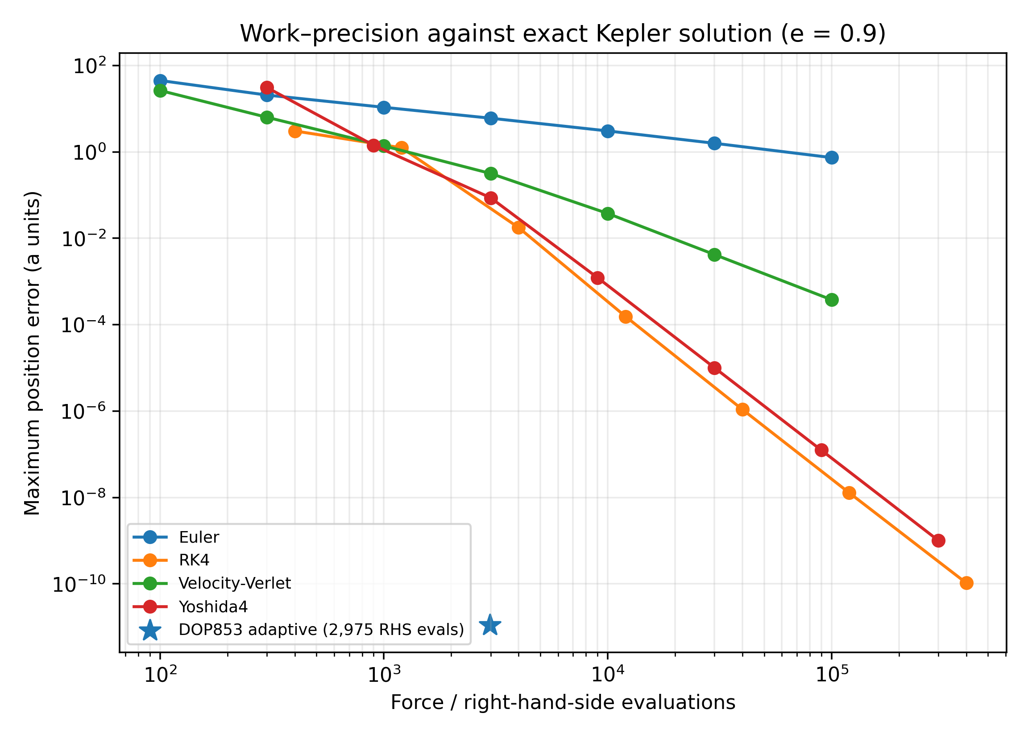  Figure 18. Work–precision comparison against the analytical eccentric Kepler solution; fixed-step work uses cached acceleration evaluation counts, while DOP853 uses the solver-reported evaluation count.

The eccentric work–precision comparison uses the analytical Kepler solution and spans 10²–10⁵ steps per orbit. The adaptive DOP853 run used 2,975 right-hand-side evaluations and reached maximum position discrepancy 1.11×10⁻¹¹a. It therefore outperforms the displayed fixed-step points by orders of magnitude at the measured point; any discussion of fixed-step cost must include this adaptive baseline. The number of right-hand-side evaluations is not identical to wall-clock time, and DOP853’s adaptive overhead differs from fixed-step methods.

5.10. Eccentric convergence and three-body return test
For the eccentricity-0.9 Kepler problem, the analytical reference is obtained by solving Kepler’s equation and reconstructing the orbit, avoiding an approximate numerical reference for fixed-step convergence. Over the four finest usable levels, observed global position-error orders were 1.93 for velocity-Verlet, 4.05 for RK4, and 4.00 for Yoshida4. Euler remains outside its asymptotic regime for the eccentric grid and is not assigned an order from those points.
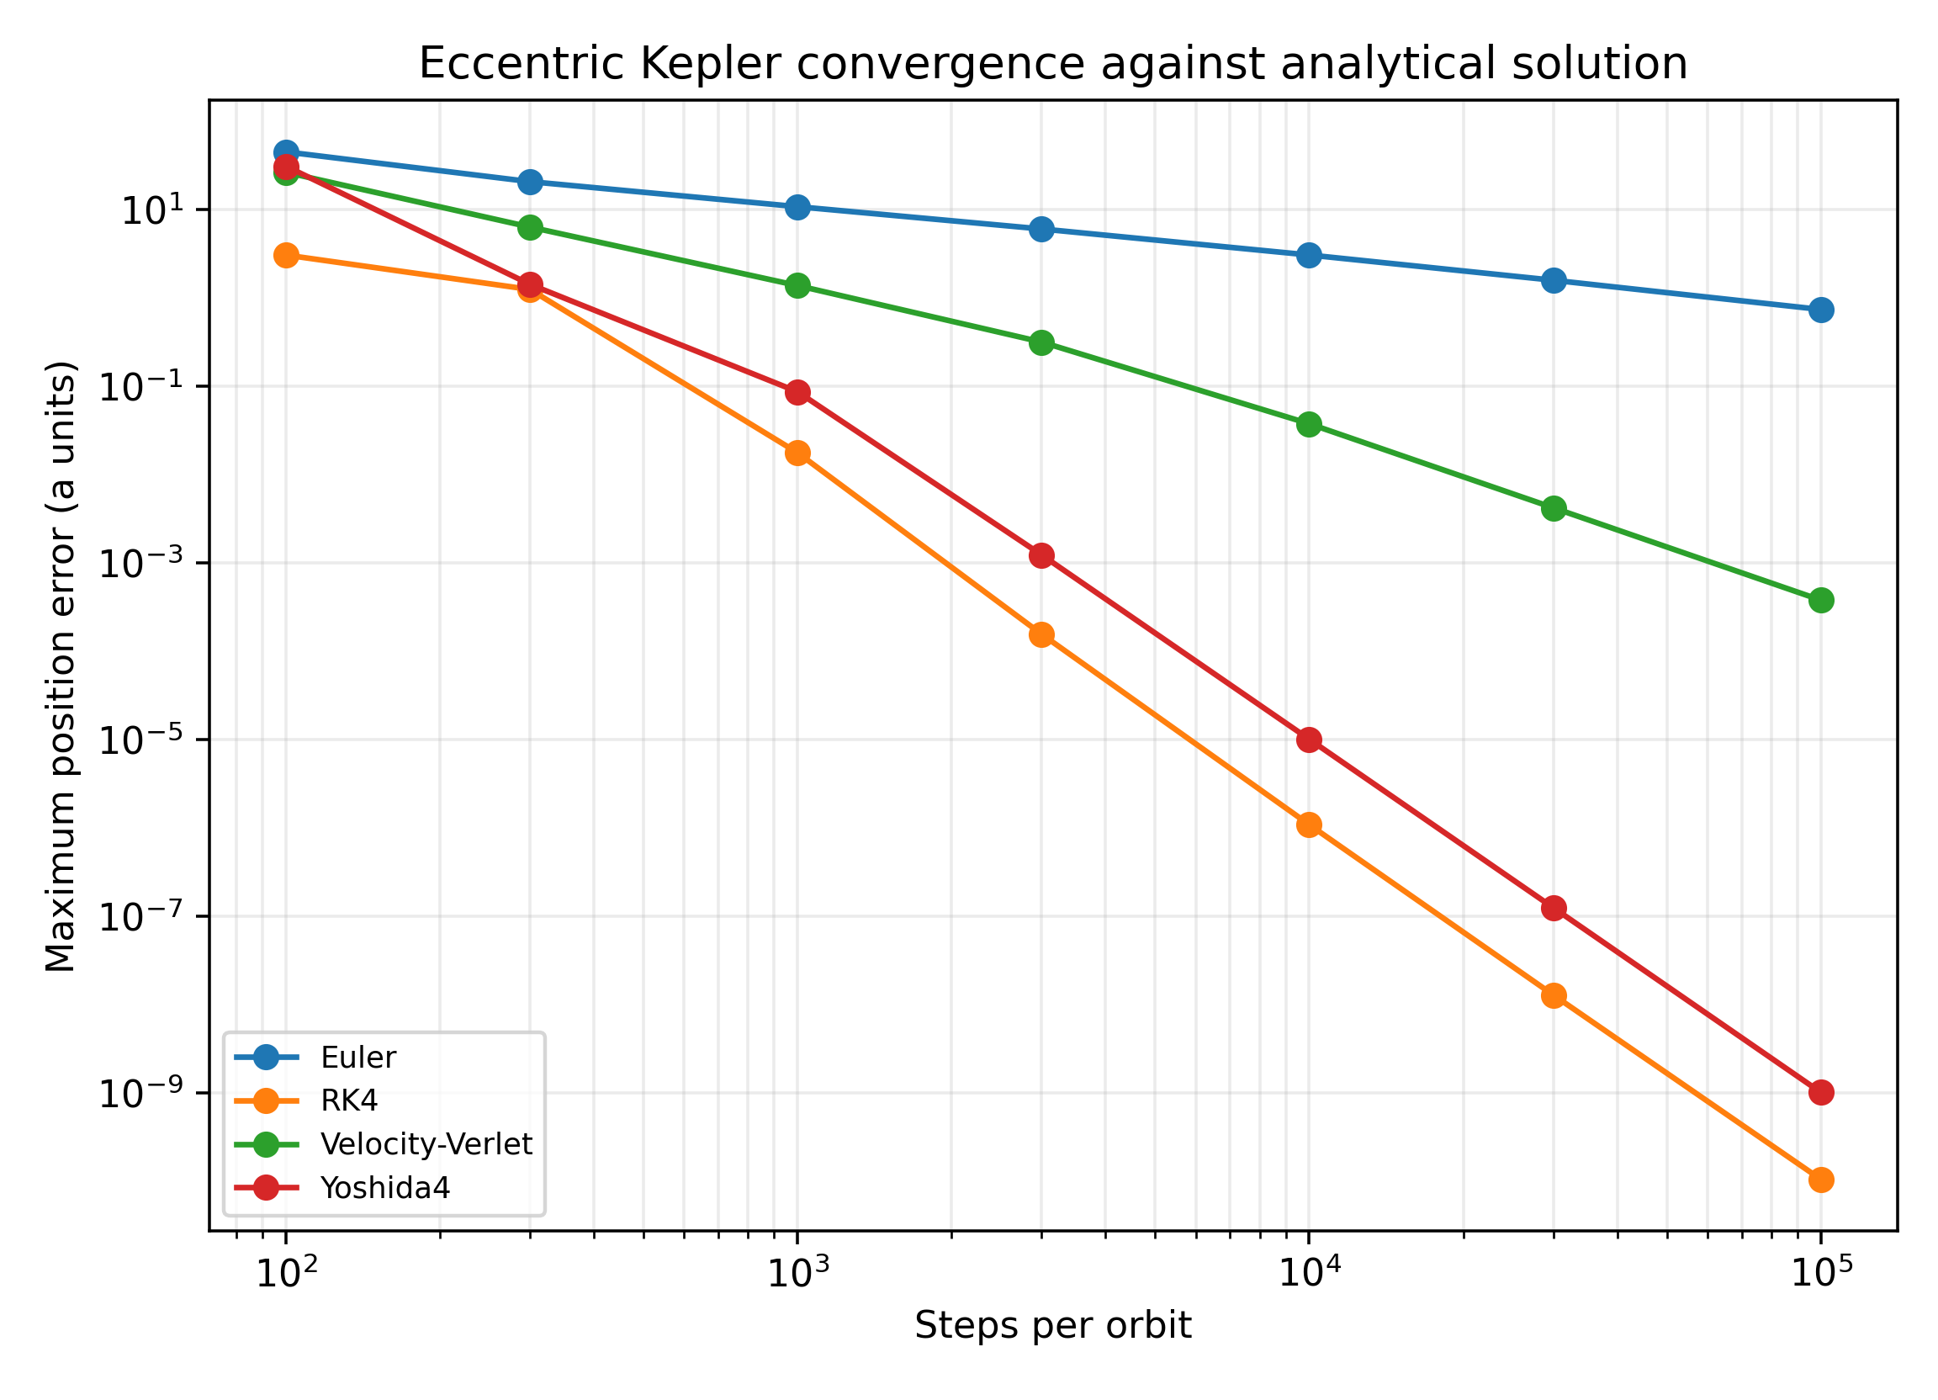  Figure 19. Eccentric-orbit global position-error convergence against the analytical Kepler solution. | 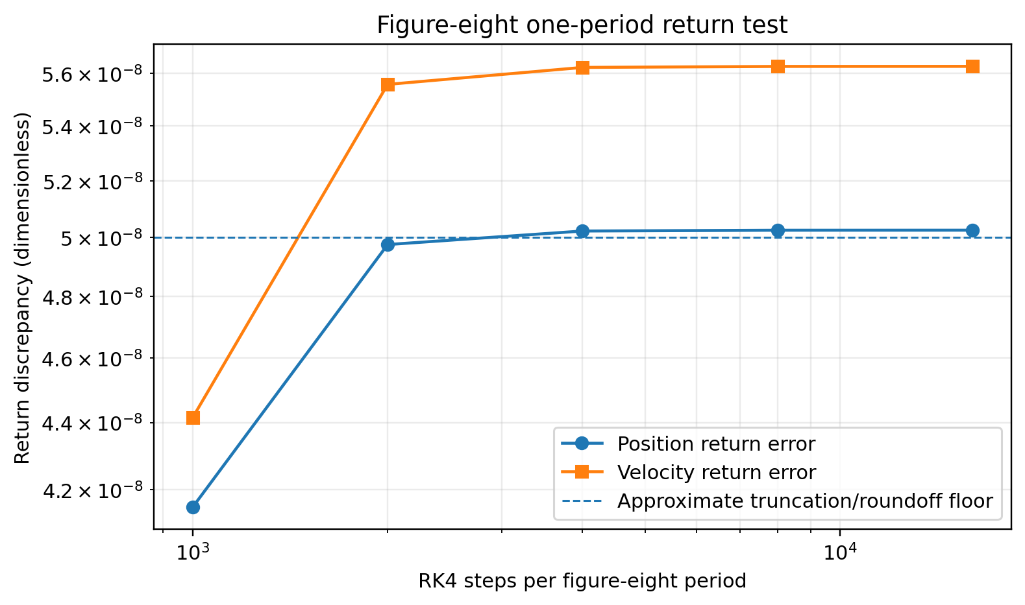  Figure 20. Figure-eight one-period return discrepancy for RK4. The plateau reflects rounded initial conditions and period, limiting its use as a convergence reference.

The equal-mass figure-eight choreography was integrated with RK4 for exactly one nominal period T ≈ 6.32591398 using the rounded initial conditions of Chenciner and Montgomery (2000). The position return discrepancy decreases from 4.15×10⁻⁸ at 1,000 steps per period, then plateaus near 5.03×10⁻⁸; the velocity return discrepancy similarly plateaus near 5.63×10⁻⁸. This floor is consistent with the finite precision of the published initial conditions and period, so the test is reported as a return check, not as evidence of fourth-order convergence. The Pythagorean problem, originating with Burrau (1913) and later studied by Szebehely and Peters (1967), is under-resolved in this implementation and is not used to rank integrators.

6. Discussion
The long-duration eccentric experiment directly tests the paper’s central distinction. At 10,000 steps per orbit over 1,000 periods, velocity-Verlet and Yoshida4 maintained bounded energy-error envelopes, but their phase errors still accumulated. RK4 delivered lower phase error than velocity-Verlet at the final time for this particular step size, while its energy error showed a secular trend. Yoshida4 had the smallest measured phase discrepancy among the fixed-step methods in this setup. These results do not imply that symplectic methods always give more accurate trajectories; rather, they show why conservation and pointwise accuracy must be reported separately.
The adaptive DOP853 baseline is essential context: at 2,975 function evaluations it reached a maximum discrepancy of 1.11×10⁻¹¹a over the one-orbit eccentric test, much smaller than the fixed-step points shown in the work–precision plot. It would be misleading to describe RK4 as highly accurate per evaluation without acknowledging that result. The work–precision comparison is a finite-interval benchmark; long-duration adaptive behaviour was not measured here.
The observed circular-orbit energy slope of 3.32 versus 2.04 for e = 0.9 is consistent with a problem-specific cancellation hypothesis, but does not prove it. The finest circular points are influenced by the floating-point floor. Likewise, the figure-eight return plateau is limited by rounded initial conditions, and the Pythagorean close encounter requires a better-resolved, independently checked integration. The direct-force scaling trend is consistent with O(N²), but the short timing kernel does not establish a hardware-independent performance law.

7. Limitations
The model is Newtonian and excludes relativistic corrections, solar oblateness, radiation pressure, tides, dissipation, and precision planetary ephemerides. The long eccentric run uses one fixed timestep and one orbital configuration; other eccentricities and timestep choices could change the balance between energy and phase error. No direct comparison against REBOUND, WHFast, IAS15, or JPL Horizons was completed. Consequently, this manuscript does not claim external validation, predictive accuracy for real Solar System ephemerides, or superiority over established N-body packages. The Pythagorean integration remains under-resolved and is described only as a cautionary case.

8. Reproducibility, data availability, and AI-use disclosure
The accompanying research package contains the direct-force implementation, convergence and work–precision scripts, raw CSV outputs, figures, environment metadata, and this manuscript. Array operations use NumPy (Harris et al., 2020), adaptive integration uses SciPy (Virtanen et al., 2020), and compiled benchmark kernels use Numba (Lam et al., 2015). The computational environment recorded Python 3.13.5, NumPy 2.3.5, SciPy 1.17.0, Matplotlib 3.10.8, Numba 0.65.1, and pandas 2.2.3 on Linux x86_64 with an AMD EPYC 9V74 80-Core Processor visible to the runtime (three logical CPUs available to the process). Run commands and initial conditions are documented in the package. A permanent public archive and Zenodo DOI must be added before public release; until then, the supplied repository package permits local inspection but does not provide a persistent public archive.
AI-use disclosure: Generative AI tools assisted with code review, manuscript editing, and identifying numerical checks. The author is responsible for verifying the equations, implementation, measurements, references, and claims in the final manuscript.

9. Conclusion
This study benchmarks Euler, velocity-Verlet, RK4, and Yoshida4 in direct Newtonian gravitational integration using analytical two-body references, convergence tests, invariant diagnostics, long-duration eccentric motion, perturbation and binary tests, scaling, and softening sensitivity. Fine-grid tests recover first-order Euler, second-order velocity-Verlet, and fourth-order RK4 and Yoshida4 position convergence where the fits remain above the roundoff floor. Over 1,000 eccentric periods, the symplectic methods retain bounded energy error while phase error grows, demonstrating why conservation alone cannot guarantee trajectory fidelity. The adaptive DOP853 baseline substantially outperforms the fixed-step points in the one-orbit work–precision test. The contribution is a transparent benchmark and numerical interpretation, not a new algorithm. Public archival and external REBOUND/JPL Horizons validation remain future work.

References
Aarseth, S. J. (2003). Gravitational N-Body Simulations: Tools and Algorithms. Cambridge University Press. https://doi.org/10.1017/CBO9780511535246.
Barnes, J., & Hut, P. (1986). A hierarchical O(N log N) force-calculation algorithm. Nature, 324, 446–449. https://doi.org/10.1038/324446a0.
Brouwer, D. (1937). On the accumulation of errors in numerical integration. The Astronomical Journal, 46, 149–153. https://doi.org/10.1086/105361.
Burrau, C. (1913). Numerische Berechnung eines Spezialfalles des Dreikörperproblems. Astronomische Nachrichten, 195, 113–118. https://doi.org/10.1002/asna.19131950602.
Chenciner, A., & Montgomery, R. (2000). A remarkable periodic solution of the three-body problem in the case of equal masses. Annals of Mathematics, 152(3), 881–901. https://doi.org/10.2307/2661357.
Hairer, E., Lubich, C., & Wanner, G. (2006). Geometric Numerical Integration: Structure-Preserving Algorithms for Ordinary Differential Equations (2nd ed.). Springer. https://doi.org/10.1007/3-540-30666-8.
Hairer, E., Nørsett, S. P., & Wanner, G. (1993). Solving Ordinary Differential Equations I: Nonstiff Problems (2nd revised ed.). Springer. https://doi.org/10.1007/978-3-540-78862-1.
Harfst, S., Gualandris, A., Merritt, D., Spurzem, R., Portegies Zwart, S., & Berczik, P. (2007). Performance analysis of direct N-body algorithms on special-purpose supercomputers. New Astronomy, 12(5), 357–377. https://doi.org/10.1016/j.newast.2006.11.003.
Harris, C. R., Millman, K. J., van der Walt, S. J., et al. (2020). Array programming with NumPy. Nature, 585, 357–362. https://doi.org/10.1038/s41586-020-2649-2.
International Astronomical Union. (2012). Resolution B2: Re-definition of the astronomical unit of length. XXVIIIth General Assembly. https://www.iau.org/static/resolutions/IAU2012_English.pdf.
Lam, S. K., Pitrou, A., & Seibert, S. (2015). Numba: A LLVM-based Python JIT compiler. In Proceedings of the Second Workshop on the LLVM Compiler Infrastructure in HPC. https://doi.org/10.1145/2833157.2833162.
Rein, H., & Liu, S.-F. (2012). REBOUND: An open-source multi-purpose N-body code for collisional dynamics. Astronomy & Astrophysics, 537, A128. https://doi.org/10.1051/0004-6361/201118085.
Rein, H., & Spiegel, D. S. (2015). IAS15: A fast, adaptive, high-order integrator for gravitational dynamics, accurate to machine precision over a billion orbits. Monthly Notices of the Royal Astronomical Society, 446(2), 1424–1437. https://doi.org/10.1093/mnras/stu2164.
Rein, H., & Tamayo, D. (2015). WHFast: A fast and unbiased implementation of a symplectic Wisdom–Holman integrator for long-term gravitational simulations. Monthly Notices of the Royal Astronomical Society, 452(1), 376–388. https://doi.org/10.1093/mnras/stv125.
Szebehely, V., & Peters, C. F. (1967). Complete solution of a general problem of three bodies. The Astronomical Journal, 72, 876. https://doi.org/10.1086/110355.
Virtanen, P., Gommers, R., Oliphant, T. E., et al. (2020). SciPy 1.0: Fundamental algorithms for scientific computing in Python. Nature Methods, 17, 261–272. https://doi.org/10.1038/s41592-019-0686-2.
Wisdom, J., & Holman, M. (1991). Symplectic maps for the N-body problem. The Astronomical Journal, 102, 1528–1538. https://doi.org/10.1086/115978.
Yoshida, H. (1990). Construction of higher order symplectic integrators. Physics Letters A, 150(5–7), 262–268. https://doi.org/10.1016/0375-9601(90)90092-3.

