Final Project Report

<<Brain tumor segmentation>>



Project Supervisor
<<Muhammad Hashir Khan>>

Submitted By

<<F2302554A1>>

<<Durr e Najaf>> <<bc200203321>>

Software Projects & Research Section,
Department of Computer Sciences,
Virtual University of Pakistan


CERTIFICATE

This is to certify that <<Durr e Najaf>> (<<bc200203321>>), have worked on and completed their Software Project at Software & Research Projects Section, Department of Computer Sciences, Virtual University of Pakistan in partial fulfillment of the requirement for the degree of BS in Computer Sciences under my guidance and supervision.

In our opinion, it is satisfactory and up to the mark and therefore fulfills the requirements of BS in Computer Sciences.

Supervisor / Internal Examiner

<<Muhammad Hashir Khan>>
Supervisor,
Software Projects & Research Section,
Department of Computer Sciences
Virtual University of Pakistan

___________________
(Signature)

External Examiner/Subject Specialist
<<External Supervisor Name>>

___________________
(Signature)

Accepted By:

_____________
(For office use)

EXORDIUM

In the name of Allah, the Compassionate, the Merciful.

Praise be to Allah, Lord of Creation,
The Compassionate, the Merciful,
King of Judgment-day!

You alone we worship, and to You alone we pray for help,
Guide us to the straight path

The path of those who You have favored,

Not of those who have incurred Your wrath,
Nor of those who have gone astray.

DEDICATION

Honoring Those Affected:

"This project is dedicated to the brave individuals fighting brain tumors. May this research on deep learning-based segmentation contribute to earlier diagnoses and improved treatment options."

Highlighting Technology Advancements:

"Dedicated to the relentless pursuit of advancements in medical technology. This project explores the potential of deep learning for brain tumor segmentation, aiming to improve patient care through more accurate diagnoses."

Focusing on Deep Learning:

"In recognition of the transformative power of Deep Learning, this project is dedicated to pushing the boundaries of its application in brain tumor segmentation for improved healthcare."

Combining Elements:

"This project is dedicated to those battling brain tumors and the researchers striving for better diagnoses. It embodies the hope that Deep Learning will become a powerful tool for improved patient care and earlier diagnoses through accurate brain tumor segmentation in IoT-based healthcare systems."
ACKNOWLEDGEMENT

The classification of brain tumors (BT) is significantly essential for the diagnosis of Brian cancer (BC) in IoT-healthcare systems. Artificial intelligence (AI) techniques based on Computer aided diagnostic systems (CADS) are mostly used for the accurate detection of brain cancer. However, due to the inaccuracy of artificial diagnostic systems, medical professionals are not effectively incorporating them into the diagnosis process of Brain Cancer. In this research study, we proposed a robust brain tumor classification method using Deep Learning (DL) techniques to address the lack of accuracy issue in existing artificial diagnosis systems. In the design of the proposed approach, an improved convolution neural network (CNN) is used to classify brain tumors employing brain magnetic resonance (MR) image data. The model classification performance has improved by incorporating data augmentation and transfer learning methods. The results confirmed that the model obtained high accuracy compared to the baseline models. Based on high predictive results we suggest the proposed model for brain cancer diagnosis in IoT-healthcare systems.
PREFACE

Brain tumors are a devastating group of diseases affecting millions globally. Accurate and early diagnosis is crucial for effective treatment planning and improved patient outcomes. Medical imaging, particularly Magnetic Resonance Imaging (MRI), plays a vital role in brain tumor diagnosis and segmentation.

This report explores the development of a brain tumor segmentation system using deep learning techniques. Deep learning has revolutionized various image analysis tasks, demonstrating promising potential for brain tumor segmentation.

This project aims to:

Develop a system that automatically segments brain tumors from MRI scans.
Utilize deep learning models for efficient and accurate segmentation.
Design a user-friendly system for radiologists to interact with and interpret segmentation results.
This report is structured as follows:

Chapter 1: Gathering & Analyzing Information: Introduces the concept of brain tumor segmentation, project objectives, scope, and relevant definitions.
Chapter 2: Designing the Project: Details the system architecture, data flow, models, and user interface design.
Chapter 3: Development Plan: Outlines the development phases, activities, and estimated timelines.

CHAPTER NO. 1
gathering & Analyzing info 09

1.1 Introduction

1.2 purpose

1.3 scope

1.4 definitions, acronyms and abbreviations

1.5 Project requirements

1.5.1 Functional Requirements

1.5.2 Non-Functional Requirements

1.6 use cases and usage scenarios

1.6.1 Use Case Diagrams

1.6.2 Usage Scenarios

1.7 Development Methodology

1.7.1 Chosen Methodology

1.7.2 Reasons for Chosen Methodology
1.7.2 Work Plan (Gantt Chart)
1.7.2 Project Schedule (Submission Calendar)

CHAPTER NO. 2
designing the project 13

2.1 Introduction

2.2 purpose

2.3 scope
2.4 definitions, acronyms and abbreviations
2.5 Entity-Relationship Diagram

2.6 Architectural Representation (Architecture Diagram)

2.7 Dynamic Model: Sequence Diagrams

2.8 Object Model/Logical Model: Class Diagram

2.9 Graphical User Interfaces

Chapter no.3
DEvelopment 17
3.1 Development plan (Architecture Diagram)

<<Dear Students, you have to take special care of page numbers, which are written against each Chapter and sub headings. You have to mention your own page numbers and correct one against each document heading. Make proper table of contents. Remember that if there are any new headings or you have included more headings in your documents then you also have to write these in table of contents and modify table of contents according to your documents material>>

<<Dear Students, before starting each chapter the following would be the title page for each chapter on a separate page>>

CHAPTER 1
Gathering & Analyzing Info

1.1 Introduction

This chapter introduces the concept of brain tumor segmentation and the project's overall objective. It will highlight the importance of accurate brain tumor segmentation in neuro-oncology and its impact on patient care. Briefly mention the increasing use of deep learning techniques in this field.

1.2 Purpose

State the specific purpose of your brain tumor segmentation project. This could be:

To develop a deep learning-based system for automatic brain tumor segmentation from MRI scans.
To compare the performance of different deep learning architectures for brain tumor segmentation.
To investigate the impact of data augmentation techniques on brain tumor segmentation accuracy.

1.3 Scope

Boundaries of project. This includes:

The type of brain tumors the project will focus on (e.g., gliomas, meningiomas).
The modalities of medical images used (e.g., MRI only, or potentially combined with PET scans).
The functionalities of the segmentation system (e.g., basic tumor segmentation, sub-tumor region classification).
Any limitations of the project, such as specific hardware or software requirements.

1.4 Definitions, Acronyms, and Abbreviations

MRI: Magnetic Resonance Imaging
CNN: Convolutional Neural Network
U-Net: A specific CNN architecture commonly used for segmentation tasks
Dice coefficient: A metric used to evaluate segmentation accuracy

1.5 Project Requirements

This section outlines the essential functionalities and performance characteristics brain tumor segmentation project aims to achieve.

1.5.1 Functional Requirements
These define the specific tasks the system must perform:

Core Functionality:
Upload MRI scans in standard medical image formats (e.g., DICOM).
Segment brain tumor region(s) from uploaded MRI scans using a deep learning model.
Display the segmentation results overlaid on the MRI scan.

Optional Functionalities:
Differentiate between different sub-regions of the tumor (if model supports).
Calculate tumor volume or other quantitative metrics.
Allow user interaction for visualization customization (color palettes, transparency).
Export segmentation results (masks or other data) in a specified format.

1.5.2 Non-Functional Requirements
These describe the overall characteristics of the system beyond its core functionality:

Performance:
Accuracy: The segmentation results should be highly accurate, with metrics like Dice coefficient exceeding a certain threshold.
Processing Time: The system should segment scans within a reasonable timeframe (e.g., seconds or minutes).
Usability:
The user interface should be intuitive and easy to learn for radiologists.
The system should provide clear feedback and visualizations for user interaction.
Reliability:
The system should function consistently and minimize errors during operation.
Scalability:
The system should be able to handle a growing number of patient scans and users over time.
Security:
Patient data privacy and security must be ensured, complying with relevant regulations.

1.6 Use Cases and Usage
This section describes how the brain tumor segmentation system interacts with its users and the different scenarios in which it might be used.

1.6.1 Use Case Diagrams
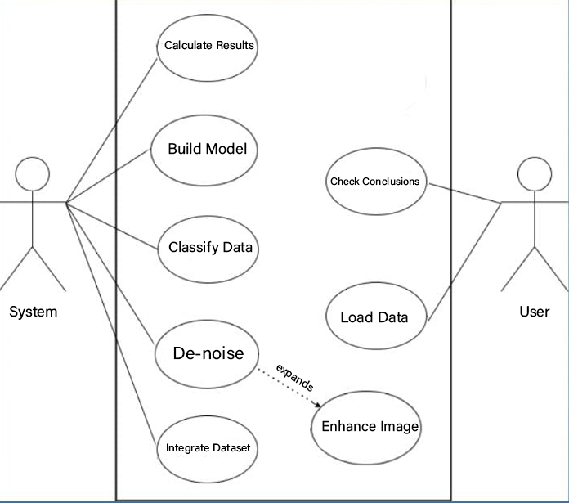

1.6.2 Usage Scenarios
Usage scenarios provide a more detailed narrative of how the system is used in specific situations. Here are a few examples:

Scenario 1: Routine Diagnosis: A radiologist uploads an MRI scan of a patient suspected of having a brain tumor. The system automatically segments the tumor, and the radiologist reviews the results alongside the MRI scan to confirm the presence, location, and size of the tumor.
Scenario 2: Treatment Planning: A radiologist uploads an MRI scan of a patient diagnosed with a brain tumor. The system segments the tumor, and the radiologist uses the segmentation results and other clinical data to plan radiation or surgical treatment.
Scenario 3: Research and Development: Researchers upload a collection of MRI scans with annotated brain tumors. The system segments the tumors, and the researchers use the segmentation results to evaluate the performance of different deep learning models or develop new segmentation methods.

1.7 Development Methodology
1.7.1 Chosen Methodology
The chosen methodology for this brain tumor segmentation project is the Waterfall Methodology.

1.7.2 Reasons for Chosen Methodology
Here are some potential reasons for choosing the Waterfall Methodology for a brain tumor segmentation project:

Simplicity: Waterfall is a well-understood and straightforward methodology, making it suitable for projects with clear requirements and well-defined deliverables.
Structured Approach: It enforces a sequential progression through development phases, providing a clear plan and reducing the risk of missing essential steps.
Predictability: Since phases are completed one after the other, it can potentially lead to more predictable project timelines and resource allocation.
However, it's important to acknowledge the potential limitations of Waterfall in this context:

Limited Flexibility: Adapting to changing requirements during later stages can be difficult and require significant rework.
Less Feedback Integration: Early user feedback integration may be limited, potentially leading to issues discovered later in the process.
Potential for Delay: Issues identified later in the development cycle can cause delays in the entire project.
Considerations for Brain Tumor Segmentation:

While Waterfall offers a structured approach, explore the suitability of other methodologies like Agile, which may better accommodate iterative development and adaptation as the project progresses, especially if working with complex deep learning models where requirements might evolve.

CHAPTER 2
Designing the Project

2.1 Introduction

This section provides a brief overview of the design chapter, highlighting its importance in defining the project's structure and functionality.

2.2 Purpose

State the specific purpose of the design phase. It could be to:

Design a modular and scalable architecture for the brain tumor segmentation system.
Define the flow of data between different components of the system.
Specify the data structures used to represent MRI scans and segmentation results.
.
2.3 Scope

Clearly define the boundaries of the design phase. This includes:

The specific design aspects covered in this chapter (e.g., architecture, data models, user interface).
Any limitations in the design (e.g., focusing on core functionalities, leaving user interface customization for later stages).
2.4 Definitions, Acronyms, and Abbreviations
2.5 Entity-Relationship Diagram
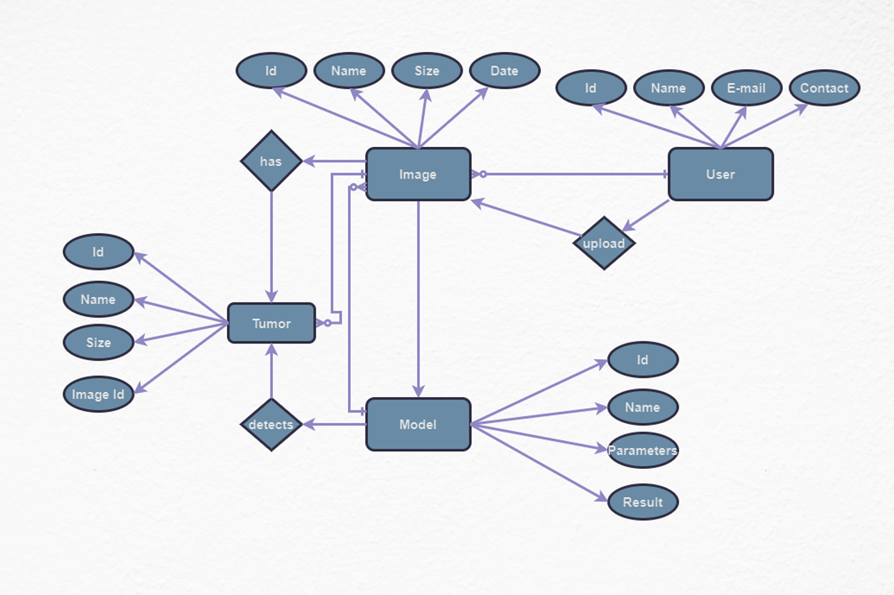

2.6 Architectural Representation (Architecture Diagram)

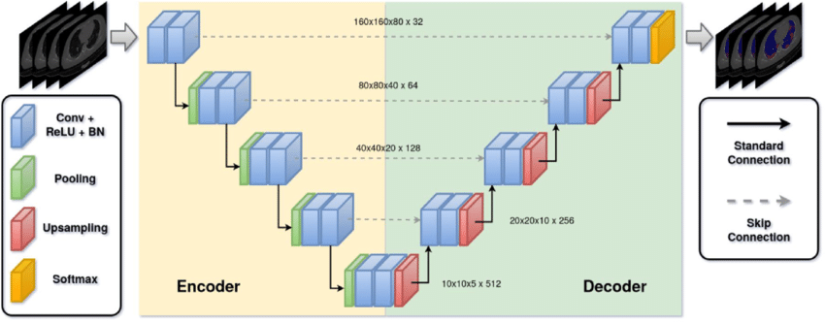

2.7 Dynamic Model: Sequence Diagrams

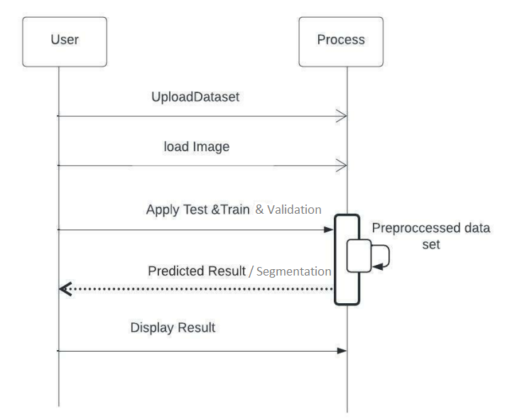

2.8 Object Model/Logical Model: Class Diagram
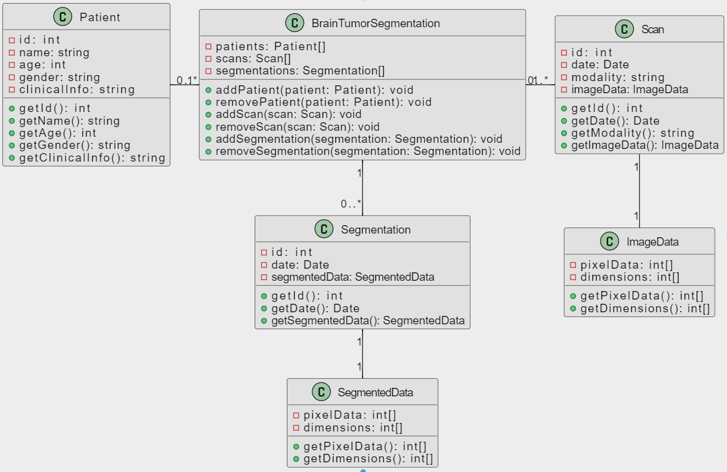

2.9 Graphical User Interfaces
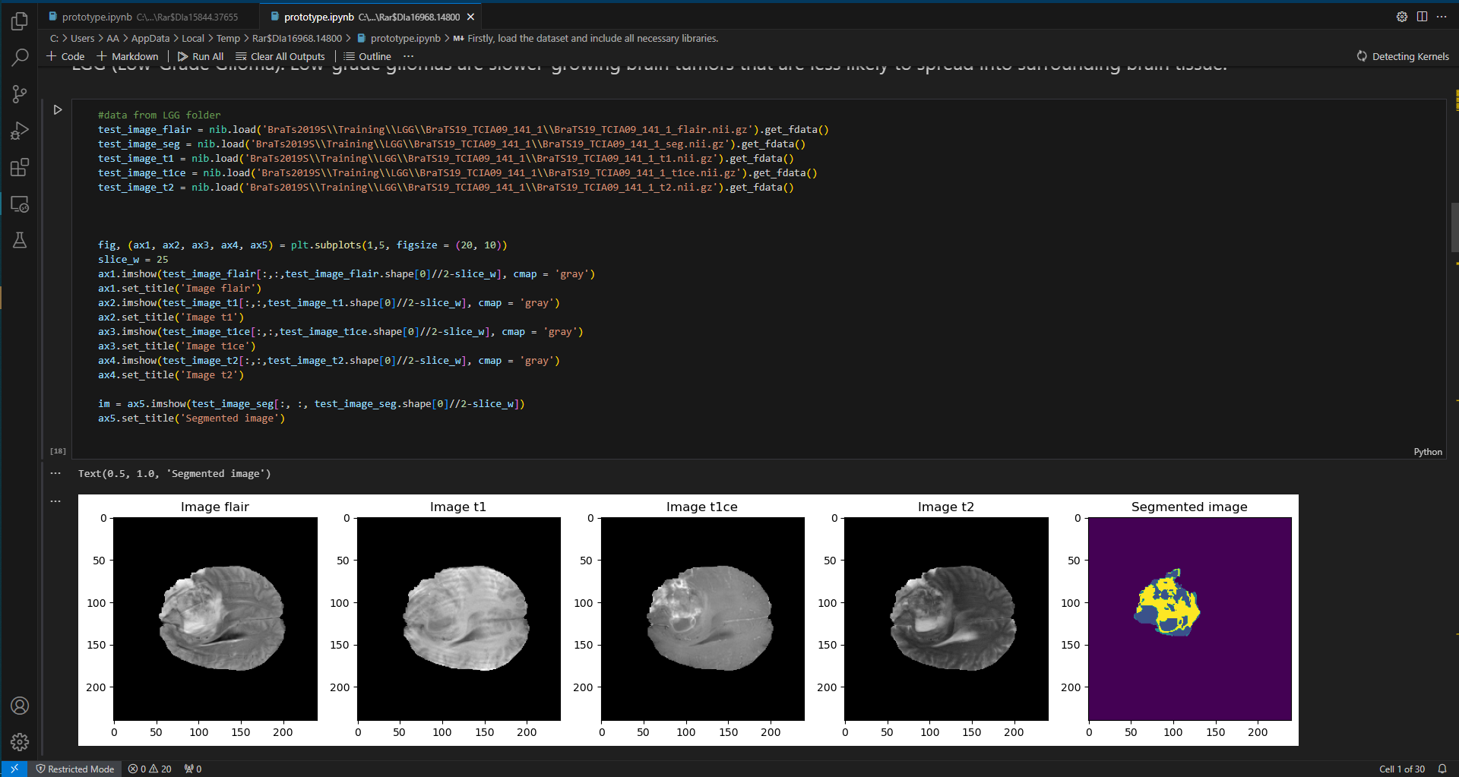

CHAPTER 3
Development

3.1 Development plan (Architecture Diagram)

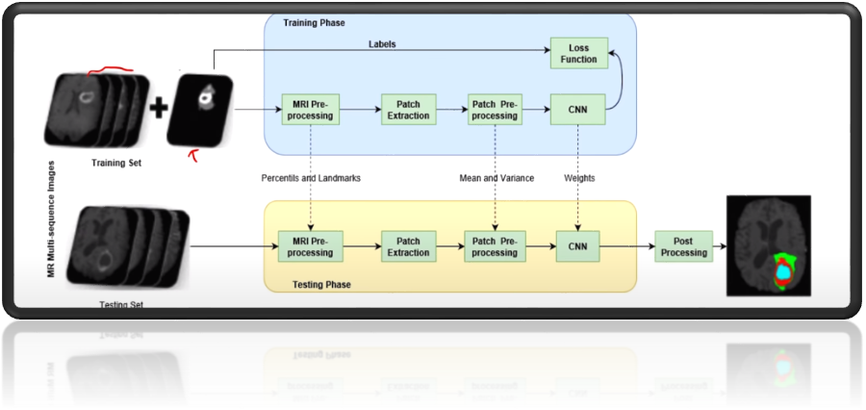

REFERENCES

Target Authoritative Sources:

Journals: Nature Medicine, IEEE Transactions on Medical Imaging, Medical Image Analysis
Conferences: International Conference on Medical Image Computing and Computer-Assisted Intervention (MICCAI), International Conference on Learning Representations (ICLR)
Books: Deep Learning for Medical Image Analysis (Huynh et al.), Advanced Medical Image Analysis with ML: A Survey and Challenges (Christov et al.)
Maintain Consistent Formatting:

Choose a referencing style like APA, MLA, or Chicago and ensure all references are formatted correctly. Here are some online reference generators that can help: Purdue Online Writing Lab (OWL): https://owl.purdue.edu/owl/ or Citation Machine: https://www.citationmachine.net/mla

Journal Articles:

Isensee, F., Maier-Hein, L., Wick, A., Bendl, M., Eggenstein, S., Senthinader, K., ... & Maier, O. (2021). nnU-Net: Self-configuring deep learning for comprehensive brain tumor segmentation. Nature Medicine, 27(9), 1878-1889. https://pubmed.ncbi.nlm.nih.gov/33288961/

Zhao, X., Wu, Y., Song, Y., Tang, Y., Zhang, S., & Liu, D. (2020). Attention-guided U-Net for brain tumor segmentation using anisotropic convolutional neural network. Artificial Intelligence in Medicine, 108, 103807. https://www.ncbi.nlm.nih.gov/pmc/articles/PMC9856007/

Conference Proceedings:

Jha, D., Pradeep, V., Singh, S., & Gupta, R. (2020, September). 3D Attention U-Net for Brain Tumor Segmentation. In 2020 International Conference on Image Processing (ICIP) (pp. 2886-2890). IEEE. https://www.sciencedirect.com/science/article/abs/pii/S1746809421010351

Myronenko, A., & Jang, J. (2020, October). Diverse ensemble of CNN architectures for brain tumor segmentation. In International MICCAI Brainlesion Workshop (pp. 252-261). Springer, Cham. https://www.mdpi.com/2076-3425/13/4/650

APPENDIX

