
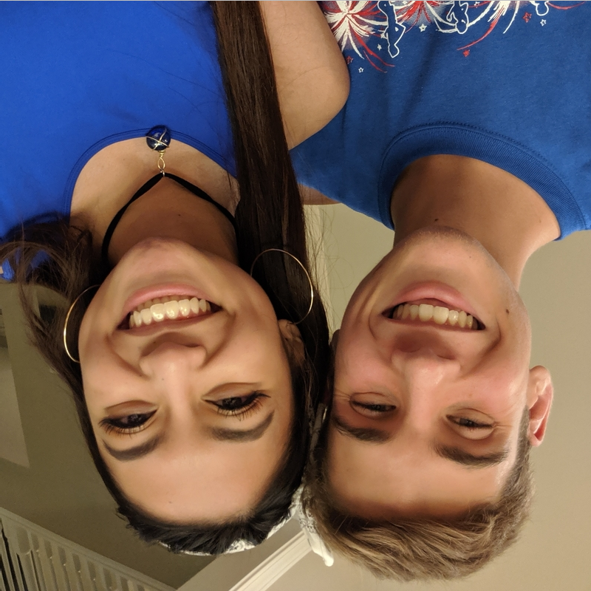

ORIGINAL IMAGE:
POSTCONDITION vertFlip():
POSTCONDITION horizFlip():

