Week1 - GPU and CPU toggle screenshots
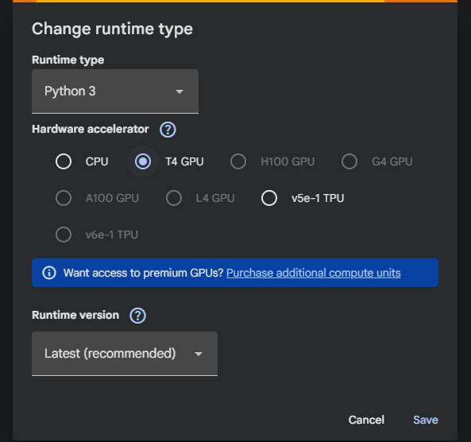

Changed the runtime to GPU
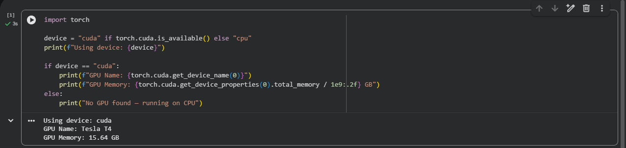

Changed the runtime to CPU
