Testing the inputof students

Students didn’t worked

Saved stud no into an integer when an archaic one kused letters aswell as numbes

Staff didn’t work

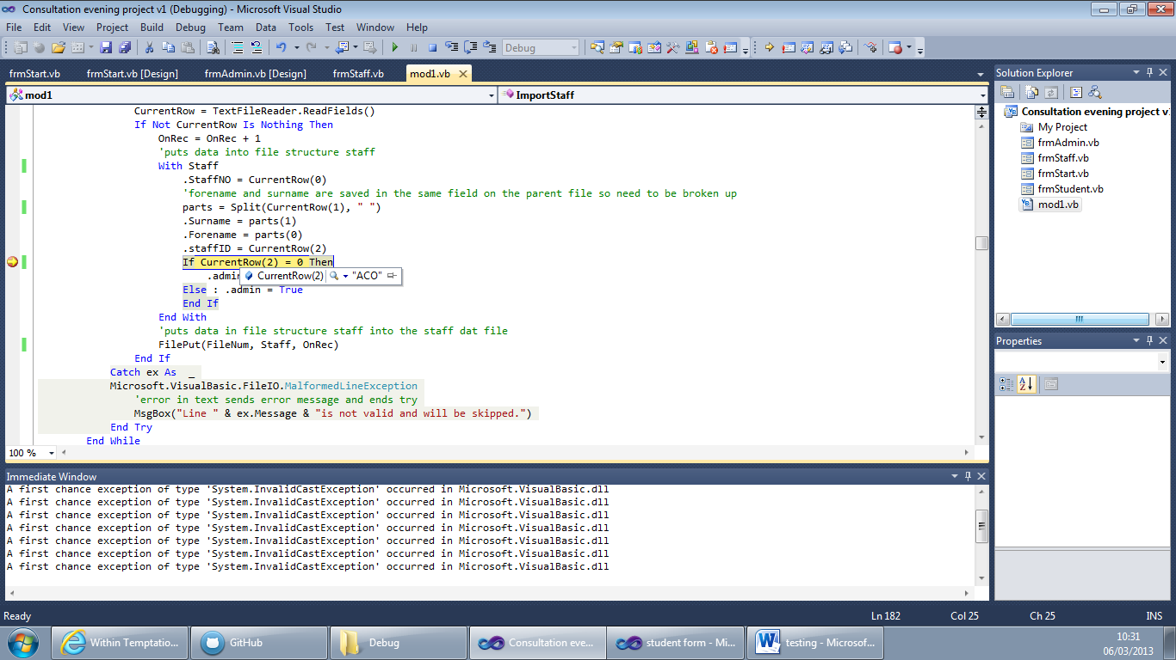

This was because I was using currentrow(2) when I should have been using currentrow(3). This typo meant that was comparing a string with a number causing the code to fail. It was hard to catch because the code is in a try so if it fails the code does not and it moves to the next record.