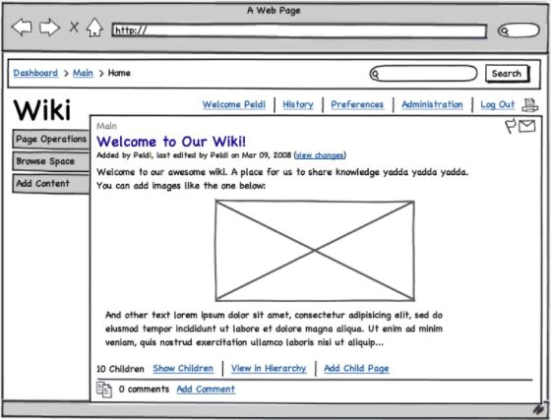

1. Tablets:

* Keep the upper line with path, search bar and Search button;
* On the left side replace these 3 options with icons and central part of the page should take the largest part of the page;
* Menu above the main part keep as it is;
* Main part of the page is kept as it is;

1. Mobile phones:

* Remove path from the upper line and keep just search bar with Search button;
* Implement hamburger menu in the upper left corner with options from the menu that is above the main part and add one more option ‘Edit’ (on click on this option three options from left side of the page are shown);
* Main part of the page is kept as it is;
* Options for children should be aligned so that every option is one row;
* Part with comments: icon should be removed, in one line information about number of comments and under option ‘Add Comment’;