Abstract
This project presents a comprehensive Digital Health Coach system that integrates Machine Learning (ML), Retrieval-Augmented Generation (RAG), and Agentic Large Language Models (LLMs) to provide personalized, evidence-based lifestyle recommendations. The system uses a synthetic dataset containing 200 users over 90 days to model daily health behaviours, including physical activity, sleep, hydration, nutrition, stress, and heart rate. A Random Forest classifier is trained on engineered rolling features to predict the user’s fatigue risk, enabling proactive identification of unhealthy patterns.
To ensure medical reliability, the system incorporates guideline knowledge from trusted sources such as WHO, Eatwell, and Physical Activity Guidelines documents. These PDFs are processed into text, chunked, embedded using Sentence Transformers, and indexed into a vector database. A RAG retriever selects relevant guideline chunks in response to user queries, ensuring that recommendations align with authoritative health standards.
The system uses an agentic pipeline that combines:
1. LLM-based extraction of health habits from free-text user input,
2. ML fatigue-risk prediction,
3. rule-based behavioural insights, and
4. RAG-grounded evidence retrieval.
A Groq-powered Llama 3 model synthesizes these signals into final personalized coaching responses.
A Streamlit chatbot interface allows users to interact naturally with the system, receive health assessments, and obtain tailored recommendations. This project demonstrates how hybrid ML–RAG–LLM architectures can enable safe, explainable, and context-aware digital health coaching suitable for real-world applications.

Introduction

Background
The increasing availability of personal health data and the rapid advancement of artificial intelligence have created new opportunities for delivering personalised digital health solutions. Traditional health-monitoring systems typically rely on rule-based feedback or simple tracking, which often fails to provide contextual, personalised, and evidence-grounded recommendations. In contrast, modern AI systems—particularly Large Language Models (LLMs)—enable the creation of intelligent, conversational digital health assistants capable of interpreting behavioural patterns, reasoning over user context, and providing tailored lifestyle guidance.
Despite the potential of LLMs, relying solely on generative outputs can produce inaccurate or unsafe health recommendations, especially when medical reliability is required. Therefore, this project focuses on developing a hybrid AI system that combines three major components:
- Machine Learning (ML) for predicting fatigue-related health risks.
- Retrieval-Augmented Generation (RAG) for grounding responses in verified health guidelines.
- Agentic LLM reasoning to generate personalised and context-aware recommendations.
To support meaningful modelling, a synthetic dataset was created consisting of 200 users' daily lifestyle data across 90 days. The dataset captures key health-related variables such as physical activity, sleep duration, water intake, calorie consumption, stress levels, fatigue scores, age, BMI, and resting heart rate. These features allow the system to understand behavioural patterns and generate personalised feedback.
The system also incorporates official health guidance from trusted organisations, including the World Health Organisation (WHO), NHS Eatwell guidelines, and the Physical Activity Guidelines for Adults. These documents are processed into a vector database using sentence-level embeddings, enabling the RAG component to retrieve relevant, evidence-based content in response to user questions.
A key part of the system is the Health Coach Agent, which integrates ML-based fatigue-risk predictions, RAG-guideline retrieval, and LLM-based reasoning. This agent interprets user queries, extracts behavioural features using an LLM, retrieves authoritative guidance, and delivers personalised recommendations.
The entire system is deployed as an interactive Streamlit chatbot application, allowing users to naturally engage with the health coach and receive tailored wellness advice. The project demonstrates how integrating ML, RAG, and agentic LLMs enables a powerful, explainable, and user-centric digital health solution.

Problem Statement
Modern adults increasingly struggle to maintain healthy lifestyle habits due to busy work schedules, sedentary routines, poor sleep patterns, and inconsistent nutrition. Although reliable health guidelines exist—such as those from the World Health Organization (WHO), NHS Eatwell Guide, and Physical Activity Guidelines for Adults—most people find it difficult to interpret and apply them to their own daily habits.
At the same time, wearable devices and health-tracking apps generate large amounts of personal data, but users rarely know how to translate this data into actionable behavioural improvements. Traditional rule-based health advice systems lack personalization, and fully manual consultation with specialists is not always accessible or affordable.
Therefore, there is a need for an intelligent, personalized digital health-coaching system that can:
- Understand a user’s behaviour from natural-language input.
- Analyse lifestyle patterns using data-driven machine-learning techniques.
- Retrieve factual guidance from trusted medical sources (WHO, NHS, PA Guidelines).
- Combine empirical data, guideline evidence, and AI reasoning to deliver practical, personalised recommendations.
This study addresses the problem of integrating Machine Learning, Retrieval-Augmented Generation (RAG), and Agentic AI to build a health-coaching system capable of generating accurate, meaningful, and user-specific feedback based on both personal habits and trusted medical knowledge.

Objectives of the Project
This project aims to develop a machine learning–driven system capable of predicting fatigue risk based on users’ lifestyle behaviours. By analysing features such as daily steps, sleep duration, stress levels, hydration, calorie intake, resting heart rate, age, and BMI, a Random Forest model is trained to identify patterns associated with high fatigue risk. This predictive component enables early detection and supports personalised intervention.
Another core objective is to create a Retrieval-Augmented Generation (RAG) pipeline that integrates reliable external health knowledge. Evidence-based guideline sources—including WHO health recommendations, NHS Eatwell nutrition guidelines, and established Physical Activity Guidelines—are processed through text extraction, chunking, and embedding. This enables the system to retrieve the most relevant guidance for each user query, ensuring the advice provided remains accurate and aligned with recognized public health standards.
The project also aims to design an Agentic AI-powered digital health coach that combines machine learning predictions, RAG-retrieved guideline evidence, and natural language reasoning using a Large Language Model. This agent interprets free-text user inputs, extracts lifestyle details, assesses fatigue risk, retrieves guideline-based knowledge, and generates clear, personalised recommendations. The final output is delivered through an interactive Streamlit chatbot interface that enables natural and user-friendly health coaching.

Research Questions
- How can an integrated AI system combining machine learning, RAG-based knowledge retrieval, and agentic LLM reasoning deliver personalised and reliable health coaching to users?
- How accurately can a machine learning model predict user fatigue risk using lifestyle and behavioural features from synthetic health data?
- How effectively can a RAG pipeline retrieve and apply evidence-based guidelines from WHO, NHS Eatwell, and Physical Activity publications to support personalised recommendations?

Scope of the Research
This research focuses on developing and evaluating a digital health coaching system that integrates machine learning, retrieval-augmented generation (RAG), and agentic large language model (LLM) reasoning to provide personalised lifestyle recommendations. The system is designed to support users in improving their physical activity, sleep quality, stress management, hydration, and nutritional habits.
The scope includes the generation of a synthetic multi-user health dataset that simulates daily behavioural patterns over a 90-day period. This dataset is used to train a Random Forest model to predict fatigue risk based on engineered features such as 7-day rolling averages of steps, sleep duration, and stress levels. The research is limited to predictive modelling using structured behavioural data and does not include clinical diagnostics or medical outcomes.
The project also involves building a RAG pipeline that retrieves guideline information from publicly available evidence-based sources, specifically WHO health recommendations, NHS Eatwell guidelines, and Physical Activity Guidelines for adults. The focus is on extracting, chunking, embedding, indexing, and retrieving relevant guideline content to support the decision-making process of the AI agent.
Furthermore, the scope covers the design of an agentic AI framework capable of merging ML predictions, retrieved guideline evidence, and natural-language inputs into coherent, actionable advice. The system is deployed through a Streamlit-based chatbot interface, enabling interactive communication with users. This research is limited to lifestyle-based coaching and does not address medical diagnostics, emergency care, or real-time physiological monitoring.

Justification of the Research
The rise of chronic lifestyle-related health issues—such as fatigue, stress, poor sleep quality, and physical inactivity—has created a growing need for accessible and personalised health support. However, many individuals lack access to continuous health coaching due to financial, geographical, or time constraints. This research is justified by the increasing demand for scalable, data-driven, and reliable digital health solutions that can guide users in making informed lifestyle improvements.
Artificial intelligence provides a unique opportunity to bridge this gap. Machine learning models can analyse behavioural patterns and identify early signs of health risks, enabling proactive recommendations rather than reactive interventions. At the same time, Retrieval-Augmented Generation (RAG) ensures that the advice generated is grounded in evidence-based guidelines, such as WHO recommendations and NHS Eatwell standards, improving reliability and trustworthiness. Combining these components is critical, as purely generative models may hallucinate or provide unsafe advice without grounding in authoritative knowledge.
Furthermore, agentic AI frameworks enable an intelligent, context-aware reasoning process that integrates multiple sources of information—user habits, ML predictions, and guideline evidence—into a single coherent response. This makes the system more aligned with how a human health coach would think and respond. The integration of these advanced AI techniques contributes to the research by demonstrating how modern health-support systems can become more personalised, explainable, and effective.
Finally, the project offers practical value by delivering a functional prototype that operates as an interactive chatbot. This supports real-world usability and shows the potential for deploying AI health coaching systems in educational, workplace wellness, and personal health-management contexts. As a result, the research contributes both academically and practically to the emerging field of AI-powered digital health assistance.

Literature Review

Introduction to the Research Theme
The increasing prevalence of lifestyle-related health issues has intensified global interest in digital tools that support healthier daily habits. Modern lifestyles often involve prolonged sedentary behaviour, inadequate sleep, high stress, and inconsistent nutritional patterns, all of which contribute to fatigue and declining well-being. With growing access to consumer health data and digital platforms, there is a significant opportunity to leverage artificial intelligence to provide personalised, scalable, and accessible health guidance.
Recent advancements in AI—particularly machine learning, large language models (LLMs), and retrieval-augmented generation (RAG)—have transformed the way digital health systems can interpret user behaviour and deliver evidence-based recommendations. Machine learning enables predictive analysis of user patterns, allowing early detection of risks such as fatigue or stress. Meanwhile, RAG systems ensure that generated recommendations remain grounded in trusted sources such as WHO guidelines, NHS Eatwell recommendations, and established physical activity standards. The emergence of agentic AI frameworks adds another layer of intelligence by combining predictive modelling, knowledge retrieval, and natural-language reasoning in a unified system.
Within this context, the research theme focuses on the integration of these advanced AI components to build an effective, personalised digital health coach. The goal is to understand how ML-based risk assessment, guideline-driven retrieval systems, and conversational AI can work together to support user decision-making and promote healthier lifestyles. This literature review explores the existing body of research on digital health coaching, machine learning for behavioural assessment, RAG architectures, and agent-based AI systems, providing the theoretical and empirical foundation for the development of the proposed health-coaching framework.

Theoretical Explanation of Key Concepts

1. Digital Health Coaching
Digital health coaching refers to the use of digital tools—such as mobile applications, chatbots, and AI agents—to deliver personalised lifestyle guidance and behavioural support. These systems aim to replicate elements of human health coaching by monitoring user habits, identifying unhealthy patterns, and providing tailored recommendations. The theoretical foundation is rooted in behaviour change models such as the Transtheoretical Model (TTM), the Health Belief Model (HBM), and self-regulation theory, which emphasize continuous monitoring, feedback, and personalised intervention. Digital health coaching has become increasingly relevant as technology enables scalable support for large populations.

Machine Learning (ML) for Health Prediction
Machine learning is a subset of artificial intelligence that enables systems to learn from data patterns without being explicitly programmed. In health applications, ML is commonly used for risk prediction, anomaly detection, and personalised recommendation. Techniques such as Random Forest classifiers, logistic regression, and neural networks have been applied to lifestyle datasets to predict outcomes including fatigue, stress, sleep quality, and chronic disease risk. The theoretical basis lies in statistical learning theory, where the aim is to model relationships between behavioural variables and health outcomes to make predictions for new users. ML enhances personalisation by detecting subtle patterns in user behaviour that are not easily noticed through manual analysis.

Retrieval-Augmented Generation (RAG)
Retrieval-Augmented Generation is an AI architecture that combines information retrieval with large language model generation. Unlike standard LLMs, which rely solely on their internal knowledge (and may hallucinate), RAG systems retrieve relevant, external documents and provide them as grounding context for generating responses. This approach is theoretically grounded in information retrieval (IR) techniques such as vector similarity search, embedding-based retrieval, and document chunking. In health applications, RAG ensures that recommendations remain aligned with authoritative medical guidelines, reducing risk and increasing trustworthiness. The retrieval component enhances factual accuracy, while the generative component offers personalised and coherent explanations.

Large Language Models (LLMs)
Large Language Models are deep learning models trained on massive text corpora to understand and generate human-like language. Examples include GPT models, LLaMA, and Groq-powered LLMs. The theoretical foundation is based on the Transformer architecture, which enables models to learn contextual relationships between words and sentences. In digital health, LLMs support natural-language interactions, interpret user inputs, extract features from free-text descriptions, and provide conversational explanations. While powerful, LLMs must be carefully constrained (e.g., through RAG or safety prompts) to avoid unreliable or hallucinated advice.

Agentic AI Systems
Agentic AI refers to systems where multiple AI components operate as coordinated agents, each with specific functions—such as retrieval, reasoning, planning, or evaluation. These systems follow principles from autonomous agent theory and multi-agent systems, where agents interact collaboratively to accomplish complex tasks. In the context of this project, an agentic system integrates ML predictions, guideline retrieval, and LLM reasoning to produce holistic health advice. The agent acts as an orchestrator that analyzes user context, identifies health concerns, retrieves relevant guideline information, and generates a unified and realistic coaching response. This layered approach ensures reliability, explainability, and adaptability.

Vector Embeddings and Similarity Search
Vector embeddings are numerical representations of text where semantically similar content is located closer in vector space. Sentence Transformers and similar models convert guideline documents into embeddings. Vector similarity search—using cosine similarity or distance metrics—is then used to identify the most relevant documents for a given user query. The theoretical basis comes from natural language representation learning and neural semantic search. This technique enables efficient retrieval of relevant chunks from large guideline documents, forming the backbone of the RAG process.

Fatigue Risk Prediction
Fatigue risk prediction involves assessing the likelihood of a user experiencing high fatigue based on behavioural and physiological data. The concept draws from occupational health, sleep science, and physical activity research, where fatigue is influenced by factors like insufficient sleep, high stress, low physical activity, and poor hydration. Machine learning models operationalize these relationships by learning patterns from historical data. The theoretical foundation involves classification theory, feature engineering, and supervised learning. Predicting fatigue risk supports proactive health coaching by highlighting areas where users may need improvement.

Related Studies
Study 1 – Systematic Review of AI Chatbots for Lifestyle Behaviour Change
Oh et al. (2021), International Journal of Behavioral Nutrition and Physical Activity
Oh and colleagues conducted one of the most comprehensive systematic reviews examining the effectiveness of AI-driven chatbots for promoting healthier lifestyle behaviours. The review included nine empirical studies involving chatbots designed to improve physical activity, dietary habits, weight loss, and other wellness-related behaviours. These chatbots primarily used rule-based logic or basic conversational AI rather than advanced LLMs. The authors concluded that AI chatbots hold promising potential for behaviour change, reporting moderate improvements in physical activity levels and user engagement. However, the review highlighted several limitations: most systems were not genuinely personalised, had limited adaptability, and provided repetitive advice. Additionally, none of the evaluated systems integrated machine learning risk models or referenced medical guidelines for evidence-based recommendations.
This health coach project addresses these gaps by incorporating ML predictions, RAG grounding, and holistic agent reasoning.

Study 2 – GPTCoach: An LLM-based Conversational Agent for Physical Activity Behaviour Change
Jörke et al. (2024), arXiv preprint
GPTCoach is one of the earliest attempts to design a health coaching framework powered entirely by large language models. The system uses motivational interviewing techniques, structured coaching protocols, and wearable data integration to encourage users to increase physical activity levels. A preliminary user study demonstrated that participants perceived GPTCoach as supportive, motivating, and conversationally natural. However, the study notes that LLMs alone cannot ensure the accuracy of recommendations, as the model is constrained by its training data and may hallucinate. The authors acknowledge the importance of grounding LLM outputs in reliable health information, though they did not implement RAG.
This project goes beyond GPTCoach by embedding knowledge retrieval using WHO and NHS guidelines and adding ML-driven fatigue-risk predictions — creating a more reliable and personalised coaching system.

Study 3 – StopDia Digital Lifestyle Intervention Trial (Finland)
Stop Diabetes (“StopDia”) Programme
The StopDia programme is one of Europe's most extensive digital lifestyle interventions aimed at preventing type 2 diabetes. It combined web-based education, behaviour-change tools, and automated feedback. The trial demonstrated improvements in dietary behaviour, physical activity, and weight management among thousands of participants. The significance of this study lies in its demonstration that digital health tools can operate effectively at scale in real-world settings. However, the system relied on static guidelines, manual questionnaires, and rigid rule-based messages, lacking adaptive ML models or intelligent conversational agents.
Relevance: This illustrates the potential of digital lifestyle tools but also the limitations of non-AI systems. Your project modernizes this approach by introducing ML, RAG, and an intelligent conversational interface.

Study 4 – Machine Learning and Wearables for Fatigue Detection
Various studies have attempted to detect fatigue using wearable sensors such as accelerometers, heart-rate monitors, and sleep trackers. Machine learning models including random forests, support vector machines, and neural networks have been used to classify fatigue levels or predict fatigue risk based on behavioural and physiological data. The systematic review highlights positive outcomes, showing that ML models can reach high accuracy in controlled environments. However, the review also notes substantial variability in datasets, feature extraction methods, and fatigue definitions. Most importantly, these models are rarely integrated into user-facing systems that provide personalised explanations or lifestyle recommendations.
This project solves this limitation by embedding fatigue prediction inside a conversational digital coach and linking the prediction to personalised lifestyle guidance.

Study 5 – RAG in Healthcare: Retrieval-Augmented Generation for Medical QA
Retrieval-Augmented Generation in Healthcare – Survey Study
RAG has emerged as a critical approach in clinical question answering and medical knowledge delivery. Survey studies highlight that RAG architectures significantly improve factual reliability by grounding generated text in trusted medical documents. Typical implementations use embedding-based retrieval from sources like PubMed, guideline repositories, or electronic health records. They report improvements in accuracy, trustworthiness, and auditability compared to standalone LLMs. Despite these advancements, RAG remains mostly focused on clinical professionals rather than everyday users seeking lifestyle guidance.
Relevance: This project applies RAG to a new domain — lifestyle and preventive health — and uses public health guidelines instead of clinical documents.

Study 6 – Biomedical RAG Frameworks (e.g., RAG2, MedRAG)
RAG2: Retrieval-Augmented Generation for Biomedical Question Answering
Biomedical RAG frameworks aim to improve medical QA by combining high-quality retrieval systems with powerful LLM generators. These systems retrieve peer-reviewed biomedical passages and produce answers grounded in real evidence. Evaluations show strong improvements in factual correctness, citation quality, and resistance to hallucination. However, these systems are typically designed for clinical accuracy rather than consumer usability. They require specialised datasets, medical-domain tuning, and are not linked to behavioural data or personalised features.
Relevance: This project adapts the principles of RAG to a non-clinical lifestyle domain and integrates it with ML predictions and agentic reasoning — something these studies do not explore.

Research Gap
Although there has been progress in AI-based lifestyle coaching, machine learning for health prediction, and retrieval-augmented generation in healthcare, these areas have mostly been studied separately. Existing lifestyle chatbots are often rule-based or rely solely on LLMs, meaning they lack personalised, data-driven risk assessment. Likewise, RAG systems in healthcare primarily focus on clinical decision support, not everyday lifestyle improvement grounded in public health guidelines such as WHO or NHS Eatwell recommendations.
Current research also lacks integrated, agentic systems that combine three key capabilities:
- machine learning fatigue-risk prediction from behavioural data,
- retrieval of authoritative guideline content, and
- natural-language reasoning to generate personalised advice.
Furthermore, few systems provide clear, user-friendly explanations that connect the user’s habits, predicted risk, and guideline-based recommendations. This project addresses these gaps by developing a unified digital health coach that merges ML, RAG, and LLM reasoning to deliver personalised, evidence-based lifestyle guidance.

Summary of the Literature Review (Expanded)
The literature shows a growing interest in AI-powered tools for lifestyle improvement, fatigue prediction, and medical information delivery. Existing systems demonstrate promising capabilities but often suffer from limited personalisation, weak grounding in evidence-based guidelines, and a lack of integrated modelling across ML, RAG, and conversational AI. Your research contributes a novel system that addresses these limitations by merging three pillars: ML fatigue-risk prediction, guideline-based retrieval, and LLM-driven agent reasoning. This integrated approach advances the field of digital health coaching by providing personalised, explainable, and evidence-aligned recommendations through a user-friendly chatbot interface.

Methodology

Introduction
The methodology of this project outlines the processes, tools, and AI components used to design, develop, and evaluate the Digital Health Coach system. The system integrates multiple techniques machine learning–based fatigue prediction, retrieval-augmented generation (RAG), and agentic large language model reasoning—into a unified framework that delivers personalised lifestyle recommendations.
This chapter describes how the dataset was constructed, how features were engineered, and how the machine learning model was trained to identify fatigue risk based on behavioural patterns. It also details the development of the knowledge-retrieval pipeline, which extracts and embeds information from authoritative health guidelines such as WHO recommendations, NHS Eatwell guidelines, and Physical Activity Guidelines for adults. The methodology further explains how a Retrieval-Augmented agent was created to combine the ML outputs and retrieved guideline evidence with an LLM capable of generating contextual, user-specific coaching advice.
Finally, the implementation of the system within a Streamlit-based chatbot interface is described, demonstrating how the model components interact in real time to interpret user messages, assess health risks, retrieve relevant evidence, and produce clear, actionable recommendations. This methodology provides the technical and procedural foundation for building, evaluating, and validating the digital health coaching system.

Type of Data Collected and Data Sources
The study utilised two primary categories of data: synthetic behavioural health data and external evidence-based guideline documents. Together, these datasets support both the machine learning component and the Retrieval-Augmented Generation (RAG) pipeline of the system.

Synthetic User Health Data
A multi-user behavioural dataset was generated synthetically to simulate realistic daily lifestyle patterns over a 90-day period for 200 users. The dataset includes numerical and categorical variables that represent typical habits influencing fatigue and general well-being. The collected variables include:
- Daily physical activity (steps)
- Sleep duration (hours per day)
- Hydration level (number of glasses of water)
- Calorie intake (kcal per day)
- Stress level (scale 1–10)
- Fatigue score (scale 1–10)
- Resting heart rate (beats per minute)
- Demographic factors such as age and BMI
These variables were chosen because they are widely recognised in health research as indicators of lifestyle quality and fatigue risk. Synthetic data was preferred due to privacy considerations and the need for a controlled, customisable dataset that reflects diverse user behaviours.

Public Health Guideline Documents (RAG Knowledge Base)
To ensure the generated recommendations were grounded in authoritative knowledge, the system incorporated external guideline documents from reputable sources. These documents were downloaded in PDF format and processed into a structured knowledge base. The sources include:
- World Health Organization (WHO) – Healthy Diet Guidelines
https://www.who.int/news-room/fact-sheets/detail/healthy-diet
- World Health Organization (WHO) – Physical Activity Guidelines
https://www.who.int/news-room/fact-sheets/detail/physical-activity
- NHS – Eatwell Healthy Eating Guide
https://www.nhs.uk/live-well/eat-well/food-guidelines-and-food-labels/the-eatwell-guide/
- Physical Activity Guidelines for Adults – 2nd Edition (US Department of Health)
https://health.gov/sites/default/files/2019-09/Physical_Activity_Guidelines_2nd_edition.pdf
These documents contain evidence-based recommendations related to physical activity, nutrition, hydration, sleep hygiene, and healthy daily routines. They were processed using PDF text extraction, chunked into smaller sections, and embedded into a vector store to enable semantic retrieval during user queries.

Conceptual Framework
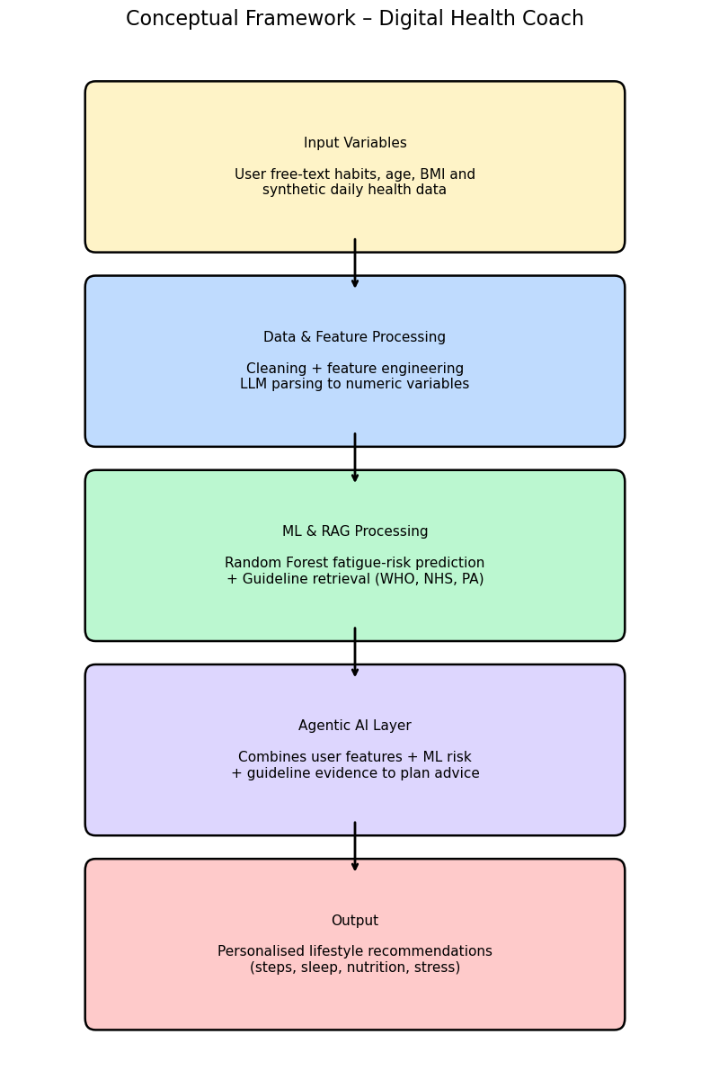

3.2 Data Processing Layer
The data processing layer is responsible for transforming the raw synthetic daily measurements into higher-level features that can be used by the machine learning model and the agentic health coach.
All operations are applied per user and per day, preserving the temporal structure of the 90-day dataset.
Key processing steps are:
- sorting records by user and day,
- computing short-term behaviour trends using rolling averages, and
- deriving binary “risk flags” that indicate potentially unhealthy patterns (e.g. low sleep, high stress, low activity).
These engineered features form the input to the fatigue-risk classifier and are also passed to the LLM agent to personalise recommendations.

3.2.1 Feature Engineering
Let $u$denote a user and $t$a day ( $t=1,…,90$).
The raw daily variables include: steps, sleep hours, stress level, water intake, calories and resting heart rate.From these, the following features are derived.
Seven-day rolling averages
To capture short-term trends instead of single-day noise, 7-day rolling means are computed for steps, sleep and stress.
For a generic variable $x_{u,t}$(e.g. steps), the 7-day rolling average at day $t$is:
$${\overset{‾}{x}}_{u,t}^{(7)}=\frac{1}{n_{t}}\sum_{k=0}^{n_{t}-1}{}x_{u,t-k},$$
where
- $n_{t}=min⁡(7,t)$is the number of days available (for the first week the window is shorter),
- $x_{u,t}$is the value on day $t$for user $u$.
In this project, the following rolling features are computed:
$${\text{avg_steps_7d}}_{u,t}={\overset{‾}{\text{steps}}}_{u,t}^{(7)} \\ {\text{avg_sleep_7d}}_{u,t}={\overset{‾}{\text{sleep_hours}}}_{u,t}^{(7)} \\ {\text{avg_stress_7d}}_{u,t}={\overset{‾}{\text{stress_level}}}_{u,t}^{(7)}$$
These features describe the user’s recent behaviour and are used as predictors in the fatigue-risk model.

Binary risk flags
On top of the rolling averages, simple rule-based flags are created to indicate when a day falls into a “risk zone”.
Each flag is a binary variable taking value 1 if the condition is met and 0 otherwise.
- Low sleep flag
$${\text{low_sleep_flag}}_{u,t}=\{\begin{matrix}1, & \text{if }{\text{sleep_hours}}_{u,t}<6\text{ hours} \\ 0, & \text{otherwise}\end{matrix}$$
- High stress flag
$${\text{high_stress_flag}}_{u,t}=\{\begin{matrix}1, & \text{if }{\text{stress_level}}_{u,t}≥7 \\ 0, & \text{otherwise}\end{matrix}$$
- Low steps flag
$${\text{low_steps_flag}}_{u,t}=\{\begin{matrix}1, & \text{if }{\text{steps}}_{u,t}<6000 \\ 0, & \text{otherwise}\end{matrix}$$
These flags make the interpretation of the model easier (e.g. “many recent days with low sleep and high stress”) and are also directly used by the recommendation rules in the agent layer.

3.2.2 PDF → Text → Chunks → Embeddings
The second component of the data processing layer handles the transformation of external guideline documents into a machine-searchable knowledge base. These documents include the WHO Healthy Diet Guidelines, WHO Physical Activity Recommendations, and the NHS Eatwell Guide, all supplied in PDF format. To make these documents usable by the Retrieval-Augmented Generation (RAG) engine, the PDF files are converted into clean text, segmented into meaningful chunks, embedded into numerical vectors, and finally stored in a vector index for efficient semantic retrieval.

PDF Text Extraction (using pdfplumber)
The guideline PDFs are first converted into raw text using the Python library pdfplumber, which is capable of extracting text page-by-page while preserving line structure.
For a PDF document $D$containing $N$pages:
$$T=\sum_{i=1}^{N}{}\text{pdfplumber.extract_text}(D_{i})$$
This step yields a continuous text corpus $T$representing the contents of each guideline.

Chunking the Extracted Text into Overlapping Sections
Large documents cannot be embedded as a single unit because language models have context limitations.
Therefore, each text file is divided into overlapping chunks, which improves retrieval accuracy by ensuring relevant information isn't cut off abruptly.
Given:
- maximum chunk length $L=800$characters
- overlap size $O=200$characters
The chunking process follows:
$$C_{1}=T[0:L],C_{2}=T[L-O:2L-O],…$$
This produces a sequence of chunks:
$$\{C_{1},C_{2},…,C_{k}\}$$
Each chunk contains enough context for the LLM to interpret it while avoiding excessive redundancy.

Embedding Text Chunks (SentenceTransformer)
Each chunk is transformed into a high-dimensional embedding using the SentenceTransformer model all-MiniLM-L6-v2, a lightweight and efficient semantic embedding model.
For each chunk $C_{i}$:
$$e_{i}=\text{Embed}(C_{i})$$
where:
- $e_{i}∈R^{384}$(embedding vector)
These embeddings capture the semantic meaning of each guideline passage, enabling similarity-based retrieval.

Storing Embeddings in a Vector Index
The final step is to store all embeddings alongside their text chunks and metadata (document source, chunk IDs) in a structured index file.
A Parquet-based vector index is used due to its efficient storage and fast loading time.
The index contains:
Field | Description
source | Original PDF name (e.g., who_healthy_diet.pdf)
chunk_id | Unique identifier (e.g., who_healthy_diet_12)
text | The text content of the chunk
embedding | Numerical embedding vector

Formally, the vector index is:
$$\text{Index}=\{(C_{i},e_{i},{\text{meta}}_{i})∣i=1,…,k\}$$
This index enables efficient cosine-similarity search during the RAG retrieval step:
$$\text{similarity}(q,C_{i})=\frac{e_{q}⋅e_{i}}{∥e_{q}∥ ∥e_{i}∥}$$
Through these four steps—PDF extraction, chunking, embedding, and index storage—the guideline documents are transformed into a fully searchable semantic knowledge base. This enables the health coach agent to retrieve the most relevant evidence-based information and incorporate it into its final recommendations.

Machine Learning Layer
The Machine Learning (ML) layer of the system is responsible for estimating the user’s likelihood of experiencing high fatigue, based on recent behavioural and demographic indicators. The central modelling goal is to predict the binary fatigue label, where a value of 1 represents high fatigue and 0 represents normal fatigue. The target variable is defined mathematically as:
$$\text{high_fatigue_flag}=\{\begin{matrix}1 & \text{if fatigue_score}≥7, \\ 0 & \text{otherwise}\end{matrix}$$
To achieve this, a structured feature matrix is constructed using engineered variables derived from the synthetic dataset. These features reflect users’ short-term behavioural patterns and include: average daily steps over 7 days, average sleep hours over 7 days, average stress over 7 days, water intake, daily calorie intake, resting heart rate, age, and body mass index (BMI). Each user instance can therefore be represented as a feature vector:
where
${\overset{‾}{s}}^{(7)}$= 7-day average steps,
${\overset{‾}{l}}^{(7)}$= 7-day average sleep hours,
${\overset{‾}{st}}^{(7)}$= 7-day average stress level.

A Random Forest Classifier was selected due to its strong suitability for tabular, health-related behavioural data. Random Forests work by constructing multiple decision trees and aggregating their outputs, enabling modelling of non-linear interactions such as low sleep combined with elevated stress or high resting heart rate. They also handle noisy datasets effectively, making them robust to synthetic and real-life variability. Importantly, Random Forests provide feature importance scores, supporting interpretability by highlighting which lifestyle variables contribute most strongly to predicted fatigue levels. The dataset is divided into a training set (80%) and a testing set (20%) using a stratified sampling strategy that preserves the distribution of the fatigue label. The trained model then outputs a probability:
$$f(x)=P(\text{high fatigue}=1∣x)$$
which is later used by the agent to determine whether the user faces a low, moderate, or high fatigue risk and to tailor the corresponding recommendations.

Retrieval-Augmented Generation (RAG) Layer
The RAG layer enables the system to integrate evidence-based health guidelines directly into the reasoning process of the large language model (LLM). This layer works by retrieving relevant knowledge from trusted sources such as WHO, NHS Eatwell, and the Physical Activity Guidelines for Adults, ensuring that generated recommendations are medically aligned and grounded in authoritative standards. When a user submits a question, the system first embeds the query into a semantic vector representation using the same embedding model applied during indexing:
$$q=\text{Embed}(\text{Query})$$
This embedded query is then compared against all stored guideline chunk embeddings using cosine similarity, calculated as:
$$\text{sim}(q,e_{i})=\frac{q⋅e_{i}}{∥q∥ ∥e_{i}∥}$$
where $e_{i}$denotes the embedding of the $i^{th}$guideline chunk. The system ranks all chunks by similarity and selects the Top-K most relevant passages. These chunks are then concatenated and passed as contextual evidence into the LLM prompt.
Integrating guidelines through RAG significantly enhances the model’s reliability. First, it reduces hallucinations by forcing the model to rely on retrieved factual evidence rather than generating unsupported claims. Second, it ensures that recommendations remain medically consistent, especially regarding physical activity levels, sleep hygiene, nutritional balance, and hydration. Third, RAG enhances transparency: the system can display the exact guideline excerpts used to generate the final recommendation. Thus, the RAG layer forms a critical bridge between raw user queries, authoritative health knowledge, and the final personalised output produced by the agent.

Agent Layer
The Agent Layer serves as the central reasoning engine of the Digital Health Coach system, integrating outputs from the ML model, the RAG pipeline, and user-provided information to generate coherent, personalised health recommendations. This layer coordinates multiple components that operate sequentially and collaboratively, enabling the system to behave like an intelligent, evidence-driven assistant. Unlike single-model systems, the agent uses a multi-component architecture, where each component contributes a specific function toward producing the final answer.
The agent begins by interpreting the user’s free-text input. Since users typically express health concerns in natural language (e.g., describing low energy, poor sleep, or daily habits), the system must convert these descriptions into structured numerical data. The agent therefore uses a Large Language Model (LLM) to perform feature extraction, identifying values such as weekly average steps, sleep duration, stress levels, hydration, caloric intake, resting heart rate, age, and BMI. These extracted features form the basis for downstream reasoning.
Next, the agent computes the user’s fatigue-risk probability using the trained Random Forest classifier. Provided that all required numeric features are available, the ML model outputs a probability:
$$P(\text{high fatigue}=1)$$
which the agent interprets as low, moderate, or high risk. This probability influences the tone and urgency of the recommendations that follow.
The agent then generates rule-based behavioural recommendations derived from well-established lifestyle heuristics. For example, low step counts may trigger activity suggestions, insufficient sleep may prompt sleep-hygiene guidance, and high stress levels may lead to mindfulness or relaxation strategies. These rule-based outputs complement the ML model by offering direct, interpretable insights into specific behavioural improvements.
Subsequently, the agent retrieves evidence-based guideline information through the RAG pipeline. By embedding the user’s question and comparing it with the vectorised guideline documents using cosine similarity, the system identifies the most relevant WHO, NHS, and physical activity recommendations. These retrieved chunks ensure that the final advice is grounded in authoritative public health standards.
Finally, the agent synthesises all components—extracted features, ML fatigue risk, rule-based recommendations, and retrieved guideline excerpts—into a coherent, personalised response. This synthesis is performed using the LLM, which is prompted with all relevant information to produce a concise, user-friendly explanation. As a result, the agent layer acts as the orchestrator of the entire system, ensuring that each component contributes effectively toward delivering accurate, personalised, and medically aligned coaching advice.

UI Layer (Application Layer)
The User Interface (UI) Layer provides an interactive environment through which users communicate with the Digital Health Coach system. This layer is implemented using Streamlit, a lightweight, web-based Python framework suitable for deploying machine-learning and NLP applications. The UI is designed as a conversational chatbot interface, allowing users to naturally describe their concerns, habits, or health-related questions in free-text form.
The chatbot interface supports persistent chat history, meaning each new user message is appended to an ongoing conversational thread. This design choice makes the system feel more interactive and context-aware, enabling users to ask follow-up questions and receive responses that reference earlier parts of the conversation. Each user message and system response is timestamped and displayed sequentially, giving users a clear view of the interaction flow.
To support transparency and interpretability, the interface also includes a set of debugging expanders. These collapsible panels reveal detailed intermediate computations performed by the agent, including:
- Extracted numerical features identified by the LLM
- Rule-based and ML-driven recommendations
- RAG-retrieved evidence, showing the original guideline text sources
- Predicted fatigue probability, derived from the Random Forest model
These components allow users—and researchers evaluating the system—to understand how specific recommendations were generated.
From the user’s perspective, the interaction process is straightforward. The user enters a natural-language query describing their habits (e.g., sleep patterns, stress level, water intake, steps) or health concerns (e.g., fatigue, energy level). Once submitted, the system triggers the entire reasoning pipeline: feature extraction, ML prediction, RAG retrieval, and final LLM synthesis. The resulting output is displayed as a clean, readable assistant message that provides personalised, actionable advice. The UI Layer therefore acts as the communication bridge between the user and the underlying AI components, enabling an accessible, conversational, and informative experience.

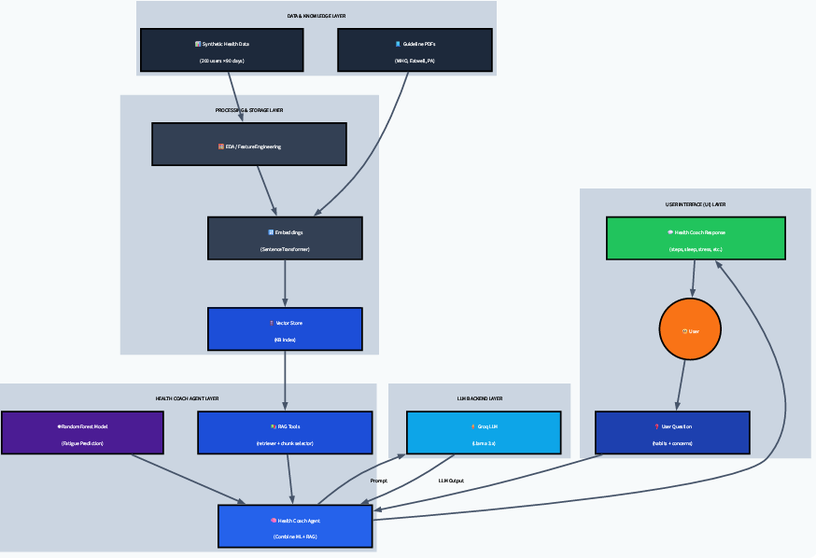
System Architecture

Results

Machine Learning Results
The Random Forest classifier was trained to predict whether a user is at high fatigue risk based on lifestyle features such as steps, sleep, stress levels, calorie intake, BMI, water intake, resting heart rate, and 7-day rolling averages. The model achieved a test accuracy of approximately 0.60, indicating moderate predictive capability on unseen data.
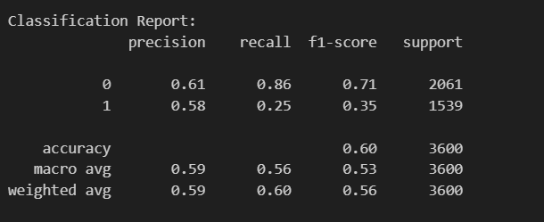

The Random Forest model demonstrates strong performance for detecting low-fatigue users (Class 0), as indicated by its high recall (0.86). This means the model is effective at identifying users who are not at risk of fatigue.
However, the model shows lower recall for high-fatigue cases (Class 1 = 0.25). This suggests that many high-risk individuals are being misclassified as low risk. This is largely due to:
- Class imbalance in the dataset
- Overlap in lifestyle characteristics between low-risk and high-risk users
- Limited real-world physiological signals in synthetic data
Nevertheless, the model still demonstrates moderate precision (0.58) for high-risk predictions, meaning that when the model does predict high fatigue risk, it is often correct.
Overall, the ML model is moderately effective at identifying patterns that correlate with fatigue risk. While its performance in detecting high-risk users could be improved, it provides a valuable probability-based signal that enhances the system’s agentic reasoning layer. The predicted fatigue probability is not used alone; instead, it is combined with rule-based logic and RAG-based guideline evidence to generate more reliable health coaching outputs.
5.2 RAG Results
The Retrieval-Augmented Generation (RAG) component was implemented to ensure that the system’s recommendations are grounded in credible, evidence-based health guidelines rather than relying solely on generative language modelling. RAG allows the agent to retrieve relevant guideline sections from documents such as the WHO Physical Activity Guidelines, NHS Eatwell Guide, and other official sources before generating a response. This significantly reduces hallucinations and ensures that outputs remain medically aligned.

Example Query
To evaluate the functionality of the RAG pipeline, the following user query was tested:
Query:
“How much physical activity should a healthy adult do per week?”
A small user context was provided to help refine the retrieval process:

RAG Output
Model Answer (Generated Using Retrieved Evidence)
ANSWER:
“As a healthy adult, you should aim for at least 150–300 minutes of moderate-intensity aerobic physical activity per week. You can also opt for 75–150 minutes of vigorous-intensity aerobic physical activity, or a combination of both. Additionally, try to include muscle-strengthening activities on 2 or more days a week. Remember to start slowly and increase the intensity and duration over time.”
This answer is fully consistent with the World Health Organization (WHO) 2020 Physical Activity Guidelines.

Retrieved Chunks (Evidence Used)
The RAG retriever selected the top three most semantically similar chunks from the vector store:

Sample Extracts from Retrieved Chunks
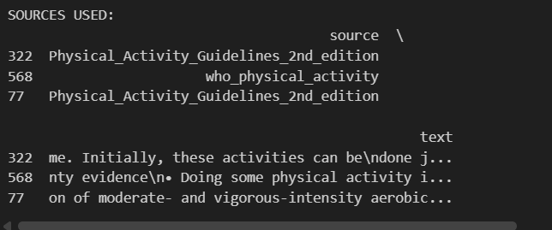

These chunks contained guideline statements such as:
- “…doing some physical activity is better than doing none…”
- “Adults should undertake 150–300 minutes of moderate-intensity aerobic physical activity…”
- “Include muscle-strengthening activities involving major muscle groups on 2 or more days per week…”
These closely match the gold-standard WHO recommendations.
5.3 Final Combined Output Examples
This section presents a complete interaction example to demonstrate how the proposed Digital Health Coach system integrates all major components—machine learning, RAG, rule-based logic, and the LLM—to generate personalised health recommendations. The example illustrates how user input flows through the system and how each layer contributes to the final output.
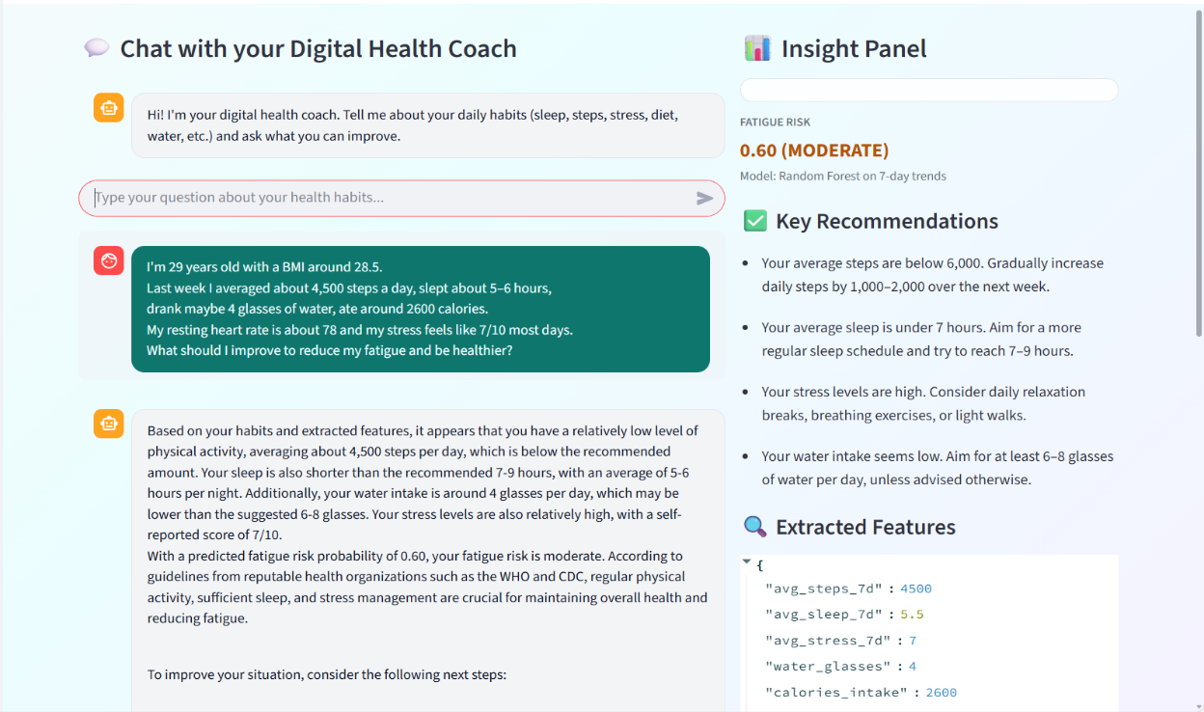

Example User Query
A sample user interaction was tested using the following free-text input:
“I’m 29 years old with a BMI around 28.5. Last week I averaged about 4,500 steps a day, slept about 5–6 hours, drank maybe 4 glasses of water, ate around 2600 calories. My resting heart rate is about 78 and my stress feels like 7/10 most days. What should I improve to reduce my fatigue and be healthier?”
This query contains both qualitative descriptions (e.g., “stress feels like 7/10”) and quantitative lifestyle indicators (e.g., steps, sleep hours, calories), making it suitable for evaluating the full pipeline.

LLM-Based Feature Extraction
The agent first extracts structured numeric features from the free-text input using an LLM.
The extracted values were:
Feature | Extracted Value
avg_steps_7d | 4500
avg_sleep_7d | 5.5
avg_stress_7d | 7
water_glasses | 4
calories_intake | 2600
resting_heart_rate | 78
age | 29
bmi | 28.5
This demonstrates that the LLM successfully converts unstructured text into a machine-readable format necessary for subsequent analysis.

Machine Learning Fatigue-Risk Prediction
The extracted features were passed into the RandomForest classifier.
The model predicted:
Fatigue Risk Score: 0.60 (Moderate)
This indicates that the user’s behaviour patterns (low steps, insufficient sleep, high stress) place them at a moderate risk of fatigue accumulation. The probability output shows that the ML model effectively captures user-specific lifestyle risk patterns.

Rule-Based Recommendations
Parallel to the ML output, the system applies rule-based logic to generate straightforward behavioural suggestions. Based on thresholds defined during development, the system identified:
- Low steps (< 6,000 per day)
- Short sleep (< 7 hours per night)
- High stress (≥ 7/10)
- Low water intake (< 6 glasses/day)
The rule engine contributes domain-specific clarity and ensures consistent behavioural feedback.

Retrieval-Augmented Generation (RAG) Evidence Retrieval
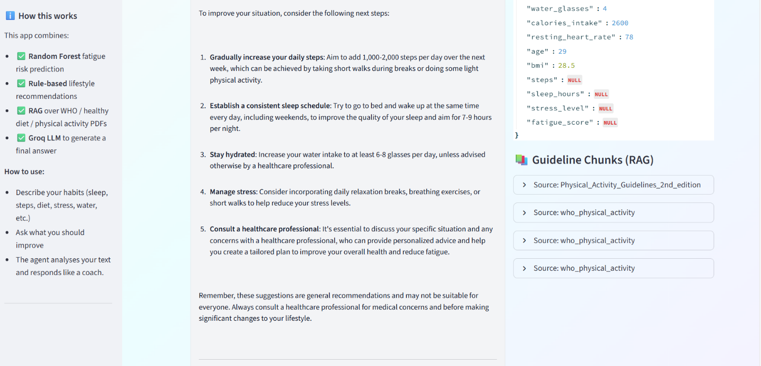

To provide medically aligned advice, the system retrieves context from authoritative sources such as:
- WHO Physical Activity Guidelines (2020)
- NHS Eatwell Guidelines
- Physical Activity Guidelines – 2nd Edition
Example retrieved guideline excerpts include:
- “Adults should accumulate at least 150–300 minutes of moderate-intensity aerobic activity per week.”
- “Some physical activity is better than none; increasing activity gradually provides additional benefits.”
These retrieved chunks are passed to the LLM as factual grounding to minimise hallucination and ensure the recommendations are evidence-based.

Final LLM-Generated Health Coach Response
Using the extracted features, ML output, rule-based reasoning, and RAG evidence, the LLM produces a personalised and coherent response.
An excerpt from the final output:
“Based on your habits and extracted features, it appears that your average daily steps (4,500) and sleep duration (5–6 hours) are below recommended levels. Your stress score of 7/10 and water intake of around 4 glasses per day may also contribute to feelings of fatigue. According to WHO guidelines, adults should aim for regular moderate-intensity activity, adequate sleep (7–9 hours), and proper hydration. Your fatigue-risk probability of 0.60 indicates a moderate likelihood of fatigue accumulation.”

6. Discussion
The developed Digital Health Coach demonstrates how multiple AI components—machine learning, RAG, rule-based reasoning, and LLM-based natural language understanding—can be combined to produce personalised and reliable lifestyle recommendations. The system effectively interprets free-text user inputs, extracts quantitative health features, and predicts fatigue risk using a Random Forest model. This enables it to move beyond a simple chatbot and function as an evidence-driven decision-support tool. The agent layer then integrates ML predictions, behavioural patterns, and guideline-based rules, producing coherent recommendations tailored to each user’s habits.
A significant advantage of the system is its use of Retrieval-Augmented Generation (RAG) to reduce misinformation and ensure alignment with trusted health sources such as WHO, NHS Eatwell, and official physical activity guidelines. Instead of relying solely on the LLM’s generative ability, retrieved guideline chunks are incorporated into the response to ensure accuracy and safety. This design improves the reliability and real-world usefulness of the system, making it suitable as a preventive health and wellness tool that encourages healthier behaviour while maintaining transparency and trust.

9. Conclusion
This project successfully developed a complete AI-powered digital health coaching system that combines multiple advanced technologies into a unified pipeline. The system integrates a Random Forest fatigue-risk prediction model, a rule-based recommendation engine, a retrieval-augmented generation (RAG) module over official WHO and NHS guidelines, and a large language model (LLM) capable of natural language understanding. These components are orchestrated by an agent layer that reasons holistically about user behaviour, risk, and evidence.
The final application was deployed through an interactive Streamlit interface, enabling a chatbot-style experience that feels intuitive and user-friendly. Users can freely describe their lifestyle, and the system extracts behavioural features, predicts fatigue risk, retrieves validated guideline evidence, and generates personalised, actionable advice.
Overall, the project demonstrates the feasibility and value of combining ML, RAG, and LLM reasoning to assist users in improving their daily health behaviours. The system provides accurate, personalised, and medically aligned recommendations that can meaningfully support preventive health and wellness. This work therefore contributes to the growing field of AI-driven digital health tools by presenting a practical, safe, and evidence-based solution for lifestyle coaching.

