Remaining Useful Life Prediction for Turbofan Engines: CW1 Technical Record
Module: NB6057CEM Artificial Neural Networks Student: K A D Dushara Kalubowila Student ID: KIC-BSCCSAI-251P-052 Word count (body): 1,493 (excluding tables, figures, captions and references)
Figures are in results/figures/; every number below comes from results/ or the executed notebooks.

T1 Problem definition and data preparation
Problem and provenance. The intended user is an aircraft-engine maintenance planner who must schedule maintenance before failure without replacing parts early. The target is remaining useful life (RUL) in cycles (regression); the unit of observation is one engine's most recent 30 cycles of sensor readings.
Data come from NASA's C-MAPSS simulation (Saxena et al., 2008), publicly released by the NASA Prognostics Center of Excellence; data.gov lists it as a U.S. Government Work (public domain). Subset FD001 has one operating condition and one fault mode: 100 run-to-failure training engines (20,631 rows) and 100 truncated test engines with separately supplied true RUL. The data are simulated, so contain no personal data; the main ethical risk is over-trust in a safety-critical setting, where late predictions endanger lives.
Data audit. There are no missing values, duplicates or cycle gaps. Seven constant channels and two-valued sensor 6 are dropped, leaving 14 sensors. Lifetimes span 128–362 cycles (Fig. 1), so elapsed cycles cannot predict RUL; the shortest test engine (31 cycles) fits a 30-cycle window. Sensors drift slowly, then accelerate near failure (Fig. 2), motivating piecewise-linear labels capped at 125 cycles (Fig. 4). After windowing, 31.4% of targets sit at the cap (Fig. 5), so evaluation also examines low-RUL behaviour.
Leakage-safe pipeline. Windows from one engine overlap, so I split engines, not rows: 80 training and 20 validation (seed 42, data/splits/fd001_split.json). Feature selection and min-max scaling are fitted on training engines only (models/preprocess_fd001.json); the cycle counter is never an input; no augmentation is used. Correction: during the reported runs the shared loader also read the test files, including labels, whenever training data were loaded. The labels were never used for fitting or selection, but this was not enforced. The loader is now split (load_prepared, load_test_inputs, load_test_labels), the rebuilt training and validation arrays are byte-identical, and only scripts/evaluate.py reads test labels, refusing to run if frozen files differ from the hash manifest.
Partition | Engines | Windows (30 × 14)
Train | 80 | 14,459
Validation | 20 | 3,272
Test (official) | 100 | 100 (last window per engine)

T2 Learning from first principles
A NumPy MLP (src/numpy_mlp.py) maps 28 inputs (per-sensor window mean and slope, standardised) through 32 ReLU units to a linear output, with ½·MSE loss on RUL/125 and 961 parameters. Each unit's weighted sum, bias and nonlinearity loosely mirror synaptic weighting and firing, without spikes or biological learning. Mini-batch gradient descent (learning rate 0.05, batch 64, early-stopping patience 20) reduced training loss from 1.049 to 0.0054, stopping at epoch 57 and restoring epoch 37 (validation RMSE 12.99; Fig. 6).
Analytical gradients were compared with central finite differences (ε = 1e-5, batch of 8) for 10 entries spanning W1, b1, W2 and b2. The smallest pre-activation magnitude (0.0067) was far larger than any perturbation could change it (2.4e-5), so no ReLU kink was crossed. The maximum relative error was 1.3e-10, well inside a tolerance of 1e-6 justified by O(ε²) truncation and float64 rounding.
As a controlled check, the network overfitted 16 examples (loss 0.907 → 4.3e-5 in 3000 epochs). In a learning-rate sweep, 0.005 converged slowly and 0.5 diverged in epoch 1, which the stopping rule reports as diverged (Fig. 8). Without standardisation, validation RMSE was 20.45: slopes were about 100× smaller than means and effectively ignored.

T3 Baseline and framework models
Baseline. A random forest (300 trees) on 56 window features (mean, slope, last value and standard deviation per sensor), trained on the same windows and evaluated with the same metric.
Model | Architecture (input 30 × 14) | Parameters
Window MLP | Flatten 420 → Linear 128 → ReLU → Dropout → Linear 64 → ReLU → Dropout → Linear 1 | 62,209
LSTM | 2-layer LSTM (64 units) → last time step → Dropout → Linear 1 | 53,825
Both networks have two hidden layers, similar capacity and the same 30-cycle input. The MLP gives each cycle-and-sensor position its own weights, so it can use order within the window but shares nothing across time and keeps no state; the LSTM reuses recurrent weights at each step and carries a gated state. The scaled target is bounded in [0, 1], but both use an unconstrained linear output with MSE loss (a bounded output was not tested; negative predictions are clipped at inference). The MLP uses ReLU with Kaiming initialisation; the LSTM uses sigmoid gates and tanh activations with PyTorch defaults. Both use Adam (learning rate 1e-3, weight decay 1e-5, batch 256) and validation early stopping (patience 10), saving the best weights per seed (Fig. 9).
Fair comparison. Before any tuning I fixed a budget in configs/tuning_plan.json: four candidates per network (width × dropout) and three for the forest, each run with seed 0 and selected on validation RMSE. All 11 trials are reported (results/metrics/tuning.json). The selected configurations are frozen as configs/final_*.json.
Traceability. Preparation (src/data.py), training (src/train_torch.py, scripts/train_*.py) and evaluation (scripts/evaluate.py) are separate. Each metrics file records configuration, seed, library versions, platform and threads. All runs used CPU PyTorch 2.14.1 (Python 3.12.3, Linux). No pretrained weights or borrowed code were used. Re-running all 11 tuning trials reproduced every score exactly (results/metrics/tuning_rerun_check.txt).

T4 Experiments and evaluation
Repeated evaluation. Each final model was trained with seeds 0–2 on the fixed split. results/results_table.csv links every run to its configuration, checkpoint, validation score and test score.
Model | Val RMSE | Test RMSE | Test MAE | PHM08 score
Random forest | 12.79 ± 0.03 | 12.13 ± 0.13 | 8.98 ± 0.07 | 226 ± 6
Window MLP | 12.81 ± 0.02 | 13.40 ± 0.44 | 10.05 ± 0.27 | 281 ± 18
LSTM | 12.83 ± 0.11 | 13.27 ± 0.43 | 9.81 ± 0.34 | 280 ± 18
RMSE (cycles, penalising large errors) is primary; MAE gives typical error and the PHM08 score penalises dangerous late predictions. The models were indistinguishable on 20 validation engines, but on 100 test engines the forest was about 1.2 cycles better with a third of the networks' seed spread. The LSTM's mean RMSE was slightly below the MLP's (13.27 vs 13.40), but the gap is far smaller than either seed standard deviation (about 0.43), so no advantage is established. All models are accurate below about 40 cycles; at 50–100 cycles most residuals are late (Fig. 10); time-ordered predictions track the last 50 cycles closely (Fig. 11).
Ablation. Setting the MLP's dropout from 0.1 to 0 lowered validation RMSE in all three seeds (12.81 → 12.67), so the claim that dropout helps is not supported. Remaining confounders are the overlapping effect of early stopping and weight decay, single-seed selection of dropout, and only 20 validation engines. The final configuration was not changed after this result.
Errors and robustness. Near-median errors are about ±7 cycles. The five largest errors (Fig. 12) fall into two patterns. Engines 93, 45 and 3 were predicted early because their sensors degraded before the labelled knee. Engines 67 and 50 were predicted about 30 cycles late because only 71–74 cycles had been observed, too little to show degradation.
Both stress tests were fixed in advance in configs/evaluation_protocol.json. In the history-length subgroups (n = 50 each), every model is worse on short histories, with the LSTM the most affected (14.34 vs 12.09). Under Gaussian noise added to the scaled inputs (Fig. 13), the forest leads up to σ = 0.02 but degrades fastest (24.9 at σ = 0.10, against 18.3 for the MLP and 20.1 for the LSTM). Synthetic noise is not the same as real sensor faults, so this shows relative sensitivity only.

T5 Recommendation and use
Model | Test RMSE | Size | ms/engine (batch 1) | ms/100 engines
Random forest | 12.13 | 373,148 tree nodes | 55.7 | 75.1
Window MLP | 13.40 | 62,209 parameters | 0.21 | 1.99
LSTM | 13.27 | 53,825 parameters | 0.62 | 3.33
I recommend the random forest for clean FD001-like data. It is the most accurate and most stable model, and its latency is ample for decisions made once per cycle; the timing includes n_jobs=-1 thread start-up. Where inputs may be noisier than the benchmark, the window MLP is preferable: it is the most robust to noise and the cheapest to run. The LSTM's mean RMSE was 0.13 cycles lower than the MLP's, well within seed variation, at three times the inference time; on this evidence its advantage is not established, so the hypothesis that recurrent modelling helps on FD001 remains unconfirmed.
scripts/predict.py loads the saved preprocessing and three seed checkpoints and validates input. For test engine 31 it predicts 11 cycles (true: 8) and advises immediate maintenance. It rejects empty files, negative cycle numbers, a 20-cycle history and a missing sensor (exit code 2), and refuses an FD002 engine as out of scope (exit code 3).
Exploratory follow-up. Two later experiments were designed after these test results were known and reuse the same test set, so they are descriptive only (experiments/, notebooks 04–05):
Follow-up (3 seeds) | Inputs | Test RMSE
v1 neural upgrade (MLP) | 140 pooled window features | 12.69 ± 0.20
v2 history MLP | 113 whole-history features | 9.75 ± 0.43
v2 history forest (comparator) | same history features + ordered pooled-window means (197) | 10.93 ± 0.10
V2 adds history (initial levels, trends), so its gain over the original models mixes information and architecture; their shares were not measured. New data are needed. The recommendation above is unchanged.
Limitations. The data are simulated, cover one operating condition and one fault mode, and the test set has 100 engines. Predictions for short histories are late. The cap at 125 cycles is an assumption, and RMSE against uncapped truth is higher (13.4–14.9). These results do not establish readiness for deployment. A feasible next experiment is to repeat the comparison on FD004, which has six operating conditions and two fault modes, using condition-wise normalisation.

T6 Reproducibility
The README lists setup, run and smoke-test commands (python scripts/smoke_test.py, about 7 s). Dependencies are pinned in requirements.txt. The raw data are fetched by scripts/download_data.py and not redistributed. Splits, seeds, configurations, checkpoints and JSON or CSV metrics are all included. Follow-up models run with scripts/predict_neural_history.py. Demonstration video: https://drive.google.com/drive/folders/1sSR8g8CIEi_t4GLRz3SaDFI6rsfcLA5K?usp=sharing. Source code: https://github.com/DusharaDT3/cmapss-rul.

Appendix: figures
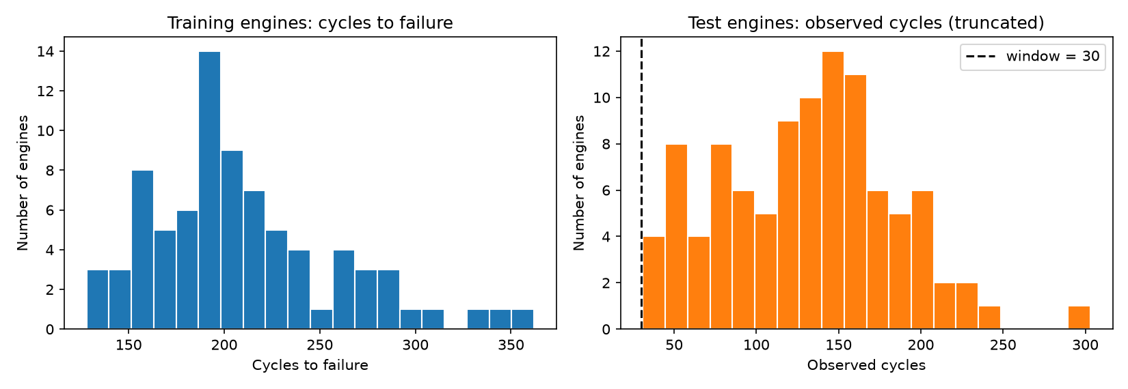
Fig. 1. Training-engine lifetimes and observed test-engine lengths, with the 30-cycle window.
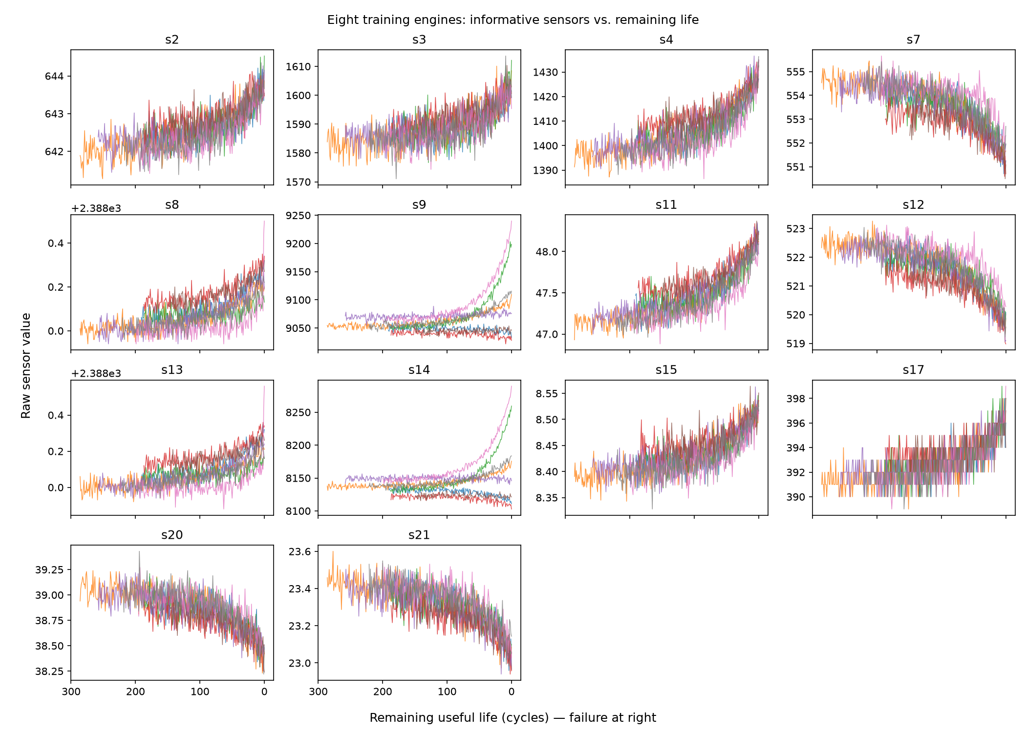
Fig. 2. The 14 retained sensors against remaining life for eight training engines.
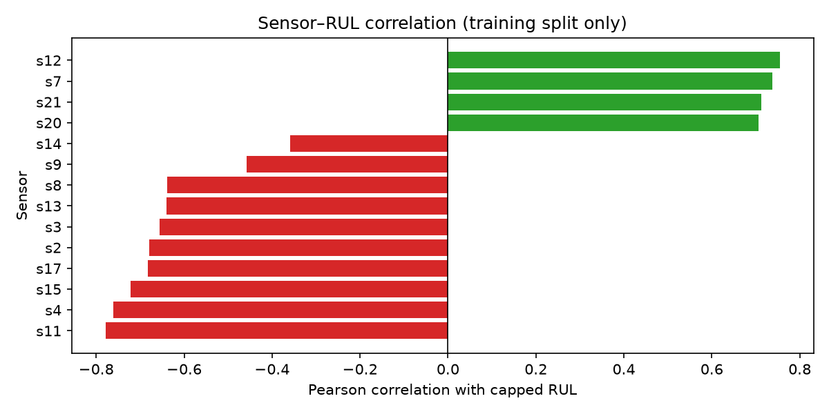
Fig. 3. Pearson correlation of each sensor with capped RUL (training split).
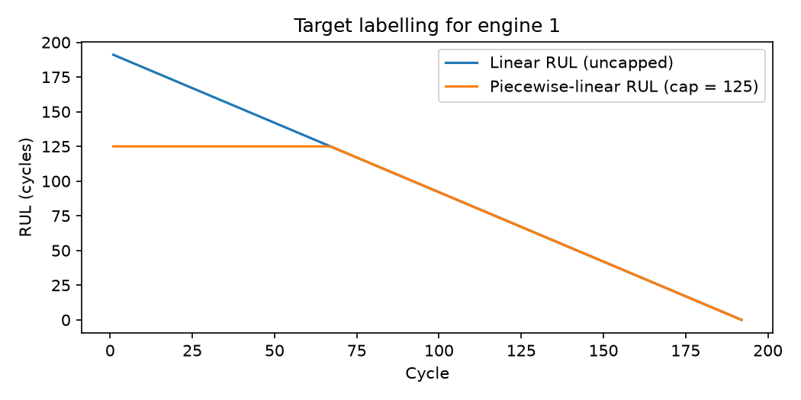
Fig. 4. Linear vs piecewise-linear (capped at 125) RUL target.
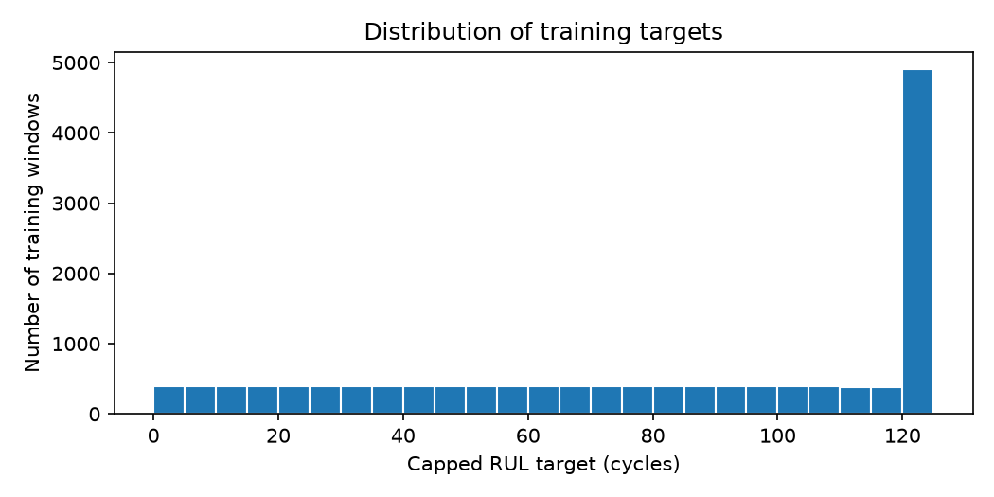
Fig. 5. Distribution of capped training targets after windowing.
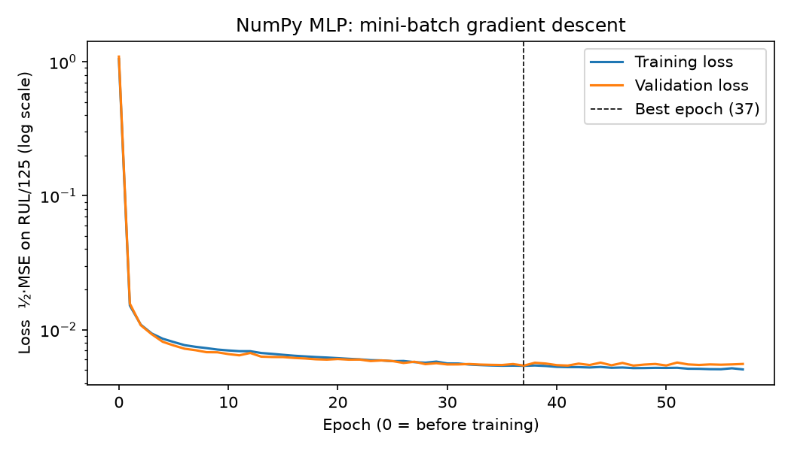
Fig. 6. NumPy MLP training and validation loss; dashed line marks the restored epoch.
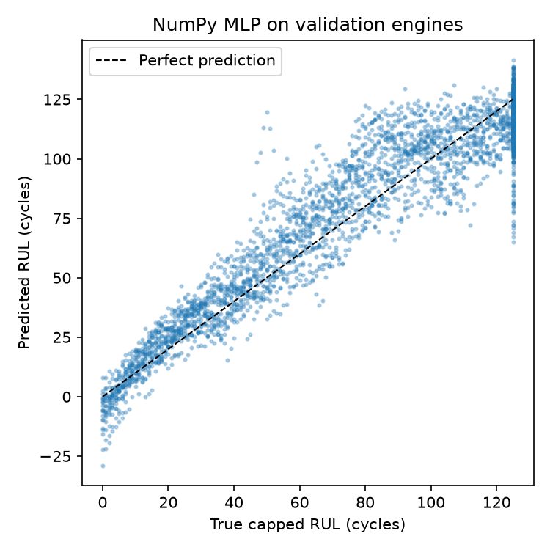
Fig. 7. NumPy MLP predictions on validation engines.
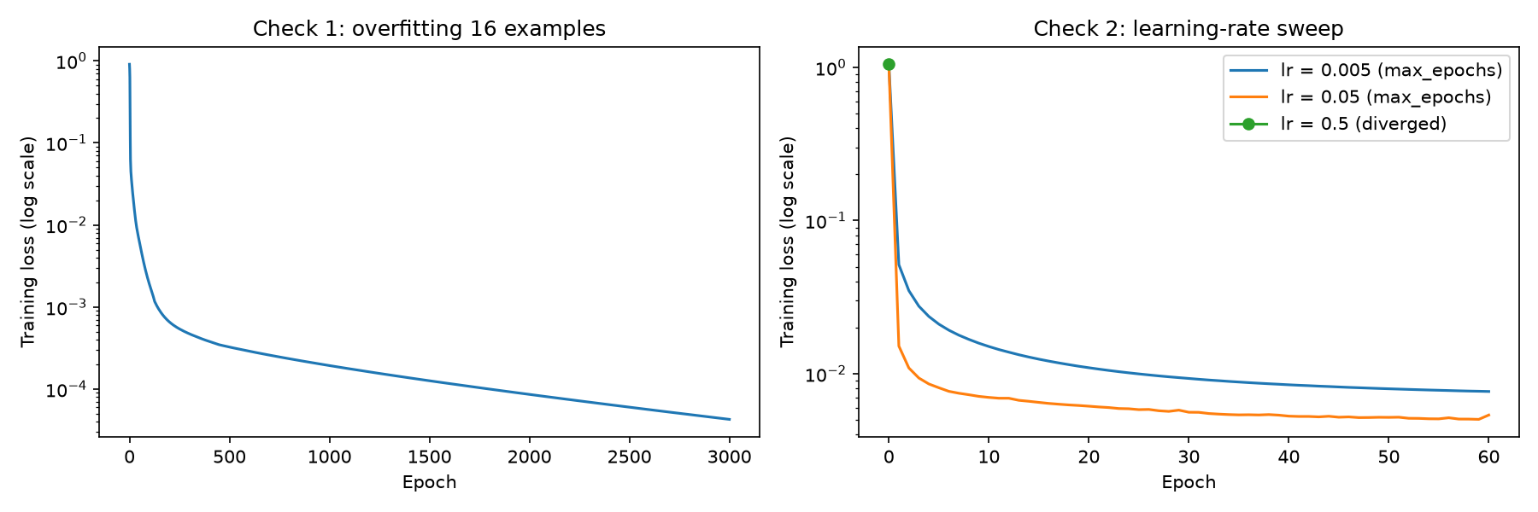
Fig. 8. Tiny-batch overfitting check and learning-rate sweep.
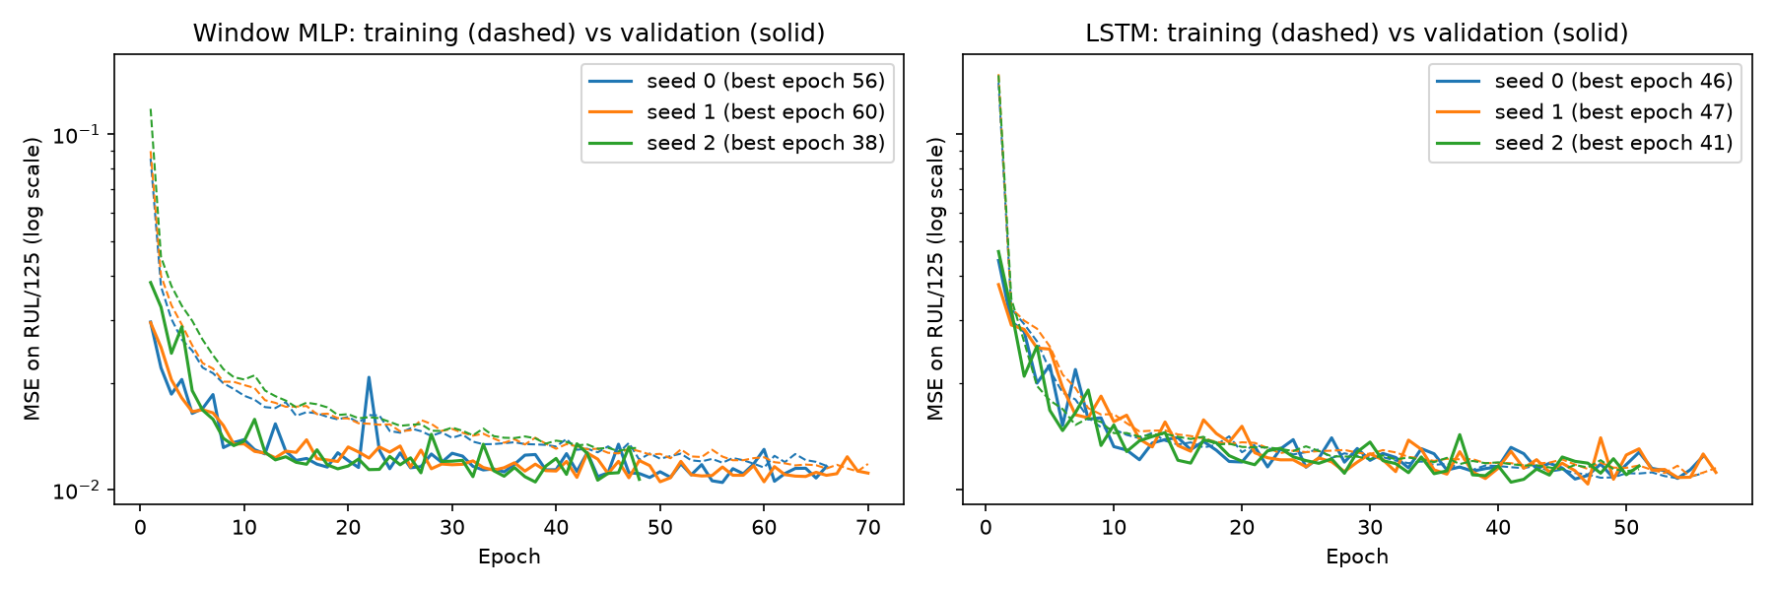
Fig. 9. Training (dashed) and validation (solid) loss for both networks, three seeds.
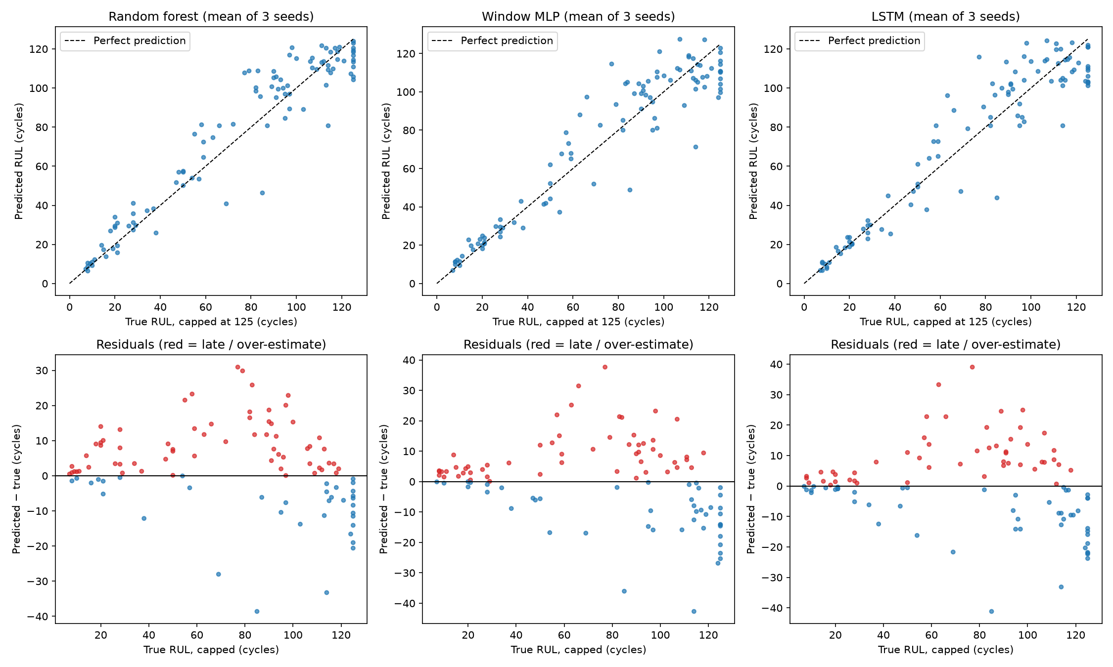
Fig. 10. Test predictions vs capped truth (top) and residuals (bottom; red = late).
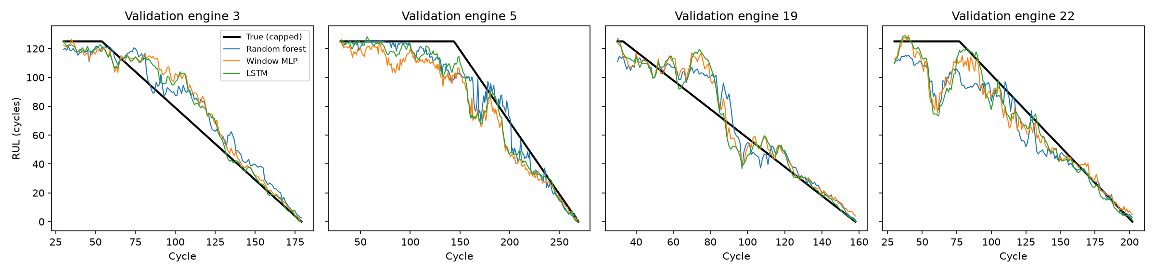
Fig. 11. Time-ordered predictions on four validation engines.
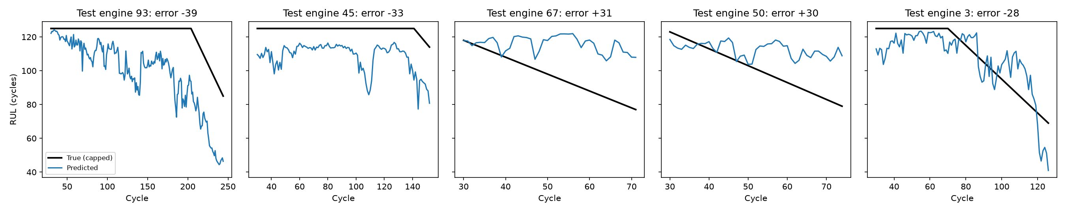
Fig. 12. The five largest random-forest test errors over each engine's observed history.
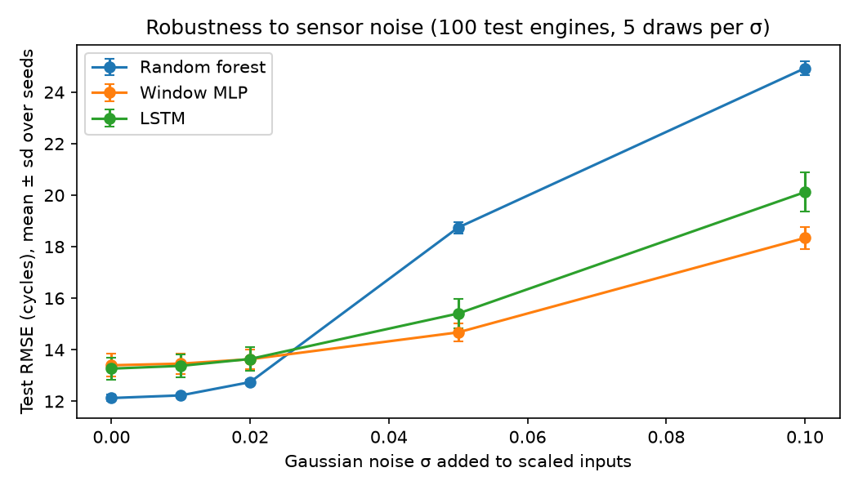
Fig. 13. Test RMSE under Gaussian input noise (mean ± sd over seeds).

References
Saxena, A., Goebel, K., Simon, D. and Eklund, N. (2008) 'Damage propagation modeling for aircraft engine run-to-failure simulation', International Conference on Prognostics and Health Management (PHM 2008), Denver, CO, 6–9 October. IEEE.

