SMART LEARNING MANAGEMENT SYSTEM
Business Process Flows
Version 1.0 | Portfolio draft for review and validation
Project: Smart Learning Management System (LMS) Utilizing Data Analytics and Machine Learning to Enhance Student Performance and Engagement
Purpose: Visualise the main user and system workflows and support traceability from the BRD/FRD to user stories, acceptance criteria and future test cases.

1. Scope and conventions
- These are proposed high-level process flows based on the existing BRD, FRD and product backlog portfolio artefacts.
- Decision branches are labelled Yes/No; the flow should be validated with the relevant stakeholder before being treated as an approved process.
- TBC items are called out rather than assigned invented business rules.
- ML risk classifications are early-warning indicators and must not be treated as final academic decisions.

2. Process flow index
Flow ID | Process | Purpose
PF-01 | User Sign-in and Role-Based Access | Authenticate a user and route them to permitted LMS functionality.
PF-02 | Student Assignment Submission | Allow a student to submit an assignment and receive an accurate submission status.
PF-03 | Academic Data Validation and Dashboard | Validate available student data and show role-appropriate performance information.
PF-04 | ML-Based At-Risk Prediction | Generate a risk indicator from eligible student data without presenting it as a final academic decision.
PF-05 | Risk Notification and Review | Make a risk alert available to the student and relevant authorised staff, subject to agreed notification rules.
PF-06 | Tutor Reviews Student Submission | Allow a tutor to access submissions only for courses within their authorised scope.

PF-01 — User Sign-in and Role-Based Access
Authenticate a user and route them to permitted LMS functionality.
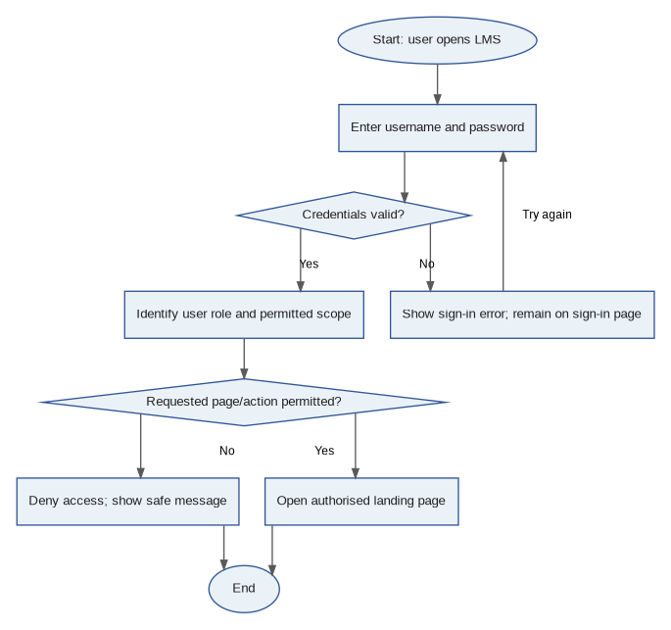
Open decisions / notes: Exact account lifecycle, lockout rules and session-expiry settings are not defined in the source requirements and must be confirmed.

PF-02 — Student Assignment Submission
Allow a student to submit an assignment and receive an accurate submission status.
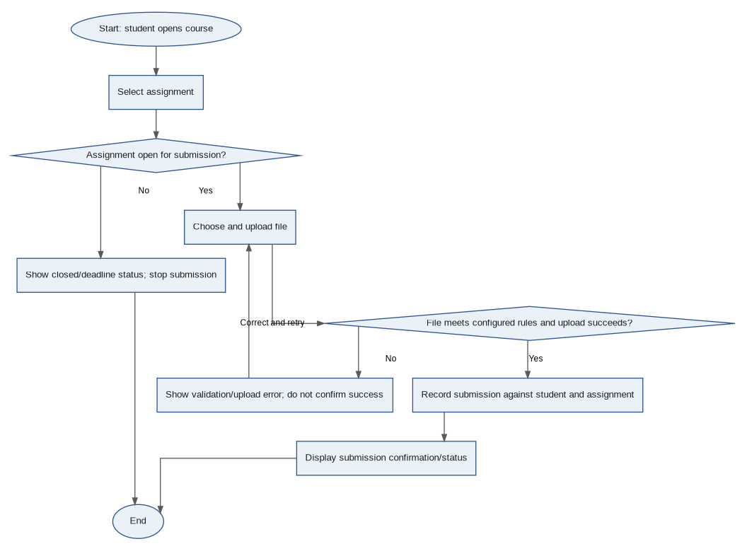
Open decisions / notes: Accepted file types, maximum file size, resubmission and late-submission rules are open decisions; this flow assumes the approved rules are configured.

PF-03 — Academic Data Validation and Dashboard
Validate available student data and show role-appropriate performance information.
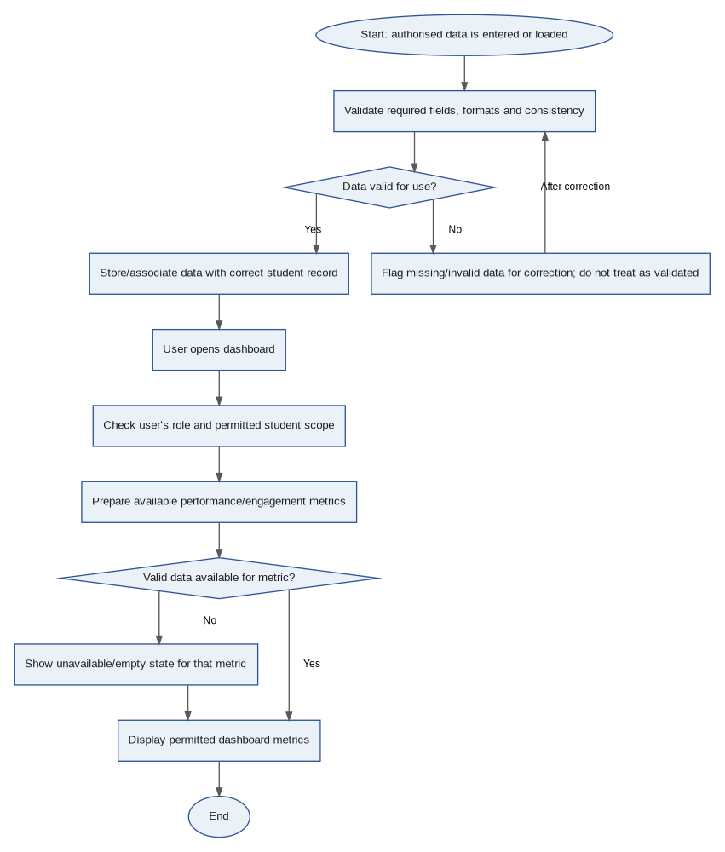
Open decisions / notes: The exact mandatory field list, valid ranges, refresh frequency and metric definitions need stakeholder confirmation.

PF-04 — ML-Based At-Risk Prediction
Generate a risk indicator from eligible student data without presenting it as a final academic decision.
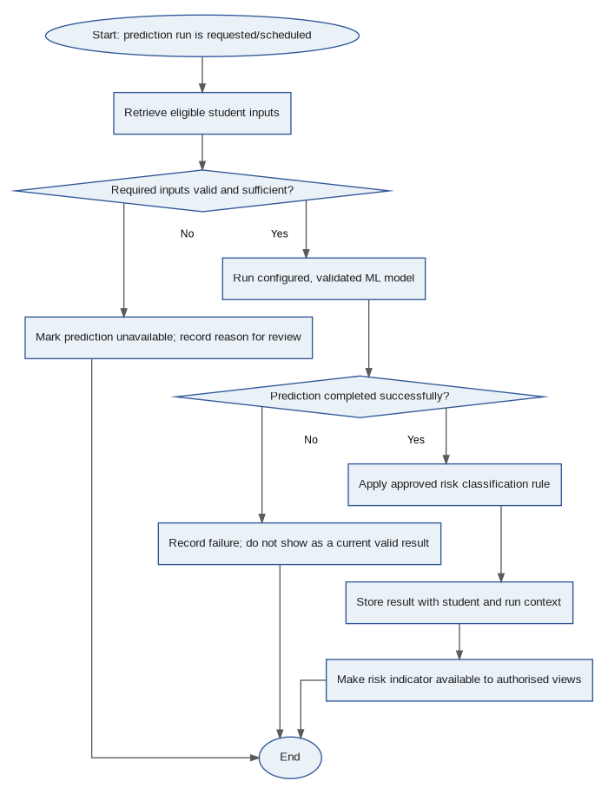
Open decisions / notes: Prediction schedule/trigger, input schema, missing-data strategy, risk threshold, stale-result handling and model acceptance metrics are TBC. A risk indicator is an early-warning signal, not a final academic judgement.

PF-05 — Risk Notification and Review
Make a risk alert available to the student and relevant authorised staff, subject to agreed notification rules.
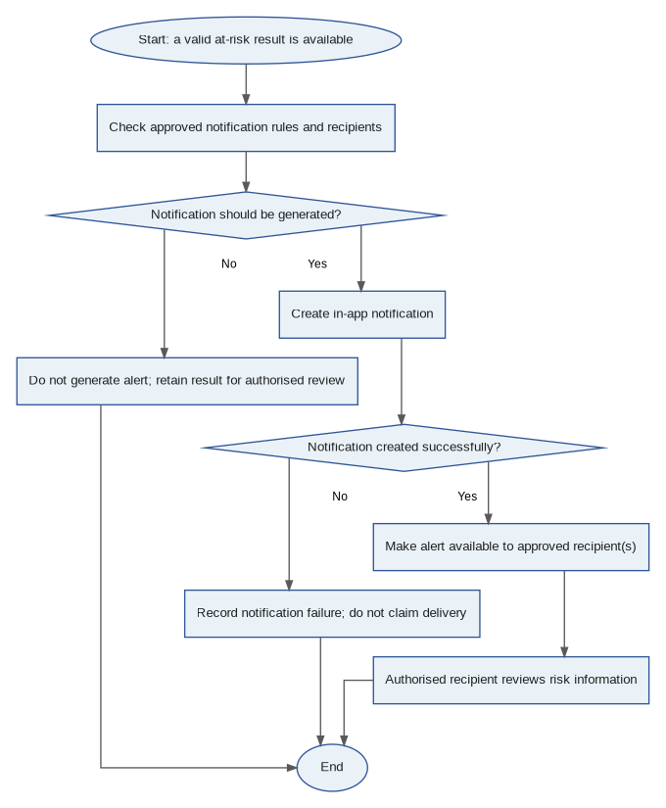
Open decisions / notes: Recipient selection, retry rules, duplicate suppression, read/unread state and whether alerts are sent to administrators must be agreed before implementation.

PF-06 — Tutor Reviews Student Submission
Allow a tutor to access submissions only for courses within their authorised scope.
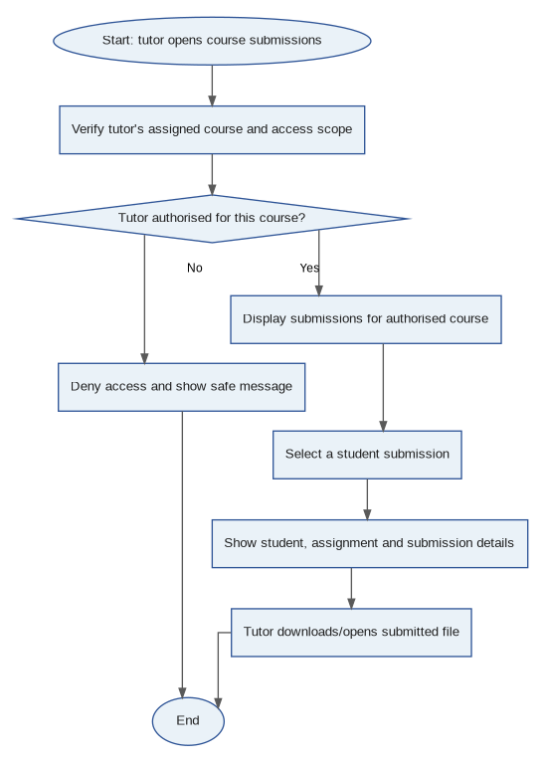
Open decisions / notes: Marking, grades, tutor feedback and resubmission approval are not included unless they are confirmed as in-scope functions.

3. Traceability to product backlog
Flow ID | Related backlog items | Potential test coverage
PF-01 | EP-01; US-001–US-004 | Authentication, role permissions and secure access tests
PF-02 | EP-03; US-011–US-012 | Assignment submission and negative upload/deadline tests
PF-03 | EP-02, EP-05, EP-08; US-005–US-008, US-016–US-018, US-027–US-028 | Data validation, access scope, dashboard and empty-state tests
PF-04 | EP-06; US-019–US-022, US-031 | Input validation, prediction success/failure and model evaluation tests
PF-05 | EP-07; US-023–US-026 | Notification generation, recipient scope, failure and duplicate tests
PF-06 | EP-03; US-013 | Tutor permissions and submission review/download tests

4. Questions to resolve before sign-off
- Which user roles are in scope, and what exact permissions apply to each role?
- What are the mandatory student fields, data validation rules and duplicate-record rules?
- What are the accepted assignment file types, maximum file size, resubmission and late-submission rules?
- What triggers a prediction, what is the approved at-risk threshold, and how are missing inputs handled?
- Who receives risk notifications, and what are the retry, duplicate suppression and read/unread rules?
- What are the privacy, retention, audit and administrator-visibility requirements?
- What model evaluation measures and acceptance thresholds must be met before the model is used?

5. Document status
Draft for portfolio use. The flows reflect the current project scope and identify unresolved details. Validate them with the product owner, academic stakeholders and technical/ML owners before using them as implementation or compliance specifications.

