NAME-DUSHYANT SINGH
CSE B
202401100200138
1. GitHub repository URL-https://github.com/Dushyant-singh2005/github-skills-challenge
2. Pull request URL used to validate the workflows-https://github.com/Dushyant-singh2005/github-skills-challenge/pulls
3. Screenshot showing the GitHub Actions workflows
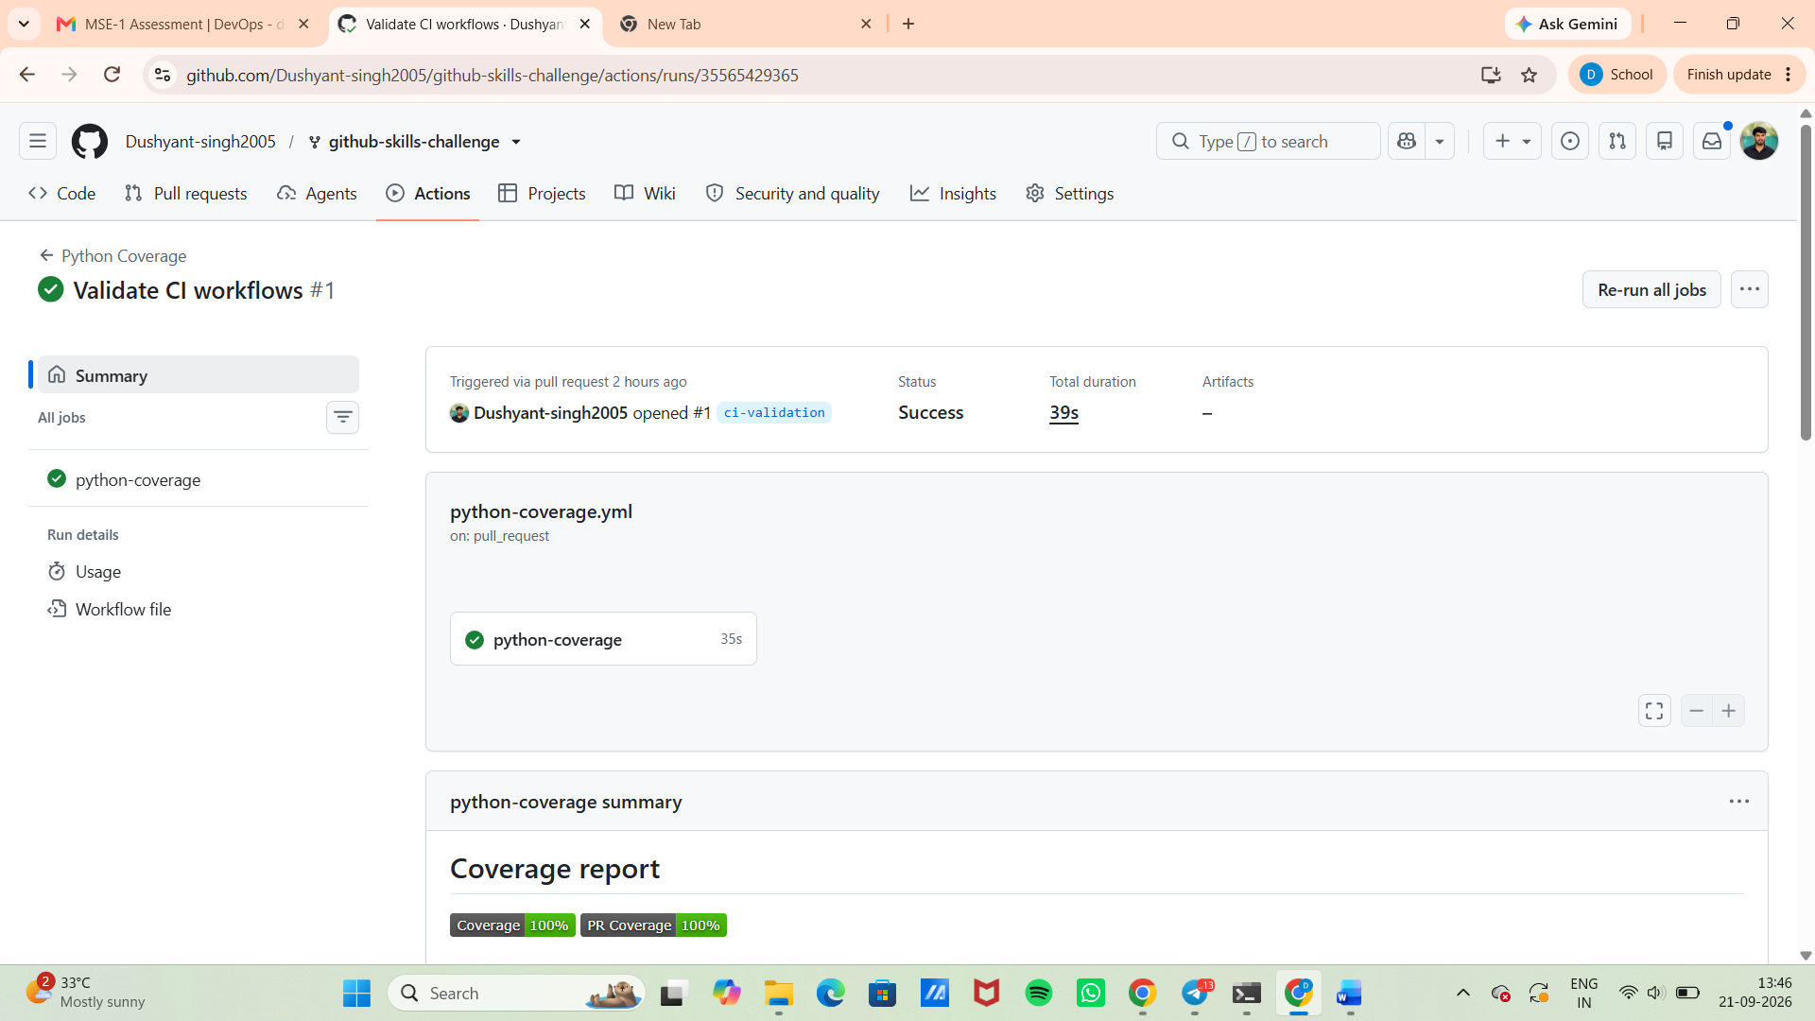
4. Screenshot showing a successful test workflow execution
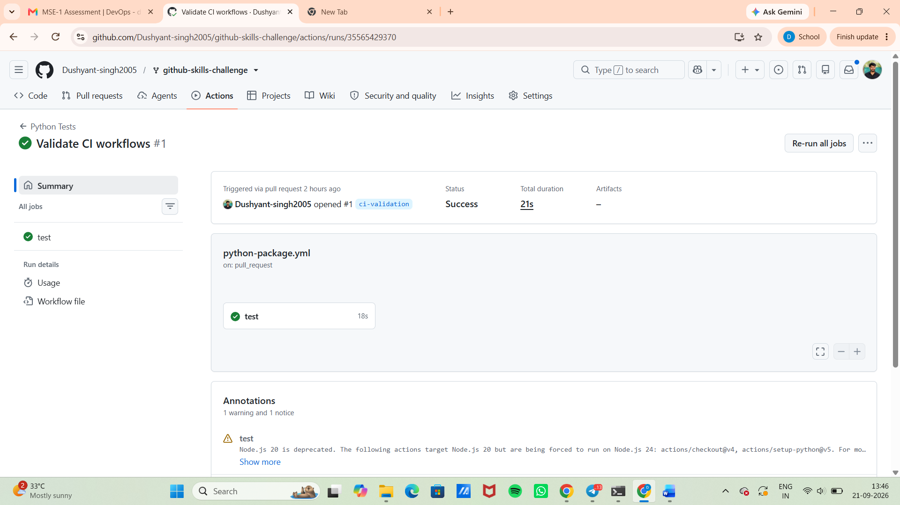
5. Screenshot showing the coverage result/comment on the pull request
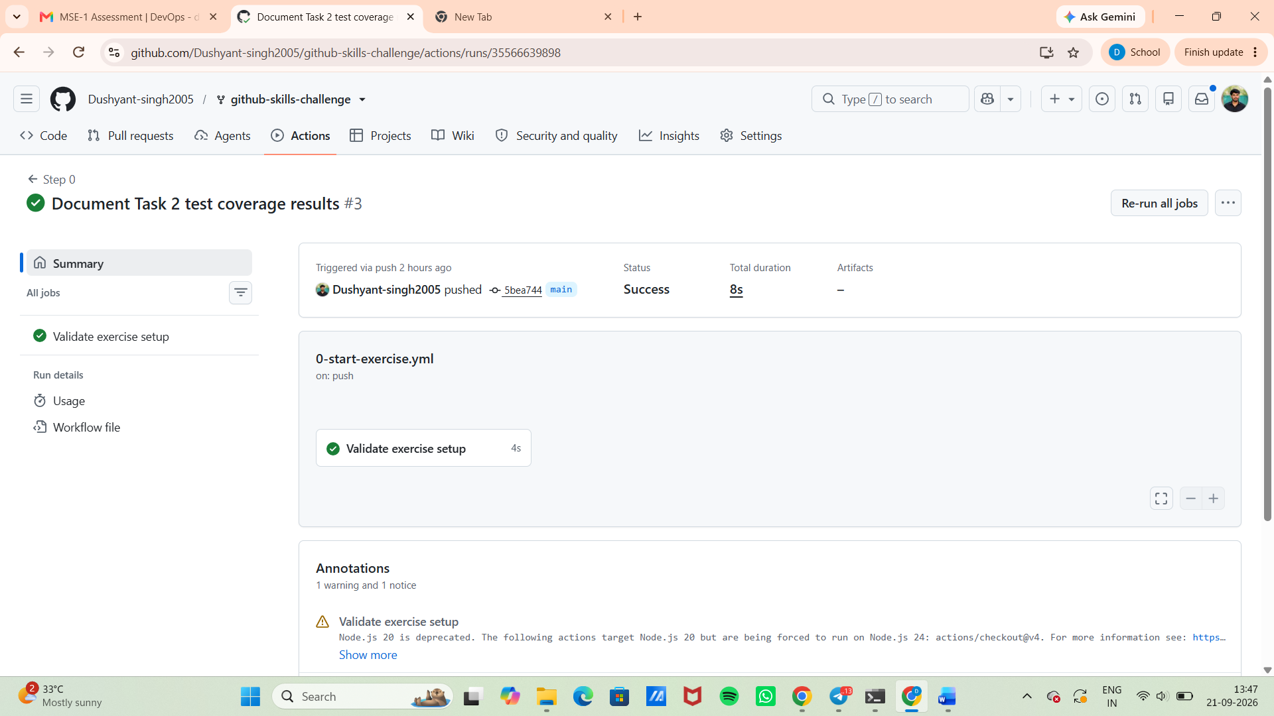
6. Screenshot showing the final repository/workflow files
