**Lab12: Demonstrate setting updatation for Mozilla Firefox.**

The web browser is the most important piece of software on our computer. We use web browser to maintaining our social networks to online banking. Hackers exploit browser vulnerabilities to attack your computer and steal sensitive data, so it is very important you keep your web browser up to date.Mozilla Firefox is the default web browser on Ubuntu.

**How to update the installed Firefox browser on Ubuntu**

This section contains the various ways to upgrade the Firefox browser on Ubuntu; the below-mentioned methods can be followed to update Firefox

* Using Ubuntu Terminal
* Using Ubuntu Software Centre

**Method 1: How to update Firefox using Ubuntu terminal**

You can use the Ubuntu command line terminal to update the Firefox to the latest version.

* The very first practice you must follow is to check the current version of your Firefox, open the terminal “**Ctrl+Alt+T,**” and run the following command:

**$ firefox --version**



* Once it is opened, execute the following command in the terminal to get the updated information about the packages:

**$ sudo apt update**

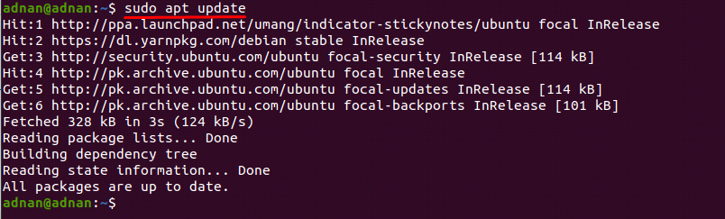

* The above command will come down with the latest versions that are available. You can execute the following command to finally install the available updates, and the packages will be upgraded to the latest available versions.

**$ sudo apt upgrade**

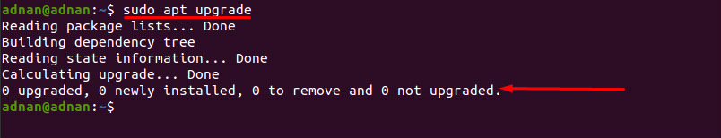

* The above command will upgrade the packages of the whole system. However, if you want to update Firefox only; to upgrade Firefox, use the command given below:

**$ sudo apt install --only-upgrade firefox**

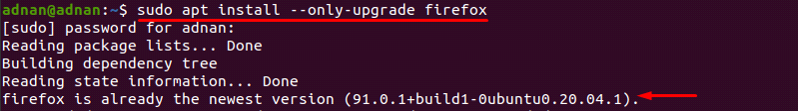

* Alternate to the above, you can also use the install command in Ubuntu to get the updated version of the tool (even if it is already installed). The below-stated command will update the packages list of Ubuntu:

**$ sudo apt update**

* After updating the system, you can go for installation of Firefox (updates to the newest version if available):

**$ sudo apt install firefox**

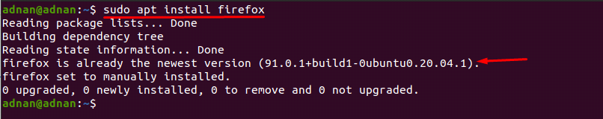

**Method 2: How to update Firefox using Ubuntu Software Center**

Ubuntu software center is the built-in application in Ubuntu to provide ease of installation, updating of basic ubuntu packages. You can update the Firefox using the Ubuntu Software Centre by following simple steps as given below:

**Step 1:** Navigate to the “**Ubuntu Software Center**” icon available on the taskbar of Ubuntu; click on it to open:

**Step 2:** Now, click on the update tab available on the top of “**Ubuntu Software**”; if there is any update available, you will get the information here, and you can update the software easily.

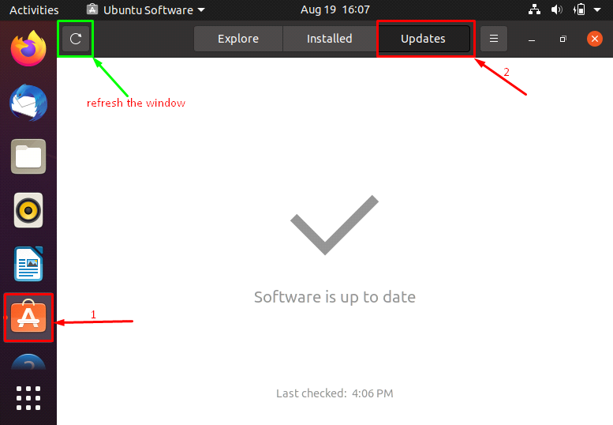

* Alternatively, you can update Firefox by opening the installed version. To do this, click on the Firefox icon, which you can find on the taskbar of Ubuntu:

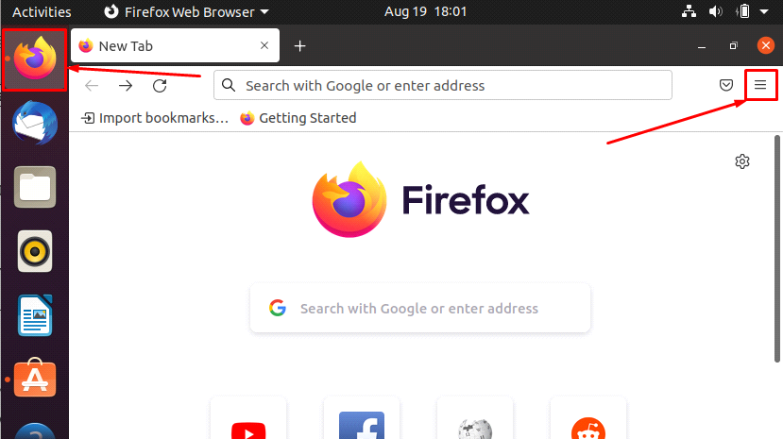

* Click on the open application menu icon placed on the top bar of the Firefox window, scroll down on this menu, and click on “**Help**”.

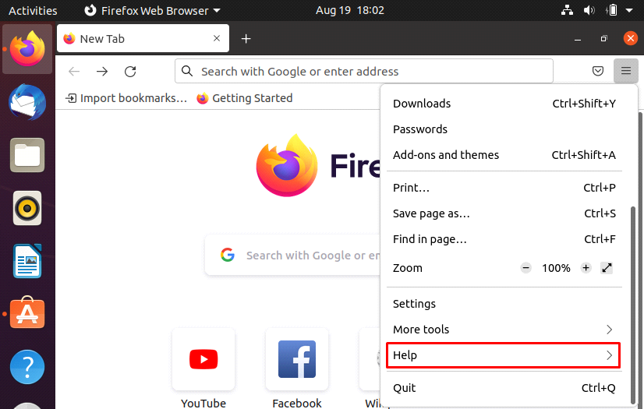

* After that, you will find the “**About Firefox**” option:

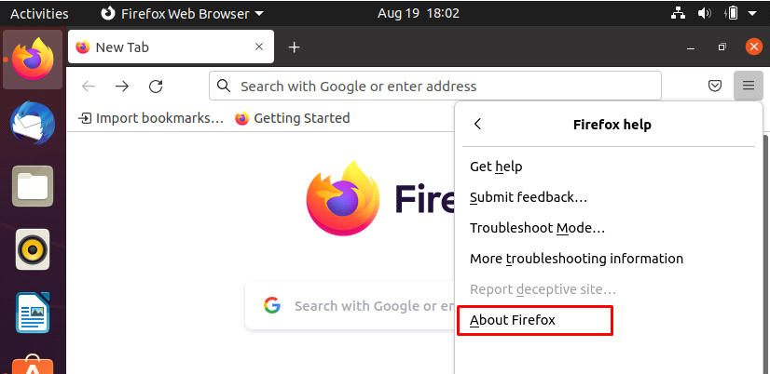

* Upon clicking this option, a new window will be displayed that contains the current version of Firefox, and it also shows if there is any update available; you can download and install the update from here too.

