**8. Demonstrate how to track Bugs using Bugzilla.**

**What is Bugzilla?**

Bugzilla is a bug tracking tool that helps to track the issues related to their product. Bugzilla tool is written in Perl language, and it uses MySQL database. It is a bug tracking tool. However, it can also be used as a test management tool because it can be linked with other Test case management tools such as Quality Center, Test link, etc. It is an open source tool, i.e., this tool is available to the users at a free of cost.

**The following are the features of a Bugzilla:**

* Advanced Search capabilities
* Email Notifications controlled by user preferences
* Bug lists in multiple formats
* Scheduled reports by email
* Automatic Duplicate Bug Detection
* File/Modify Bugs by email
* Time Tracking
* Request System
* Move Bugs Between Installations
* "Watch" Other Users
* Reports and Charts

**Logging in to Bugzilla**

The Bugzilla installation requires the several software. But, some websites provide Bugzilla web application, and <https://bugzilla.mozilla.org/home> website is one of them.

* Navigate to <https://bugzilla.mozilla.org/home> website. When you click on the given URL, Welcome page appears which is shown below:

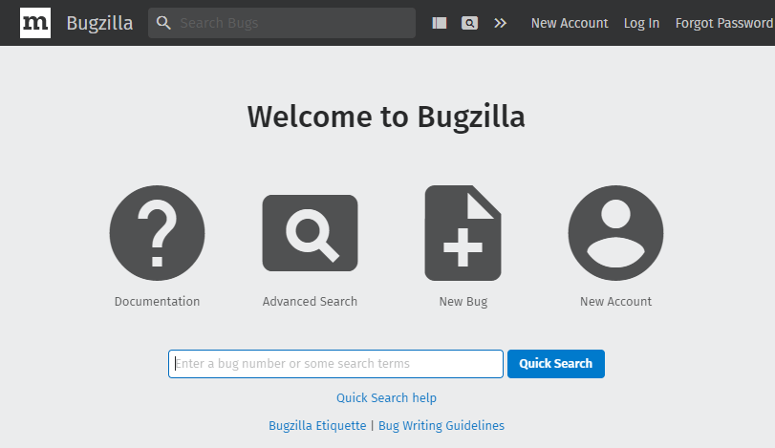

* If you are already an existing user, then you can log in to the Bugzilla. If you are the first user, then you can create a New Account. Click on the **New Account** to create a new user.

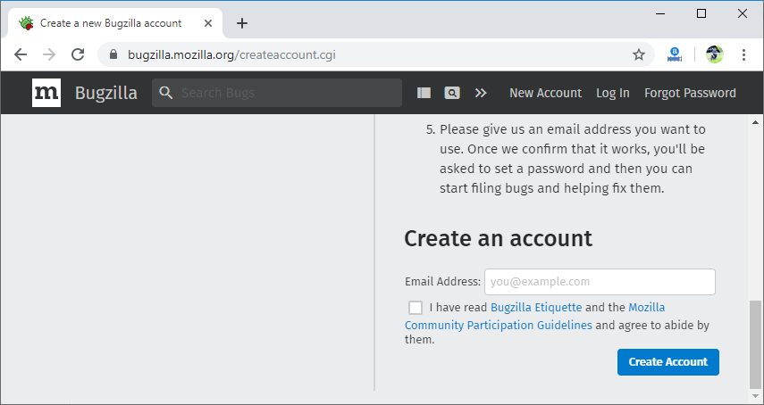

* In the above screen, enter your email id and click on the Create Account button. On clicking on the Create Account button, a confirmation mail is sent to your email id.When you click on the link sent to your email id, then the **Bugzilla** page appears asking to reset the password.

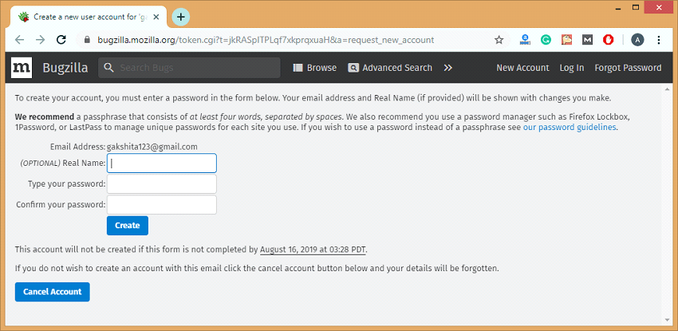

* When you enter the name and password, click on the Create button.

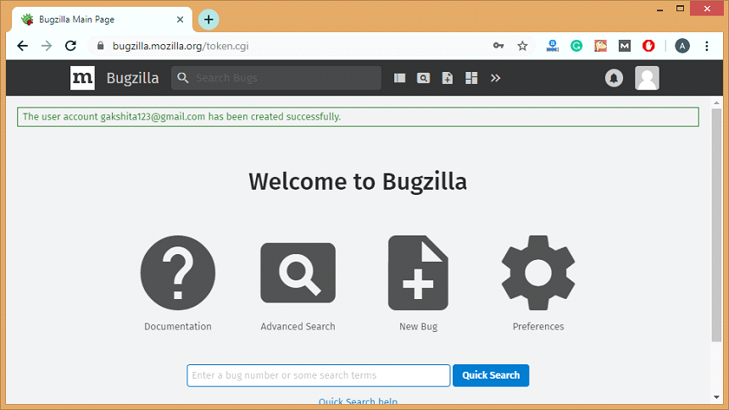

**Following are the steps required to file a bug:**

**Step 1:** Click on the **New Bug** icon to file a new bug.

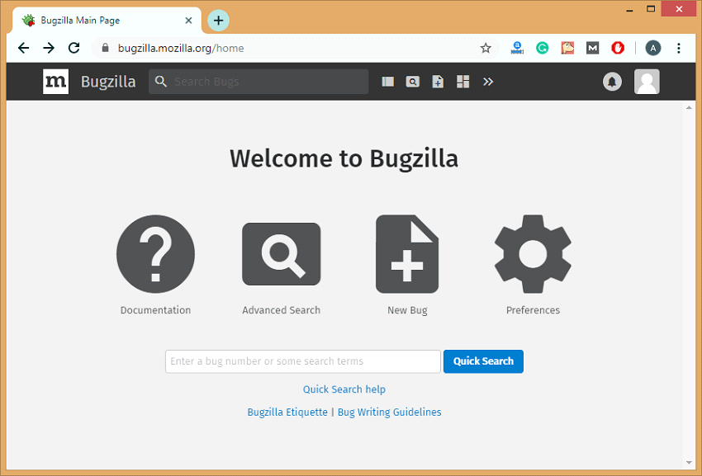

Step 2: On clicking on the New Bug, you will be redirected to the new page showing all the products.

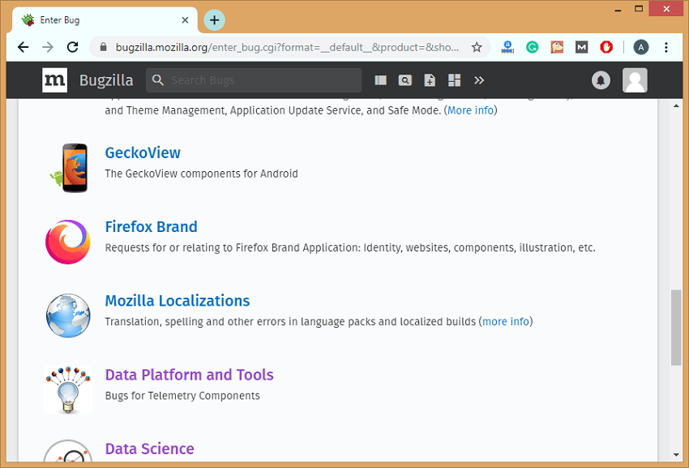

Step 3: Suppose I choose the product Data Platform and Tools. When I select the product, the screen appears, which is shown below:

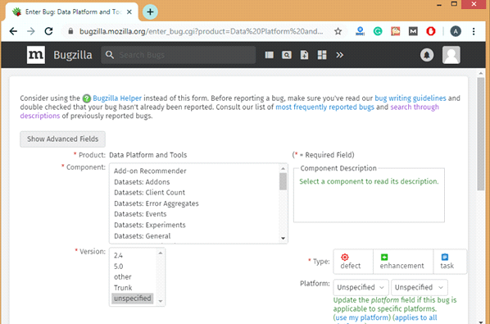

In the above screen, we need to fill the following fields:

Product: It is a product that you selected just now, i.e., Data Platform and Tools.

Component: Each product can be split into several components based on its functionalities.

Version: Version of the product determines the product in which the bug has been detected.

Summary: It is used to define the summary of a product.

Request information from:

Attachment: File can also be attached related to the bug.

Description: It provides the complete description of a bug.

Security: You can check the security box so that this bug can be kept hidden from the public until and unless it gets resolved.

**Searching for a particular bug.**

There are two types of searches:

* Simple search
* Advanced search

**Simple search**

**Follow the steps to search for a bug:**

**Step 1:** Click on the **Search icon** available on the home page.

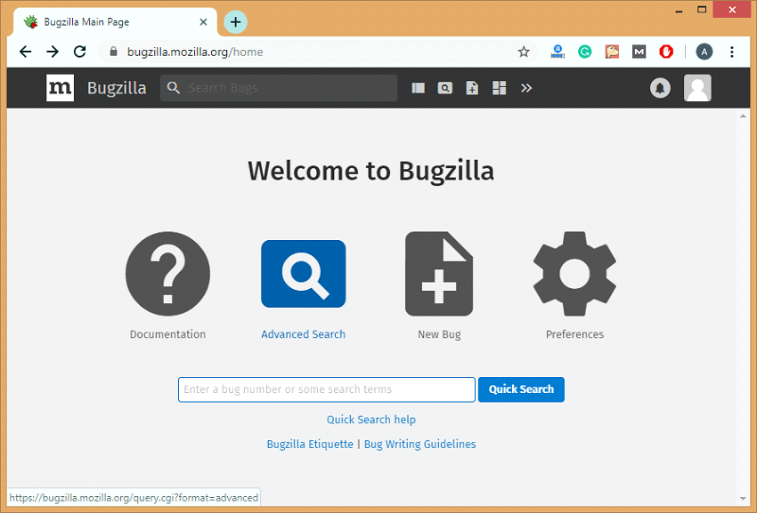

Step 2: After clicking on the search icon, the screen appears which is shown below:

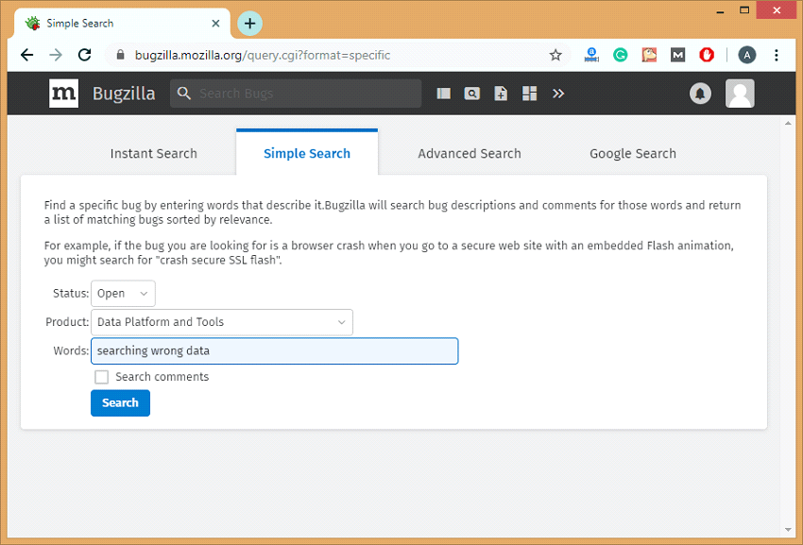

In the above screen, we need to enter the three fields, i.e., Status, Product, and Words.

Step 3: Click on the Search button. After clicking on the Search button, the bug list appears which is shown below:

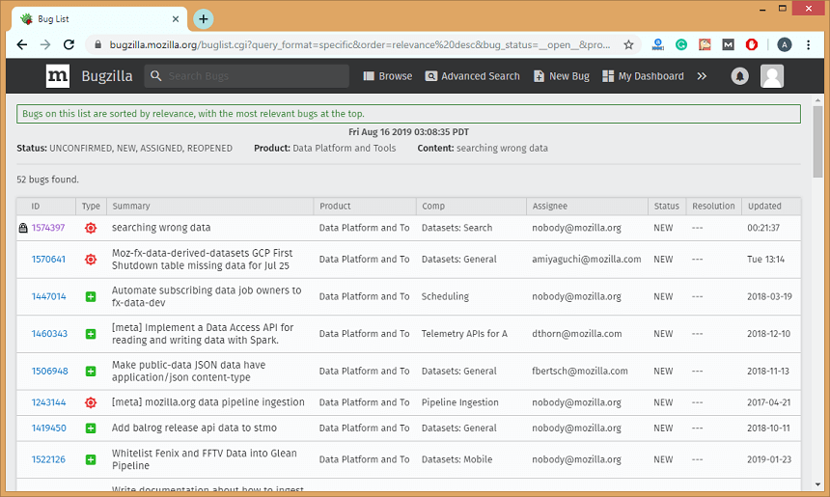

Screen shot of email received about the reported bug…...

