**Project 1: Estimating the Dynamical Mass of a Galaxy Cluster**

In this short project, you will use the steps discussed in class to estimate the dynamical mass of a galaxy cluster, which is the total mass of the cluster independent of light.

For this, first, you must get information on a field with many galaxies, several of which are potential members of a cluster. We will make use of the SDSS spectroscopic data archive for this. In the interest of saving time, we will use the redshift determined by the SDSS itself for the galaxies in the field. The alternative is to download the spectrum of each galaxy, use the spectral features to determine the redshift.

There are many ways to extract the data we want from the SDSS archive. We will use an SQL query. Copy-paste the below SQL query to the SDSS page:

--------

SELECT

s.objid,sz.ra as ra,sz.dec as dec,pz.z as photoz,pz.zerr as photozerr,sz.z as specz,sz.zerr as speczerr,b.distance as proj_sep,s.modelMag_u as umag,s.modelMagErr_u as umagerr,s.modelMag_g as gmag,s.modelMagErr_g as gmagerr,s.modelMag_r as rmag, s.modelMagerr_r as rmagerr,s.type as obj_type

FROM BESTDR16..PhotoObjAll as s

JOIN dbo.fGetNearbyObjEq(258.1294,64.0926,10.0) AS b ON b.objID = S.objID

JOIN Photoz as pz ON pz.objid = s.objid

JOIN specObjAll as sz ON sz.bestobjid = s.objid

WHERE s.type=3 and sz.z > 0.05 and sz.z < 0.20

--------

If you are interested in knowing the details of this SQL script, talk to me. Briefly, the query will return a table with whole lot of information on galaxies with redshifts between 0.05 and 0.20 found within a 10-arcminute radius circle centred on the (RA, Dec) = 258.1294, 64.0926

Put this query in the following page (do not forget to clear the query box by hitting “clear query” before copy+pasting the above script).

<http://skyserver.sdss.org/dr16/en/tools/search/sql.aspx>

1. Identify galaxies that you think are members of a cluster. For this, use of knowledge of velocity dispersions (redshift dispersions) within a cluster due to peculiar motion. The choice of lower and upper redshift cut for cluster members will be subjective but should be guided by some logic.

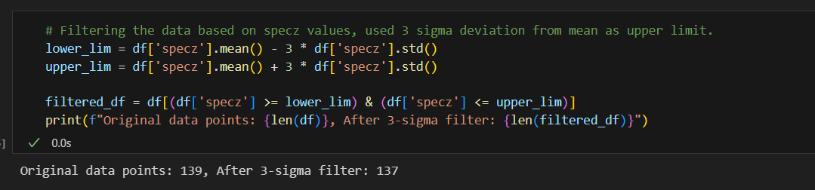Ans:- To identify galaxies that are member of a cluster, I uses a standard approach based on the distribution of spectroscopic redshift (specz). The logic is to calculate the mean and standard deviation of redshift for all the galaxies, To define cluster members as galaxies whose redshift lies within ± 3 standard deviation (3*sigma) of the mean.

Result: Total 137 out of 139 galaxies are the members of the cluster.

1. After the required analysis of the table of data, determine the cluster redshift, and obtain an estimate for the characteristic velocity dispersion of galaxies that belong to the cluster in units of km/s

Ans:- Cluster redshift is the mean of redshift of galaxies that fall between 3-sigma limit. To obtain an estimate for the characteristic velocity dispersion of galaxies that belong to cluster is the standard deviation of velocity dispersion data. Velocity dispersion is calculated by given formula.

$$v=c. \frac{{(1+z)}^{2}- {(1+z_cluster)}^{2}}{{(1+z)}^{2}+ {(1+z_cluster)}^{2}}$$

Where,

v = relative velocity (dispersion)

c = speed of light

z = redshift of individual galaxy

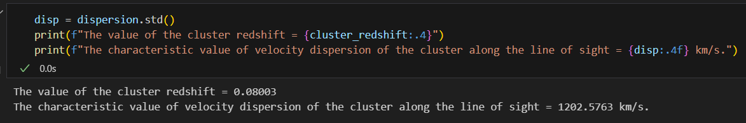 z_cluster = mean of cluster redshift

Result – Cluster redshift = 0.08003

Velocity dispersion = 1202.5763 km/s

1. Estimate the characteristic size of the cluster in Mpc.

Ans:- The characteristic size (diameter) of the cluster is 0.919 Mpc.

To calculate diameter, first calculate the r (co-moving distance) by given formula

$$r= \frac{cz}{H0} (1+ \frac{z}{2}\left(1+q0\right))$$

Where,

c = speed of light

z = redshift of individual galaxy

q0 = -0.534 (deceleration parameter)

ra is the angular diameter distance, given by:

$$Da= \frac{r}{1+z}$$

Then, Diameter of galaxy cluster is-

Diameter (Mpc) = $Da * θ$

Where,

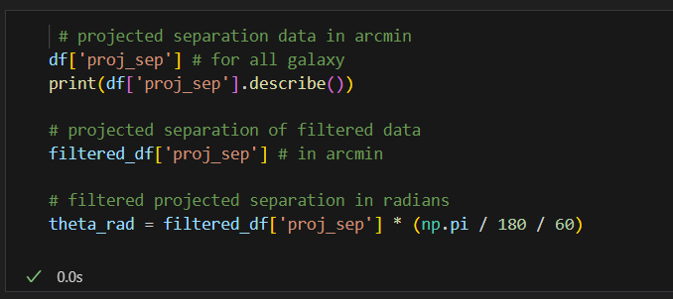 $θ$ = Angular size in radian.

$θ$ is given as ‘proj_sep’ projected separation data in given .csv file. It’s unit is in arcminutes. To convert it from arcmin to radians, I multiplied by $π$/ 180 / 60.

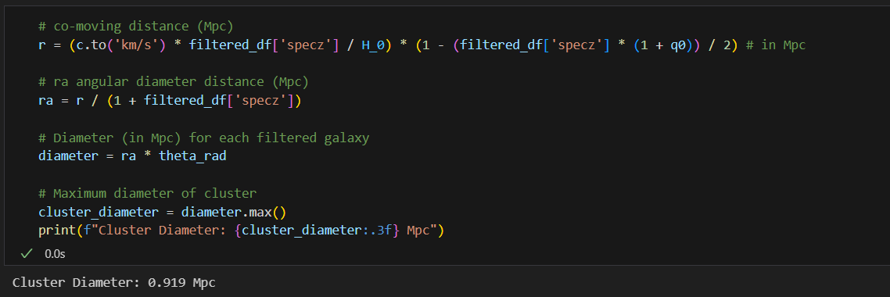

The Diameter contains all the values of individual galaxies, so the final cluster diameter is the max value of all the values. By using diameter.max(), I get the Cluster diameter = 0.919 Mpc.

1. Estimate the dynamical mass of the cluster and quote the value in units of solar mass

Ans:- To estimate the dynamical mass of the galaxy cluster, by using the virial theorem:

$$M_{dyn}= \frac{3σ^{2}R}{G}$$

Where,

$σ$ = velocity dispersion in m/s

R = Cluster radius in meters

G = Gravitational constant in SI unit.

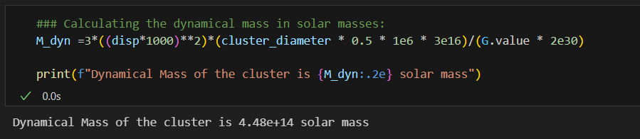 To convert the final result into solar masses by dividing by 2 x ${10}^{30} kg.$

The dynamical mass of the cluster is 4.48e+14 solar mass.

1. Is the estimate of dynamical mass consistent with what is expected from the luminous mass? If not, explain with the support of numbers the inconsistency.

Ans:- The cluster's dynamical mass is 4.48×10^14 solar masses, but its total luminous mass is only 7.42×10^12 solar masses. This results in a stellar mass fraction of about 1.65%, indicating that the visible matter makes up only a small portion of the total mass inferred from gravitational effects. The large discrepancy, with roughly 98% of the mass being non-luminous, is a common sign of dark matter presence.

Also, explore at least a few relevant plots that were used to arrive at values (such as a histogram of velocity dispersions of galaxies, a histogram of angular separation between galaxies and the value that you chose indicated by a vertical line, etc.

