Group Project Deliverable 3: Comparison Report
Anulekha Kavutarapu and Dushyanth Shanubhoganahalli Nandeesh
University of the Cumberlands
MSCS-632-M30 Advanced Programming Languages
Dr. Jay Thom
10/04/2026

Comparing C# and Ruby Through a Book Cataloging System
Introduction
We built the same console Book Cataloging System in C# (Anulekha) and Ruby (Dushyanth) so that any difference in the code would come from the languages rather than the design. Both programs follow one specification, produce identical output on 19 scripted test scenarios, and read and write the same JSON file. The source code, tests, and build instructions are in our repository: https://github.com/DushyanthNandeesh/book-catalog-csharp-ruby.
Language Features and Syntax
The largest difference is the type system. In C#, the Book class declares int Year and string Title, so the compiler rejects wrong assignments before the program runs, and System.Text.Json refuses to load "1990" as an int (Microsoft, n.d.-b). Ruby's attr_reader :year declares no type, so we wrote the checks ourselves with is_a?(Integer) and applied them when loading files. Dynamic typing made Book shorter to write, but it moved error discovery from compile time to run time (Sebesta, 2019).
Both languages query collections with chained operations, as Table 1 shows. C# uses LINQ lambdas and needs comparer objects such as StringComparer.OrdinalIgnoreCase, while Ruby passes blocks and simply calls downcase (Microsoft, n.d.-a; Ruby, n.d.). In each language the Catalog exposes itself as a collection (IEnumerable<Book> in C#, include Enumerable with an each method in Ruby), which is why one design supports every query. One private method serves all three searches: C# passes a Func<Book, string> and Ruby passes a block.
Table 1
Key Code Compared Between C# and Ruby
C# | Ruby
Searching a collection  _books.Where(b => field(b).Contains(  needle, StringComparison.OrdinalIgnoreCase))  .OrderBy(b => b.Title,  StringComparer.OrdinalIgnoreCase) | Searching a collection  select { |book| field.call(book)  .downcase.include?(needle) }  .sort_by { |book|  [book.title.downcase, book.id] }
Declaring and checking the year  public int Year { get; init; }  year >= 1000 && year <= DateTime.Now.Year | Declaring and checking the year  attr_reader :year  year.is_a?(Integer) &&  year.between?(1000, Time.now.year)
Handling a bad data file  catch (Exception ex) when (ex is JsonException  or IOException) { return Corrupt; } | Handling a bad data file  rescue JSON::ParserError, SystemCallError  LoadResult.new(:corrupt, [])

Programming Paradigms
Both programs are object-oriented, with Book, Catalog, and Storage classes, but they lean differently. C# keeps behavior in typed classes and borrows functional style through LINQ and lambdas. In Ruby everything is an object and blocks make functional iteration the normal way to loop, so our Ruby search and report code contained no explicit loops. Smaller contrasts follow the same pattern: C# uses a record for report groups and a static class for validation, while Ruby uses Struct.new(:name, :books) and a module.
Challenges
Keeping the programs identical was the main challenge, and running both on the same input (Figure 1) exposed real differences. Ruby saved an empty catalog as a blank-line array while C# saved [], so we fixed storage.rb. Ruby integers have no size limit, so a huge ID was accepted in Ruby but rejected in C#. Ruby's sort_by is not stable, so equal titles needed an ID tiebreaker, and Ruby's File.exist? is true for folders unlike C#'s File.Exists. In each case C#'s stricter library behavior matched our specification by default, and Ruby needed extra code.
Performance
We benchmarked 100,000 books with the benchmark folder in the repository (Linux, Ruby 3.2.3, .NET 8; average of three runs). C# was faster on every operation, about 10 times for search and 5 to 6 times for reports (Table 2), as expected from compiled, statically typed code. Ruby started faster, and for normal catalog sizes neither difference is noticeable.
Table 2
Benchmark Results for 100,000 Books (Milliseconds)
Operation | C# | Ruby
Search by title | 2.9 | 28.7
Genre report | 52.9 | 271.9
Author report | 33.8 | 200.2
Load JSON file | 181.0 | 397.6
Program start and exit | 90 | 63

Overall Experience
C# was easier to debug: the compiler and its nullable-reference warnings caught mistakes before we ran anything, at the cost of more declarations and a heavier setup of SDK, project file, and packages. Ruby was quicker to start, and calls such as select and sort_by read almost like English, but we relied on tests to catch problems the C# compiler found for us. The applications ended up close in size, 274 lines of C# against 251 of Ruby without blanks or comments, a smaller gap than we predicted. C# suits larger, long-lived projects where safety and speed matter, and Ruby suits quick, flexible development. With a shared specification and shared tests, both worked equally well for this application.
Figure 1
Both Programs Listing the Same Ten Books
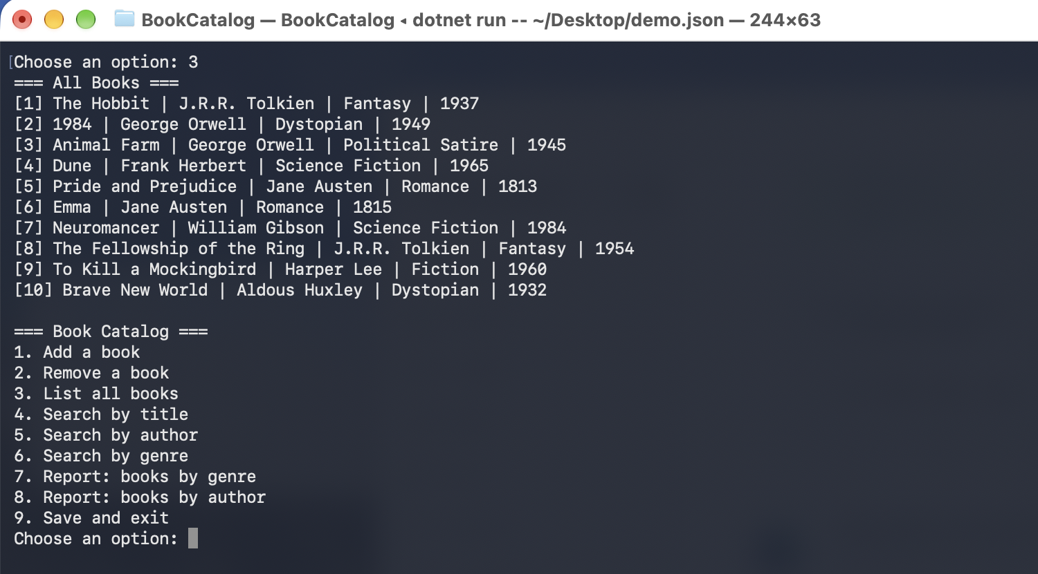 | 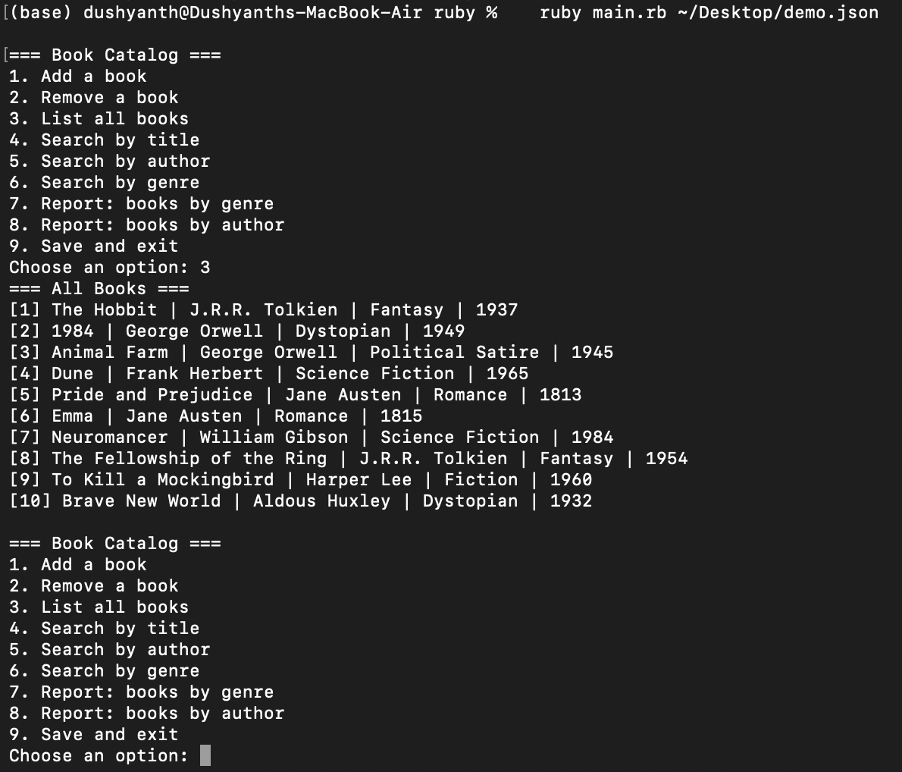
Note. Left: C# (.NET 8). Right: Ruby (4.0.7). Both screenshots were taken on our MacBooks and show identical text.
References
Microsoft. (n.d.-a). Language integrated query (LINQ). Microsoft Learn. https://learn.microsoft.com/en-us/dotnet/csharp/linq/
Microsoft. (n.d.-b). System.Text.Json overview. Microsoft Learn. https://learn.microsoft.com/en-us/dotnet/standard/serialization/system-text-json/overview
Ruby. (n.d.). Documentation. https://www.ruby-lang.org/en/documentation/
Sebesta, R. W. (2019). Concepts of programming languages (11th ed.). Pearson.

