Group Project Deliverable 2: Core Functionality Implementation
Anulekha Kavutarapu and Dushyanth Shanubhoganahalli Nandeesh
University of the Cumberlands
MSCS-632-M30 Advanced Programming Languages
Dr. Jay Thom
10/03/2026

Core Functionality of the Book Cataloging System in C# and Ruby
Introduction
This report describes the work completed on Day 2 of the cross-language project. The Book Cataloging System now runs in both C# and Ruby, and every feature in the shared specification from Deliverable 1 is implemented in both versions. Anulekha built and tested the C# version, and Dushyanth built and tested the Ruby version. Both programs are console applications with the same menu, rules, and messages, and both read and write the same JSON data file.
The complete source code, a detailed README with build and run instructions, the unit tests, and the cross-language test scripts are in the team repository: https://github.com/DushyanthNandeesh/book-catalog-csharp-ruby
Core Functionality
Table 1 shows each core requirement and where it is implemented. All features work in both languages and were checked with the tests described later in this report.
Table 1
Core Features and Where They Are Implemented
Feature | C# (Anulekha) | Ruby (Dushyanth)
Book storage | Book class; List<Book> in Catalog.cs | Book class; Array in catalog.rb
Add and remove | Catalog.Add, Catalog.Remove | Catalog#add, Catalog#remove
Search by title, author, genre | LINQ Where and OrderBy | select and sort_by with blocks
Reports by genre or author | LINQ GroupBy | group_by with blocks
JSON persistence | Storage.cs with System.Text.Json | storage.rb with the json library
Input validation and error handling | Validation.cs; try and catch | validation.rb; rescue
Console menu | Program.cs | main.rb

Three details were not fixed in the Deliverable 1 specification, so we decided them together and applied them to both programs. First, "List all books" is sorted by ID. Second, if the input ends (for example, when a script is used instead of a keyboard), the program saves and exits as if option 9 had been chosen. Third, a missing or corrupt data file produces a message and an empty catalog rather than a crash. The repository layout also changed slightly: the C# project sits in csharp/BookCatalog so that its unit tests can live beside it in csharp/BookCatalog.Tests.
Use of Language-Specific Features
The assignment asks for classes and LINQ in C# and for dynamic typing, built-in classes, and blocks in Ruby. Table 2 places the two implementations side by side. The sections that follow discuss what the differences mean.
Table 2
Key Code Compared Between the Two Languages
C# | Ruby
Searching a collection  _books  .Where(b => field(b).Contains(  needle,  StringComparison.OrdinalIgnoreCase))  .OrderBy(b => b.Title,  StringComparer.OrdinalIgnoreCase)  .ThenBy(b => b.Id)  .ToList(); | Searching a collection  select { |book|  field.call(book).downcase  .include?(needle) }  .sort_by { |book|  [book.title.downcase,  book.id] }
Typing a field  public int Year { get; init; }  int.TryParse(text?.Trim(),  NumberStyles.None,  CultureInfo.InvariantCulture,  out value); | Typing a field  attr_reader :year  year.is_a?(Integer) &&  year.between?(1000, Time.now.year)  cleaned.match?(/\A\d+\z/)
Passing behavior into a method  private static void Search(  string fieldName,  Func<string, List<Book>> method)  Search("title",  catalog.SearchByTitle); | Passing behavior into a method  def search(field_name)  query = prompt("Search #{field_name}: ")  show_books('Search Results', yield(query))  end  search('title') { |q| @catalog.search_by_title(q) }
Handling a bad data file  catch (Exception ex) when  (ex is JsonException  or IOException  or UnauthorizedAccessException)  { return new LoadResult(  LoadStatus.Corrupt, ...); } | Handling a bad data file  rescue JSON::ParserError,  SystemCallError,  EncodingError  LoadResult.new(:corrupt, [])

Static versus dynamic typing
In C#, the compiler knows that Year is an int and Title is a string, so a wrong assignment fails before the program runs. In Ruby, attr_reader :year declares no type, so a Book could hold any kind of value. We therefore added explicit type checks in validation.rb (for example, is_a?(Integer)) and used them when loading the JSON file. The C# loader gets some of this checking for free: System.Text.Json refuses to turn the text "1990" into an int (Microsoft, n.d.-b). In Ruby, we wrote the equivalent check by hand.
LINQ versus blocks
Both languages express searching and grouping as a chain of operations on a collection. C# uses LINQ methods such as Where, OrderBy, and GroupBy with lambda expressions (Microsoft, n.d.-a). Ruby uses Enumerable methods such as select, sort_by, and group_by with blocks (Ruby, n.d.). In both versions the Catalog class makes this possible by exposing itself as a collection: the C# Catalog implements IEnumerable<Book>, and the Ruby Catalog includes Enumerable and defines each. The Ruby chain is shorter, mainly because Ruby needs no comparer objects. It sorts with downcase, while C# passes StringComparer.OrdinalIgnoreCase.
Data structures, memory, and concurrency
Both versions store books in a growable list (List<Book> in C#, Array in Ruby) and use a small data type for report groups: a record in C# and a Struct in Ruby. Both languages are garbage collected, so neither program manages memory by hand. C# does distinguish value types (int) from reference types (Book), while every Ruby value is an object reference. This project option does not require concurrency, so neither version uses threads.
Code Quality
Each version is split into five source files with one job each: the book type, validation, the catalog, storage, and the menu. Business rules live in Catalog and Validation, and only the menu file reads from the keyboard or prints, so the logic can be tested without the console. Every file starts with a comment explaining its purpose, and comments mark where a language-specific feature is used. Each language follows its own conventions: PascalCase methods and braces in C#, snake_case methods and a frozen_string_literal comment in Ruby. The C# project enables nullable reference types and builds with no warnings. Table 3 summarizes the size of each version.
Table 3
Size of Each Implementation
Measure | C# | Ruby
Application source files | 5 | 5
Lines of code (no blanks or comments) | 274 | 251
Comment lines | 62 | 55
Unit test files | 4 | 5
Unit test lines of code | 174 | 144

The two versions are close in length. The Ruby code is about 8% shorter, but the C# code is more explicit about types and intent. The difference was smaller than the team predicted in Deliverable 1, which we will examine further in the final report.
Testing and Debugging
We tested at three levels. First, each language has 17 unit tests covering validation, adding, removing, searching, reports, and file loading (xUnit for C#, Minitest for Ruby). Second, a shared script (tests/compare.sh) feeds the same keyboard input to both programs for 19 scenarios and checks that the on-screen output and the saved JSON file are identical. The scenarios include valid and invalid additions, removals, empty searches, an empty catalog, mixed capitalization, accented characters, a missing data file, and seven kinds of corrupt data file. Third, we ran both programs by hand. Table 4 shows the results.
Table 4
Test Results
Test | What it checks | Result
Ruby unit tests (Minitest) | 17 tests, 61 assertions | All passed (Figure 6)
C# unit tests (xUnit) | The same 17 checks, run with dotnet test | All 17 passed (Figure 12)
Cross-language comparison | 19 scenarios, screen output and JSON file | 19 passed, 0 failed (Figure 13)

The comparison test found a real bug. When the catalog was empty, the Ruby program saved a file containing an opening bracket, a blank line, and a closing bracket, while the C# program saved []. The cause was the JSON.pretty_generate method in the version of Ruby's json library we used, which formats empty arrays differently. We fixed it by writing [] directly when the catalog is empty (Storage.to_json_text in storage.rb), and both programs now save identical files.
Comparing the two languages also exposed three smaller differences that we handled before they became bugs. Ruby integers have no size limit, so a very long number typed as an ID would have been accepted in Ruby but rejected in C#; Validation.parse_int now applies the same 32-bit limit. Ruby's sort_by is not stable, so equal titles could appear in a different order than in C#; both versions now sort ties by ID. Ruby's File.exist? is true for a folder, while C#'s File.Exists is not, so the Ruby loader uses File.file?.
Screenshots
Figures 1 to 6 show the Ruby application and its unit tests, and Figures 7 to 12 show the C# application and its unit tests. All were captured on MacBooks using the sample data in data/books.json: Ruby 4.0.7 for Ruby and .NET 8 for C#. Figure 13 shows the cross-language comparison test. The text on screen is identical between the two languages.
Figure 1
Ruby: Listing All Books
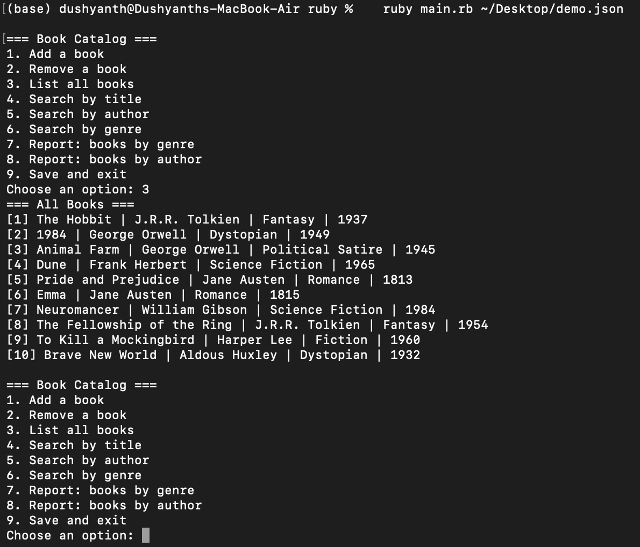
Note. The program was started with ruby main.rb, then option 3 was chosen.
Figure 2
Ruby: Searching by Title and by Author
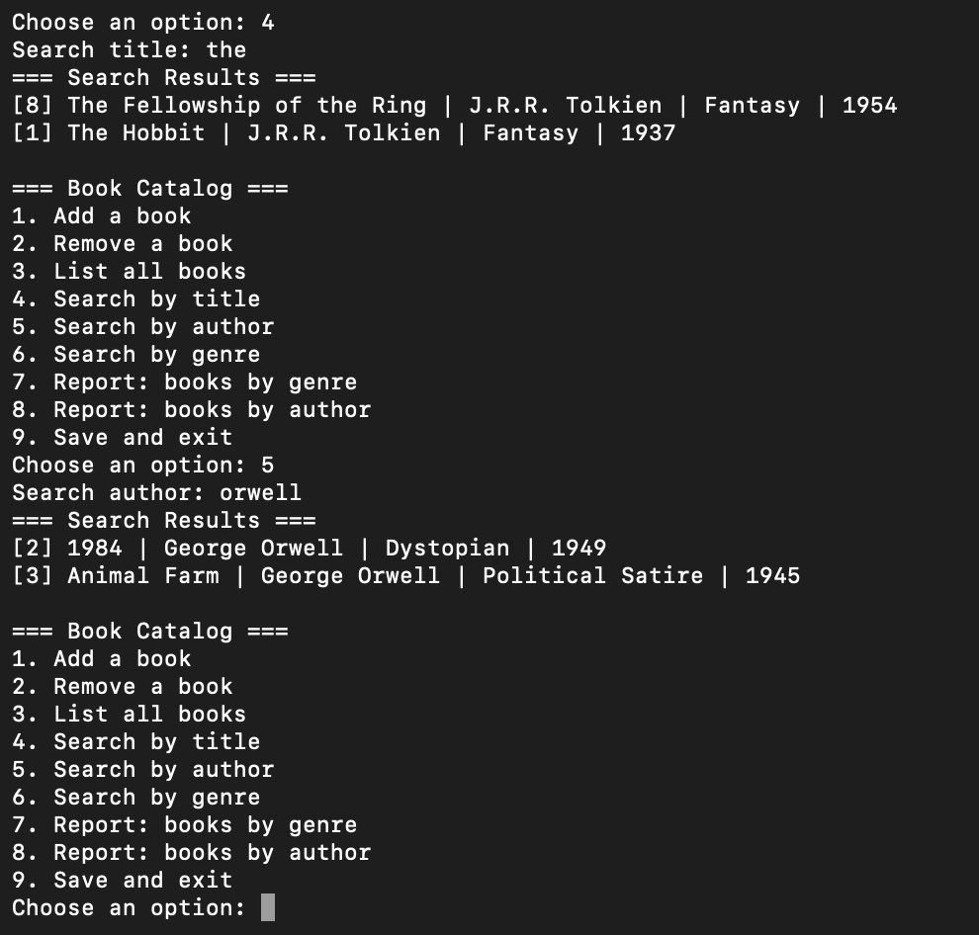
Note. Searches are case-insensitive partial matches, and results are sorted by title.
Figure 3
Ruby: Reports Grouped by Genre and by Author
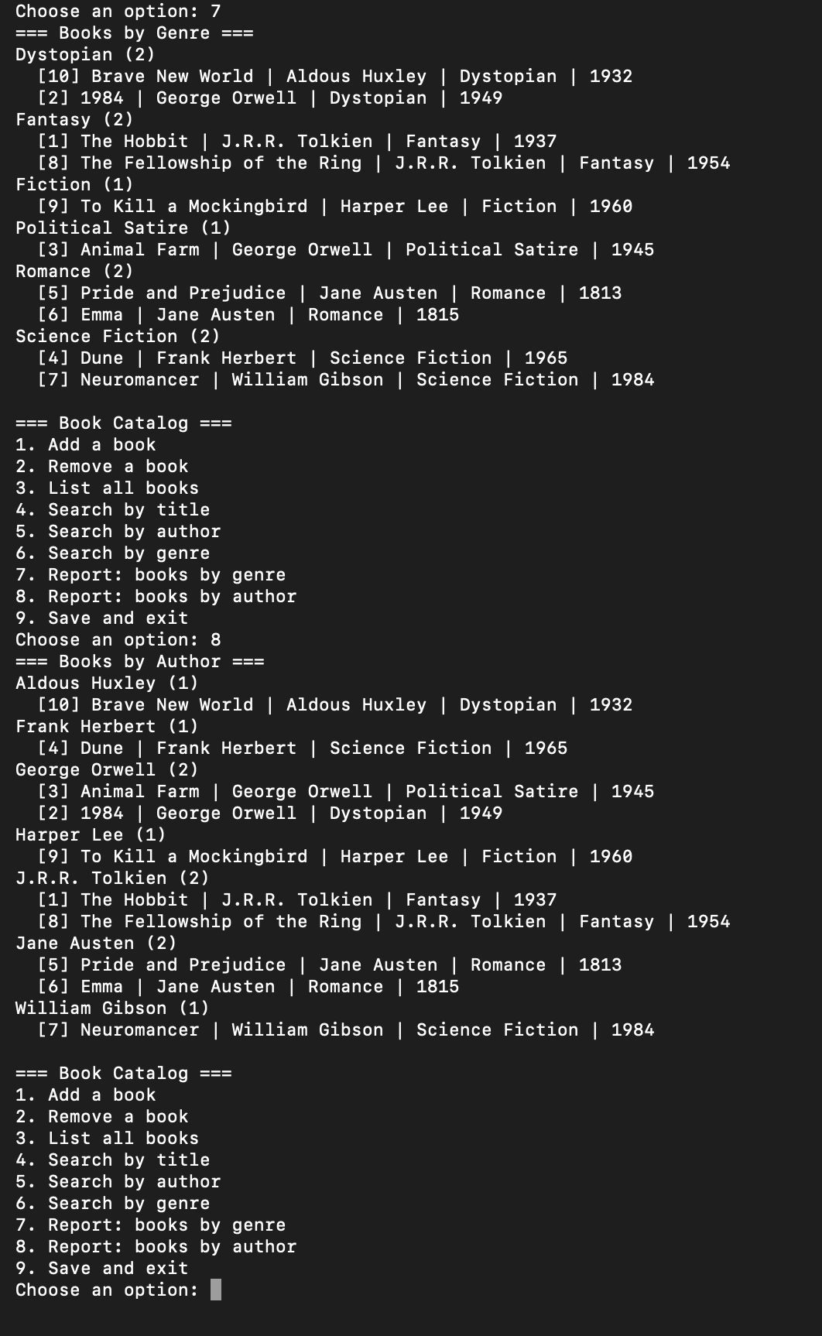
Note. Groups are sorted alphabetically, and books within each group are sorted by year.
Figure 4
Ruby: Adding a Book
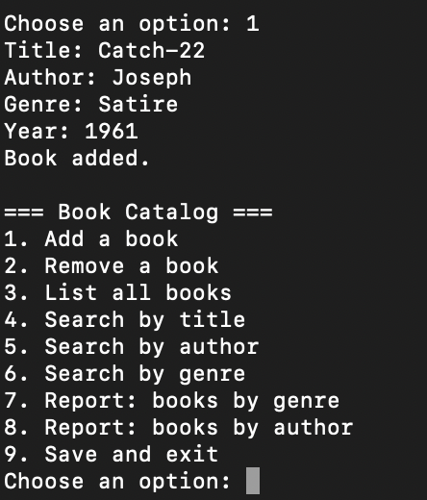
Note. The program prompts for title, author, genre, and year, then confirms with "Book added."
Figure 5
Ruby: Rejecting an Invalid Year and Removing a Book
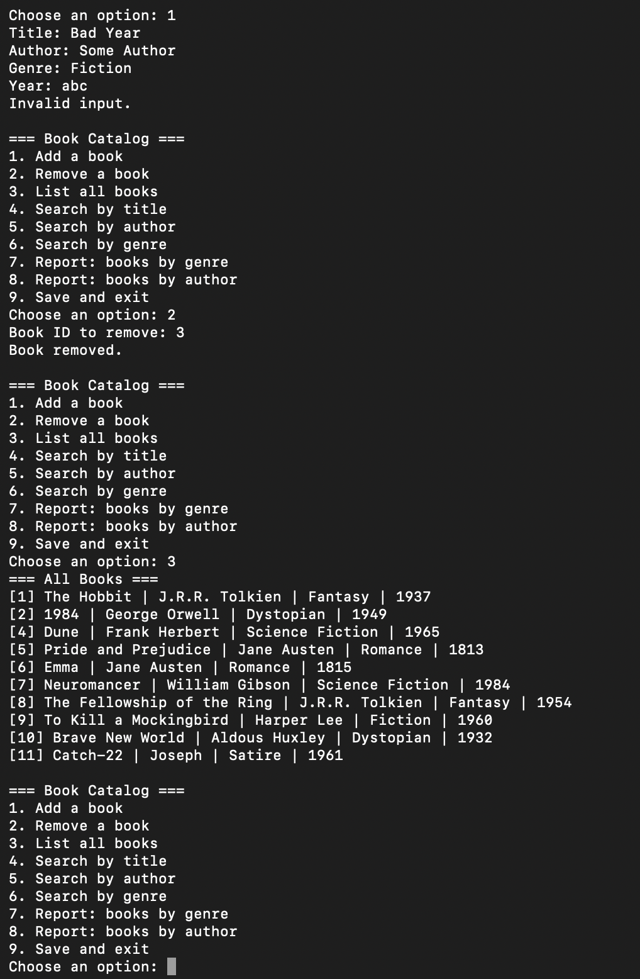
Note. The year "abc" is rejected. Book 3 is then removed by ID, and the final list shows it is gone and that the book added earlier has ID 11.
Figure 6
Ruby: Unit Tests
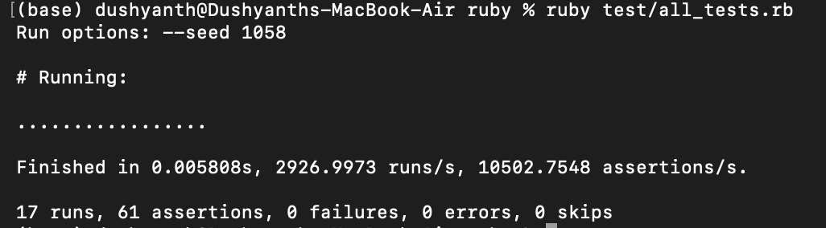
Note. Output of ruby test/all_tests.rb: 17 tests and 61 assertions, with no failures.
Figure 7
C#: Listing All Books
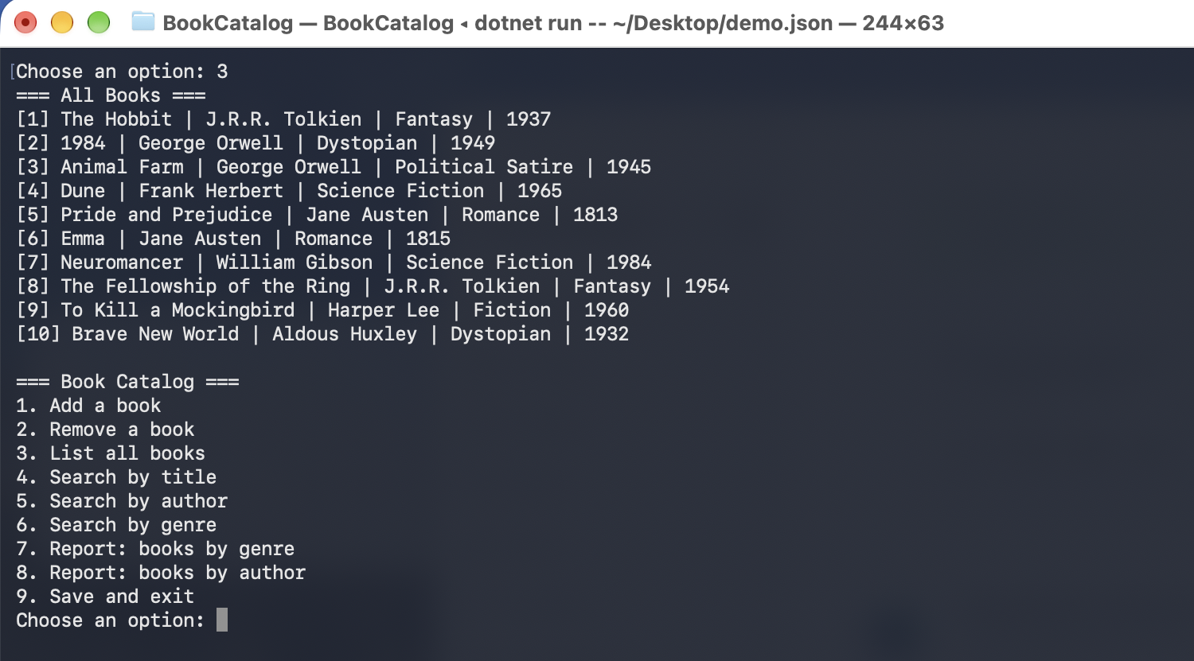
Note. The program was started with dotnet run, then option 3 was chosen.
Figure 8
C#: Searching by Title and by Author
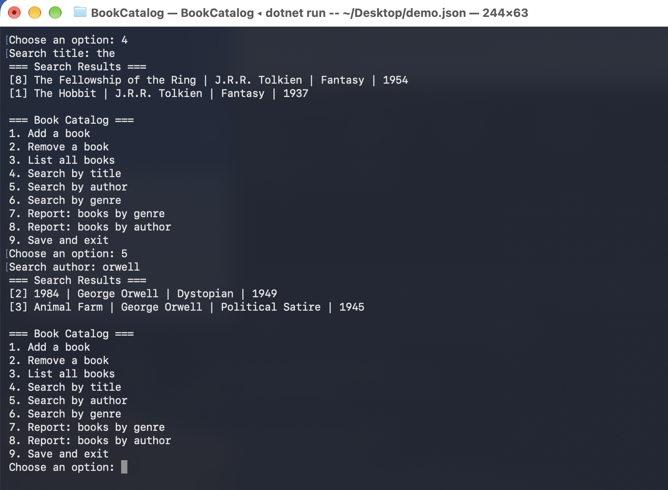
Note. The search results match the Ruby version in Figure 2 exactly.
Figure 9
C#: Reports Grouped by Genre and by Author
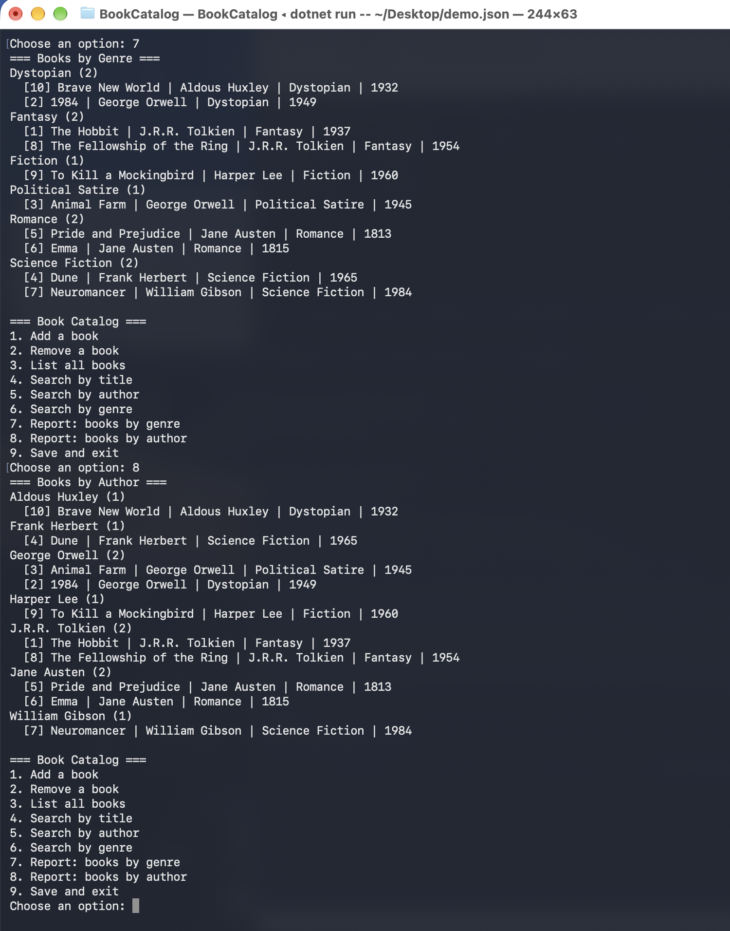
Note. Groups are sorted alphabetically, and books within each group are sorted by year.
Figure 10
C#: Adding a Book
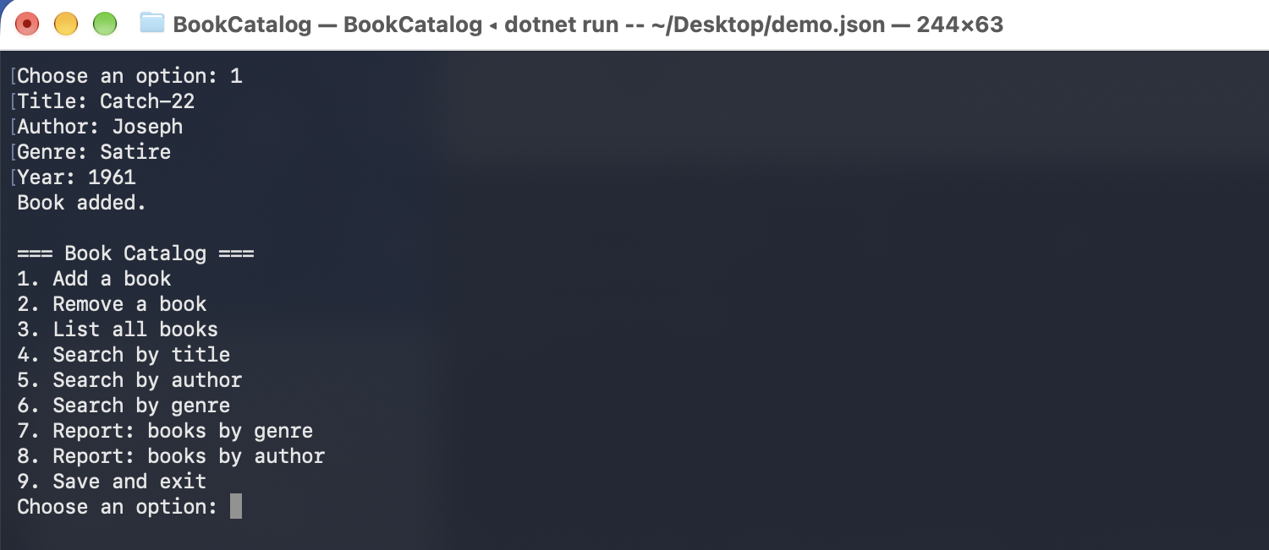
Note. The program prompts for title, author, genre, and year, then confirms with "Book added."
Figure 11
C#: Rejecting an Invalid Year and Removing a Book
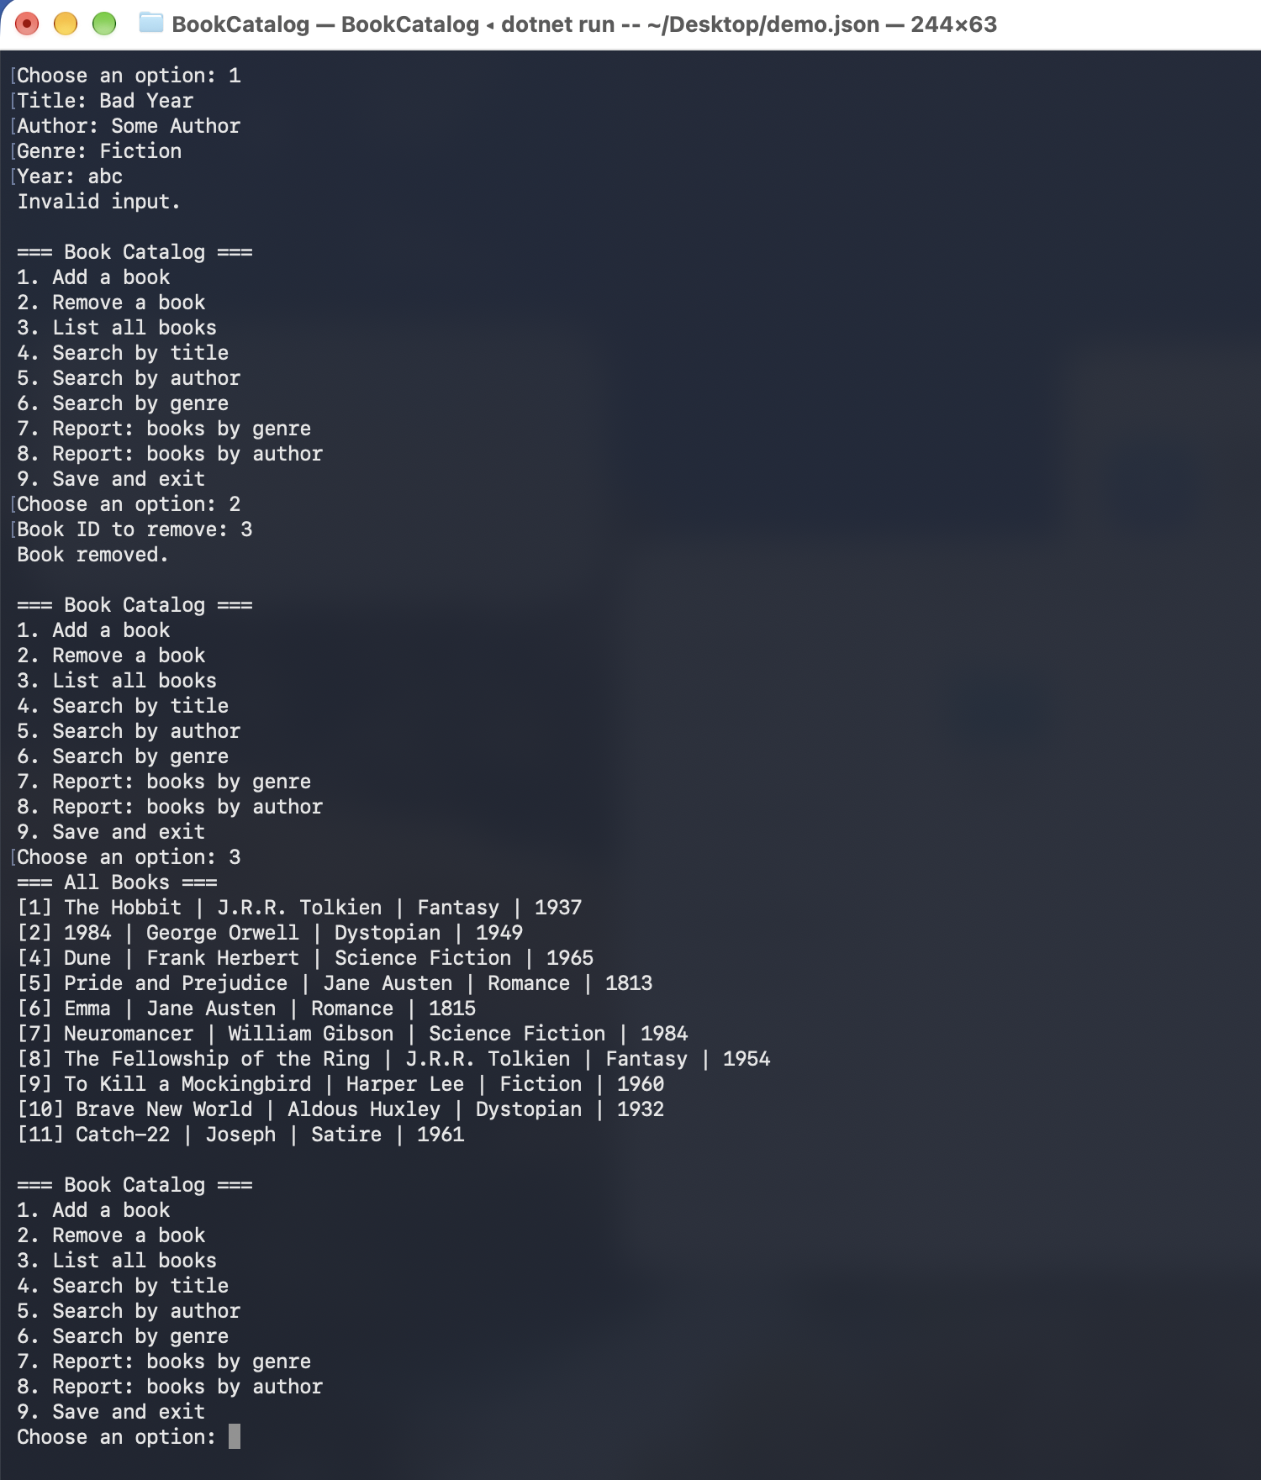
Note. The year "abc" is rejected. Book 3 is then removed by ID, and the final list shows it is gone.
Figure 12
C#: Unit Tests
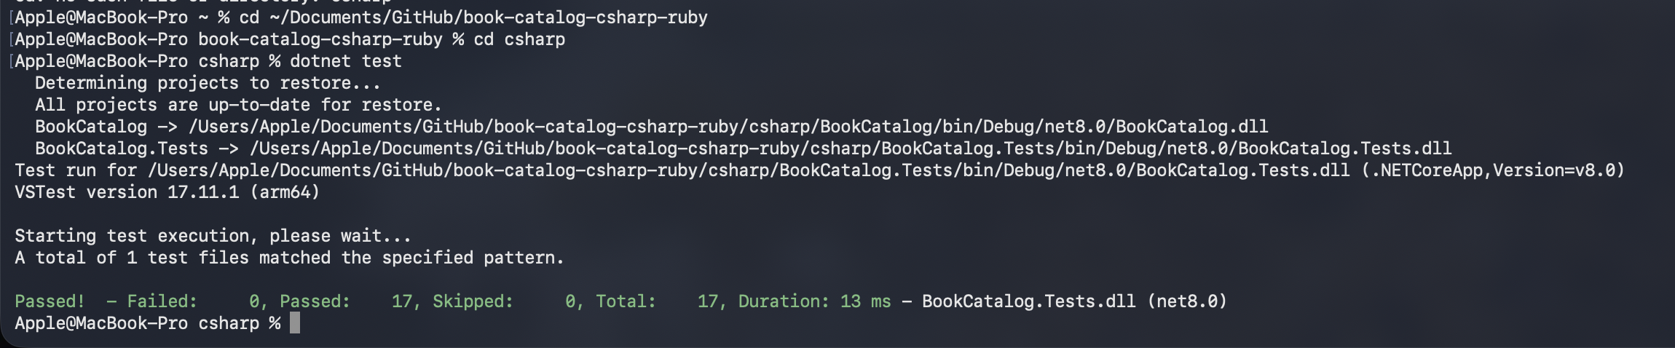
Note. Output of dotnet test: 17 tests passed and 0 failed.
Figure 13
Cross-Language Comparison Test
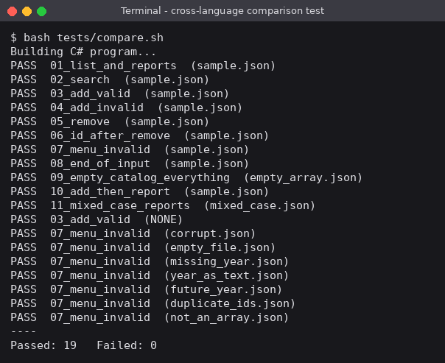
Note. Every scenario ran through both programs. "PASS" means the screen output and the saved JSON file matched.
Conclusion
Both implementations are complete, documented, and tested, and they behave identically on every scenario we tried. The work so far shows the main contrasts we expected: compile-time types and LINQ in C# against dynamic types and blocks in Ruby, with the Ruby search and report code shorter and the Ruby validation code longer. Testing both versions against the same inputs was valuable because it exposed a real difference in library behavior. On Day 3 we will finish the polish, write the comparison report, and prepare the presentation.

References
Microsoft. (n.d.-a). Language integrated query (LINQ). Microsoft Learn. https://learn.microsoft.com/en-us/dotnet/csharp/linq/
Microsoft. (n.d.-b). System.Text.Json overview. Microsoft Learn. https://learn.microsoft.com/en-us/dotnet/standard/serialization/system-text-json/overview
Ruby. (n.d.). Documentation. https://www.ruby-lang.org/en/documentation/

