Outputs :

**1)JSP FULL STACK:**

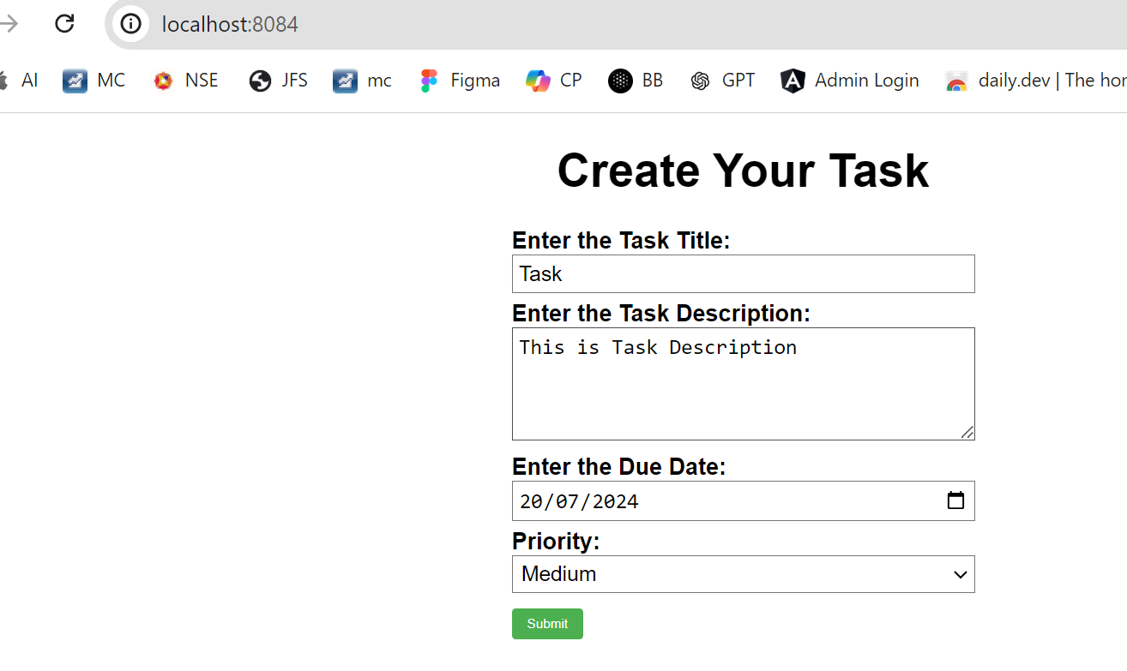*This index.jsp page is to enter tast details

*This is to check our task details after submitting

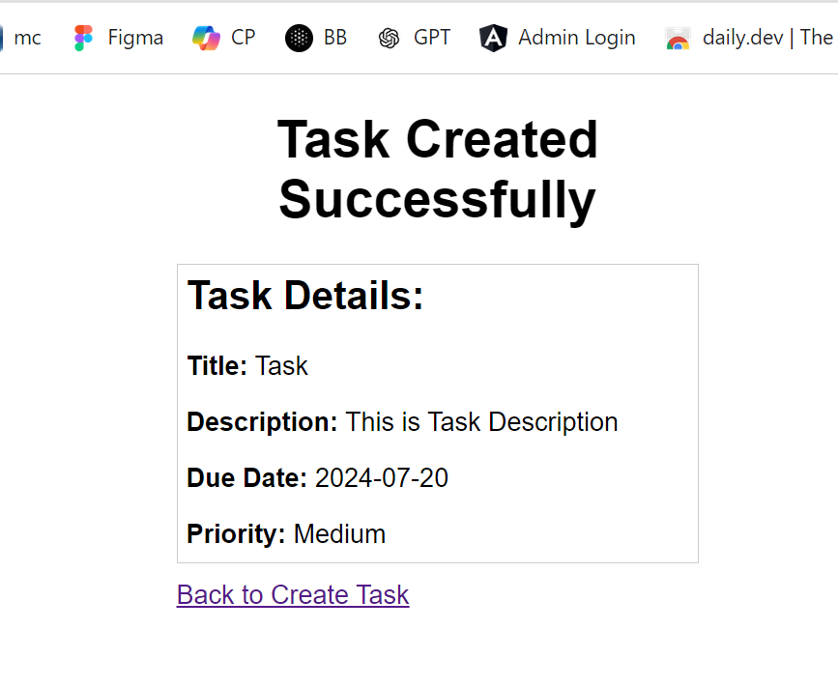

*If any details are not entered it will redirect to error.jsp

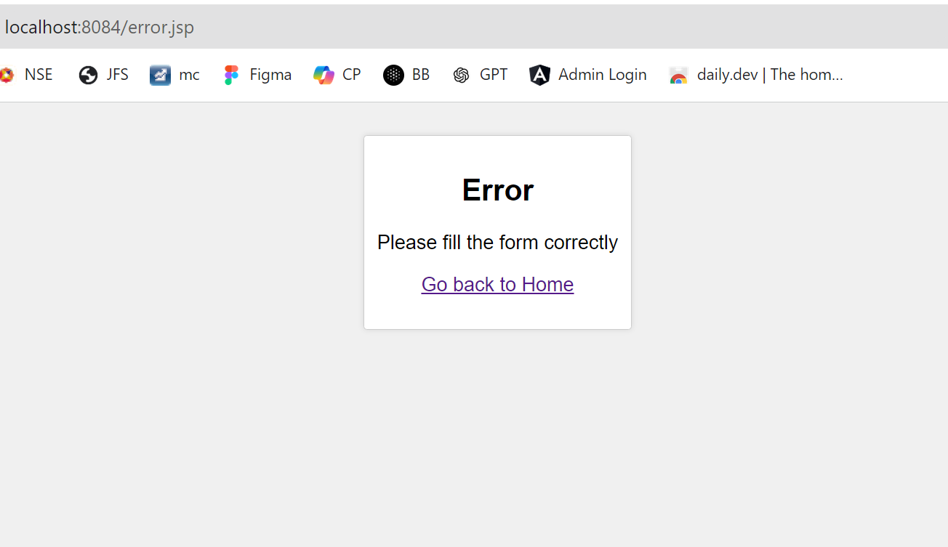

**2)SpringBoot Full Stack:**

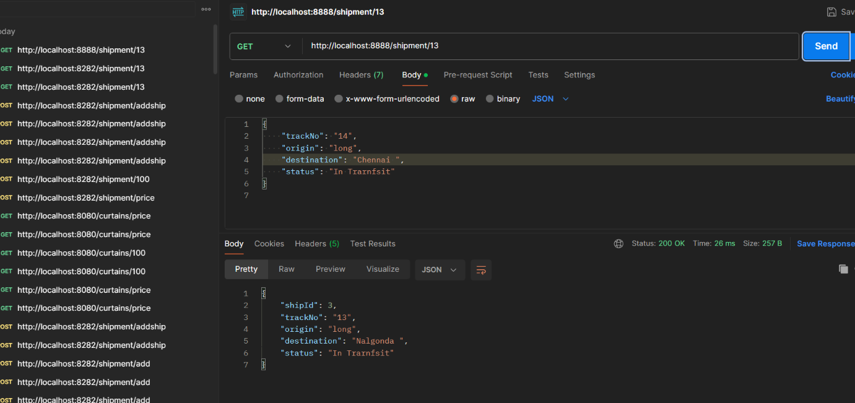*getting shipment details with trackno :

*Deleting shipment details with shipId

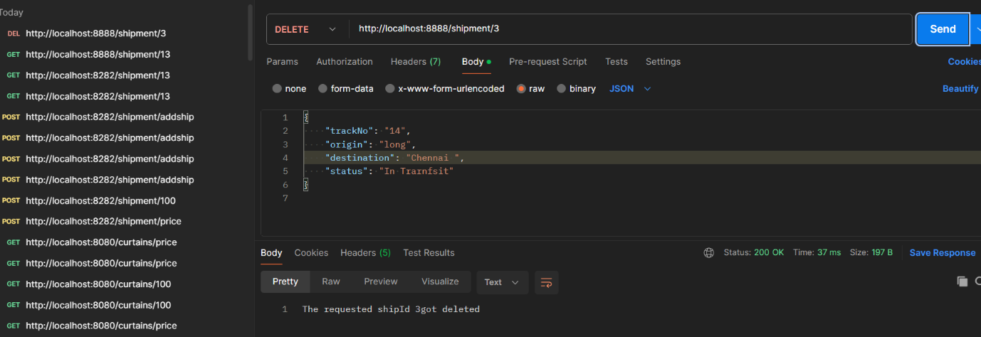

**3)Spring JPA: Description Implement the JPQL statement to fetch the list of curtains whose price is greater than the given price and the list of curtains whose brand is equal to the given brand name.**

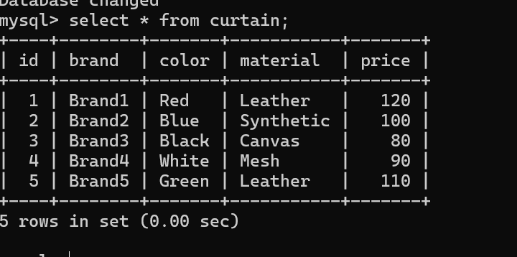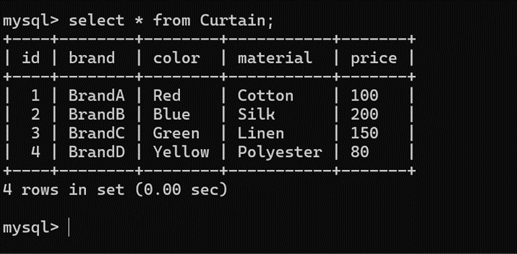

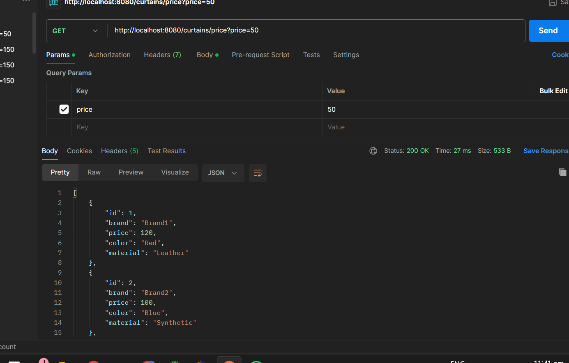

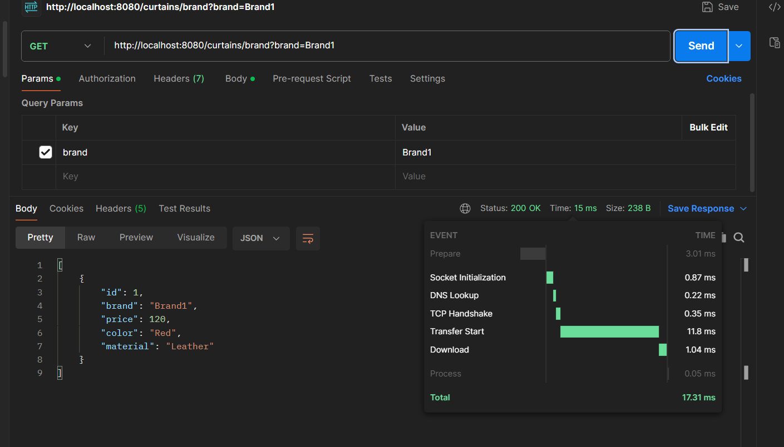

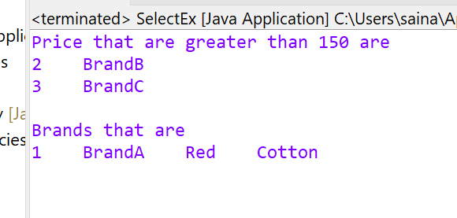

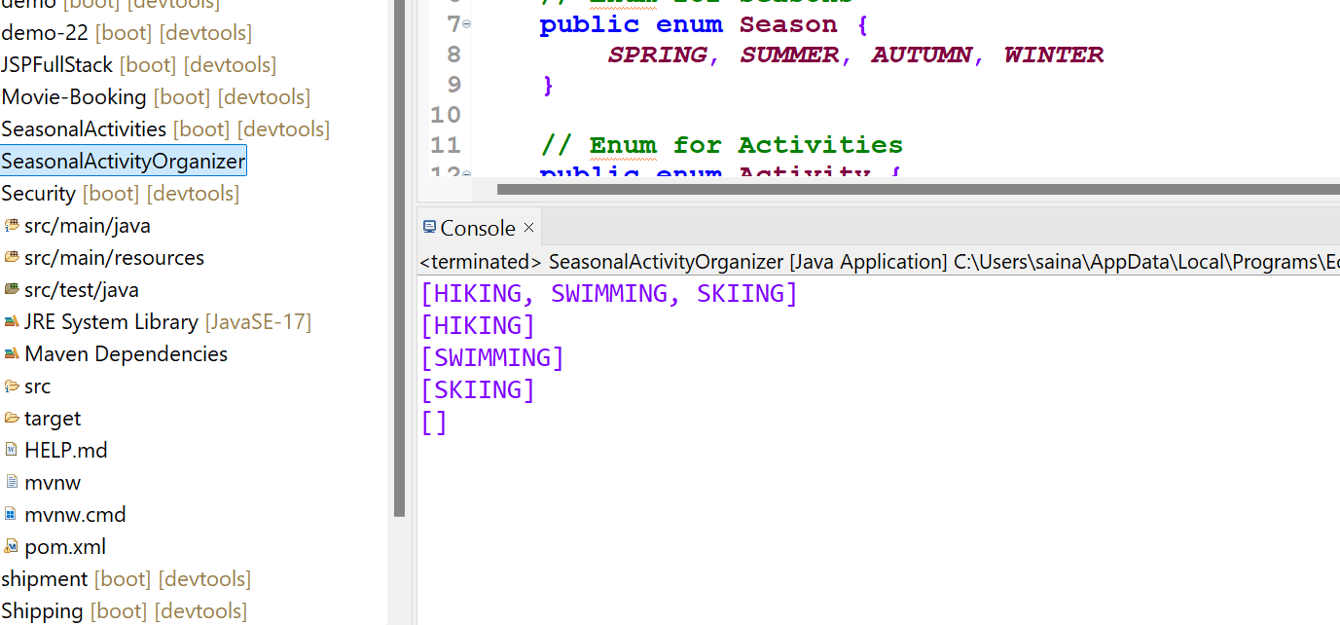**4)Seasonal Activity Organizer**