Implementation Document

1. ASP.NET Core MVC (Model-View-Controller)
We used ASP.NET Core MVC as the primary web framework. This allowed us to cleanly separate the responsibilities of data handling, business logic, and UI rendering, which improves scalability and code readability.
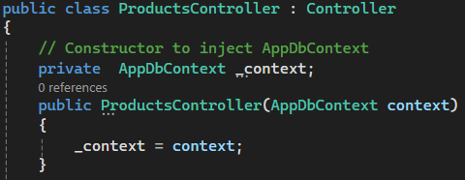
This shows the standard use of MVC pattern, a controller receiving input and handling data logic with injected services.

2. Entity Framework Core (EF Core) — Partially Used
We initially set up our database access using EF Core because of its LINQ capabilities and tight integration with ASP.NET. However, as the team included less experienced developers, we eventually supplemented (and sometimes replaced) EF Core with raw SQL for clarity and control.
Used:
- DbContext setup for table mapping and foreign keys.
- LINQ queries for retrieving complex, relational data.
Code Example:
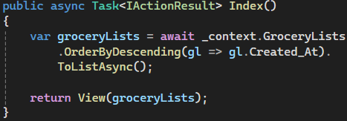
This uses EF Core LINQ to retrieve grocery lists in descending order, easy to read, but harder for beginners to debug when it breaks.

Dropped in some places:
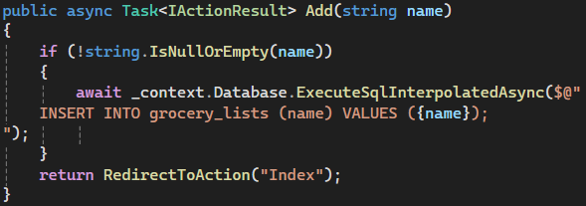
We chose raw SQL here because some developers found EF’s object-relational mapping and save pattern harder to reason about. It also gave us fine-grained control over the exact SQL executed.

3. Raw SQL via ExecuteSqlInterpolatedAsync and FromSqlInterpolated
To ensure accessibility and efficiency for all team members, we used raw SQL for insertion and updates in more complex cases.
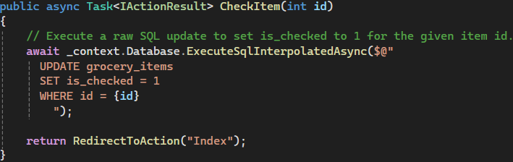
This approach made it easier to write precise updates without relying on EF’s change tracking or model state.

4. Microsoft SQL Server
Our backend uses Microsoft SQL Server, which integrates well with EF Core and raw SQL. This database was chosen for its robustness, relational capabilities, and compatibility with .NET tools like LINQPad and SQL Server Management Studio (SSMS) for debugging.

5. ViewModels for UI Binding
We used strongly-typed ViewModels to transfer data between controller and view, ensuring that Razor pages had exactly the properties they needed. no more, no less.
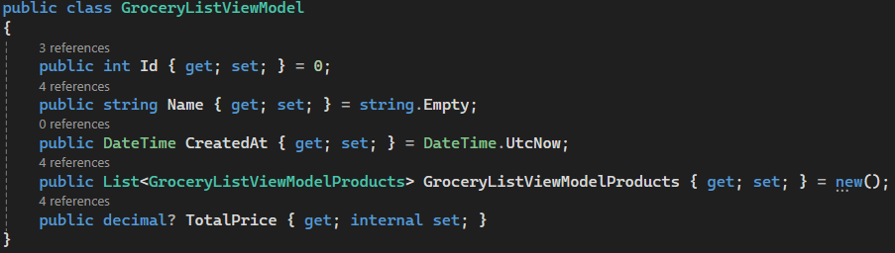
This abstraction allowed us to format prices, handle display logic, and avoid tight coupling with the database models.

6. LINQ with .Include() and .ThenInclude()
Wherever possible, we leveraged EF Core's powerful .Include() syntax to eager-load nested relationships (e.g., a list item → product → retailer data).
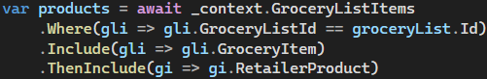
This helped reduce SQL round-trips and gave us the data in one go, which improves performance when used correctly.

7. TempData for Conditional Modal Display
To give feedback to users when no active grocery list was available, we stored a flag in TempData:
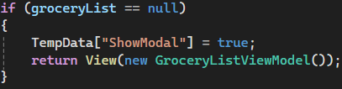
Then in the Razor view, we used this to decide whether to show a modal popup.

8. Dependency Injection (DI)
ASP.NET Core’s built-in DI was used to inject AppDbContext into controllers.
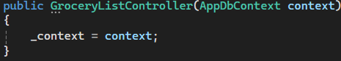
This made our code more testable and maintainable, and avoided hard-coding dependencies.

9. Code Structure and Layering
While not a formal 3-layer architecture, our code is loosely separated into:
- Controllers (handling HTTP logic and user interaction),
- ViewModels/DTOs (data formatting),
- AppDbContext/EF (data access logic).

Lessons Learned
- EF Core is very powerful but has a learning curve. Developers with less backend experience struggled with abstracted operations (e.g., .SaveChangesAsync() after modifying an object), leading us to switch to raw SQL in critical places.
- Raw SQL, while less “modern,” gave us clearer control and immediate results. For simple CRUD operations, it reduced debugging time.
- ViewModels and DTOs are essential for clean separation between database and front-end — we avoided leaking entity models directly into Razor views.

