*Teehm Sicks*

Project Portfolio

*A website that provides you with recipes tailored to what you already have in your kitchen, allowing you the ability to make fully customizable meal plans while being able to budget everything*

Due Date: 4/7/2021

**Introduction** 1

**The Teehm Sicks Team** 2

**System Requirements** 2

Requirements 2

User Stories 2

*User Story #1* 2

*User Story #2*2

**Project Management** 2

Continuity of Operations Plan (COOP) 2

Project Plan *3*

*System Architecture Design and Development <Proposal & Milestone 1>* 3

*System Implementation <Milestone 1 & Milestone 2> 0*

**System Design 0**

System Architecture <Milestone #1> 0

*Component Design 0*

*Data Flow 0*

[Project portfolio template directives and placeholders (delineated by “[ ]” or “< >” and/or highlighted or optional sections not included) should be removed from the document prior to submission. Empty sections for inclusion in later submissions may remain in the document for early submissions.]

[IMPORTANT: All diagrams developed using Enterprise Architectures must include the following acknowledgement: “Thanks to SPARX Systems for LSU student and faculty use of Enterprise Architect for academic purposes”.]

# Introduction

As a college student, finding simple recipes that are delicious and affordable can be very troublesome. Our website aims to relieve this burden by allowing you to search for recipes based on what you already have in your kitchen. By addressing the lack of access to recipes based on what you have, we will create a website that provides you with a list of recipes tailored to what you already have in your refrigerator, allowing you the ability to make fully customizable meal plans while being able to budget everything. Viable features will include the ability to search nearby stores for ingredients needed for particular dishes. If time permits also allow the ability to have a popular section and a rating System for all the recipes. If possible we would also like to set up a social media style platform with the ability to add friends to see what recipes they have liked or uploaded.



Python Django

Core Features:

* Finding recipes with certain ingredients
* Filter recipes based off of budget
* Allows for meal plans

Viable Features:

* Searching for nearby stores with access to ingredients for recipes
* Most popular section
* Rating System for recipes(Like/Favorite button)

Stretch Features

* Social networking that allows for sharing recipes
* Custom uploading of personal recipes

# 

# The Teehm Sicks Team

https://github.com/IkaikaL/CSC-338-Teehm-Sicks-Repository

Milestone 1:

Jacob Dickson (Team leader): Revise Portfolio, complete/create WBS for milestone 1 and 2, and assisted in making UML diagrams

Ikaika Lee: created python outline of basic classes and methods, assisted in making UML diagrams

Steven Pimpinella: assisted in making UML diagrams, approved python outline

Andrew Drummond: assisted in making UML diagrams, approved python outline

Anthony Vuong: directed the process of making UML diagrams, approved python outline

Khanh V: assisted in making UML diagrams, approved python outline

# System Requirements

## Requirements

Access to the internet and a web browser

## User Stories

### User Story #1

*As a user, I want to like or favorite recipes, so I can find them again easier.*

### User Story #2

*As someone with little time, I want to be able to search for recipes, so I can spend less time looking and more time preparing my meal*

# Project Management

## Continuity of Operations Plan (COOP)

The team will communicate primarily online through the official Teehm Sicks™ Discord and groupme along with meeting in class every Monday and Wednesday. Should anything happen that would restrict one or more members from attending class, the method of communications will instead only take place digitally to maintain safety and communication. If one person should drop the class making them unable to participate, the work will be distributed to the other members along with a possible reduction in features to accommodate for the loss of a member.

## Project Plan

### System Architecture Design and Development

|  |  |  |  |  |  |  |  |  |
| --- | --- | --- | --- | --- | --- | --- | --- | --- |
| **#** | **Activity** | **Pre #** | **Estimated**  **Effort** | **Actual**  **Effort** | **Estimated**  **Start Date** | **Estimated**  **Finish Date** | **Actual**  **Start Date** | **Actual**  **Finish Date** |
| 1 | Complete Component Diagram |  | 3 | 3 | 2/2/2021 | 2/9/2021 | 2/12/2021 | 2/12/2021 |
| 2 | Complete Data Flow Diagram |  | 2 | 1 | 2/2/2021 | 2/9/2021 | 2/12/2021 | 2/12/2021 |
| 3 | Complete WBS For Milestone Two |  | .5 | .5 | 2/2/2021 | 2/9/2021 | 2/15/2021 | 2/15/2021 |
| 4 | System Architecture |  | 1 | 1 | 2/2/2021 | 2/9/2021 | 2/13/2021 | 2/15/2021 |
| 5 | Create Basic Classes and Methods | 4 | 3 | 4 | 2/14/2021 | 2/15/2021 | 2/14/2021 | 2/15/2021 |

### System Implementation

|  |  |  |  |  |  |  |  |  |
| --- | --- | --- | --- | --- | --- | --- | --- | --- |
| **#** | **Activity** | **Pre #** | **Estimated**  **Effort** | **Actual**  **Effort** | **Estimated**  **Start Date** | **Estimated**  **Finish Date** | **Actual**  **Start Date** | **Actual**  **Finish Date** |
| 1 | Make Component Designs |  | 10 |  | 2/17/2021 | 2/22/2021 |  |  |
| 2 | Make Class Diagrams for Architecture Components | 1 | 20 |  | 2/22/2021 | 2/26/2021 |  |  |
| 3 | Implement Core Functionality | 1,2 | 30 |  | 2/26/2021 | 3/8/2021 |  |  |
| 4 | Update WBS for Milestone 2 | 1,2,3 | 1 |  | 3/8/2021 | 3/10/2021 |  |  |
| 5 | HTML/Front End Implementation (Khanh V) |  | 10 |  | 3/1/2021 | 3/26/2021 |  |  |
| 6 | Recipe Submission (Ikaika Lee) | 5 | 7 |  | 3/1/2021 | 3/20/2021 |  |  |
| 7 | Recipe Searching (Anthony Vuong) | 5, 8 | 10 |  | 3/1/2021 | 3/21/2021 |  |  |
| 8 | Text document/Database (Andrew Drummondand Steven Pimpinella) |  | 5 |  | 3/1/2021 | 3/20/2021 |  |  |
| 9 | Meal Plan (Jacob Dickson) | 5, 8 | 15 |  | 3/1/2021 | 3/21/2021 |  |  |

# System Design

The website will feature a main webpage that will have the option for either a new submission from the user or a button to begin the filtering process to determine what recipe they are looking for. The website will pull from a text document with a list of recipes along with their ingredients comparing to the three filter keywords provided by the user.

## System Architecture <Milestone #1>

Website will use a text document as a database of recipes to help users decide on possible recipes to make based on its name, price, ingredient

### Component Design

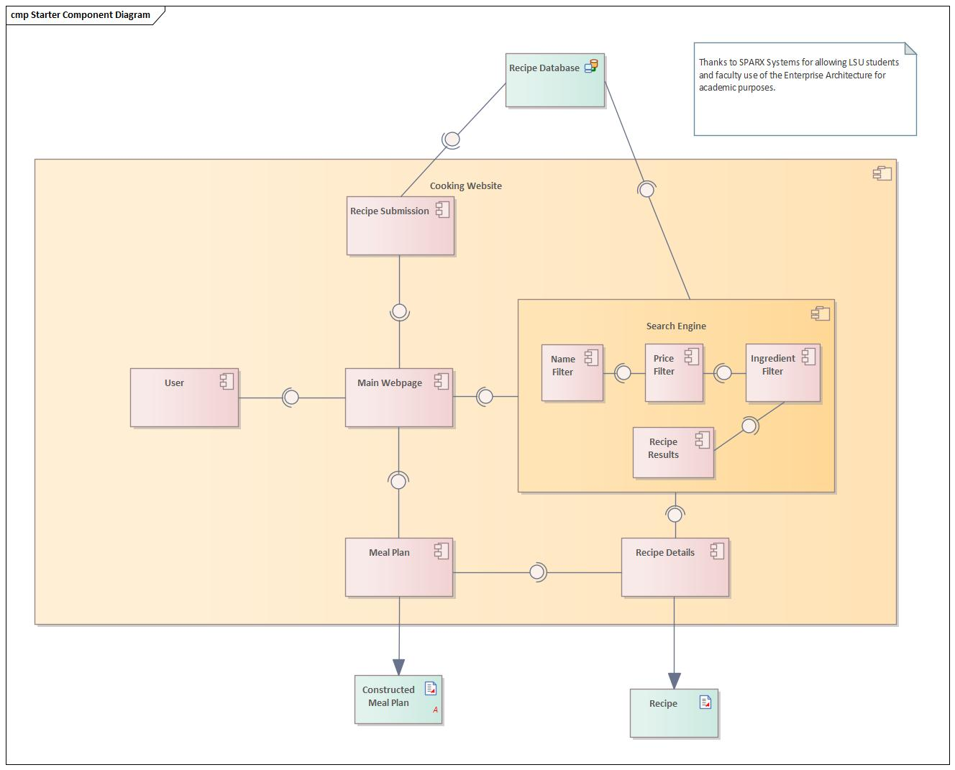

[*Architecture overview, to include user I/O, external data sources, and major system components.*]

### Data Flow

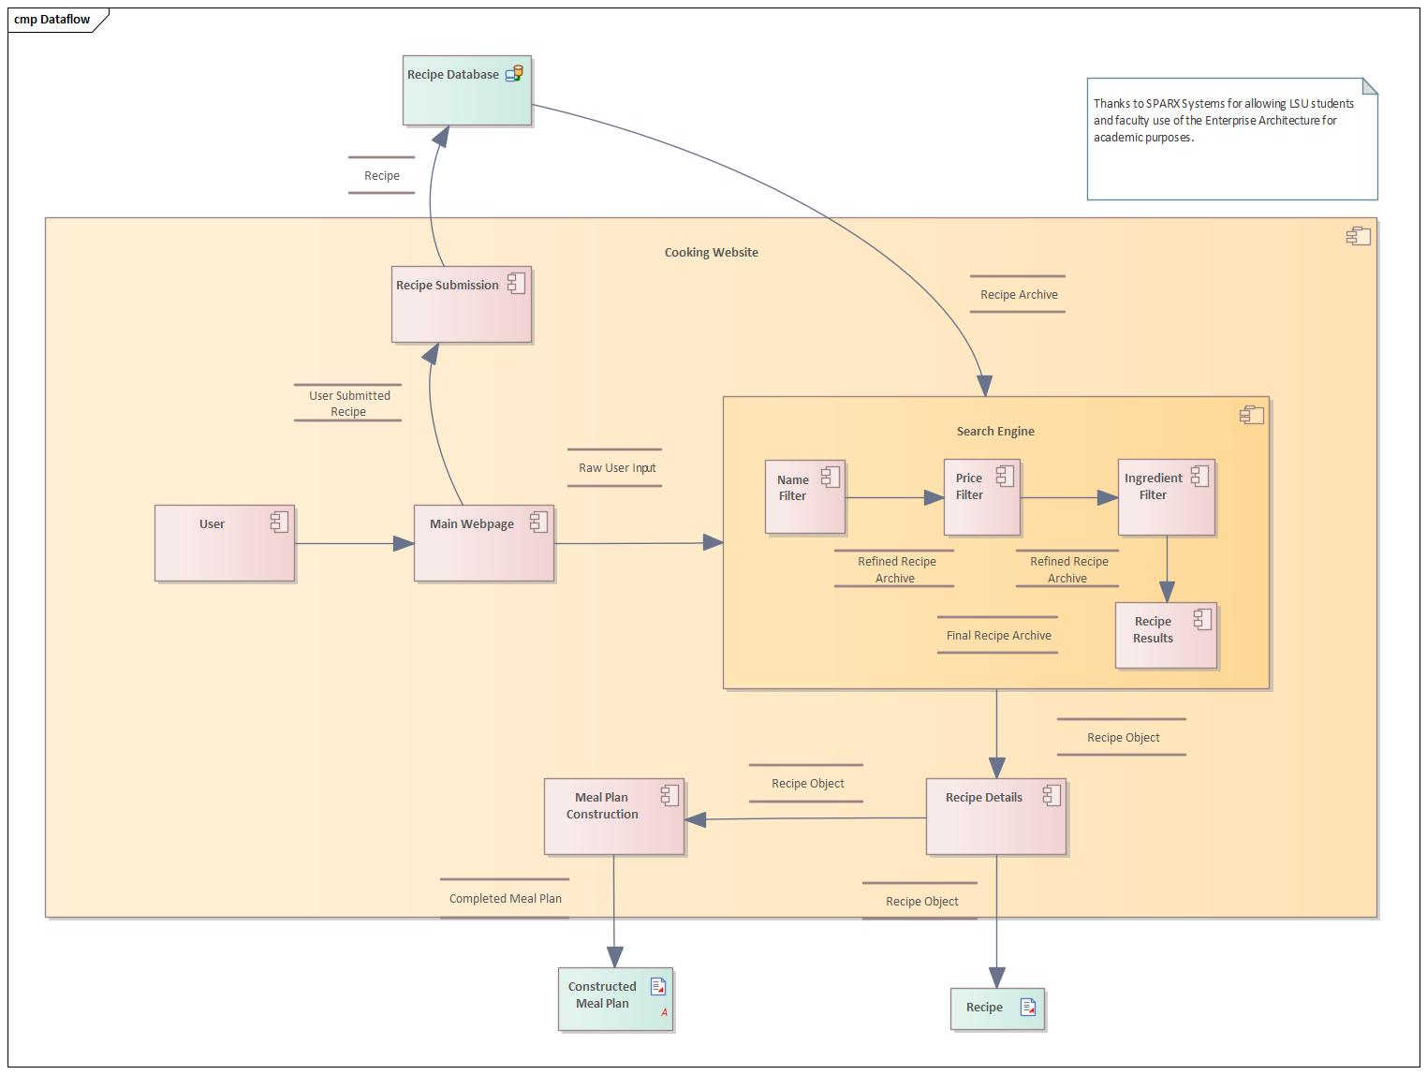

[*Architecture data flow discussion: a high-level description of the data between both internal major components and external data sources.*]