**XAMPP installation**

1. Type this url into the search bar: https://www.apachefriends.org/download.html

2. Download the latest version of XAMPP, however, if it does not work, try downloading the versions that are in the picture above.

3. After that, open the downloaded file and you will see this.

4. Click next

5. Check all of the options, then press next

6. Install XAMPP in drive D if applicable because it is better to install it to drive D instead of drive C because there are permission issues that occur sometimes when it is installed in drive C.

7. Keep on clicking next until you reach here.

8. Click finish, making sure that you do not uncheck the “Do you want to start the Control Panel now?” option.

9. Press the “Start” button beside MySQL

10. Press the “Start” button beside Apache

11. Go to the location where you installed xampp, then open the folder “Xampp” and then go to “htdocs”

12. Extract the zip here

**Database Import**

1. Type this url into the search bar: <http://localhost/phpmyadmin/>

2. Press New on the left Navigation Bar

3. Name the new database “erlss”

4. Press Create

5. Press Import on the menu above

6. Choose File “erlss.sql” from the zip

7. Press Go

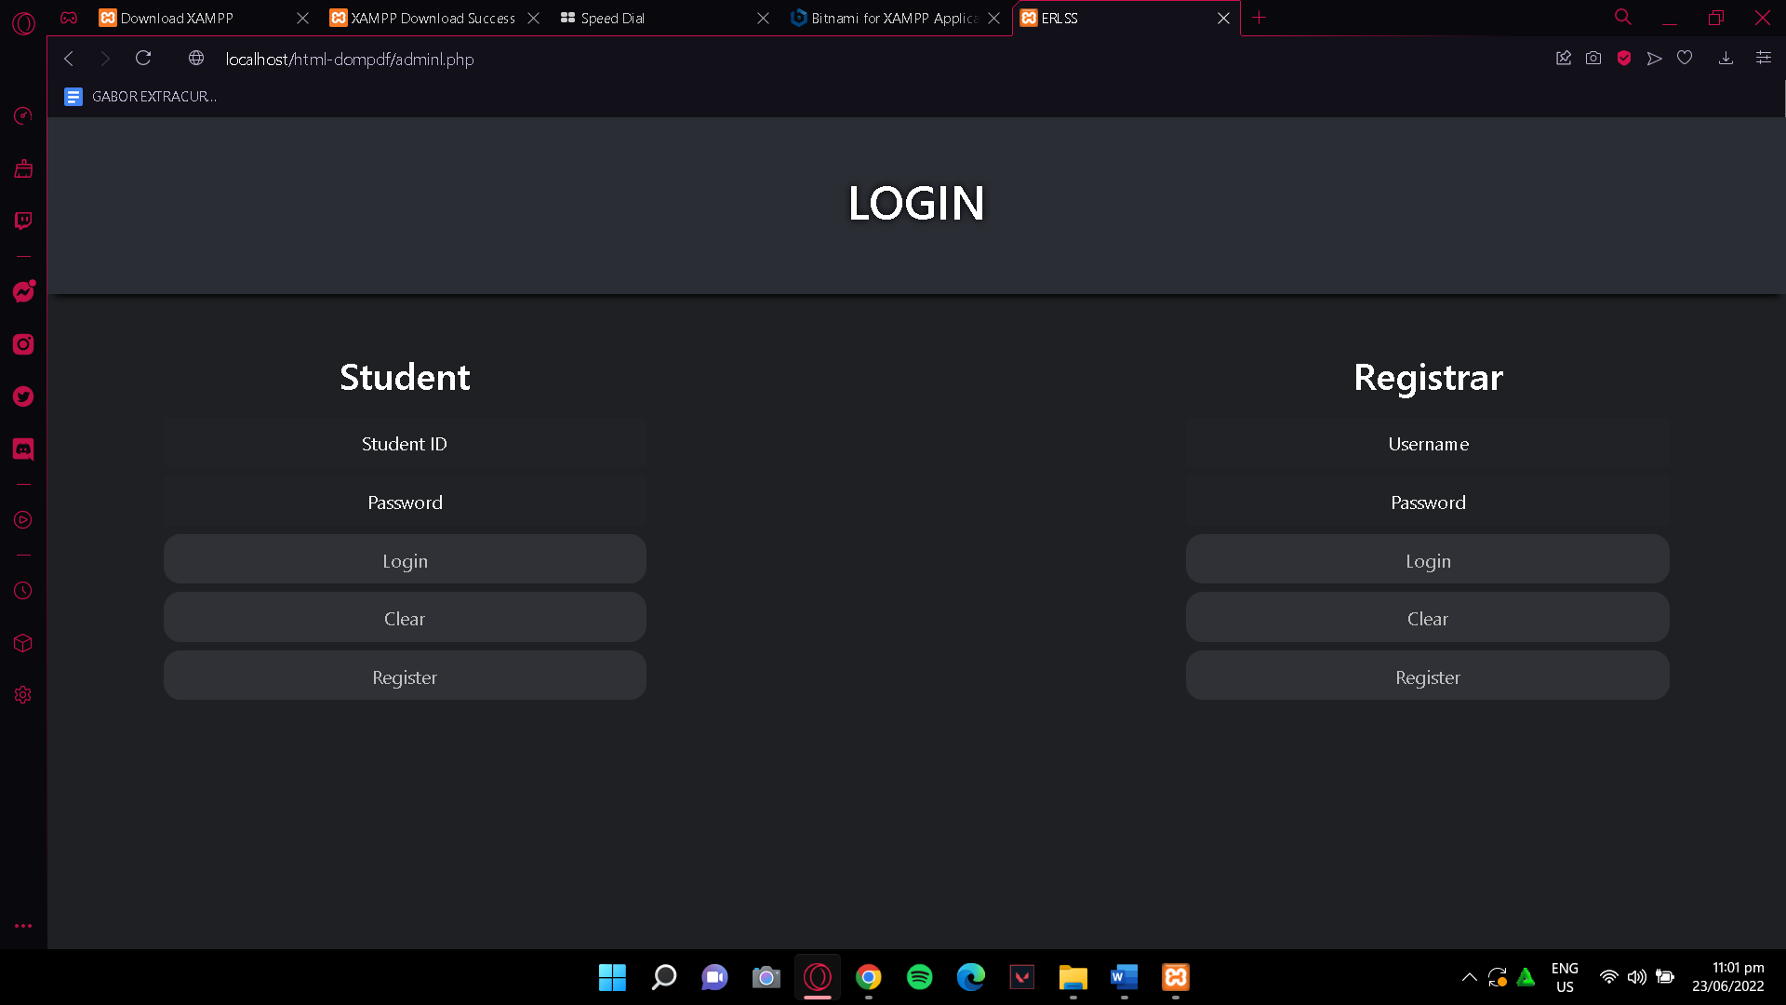

8. If successful, you can now open the site by typing in the url:

http://localhost/html-dompdf/adminl.php