# **Functional Design with User stories**

**Functional Design with User stories** 1

User story 1: View products 2

User story 2: Product details 2

User story 3: Search products 3

User story 4: Add product to shopping cart 3

User story 5: View shopping cart 3

User story 6: Modify shopping cart 3

User story 7: Make an order 4

User story 8: Register an account 4

User story 9: Login 4

User story 10: Change user settings 4

User story 11: View previous orders 5

User story 12: Manage all orders 5

User story 13: Manage all customers 5

User story 14: Manage all products 5

User story 15: Manage all categories 6

# **Database**

## ERD

## 

## Custom checks

1. Products.stock can’t be negative.
2. Orders.expected_delivery_date can’t be after Orders.ordered_at

# **User stories**

## User story 1: View products

As a user I want to be able to view all offered products so I know what I want to order.

* A list of all products is displayed
* Each product has a name, image, price and stock displayed
* Pagination is supported
  + The page number can easily be changed
  + The amount of products on a page can be modified

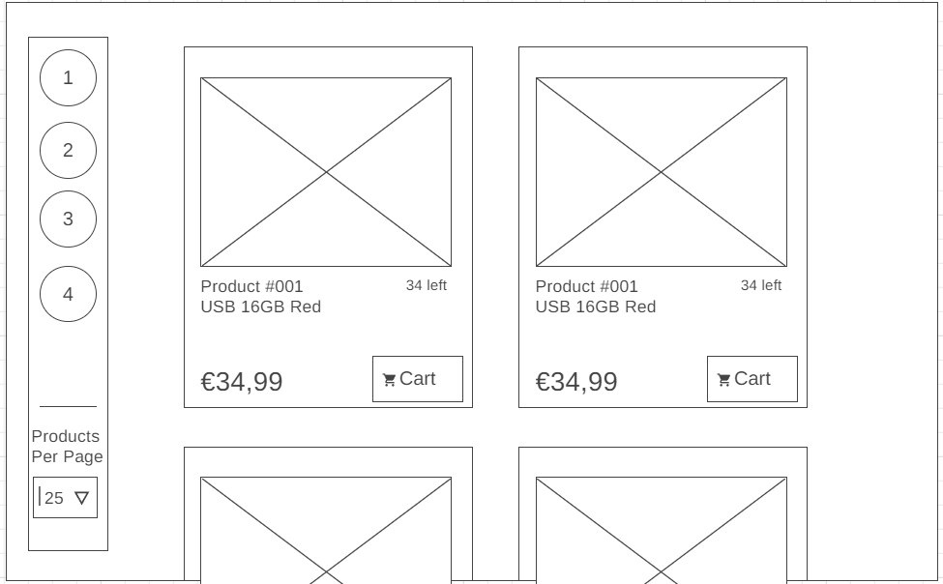

## User story 2: Product details

As a user I want to be able to view details of a product so I can make a more thought out decision.

* Details of the product are displayed
  + Name, product number, image, price, stock, description and specs
* The product can be added to the shopping cart.

## User story 3: Search products

As a user I want to be able to search for a product, so that I can look for a product more specific

* You can search by name
  + The product can start, end, or contain the text.
* When no text is inputted, the filter is not active.

## User story 4: Add product to shopping cart

As a user I want to be able to add a product to my shopping cart, so that I can make an order.

* The shopping cart contains a product and a quantity.
* Each product has a button to add the product.
* When a product is added, but it already exists, the quantity will be updated
  + The stock of the product is taken into account here.

## User story 5: View shopping cart

As a user I want to be able to view all the items on my shopping cart, so that I can ensure everything is correct.

* Every product on the cart is displayed
  + It displays the image, name, quantity and price.
* The absolute total price is also displayed

## User story 6: Modify shopping cart

As a user I want to be able to modify the items and their quantity on my shopping cart, so that I can ensure everything is correct.

* Per product, you can press a minus button to decrease the quantity
  + If the quantity is 0 or lower, remove the product from the cart.
* Per product, you can press a plus button to increase the quantity
  + The quantity can’t be higher then the current stock of the product.
* Per product you can press a delete button to remove the product from the cart.

## User story 7: Make an order

As a user I want to be able to turn my shopping cart into an order, so that I can purchase the products that I want.

* The information of the customer can be entered.
  + Name, Email, Password, Country, City, Address and ZipCode.
  + If the customer is not logged in, create an account with the information.
    - The email needs to be unique. This should be visually indicated.
    - An email is sent to the customer when the account is created.
  + If the customer is currently logged in, use the existing information.
* There needs to be a place where coupon codes can be entered.
  + When the order is finalized, this coupon will be deleted.
  + There should be a visual indication that the coupon is applied.
* A payment option can be selected.
* An email is sent to the customer containing the information about the order.

## User story 8: Register an account

As a user I want to be able to register an account, so that I can look at previous interactions with nerdygadgets.

* A form containing name, email and password
  + All fields need to be entered and valid. A visual indication appears when this is not the case.
  + An email is sent to the customer, containing a confirmation link.
    - When the link in the email is confirmed, the account will be usable.
* The user is send to the login page

## User story 9: Login

As a user I want to be able to log into my account so that I can use previous interactions with nerdygadgets

* A form containing email and password
* When the credentials are correct, the user is notified of the success.
* When the credentials are incorrect, notify the user.

## User story 10: Change user settings

As a user I want to be able to change my properties so that I can change the interactions with nerdygadgets.

* A place to change the used email.
  + A new email is sent to notify both the old and new email of this change.
  + The user is logged out.
* A place to update the password.
  + The previous password needs to be entered too, for security reasons.
  + The user is automatically logged out.
* All the personal information can be modified.
  + Name, country, city, address, zip code

## User story 11: View previous orders

As a logged in user, I want to be able to view my previous orders so that I can make sure I ordered things.

* All previous orders are displayed
  + For each order, you can see the date, products, total price and status.

## User story 12: Manage all orders

As a logged in administrator, I want to be able to manage the orders so that I can uphold the packages.

* A list of all orders is displayed
  + For each order you can see the date, products, total price and status.
* You can delete or edit an order
  + Split between modifying the order details, and the order items.

## User story 13: Manage all customers

As a logged in administrator, I want to be able to manage the customers so that I can control the accounts.

* A list of all customers is displayed
  + For each customer you can see the email, name and role.
* You can set the status of each customer, between Customer or Admin.

## User story 14: Manage all products

As a logged in administrator, I want to be able to manage the products so that I can control the webshop.

* A list of all products is displayed
* Each product can be edited or deleted
  + A modal form with the needed information pops up when editing.
* A new product can be added
  + A modal form with the needed information pops up
* A product can be added under a category.

## User story 15: Manage all categories

As a logged in administrator, I want to be able to manage the categories so that I can control the webshop.

* A list of all categories is displayed
* Each category can be edited or deleted
  + A modal form with the needed information pops up when editing.
  + When deleting a category, ask for extra confirmation and notify the admin that all nested products will be set under ‘no-category’.
* A new category can be added
  + A modal form with the needed information pops up