Warren County Community Health Assessment 2017 Update

Prepared by the Warren County Health District

September 1, 2017





#### A report prepared to supplement the 2016 Warren County Community Health Assessment

##### 

# Introduction

Social Determinants of Health are the conditions that affect quality of life, health, functioning, and risks in a community. social Determinants of Health impact where people live, work, and play, even if people are not aware of their influence.1

The annual update to the *Warren County Community Health Assessment 2016* utilizes data to describe how the environment in Warren County has changed over the last year and how areas of the county have changed in relation to one another. This report will describe the five categories of the social determinants of health as described in Healthy People 2020. These categories are Social and Community Context, Economic Stability, Health and Health Care, Education, and Neighborhood and Built Environment.

## Intracounty Comparisons

The social determinants of health are evaluated at the intracounty level to draw comparisons between the differing areas of Warren County. Census Tract-level data is used for mapping to see how areas compare to one another. In order to generate tables that can be understood, census tracts have been combined into a series of geographical areas that are similar to one another. The result is 7 different areas that are similar in culture and population size.

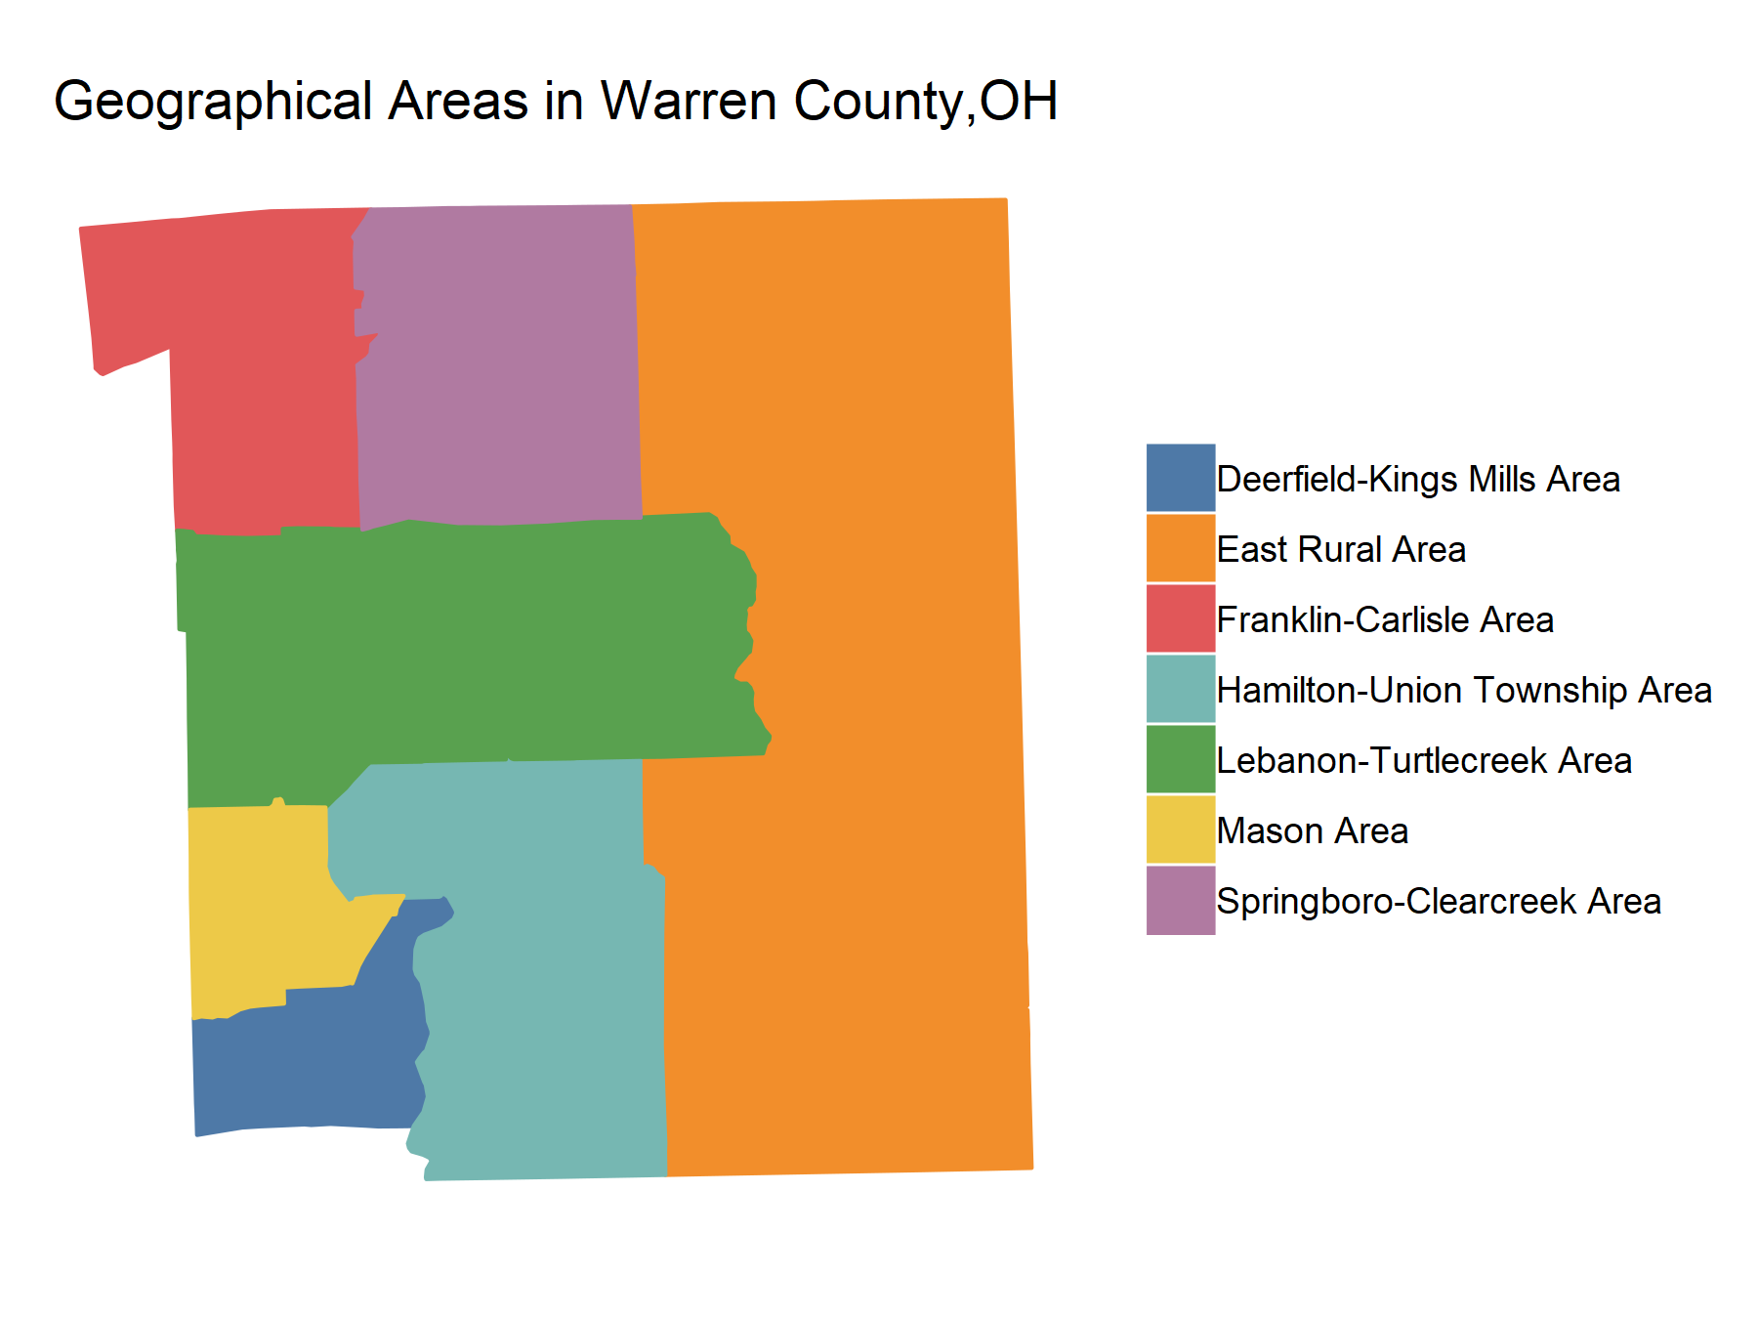

##### 

## Methods

This report is generated using a series of datasets from various public and non-public datasets. These data have been accessed in the most raw version of data that is available or the data was retrieved from a web API. This ensures that analyses that are conducted are being done on the original data and are not calculations based on the calculations of others.

All of the code for the generation of these reports is devleoped using the R Statistical Programming Language2 and the R Studio IDE3. The code used for the devleopment of this report is available on [GitHub](https://github.com/DustinRatliff/AnnualUpdate). A copy of this report will be maintained on the Warren County Health District [website](http://warrenchd.com/document-category/assessments).

### Data Analysis

The data that has been compiled is analyzed using multiple methodologies. Data is first assessed to identify what information can be found in the raw information. The data then goes through the following process4 :

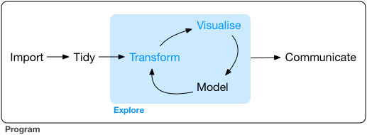

Data is summarily analyzed at the inter-county and intra-county level to identify differences. These type of analysis allow an exploration of the county for sub-county data and identify areas that are more likely to have health disparities.

### Data Sets

The following data sets have been used to develop this analysis:

* 2015 American Community Survey5
* 2015 Area Health Resources Files6
* 1960 - 2015 Uniform Crime Reporting Program Data7

##### 



# Social and Community Context

Social and community context includes the social settings in which people live and act. It includes social relationships and the social, religious, cultural, and occupational institutions with which they interact. An important aspect of an individual’s social context is the sense of cohesion and interpersonal trust among community members and an individual’s sense that they belong and are supported in their community. Social cohesion is strongly influenced by racial discrimination and inequality.1

## Population

Understanding the populations of the different areas of the county allows one to understand where populations are distributed throughout the county. These data provide context for the locations where the population resides in the county.

### Map

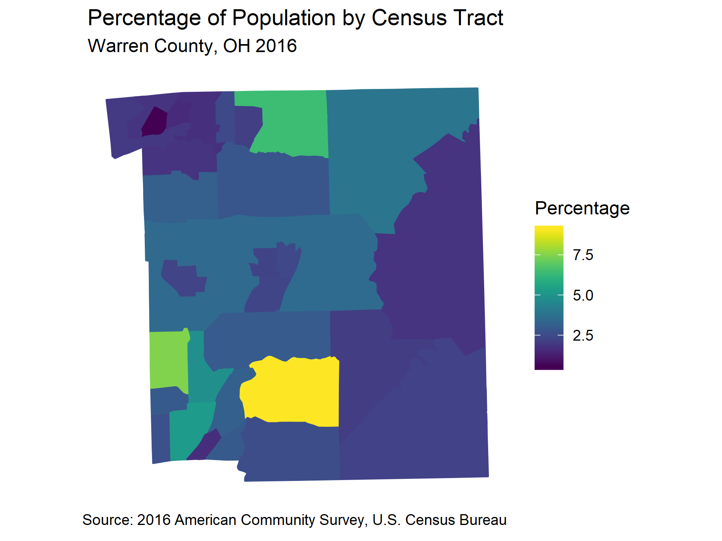

##### 

### Chart

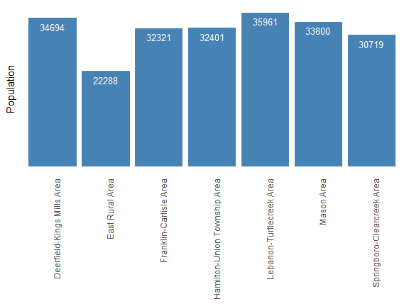

### Table

| **Table 1.1 Population in Warren County, OH in 2016 by County Area** | | |
| --- | --- | --- |
| **Area** | **Population** | **Percentage** |
| Deerfield-Kings Mills Area | 34694 | 15.6 |
| East Rural Area | 22288 | 10.0 |
| Franklin-Carlisle Area | 32321 | 14.5 |
| Hamilton-Union Township Area | 32401 | 14.6 |
| Lebanon-Turtlecreek Area | 35961 | 16.2 |
| Mason Area | 33800 | 15.2 |
| Springboro-Clearcreek Area | 30719 | 13.8 |

##### 

## Race and Ethnicity

Some racial and ethnic minority populations experience health disparities and problems at disproportionately higher rates than majority populations. Understanding the geographical and proportional distribution of minority populations allows services and programs to be targeted in a manner that is culturally and linguistically appropriate.

### Map

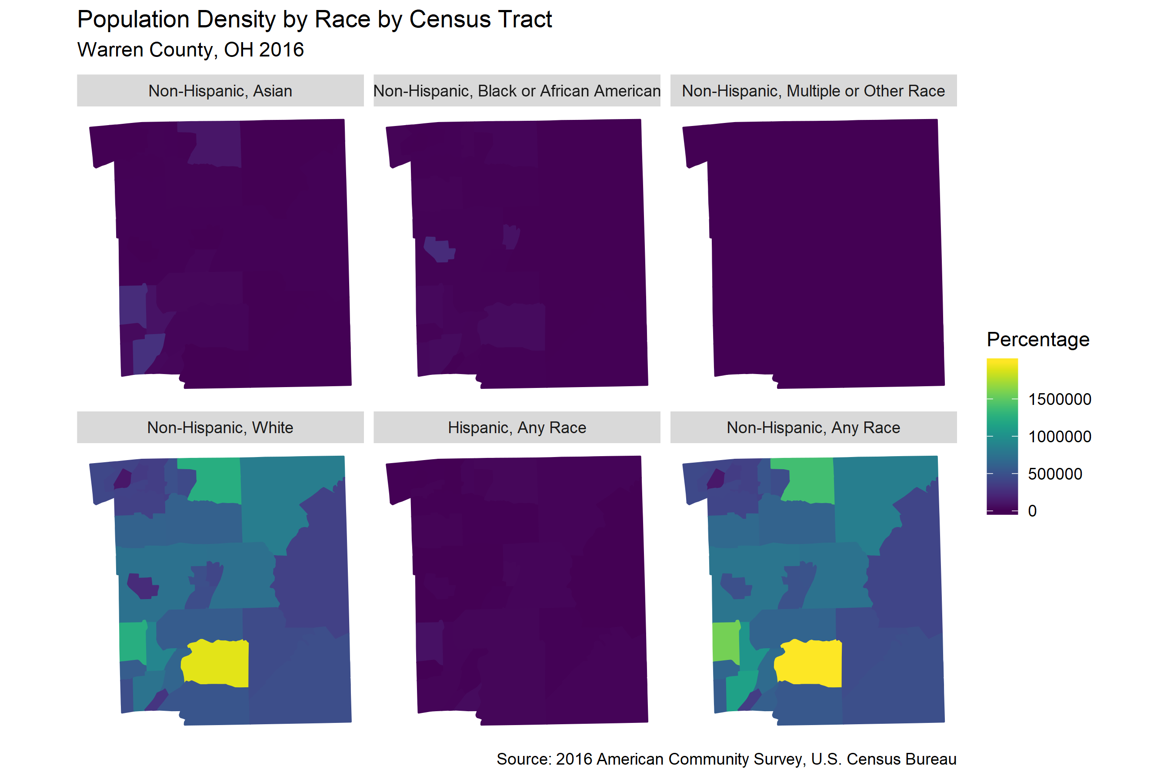

##### 

### Table

| **Table 1.2 Population by Race in Warren County, OH in 2016 by County Area** | | |
| --- | --- | --- |
| **Race** | **Count** | **Percentage** |
| Hispanic, Any Race | 5630 | 2.57 |
| Non-Hispanic, American Indian & Alaskan Native | 119 | 0.05 |
| Non-Hispanic, Asian | 10607 | 4.84 |
| Non-Hispanic, Black or African American | 7514 | 3.43 |
| Non-Hispanic, Multiple or Other Race | 734 | 0.34 |
| Non-Hispanic, Native Hawaiian or Pacific Islander | 43 | 0.02 |
| Non-Hispanic, White | 194312 | 88.74 |

##### 

## Gini Coefficient of Income Inequality

The Gini coefficient is a measure of statistical dispecrsion that can be used to represent the wealth distribution of a population. Most commonly this measurement is used to identify areas of inequality. A Gini coefficient of 1 is complete income inequality, where one person has all of the income and everyone else has none. A Gini coefficient of 0 is complete equaltiy where everyone has the same income.

### Map

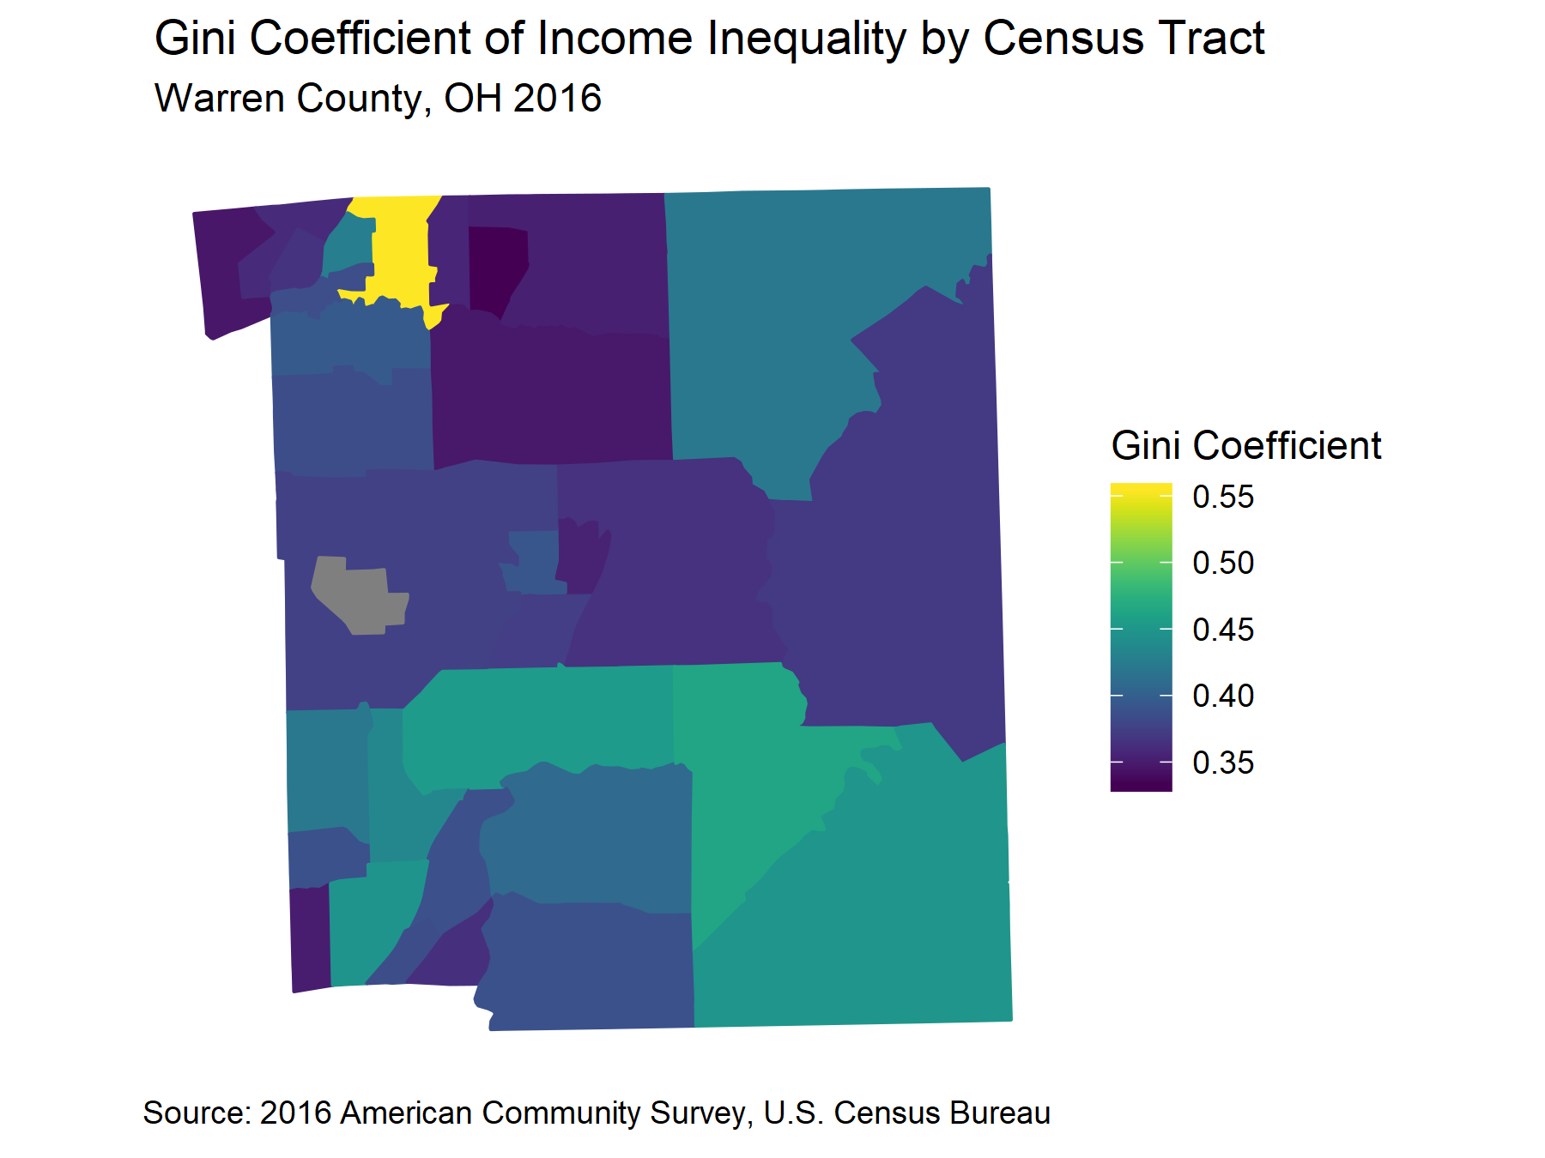

##### 

### Chart

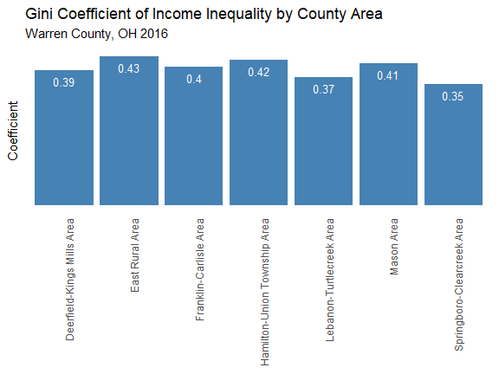

### Table

| **Table 1.3 Gini Coefficeint of Income Inequality by County Area Warren County, OH in 2015 by County Area** | |
| --- | --- |
| **Area** | **Coefficient** |
| Deerfield-Kings Mills Area | 0.380 |
| East Rural Area | 0.420 |
| Franklin-Carlisle Area | 0.370 |
| Hamilton-Union Township Area | 0.420 |
| Lebanon-Turtlecreek Area | 0.380 |
| Mason Area | 0.400 |
| Springboro-Clearcreek Area | 0.340 |

##### 



# Economic Stability

Economic stability is the state or condition of having adequate money, goods, and means of support. Economic stability includes measures such as poverty, employment status, food security and housing stability.1

## Median Income

Median income is the amount that divides the income distribution into equal amounts. Half of all incomes are below the median, and half are above the median. Median family income is the income of the householder and all other individuals older than 15 who are related to the householder. Median family income is usually higher than median household income because many households consist of only one person. Median family income is an indicator of the general socioeconomic status of a community.

### Map

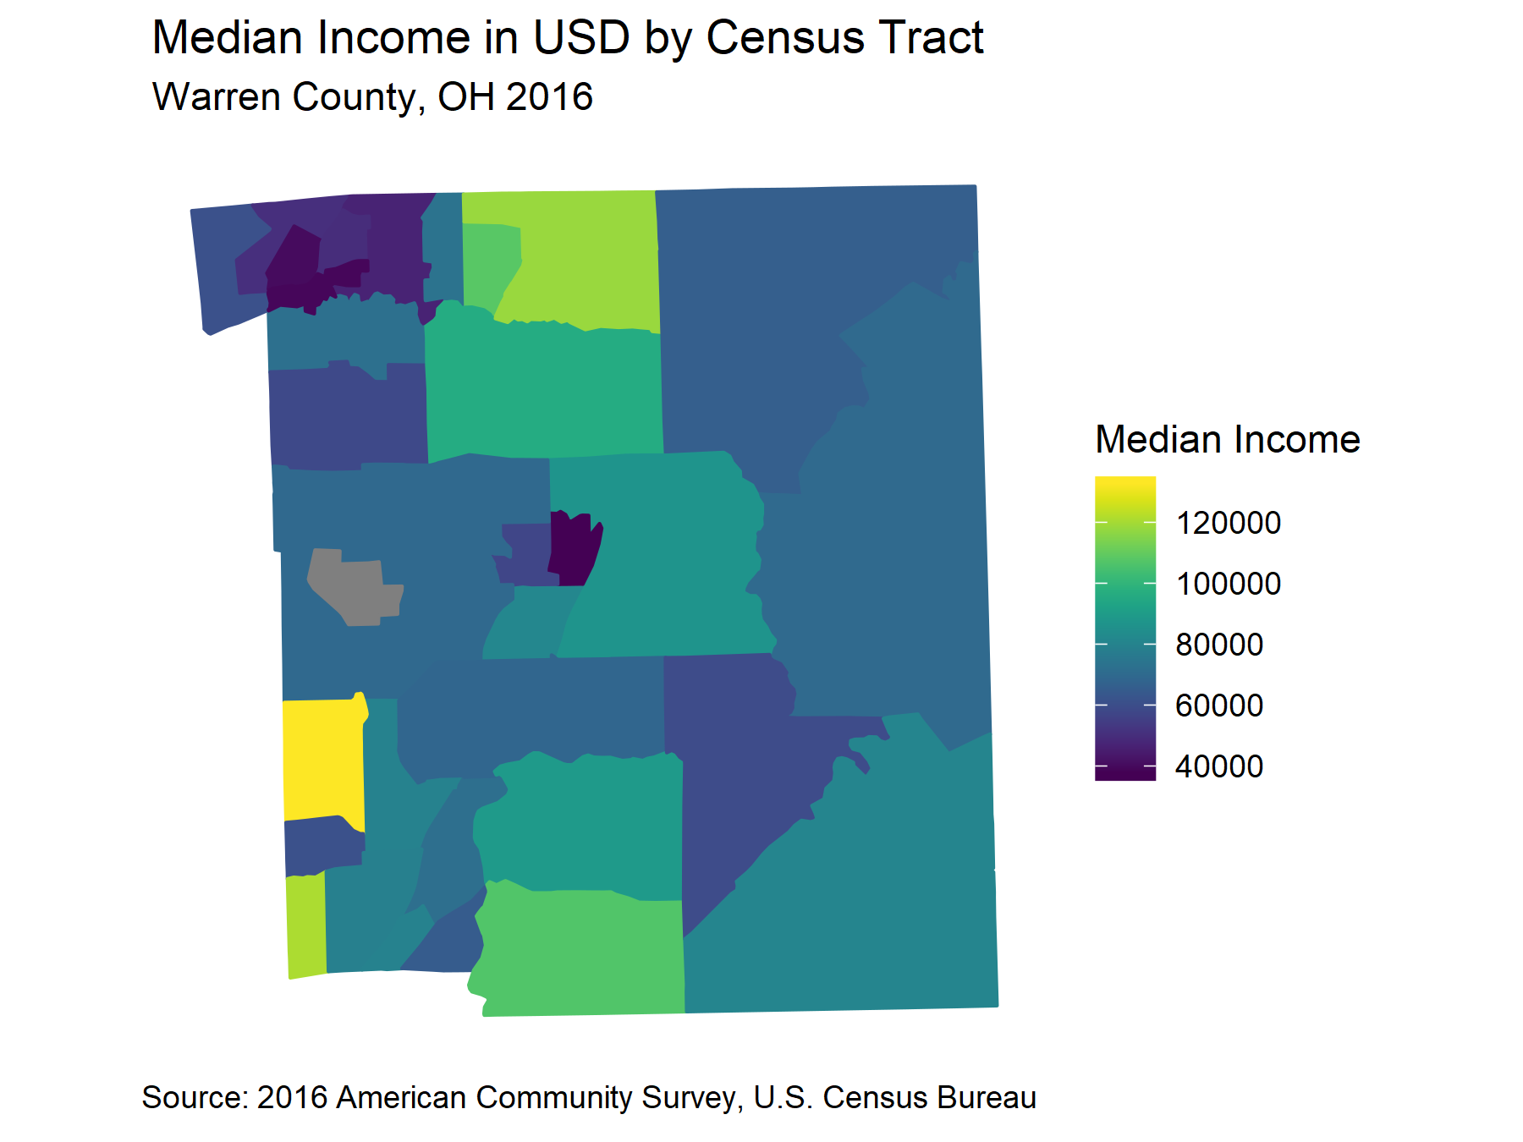

##### 

### Chart

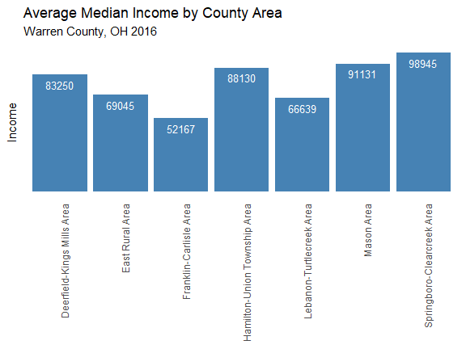

### Table

| **Table 2.1 Population in Warren County, OH in 2016 by County Area** | |
| --- | --- |
| **Area** | **Income** |
| Deerfield-Kings Mills Area | 83250 |
| East Rural Area | 69045 |
| Franklin-Carlisle Area | 52167 |
| Hamilton-Union Township Area | 88130 |
| Lebanon-Turtlecreek Area | 66639 |
| Mason Area | 91131 |
| Springboro-Clearcreek Area | 98945 |

##### 

## Poverty

Poverty has a close association with health. Individuals with low incomes are more likely to have limitations with routine activities due to chronic illness, are more likely to be obese, and have elevated blood lead levels. The income to poverty ratio is the proportion of people andfamilies whose incomes fall below a poverty threshold, adjusted for family size. If income is half of the threshold, the family is at 50% poverty. Poverty is one of the social determinants of healthand interacts with health in a number of ways. A community’s income to poverty ratio is one way to assess its overall level of health.

### Map

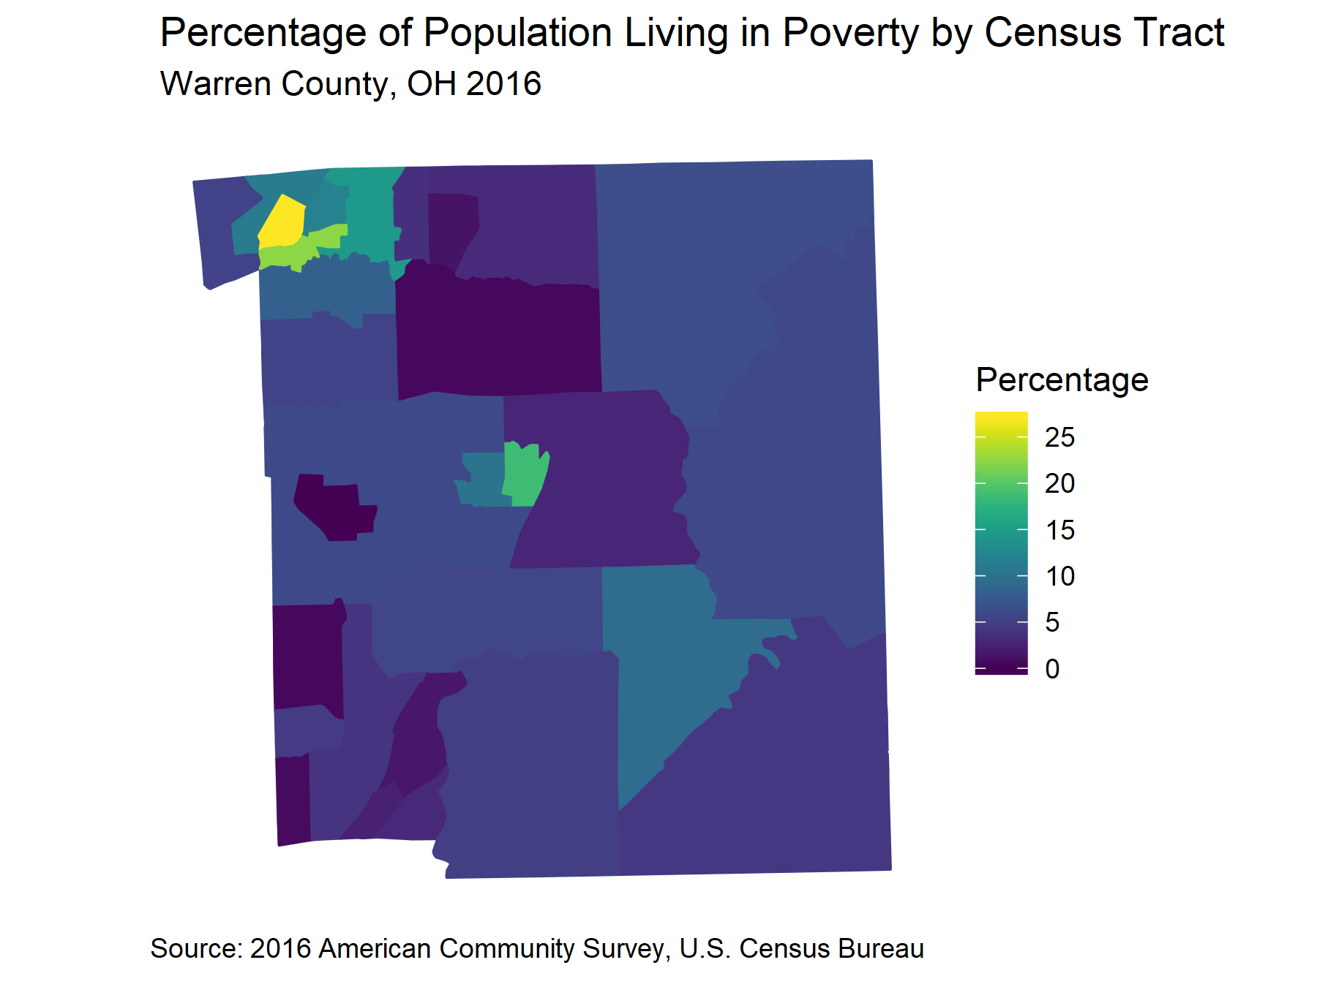

##### 

### Chart

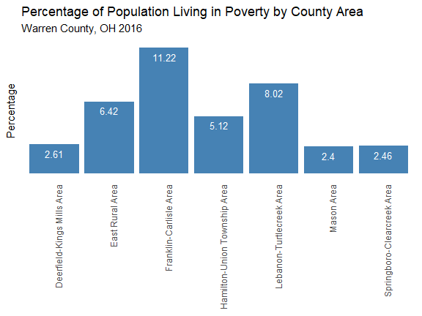

### Table

| **Table 2.2 Poverty by County Area in Warren County, OH in 2016 by County Area** | | | |
| --- | --- | --- | --- |
| **Area** | **Count** | **Population** | **Percentage** |
| Deerfield-Kings Mills Area | 903 | 34630 | 2.61 |
| East Rural Area | 1421 | 22140 | 6.42 |
| Franklin-Carlisle Area | 3605 | 32123 | 11.22 |
| Hamilton-Union Township Area | 1654 | 32299 | 5.12 |
| Lebanon-Turtlecreek Area | 2438 | 30412 | 8.02 |
| Mason Area | 809 | 33660 | 2.40 |
| Springboro-Clearcreek Area | 751 | 30468 | 2.46 |

##### 



# Health and Healthcare

Most people need medical care at some time in their lives. Access to affordable, quality health care is important to physical, social, and mental health. Health insurance helps individuals and families access needed primary care, specialists, and emergency care, but does not ensure access on its own-it is also necessary for providers to offer affordable care, be available to treat patients, and be in relatively close proximity to patients.1

## Insurance

Access to health care coverage is impacted by medical insurance coverage. Lack of insurance can lead to not getting needed preventive care, or not seeking care in a timely manner. Healthy People 2020 objective AHS-1 calls for 100% health care coverage.

### Map

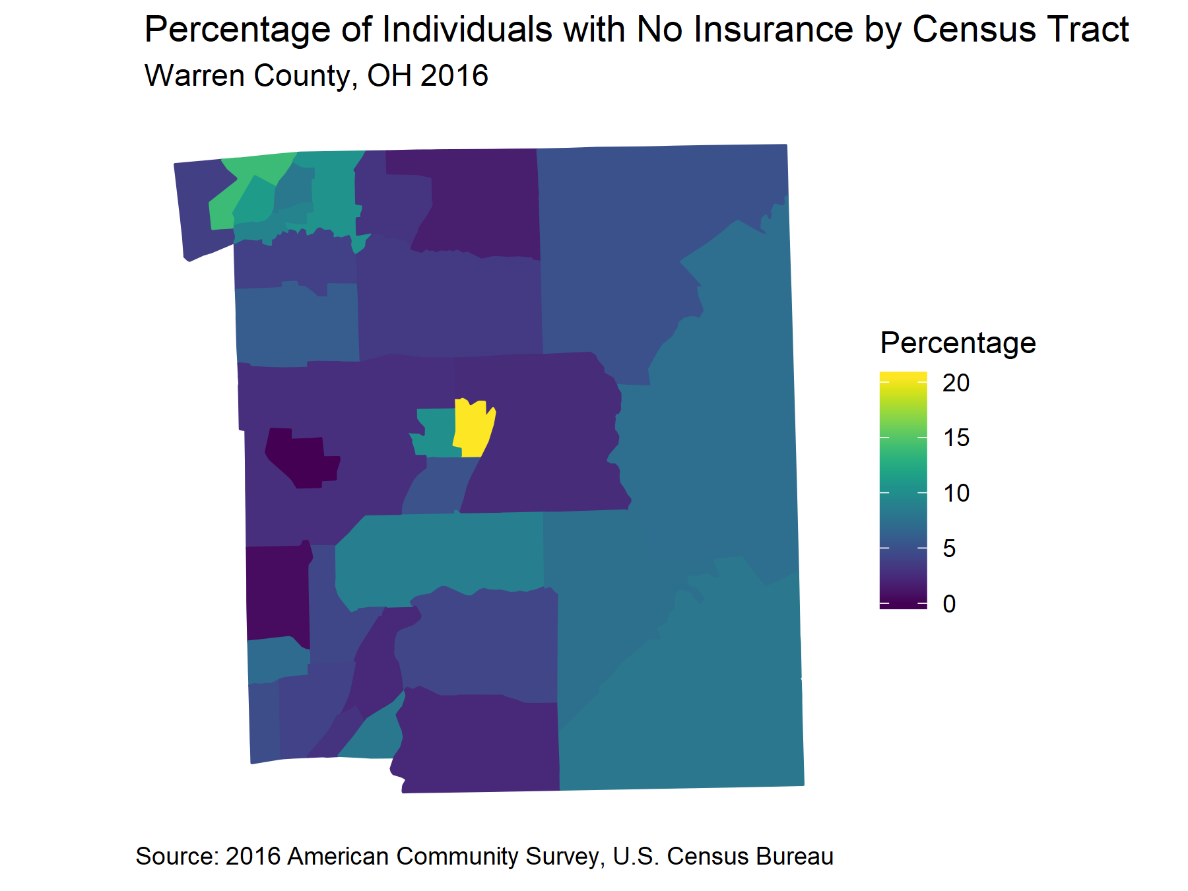

##### 

### Chart

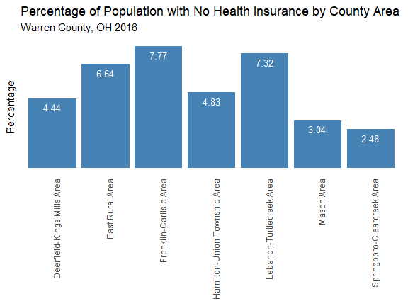

### Table

| **Table 3.1 Percentage of Uninsused by County Area in Warren County, OH in 2016 by County Area** | | | |
| --- | --- | --- | --- |
| **Area** | **Count** | **Population** | **Percentage** |
| Deerfield-Kings Mills Area | 1537 | 34630 | 4.44 |
| East Rural Area | 1469 | 22140 | 6.64 |
| Franklin-Carlisle Area | 2496 | 32123 | 7.77 |
| Hamilton-Union Township Area | 1561 | 32299 | 4.83 |
| Lebanon-Turtlecreek Area | 2225 | 30412 | 7.32 |
| Mason Area | 1023 | 33660 | 3.04 |
| Springboro-Clearcreek Area | 756 | 30468 | 2.48 |

##### 



# Neighborhood and Built Environment

Neighborhood and built environments have health impacts for the people who live there. Aspects of neighborhood environments include walkability, land use mix and urbanity, retail, recreational areas, restaurants, fast food outlets, cultural and education institutions, and pollution, such as from traffic or waste sites. Healthy People 2020 classifies neighborhood and built environment factors into these four categories.1

## Owner-Occupied Housing

People who own their own home are more likely to be in a stable housing arrangement. Home ownership is associated with educational achievement, civic participation, greater levels of well-being, and less likelihood of being a victim of crime.

### Map

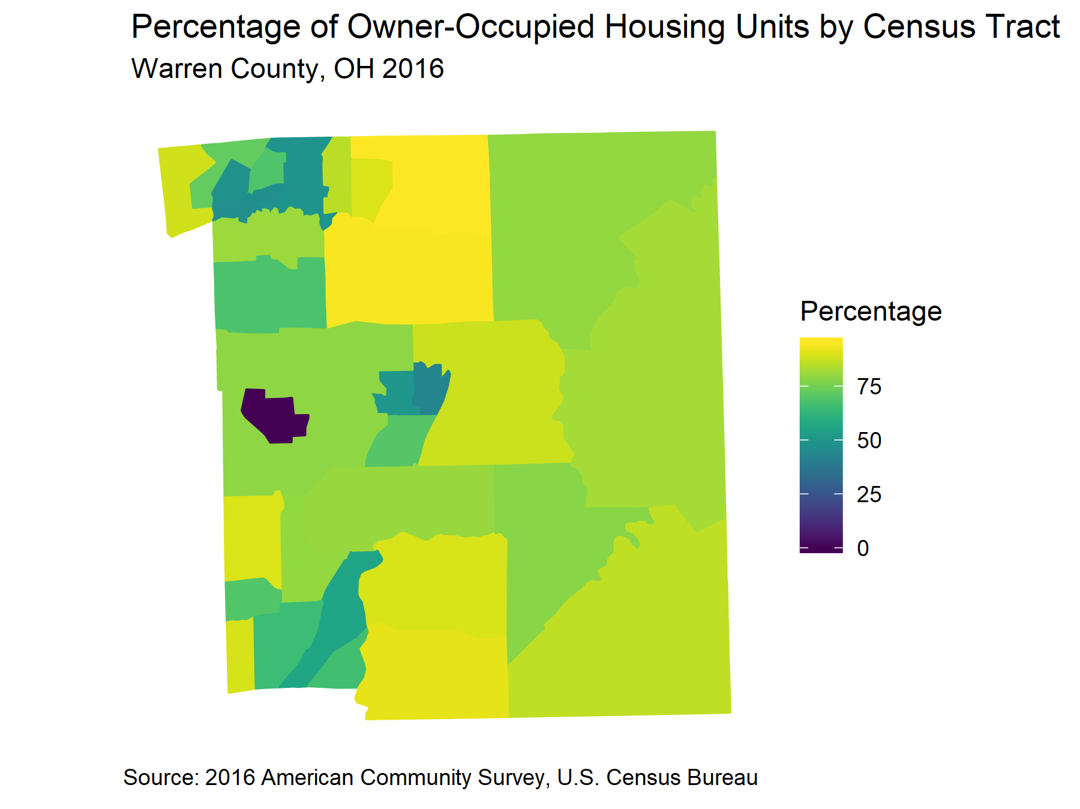

##### 

### Chart

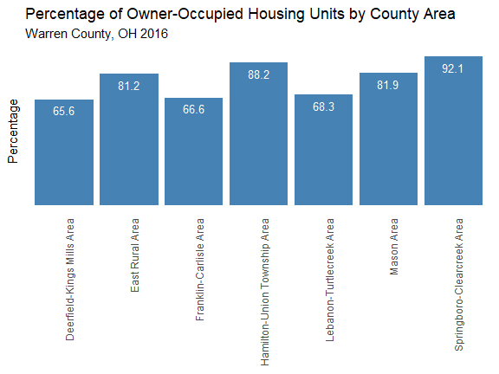

### Table

| **Table 4.1 Percentage of Owner-Occupied Housing Units in Warren County, OH in 2016 by County Area** | | | |
| --- | --- | --- | --- |
| **Area** | **Owner-Occupied Houses** | **Total Houses** | **Percetage** |
| Deerfield-Kings Mills Area | 8755 | 13352 | 65.60 |
| East Rural Area | 6887 | 8481 | 81.20 |
| Franklin-Carlisle Area | 8390 | 12600 | 66.60 |
| Hamilton-Union Township Area | 9748 | 11052 | 88.20 |
| Lebanon-Turtlecreek Area | 7672 | 11229 | 68.30 |
| Mason Area | 10185 | 12439 | 81.90 |
| Springboro-Clearcreek Area | 9495 | 10313 | 92.10 |

##### 

## New Houses

Newer housing stock indicates development in an area and a greater likelihood that the houses are made with safer materials and are less liekly to contain harmful chemicals. Houses that are 15 years or older are more likely to need costly repairs.

### Map

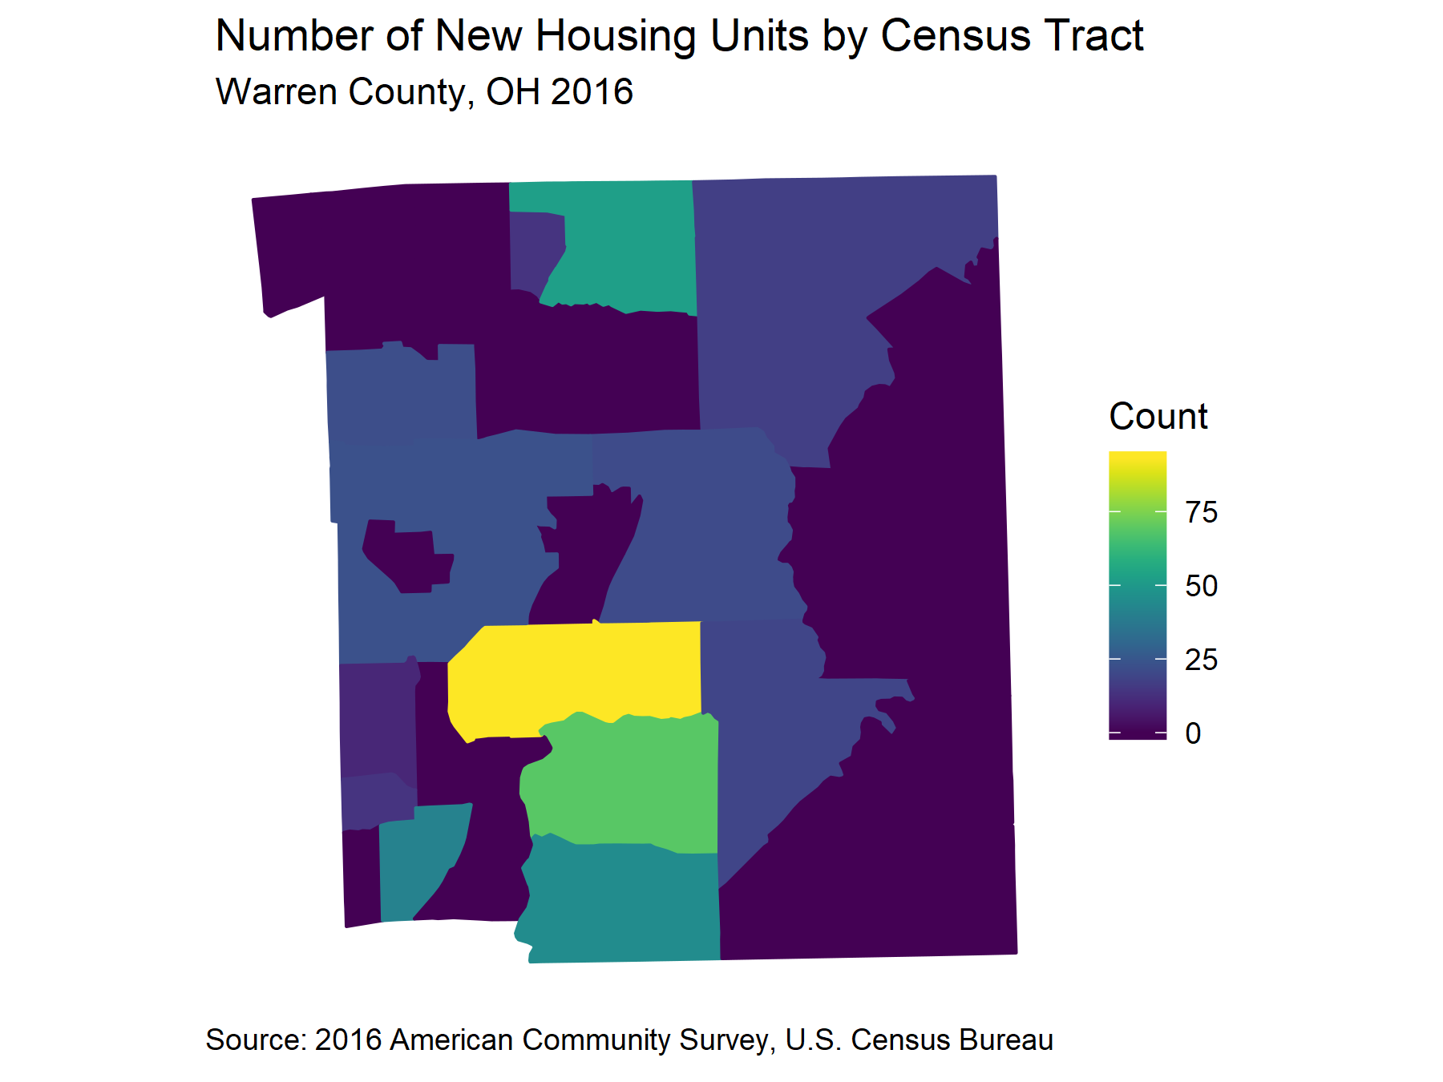

##### 

### Chart

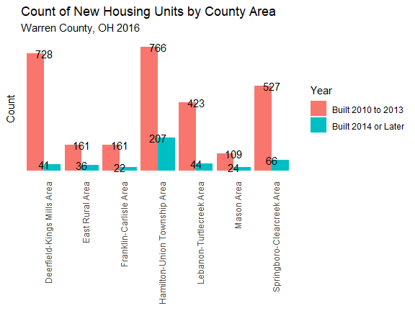

### Table

| **Table 4.2 Age of Housing Units in Warren County, OH in 2016 by County Area** | | | | |
| --- | --- | --- | --- | --- |
| **Area** | **Built 2014 or Later** | **Built 2010 to 2013** | **Built 2000 to 2009** | **Built Before 2000** |
| Deerfield-Kings Mills Area | 41 | 728 | 3156 | 9992 |
| East Rural Area | 36 | 161 | 1799 | 6979 |
| Franklin-Carlisle Area | 22 | 161 | 1959 | 11412 |
| Hamilton-Union Township Area | 207 | 766 | 5417 | 5176 |
| Lebanon-Turtlecreek Area | 44 | 423 | 2712 | 8987 |
| Mason Area | 24 | 109 | 4204 | 8430 |
| Springboro-Clearcreek Area | 66 | 527 | 3134 | 7075 |

##### 

## Crime

Crime and violence are aspects of the neighborhood and built environments that impact overall health. A sense of security and well-being is an important social determinant of health.

| **Table 4.3 Crime in Warren County, OH in 2016** | | | | | |
| --- | --- | --- | --- | --- | --- |
| **Geography** | **Population** | **# of Property Crimes** | **Property Crime Rate** | **# of Violent Crimes** | **Violent Crime Rate** |
| Ohio | 11631449 | 271175 | 2331.4 | 159763 | 1373.5 |
| Warren County | 227168 | 2425 | 1067.5 | 851 | 374.6 |
| Medina County | 183317 | 1189 | 648.6 | 517 | 282.0 |
| Delaware County | 175635 | 2165 | 1232.7 | 818 | 465.7 |

##### 

### Property Crime

Property crime includes household burglary, motor vehicle and property theft.

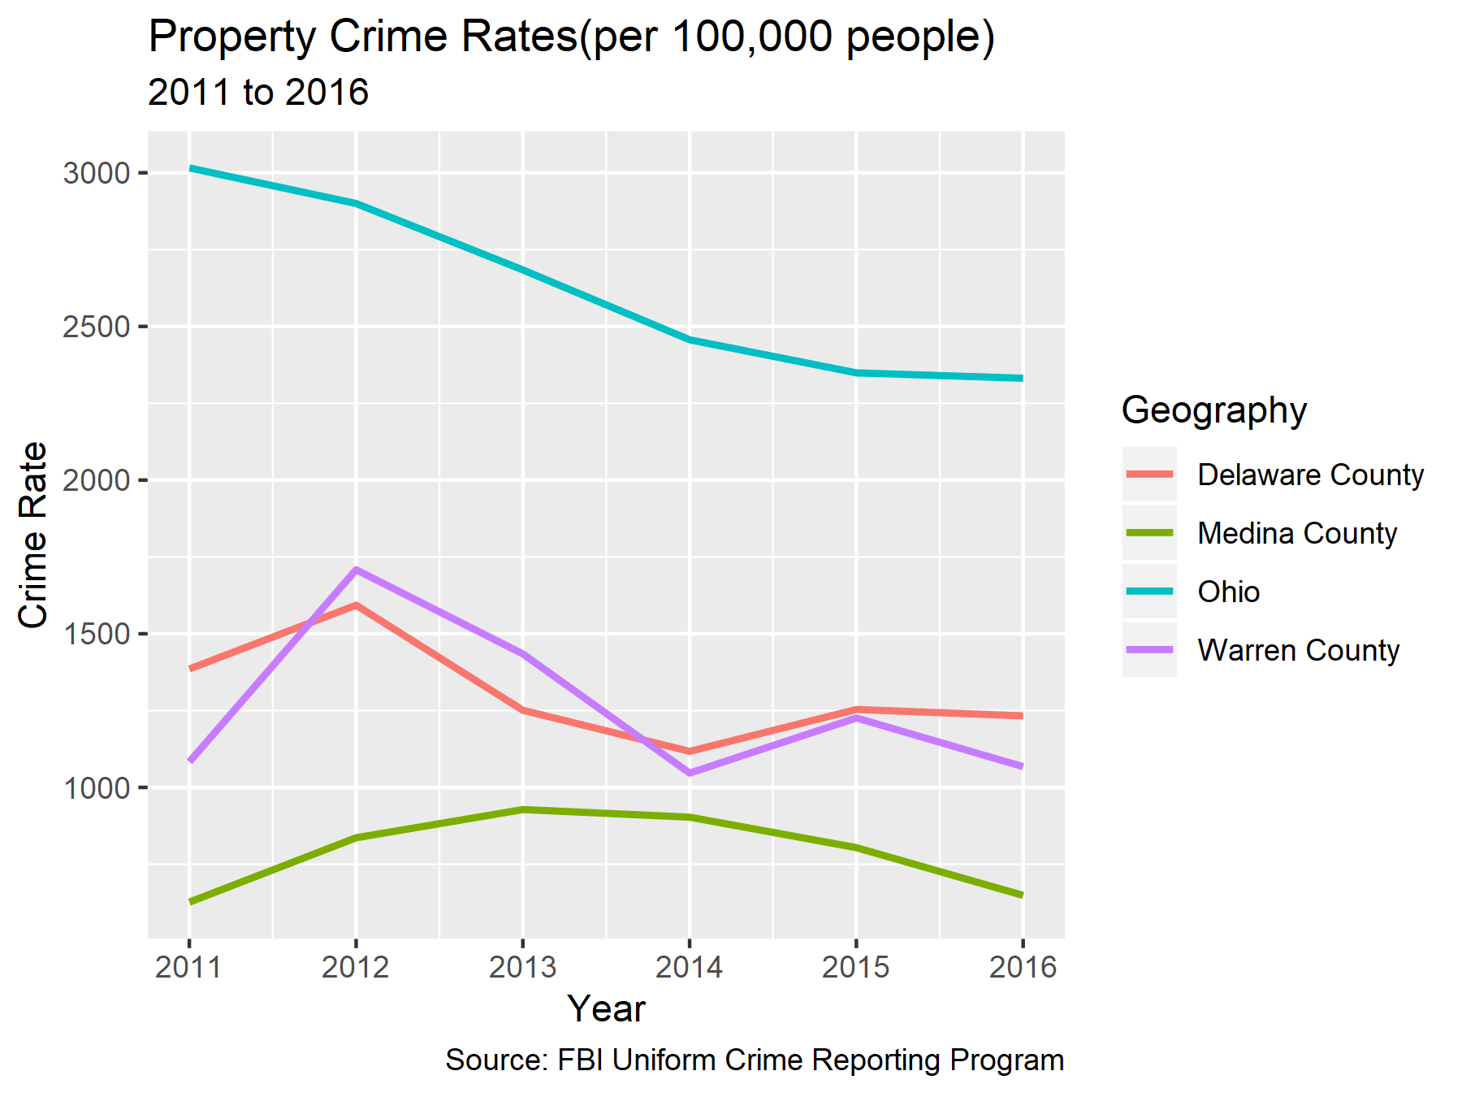

##### 

### Violent Crime

Violent crime involves force or the threat of force and includes murder, rape and sexual assault, robbery, aggravated assault, and assault.

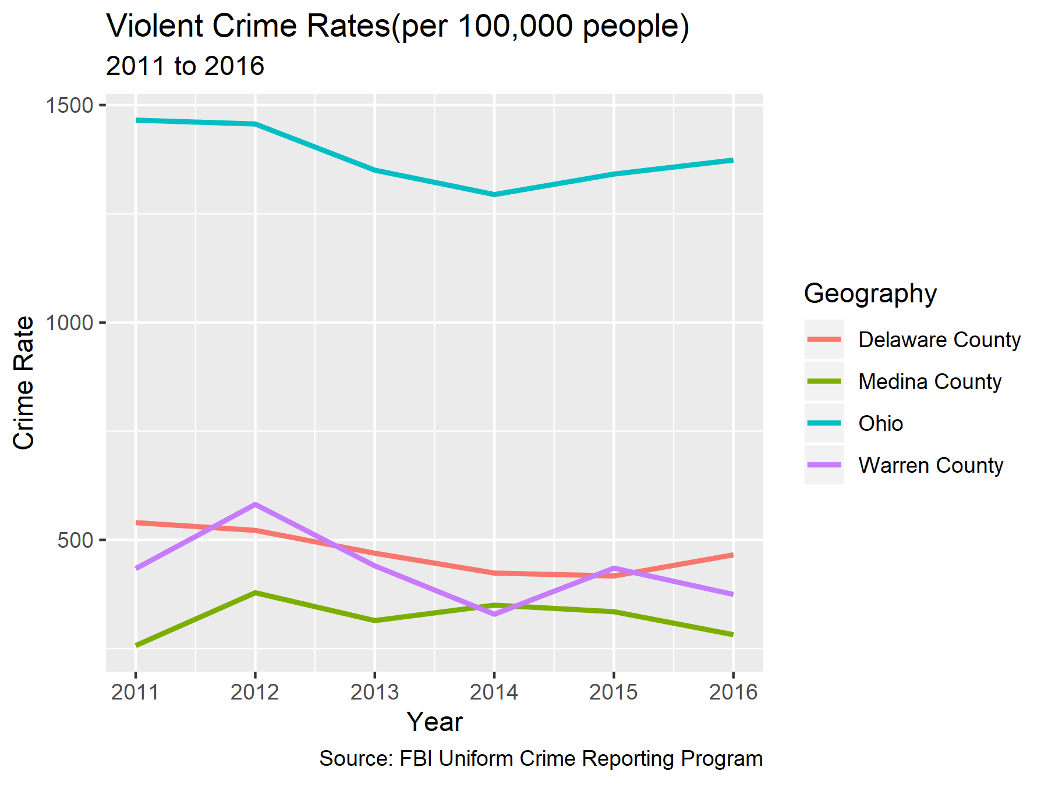

##### 



# Education

The amount of education a person has is often called “educational attainment” in academic literature. Just as education and educational attainment can effect health outcomes, a person’s health can affect the amount of education that he or she is able to attain. The CDC reports that “Health-related factors such as hunger, physical and emotional abuse, and chronic illness can lead to poor school performance”.1,8

## Educational Attainment

Higher educational attainment is associated with better health outcomes. Education impacts health literacy, knowledge, and behaviors, improves income and work conditions, and contributes to social support and a sense of control.

### Map

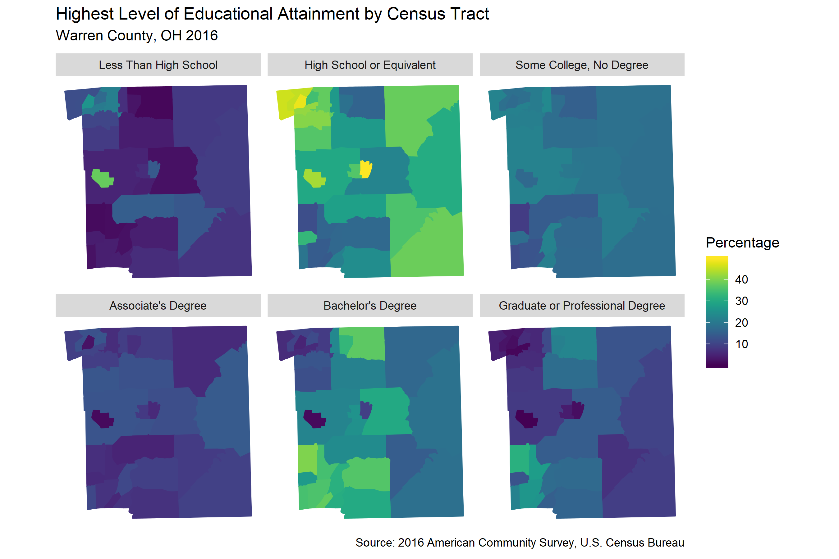

##### 

### Chart

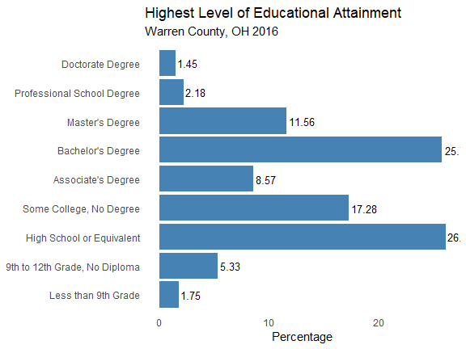

### Table

| **Table 5.1 Educational Attainment in Warren County, OH in 2016 by County Area** | | |
| --- | --- | --- |
| **Education** | **Count** | **Percentage** |
| Less than 9th Grade | 2588 | 1.75 |
| 9th to 12th Grade, No Diploma | 7877 | 5.33 |
| High School or Equivalent | 38588 | 26.10 |
| Some College, No Degree | 25555 | 17.28 |
| Associate's Degree | 12673 | 8.57 |
| Bachelor's Degree | 38132 | 25.79 |
| Master's Degree | 17098 | 11.56 |
| Professional School Degree | 3221 | 2.18 |
| Doctorate Degree | 2140 | 1.45 |

### References

1. *Healthy People 2020*. U.S. Department of Health; Human Services, Office of Disease Prevention; Health Promotion; 2010.

2. R Core Team. *R: A Language and Environment for Statistical Computing*. Vienna, Austria: R Foundation for Statistical Computing; 2014. <http://www.R-project.org/>.

3. RStudio Team. *RStudio: Integrated Development Environment for R*. Boston, MA: RStudio, Inc.; 2015. <http://www.rstudio.com/>.

4. Wickham H, Grolemund G. *R for Data Science: Import, Tidy, Transform, Visualize, and Model Data*. 1st ed. O’Reilly Media, Inc.; 2017.

5. Bureau USC. American community survey. 2015.

6. Services Administration HR &. Area health resources files. 2015.

7. Investigation USFB of. Uniform crime reporting program data, offenses known and clearances by arrest.

8. *Issue Brief 6: Education and Health*. Robert Wood Johnson Foundation; 2009.