Infant Mortality Annual Report - 2016

Prepared by the Warren County Health District

September 1, 2017





#### A report prepared to describe infant mortality in Warren County in 2016

##### 

# Introduction

The Infant Mortality Report is part of an initiative to improve access to prenatal care, decrease infant mortality, and improve maternal and child health in Warren County. The risks to the health of mothers and their infants need to be identified and assessed in order to find solutions to improve and protect their short-term and long-term health.

The data in this report is developed using data collected from the birth and death records of residents in Warren County. The data is deidentified and compiled to identify trends of concern and to identify areas of the data that require additional exploration and analysis.

## Methods

This report is generated using a series of datasets from various public and non-public datasets. These data have been accessed in the most raw version of data that is available or the data was retrieved from a web API. This ensures that analyses that are conducted are being done on the original data and are not calculations based on the calculations of others.

All of the code for the generation of these reports is devleoped using the R Statistical Programming Language1 and the R Studio IDE2. The code used for the devleopment of this report is available on [GitHub](https://github.com/DustinRatliff/AnnualUpdate). A copy of this report will be maintained on the Warren County Health District [website](http://warrenchd.com/document-category/assessments).

### Data Analysis

The data that has been compiled is analyzed using multiple methodologies. Data is first assessed to identify what information can be found in the raw information. The data then goes through the following process3 :

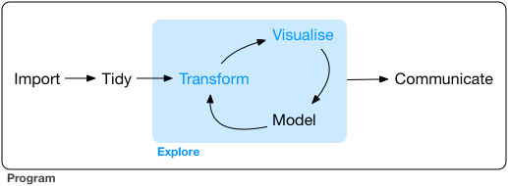

Data is summarily analyzed at the inter-county and intra-county level to identify differences. These type of analysis allow an exploration of the county for sub-county data and identify areas that are more likely to have health disparities.

### Data Sets

The following data sets have been used to develop this analysis:

* 2016 Death Data File4
* 2016 Restricted Access Ohio Resident Live Births5

### Indicators

The following indicators will be part of the Infant Mortality Annual Report:

* Infant Mortality
* Preterm Birth
* Small for Gestational Age
* Pregnancy Spacing
* Maternal Smoking
* Prenatal Care
* Breastfeeding
* Safe Sleep

##### 

# Infant Mortality

Infant mortality is the death of an infant before their first birthday.6 Infant mortality is an indicator of inequality in an area.

$$Infant Mortality Rate=\frac{Number of Resident Infant Deaths}{Number of Resident Live Births} × 1,000$$

###### IMR in 2016: 5.3

###### IMR in 2015: 4.2

#### There has been a 26% INCREASE in IMR over the last year

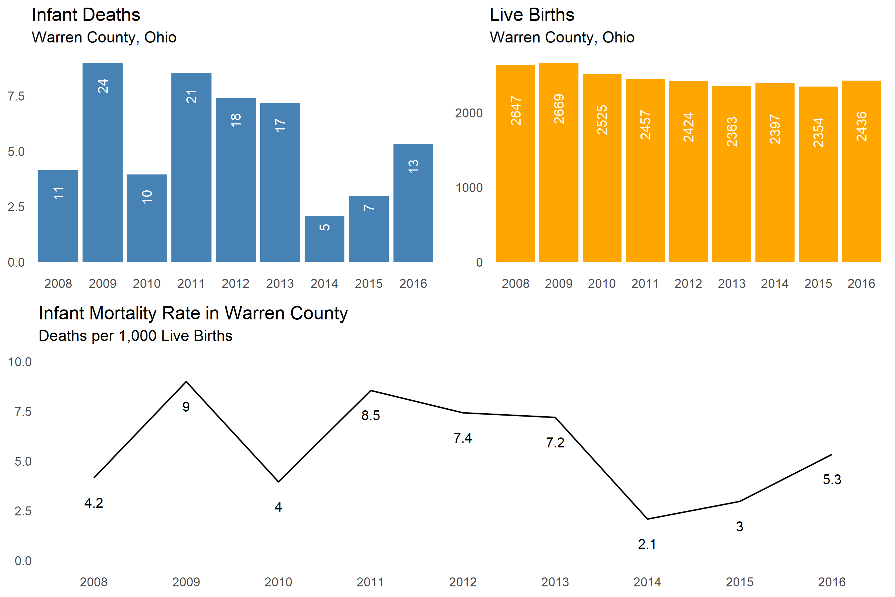

##### 

# Preterm Birth

#### Preterm Births are infants born before 37 weeks gestation

#### Very-Preterm Births are infants born before 32 weeks of gestation

#### Less than 23 Weeks births are infants born before 23 week of gestation

###### 250 preterm babies were born in 2016

#### There was a 8.7% increase in the number of preterm births between 2015 and 2016

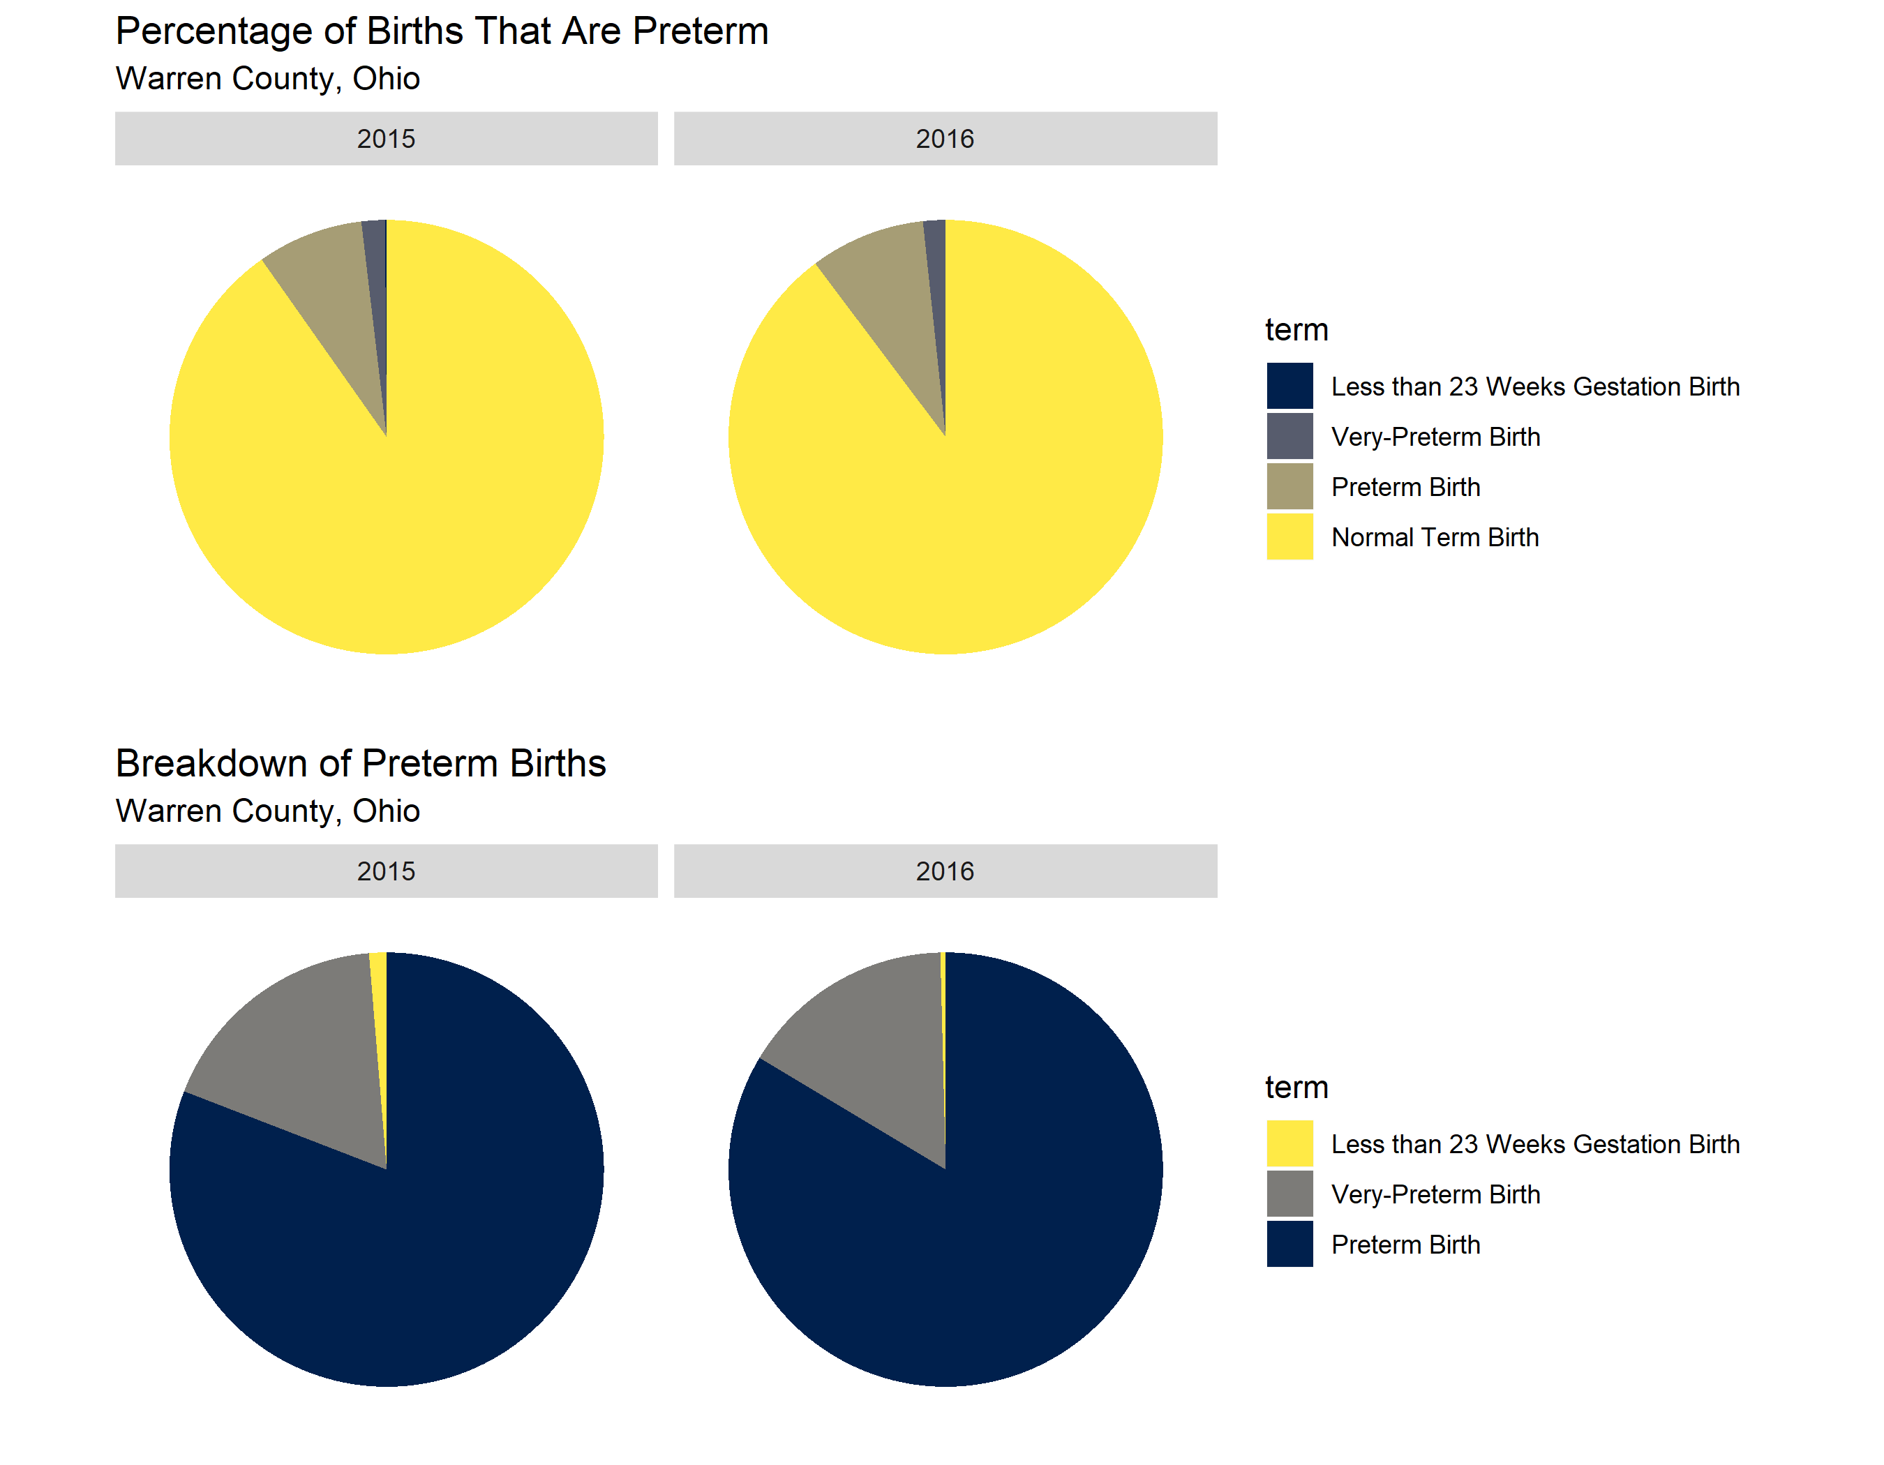

### References

1. R Core Team. *R: A Language and Environment for Statistical Computing*. Vienna, Austria: R Foundation for Statistical Computing; 2014. <http://www.R-project.org/>.

2. RStudio Team. *RStudio: Integrated Development Environment for R*. Boston, MA: RStudio, Inc.; 2015. <http://www.rstudio.com/>.

3. Wickham H, Grolemund G. *R for Data Science: Import, Tidy, Transform, Visualize, and Model Data*. 1st ed. O’Reilly Media, Inc.; 2017.

4. Health OD of. Ohio death data file. 2016.

5. Health OD of. Restricted access ohio resident live births. 2016.

6. Infant mortality. <https://www.cdc.gov/reproductivehealth/maternalinfanthealth/infantmortality.htm>. Published August 3, 2018. Accessed September 27, 2018.