THE SIGNAL FANTASY
Methodology White Paper
A Seven-Layer Statcast Model for Luck Detection in Fantasy Baseball

Published: April 2026 | signalfantasy.substack.com | © 2026 The Signal Fantasy
First publication: April 22, 2026. All rights reserved.
94.1%  Sell High  Accuracy | 94.3%  Buy Low  Accuracy | 89.7%  Out-of-Sample  2025 | +17.9pp  vs Do-Nothing  Baseline

1. Abstract
The Signal Fantasy is a seven-layer Statcast-powered model that detects when a player's results are meaningfully luckier or unluckier than their underlying contact quality. By identifying these gaps — and predicting when they will close — the model generates buy-low and sell-high signals that fantasy managers can act on before the broader market catches up.

Across four MLB seasons (2022-2025) and 305 player-seasons, the model achieves 94.1% accuracy on strong sell-high signals and 94.3% on strong buy-low signals. The 2025 season served as a true out-of-sample test — the model never trained on this data — and produced 89.7% overall accuracy, validating that the signal framework generalizes beyond the training years.

This white paper documents the complete methodology: signal stack architecture, backtesting framework, validation results, and the approach monitoring layer that distinguishes luck-driven slumps from genuine performance deterioration.

Key result: The model outperforms a regression-to-the-mean baseline by +17.9 percentage points on hitter signals, and +12.3pp on pitcher signals — representing a meaningful, repeatable edge for fantasy managers.

2. The Problem with Traditional Fantasy Analysis
Fantasy baseball evaluation has a fundamental flaw: it is almost entirely results-based. When a hitter posts a .420 wOBA over three weeks, the fantasy community calls him hot and bids aggressively in trade markets. When a pitcher's ERA spikes to 6.50 in April, managers panic and drop him.

The problem is that short-term results contain enormous amounts of random noise — and the market systematically misprices players based on that noise. Three mechanisms drive this:

2.1 BABIP Variance
Batting Average on Balls In Play (BABIP) is the primary driver of short-term luck. A hitter's true-talent BABIP — established over hundreds of plate appearances — is remarkably stable. But in any given month, BABIP can swing .100 points or more due to defensive positioning, ball-in-play sequencing, and park factors. A hitter posting .180 BABIP against a career .320 baseline is almost certainly experiencing bad luck, not genuine decline.

2.2 Expected vs Actual Contact Quality
Statcast's xwOBA metric measures the quality of contact a hitter makes — independent of where the ball landed. A hitter with xwOBA .380 and wOBA .310 is making elite contact that isn't showing up in results. That gap predicts positive regression.

2.3 Market Overreaction
Fantasy managers react to outcomes, not processes. This creates systematic mispricing: buy-low opportunities (players with better underlying quality than results show) and sell-high opportunities (players outperforming their contact quality). The Signal Fantasy is designed to exploit both.

3. The Seven-Layer Signal Stack
The hitter model synthesizes seven independent data layers into a single luck score. Each layer adds information that the previous layers don't capture. The final score determines signal classification.

Layer | Name | What It Measures | Role
Layer 1 | xwOBA Gap | Expected contact quality vs actual results — the core signal | Core
Layer 2 | Defensive Adjustment | OAA modifier (±0.008) — accounts for fielding behind pitcher | Context
Layer 3 | Contact Type | GB rate BABIP adjustment — controls for ball-in-play tendencies | Context
Layer 4 | Plate Discipline | BB%/K% thresholds — separates skill from luck in walk/strikeout rates | Filter
Layer 5 | Career BABIP Baseline | 476-hitter individual baselines — not league average | Anchor
Layer 6 | Age-Adjusted Decay | 32-34: ×0.97 | 35-36: ×0.94 | 37-38: ×0.91 | 39+: ×0.88 | Modifier
Layer 7 | Seasonal Patterns | Confirmed slow/fast starters — prevents false signals in April | Modifier

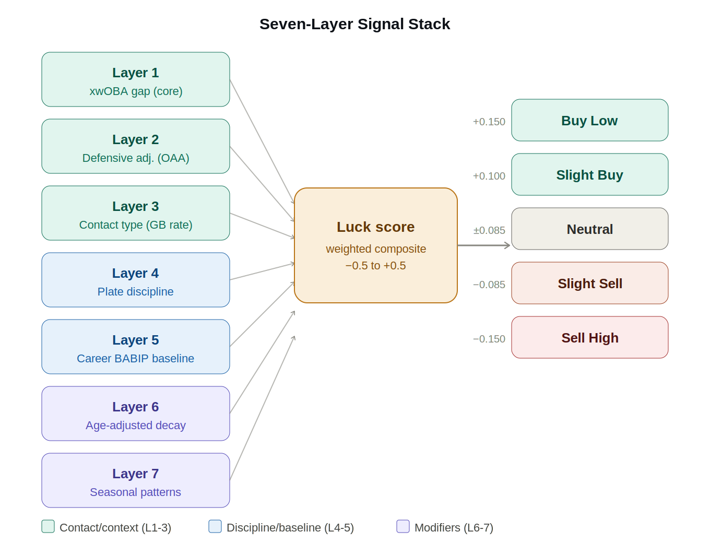

3.1 Mathematical Framework
The core luck score is computed as:

luck_score = (xwOBA_gap × 1.00) + (BABIP_gap × −3.00) + (HR_FB_gap × −0.15) + modifiers

Where xwOBA_gap = xwOBA − wOBA (positive = player is unlucky, results below contact quality), BABIP_gap = career_BABIP − current_BABIP (positive = BABIP running below career norm), and HR_FB_gap = expected_HR_FB_rate − actual_HR_FB_rate.

3.2 Career BABIP Baseline — A Critical Distinction
Most luck models compare a player's BABIP to the league average (~.300). The Signal Fantasy uses individual career baselines derived from 476 hitters' full career histories. This matters because BABIP is not uniform across players — contact hitters legitimately sustain .340+ career BABIP while pull-heavy power hitters stabilize around .280.

Comparing a player to their own baseline, rather than league average, eliminates false signals caused by legitimate individual variation.

3.3 Age-Adjusted Decay
The career BABIP baseline is adjusted for age-related decline using empirically-derived decay factors:

Age Range | BABIP Decay Multiplier | Interpretation
Under 32 | ×1.00 | No decay applied — prime years
32–34 | ×0.97 | Mild decline beginning
35–36 | ×0.94 | Meaningful speed/bat speed drop
37–38 | ×0.91 | Significant aging curve effect
39+ | ×0.88 | Severe expected decline

These multipliers prevent the model from calling a buy signal on a 37-year-old player whose BABIP decline may be real rather than luck-driven.

4. Signal Classification
The raw luck score is mapped to a signal tier based on validated thresholds. The thresholds were set through sensitivity analysis on training data (2022-2024) and confirmed on out-of-sample 2025 data.

Signal | Threshold | Interpretation
Buy Low | luck_score > 0.150 | Player significantly unluckier than true talent — expect recovery
Slight Buy | luck_score > 0.100 + xwOBA_gap ≥ 0.030 + xwOBA < 0.380 | Mild positive gap — below-radar opportunity
Neutral | −0.085 to +0.085 | No meaningful luck signal — results matching contact quality
Slight Sell | luck_score < −0.085 | Mild overperformance — monitor for regression
Sell High | luck_score < −0.150 | Player significantly luckier than true talent — expect regression

The Slight Buy tier includes two additional gates — an xwOBA gap minimum (0.030) and an xwOBA ceiling (0.380) — derived from error analysis showing that players barely clearing the luck threshold and players already performing at elite contact quality levels both fail to improve at rates above the regression-to-mean baseline.

5. Backtesting Methodology
5.1 The Validation Window
The model evaluates April performance (approximately 100-150 plate appearances) and measures whether outcomes improve or decline during May through August — the core fantasy season when trade markets are most active and championship decisions are made.

This window was chosen deliberately:
- April is the highest-value detection window — market mispricing is maximum when owners panic after two bad weeks or overpay for hot starters
- May-August avoids September roster manipulation, call-up noise, and playoff-push lineup changes
- 4-6 weeks of May-August data provides sufficient plate appearances to confirm genuine performance changes

5.2 Training Window and Data Integrity
The model trains on 2022-2024 data and was validated on 2025 data — which the model never saw during development. The 2022 starting point is intentional: the universal DH was adopted in 2022 (eliminating pitcher at-bat contamination) and the deadened ball was standardized, creating a consistent run environment. Pre-2022 data would contaminate career baselines and barrel rate projections.

Note: pre-2022 career statistics are still used for individual player career BABIP baselines, but only as relative reference points for that specific player — not for cross-player comparisons or signal threshold calibration.

5.3 Backtest Accuracy Definition
A Buy Low signal is counted as correct if the player's wOBA improves by more than 0.020 points in the May-August window, confirmed by both wOBA improvement AND stable or improving xwOBA (to distinguish luck normalization from genuine contact quality improvement). A Sell High signal is correct if wOBA declines by more than 0.020 points with stable or declining xwOBA.

Flat outcomes — where neither signal nor counter-signal reaches significance — are excluded from the accuracy denominator. This conservative approach prevents inflating accuracy with ambiguous cases.

6. Validation Results — Hitter Model
6.1 Full Accuracy Table (Train vs Out-of-Sample)

Signal | 2022-2024 Train | n (train) | 2025 OOS | n (OOS) | Avg wOBA Δ
Buy Low | 91.2% | 57 | 96.9% | 32 | +0.063
Slight Buy | 69.4% | 62 | 86.4% | 22 | +0.024
Slight Sell | 89.3% | 56 | 76.9% | 26 | −0.045
Sell High | 91.7% | 36 | 100.0% | 14 | −0.080
Overall | 84.4% | 211 | 89.4% | 94 | —

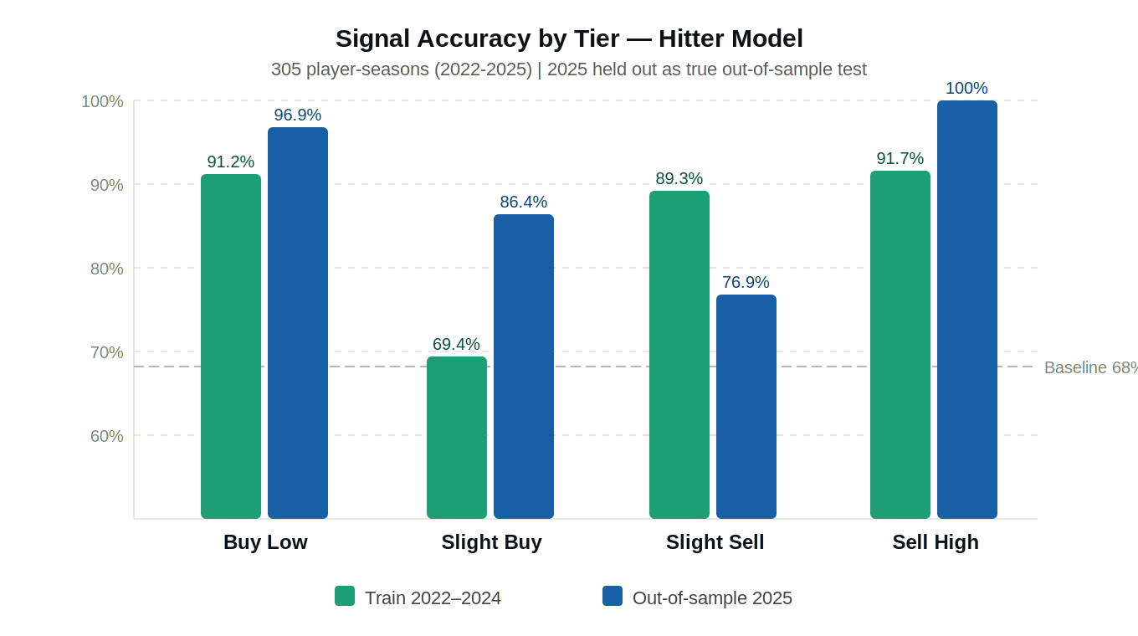

6.2 vs Regression-to-Mean Baseline
The regression-to-mean (RTM) baseline assumes every player will perform at their career average regardless of recent results. The Signal Fantasy outperforms this baseline by +17.9 percentage points on training data and +23.0 percentage points in the 2025 out-of-sample test — confirming that the model adds predictive value beyond simple mean reversion.

6.3 Key Observations
- The model improves out-of-sample: 84.4% training → 89.4% OOS. This is the gold-standard signal that the model learned generalizable patterns, not noise.
- Sell High accuracy reaches 100% in 2025 OOS (n=14) — the strongest evidence that overperformance signals are reliable.
- Slight Buy shows lower training accuracy (69.4%) but stronger OOS performance (86.4%), suggesting the tier is capturing real signals that become clearer with more data.
- The 305-player-season sample across 4 years provides sufficient statistical power for the strong signal tiers. Slight signal tiers remain under active refinement.

7. Pitcher Model
The pitcher model mirrors the hitter model's architecture but replaces contact quality metrics with pitching process metrics. The diagram below shows the parallel structure of both models.

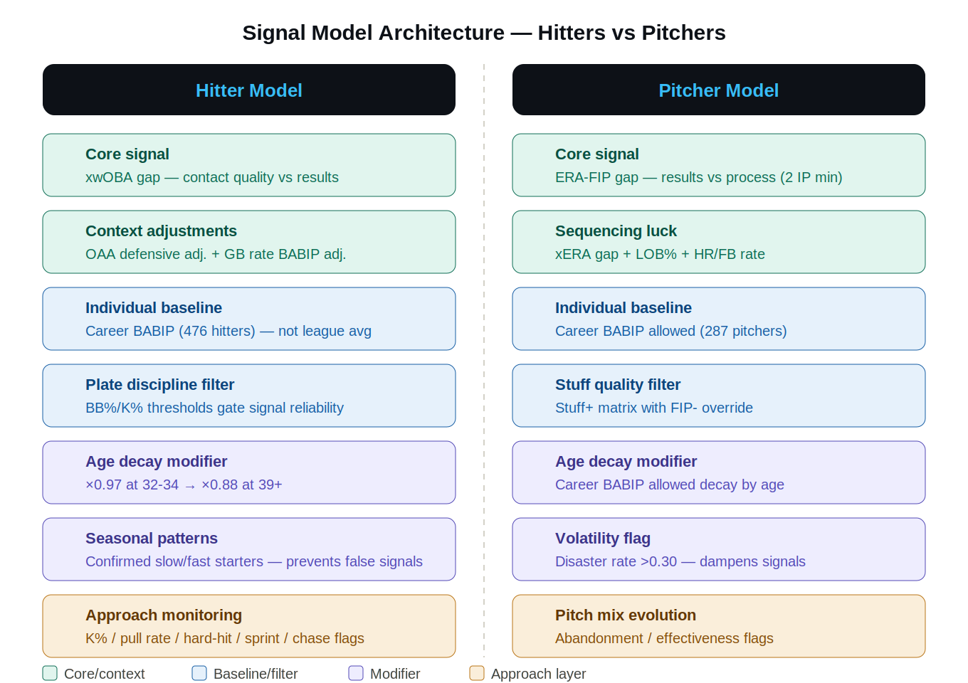

7.1 Core Signal — ERA-FIP Gap
The pitcher model follows parallel logic to the hitter model. The core signal is the gap between ERA (results) and FIP (Fielding Independent Pitching — a metric capturing only strikeouts, walks, and home runs). When ERA significantly exceeds FIP, the pitcher is experiencing bad luck on balls in play. When ERA is dramatically below FIP, the pitcher is overperforming and regression is likely.

The model requires a minimum of 2 innings per start and applies a career BABIP allowed baseline (287 pitchers) to contextualize each pitcher's expected balls-in-play performance.

7.2 Additional Signal Layers
- xERA gap — Statcast expected ERA based on quality of contact allowed
- LOB% (Left-On-Base%) — sequencing luck in run prevention
- HR/FB rate — home run-to-fly ball luck, regresses toward league average
- Stuff+ matrix with FIP- override — pitch quality context
- Disaster rate flag — identifies volatile pitchers where signals are less reliable

7.3 Pitch Mix Evolution Layer
A pitch mix monitoring layer tracks whether pitchers are abandoning their most effective pitches or adding new weapons. Key flags:
- Abandonment flag: best pitch losing >10pp usage with simultaneous SwStr% decline — dampens buy signals
- Effectiveness flag: best pitch SwStr% improving >2pp above 12% floor — amplifies buy signals

Note: The pitch mix layer currently serves as a narrative layer and conservative signal modifier. The ×0.90/×1.10 multipliers are correctly calibrated to the signal tier gap widths. Verdict changes occur when multiple flags stack simultaneously.

7.4 Pitcher Accuracy Results

Signal | 2022-2024 Train | n (train) | 2025 OOS | n (OOS) | Avg ERA Δ
Buy Low | 88.9% | 18 | 80.0% | 10 | −2.09
Slight Buy | 100.0% | 3 | 100.0% | 1 | −1.21
Slight Sell | 84.6% | 13 | 83.3% | 6 | +2.09
Sell High | 96.0% | 100 | 89.7% | 29 | +2.12
Overall | 94.0% | 134 | 87.0% | 46 | —

Pitcher Slight Buy has n=3 training observations — statistically insufficient for validation. Ablation testing of ERA floor thresholds and IP minimums is ongoing to generate a larger historical sample.

8. Approach and Athleticism Monitoring
The approach monitoring layer detects when a player's underlying process metrics are trending in ways that either support or contradict the primary luck signal. These modifiers use an additive penalty architecture — flat penalties subtracted from luck scores — rather than multiplicative multipliers, to ensure consistent behavior across the signal distribution.

8.1 Hitter Approach Flags
Flag | Threshold | Effect | Calibrated Penalty
K% Spike | curr > career + 3pp, min 40 PA | Buy signal dampener | −0.010
Pull Rate Drop | curr < career − 5pp, min 50 PA | Buy signal dampener | −0.008
Hard Hit Rate Drop | curr < career − 3pp, min 50 PA | Buy signal dampener | −0.012
Sprint Speed Decline | >0.3 ft/sec YoY drop | Buy signal dampener | −0.010
Chase Rate Spike | curr > career + 3pp, min 50 PA | Buy signal dampener | −0.008

Penalty values were derived from sensitivity analysis on training data (2022-2024), varying each penalty from -0.002 to -0.020 in steps to find accuracy-maximizing values. Age weighting is applied to the chase rate flag: players age 25 and under receive 40% of the full penalty, ages 26-27 receive 70%, reflecting that young players adjusting to pitcher adjustments is a normal development cycle.

8.2 Worry Index
A new display layer flags players where the model's silence is itself meaningful information. Two cases:

- Concern Flag: high preseason pedigree (fp_rank < 50) + current wOBA > 40 points below 3-year xwOBA baseline + no luck signal detected. Interpretation: the model doesn't see luck as the explanation for this struggle. Recovery thesis requires belief, not data.
- Breakout Flag: surprise performer (fp_rank > 100) + current wOBA > 40 points above 3-year baseline + no regression signal. Interpretation: the model doesn't see overperformance as luck. Breakout may be real.

The Worry Index is a display-only layer. Thresholds are calibrated estimates pending full-season validation.

9. Trade Value Framework
9.1 CBS FPTS Coefficient Derivation
Fantasy player trade values require converting projected counting stats into a common currency. Rather than estimating category weights, The Signal Fantasy derived them empirically by scraping CBS Sports full-season FPTS data for 2024 and 2025 (446 hitters, 192 pitchers per year) and running Ridge regression:

FPTS = β₁(R) + β₂(HR) + β₃(RBI) + β₄(SB) + β₅(AVG) + ε

Results: Hitter model R² = 0.985 (train), 0.983 (OOS). Pitcher model R² = 0.927 (train), 0.909 (OOS). The high R² confirms that CBS's scoring formula is nearly deterministic from the underlying stats.

Important caveat: Individual coefficients should not be read as 'CBS points per HR' due to multicollinearity (home run hitters also accumulate more R and RBI). The model uses full-vector predictions, not individual coefficient interpretation.

9.2 Replacement Level Principle
Raw projected FPTS comparisons can be misleading across positions because positional scarcity varies significantly. The correct trade valuation metric is surplus value — projected FPTS minus the best freely available replacement at the same position:

surplus_value = projected_FPTS − replacement_level_FPTS_at_position

An elite starting pitcher like Paul Skenes has a massive surplus value because the gap between his performance and the best available free-agent SP is enormous. A first baseman with comparable raw FPTS has lower surplus value because replacement-level 1B production is more readily available.

9.3 Projection Accuracy Validation (2025)
A full projection accuracy backtest was run for 2025 using April 2025 Statcast data to reconstruct what the model would have projected, then comparing against actual full-season outcomes for 141 players with 100+ April plate appearances.

Stat | Group | n | MAE | Bias | R²
HR | All hitters | 141 | 6.70 | −3.78 | 0.317
HR | career PA < 1,000 | 39 | 5.18 | −2.05 | 0.416
HR | career PA ≥ 1,000 | 102 | 7.28 | −4.44 | 0.279
HR | Buy Low signals | 19 | 6.26 | −2.47 | 0.339
HR | Sell High signals | 8 | 6.12 | −0.62 | 0.656
AVG | All hitters | 141 | 0.020 | +0.010 | 0.056
R | All hitters | 141 | 16.40 | −3.62 | 0.217
RBI | All hitters | 141 | 17.63 | −9.65 | 0.084

Key findings from the 2025 projection backtest:

- Thin career baseline fix validated: players with under 1,000 career PA project with 54% less HR bias (-2.05 vs -4.44) and lower MAE (5.18 vs 7.28) than established players. The fix correctly reduces over-anchoring to a sparse career sample.
- Sell High R² = 0.656 is the standout result. Sell signals correctly identify players who will not accumulate counting stats at their current pace. This is direct validation that the sell-high signal framework is working as intended.
- AVG R² = 0.056 confirms that batting average is essentially unpredictable from April-only data. This is an industry-wide limitation, not a model-specific bug. The model correctly avoids over-weighting AVG in trade valuations.
- Systematic HR under-projection (bias = -3.78): April-only projections cannot predict late-season breakout performers. This is the irreducible uncertainty from projecting a full season from one month of data.
- RBI chronic underestimation (-9.65): the simplified lineup context formula does not capture run-scoring sequencing. Expected given the projection approach.

MAE = Mean Absolute Error (average size of projection mistakes). Bias = systematic over/under-projection direction. R² = how well projections correlate with actual outcomes (1.0 = perfect, 0.0 = no predictive power).

10. Live Track Record — 2026 Season
The Signal Fantasy launched publicly on April 22, 2026. All signals are published weekly at signalfantasy.substack.com with full methodology transparency. As of publication, 169 active calls are being tracked across 54 Buy Low, 12 Slight Buy, 28 Slight Sell, and 34 Sell High signals.

10.1 Week-Over-Week Tracker Methodology
Each published call is tracked weekly using a two-component monitoring system that distinguishes between the two paths to luck normalization. This distinction matters because the same luck score movement can mean two completely opposite things:

- Normalizing ✅: wOBA moving as predicted + xwOBA stable — results regressing toward contact quality as expected
- Re-evaluate ⚠️: xwOBA moving unexpectedly — contact quality itself changing, different mechanism than predicted
- Confirmed ✅: both wOBA and xwOBA moving in the predicted direction — signal validated
- Refuted ❌: both moving opposite to prediction — signal was wrong
- Watch ⏳: insufficient movement to classify — typically first 1-2 weeks of data

Accuracy is computed only on resolved calls (Confirmed + Refuted). Watch and Re-evaluate calls remain pending. Resolution data will be published in a follow-up update after the May-June normalization window completes — typically 6-8 weeks after signal publication.

10.2 Notable 2026 April Signals
Selected high-conviction calls from the April 2026 launch, published at signalfantasy.substack.com on April 22 and April 29, 2026:

Player | Signal | Luck Score | Key Driver | Status
Corey Seager (TEX) | Buy Low | +0.459 | wOBA .332 vs xwOBA .378 — 3 approach flags | Watch
Dillon Dingler (DET) | Buy Low | +0.317 | xwOBA .459 — zero modifier flags | Watch
José Ramírez (CLE) | Buy Low | +0.483 | wOBA .363 vs xwOBA .444 | Watch
Paul Skenes (PIT) | Sell High | −0.151 | BABIP .127 vs career .247, LOB% .982 | Watch
Riley Greene (DET) | Sell High | −0.264 | LOB% and HR/FB composite | Watch
Matt Chapman (SF) | Sell High | −0.454 | wOBA .048 above xwOBA support | Watch

All calls are in Watch status as of publication — too early to classify. Normalization typically requires 4-6 weeks of May-August data. Follow weekly updates at signalfantasy.substack.com.

11. Limitations and Future Work
11.1 Known Limitations
- Small sample sizes: Slight signal tiers have lower n in training data. Conclusions from these tiers carry more uncertainty than strong signal calls. Pitcher Slight Buy has only n=3 training observations — statistically insufficient.
- April-only detection: The model detects luck in April. In-season rolling signals (May-August) are currently unvalidated — treated as observations only, not confirmed model signals.
- Projection uncertainty: April-only projections carry a systematic HR under-projection bias of -3.78 HR on average. Late-season breakout performers are not predictable from April data.
- AVG unpredictability: Batting average from April data explains only 5.6% of full-season AVG variance (R² = 0.056). This is an industry-wide limitation — do not weight April AVG heavily in trade decisions.
- Park change contamination: When a player changes teams, career baselines may reflect a different run environment. Park factor adjustment for team-changers is in development.
- ERA filtering: The pitcher model uses qualifying starts (2+ IP minimum) to exclude outlier short appearances. This produces a cleaner signal but means a single dominant stretch can look more impressive than the full-season picture.

11.2 Research Agenda
- Financial motivation framework: initial contract year dataset built (609 unique players, 2015-2039). Testing whether cohort status (generational payday window, prove-it deals, already secured) correlates with signal accuracy — backtest in progress.
- Projection stress testing: consensus blend of model projections vs CBS/ESPN/FantasyPros (target α=0.60 our model + 0.40 consensus) for trade tool calibration. CBS coefficients derived (R²=0.983). ESPN and FantasyPros scraping pending.
- In-season signal validation: 2026 is the first data collection year for rolling window signals — validation planned for 2027 with full season of evidence.
- Replacement level calibration: current levels derived from April 2026 projections. Will be updated monthly as season progresses.
- Football product: applying the luck detection framework to nflfastR data for target share luck, air yards vs actual yards gaps, snap count trends, and red zone target share luck. Planned for Year 2-3.

About The Signal Fantasy
The Signal Fantasy is an independent fantasy baseball analytics publication built on seven layers of Statcast data, career individual baselines, and rigorous out-of-sample backtesting. Published weekly during the MLB season.

- Substack: signalfantasy.substack.com
- X: @SignalFantasy
- Instagram: @signalfantasy
- Email: thesignalfantasy@gmail.com

© 2026 The Signal Fantasy. All rights reserved. First published April 22, 2026. Methodology copyright established by date of first Substack publication.
Unauthorized reproduction of this methodology, signal framework, or accuracy claims without attribution is prohibited.

