Dustin Smith

CS-320

October 13, 2023

Final project

When I began writing the code for my projects, I tried to utilize them as two different identities. In the first one I utilized as a software developer and the other I used as a schemer or a person trying to prove the software developer did not understand what they were doing at all. As I was developing the code itself, I was trying to get the testing to show the boundaries and specifications for each one in the Junit testing software.

Going more in depth in the getters and setters was my focus trying to get them to one hundred percent. I was utilizing what I had done to try and keep the code itself easy to understand for someone that does not know anything about code at all. I also was trying to indicate the importance of how things worked within my code.

During this entire process I ensured that the code itself was organized and easy to understand. Portions of my code for each of my models and services are going to be provided so that you can see the organization and how much easier they are to understand at the end of my reflection.

During my code I was using two forms of testing which were unit and static testing which are forms of whitebox testing. I used static testing after an attempt of my Junit test failing. The static testing is used for studying the code and identifying any bugs. Once this was done I figured out what was wrong with my code. I had made an error in the logic branch of the code and of course that was why it was failing.

I did not utilize any security scanning which security testing is always important. This way we can keep the vulnerabilities to a minimum. I am also very interested in going into security so that is also why I have such a big feeling for security.

As I continued my project, I realized the importance of the testing of code. Testing your code is very important for the best outcome of your code. Utilizing testing is a key factor for better software development.

I tried to remove a bias which everyone has experienced which was I know I wrote the code correctly. This is definitely not an easy task to accomplish because you get frustrated thinking that you did the code correctly but in reality, it was not correct. Everyone makes mistakes and that is ok to do as long as you try to fix them at the best of your ability.

In the future I hope to gain more knowledge of other testing techniques because this part of the software development lifecycle is so important. I am very interested in going into data science or security when I graduate with my bachelor’s degree in computer science. I do believe that understanding all phases of the software development lifecycle is key in any job that deals with software development. The reason why is because we have to work as a team to understand any issues and if I learn all I can everyday about all the different phases and keep researching new things then it will allow me to grow in the field.

It takes a lot of work to be in school full time and work as a manager full time while doing my degree path but I know that it will be worth it in the end. I think that having a mindset that you can overcome any obstacles that get in your way as long as you keep trying was key for me doing this degree, work and dealing with the things that have been going on in my life. I am super excited to continue to learn more about this field and keep pushing myself on things that do not come as easy to me. I know that when I finish it will be worth ever struggle I have done and will bring me more happiness in my life.

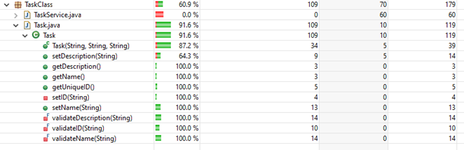

Starting here is where all my came into play and shows the organization of my code. This also shows the techniques that I utilized in my code and the outcome of a test. This type of coding allows for others that do not understand code to be able to read it without getting lost on the end goal of the project. I hope to improve even more as I continue my journey in my classes and in this field.

I truly believe that everything happens for a reason and all the work that I am putting into my classes will be well worth it in the end. Through all the struggles I have had to endure this year I know that one day you will see me do great things with this degree. I have enjoyed every bit of this class and I hope that I can continue to learn as much as I can before I start in this amazing field of tech.

