Project Proposal

BProtective

Nguyen Huu Phuc Trinh

September 9, 2020

1. **Description**

BProtective’s main purpose is to ensure the safety of its users. There are 3 states of status users can set depends on different situations such as “Safe”, “Feeling Unsafe”, and “Emergency”. BProtective will have “Bond” functionality, which means users bond and share their locations as well as current statuses; it could be parents to children, siblings, or friends to friends.

To break down the 3 statuses:

1. Safe: Users are feeling safe and their location is hidden from surrounded users (strangers) but display for their bonds (depends on privacy settings).
2. Unsafe: Users are still safe but feeling threaten by someone or surrounded environment. Users can share their status and locations to their bonds depends on privacy settings.
3. Emergency: Users are currently in emergency mode and desperately for help. BProtective will send alarm to all surrounded users, so the neighborhoods within the parameter can help. Also, BProtective will call emergency parallelly.

To break down 3 types of Users in BProtective:

1. Normal Users: Can sign up and be able to set their statuses, be protected and bond with other users.
2. Authority: Be able to view the list of current emergency signals and the map would lead the authority toward emergency signal if they chose to process it.
3. Admin: Be able to add and remove authorities, ban users (fake emergency alarm), as well as analyze the statuses based on area.
4. **Operation System**
5. Mobile (iOS, Android): Mainly for Normal Users. Authority can check emergency list and showing paths to lead toward that emergency signal.
6. Website: For Admin and Authorities. Admin can add, remove authorities and ban users. Also, the analyzation of signals will be view and done on website.

1. **Programming Languages (Can be changed)**

iOS: Swift 5

Android: Java

Web: Flask (Python framework for web backend)

Database: Firebase (Easier to work with multi-platform)

1. **Use Cases**

|  |  |  |  |
| --- | --- | --- | --- |
| **Use Case #** | **Name** | **Actor** | **Description** |
| 1 | Sign up | Normal User | Anna feels like she need to know where her children are and want to constantly check on them as she worries to sick after seeing the crimes on the news or Amber Alert, she cannot concentrate on her work. So, she downloaded BProtective and created an account for herself as well as asked her children to do so. |
| 2 | Bond | Normal User | Anna bonds her account with her children so she knows where they are as well as knowing what their statuses is. Are they safe? Feeling unsafe or currently having an emergency. |
| 3 | Set status (safe as default) | Normal User | Bella is at school, she wants to let her parents know that she is currently fine, she sets the status to safe, so her parents know that she is currently at school and safe. |
| 4 | Set status (Unsafe) | Normal User | Jane left the library and realized it is almost midnight. She walks home and the area is kind of dark due to lack of lights. She sets her status to Unsafe; her parents can see it know that she is currently feeling unsafe. |
| 5 | Set Status (Emergency) | Normal User | Tommy is busy, his only free time is at night, and he usually jogs around that time. All the sudden, someone draws weapons on him and tries to steal his belonging. Tommy quickly set the status to emergency, now everyone knows Tommy is in danger. Neighborhood came out to help him out instantly. Tommy is now safe. |
| 6 | Add Authorities | Admin | Torry had been requested by authorities to create and approve accounts for Police departments. So he did as requested. |
| 7 | Ban Users | Admin | Torry had saw few reports about a user with ID 112233 had been turning on Emergency alarm “for fun”. Torry sent out a notice and banned that account for 2 weeks. Next time it would be a permanent ban. |
| 8 | Analyze Status | Admin | Every month, Torry does an analyze on different areas to see if that area is safe or not. Then he will report that to the authority. |
| 9 | View Emergency and approach | Authority | Holland is on his watch at night, driving around the area. He suddenly received an emergency displaying on BProtective, he immediately choose to show the path toward the victim(s). |

1. **Diagrams**

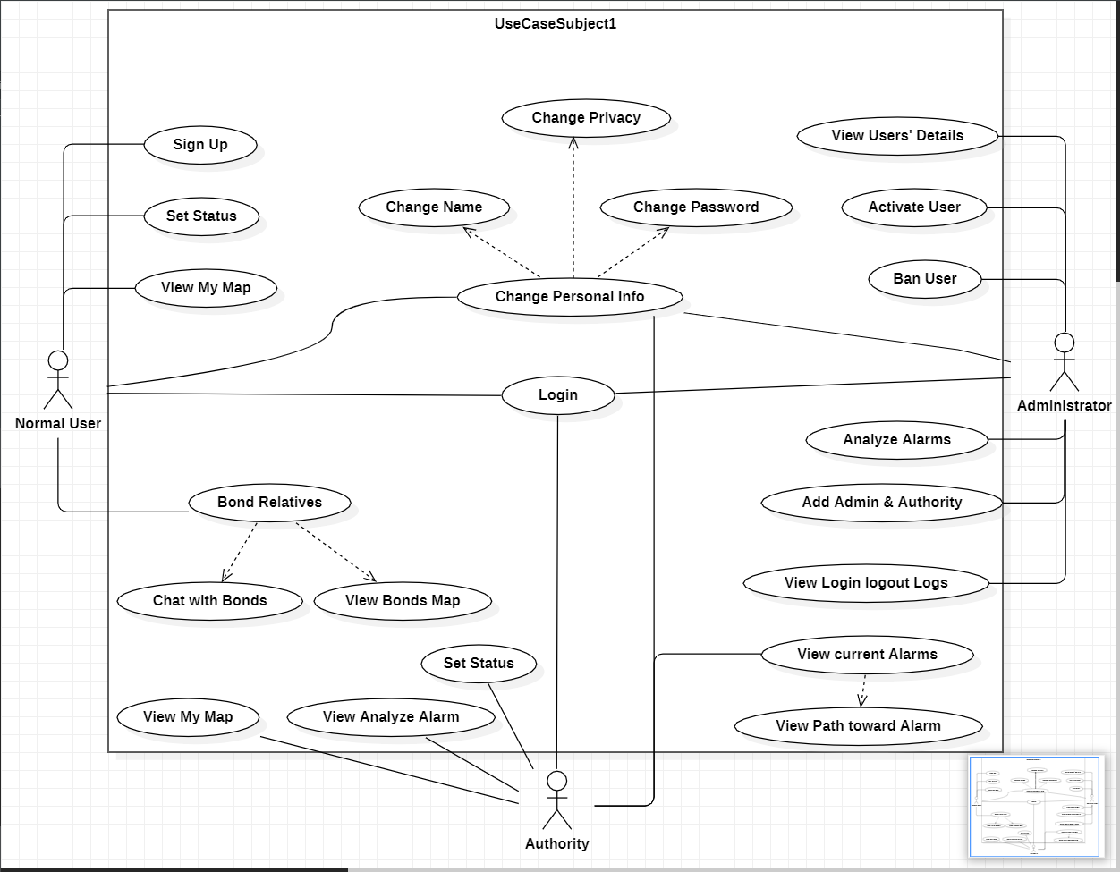

*Use Case Diagram*

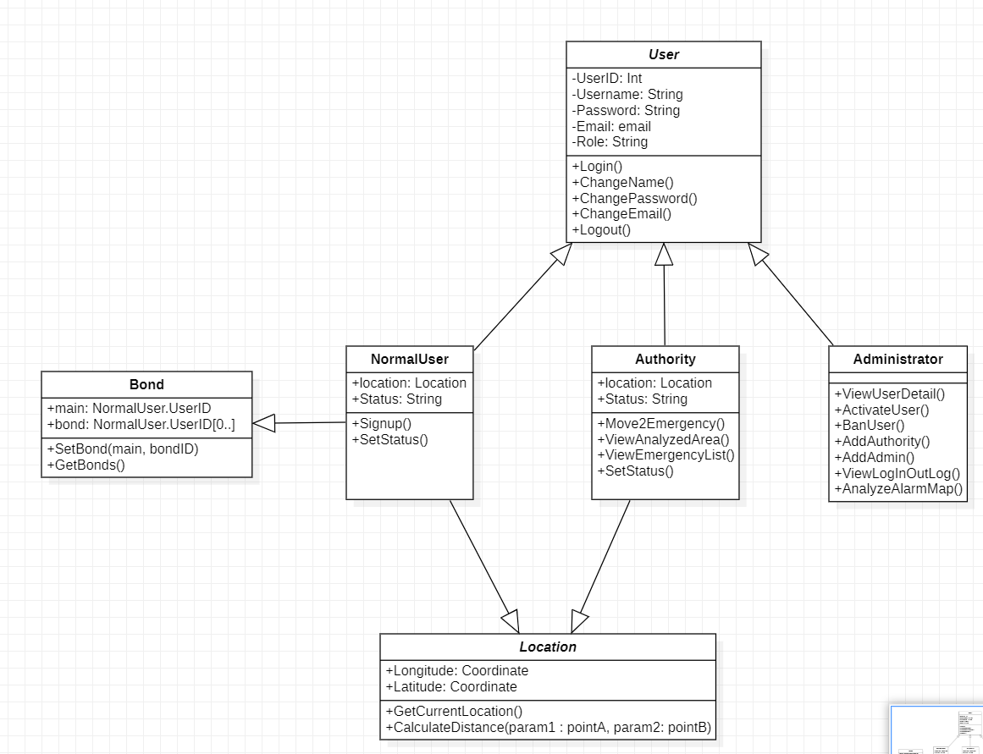

*Class Diagram*

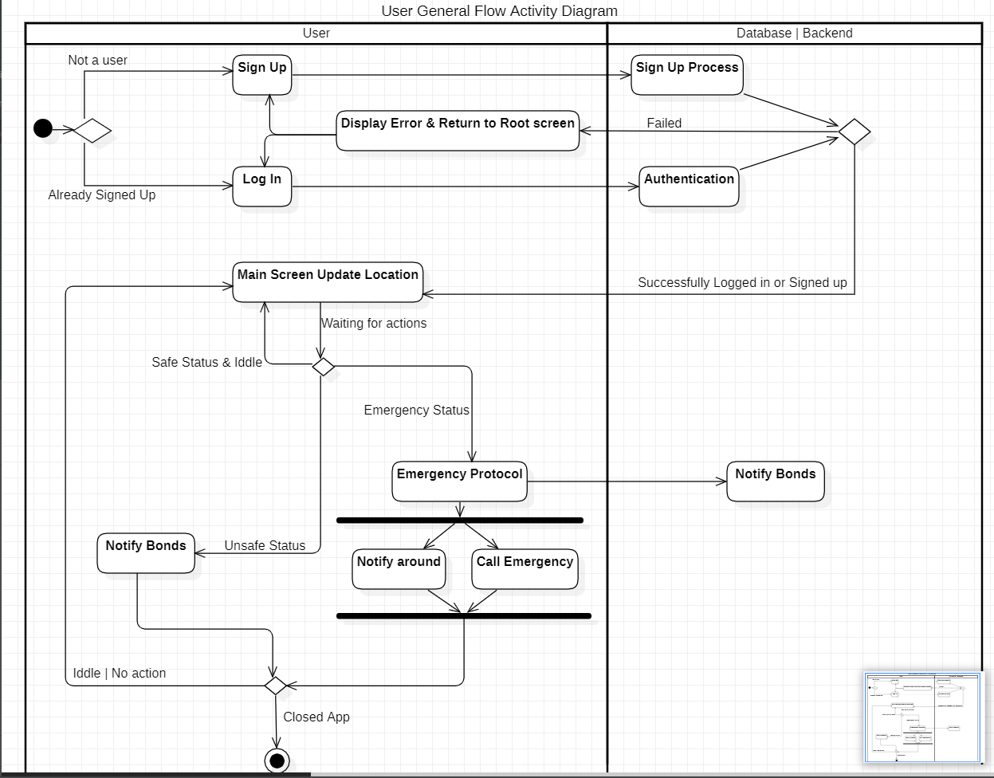

*User General Flow Activity Diagram*

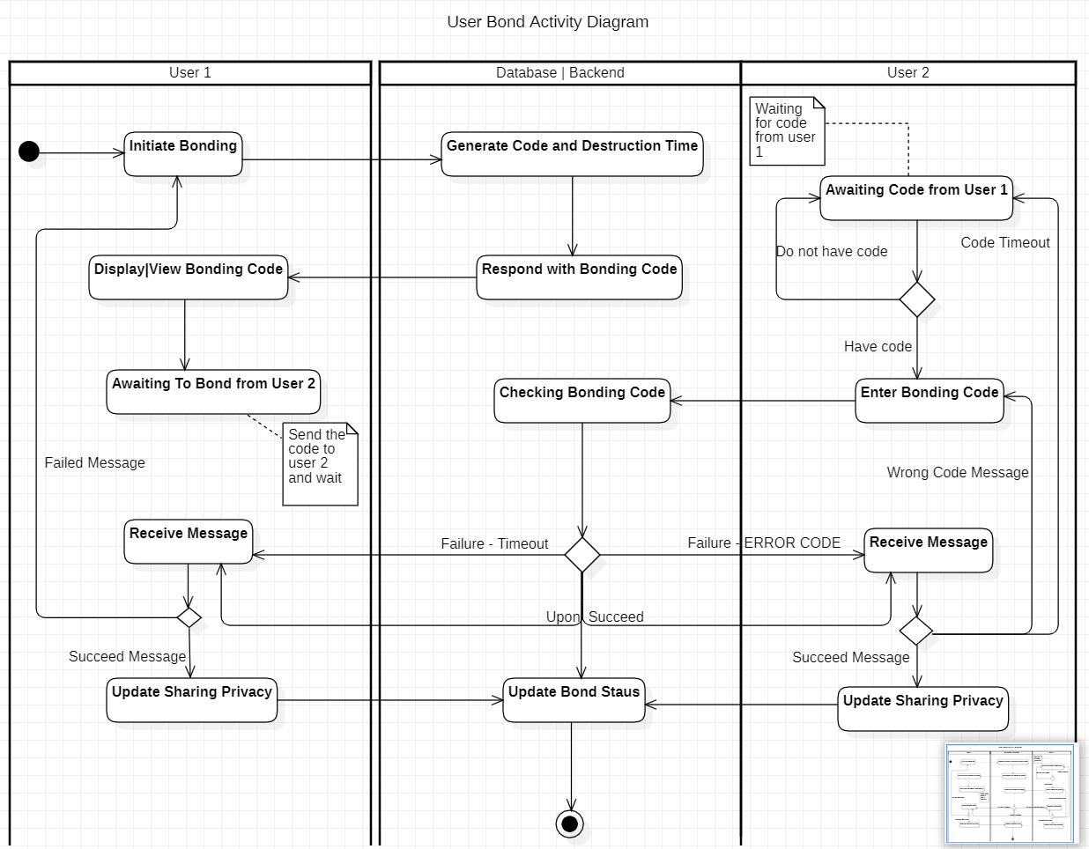

*User Bond Activity Diagram*

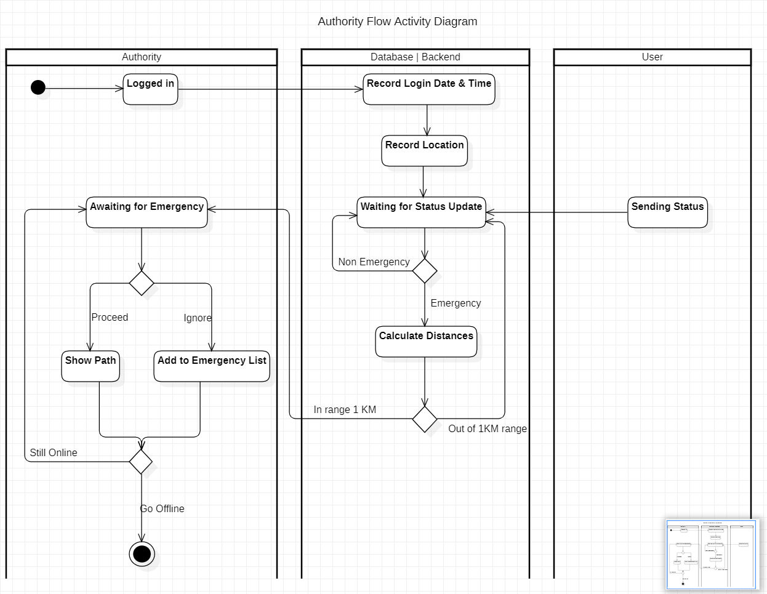

*Authority Flow Activity Diagram*