**安卓个人博客**

题 目**： 乐学成语**

|  |  |
| --- | --- |
| 系 院 | 信息工程系 |
| 专 业 | 软件技术 |
| 班 级 | 2014级2班 |
| 姓 名 | 尹越 |
| 学 号 | 1423111006 |
| 指导教师 | 冯君 |

2016年06月12日

博客一

乐学成语之拼成语游戏

今天讲一篇关于成语的小游戏的开发。

1. 项目中新建一个Activity，命名为GameActivity。
2. 首先在布局文件中设计一下基本的控件布局。

我们需要上方并排的四个TextView控件，其父容器为横向LinearLayout，设置TextView长宽相同，文本默认为“·”，大小为40sp。

<LinearLayout

android:id=*"@+id/linearLayout2"*

android:layout_width=*"fill_parent"*

android:layout_height=*"wrap_content"*

android:layout_alignParentLeft=*"true"*

android:layout_alignParentTop=*"true"*

android:orientation=*"horizontal"* >

<TextView

android:id=*"@+id/game_str1"*

android:layout_width=*"50dp"*

android:layout_height=*"50dp"*

android:layout_margin=*"5dp"*

android:layout_weight=*"1"*

android:background=*"#f0f0f0"*

android:gravity=*"center"*

android:text=*"@string/gameStr1"*

android:textAppearance=*"?android:attr/textAppearanceLarge"*

android:textColor=*"#000000"*

android:textSize=*"40sp"* />

<TextView

android:id=*"@+id/game_str2"*

android:layout_width=*"50dp"*

android:layout_height=*"50dp"*

android:layout_margin=*"5dp"*

android:layout_weight=*"1"*

android:background=*"#f0f0f0"*

android:gravity=*"center"*

android:text=*"@string/gameStr2"*

android:textAppearance=*"?android:attr/textAppearanceLarge"*

android:textColor=*"#000000"*

android:textSize=*"40sp"* />

<TextView

android:id=*"@+id/game_str3"*

android:layout_width=*"50dp"*

android:layout_height=*"50dp"*

android:layout_margin=*"5dp"*

android:layout_weight=*"1"*

android:background=*"#f0f0f0"*

android:gravity=*"center"*

android:text=*"@string/gameStr3"*

android:textAppearance=*"?android:attr/textAppearanceLarge"*

android:textColor=*"#000000"*

android:textSize=*"40sp"* />

<TextView

android:id=*"@+id/game_str4"*

android:layout_width=*"50dp"*

android:layout_height=*"50dp"*

android:layout_margin=*"5dp"*

android:layout_weight=*"1"*

android:background=*"#f0f0f0"*

android:gravity=*"center"*

android:text=*"@string/gameStr4"*

android:textAppearance=*"?android:attr/textAppearanceLarge"*

android:textColor=*"#000000"*

android:textSize=*"40sp"* />

</LinearLayout>

与这个LinearLayout平行的仔放置一个纵向LinearLayout，再在其中放置两个横向LinearLayout，接下来在最里面的两个LinearLayout中分别放置两个Button。这样就可以使最里面的Button展现出“田”字结构来，方便选择。Button注意也要长款相等且适中。

<LinearLayout

android:id=*"@+id/linearLayout1"*

android:layout_width=*"wrap_content"*

android:layout_height=*"wrap_content"*

android:layout_centerHorizontal=*"true"*

android:layout_centerVertical=*"true"*

android:orientation=*"vertical"* >

<LinearLayout

android:layout_width=*"match_parent"*

android:layout_height=*"wrap_content"* >

<Button

android:id=*"@+id/game_show_str1"*

android:layout_width=*"100dp"*

android:layout_height=*"100dp"*

android:layout_margin=*"2dp"*

android:layout_weight=*"1"*

android:background=*"#f0f0f0"*

android:gravity=*"center"*

android:text=*"@string/gameShowStr1"*

android:textColor=*"#000000"*

android:textSize=*"60sp"* />

<Button

android:id=*"@+id/game_show_str2"*

android:layout_width=*"100dp"*

android:layout_height=*"100dp"*

android:layout_margin=*"2dp"*

android:layout_weight=*"1"*

android:background=*"#f0f0f0"*

android:gravity=*"center"*

android:text=*"@string/gameShowStr2"*

android:textColor=*"#000000"*

android:textSize=*"60sp"* />

</LinearLayout>

<LinearLayout

android:layout_width=*"match_parent"*

android:layout_height=*"wrap_content"* >

<Button

android:id=*"@+id/game_show_str3"*

android:layout_width=*"100dp"*

android:layout_height=*"100dp"*

android:layout_margin=*"2dp"*

android:layout_weight=*"1"*

android:background=*"#f0f0f0"*

android:gravity=*"center"*

android:text=*"@string/gameShowStr3"*

android:textColor=*"#000000"*

android:textSize=*"60sp"* />

<Button

android:id=*"@+id/game_show_str4"*

android:layout_width=*"100dp"*

android:layout_height=*"100dp"*

android:layout_margin=*"2dp"*

android:layout_weight=*"1"*

android:background=*"#f0f0f0"*

android:gravity=*"center"*

android:text=*"@string/gameShowStr4"*

android:textColor=*"#000000"*

android:textSize=*"60sp"* />

</LinearLayout>

</LinearLayout>

再在外层添加一个Button

和一个TextView分别作测试按钮和记分控件

<Button

android:id=*"@+id/button1"*

android:layout_width=*"wrap_content"*

android:layout_height=*"wrap_content"*

android:layout_alignParentBottom=*"true"*

android:layout_alignRight=*"@+id/linearLayout1"*

android:onClick=*"test"*

android:text=*"测试"* />

<TextView

android:id=*"@+id/myscore"*

android:layout_width=*"wrap_content"*

android:layout_height=*"wrap_content"*

android:layout_alignRight=*"@+id/linearLayout2"*

android:layout_below=*"@+id/linearLayout2"*

android:layout_marginRight=*"10dp"*

android:layout_marginTop=*"27dp"*

android:textColor=*"#ff0000"*

android:text=*"分数：0"* />

示例图如下：

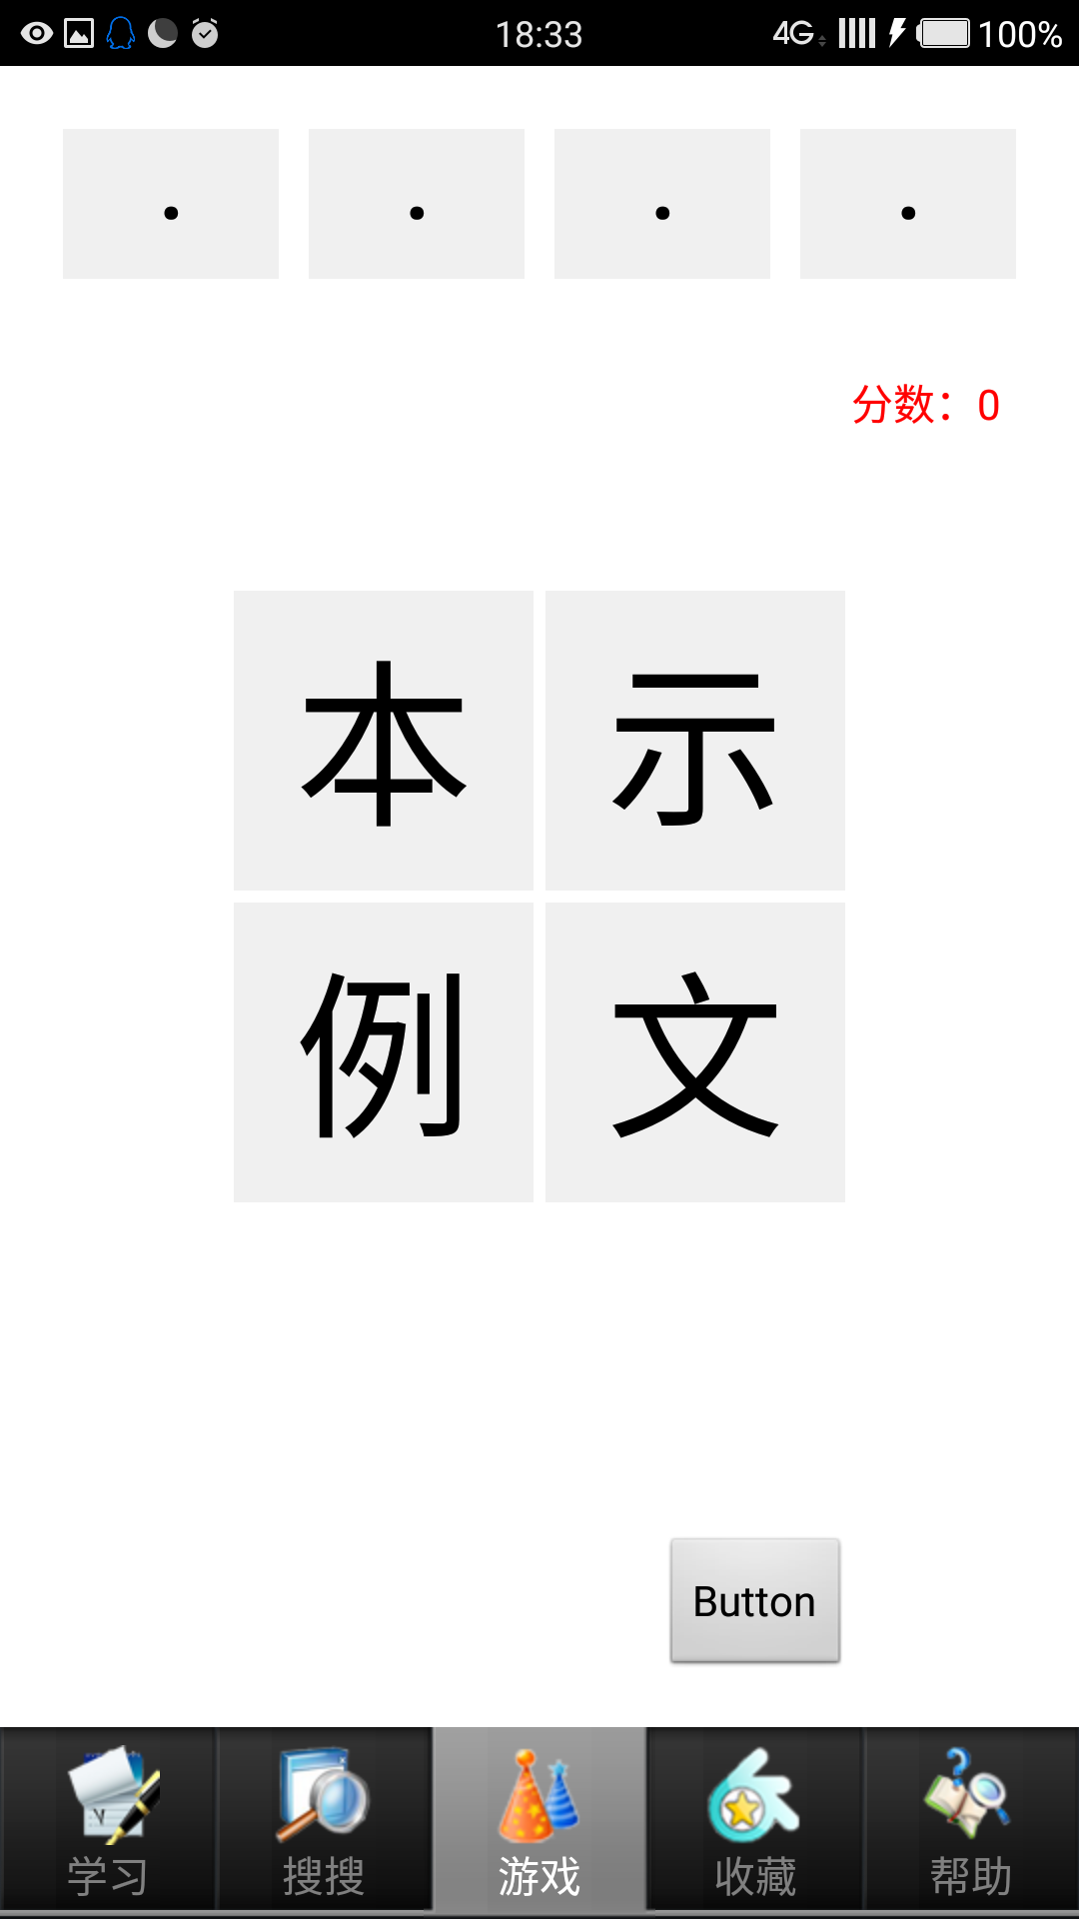

二、

首先，我们对四个TextView和四个Button分别定义，并在OnCreate()方法里分别初始化，对Button进行监听。

String idiomStr = "";

**private** TextView game_str1, game_str2, game_str3, game_str4;

**private** Button game_show_str1, game_show_str2, game_show_str3,

game_show_str4;

**int** nowPosition = 0;

**int** score = 0;

@Override

**protected** **void** onCreate(Bundle savedInstanceState) {

**super**.onCreate(savedInstanceState);

setContentView(R.layout.*activity_game*);

game_str1 = (TextView) findViewById(R.id.*game_str1*);

game_str2 = (TextView) findViewById(R.id.*game_str2*);

game_str3 = (TextView) findViewById(R.id.*game_str3*);

game_str4 = (TextView) findViewById(R.id.*game_str4*);

game_show_str1 = (Button) findViewById(R.id.*game_show_str1*);

game_show_str2 = (Button) findViewById(R.id.*game_show_str2*);

game_show_str3 = (Button) findViewById(R.id.*game_show_str3*);

game_show_str4 = (Button) findViewById(R.id.*game_show_str4*);

MyButton listener = **new** MyButton();

game_show_str1.setOnClickListener(listener);

game_show_str2.setOnClickListener(listener);

game_show_str3.setOnClickListener(listener);

game_show_str4.setOnClickListener(listener);

}

**class** MyButton **implements** OnClickListener {// 匿名内部类

**public** **void** onClick(View view) {

**switch** (view.getId()) {

**case** R.id.*game_show_str1*:

showMyAnswer(game_show_str1.getText().toString());

**break**;

**case** R.id.*game_show_str2*:

showMyAnswer(game_show_str2.getText().toString());

**break**;

**case** R.id.*game_show_str3*:

showMyAnswer(game_show_str3.getText().toString());

**break**;

**case** R.id.*game_show_str4*:

showMyAnswer(game_show_str4.getText().toString());

**break**;

}

}

}

**public** **void** showMyAnswer(String str) {// 显示选中的文字

**switch** (nowPosition) {

**case** 0:

game_str1.setText(str);

nowPosition++;

**break**;

**case** 1:

game_str2.setText(str);

nowPosition++;

**break**;

**case** 2:

game_str3.setText(str);

nowPosition++;

**break**;

**case** 3:

game_str4.setText(str);

nowPosition++;

**break**;

}

**if** (nowPosition > 3) {

nowPosition = 0;

judgeAnswer();

}

}

**public** **void** judgeAnswer() {

String myAnswer = game_str1.getText().toString()

+ game_str2.getText().toString()

+ game_str3.getText().toString()

+ game_str4.getText().toString();

Log.*e*("GameActivity", "name=" + myAnswer + "=" + idiomStr);

// 模式1

**if** (idiomStr.equals(myAnswer)) {// 将我的答案和标准答案比对

// 成功

score++;

TextView textview = (TextView)findViewById(R.id.*myscore*);

textview.setText("分数："+score);

} **else** {

// 失败

}

**try** {

Thread.*sleep*(100);

} **catch** (InterruptedException e) {

// **TODO** Auto-generated catch block

Toast.*makeText*(GameActivity.**this**, e.toString(),1).show();

}

game_str1.setText("·");

game_str2.setText("·");

game_str3.setText("·");

game_str4.setText("·");

getIdiom();

}

@Override

**public** **boolean** onCreateOptionsMenu(Menu menu) {

// Inflate the menu; this adds items to the action bar if it is present.

getMenuInflater().inflate(R.menu.*game*, menu);

**return** **true**;

}

**public** **void** test(View view) {

getIdiom();

}

**public** **void** getIdiom() {// 在选项区显示随机的成语

AnimalDao ad = AnimalDao.*getInstance*(**this**);

/**

* 随机数

*/

idiomStr = ad.getOneRandomAnimal();

**char**[] stringArr = idiomStr.toCharArray();

Random random = **new** Random();

**int** rs[] = **new** **int**[4];

**for** (**int** i = 1; i < rs.length; i++) {

rs[i] = random.nextInt(4);

**for** (**int** j = 0; j < i; j++) {

**if** (rs[i] == rs[j]) {

i--;

}

}

}

// for (int i = 0; i < rs.length; i++) {

// System.out.println(rs[i] + " ");

// }

game_show_str1.setText(String.*valueOf*(stringArr[rs[0]]));

game_show_str2.setText(String.*valueOf*(stringArr[rs[1]]));

game_show_str3.setText(String.*valueOf*(stringArr[rs[2]]));

game_show_str4.setText(String.*valueOf*(stringArr[rs[3]]));

}

