Title of Paper: Secondary Title

Your Name(s)

Dept. of Electrical Engineering and Computer Science  
York University

Toronto, Ontario, Canada M3J 1P3  
your_email_address(es)

# ABSTRACT

Write the abstract last. It should be a single paragraph of about 150 words. In the abstract, tell the reader *what you did* and *what you found*. Writing in the past tense is preferred, since you are telling the reader what you did, not what you are doing or plan to do. On "what you found", focus on the most salient result(s). A common mistake in preparing an abstract is treating it as an introduction to the paper. An abstract is not an introduction! However, if it improves the flow or if the topic is truly obscure, then perhaps one introductory sentence can be included. But, get to the point: tell the reader what you did and what you found.

## Keywords

Include a few keywords, separated by commas

# INTRODUCTION

The opening section of a research paper is typically called Introduction, although other labels, such as Background, are fine as well. The introduction gives the context for the research. Usually opening comments characterize the state of the art and indicate why the subject matter is interesting and relevant. A user interface problem or challenge is identified and the reader is alerted, early on, to the solution that is developed in the rest of the paper. It is common practice to give an overview of the contents of the entire paper, usually at a convenient place within the first page or so of the introduction.

The introduction may span several sections. Any reasonable organization is fine. Subsequent sections may use the same level of heading as the introduction. Sub-sections may be added, as appropriate. It’s your story to tell! Take liberties to prepare and organize the introduction as you see fit.

Usually a literature review is expected. This is typically organized in a separate section, with an appropriate heading (e.g., Related Work). The literature review discusses earlier published work related to the subject matter of the research. Points relevant to the current research are presented. A citation is included for any previous work mentioned. Include figures, charts, or tables, as appropriate.

The main ideas developed in the paper should be laid out in detail. Use formulas, screen snaps, sketches, or any appropriate visual aid to help the reader understand the solution to a problem that the research presents.

## About This Template

This template is modeled after that for papers submitted to the ACM's annual "*CHI*" conference, formally called the *ACM Conference on Human Factors in Computing Systems*. Refer to papers in the *CHI* proceedings for examples on formatting and presenting ideas. These can be found in the ACM Digital Library (http://portal.acm.org/dl.cfm) or Google Scholar (http://scholar.google.com/).

## Writing Style

Research papers are written in English. Spelling and punctuation may use any dialect of English (e.g., British, Canadian, US, etc.) provided this is done consistently. Hyphenation is optional. To ensure suitability for an international audience, please pay attention to the following:

* Write in a straightforward style.
* Try to avoid long or complex sentence structures.
* Briefly define or explain all technical terms that may be unfamiliar to readers.
* Spell out all acronyms the first time they are used – e.g., “Digital Signal Processing (DSP)”.
* Explain local references (e.g., not everyone knows city names in a particular country).
* Explain “insider” comments. Ensure that the audience understands any reference whose meaning is not described (e.g., do not assume that everyone has used a Macintosh or a particular application).
* Explain colloquial language and puns. Understanding phrases like “red herring” may require a local knowledge of English. Humor and irony are difficult to translate.
* Use unambiguous forms for culturally localized concepts, such as times, dates, currencies and numbers (e.g., “1-5-97” or “5/1/97” may mean 5 January or 1 May, and “seven o’clock” may mean 7:00 am or 19:00). For currencies, indicate equivalences – e.g., “Participants were paid 10,000 lire, or roughly $5.”
* Be careful with the use of gender-specific pronouns (*he*, *she*) and other gendered words (*chairman*, *manpower*, *man-months*). Use inclusive language that is gender-neutral (e.g., *she* *or* *he*, *they*, *s/he*, *chair*, *staff*, *staff-hours*, *person-years*).
* If possible, use the full (extended) alphabetic character set for names of persons, institutions, and places (e.g., Grønbæk, Lafreniére, Sánchez, Universität, Weißenbach, Züllighoven, Århus, etc.). These characters are already included in most versions of the Times, Helvetica, and Arial fonts.
* Write in the third person, not the first person. For example, “participants were asked to complete a questionnaire” is preferred over “I asked participants to complete a questionnaire”.
* Do not refer directly to the reader via "you". For example, “when installing an application…” or "when the user installs an application…" is preferred over “when you install an application…”.

On writing style (including rules for punctuation, etc.), Strunk and White’s *The Elements of Style* is recommended [8]. For example, their Rule 17 is "Omit needless words". The goal is to remove extra words that add nothing. Instead of "the time it takes to compose a message…", write "the time to compose a message…".

## Mechanics of Style

Prepare your report using the styles in the template, without modification. Do not pad with white space. Work within the template format. Leave the spacing between paragraphs and lines as is.

Since a figure (and its caption) occupy considerable vertical space, the manuscript might have some unused whitespace at the bottom of columns where figures were pushed to the next column. That's fine while writing and editing. However, after the manuscript is finished, or near finished, make final adjustments to the positions of figures to avoid whitespace at the bottom of columns.

### Punctuation

Proper punctuation includes use of the period, comma, semicolon, dash, quotation marks, parentheses, etc. There are many sources on the correct use of punctuation. For researchers in human-computer interaction, the *Publication Manual of the American Psychological Association* (APA) is essential [1]. Information is also available on the Internet. As an example, try searching on “how to use a comma” (in quotations).

Commas are often incorrectly used. Do not insert a comma, simply because you think a pause is needed in the flow of the sentence. There is always a structural reason – a rule – for the use of a comma.

A common use of commas is to set off a parenthetical clause. A parenthetical clause is a phrase that is added to provide extra information. For example: “Human-computer interaction, a field that extends back more than 30 years, is studied in most universities.” Note that the sentence is grammatically intact if the parenthetic clause is removed. As in the example just given, commas are used to set off the parenthetical clause. For a small parenthetical clause, the commas may be omitted if the disruption to the flow of the sentence if minor. However, never use just one of the commas: use both, or none.

Of course, this template would greatly expand if paragraphs such as the above were included for every punctuation mark and every formatting rule. Please consult the APA manual (see above) or related references available on the Internet. However, a few additional points of style are worth mentioning.

### Mathematical Expressions and Numerals

One would not write, “fiveplusevenequalstwelve”. Similarly, it is incorrect to write “5+7=12”. Use spaces in mathematical expressions, as you would in crafting sentences: 5 + 7 = 12. This applies to a number with units: 5 cm.

Generally, numbers less than ten are spelled out (e.g., “The task was repeated five times.”), whereas numbers 10 or above are set as numerals (e.g., “The 12th trial was repeated.”). But, there are many exceptions. Try an Internet search on “APA Style” for further information.

### Variables and Italics

Always set variables in italics: *x* = 33 pixels. The exception is Greek letters used as variables; set plain: σ = 1.32 cm.

Speaking of italics, one tip for style is to set the name of a company plain, but the name of a company's product in italics. Examples include Microsoft *Windows 7*, Samsung *Galaxy Tab 10.1*, or Nintendo *DS Lite*.

If a company or organization is mentioned that readers will likely not know, give the URL, perhaps in a footnote. Here's an example: The evaluation used the *Fitaly* soft keyboard from Textware Solutions.[1]

### Nitpicky Details

Use “for example,” within a sentence but “e.g.,” within parentheses. In the latter case, always set as e-PERIOD-g-PERIOD-COMMA, and not in italics.

A common abbreviation for “that is,” is “i.e.,”. Always set as shown here: i-PERIOD-e-PERIOD-COMMA.

A common abbreviation for “and others” is “et al.”. Always set as shown here.

## Citations and References

Citations and references are the connections that tie research together. References are listed at the end in a separate section. The list is numbered and sorted by the first author's surname. The list herein includes examples of correctly-formatted references for each of the most common sources. These include a full book [4], a chapter in a book [2], a conference paper [7], a journal paper [3], a magazine article [10], and a web page [9].

Note that the reference list is aligned left, unlike the rest of the paper which is justified.

If space is limited, abbreviate the names of conferences or journals (e.g., *Proc CHI '08*). If space allows, give the full name (e.g., *Proceedings of the ACM SIGCHI Conference on Human Factors in Computing Systems – CHI 2008*). Consistently use one style or the other for all references.

Only sources cited in the paper should appear in the reference list.

There are several ways to correctly cite a source. This is largely a matter of style – how you wish to present and organized the discussion. An author may be named, for example, “Grudin [2] provided a detailed analysis of typing errors”. However, only use family names (i.e., it is incorrect to write “Jonathan Grudin [2] provided…”).

If there are three or more authors, cite as follows: “Two-handed interaction was studied by Hinckley et al. [3]”.

Often, the authors are not specifically named, for example, “This deficiency has been noted in previous research [3].” Do not restate the title of the article or book; just state the point you wish to make and cite the source.

Do not treat citations as nouns. The following is incorrect: “Two-handed interaction was analysed in [3]”. Instead, present as follows: “Two-handed interaction was analysed by Jones [3].” There is an exception. Within parentheses, citations may be treated as nouns: “Other researchers report similar results (see [1] for a review)”.

Include a specific page number when directly quoting from a source, for example, "Jones and Smith argue and that "research is not finished until the results are published" [5, p. 321]". A page number should also be included when citing a specific point from a book, for example, "Norman, provides a distinction between errors and slips [8, p. 43]".

Consider using a tool for "managing" citations and references. *EndNote* is recommended.[2]

# METHOD

If the methodology in the research involves data collection and follows either a *correlational*, *observational*, or *experimental* methodology (see [4], chap. 4), there will be a section following the introduction with a level-1 heading called "METHOD". It describes the methodology used in the research. Other titles are sometimes used, such as "METHODOLOGY", "USER STUDY", or "EXPERIMENT".

## Participants

The first sub-section in the method section is called "Participants". Indicate the number of participants, the population from which they were drawn, and how they were selected. Give relevant demographic information, such as age and gender, and any other pertinent information, such as prior experience related to the topic. Indicate if they were paid, volunteered or if there was some other incentive for participating.

## Apparatus

The next subsection is called "Apparatus". Other titles can be used, such as “Hardware and Software”. Describe the hardware and software used in the research.

Use figures, photos, or screen snaps if they might help the reader understand the materials used in the experiment. An example is given in Figure 1, using the same caption as in the original publication [6]. All figures must be cited and referred to in the text. As a general rule, figures are positioned at a convention location after they are first cited in the text.

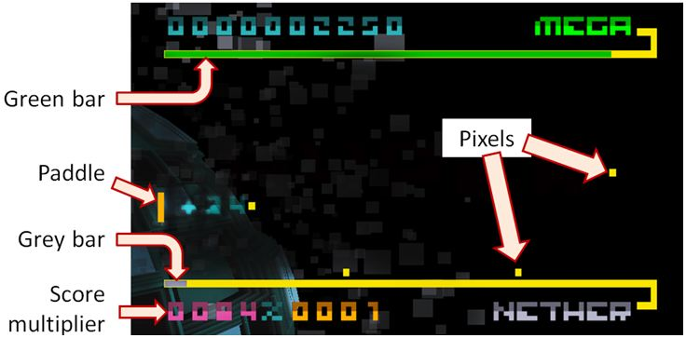

Figure 1. Screenshot of *Bit.Trip Beat* in level 1-1.

Figures should *not* be set within the text of a paragraph. Use the full column width for all figures, as in Figure 1.

Note that Figure 1 includes annotations to the screenshot. Annotations are a powerful way to clarify and highlight the key points that are illustrated in a figure. So, use annotations. The reader will benefit from the added information they provide.

An important criterion for research is “reproducibility”. Research that cannot be reproduced is useless. Include sufficient detail in the Apparatus section so that an experience researcher could reproduce the research if he or she chose. Do not overdo it. Give sufficient and required details, but nothing more.

## Procedure

In the procedure section, indicate what the participants did. Make sure the experiment task is clearly described. An over-the-shoulder photo showing a participant doing the experiment task is helpful. An example is shown in Figure 2, using the same caption as in the original publication [5].

Restate any instructions given to participants or if they were allowed to practice (for experiments gathering performance data). Indicate approximately how long the experiment took for each participant.

As with the Apparatus section, think of reproducibility when writing the Procedure section.

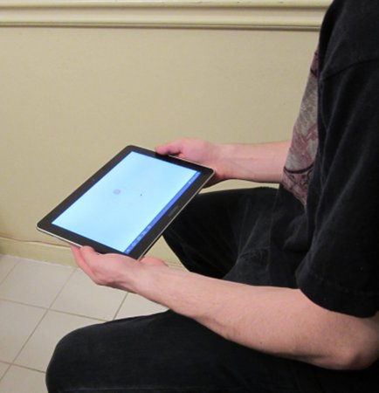

Figure 2. A participant performing the tilt-based position-select task.

## Design

The last sub-section in the Method section is called Design. Here, the design of the experiment is described, often beginning with a succinct summary, such as "The user study employed a 2 × 5 within-subjects design".

Name the independent variables and give the levels of each independent variable. A convenient and helpful way to do this is through a bulleted list (see [6] for an example).

Name the dependent variables. Most commonly, dependent variables are variations on speed and accuracy. Often the reciprocal is used: time (or task completion time) and error rate (again, see [6] as an example). Provide extra details, as necessary, to ensure each dependent variable is clearly defined (i.e., the exact way measurements were gathered).

Conclude the Design section with an overview statement that calculates and states the total number of trials in the user study. An example (from [6]) is "The total number of trials was 18 participants × 2 input methods × 5 trials = 180 trials.".

It is recommend you consult papers from the CHI conference proceedings for examples of what information to include and how to include it.

# RESULTS AND DISCUSSION

Give and discuss the results in the next section. Begin with overall results and work towards more detailed results. Use charts, figures, or tables, as appropriate. Use subsections, as appropriate. Again, it's your story to tell.

Figures and tables are numbered and include a caption. As a general rule, captions for figures are located below the figure, whereas captions for tables are located above the table. Locate figures and tables close to, but after, the place where they are first cited. Do not use expressions such as “The figure below shows…”. Cite as follows: “Figure 1 shows…”. The following is an example of how to cite and discuss information presented in a figure: “As seen in Figure 3, entry speed was higher for females than for males. The mean entry speed for females was 26.8 wpm, which was 14.0% higher than the speed of 23.5 wpm observed for males.”

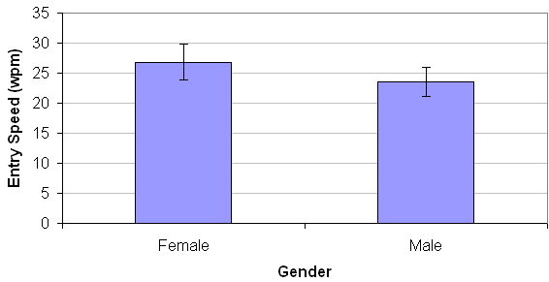

Figure 3. Entry speed (wpm) by gender.

Try to explain the results. If you found that a relationship exists or doesn't exist, explain why.

The results of statistical tests are included in parentheses. For the example above, the following might be added: “The difference was statistically significant (*F*1,5 = 6.87, *p* < .05)”.

# CONCLUSION

Finish with a conclusion. Restate the important findings. Suggest future work or improvements to the research.

# ACKNOWLEDGMENT

This section is optional. You can thank people or funding agencies who helped with the research.

# REFERENCES

1. APA, *Publication manual of the American Psychological Association*, 6th ed. Washington, DC: APA, 2010.

2. Grudin, J. T., Error patterns in novice and skilled transcription typing, in *Cognitive aspects of skilled typing*, (W. E. Cooper, Ed.). New York: Springer, 1983, 121-143.

3. Hinckley, K., Pausch, R., Proffitt, D., and Kassell, N. F., Two-handed virtual manipulation, *ACM Transactions on Computer-Human Interaction*, *5*, 1998, 260-302.

4. MacKenzie, I. S., *Human-computer interaction: An empirical research perspective*. Waltham, MA: Morgan Kaufmann, 2013.

5. MacKenzie, I. S. and Teather, R. J., FittsTilt: The application of Fitts' law to tilt-based interaction, *Proceedings of the 7th Nordic Conference on Human-Computer Interaction - NordiCHI 2012*, (New York: ACM, 2012), 568-577.

6. Medryk, S. and MacKenzie, I. S., A comparison of accelerometer and touch-based input for mobile gaming, *Proceedings of the International Conference on Multimedia and Human-Computer Interaction - MHCI 2013*, (Ottawa, Ontario: ASET, Inc, 2013), 117.1-117.8.

7. Pino, A., Tzemis, E., Ioannou, N., and Kouroupetroglou, G., Using Kinect for 2D and 3D pointing tasks: Performance evaluation, *Proceedings of Human-Computer Interaction International - HCII 2013*, (Berlin: Springer, 2013), 358-367.

8. Strunk, W., Jr. and White, E. B., *The elements of style*, 4th ed. Needham Heights, MA: Pearson, 2000.

9. Taylor&Francis, *HCI style guidelines for final submissions*, <http://www.tandf.co.uk/journals/authors/HHCIguidelines.pdf>, (accessed 7 February 2012).

10. Weiser, M., The computer for the 21st century, *Scientific American*, (1991, September), 94-105.

1. http://www.textware.com/
2. www.endnote.com