影像擷取器

1. 介面設計

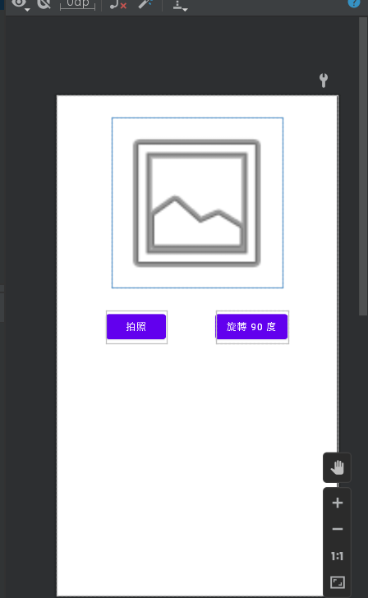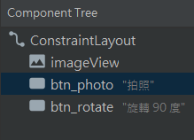

**2.程式設計**

**package com.italkutalk.lab11_2**

**import android.content.ActivityNotFoundException**

**import android.content.Intent**

**import android.graphics.Bitmap**

**import androidx.appcompat.app.AppCompatActivity**

**import android.os.Bundle**

**import android.provider.MediaStore**

**import android.widget.Button**

**import android.widget.ImageView**

**import android.widget.Toast**

**class MainActivity : AppCompatActivity() {**

**private var angle = 0f**

**//取得返回的影像資料**

**override fun onActivityResult(requestCode: Int, resultCode: Int, data: Intent?) {**

**super.onActivityResult(requestCode, resultCode, data)**

**//識別返回對象及執行結果**

**if (requestCode == 0 && resultCode == RESULT_OK) {**

**//取得影像並顯示於 ImageView**

**val image = data?.extras?.get("data") ?: return**

**findViewById<ImageView>(R.id.imageView).setImageBitmap(image as Bitmap)**

**}**

**}**

**override fun onCreate(savedInstanceState: Bundle?) {**

**super.onCreate(savedInstanceState)**

**setContentView(R.layout.activity_main)**

**findViewById<Button>(R.id.btn_photo).setOnClickListener {**

**//建立一個要進行影像獲取的 Intent 物件**

**val intent = Intent(MediaStore.ACTION_IMAGE_CAPTURE)**

**//用 try-catch 避免例外產生，若產生則顯示 Toast**

**try {**

**startActivityForResult(intent, 0) //發送 Intent**

**} catch (e: ActivityNotFoundException) {**

**Toast.makeText(this, "此裝置無相機應用程式", Toast.LENGTH_SHORT).show()**

**}**

**}**

**findViewById<Button>(R.id.btn_rotate).setOnClickListener {**

**angle += 90f //原本角度再加上 90 度**

**findViewById<ImageView>(R.id.imageView).rotation = angle //使 ImageView 旋轉**

**}**

**}**

**}**

**3.成果**

