Aging concomitantly reduces skeletal muscle proteome plasticity and hypertrophic responses to resistance training

Dustyn T. Lewis¹, J. Max Michel¹, Mason C. McIntosh¹, Dakota R. Tiede¹, Daniel L. Plotkin¹, Madison L. Mattingly¹, Nicholas J. Kontos¹, George Kontos Jr. ¹, Breanna J. Mueller¹, Samuel C. Norton¹, Joshua S. Godwin¹, Brad J. Schoenfeld², Melissa D. Boersma³, Andrew D. Frugé⁴, C. Brooks Mobley¹, Andreas N. Kavazis¹, Michael D. Roberts^{1,5,*}

Running title: Aging, resistance training, and the muscle proteome

Affiliations: ¹School of Kinesiology, Auburn University, Auburn, AL, USA; ²Department of Exercise Science and Recreation, Applied Muscle Development Laboratory, CUNY Lehman College, Bronx, NY, USA; ³Department of Chemistry and Biochemistry, Auburn University, Auburn, AL, USA; ⁴College of Nursing, Auburn University, Auburn, AL, USA; ⁵Edward Via College of Osteopathic Medicine – Auburn Campus, Auburn, AL, USA

*Address correspondence to:
Michael D. Roberts, PhD
Professor & Director, Nutrabolt Applied and Molecular Physiology Laboratory
School of Kinesiology, Auburn University
301 Wire Road, Office 286
Auburn, AL 36849
E-mail: mdr0024@auburn.edu
ABSTRACT
Skeletal muscle mass and training adaptations decline with aging, yet the proteomic basis of
these attenuated responses remains unclear. We hypothesized that aging is accompanied by diminished proteome plasticity in response to resistance training (RT). The soluble proteome of VL biopsies was profiled in 17 younger (21.9 ± 2.5 yr) and 15 older (57.5 ± 6.9 yr) untrained males before and after 10–12 weeks of supervised RT using data-independent acquisition mass spectrometry (2,113 quantified proteins). At baseline, we detected 196 differentially expressed proteins (DEPs) between age groups by Π-score (278 by FDR). A 5.6-fold difference in older adults (100 vs. 18 Π-score DEPs; 134 vs. 0 FDR-significant). Despite this quantitative attenuation, 61.6% of proteins changed in the same direction in both age groups (Spearman ρ = 0.284, p = 3.46 × 10⁻⁴⁰), indicating conserved but amplitude-compressed training responses (median |log₂FC|: 0.13 young vs. 0.09 old). RT in older adults partially reversed the aging proteome in that directionally different changes were observed in 75.2% of aging- or training-significant proteins showing opposite-sign changes (e.g., cytoplasmic translation NES = −2.90 with aging, +2.60 with training). Nine co-expression modules were identified, with age emerging as the dominant organizing principle (Turquoise module r-equiv = +0.58, p < 0.001). Module eigengenes discriminated age groups at the univariate level (Turquoise/Lipid Catabolism AUC = 0.96, q < 0.012), and training-induced module changes correlated with hypertrophic outcomes. Aging markedly attenuates but does not qualitatively alter skeletal muscle proteome plasticity. RT partially reverses aging proteome signatures, with translational machinery being the most responsive and mitochondrial programs the least responsive. Baseline proteomic state constrains adaptive capacity, suggesting that the molecular features distinguishing aging muscle directly may limit its hypertrophic response to RT.

Keywords: skeletal muscle, proteomics, resistance training, aging, proteostasis, hypertrophy, anabolic resistance, mitochondria
INTRODUCTION
Maintaining or increasing skeletal muscle mass is imperative among middle-aged and older adults for reducing the risk of life-threatening injuries from falls, cardiometabolic disease, and enhancing quality of life (1-3). Skeletal muscle mass typically peaks in the third to fourth decade and declines progressively thereafter, with losses accelerating after age 60 (4). This age-related loss (i.e., sarcopenia) affects up to 45% of adults over 70 years, representing a major public health concern with attributed healthcare costs of $40.4 billion annually (5, 6). Although resistance training (RT) is a viable strategy to maintain or increase muscle mass and strength, the hypertrophic responses are attenuated in older adults. This is evident in diminished changes in lean body mass relative to younger adults after equivalent training (7, 8) compounded by selective type II fiber atrophy that accounts for the majority of age-related muscle loss (9). This dissociation between preserved strength, achieved partly through enhanced neural adaptations (i.e., voluntary activation and motor unit recruitment) (10, 11), and attenuated hypertrophy (i.e., anabolic resistance) represents a fundamental barrier to exercise-based interventions for sarcopenia prevention (6).
At the molecular level, several mechanisms contribute to the attenuated hypertrophic response in older adults, many of which reflect a broader loss of proteostasis, a primary hallmark of biological aging (12). Aging may blunt activation of the mTORC1 pathway in response to mechanical loading and amino acid availability, reducing muscle protein synthetic rates (13), though the magnitude and consistency of these deficits remain debated (14, 15). Age-related deficits in autophagy-lysosomal and ubiquitin–proteasome systems impair protein quality control and promote accumulation of damaged proteins (16). Age-related deficits in mitochondrial oxidative capacity may also constrain bioenergetic resources needed for hypertrophic remodeling (17). Satellite cell dysfunction, characterized by a type II fiber–specific decline in satellite cell content and impaired activation in response to loading (18, 19), may compromise regenerative capacity. Similarly, reported deficits in cumulative protein synthesis coupled with attenuated ribosomal biogenesis may contribute to impaired RT responses in older individuals (20).
We put forth a recent hypothesis to suggest that aging is associated with reduced “proteome plasticity” to RT (21); this being a term we use herein to denote the capacity of the muscle proteome to dynamically respond to anabolic stimuli, operationalized as the number, magnitude, and functional coherence of training-induced protein abundance changes. Several lines of evidence support this concept. For instance, baseline proteomic differences between younger and older muscle are substantial (21-27), including mitochondrial metabolism, molecular chaperones, and cytoskeletal elements. These baseline differences could factor into the diminished training adaptations and constrained plasticity of the aged proteome. Chronic transcriptomic responses to RT are similarly dampened in older adults, with seven-fold fewer responsive transcripts in older type II fibers (28), Nevertheless, RT can partially reverse age-related gene expression signatures (29). Pre-training transcriptomic profiles predict response heterogeneity (30), and ribosomal production predicts hypertrophy in older adults (31), suggesting that aging constrains both transcriptional and translational plasticity. However, direct comparisons of training-induced proteome remodeling between younger and older adults remain scarce.
Among the limited studies examining RT-induced proteomic changes across age groups, limitations include designs that did not train both age groups for direct comparison (21), an emphasis on muscle function (rather than size changes) and proteomic outcomes (32), or limited dynamic range detection with first generation proteomic interrogation techniques (22). Deep proteomics studies of exercise-induced skeletal muscle adaptations have arisen recently with notable contributions from the MoTrPAC consortium (33), and independent research laboratories including our own (21, 26, 32, 34-36).
The present investigation was motivated by the sparse evidence indicating that RT-induced proteome remodeling may differ between younger and older adults. Herein, the soluble proteome of vastus lateralis (VL) biopsies was profiled in 17 younger (21.9 ± 2.5 yr) and 15 older (57.5 ± 6.9 yr) untrained males before and after 10–12 weeks of supervised RT using data-independent acquisition mass spectrometry (2,113 quantified proteins). We hypothesized that skeletal muscle proteome plasticity in response to RT would be constrained in the older versus younger cohort. We further hypothesized that age-related constraints would extend to the pathway level, manifesting as discordance in training adaptations between age groups. Drawing on evidence that RT can partially reverse aging gene expression signatures, we hypothesized that RT might similarly reverse age-related proteome signatures, suggesting that at least some age-related alterations represent modifiable molecular phenotypes rather than irreversible features of aging. Beyond differential expression, we sought to identify trajectory clusters of co-regulated proteins and to determine whether baseline proteomic profiles predict training-induced hypertrophic outcomes.

METHODS
Participants and ethical approval
This study is a secondary analysis of VL muscle biopsies obtained from three parent investigations conducted at Auburn University (37-39). All parent studies were approved by the Auburn University Institutional Review Board (Protocol numbers 19-249, 20-136, & 24-863) and conducted in accordance with the Declaration of Helsinki except for two studies (20-136 & 24-863) not being registered as clinical trials. All participants provided written informed consent prior to enrollment.
A total of 17 younger (21.9 ± 2.5 yr, range: 19–26 yr) and 15 older (57.5 ± 6.9 yr, range: 42–69 yr) untrained males were included. All participants had refrained from structured resistance training for ≥6 months prior to enrollment, had a body mass index between 18.5 and 35 kg/m², had no contraindications to muscle biopsy or resistance exercise, and were not using medications known to affect muscle metabolism (e.g., corticosteroids, testosterone, growth hormone). Two individual timepoint samples from separate younger participants were flagged and removed by a four-method consensus (per-sample missingness, principal component analysis (PCA) Mahalanobis distance, median-intensity MAD, and inter-sample Pearson correlation), with the unpaired partner from each participant retained, yielding 62 analyzed samples from 17 younger and 15 older adults. Participant characteristics are presented in Table 1, and excluded samples are identified in S1 Table. As a secondary analysis, sample sizes were determined by the parent investigations. Post hoc analysis (pwr.t.test; 80% power, α = 0.10) indicated that the paired within-group contrasts could detect effects of d ≥ 0.65 (log₂FC ≥ 0.37), while the unpaired Aging and Interaction contrasts required d ≥ 0.93 (log₂FC ≥ 0.63) (S3 Table).

[INSERT TABLE 1 HERE]

Training protocol
All participants completed supervised, progressive resistance training programs targeting major muscle groups. Training was conducted twice per week over 10–12 weeks under direct supervision by trained research personnel. Specific training durations and programming details have been described in the respective parent investigations. Briefly, sessions included lower-body exercises (45° leg press, leg extensions, lying leg curls, and squat or hex-bar deadlift variations) and upper-body exercises (chest press variations and cable pull-downs or rows). Participants performed 3–5 sets of 6–15 repetitions per exercise with progressive overload guided by ratings of perceived exertion or repetitions in reserve. Volume load (sets × repetitions × load) was tracked throughout the intervention and compared between age groups. Volume load, lean body mass, and VL thickness were available for all participants (n = 17 younger, n = 15 older).

Vastus Lateralis Muscle Thickness
VL muscle thickness was assessed using B-mode ultrasound (NextGen LOGIQe R8: GE Healthcare) with a multifrequency linear-array transducer (L4-12T, 4 – 12 MHz, GE Healthcare). Briefly, participants laid supine on an athletic training table while a technician oriented the probe in the transverse plane on the lateral aspect of their thigh to obtain still images of the VL. The pre-intervention biopsy scar was used as a guide for replicating pre- and post- intervention measurements. Ultrasound settings were held constant across participants for each individual study. VL muscle thickness was quantified by measuring the linear distance from the deep aponeurosis to the superficial interface between the VL and the subcutaneous adipose tissue in ImageJ (National Institutes of Health, Bethesda, MD).

Body Composition Assessment
The height and weight of all participants was assessed using a digital column scale Seca 769; Hanover, MD). Prior to body composition testing, participants submitted a urine sample (≥5 mL) which was assessed for urine specific gravity using a handheld refractometer (ATAGO: Bellevue, WA). Across studies, urine specific gravity was ≤1.030 for all participants analyzed. Participants then laid supine for an assessment of body composition via dual-energy X-ray absorptiometry (DXA) (Lunar Prodigy; GE Corporation; Fairfield, CT) from which bone-free lean body mass (LBM) was derived.

Tissue collection and processing
VL muscle biopsies were obtained at baseline (PRE) and ≥72 hours following the final training session (POST) using the 5-gauge percutaneous needle biopsy technique with suction. The mid-belly of the right VL was identified at the midpoint between the inguinal crease and proximal border of the patella, locally anesthetized with 1% lidocaine, and approximately 50–100 mg of tissue was collected. Immediately following collection, muscle samples were cleared of visible blood, adipose, and connective tissue, and snap-frozen in liquid nitrogen. Samples were stored at −80°C until processing. For proteomic analysis, the soluble protein fraction was extracted using a 1X general tissue lysis buffer (Cell Signaling Technology; Danvers, MA, USA; catalog #: 9803) containing 20 mM Tris-HCl (pH 7.5), 150 mM NaCl, 1 mM Na2EDTA, 1 mM EGTA, 1% Triton, 2.5 mM sodium pyrophosphate, 1 mM beta-glycerophosphate, 1 mM Na3VO4, 1 µg/ml leupeptin. Briefly, ~20 mg muscle was minced on a liquid nitrogen-cooled mortar and placed in 1.7 mL tubes on ice containing 500 µL of buffer. Tissue was mechanically homogenized with tight-fitting pestles, and samples were centrifuged at 500 × g for 5 minutes. Following centrifugation, supernatants (termed ‘lysates’ hereafter) were placed in new tubes and frozen at −80°C until peptide generation. Notably, this lysis procedure tends to solubilize membrane, cytosolic, nuclear, and some contractile and extracellular matrix proteins according to prior assessments from our laboratory (40, 41), thus yielding a broad-range spectrum of proteins across all subcellular compartments.

Proteomic analysis
Protein lysates (50 µg per sample) were prepared for LC-MS/MS analysis using EasyPep Mini MS Sample Prep Kit (Thermo Fisher; Waltham, MA, USA; catalog #: A4006). Briefly, samples were transferred into new 1.7 mL microcentrifuge tubes and final volumes were adjusted to 100 µL with general cell lysis buffer (Cell Signaling). Reduction (50 µL) and alkylation (50 µL) solutions were added to samples, gently mixed, and incubated at 95°C using a heat block for 10 minutes. After incubation, the sample was removed from the heat block and cooled to room temperature. A reconstituted enzyme Trypsin/Lys-C Protease solution (25 µL) was added to the reduced and alkylated protein sample and incubated with shaking at 37°C for 2 hours to digest proteins. Digestion stop solution (25 µL) was then added to samples and peptides were cleaned using a peptide clean-up column according to the kit instructions.
An externally calibrated Thermo Orbitrap Exploris 240 (high-resolution electrospray tandem mass spectrometer) was used in conjunction with Dionex UltiMate3000 RSLC Nano System (Thermo Fisher) for proteomics. Samples were aspirated into a 20 µL loop and loaded onto the trap column (Acclaim PepMap 100 nanoviper tubing 75 µm i.d. × 2 cm; Thermo Fisher). The flow rate was set to 300 nL/min for separation on the analytical column (Easy-Spray pepmap RSLC C18 50 µM × 15 cm; Thermo Fisher). Mobile phase A was composed of 99.9% H2O (EMD Omni Solvent; Millipore, Austin, TX, USA), and 0.1% formic acid and mobile phase B was composed of 80% acetonitrile and 0.1% formic acid. A 135-minute linear gradient from 3% to 50% B was performed. The eluent was directly nanosprayed into the mass-spectrometer. During chromatographic separation, the Orbitrap Exploris was operated in a data-independent mode and under direct control of the Thermo Xcalibur 4.4.16.14 (Thermo Fisher). The MS data were acquired from (380 to 985 m/z) at 60,000 resolution. MS2 spectra were acquired in data-independent acquisition mode with a 10 m/z isolation window, 1 m/z overlap, collision energy of 28, and a resolution of 15,000. All measurements were performed at room temperature, and three technical replicates were run for each sample. Raw .dia files acquired from mass spectrometry were processed using DIA-NN (v 2.2.0) (42). All raw files were analyzed jointly in a single batch to enable retention-time alignment and match-between-runs (MBR) quantification. In silico digestion was performed with trypsin-P specificity, allowing one missed cleavage. Carbamidomethylation of cysteine was specified as a fixed modification, while oxidation of methionine was included as a variable modification, with one variable modification permitted per peptide. N-terminal methionine excision was enabled. Peptide identification was guided by the DPHLv2 spectral library (43). For protein reannotation, a reviewed Homo sapiens UniProt reference proteome (release 2020-04) supplemented with indexed retention-time (iRT) calibration peptides, reversed decoys, and common contaminants were used. Peptide and protein-level false discovery rates were controlled at 1%. Data-independent acquisition (DIA) was chosen for its superior quantitative reproducibility and depth in skeletal muscle proteomics (44).
Proteins annotated as expressed in skeletal muscle (Human Protein Atlas) were deduplicated by UniProt accession and retained if detected in ≥10 samples within at least one experimental group. Highly abundant blood proteins and common contaminants were removed. Sample outliers were identified by a four-method consensus (per-sample missingness, PCA Mahalanobis distance, median-intensity MAD, and inter-sample Pearson correlation); two individual timepoint samples were removed and the unpaired partners retained (excluded samples identified in S1 Table). Abundances were normalized by cyclic loess via the proteoDA R package (Thurman et al., https://github.com/ByrumLab/proteoDA). After filtering, 2,113 proteins were retained for downstream analysis. The quality-control pipeline is summarized in S1 Figure (normalization) and S2 Figure (imputation). Normalized (S1 Table) and imputed (S2 Table) protein matrices are provided as supplementary data.

Statistical analysis
Differentially expressed protein (DEP) abundance was assessed using the limma R package with empirical Bayes moderation (45, 46). The model accounted for the paired PRE–POST design using the duplicateCorrelation function to estimate within-subject correlation. Four contrasts were defined: Training in Young (Young_Post − Young_Pre), Training in Old (Old_Post − Old_Pre), Aging at Baseline (Old_Pre − Young_Pre), and Age × Training Interaction ([Old_Post − Old_Pre] − [Young_Post − Young_Pre]). Significance was determined using the Π-score, which is a composite metric integrating both statistical significance and fold-change magnitude (Π = p^{|log₂FC|}), with proteins considered significant at Π < 0.05. Significance was also assessed by Benjamini–Hochberg-corrected false discovery rate (FDR < 0.05) and nominal p-value (p < 0.05) to provide complementary thresholds. Missing values were imputed with missForest (ntree = 100, maxiter = 10) (47), selected from a 17-method benchmark that scored candidate methods against the non-imputed reference on fold-change preservation, pathway-level concordance, and reconstruction error; missforest was chosen for its strong composite performance, established literature precedent, and straightforward implementation (S2 Table). Differential abundance testing was performed on non-imputed data, as limma fits each protein independently using only available observations. Imputed values were employed where a complete data matrix was required (PCA, WGCNA). Additionally, the fry gene-set rotation test (limma::fry) was used to assess whether pre-defined DEP sets showed concordant or reversed behavior in an independent contrast, accounting for inter-gene correlation via the duplicateCorrelation estimate. Module-trait associations from weighted gene co-expression network analysis (WGCNA) were assessed via linear mixed models (eigengene ~ group + (1|subject)) with Kenward-Roger degrees of freedom to account for the paired design (48, 49), and effect sizes reported as equivalent correlations derived from the model t-statistics.
Protein set enrichment analysis (PSEA). Two primary approaches were used to convey pathway-level information. First, ranked-list enrichment (fgseaMultilevel) tested proteins ordered by the limma moderated t-statistic against MSigDB Hallmark, KEGG Medicus, Reactome, GO:BP, and GO Slim gene sets (size 15–500; disease, cancer, and infection-related terms excluded), with Benjamini–Hochberg correction applied per database (50). Second, concordance and reversal analyses compared contrast-level NES values across an a priori Hallmark and GO Slim collection. Over-representation analysis (fgsea::fora) was applied to proteins partitioned by scatter-plot quadrant with Benjamini–Hochberg correction and Jaccard deduplication (cutoff = 0.5) to reduce redundancy among overlapping gene sets (51).
Concordance analysis. To assess whether younger and older adults exhibit concordant proteomic responses to training, a Spearman rank correlation was computed between Training Effect logFC values across all quantified proteins. Proteins were further classified into four concordance categories based on the significance and direction of their training response in each age group. Threshold-free concordance was assessed using Rank-Rank Hypergeometric Overlap (RRHO2), which partitions proteins into quadrants of concordant and discordant regulation without reliance on significance cutoffs (51). Global proteomic composition was visualized by principal component analysis on the imputed matrix, and the contribution of age, training time point, and their interaction was quantified by permutational multivariate analysis of variance (PERMANOVA; adonis2, 999 permutations) on Euclidean distances (52). Per-contrast effect-size distributions were compared using pairwise Wilcoxon rank-sum tests on absolute log₂ fold-change (log₂FC) values.
Reversal analysis. To evaluate whether resistance training reverses age-related proteomic changes, each protein’s aging effect (Old_Pre − Young_Pre) was compared with its training response in older adults (Old_Post − Old_Pre). Proteins were classified as reversed (training-induced change opposes aging effect), exacerbated (training reinforces aging effect), or negligible (|log₂FC| < 0.2) based on the direction and magnitude of these opposing effects. DEPs were further classified into four directional categories based on whether the training response in older adults opposed or reinforced the aging effect.
Software and data availability. All statistical analyses and visualizations were performed in R (version 4.5.2). Key packages included limma, proteoDA, missForest, fgsea, msigdbr, GO.db, WGCNA, ggplot2, and patchwork. Code and processed data are available at https://github.com/Dustyn-T-Lewis/YvO_2026. Source data for all main figures are provided in S5–S11 tables.

RESULTS
Participant characteristics and training outcomes
Volume load was similar between age groups (p = 0.771; Fig. 1A). Both age groups increased DXA-derived lean body mass following training (Young: +2.21 kg, Older: +1.18 kg; between-group p = 0.179; Fig. 1B) and VL thickness (Younger: +0.47 cm, Old: +0.20 cm; Fig. 1C). Young adults gained significantly more VL thickness than older adults (Δ = 0.263 cm, p = 0.003), confirming differential hypertrophic response despite comparable training stimulus. Younger adults also showed greater gains in deadlift one-repetition maximum (interaction p < 0.001; n = 17 young, 9 old) and Type II fiber cross-sectional area (interaction p = 0.013; n = 13 young, 10 old).

[INSERT FIGURE 1 HERE]

Proteomics summary
After quality-control filtering, 2,113 proteins were quantified across 62 VL biopsies from 17 younger and 15 older adults sampled before and after resistance training. Median inter-individual coefficients of variation ranged from 23–26% across all four groups (S4 Figure). Baseline CVs were comparable between age groups, though training induced modest but significant shifts in variability, with the largest divergence occurring post-training. Principal component analysis revealed partial separation by age group, though not by training status (Fig. 2A). PERMANOVA nonetheless detected significant main effects of age (R² = 0.089, p = 0.001) and training time point (R² = 0.029, p = 0.001), while the age × time interaction was non-significant (R² = 0.013, p = 0.260). Effect-size distributions differed substantially across contrasts (all pairwise p < 0.001, Wilcoxon rank-sum on | log₂FC|; Fig. 2B). The Aging contrast exhibited the broadest spread (median |log₂FC| = 0.18), followed by Training in Young (0.13) and Training in Old (0.09), revealing progressive compression of per-protein effect sizes from the aging signature to the training response in older adults.

[INSERT FIGURE 2 HERE]

DEP analysis at three significance thresholds revealed stark contrast-dependent asymmetry (Fig. 2C; diagnostics in S5 Figure). The Aging contrast yielded the most DEPs at every threshold (196 at Π < 0.05; 278 at FDR < 0.05; 571 at p < 0.05), followed by Training in Young (100; 134; 448). Training in Old produced strikingly few DEPs (18 at Π < 0.05; 0 at FDR < 0.05)—a 5.6-fold reduction relative to younger adults. The interaction contrast identified 34 DEPs (Π < 0.05), confirming that the attenuated older response is statistically robust. Among the 196 aging-significant proteins, the most strongly depleted in older muscle were sarcomeric components (LMOD2, log₂FC = −2.35; ACTN3, −2.12), while the most elevated included GPT2 (+1.68, amino acid catabolism) and PLIN2 (+1.12, lipid droplet storage). Full per-protein results for all contrasts are provided in S3 Table.
UpSet intersection analysis of the 296 unique Π-score DEPs revealed predominantly contrast-specific signatures (Fig. 2D), with Aging contributing the largest exclusive set (175 proteins, 59%), followed by Training in Young (62, 21%), and minimal higher-order intersections. Protein set enrichment analysis (fGSEA; Hallmark, GO Slim, GO:BP, KEGG, and Reactome gene sets with BH correction per database) identified 895 significantly enriched pathway-contrast combinations across all four contrasts (padj < 0.05; Fig. 2E). The rank-position distribution of Π-score DEPs within the t-statistic–ordered proteome confirmed that significant proteins cluster at the extremes of each contrast (Fig. 2F). The Training Young and Interaction contrasts yielded the most pathway-level signal (313 and 277 pathways, respectively), while Training in Old yielded 3.7-fold fewer enriched pathways (84 vs. 313). Notably, the Interaction contrast—despite only 34 individual DEPs—identified substantial pathway-level signal (277 pathways), indicating that age-dependent training differences manifest as coordinated shifts across functionally related proteins.

[INSERT FIGURE 3 HERE]

Training responses are directionally conserved but magnitude-compressed in older adults
To assess whether younger and older adults mount qualitatively similar or distinct training responses, we compared protein-level changes between age groups. Flanked volcano plots revealed 100 Π-score DEPs in younger versus 18 in older adults (Fig. 3B–C). Despite this quantitative disparity, pathway-level insets showed overlapping enrichment themes in both age groups, though younger adults exhibited pronounced oxidative phosphorylation suppression absent in older adults.
Training-induced log₂FC values showed a weak but highly significant positive correlation between age groups (Spearman ρ = 0.284, p = 3.46 × 10⁻⁴⁰; Fig. 4A), with 61.6% of proteins changing in the same direction. All six proteins reaching Π-score significance in both age groups were directionally concordant. Effect sizes were systematically compressed in older adults (median |log₂FC|: 0.13 vs. 0.09), consistent with an intact but attenuated training response. A protein-permuted null confirmed this correlation was not circular (null mean ≈ 0, p < 0.001), and reversal classification was stable across |log₂FC| thresholds (S6 Figure).
RRHO2 analysis confirmed this pattern without reliance on arbitrary significance thresholds (Fig. 4E), with strong concordance signals in both upregulated and downregulated quadrants and negligible discordant signal, indicating that the dominant pattern is concordance between age groups.
Pathway-level concordance was stronger than protein-level concordance (Spearman ρ = 0.56, p = 4.43 × 10⁻⁷; Fig. 4D). Four pathways reached significance in both age groups, all directionally concordant. The largest age-divergent signal was in oxidative phosphorylation (Hallmark; NES: −2.11 in young vs. −0.62 in old), with 23 of 69 curated Hallmark and GO Slim pathways reaching significance in at least one age group (concordance diagnostics in S6 Figure).
Among the 121 proteins reaching Π-score significance in any training or interaction contrast (Fig. 4A), 42 showed concordant upregulation, 38 concordant downregulation, and 41 discordant responses between age groups. Concordantly downregulated proteins were enriched for extracellular matrix organization, suggesting that ECM remodeling represents a shared prerequisite for training-induced fiber adaptation regardless of age. A rotation gene set test (fry) confirmed that proteins upregulated by training in younger adults (n = 44 Π-DEPs) responded concordantly in older adults (p = 0.002; Fig. 4C), consistent with conservation of training direction despite magnitude compression.

[INSERT FIGURE 4 HERE]

Resistance training partially reverses the aging proteome signature
Having established that training responses are directionally concordant but magnitude-compressed across age groups, we next examined whether resistance training reverses age-related proteomic changes. Comparing the Aging contrast (196 Π-score DEPs; Fig. 3A) with the Training-in-Old contrast revealed 158 of 210 Π-score DEPs with opposite-sign changes between the Aging and Training-in-Old contrasts (75.2%) (Fig. 3C). Pathway-level ring insets showed a striking mirror image in that pathways downregulated with aging were upregulated with training, and vice versa.
Of the 210 proteins reaching Π-score significance across the Aging or Training-in-Old contrasts, 158 (75.2%) fell in reversal quadrants (Fig. 5A), indicating that training in older adults preferentially targets aging-dysregulated proteins. RRHO2 analysis revealed strong enrichment in both reversal quadrants of the reversal map (Fig. 5E). The strongest signal occurred in the Aging-Down/Training-Up quadrant (max −log₁₀ p = 35.9), with reciprocal reversal also significant (−log₁₀ p = 29.0). Exacerbation signals were negligible, indicating that training selectively reversed rather than exacerbated age-related proteomic changes. A protein-permuted null confirmed this correlation was not circular (null mean ≈ 0, p < 0.001), and reversal classification was stable across |log₂FC| thresholds (S7 Figure).
At the pathway level, 19 pathways showed significant enrichment in either or both contrasts (Fig. 5D), with cytoplasmic translation showing the strongest reversal (NES: −2.90 with aging, +2.60 with training). Among the 30 highest-magnitude aging DEPs (Fig. 5A–B), the majority showed directional reversal, enriched for muscle cell development and myogenesis, indicating that the structural proteins most affected by aging are precisely those most responsive to training-mediated recovery. Taken together, the reversal analysis indicates that training in older adults directionally opposes aging-related proteomic changes, with the strongest reversal in ribosomal and translational machinery and the weakest in oxidative phosphorylation and lipid catabolism pathways.

[INSERT FIGURE 5 HERE]

Weighted co-expression network analysis reveals age- and training-associated protein modules
We constructed a signed WGCNA network from 2,113 proteins across 62 samples, identifying 9 co-expression modules (65–348 proteins; 1,570 assigned, 543 unassigned; Fig. 6A). Network construction used Pearson correlation with soft-thresholding power 12 (scale-free R² = 0.874; threshold relaxed to 0.85 from the conventional 0.90 per Langfelder & Horvath guidance for small-sample studies). Because paired pre/post samples violate the independence assumption of standard module-trait correlations, associations were assessed via linear mixed models (eigengene ~ group + (1|subject)) with Kenward-Roger degrees of freedom. Age was the dominant organizing principle, with three modules reaching BH-corrected significance: Turquoise (348 proteins; lipid catabolism; r = +0.58, pBH = 4.7 × 10⁻⁵), Black (88; proteostasis/UPS; r = −0.55, pBH = 1.3 × 10⁻⁴), Yellow (195; muscle contraction; r = −0.45, pBH = 0.006). The Blue module (270; cell cycle/proteostasis) was the only module significantly associated with training in younger adults (r = +0.62, pBH = 0.002). No modules reached significance for Training in Old or the Interaction contrast. Among stratified within-group correlations, significant phenotypic association was only observed for the VL thickness change in younger adults (r = −0.69, pBH = 0.041; corrected across 9 modules within this stratum). Among the remaining stratified correlations (none BH-significant), the strongest per-trait associations were: Blue (cell cycle/proteostasis) with baseline body composition in younger adults (BMI r = −0.54, LBM r = −0.54), Red (ribosome/translation) with baseline BMI in older adults (r = +0.20), and Brown (proteasomal degradation/glycolysis) with training-induced LBM change in younger adults (r = −0.19).
Gene ontology enrichment of each module provided biological context (S10 Table; network construction diagnostics in S8 Figure). Per-module z-score heatmaps, eigengene trajectories, and over-representation analysis (ORA) enrichment for the four age- and training-associated modules are shown in S10 Table. The age-elevated Turquoise module was dominated by organic acid catabolic processes (padj = 3.95 × 10⁻²⁰) and fatty acid catabolism. The age-depleted Yellow module was enriched for striated muscle contraction (padj = 2.48 × 10⁻²¹) and myogenesis. The age-depleted Black module showed nominal enrichment for proteasome-mediated degradation (padj = 0.071) and deubiquitination (padj = 0.098). The training-responsive Blue module was enriched for cell cycle processes including protein folding and Hsp90 chaperone cycle (padj = 5.44 × 10⁻⁷). Brown showed enrichment for proteasomal degradation (padj = 2.99 × 10⁻⁶) and glycolysis (padj = 3.70 × 10⁻⁶). Green was dominated by ATP synthesis-coupled electron transport (padj = 8.15 × 10⁻⁵⁷). Magenta was enriched for translation initiation and Pink for mitochondrial biogenesis.

[INSERT FIGURE 6 HERE]

Baseline proteomic profiles predict age group and training-induced muscle hypertrophy
To determine which co-expression modules carry outcome-relevant signal, we performed univariate module-by-outcome discrimination using module eigengenes across the annotated WGCNA modules and six outcomes (Fig. 7A). The strongest signals were age-discriminating: Turquoise/M1 (Lipid Catabolism) discriminated Young from Old with AUC = 0.96 (permutation p < 0.001, q < 0.012), followed by Blue/M2 (Cell Cycle/Proteostasis; AUC = 0.89, q < 0.012) and Black/M7 (proteostasis/UPS; AUC = 0.96, q < 0.010; see LOSO-refit stability caveat below) and Yellow/M4 (muscle contraction; AUC = 0.79, q = 0.024). Within-subject Pre-to-Post timing was weaker across all modules (AUCs 0.46–0.84), and no single module reached BH significance for ΔVL or ΔLBM responder status. Per-module ROC curves across all outcomes are shown in S9 Figure.
Leave-one-subject-out validation confirmed that these in-sample AUCs were not inflated by optimism bias: both fixed-module projection LOSO and full WGCNA-refit LOSO reproduced the Turquoise (0.97 / 0.96), Blue (0.92 / 0.92), Yellow (0.80 / 0.80), and Black (0.96 / 0.97) out-of-fold AUCs within narrow confidence intervals (S9 Figure). Within-subject change (ΔME) did not discriminate age (AUC = 0.48, p = 0.89), whereas the Pre+Post+ΔME combined stack reached AUC = 0.86 (p = 0.079), supporting the view that age signal lives in static, cross-subject proteome state. Raw-protein (k = 10) Age classifiers achieved AUC = 0.996 (perm p = 0.005), whereas phenotype-only discrimination was not significant (AUC = 0.84, p = 0.12), and Brown and Black showed the lowest LOSO-refit module stability (mean Jaccard 0.63 / 0.44; failure rates 12/30 and 11/30 of folds), whereas the seven remaining modules — including the age-discriminating Turquoise, Blue, Yellow, Red, and Green — reproduced reliably (mean Jaccard ≥ 0.77, ≤2 failures). The strong Black/M7 age-discrimination AUC should therefore be interpreted with the caveat that this module’s protein composition is not robustly recovered on n−1 subsamples
Module eigengenes also tracked phenotypic adaptation with clear age stratification (Fig. 7B). In younger adults, ΔOxidative Phosphorylation was inversely associated with ΔVL (r = -0.69, p = 0.004), baseline Lipid Catabolism with ΔVL (r = 0.63, p = 0.012), and Δ Muscle Contraction with Δ LBM (r = −0.61, p = 0.015). Older adults showed weaker or null associations. These associations were drawn from a 180-test screen (9 modules × 2 sources × 5 outcomes × 2 strata); none survived BH correction across the full screen and should be interpreted as exploratory age-dependent patterns.
Within the age-associated Turquoise module (348 proteins), 10 hub candidates were identified by module membership (kME > 0.75), representing proteins central to the co-expression network. The top hub proteins (ETFB, IDH2, ALDH5A1, CRAT, ETFA) are dominated by fatty acid and organic acid catabolic enzymes, reinforcing the metabolic identity of this age-associated module. This provides protein-level evidence that the molecular features distinguishing aging muscle from younger muscle are the same features limiting its capacity for training-induced growth.

[INSERT FIGURE 7 HERE]

DISCUSSION
The present study leveraged deep quantitative proteomics to characterize how aging modulates the skeletal muscle response to resistance training. Five principal findings emerged. First, despite both age groups implementing a similar 10-12-week program, older adults exhibited markedly attenuated proteome remodeling with 5.6-fold fewer training-responsive proteins and zero FDR-significant proteins. Second, despite this compression, 61.6% of proteins changed in the same direction in both age groups, indicating a conserved but amplitude-limited training response in older individuals. Third, resistance training in older adults partially reversed the aging proteome signature, with ribosomal and translational machinery showing the strongest reversal. Fourth, co-expression network analysis identified age-divergent biological programs, with oxidative phosphorylation emerging as the pathway most resistant to training-mediated reversal and most divergent between age groups. Finally, baseline proteomic profiles were associated with age group membership and training-induced hypertrophic outcomes. Collectively, these results suggest that aging constrains the amplitude of proteome remodeling but does not render the underlying adaptive programs immutable—baseline proteomic state appears to set the boundaries of response capacity, while training can partially restore individual protein abundances within those boundaries. These findings will be expanded upon in the paragraphs below.

Attenuated but conserved training responses across age
The magnitude of the training response deficit in older adults is substantial. At the Π-score threshold, younger adults produced 100 DEPs compared with 18 in older adults—5.6-fold attenuation (Fig. 2C). At FDR < 0.05, this disparity was more pronounced (134 vs. 0). That the Π-score threshold rescued 18 training-responsive proteins where conventional FDR correction detected none highlights the utility of composite significance metrics that integrate both statistical confidence and biological effect magnitude, particularly in aging populations where genuine but underpowered effects risk being dismissed as null. The consistent pattern across all significance thresholds supports genuine biological attenuation, consistent with O’Leary et al. (32), who reported zero FDR-significant proteins in either age group despite detecting significant pathways, and our past proteomic work showing that aging predominantly affects the non-myofibrillar protein pool with marginal training-induced changes (21). Despite this quantitative deficit, the training response was not qualitatively altered. Protein-level concordance (ρ = 0.284, p = 3.46 × 10⁻⁴⁰; Fig. 4A) showed 61.6% of proteins changing in the same direction in both age groups. RRHO2 analysis confirmed strong concordance with negligible discordant signal (Fig. 4E). This “conservation with compression” pattern suggests that therapeutic strategies aimed at amplifying existing responses, rather than redirecting their trajectory, may hold promise for long-term muscular development in older adults. This is further supported by Lee-Odegard et al. (53), who showed that proteomic aging (ProtAgeGap) was inversely associated with physical activity in 45,438 UK Biobank participants, with a 12-week exercise intervention decreasing ProtAgeGap by approximately 10 months.
Pathway-level concordance (ρ = 0.56, p = 4.43 × 10⁻⁷) substantially exceeded protein-level concordance, suggesting that coordinated functional programs are better preserved across age than individual protein effect sizes, with 23 of 69 curated Hallmark and GO Slim pathways reaching significance in at least one age group (Fig. 4D). The largest age-divergent signal was in oxidative phosphorylation (Hallmark; NES: −2.11 in young vs. −0.62 in old). This extends proteomic observations from transcriptomic precedents such as those by Raue et al. (28) who reported seven-fold fewer responsive transcripts in older adults, and Thalacker-Mercer et al. (30) who reported that baseline transcriptomic profiles predict response heterogeneity. Hence, individual protein effects may be buffered by functional overlap within coordinated pathways, consistent with multi-omic exercise studies (33). In our data, aging and training shared minimal protein-level overlap (85% of Π-score DEPs were contrast-exclusive), yet pathway concordance between age groups (ρ = 0.56) nearly doubled protein concordance (ρ = 0.28). Despite age explaining modest global variance (PERMANOVA R² = 8.9%), 196 DEPs were identified, indicating that aging remodels the proteome through many small, coordinated shifts best captured at the pathway and network level. Notably, Michie et al. (54) reported that older adults exhibit chronically activated unfolded protein response (UPR) pathways at rest, while the adaptive UPR response to acute exercise is similarly activated across age, consistent with the concordant UPR upregulation we observed in both age groups, further underscoring the proteostatic disruptions that characterize aging muscle.

Resistance training partially reverses the aging proteome
A central finding is that resistance training in older adults directionally opposes age-related proteomic changes. Among 210 proteins meeting the Π < 0.05 threshold across the Aging and Training-in-Old contrasts, 158 (75.2%) showed opposite-sign changes, and among the top 30 aging-affected DEPs, 22 (73%) showed directional reversal (Fig. 5A). RRHO2 revealed asymmetric reversal, with the strongest signal in the Aging-Down/Training-Up quadrant (max −log10p = 35.9; Fig. 5E), extending the transcriptomic reversal reported by Melov et al. (29) to the proteome level. The strongest reversal occurred in ribosomal and translational machinery, with cytoplasmic translation showing complete directional inversion (Aging NES = −2.90; Training NES = +2.60; Fig. 5D). This is particularly notable given evidence that ribosome biogenesis capacity determines hypertrophic outcomes in older adults as mentioned previously. In contrast, oxidative phosphorylation showed minimal reversal, indicating a hierarchy in which translational programs are more responsive to exercise-mediated restoration than mitochondrial metabolic programs. However, a complementary distance-based permutation test applied to the 571 nominally significant aging proteins yielded a non-significant global reversal (11.5%, p = 0.116), indicating that whole-proteome distance-level reversal was modest and not statistically significant at the current sample size.
Our finding that 75.2% of aging-affected proteins show opposite-sign training responses, including 73% of the most strongly affected, suggests that a substantial portion of age-related proteomic change reflects modifiable homeostatic shifts rather than irreversible degeneration. This is consistent with Hulmi et al. (36), who demonstrated that RT-induced proteomic changes are partially reversible upon detraining, indicating that skeletal muscle retains inherent proteome plasticity. Complementary evidence at the epigenomic level further supports this capacity, as DNA methylation signatures of prior hypertrophic stimuli persist through detraining and may prime subsequent retraining responses PMID: 29382913 (47).

Co-expression network architecture
WGCNA identified nine co-expression modules organizing 1,570 of 2,113 proteins (543 unassigned). Using linear mixed models to account for the paired design, three modules were significantly associated with aging: Turquoise (lipid catabolism; r = +0.58, pBH = 4.7 × 10⁻⁵), Black (proteostasis/UPS; r = −0.55, pBH = 1.3 × 10⁻⁴), and Yellow (muscle contraction; r = −0.45, pBH = 0.006). Blue (cell cycle/proteostasis; r = +0.62, pBH = 0.002) was the only module significantly associated with training in younger adults, suggesting these programs are preferentially reactivated by RT. The Green module (oxidative phosphorylation) eigengene change was inversely correlated with hypertrophy in younger adults (r = −0.69, pBH = 0.041), reinforcing the pathway-level OxPhos suppression observed in this group. Red was enriched for translation machinery—aligning with the ribosomal divergence observed in the concordance and reversal analyses. Eight of nine modules were strongly preserved between pre- and post-training networks (Z > 10), with Magenta showing moderate preservation (Z = 9.1). Hence, the co-expression architecture of the skeletal muscle proteome is largely stable across the training intervention, even as individual protein abundances shift. This modular organization parallels WGCNA-derived transcriptional networks identified by Lavin et al. (55), who showed that baseline molecular network state shapes hypertrophic response heterogeneity in older adults undergoing 14 weeks of RT, further supporting that network-level proteome architecture constrains adaptive capacity. Notably, these module-level findings recapitulate the reversal hierarchy observed at the pathway level: the translation-associated Red (ribosome/translation) and Magenta (translation initiation) modules align with the cytoplasmic-translation programs showing the strongest training-mediated reversal, whereas the Green (oxidative phosphorylation) module — whose lack of training response tracked with reduced hypertrophy in younger adults (r = −0.69, pBH = 0.041) — corresponds to the pathways least amenable to exercise-induced restoration.This suggests that the same biological programs resistant to reversal are those whose persistent dysregulation limits adaptive outcomes.

Mitochondrial and metabolic pathway remodeling
The pronounced age-dependent divergence in mitochondrial pathway responses warrants discussion. Younger adults showed strong suppression of oxidative phosphorylation following training (Hallmark OxPhos NES = −2.11), which may reflect a shift in biosynthetic resources toward growth-related programs, while this response was almost entirely absent in older adults (NES = −0.62), generating the strongest interaction effect among all pathways (NES = +2.02). Aging itself was associated with elevated oxidative phosphorylation gene products (NES = +2.00), which may represent compensatory upregulation in response to declining mitochondrial efficiency. Robinson et al. (35) reported that resistance training increased mitochondrial protein synthesis in older but not younger adults, suggesting older muscle responds to energy demands by augmenting mitochondrial biogenesis rather than undergoing the glycolytic shift observed in younger adults, though Jessen et al. (56) recently showed that RT-induced OxPhos suppression occurs predominantly in type I fibers, suggesting the whole-muscle signal reflects fiber-type-specific remodeling. This age-specific failure to remodel mitochondrial protein content may reflect impaired mitochondrial quality control, as mitochondrial dysfunction is increasingly recognized as both a hallmark and potential driver of biological aging. The MoTrPAC mitochondrial atlas further demonstrates tissue-specific mitochondrial multi-omic remodeling during endurance training (57), with skeletal muscle showing an absence of a coordinated oxidative protein upregulation in our RT context.

Baseline proteomic signatures predict age and hypertrophic adaptation
Module eigengenes decomposed age- and training-related signal across distinct biological programs. Univariate per-module ROCs indicated that age separation is carried primarily by metabolism-linked modules (Turquoise/Lipid Catabolism, AUC = 0.96, q < 0.012) and proteostasis (Blue/Cell Cycle, AUC = 0.89, q < 0.012; Fig. 7A), with Yellow/Muscle Contraction providing a weaker but significant signal (AUC = 0.79, q = 0.024), while within-subject training-time discrimination was weaker across all modules (AUCs 0.49–0.73). Module eigengenes also tracked phenotypic adaptation with clear age stratification (Fig. 7B): in younger adults, ΔOxidative Phosphorylation was inversely associated with ΔVL (r = -0.69, p = 0.004), baseline Lipid Catabolism tracked ΔVL (r = 0.63, p = 0.012), and Δ Muscle Contraction tracked Δ LBM (r = −0.61, p = 0.015), while older adults showed weaker or null associations. Within the age-associated

Mechanistic and clinical implications
The convergence of multiple independent analytical approaches—differential expression, concordance, and network analysis—on common biological themes insights into how aging can affect the proteome. The pronounced attenuation at the protein level, combined with preserved pathway-level concordance, suggests that aging introduces bottlenecks at transcriptional and post-transcriptional levels that compress individual protein effect sizes while preserving functional program coordination. Hence, we posit that the anabolic signaling infrastructure necessary for maximal proteome remodeling is selectively impaired with aging. The conservation-with-compression pattern implies that therapeutic strategies should aim to amplify existing response amplitudes rather than redirect response trajectories. The ribosome biogenesis pathway emerges as a particularly attractive intervention target given that ribosomal proteins were among the most strongly restored by training in older adults (Figs. 5C–D), and ribosome biogenesis capacity predicts hypertrophic outcomes as previously stated; though the relative importance of translational capacity versus efficiency may shift as training progresses, with greater hypertrophy linked to lower ribosome-related gene expression after prolonged RT (58). While speculative, pharmacological, nutritional, or other interventional strategies aimed at enhancing both ribosome biogenesis and efficiency—such as leucine supplementation or resistance exercise combined with essential amino acid provision—may augment the amplitude of proteome remodeling in older adults.

Limitations
This study has several limitations. First, the analysis is secondary, drawing from parent RT investigations with shared training protocols but different nutritional supplementation paradigms (peanut protein and beetroot juice), and participant-level random intercepts accounted for within-subject correlation. Second, the sample sizes (n = 17 younger, n = 15 older) provided adequate power for detecting moderate-to-large training effects in younger adults but limited power for the interaction contrast. The complete absence of FDR-significant findings in Training Old likely reflects both biological attenuation and power limitations. Third, the aging component is cross-sectional, and comparisons between age groups may reflect cohort differences rather than biological aging per se, and a single post-training timepoint cannot capture the kinetics of proteome remodeling. Fourth, all participants were male, and results may not generalize to females given known sex differences in skeletal muscle physiology and training adaptations. Additionally, all biopsies were obtained from the VL, and results may not generalize to muscles with different fiber-type compositions or functional demands, particularly upper-body or predominantly slow-twitch muscles such as the soleus. Age-related impairments in recovery from exercise-induced muscle damage (59) may also produce differential adaptive responses depending on the RT protocol employed, and results be interpreted within the context of the specific training design used herein. Finally, the older cohort (mean age ~58 years) is younger than many participants sampled in aging studies across the literature, and results may underestimate effects in adults over 65 years old.

Conclusions
In summary, these data provide evidence that aging markedly attenuates but does not qualitatively alter skeletal muscle proteome plasticity in response to resistance training. The training response in older adults, while compressed in magnitude, retains directional conservation with younger adults and directionally opposes a substantial fraction of age-related proteomic changes. Ribosomal and translational machinery are the most responsive to training-mediated reversal, while mitochondrial metabolic programs are the least. Critically, given the lack of age-related proteome comparisons to resistance training, future research is needed to provide continued insight into this area of skeletal muscle biology.
ACKNOWLEDGMENTS
We thank the participants who devoted time to volunteer for the studies used for this analysis. We also thank past laboratory members who assisted with the prior studies.

FUNDING
Funding for the three original investigations can be found in parent publications. Proteomics analysis was funded by discretionary laboratory funds of MDR. DTL, DLP, and SCN were fully supported by Auburn University Presidential Fellowships. DRT was partially supported by an Auburn University College of Education Dean’s Fellowship. MCM was fully supported by the American Physiological Society (Porter Fellowship).

DATA AVAILABILITY
Processed proteomics data are available at DOI 10.5281/zenodo.19886624. Analysis code is available at https://github.com/Dustyn-T-Lewis/YvO_2026.

AUTHOR CONTRIBUTIONS
DTL, ANK, and MDR conceived the idea for the manuscript. JMM, MCM, DRT, DLP, MLM, NJK, GK Jr, BJM, and JSG assisted with several aspects of the parent studies which warrant co-authorship herein. SCN and MDB were involved in proteomics analysis and intellectual input during data processing. ADF and CBM provided significant supervision of students during the execution of the three studies. All authors provided intellectual insight and/or edits to the manuscript, and all authors approved the final submitted version.
REFERENCES

1. Srikanthan P, and Karlamangla AS. Muscle mass index as a predictor of longevity in older adults. Am J Med 127: 547-553, 2014.
2. Wolfe RR. The underappreciated role of muscle in health and disease. Am J Clin Nutr 84: 475-482, 2006.
3. Goodpaster BH, Park SW, Harris TB, Kritchevsky SB, Nevitt M, Schwartz AV, Simonsick EM, Tylavsky FA, Visser M, and Newman AB. The loss of skeletal muscle strength, mass, and quality in older adults: the health, aging and body composition study. J Gerontol A Biol Sci Med Sci 61: 1059-1064, 2006.
4. Cruz-Jentoft AJ, Bahat G, Bauer J, Boirie Y, Bruyere O, Cederholm T, Cooper C, Landi F, Rolland Y, Sayer AA, Schneider SM, Sieber CC, Topinkova E, Vandewoude M, Visser M, Zamboni M, Writing Group for the European Working Group on Sarcopenia in Older P, and the Extended Group for E. Sarcopenia: revised European consensus on definition and diagnosis. Age Ageing 48: 601, 2019.
5. Bijlsma AY, Meskers CG, Ling CH, Narici M, Kurrle SE, Cameron ID, Westendorp RG, and Maier AB. Defining sarcopenia: the impact of different diagnostic criteria on the prevalence of sarcopenia in a large middle aged cohort. Age (Dordr) 35: 871-881, 2013.
6. Gungor M, and Balci C. Sarcopenia in Older Adults: A Narrative Review of Current Concepts in Diagnosis and Treatment. Clin Nutr ESPEN 103276, 2026.
7. Peterson MD, Rhea MR, Sen A, and Gordon PM. Resistance exercise for muscular strength in older adults: a meta-analysis. Ageing Res Rev 9: 226-237, 2010.
8. Peterson MD, Sen A, and Gordon PM. Influence of resistance exercise on lean body mass in aging adults: a meta-analysis. Med Sci Sports Exerc 43: 249-258, 2011.
9. Nilwik R, Snijders T, Leenders M, Groen BB, van Kranenburg J, Verdijk LB, and van Loon LJ. The decline in skeletal muscle mass with aging is mainly attributed to a reduction in type II muscle fiber size. Exp Gerontol 48: 492-498, 2013.
10. Walker S, and Hakkinen K. Similar increases in strength after short-term resistance training due to different neuromuscular adaptations in young and older men. J Strength Cond Res 28: 3041-3048, 2014.
11. Siddique U, Frazer AK, Avela J, Walker S, Ahtiainen JP, Howatson G, Tallent J, and Kidgell DJ. Determining the cortical, spinal and muscular adaptations to strength-training in older adults: A systematic review and meta-analysis. Ageing Res Rev 82: 101746, 2022.
12. Lopez-Otin C, Blasco MA, Partridge L, Serrano M, and Kroemer G. Hallmarks of aging: An expanding universe. Cell 186: 243-278, 2023.
13. Paulussen KJM, McKenna CF, Beals JW, Wilund KR, Salvador AF, and Burd NA. Anabolic Resistance of Muscle Protein Turnover Comes in Various Shapes and Sizes. Front Nutr 8: 615849, 2021.
14. Fuqua JD, Lawrence MM, Hettinger ZR, Borowik AK, Brecheen PL, Szczygiel MM, Abbott CB, Peelor FF, 3rd, Confides AL, Kinter M, Bodine SC, Dupont-Versteegden EE, and Miller BF. Impaired proteostatic mechanisms other than decreased protein synthesis limit old skeletal muscle recovery after disuse atrophy. J Cachexia Sarcopenia Muscle 14: 2076-2089, 2023.
15. Markofski MM, Dickinson JM, Drummond MJ, Fry CS, Fujita S, Gundermann DM, Glynn EL, Jennings K, Paddon-Jones D, Reidy PT, Sheffield-Moore M, Timmerman KL, Rasmussen BB, and Volpi E. Effect of age on basal muscle protein synthesis and mTORC1 signaling in a large cohort of young and older men and women. Exp Gerontol 65: 1-7, 2015.
16. Jiao J, and Demontis F. Skeletal muscle autophagy and its role in sarcopenia and organismal aging. Curr Opin Pharmacol 34: 1-6, 2017.
17. Coen PM, Musci RV, Hinkley JM, and Miller BF. Mitochondria as a Target for Mitigating Sarcopenia. Front Physiol 9: 1883, 2018.
18. Snijders T, Verdijk LB, and van Loon LJ. The impact of sarcopenia and exercise training on skeletal muscle satellite cells. Ageing Res Rev 8: 328-338, 2009.
19. Verdijk LB, Snijders T, Drost M, Delhaas T, Kadi F, and van Loon LJ. Satellite cells in human skeletal muscle; from birth to old age. Age (Dordr) 36: 545-547, 2014.
20. Brook MS, Wilkinson DJ, Mitchell WK, Lund JN, Phillips BE, Szewczyk NJ, Greenhaff PL, Smith K, and Atherton PJ. Synchronous deficits in cumulative muscle protein synthesis and ribosomal biogenesis underlie age-related anabolic resistance to exercise in humans. J Physiol 594: 7399-7417, 2016.
21. Roberts MD, Ruple BA, Godwin JS, McIntosh MC, Chen SY, Kontos NJ, Agyin-Birikorang A, Michel M, Plotkin DL, Mattingly ML, Mobley B, Ziegenfuss TN, Fruge AD, and Kavazis AN. A novel deep proteomic approach in human skeletal muscle unveils distinct molecular signatures affected by aging and resistance training. Aging (Albany NY) 16: 6631-6651, 2024.
22. Deane CS, Phillips BE, Willis CRG, Wilkinson DJ, Smith K, Higashitani N, Williams JP, Szewczyk NJ, Atherton PJ, Higashitani A, and Etheridge T. Proteomic features of skeletal muscle adaptation to resistance exercise training as a function of age. Geroscience 45: 1271-1287, 2023.
23. Ubaida-Mohien C, Lyashkov A, Gonzalez-Freire M, Tharakan R, Shardell M, Moaddel R, Semba RD, Chia CW, Gorospe M, Sen R, and Ferrucci L. Discovery proteomics in aging human skeletal muscle finds change in spliceosome, immunity, proteostasis and mitochondria. Elife 8: 2019.
24. Gueugneau M, Coudy-Gandilhon C, Gourbeyre O, Chambon C, Combaret L, Polge C, Taillandier D, Attaix D, Friguet B, Maier AB, Butler-Browne G, and Bechet D. Proteomics of muscle chronological ageing in post-menopausal women. BMC Genomics 15: 1165, 2014.
25. Staunton L, Zweyer M, Swandulla D, and Ohlendieck K. Mass spectrometry-based proteomic analysis of middle-aged vs. aged vastus lateralis reveals increased levels of carbonic anhydrase isoform 3 in senescent human skeletal muscle. Int J Mol Med 30: 723-733, 2012.
26. Murgia M, Toniolo L, Nagaraj N, Ciciliot S, Vindigni V, Schiaffino S, Reggiani C, and Mann M. Single Muscle Fiber Proteomics Reveals Fiber-Type-Specific Features of Human Muscle Aging. Cell Rep 19: 2396-2409, 2017.
27. Vann CG, Roberson PA, Osburn SC, Mumford PW, Romero MA, Fox CD, Moore JH, Haun CT, Beck DT, Moon JR, Kavazis AN, Young KC, Badisa VLD, Mwashote BM, Ibeanusi V, Singh RK, and Roberts MD. Skeletal Muscle Myofibrillar Protein Abundance Is Higher in Resistance-Trained Men, and Aging in the Absence of Training May Have an Opposite Effect. Sports (Basel) 8: 2020.
28. Raue U, Trappe TA, Estrem ST, Qian HR, Helvering LM, Smith RC, and Trappe S. Transcriptome signature of resistance exercise adaptations: mixed muscle and fiber type specific profiles in young and old adults. J Appl Physiol (1985) 112: 1625-1636, 2012.
29. Melov S, Tarnopolsky MA, Beckman K, Felkey K, and Hubbard A. Resistance exercise reverses aging in human skeletal muscle. PLoS One 2: e465, 2007.
30. Thalacker-Mercer A, Stec M, Cui X, Cross J, Windham S, and Bamman M. Cluster analysis reveals differential transcript profiles associated with resistance training-induced human skeletal muscle hypertrophy. Physiol Genomics 45: 499-507, 2013.
31. Stec MJ, Kelly NA, Many GM, Windham ST, Tuggle SC, and Bamman MM. Ribosome biogenesis may augment resistance training-induced myofiber hypertrophy and is required for myotube growth in vitro. Am J Physiol Endocrinol Metab 310: E652-E661, 2016.
32. O'Leary M, Greed E, Pritchard J, Struszczak L, Bozbas E, and Bowtell J. The skeletal muscle proteomic determinants of neuromuscular function in young and older women following 8 weeks of resistance training. Exp Physiol 110: 438-453, 2025.
33. MoTr PACSG, Lead A, and MoTr PACSG. Temporal dynamics of the multi-omic response to endurance exercise training. Nature 629: 174-183, 2024.
34. Jacques M, Landen S, Sharples AP, Garnham A, Schittenhelm R, Steele J, Heikkinen A, Sillanpaa E, Ollikainen M, Broatch J, Zarekookandeh N, Hanson O, Ekstrom O, Asplund O, Lamon S, Alexander SE, Smith C, Bauer C, Woessner MN, Levinger I, Teschendorff AE, Gillberg L, Blom I, Helge JW, Harvey NR, Haupt LM, Griffiths LR, Deshmukh AS, Pietilainen KH, Piirila P, Seaborne RAE, Klevjer M, Bye A, Wisloff U, Jones-Freeman B, and Eynon N. Molecular landscape of sex- and modality-specific exercise adaptation in human skeletal muscle through large-scale multi-omics integration. Cell Rep 44: 115750, 2025.
35. Robinson MM, Dasari S, Konopka AR, Johnson ML, Manjunatha S, Esponda RR, Carter RE, Lanza IR, and Nair KS. Enhanced Protein Translation Underlies Improved Metabolic and Physical Adaptations to Different Exercise Training Modes in Young and Old Humans. Cell Metab 25: 581-592, 2017.
36. Hulmi JJ, Halonen EJ, Sharples AP, O'Connell TM, Kuikka L, Lappi VM, Salokas K, Keskitalo S, Varjosalo M, and Ahtiainen JP. Human skeletal muscle possesses both reversible proteomic signatures and a retained proteomic memory after repeated resistance training. J Physiol 603: 2655-2673, 2025.
37. Sexton CL, Smith MA, Smith KS, Osburn SC, Godwin JS, Ruple BA, Hendricks AM, Mobley CB, Goodlett MD, Fruge AD, Young KC, and Roberts MD. Effects of Peanut Protein Supplementation on Resistance Training Adaptations in Younger Adults. Nutrients 13: 2021.
38. McIntosh MC, Mueller BJ, Tiede DR, Anglin DA, Kontos GJ, Jr., Plotkin DL, Mattingly ML, Kontos NJ, Michel JM, Agyin-Birikorang A, Harrison K, Peoples BM, Roper JA, Lewis DT, Chirico MK, Kannan H, Goodlett MD, Gladden LB, Fruge AD, Robinson AT, Kavazis AN, Beck DT, and Roberts MD. Limited effects of dietary nitrate supplementation with resistance training on skeletal muscle and vascular outcomes in middle-aged and older adults. Am J Physiol Regul Integr Comp Physiol 330: R136-R150, 2026.
39. Ruple BA, Godwin JS, Mesquita PHC, Osburn SC, Sexton CL, Smith MA, Ogletree JC, Goodlett MD, Edison JL, Ferrando AA, Fruge AD, Kavazis AN, Young KC, and Roberts MD. Myofibril and Mitochondrial Area Changes in Type I and II Fibers Following 10 Weeks of Resistance Training in Previously Untrained Men. Front Physiol 12: 728683, 2021.
40. Godwin JS, Sexton CL, Kontos NJ, Ruple BA, Willoughby DS, Young KC, Mobley CB, and Roberts MD. Extracellular matrix content and remodeling markers do not differ in college-aged men classified as higher and lower responders to resistance training. J Appl Physiol (1985) 134: 731-741, 2023.
41. Roberts MD, Young KC, Fox CD, Vann CG, Roberson PA, Osburn SC, Moore JH, Mumford PW, Romero MA, Beck DT, Haun CT, Badisa VLD, Mwashote BM, Ibeanusi V, and Kavazis AN. An optimized procedure for isolation of rodent and human skeletal muscle sarcoplasmic and myofibrillar proteins. J Biol Methods 7: e127, 2020.
42. Demichev V, Messner CB, Vernardis SI, Lilley KS, and Ralser M. DIA-NN: neural networks and interference correction enable deep proteome coverage in high throughput. Nat Methods 17: 41-44, 2020.
43. Xue Z, Zhu T, Zhang F, Zhang C, Xiang N, Qian L, Yi X, Sun Y, Liu W, Cai X, Wang L, Dai X, Yue L, Li L, Pham TV, Piersma SR, Xiao Q, Luo M, Lu C, Zhu J, Zhao Y, Wang G, Xiao J, Liu T, Liu Z, He Y, Wu Q, Gong T, Zhu J, Zheng Z, Ye J, Li Y, Jimenez CR, A J, and Guo T. DPHL v.2: An updated and comprehensive DIA pan-human assay library for quantifying more than 14,000 proteins. Patterns (N Y) 4: 100792, 2023.
44. Frohlich K, Furrer R, Schori C, Handschin C, and Schmidt A. Robust, Precise, and Deep Proteome Profiling Using a Small Mass Range and Narrow Window Data-Independent-Acquisition Scheme. J Proteome Res 23: 1028-1038, 2024.
45. Smyth GK. Linear models and empirical bayes methods for assessing differential expression in microarray experiments. Stat Appl Genet Mol Biol 3: Article3, 2004.
46. Ritchie ME, Phipson B, Wu D, Hu Y, Law CW, Shi W, and Smyth GK. limma powers differential expression analyses for RNA-sequencing and microarray studies. Nucleic Acids Res 43: e47, 2015.
47. Stekhoven DJ, and Buhlmann P. MissForest--non-parametric missing value imputation for mixed-type data. Bioinformatics 28: 112-118, 2012.
48. Langfelder P, and Horvath S. WGCNA: an R package for weighted correlation network analysis. BMC Bioinformatics 9: 559, 2008.
49. Kenward MG, and Roger JH. Small sample inference for fixed effects from restricted maximum likelihood. Biometrics 53: 983-997, 1997.
50. Subramanian A, Tamayo P, Mootha VK, Mukherjee S, Ebert BL, Gillette MA, Paulovich A, Pomeroy SL, Golub TR, Lander ES, and Mesirov JP. Gene set enrichment analysis: a knowledge-based approach for interpreting genome-wide expression profiles. Proc Natl Acad Sci U S A 102: 15545-15550, 2005.
51. Liberzon A, Birger C, Thorvaldsdottir H, Ghandi M, Mesirov JP, and Tamayo P. The Molecular Signatures Database (MSigDB) hallmark gene set collection. Cell Syst 1: 417-425, 2015.
52. Anderson MJ. A new method for non‐parametric multivariate analysis of variance. Austral ecology 26: 32-46, 2001.
53. Lee-Odegard S, Austin Argentieri M, Norheim F, Drevon CA, and Birkeland KI. Reversal of proteomic aging with exercise-results from the UK biobank and a 12-week intervention study. NPJ Aging 12: 19, 2025.
54. Michie KL, Kunz HE, Dasari S, and Lanza IR. The Influence of Aging on the Unfolded Protein Response in Human Skeletal Muscle at Rest and after Acute Exercise. Med Sci Sports Exerc 56: 2135-2145, 2024.
55. Lavin KM, Bell MB, McAdam JS, Peck BD, Walton RG, Windham ST, Tuggle SC, Long DE, Kern PA, Peterson CA, and Bamman MM. Muscle transcriptional networks linked to resistance exercise training hypertrophic response heterogeneity. Physiol Genomics 53: 206-221, 2021.
56. Jessen S, Di Credico A, Moreno-Justicia R, Moesgaard L, Lemminger A, Stocks B, Di Baldassarre A, Bangsbo J, Deshmukh AS, and Hostrup M. Fibre Type-Specific Proteomics Reveals Shared and Distinct Skeletal Muscle Adaptations to Resistance Training and Beta(2)-Adrenergic Agonist. J Cachexia Sarcopenia Muscle 17: e70175, 2026.
57. Amar D, Gay NR, Jimenez-Morales D, Jean Beltran PM, Ramaker ME, Raja AN, Zhao B, Sun Y, Marwaha S, Gaul DA, Hershman SG, Ferrasse A, Xia A, Lanza I, Fernandez FM, Montgomery SB, Hevener AL, Ashley EA, Walsh MJ, Sparks LM, Burant CF, Rector RS, Thyfault J, Wheeler MT, Goodpaster BH, Coen PM, Schenk S, Bodine SC, Lindholm ME, and MoTr PACSG. The mitochondrial multi-omic response to exercise training across rat tissues. Cell Metab 36: 1411-1429 e1410, 2024.
58. Brown A, Parise G, Thomas ACQ, Ng SY, McGlory C, Phillips SM, Kumbhare D, and Joanisse S. Low baseline ribosome-related gene expression and resistance training-induced declines in ribosome-related gene expression are associated with skeletal muscle hypertrophy in young men and women. J Cell Physiol 239: e31182, 2024.
59. Li DCW, Rudloff S, Langer HT, Norman K, and Herpich C. Age-Associated Differences in Recovery from Exercise-Induced Muscle Damage. Cells 13: 2024.

Table 1. Pre-intervention characteristics
Variable | Younger (mean ± SD) | Older (mean ± SD) | p-value
Age (years) | 21.9 ± 2.5 | 57.5 ± 6.9 | <0.001
Body mass index (kg/m²) | 24.5 ± 2.8 | 28.7 ± 2.9 | <0.001
DXA LBM (kg) | 56.6 ± 5.7 | 58.3 ± 6.5 | 0.431
VL thickness (cm) | 2.08 ± 0.60 | 1.95 ± 0.41 | 0.459
Abbreviations: DXA, dual-energy x-ray absorptiometry; LBM, lean body mass (bone-free); VL, vastus lateralis
FIGURES
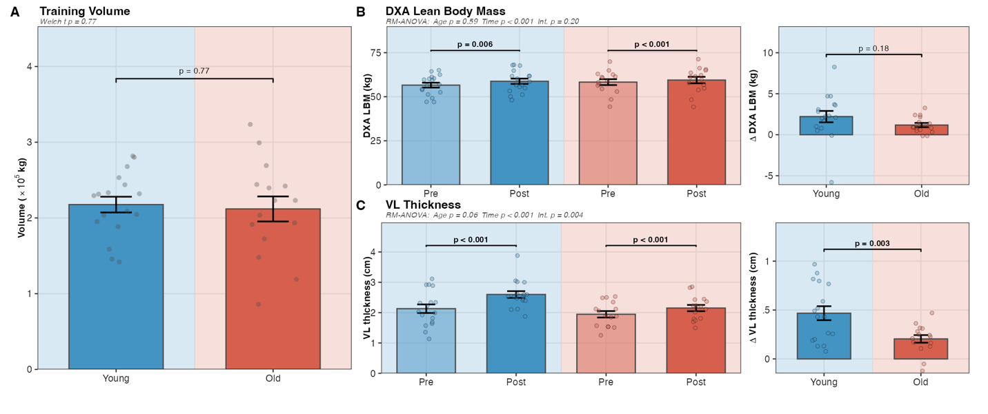
Figure 1. Phenotypic responses to resistance training in younger (n = 17) and older (n = 15) adults. (A) Volume load; groups were similar (p = 0.771). (B) DXA lean body mass pre- and post-training (left) and between-group change (right); both groups gained LBM (Young p = 0.006; Old p < 0.001); between-group Δ was not significant (p = 0.179). RM-ANOVA: Age p = 0.592, Time p < 0.001, Interaction p = 0.196. (C) VL thickness pre- and post-training (left) and between-group change (right); younger adults gained more than older adults (Δ = 0.263 cm, p = 0.003). RM-ANOVA: Age p = 0.060, Time p < 0.001, Interaction p = 0.004. Values are means ± SE. DXA, dual-energy X-ray absorptiometry; LBM, lean body mass; VL, vastus lateralis.
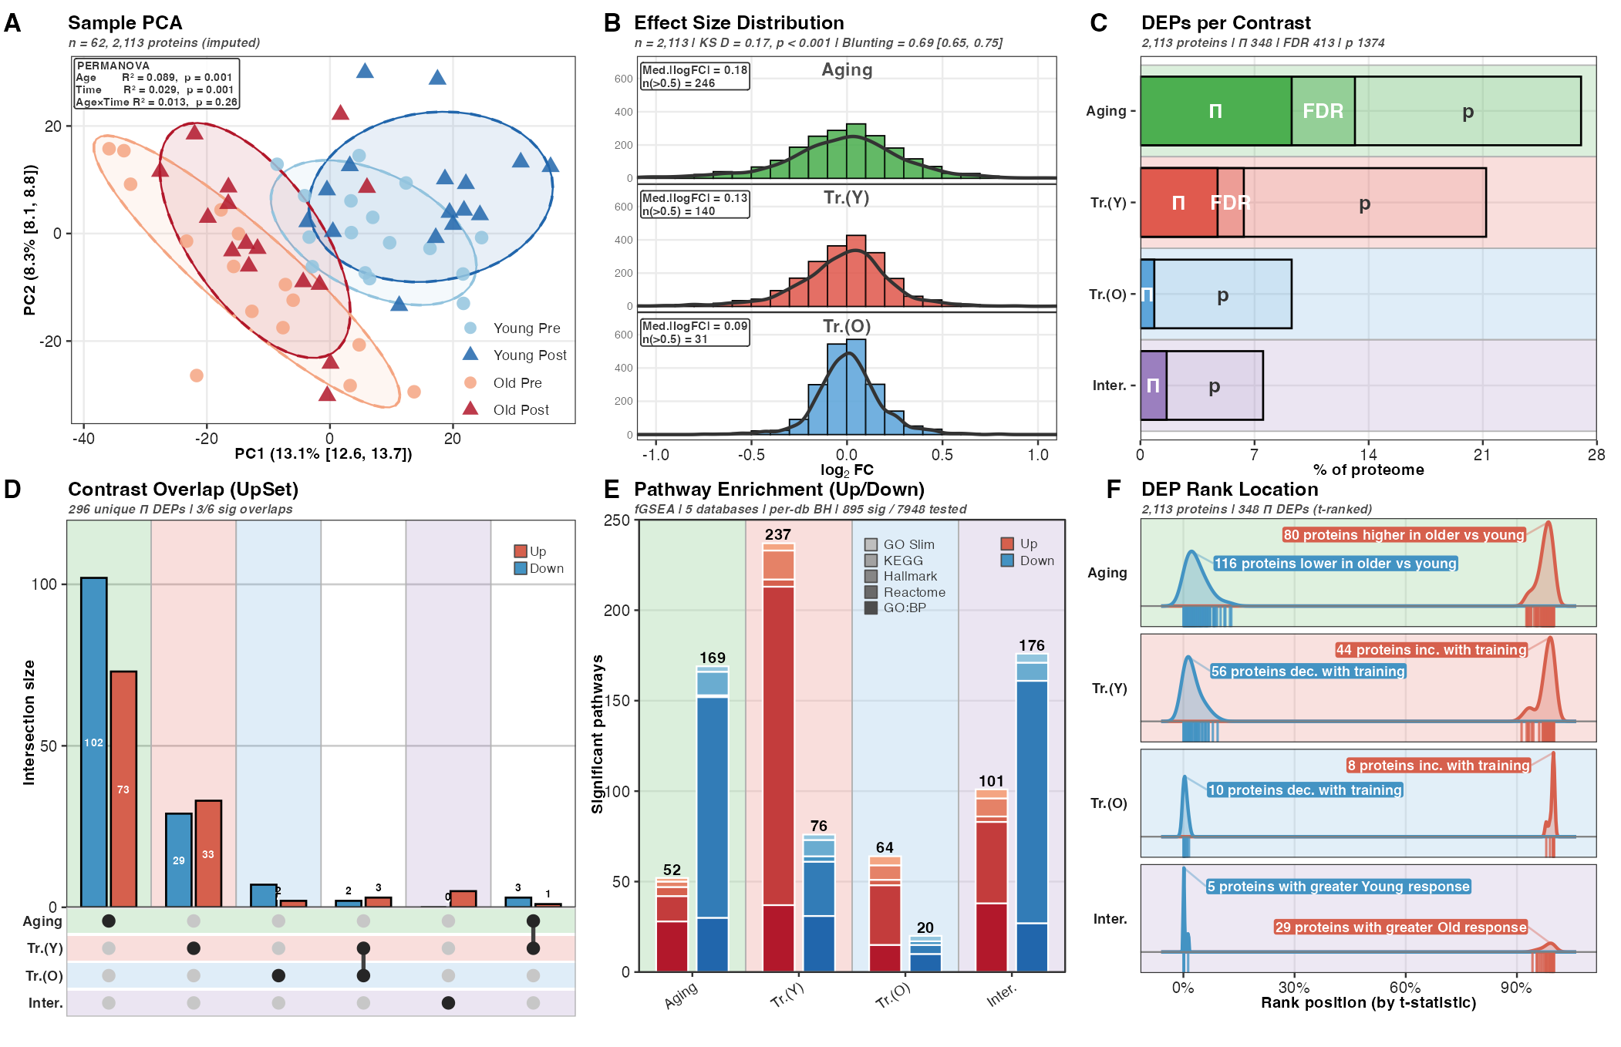
Figure 2. Proteome overview and differential expression landscape (2,113 proteins, 62 samples). (A) PCA of the imputed protein matrix; PERMANOVA: Age R² = 0.089 (p = 0.001), Time R² = 0.029 (p = 0.001), Age×Time R² = 0.013 (p = 0.260). (B) Per-contrast |log₂FC| distributions showing progressive compression from Aging (median 0.18) to Training in Young (0.13) to Training in Old (0.09). (C) DEP counts at three significance thresholds (Π-score, FDR, nominal p). (D) UpSet intersection of Π-score DEPs across contrasts. (E) Fraction of fGSEA-enriched pathways (BH-corrected) across Hallmark, GO Slim, GO:BP, KEGG, and Reactome gene sets, separated by enrichment direction. (F) DEP rank location within the t-statistic–ranked proteome per contrast. DEP, differentially expressed protein; FC, fold change; PCA, principal component analysis.
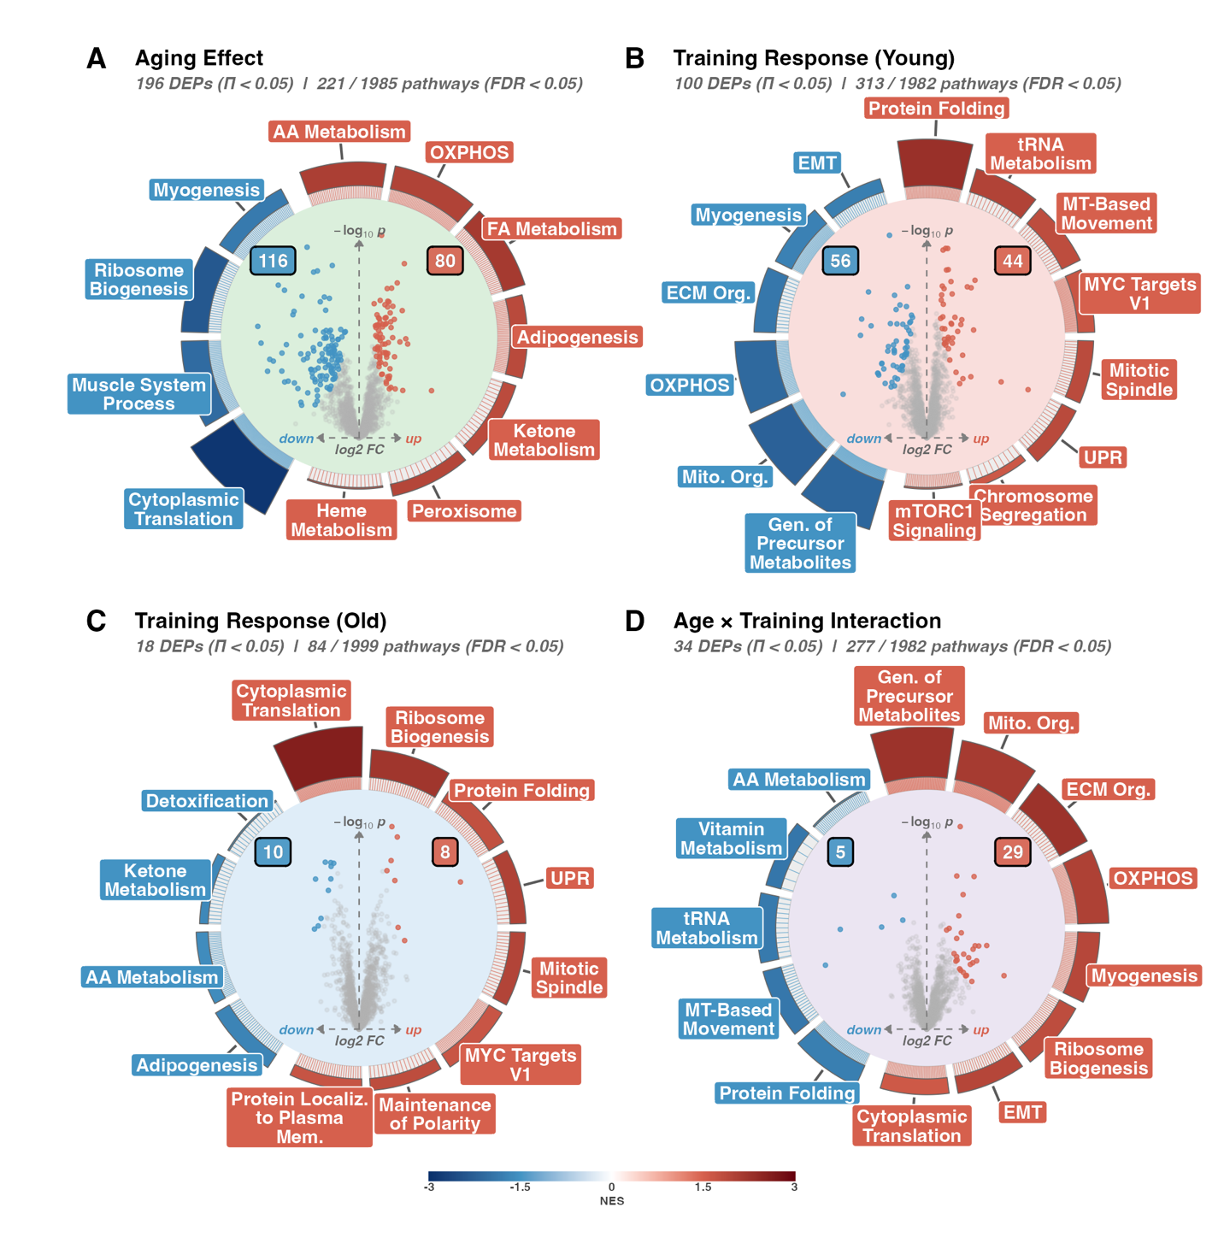
Figure 3. Volcano ring plots for the four primary contrasts. (A) Aging effect (Old_Pre − Young_Pre; 196 Π-score DEPs; 221 enriched pathways). (B) Training in Young (Young_Post − Young_Pre; 100 DEPs; 313 pathways). (C) Training in Old (Old_Post − Old_Pre; 18 DEPs; 84 pathways). (D) Age × Training interaction ([Old_Post − Old_Pre] − [Young_Post − Young_Pre]; 34 DEPs; 277 pathways). Inner scatter plots show protein-level log₂FC vs. −log₁₀(p); red, upregulated; blue, downregulated. Outer ring insets display the top fGSEA-enriched pathways coloured by normalised enrichment score (NES). DEP significance threshold: Π-score < 0.05. DEP, differentially expressed protein; NES, normalised enrichment score.
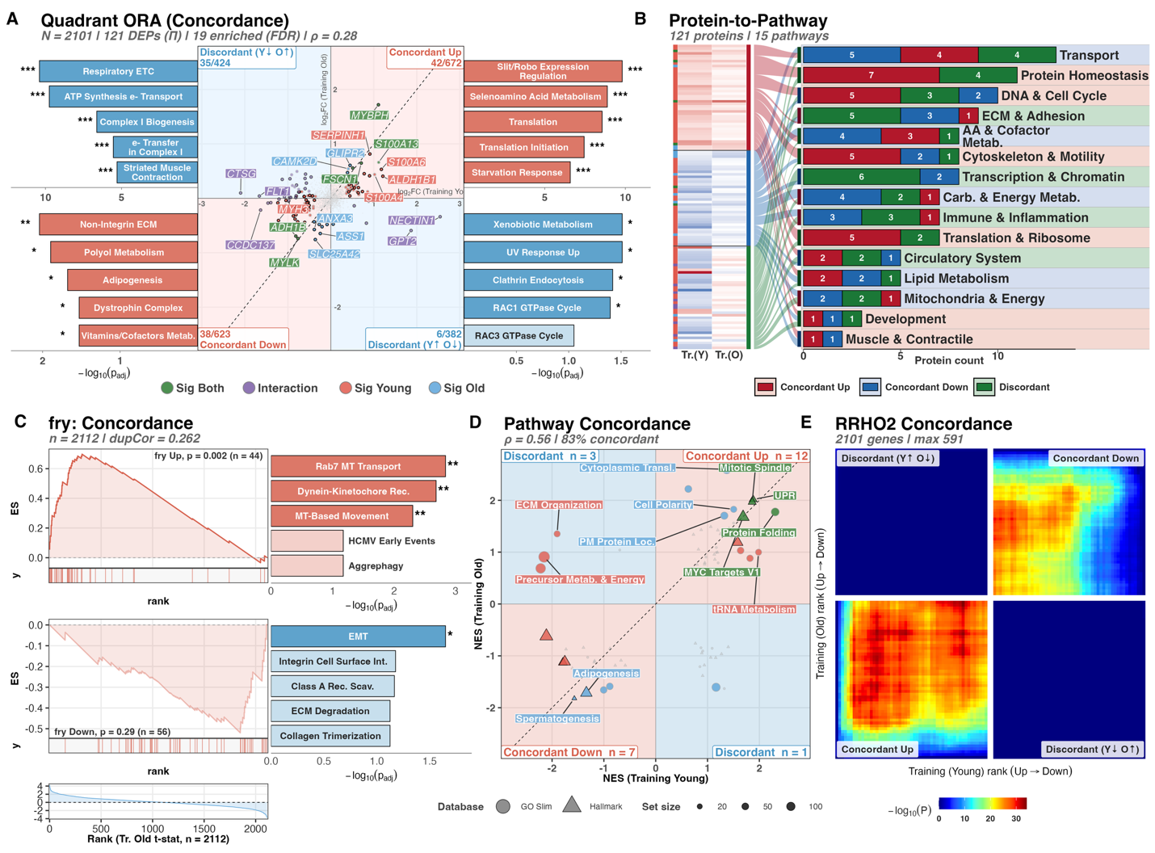
Figure 4. Training response concordance between younger and older adults. (A) Quadrant scatter of Training-in-Young vs. Training-in-Old log₂FC (2,101 proteins); 121 met Π < 0.05; 19 ORA-enriched pathways at FDR < 0.05; Spearman ρ = 0.284 (p = 3.46 × 10⁻⁴⁰). (B) Response-pattern heatmap of 121 significant proteins across 15 GO Slim categories, partitioned into concordant and discordant classes. (C) fry gene-set rotation test of Young Π-DEPs against the Training-in-Old t-statistic; Young-up p = 0.002 (n = 44), Young-down p = 0.29 (n = 56). (D) Pathway-level NES concordance across 69 a priori Hallmark/GO Slim sets; Spearman ρ = 0.564 (p = 7.29 × 10⁻⁷); 23 pathways significant. (E) Threshold-free RRHO2 concordance map. FC, fold change; NES, normalised enrichment score; ORA, over-representation analysis.
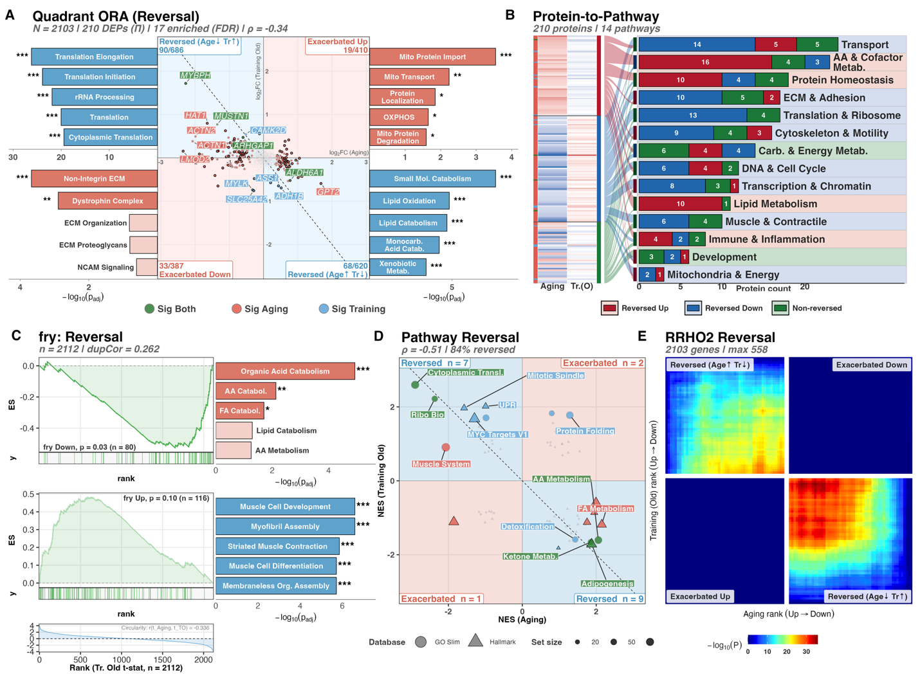
Figure 5. Resistance training in older adults partially reverses the aging proteome signature. (A) Quadrant scatter of Aging vs. Training-in-Old log₂FC (2,103 proteins); 210 met Π < 0.05; 17 ORA-enriched pathways at FDR < 0.05; Pearson r = −0.45 among 210 Π-significant proteins. (B) Reversal-pattern heatmap of 210 significant proteins across 14 GO Slim categories, partitioned into reversed and non-reversed classes. (C) fry gene-set rotation test: Aging-up proteins reversed toward lower abundance with training (p = 0.03, n = 80); Aging-down trended higher (p = 0.10, n = 116). (D) Pathway-level NES reversal across 69 a priori Hallmark/GO Slim sets; Spearman ρ = −0.51; 19 significant, 84% reversed. (E) Threshold-free RRHO2 reversal map. FC, fold change; NES, normalised enrichment score; ORA, over-representation analysis.
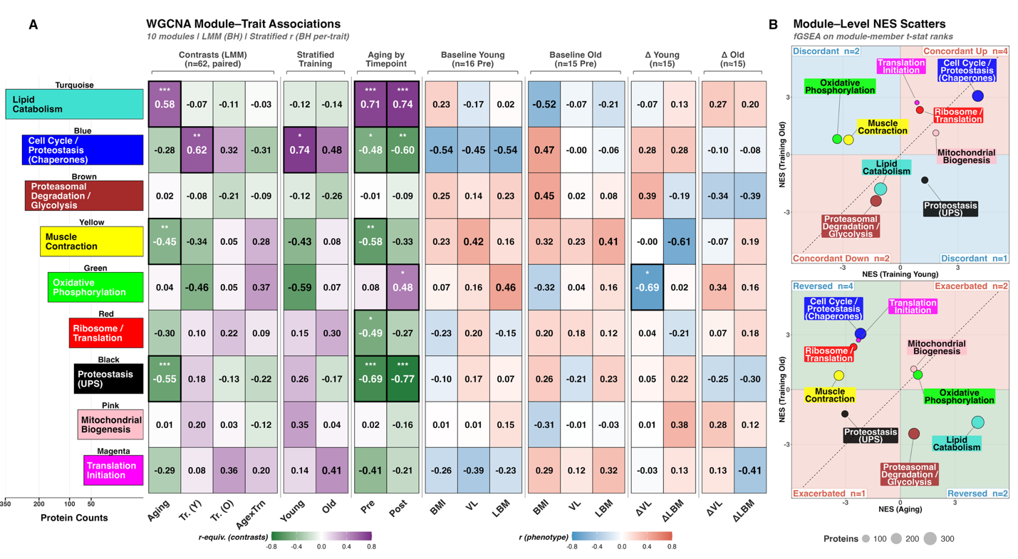
Figure 6. WGCNA co-expression network analysis of 2,113 proteins across 62 samples. (A) Module–trait association heatmap for nine modules. Left columns: r-equivalents from paired linear mixed models (Aging, Training in Young, Training in Old, Age×Training); right columns: stratified Pearson correlations with baseline phenotypes and training-induced changes per age group. BH-corrected significance and module sizes annotated. Three modules were age-associated: Turquoise/Lipid Catabolism (r = +0.58, p_BH = 4.7 × 10⁻⁵), Black/Proteostasis (UPS) (r = −0.55, p_BH = 1.3 × 10⁻⁴), Yellow/Muscle Contraction (r = −0.45, p_BH = 0.006). (B) Module-level NES for Training-in-Young vs. Training-in-Old. (C) Module-level NES for Aging vs. Training-in-Old. Bubble size reflects module protein count. NES, normalised enrichment score; WGCNA, weighted gene co-expression network analysis.
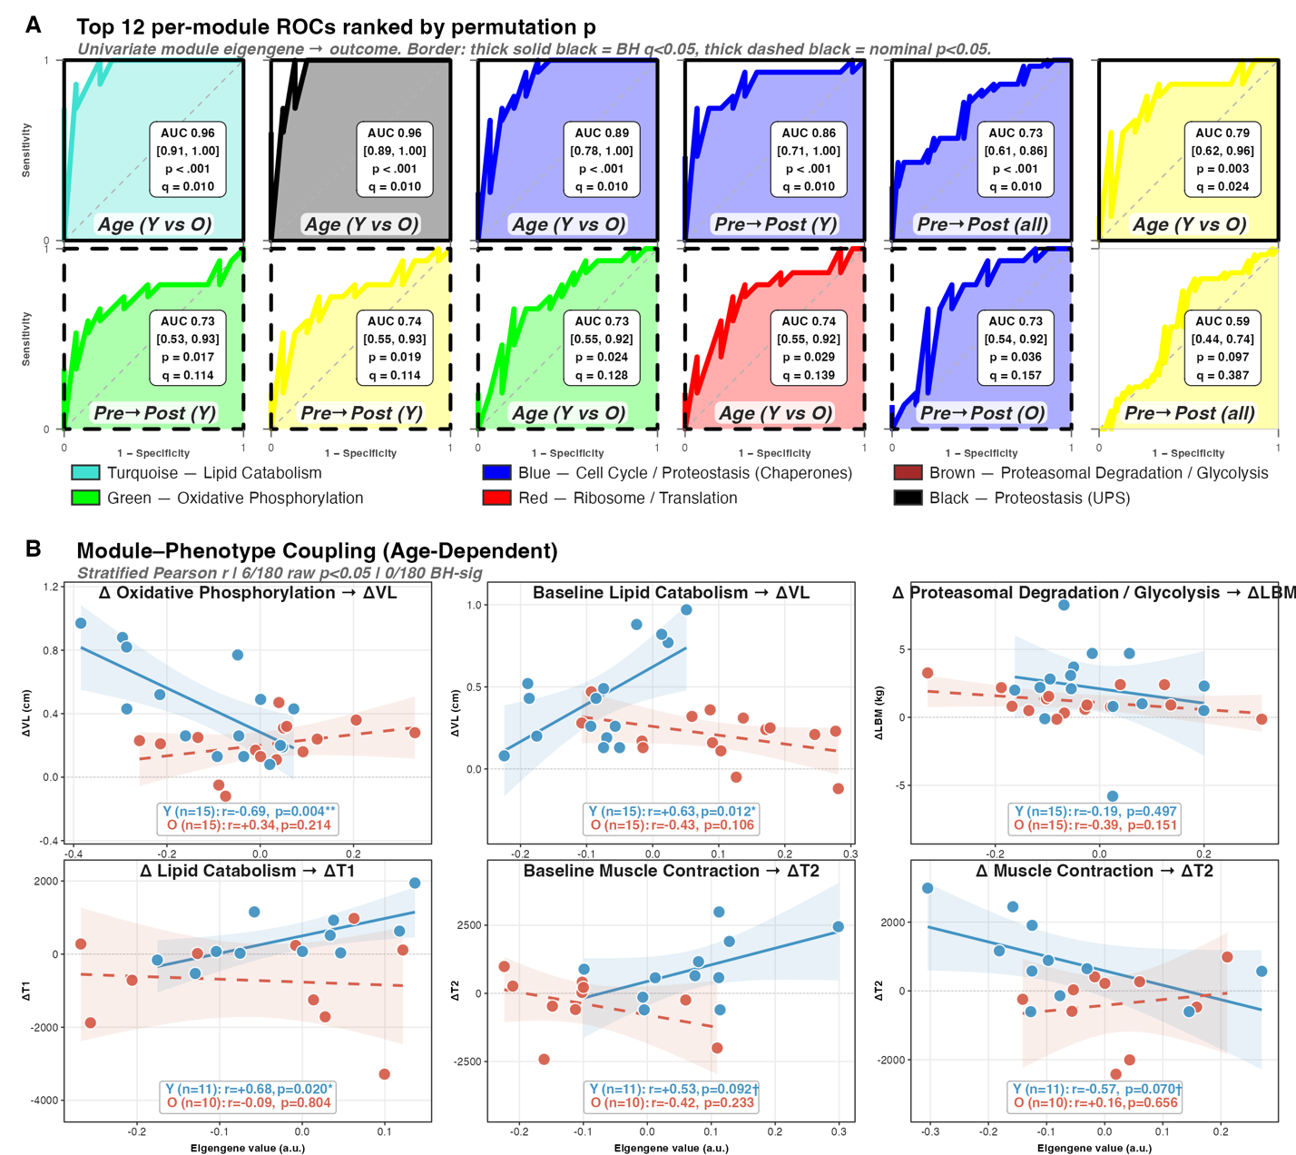
Figure 7. Module eigengene discrimination and age-stratified phenotype coupling. (A) Top-12 univariate ROCs for module eigengenes across six outcomes (Age, Pre→Post timing in Young/All/Old, ΔVL responder, baseline LBM). Thick solid border: BH q < 0.05; thick dashed: nominal p < 0.05. Turquoise/Lipid Catabolism (AUC = 0.96) and Blue/Cell Cycle (AUC = 0.89) were the strongest age discriminators (both q < 0.012). (B) Scatter plots of module eigengene values (Δ or baseline) against training-induced phenotypic changes in Δ VL thickness and Δ LBM, with stratified Pearson r per age group. Pairs with |r| > 0.50 in at least one stratum are highlighted; none survived BH correction across the 180-test screen. AUC, area under the curve; LBM, lean body mass; ROC, receiver operating characteristic; VL, vastus lateralis.
SUPPLEMENTAL APPENDIX

S1 Table. Per-sample metadata, baseline phenotype, cyclic-loess–normalized log₂ protein matrix (2,113 proteins × 62 samples), and per-protein/per-sample missingness summaries.

S2 Table. Post-imputation protein matrix (missForest; OOB NRMSE = 0.109) with Boolean imputation mask and per-protein MAR vs MNAR classification (3-method consensus). Includes 17-method imputation benchmark composite ranking.

S3 Table. Differential expression results across four contrasts with Π-score (per Xiao et al. 2014), FDR, and post hoc power analysis.

S4 Table. Pipeline QC source data — F00 panel-level data covering normalization (panels A–G) and imputation (panels H–N) diagnostics.

S5 Table. Figure 1 source data — phenotypic responses to resistance training (training volume, lean body mass, VL thickness) and S3 Figure panel data.

S6 Table. Figure 2 source data — proteome overview and DEP landscape (PCA, log₂FC density, UpSet intersections, fGSEA, rank barcode) and S4 Figure panel data; DEP counts (Fig 2C) derive from S3 Table.

S7 Table. Figure 3 source data — volcano ring plots, per-contrast pathway enrichment, and S5 Figure panels A–D (model diagnostics); S5 Figure panels E–F (imputation and outlier sensitivity) derive from S3 Table.

S8 Table. Figure 4 source data — training concordance between younger and older adults (ORA quadrants, NES scatter, pattern heatmap, fry, RRHO2) and S6 Figure panel data.

S9 Table. Figure 5 source data — aging reversal analyses (ORA quadrants, NES scatter, pattern heatmap, fry, RRHO2; includes per-protein reversal/exacerbated/negligible directional classification) and S7 Figure panel data.

S10 Table. Figure 6 source data — WGCNA module assignments, hub proteins (kME ≥ Q90), module enrichment, module-trait associations (LMM with Kenward-Roger df, BH-corrected), module-level NES summaries.

S11 Table. Figure 7 source data — univariate per-module ROCs, leave-one-subject-out validation, age-stratified module-phenotype coupling, and exploratory multivariate classifiers (raw-protein and module-eigengene stacks).

S1 Figure. Quality-control and normalization pipeline. (A) Protein filter cascade (2,837 to 2,113). (B) Per-protein missingness. (C) Pre-normalization PCA. (D) Post-normalization PCA. (E) Eta-squared variance decomposition. (F) Outlier consensus scoring. (G) Per-sample missingness.

S2 Figure. Imputation diagnostics. (H) Missingness classification scatter (MAR vs MNAR). (I) Missingness classification counts. (J) 17-method imputation benchmark (OOB NRMSE = 0.109). (K) Imputation density overlay. (L) MNAR shift diagnostic. (M) Sample integrity post-imputation. (N) DEP sensitivity heatmap.

S3 Figure. Supplementary phenotype responses to resistance training. (A) Deadlift one-repetition maximum pre- and post-training by age group. (B) Type II fiber cross-sectional area pre- and post-training. (C) Type I fiber cross-sectional area pre- and post-training.

S4 Figure. Proteome variability by experimental group. (A) Per-protein coefficient of variation (CV%, Pre vs Post; measurement reproducibility). (B) Inter-individual CV% distributions by group. (C) Intra-individual variability (per-subject Δlog₂FC from the imputed matrix).

S5 Figure. Differential expression model diagnostics across contrasts. (A) P-value histograms. (B) Pi-score distributions. (C) FDR distributions. (D) MA plots. (E) Imputation sensitivity. (F) Outlier sensitivity.

S6 Figure. Training concordance robustness diagnostics. (A) ORA pathway counts across Jaccard deduplication cutoffs. (B) Spearman rho bootstrap (1,000 replicates). (C) Quadrant counts across significance thresholds. (D) GO Slim category distribution by quadrant. (E) Top 20 fry leading-edge proteins in Training Old.

S7 Figure. Aging reversal diagnostic panels. (A) ORA deduplication sensitivity for reversal quadrants (Jaccard cutoffs 0.3–1.0). (B) Pearson r bootstrap (1,000 replicates, 95% CI) for Aging vs. Training-in-Old log₂FC correlation. (C) Circularity diagnostic: protein-permuted null distribution of Pearson r (observed r = −0.358, null mean = 0.0008, p_perm < 0.001). (D) Reversal classification threshold sensitivity (stable reversal percentage across |log₂FC| thresholds 0.05–0.30). (E) GO Slim category distribution of reversed and non-reversed proteins (210 DEPs across 15 categories). (F) fry leading-edge proteins: top 25 reversal drivers ranked by |t-statistic| in Training Old, colored by aging direction.

S8 Figure. WGCNA network construction diagnostics. (A) Scale-free topology fit. (B) Protein dendrogram with module assignments. (C) Subcellular compartment enrichment. (D) Pearson vs. biweight midcorrelation module overlap.

S9 Figure. Module eigengene discrimination and cross-validation. (A) Per-module ROC grid across all module-outcome combinations. (B) Fixed-module leave-one-subject-out sensitivity. (C) Full WGCNA-refit leave-one-subject-out sensitivity.

