**PORTFOLIO OF EVIDENCE**

**[Initial and Surname]**

[Student Number]

*[Personality Type]*

[Current Field of Interest]

[Field of Interest Description]

Most proficient in:

*[Favourite Programming Language]*

Table of contents

1 MODERATION PREPARATION 1

1.1 Introduction 1

1.2 Pre-CMPG323 Skillset 1

1.2.1 Expectations for CMPG323 2

1.2.2 Ambitions for CMPG323 2

1.3 Career Path 2

2 Training & Certifications 1

3 Project Results 1

4 Community Engagement 2

4.1 Contributing to a Community or Forum 2

4.2 Extracting Knowledge from a Community or Forum 2

5 Class Attendance 3

6 Class Participation 4

# MODERATION PREPARATION

## Introduction

As part of the preparation for this module, a form was provided to allow students an opportunity to provide details about themselves. Based on the responses received, the following basic information details were captured:

|  |  |
| --- | --- |
| Student Number | [Student Number] |
| Initials & Surname | [Initial and Surname] |
| Preferred Name | [Preferred Name] |
| Preferred Email Address | [Preferred Email Address] |
| Date of Birth | [Date of Birth] |
| Campus & Delivery Method | [Campus Delivery Method] |
| LinkedIn Profile | [LinkedIn Profile URL] |
| GitHub Profile | [GitHub Profile URL] |
| Stack Overflow Profile | [Stack Overflow Profile URL] |

Table 1‑1: Basic Student Information

## Pre-CMPG323 Skillset

Prior to the commencement of work, students were prompted to provide their current rating of specific skill sets which would be focused on and enhanced throughout the semester. Each skill has been rated as follows:

|  |  |
| --- | --- |
| **Skill** | **Rating** |
| Agile & Scrum Implementation | [Agile Knowledge] |
| API Development | [API Development Knowledge] |
| Design & Architectural Patterns Implementation | [Web Development Patterns Knowledge] |
| Testing Approach Implementation | [Testing Knowledge] |
| Robotic Process Automation Implementation | [RPA Knowledge] |
| Data Visualisation Implementation | [Power BI Knowledge] |

Table 1‑2: Skills Rating

The above table is subject to the following rating descriptions:

1. No prior knowledge/experience with implementation
2. Some knowledge but no experience with implementation
3. Some knowledge and experience with implementation
4. Advanced knowledge and experience with implementation

### Expectations for CMPG323

[Module Expectations]

### Ambitions for CMPG323

[Skills to be Acquired]

## Career Path

A number of questions were posed to students to prompt their investigation into different professions to decide which they would like to pursue. The following responses were captured for each question:

|  |  |
| --- | --- |
| **Career Options** | **Response** |
| Entrepreneurship | [Entrepreneur Ambition] |
| Non-IT Role | [Non-IT Ambition] |
| Application for Roles | [IT Roles] |
| Desired Job Role | [Desired Role Description] |
| Desired Company & Profession | [Company and Position] |

Table 1‑3: Career Ambitions

# Training & Certifications

The following achievements were obtained as part of CMPG323:

|  |  |  |  |  |  |
| --- | --- | --- | --- | --- | --- |
| **Category** | **Achievement** | **Type** | **Provider** | **Date** | **Reflection** |
| Agile & Scrum | Professional Scrum ™ with Kanban ( PSK ™) Prep Questions | Free completion | Udemy | 2023-08-10 | I have learned some questions to brighten my knowledge on Scrum and have a better understanding |
| Agile & Scrum | Basics of Scrum, Agile and Project Delivery | Free completion | Udemy | 2023-08-10 | I have more in depth understanding of Scrum principles and Aspects |
| Blender | Free Blender Crash Course! | Free Completion | Udemy | 2023-10-27 | How to use the basics of blender |
| Design Patterns & Standards | Design Patterns in Software Modeling and Design | Free completion | Udemy | 2023-09-15 | Different patterns and how to implement them |
| Design Patterns & Standards | Basics of Object Oriented Programming with C# | Free completion | Udemy | 2023-09-18 | how to implement and work with design patterns, A better understanding of OOP. |
| Design Patterns & Standards | Learn MVC + Web API from scratch - Basics to Advance | Free completion | Udemy | 2023-09-18 | Difference between MVC and Web API |
| Game development | Unity Game Development For Complete Beginners | Free completion | Udemy | 2023-08-14 | The basics of Unity and how to start creating my own 2D game |
| Power BI | Microsoft Power BI Course | Free Completion | Udemy | 2023-10-25 | The basics of power BI and how to navigate and use it |
| Power BI | Power BI for Business Users | Free Completion | Udemy | 2023-10-25 | The business-oriented side of Power BI |
| Robotics | Project STEAMBOT | Free Completion | Udemy | 2023-11-14 | STEAM application and how to apply to robotics. Also the basics of robotics with a motor and a sensor. |
| Source Control | Git: Become an Expert in Git & GitHub in 4 Hours | Free completion | Udemy | 2023-08-10 | How to use and manage Github as a source3 control platform |
| UiPath | Excel Automation using Uipath | Free completion | Udemy | 2023-10-18 | How to incorporate Excel with UiPath and automate redundant tasks. |
| UiPath | Introduction to Robotic Process Automation (RPA) and UiPath | Free completion | Udemy | 2023-10-18 | fundamentals and Implementations of RPA |
| Web API | Swagger, Openapi,asciidoc and Restdocs with spring boot | Free completion | Udemy | 2023-08-24 | Gave me a clearer understanding of API and Swagger and how to handle methods |
| Web API | Spring REST API for beginners | Free completion | Udemy | 2023-08-24 | I got a better understanding of the REST API and how the data communicates with each other |
| Web API | ASP.NET Core Dependency injection & Service Lifetimes | Free completion | Udemy | 2023-08-24 | I got to see a deeper inside into .NET core with its register and dependecny indjections |

# Project Results

The students were equipped with project briefs for five projects that aimed to guide them through the end-to-end journey of the development lifecycle – from planning to reporting. Each project was assessed individually, according to specific criteria and the results of each project are captured below:

|  |  |
| --- | --- |
| **Project** | **Result** |
| Project 1: Agile | 75% |
| Project 2: Web API | 80% |
| Project 3: Patterns & Standards | 49% |
| Project 4: RPA & Testing | 45% |
| Project 5: Reporting & Monitoring | 41% |

Table 3‑1: Project Results

Based on the performance detailed above, the student has a participation mark of <part mark>. The participation mark for CMPG323 is subject to the following calculation as part of the module mark:

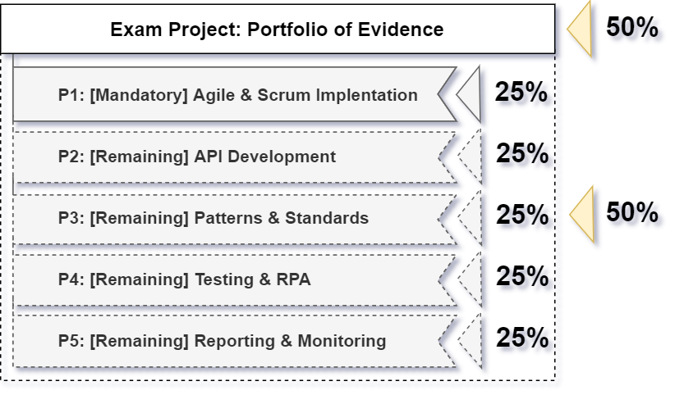

Figure 3‑1: Module Mark Calculation

# Community Engagement

Students are encouraged to use the development communities around them to extract value from as well as produce value back into. Student contribution and engagement can be measured through multiple forms which require evidence of participation and engagement.

## Contributing to a Community or Forum

The student has executed the following tasks as a contribution to a community or forum:

|  |  |  |
| --- | --- | --- |
| **Platform** | **Date** | **Reflection** |
| Click or tap here to enter text. | Click or tap here to enter text. | Click or tap here to enter text. |

## Extracting Knowledge from a Community or Forum

The student has executed the following tasks as an extraction of knowledge from a community or forum:

|  |  |  |
| --- | --- | --- |
| **Platform** | **Date** | **Reflection** |
| Click or tap here to enter text. | Click or tap here to enter text. | Click or tap here to enter text. |

# Class Attendance

Students are urged to make every effort to attend the virtual classes held every Thursday morning to ensure that they get the value and are able to utilise the opportunity to ask questions when they do not understand the work. The following attendance has been captured:

|  |  |
| --- | --- |
| **Class** | **Attendance** |
| 20 July 2023 | Did not attend |
| 27 July 2023 | Did not attend |
| 3 August 2023 | Did not attend |
| 10 August 2023 | Did not attend |
| 17 August 2023 | Did not attend |
| 31 August 2023 | Did not attend |
| 7 September 2023 | Did not attend |
| 14 September 2023 | Did not attend |
| 12 October 2023 | Attended |

Table 6‑1: Class Attendance

# Class Participation

Students are urged to make every effort to attend and engage in the virtual classes held every Thursday morning to ensure that they get the value from the class and are able to utilise the opportunity to ask questions when they do not understand the work. The following engagement has been captured as per the completion of class quizzes:

|  |  |
| --- | --- |
| **Activity** | **Completion** |
| GitHub Homework | Submitted |
| Agile Quiz | 3 |
| Design Patterns & Standards Homework | Not Submitted |
| API Assignment | Submitted |
| ASP.NET Assignment 1 | Not Submitted |
| ASP.NET Assignment 2 | Not Submitted |

Table 7‑1: Class Participation