CSA6303 - THREAT INTELLIGENCE AND NETWORK SECURITY
Assessment Tool 1: CONCEPT MAPPING
Faculty : Dr.V.Parthipan SLOT A

Topics: Network Security Fundamentals | Security Goals (CIA Triad) | Types of Network Threats |Introduction to Threat Intelligence Types of Threat Intelligence (Strategic, Tactical, Operational) — Threat Intelligence Lifecycle — Applications in IT Industry
CO1: Interpret security principles, network threats, and the role of threat intelligence in cybersecurity.

Total: 50
Student Name : Dusyaant R Register number: 192465058

Code of Conduct:

I Dusyaant R / 192465058 (Name / Reg No) certify that this submission is my original work and that I have adhered to the guidelines specified for this assessment. I understand that any violation of academic integrity rules will result in disciplinary action.

Signature of the student

CO1 – Concept Mapping Questions
No. | Concept-Mapping Question
1 | Construct a comprehensive concept map explaining the foundations of Network Security. Connect network security fundamentals with security objectives, the CIA Triad (Confidentiality, Integrity, and Availability), network assets, vulnerabilities, threats, and protective measures, and explain how these concepts collectively support secure network operations.
2 | Develop a concept map illustrating the CIA Triad as the foundation of network security. Relate Confidentiality, Integrity, and Availability to different types of network threats and demonstrate how a single threat can affect one or more security goals.
3 | Construct a concept map classifying different types of Network Threats and their potential impact on security goals. Connect threats such as malware, phishing, denial-of-service, spoofing, eavesdropping, and unauthorized access with the CIA Triad and explain the resulting security implications.
4 | Develop an integrated concept map connecting Network Security Fundamentals, Network Threats, and Threat Intelligence. Show how identifying assets, vulnerabilities, and threats leads to the collection and analysis of threat information and ultimately supports informed security decisions.
5 | Construct a concept map explaining the concept of Threat Intelligence and its role in modern network security. Relate threat actors, indicators, vulnerabilities, attack patterns, threat information, analysis, and actionable intelligence to demonstrate how Threat Intelligence helps organizations anticipate and respond to network threats.
6 | Develop a comparative concept map of Strategic, Tactical, and Operational Threat Intelligence. Connect each type with its purpose, target audience, time horizon, information requirements, decision-making process, and appropriate network-security use cases, and analyze how the three intelligence types complement one another.
7 | Construct a concept map representing the complete Threat Intelligence Lifecycle. Connect planning/direction, collection, processing, analysis, dissemination, and feedback with the identification of network threats and security requirements, showing how feedback continuously improves the intelligence process.
8 | Develop an end-to-end concept map showing how a network threat progresses from identification to actionable Threat Intelligence. Connect network security fundamentals, CIA security goals, threat detection, intelligence collection, processing, analysis, dissemination, and response, and explain the relationship between each stage.
9 | Create a scenario-based concept map for an organization experiencing a major network attack. Integrate the CIA Triad, types of network threats, Strategic Intelligence, Tactical Intelligence, Operational Intelligence, and the Threat Intelligence Lifecycle to demonstrate how the organization can understand, prioritize, and respond to the threat.
10 | Design a comprehensive concept map demonstrating the applications of Network Security and Threat Intelligence in the IT industry. Connect network security fundamentals, CIA Triad, network threats, Threat Intelligence, Strategic/Tactical/Operational Intelligence, and the Threat Intelligence Lifecycle with applications such as threat monitoring, incident response, vulnerability management, risk assessment, security operations, and organizational decision-making.
CO1 – Answers to Concept Mapping Questions
Question 1
Construct a comprehensive concept map explaining the foundations of Network Security. Connect network security fundamentals with security objectives, the CIA Triad (Confidentiality, Integrity, and Availability), network assets, vulnerabilities, threats, and protective measures, and explain how these concepts collectively support secure network operations.
Concept Map
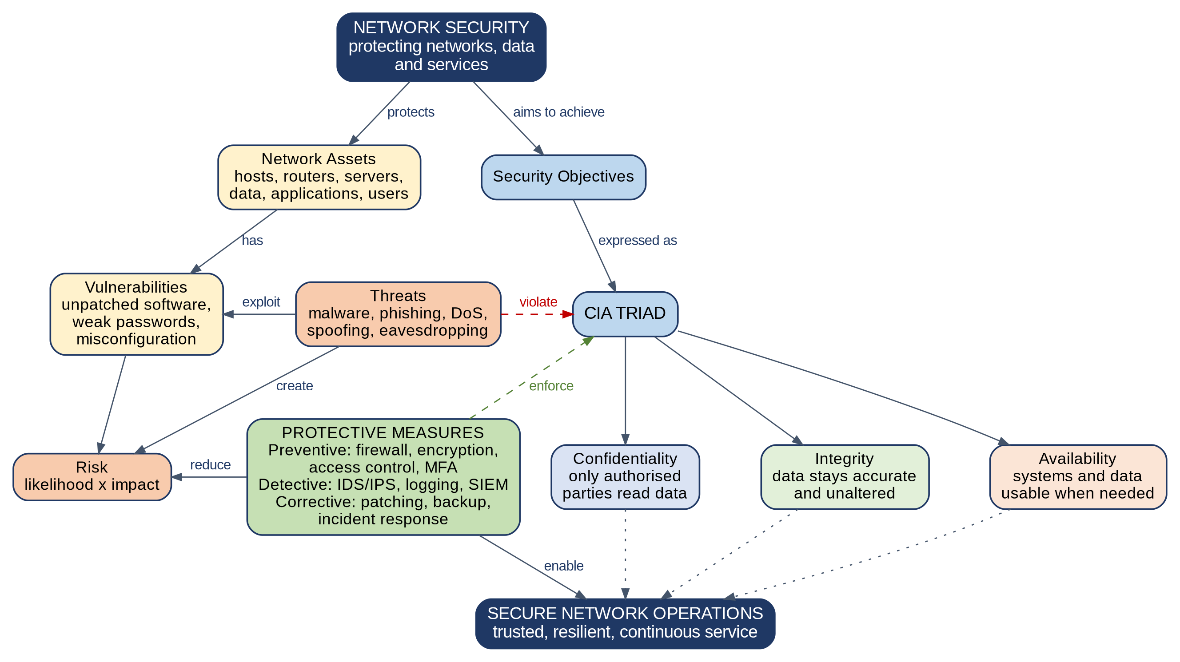
Figure 1: Concept map of the foundations of Network Security
Explanation
Network security is the discipline of protecting a network, the devices connected to it and the data it carries from misuse, disruption and unauthorised access. It is organised around a small set of connected concepts, summarised below.
Concept | Meaning | Relationship in the map
Security objectives | The goals that a secure network must achieve, expressed through the CIA Triad. | Network security aims to achieve them.
CIA Triad | Confidentiality (only authorised parties read data), Integrity (data remains accurate and unaltered) and Availability (systems and data are usable when needed). | Forms the measure against which every threat and every control is judged.
Network assets | Hosts, routers, switches, servers, applications, data and users that have value to the organisation. | Protected by network security; they are what vulnerabilities reside in.
Vulnerabilities | Weaknesses such as unpatched software, weak passwords and misconfigured devices. | Exploited by threats; found in assets.
Threats | Potential sources of harm such as malware, phishing, denial-of-service, spoofing and eavesdropping. | Exploit vulnerabilities and violate the CIA goals.
Risk | The likelihood that a threat exploits a vulnerability multiplied by the impact on an asset. | Created when threats meet vulnerabilities; reduced by controls.
Protective measures | Preventive (firewalls, encryption, access control, MFA), detective (IDS/IPS, logging, monitoring) and corrective (patching, backup, incident response) controls. | Reduce risk, counter threats and enforce the CIA goals.

How the concepts support secure network operations
The concepts form a logical chain. An organisation first identifies its network assets and decides which security objectives matter most for each of them. It then identifies the vulnerabilities that exist in those assets and the threats able to exploit them; together these determine the level of risk. Protective measures are then selected to bring that risk to an acceptable level:
- Preventive controls stop attacks before they succeed and protect confidentiality and integrity.
- Detective controls reveal attacks that bypass prevention so that they can be contained quickly.
- Corrective controls restore normal service and data after an incident, which protects availability.
When all three kinds of control work together, the CIA goals are preserved even while threats continue to exist, and the network can operate in a trusted, resilient and continuous manner. This is the meaning of secure network operations.
Question 2
Develop a concept map illustrating the CIA Triad as the foundation of network security. Relate Confidentiality, Integrity, and Availability to different types of network threats and demonstrate how a single threat can affect one or more security goals.
Concept Map
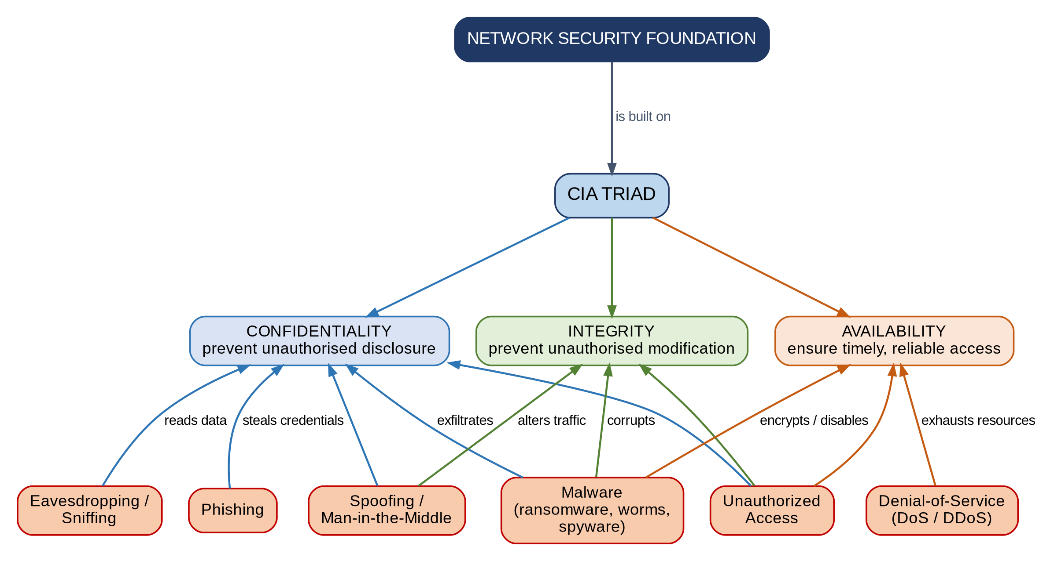
Figure 2: The CIA Triad and the threats that target each goal. Line colour shows the goal affected (blue = Confidentiality, green = Integrity, orange = Availability); a threat with several colours affects several goals.
Relating the Threats to the Security Goals
The CIA Triad is the foundation of network security because every threat can be described by which of the three goals it attacks, and every control is chosen to defend one or more of them.
Network threat | Confidentiality | Integrity | Availability | How the goals are affected
Eavesdropping / sniffing | Yes | – | – | Captured traffic exposes data to unauthorised parties.
Phishing | Yes | – | – | Deceives users into revealing credentials; often the first step of a larger attack.
Spoofing / man-in-the-middle | Yes | Yes | – | Impersonation lets the attacker read and alter data in transit.
Unauthorized access | Yes | Yes | Yes | An intruder can read, change or delete data and disrupt services.
Malware (ransomware, worms, spyware) | Yes | Yes | Yes | Steals data, corrupts files and can disable systems.
Denial-of-service (DoS / DDoS) | – | – | Yes | Exhausts bandwidth or resources so legitimate users are denied service.

How a Single Threat Can Affect One or More Goals
Some threats target only one goal. Eavesdropping affects mainly Confidentiality, and a DDoS attack affects mainly Availability. Many real attacks, however, damage several goals together. A ransomware attack that also steals data (double extortion) shows this clearly:
- Confidentiality: sensitive data is copied out of the network and may be published.
- Integrity: files are encrypted and altered, so their content can no longer be trusted.
- Availability: systems and files become unusable until they are restored, so business operations stop.
Unauthorized access behaves in the same way: the intruder who reads confidential records can also modify them and shut down the services that depend on them. A man-in-the-middle attack affects Confidentiality and Integrity together, because the attacker can both read and change the traffic.
Conclusion: the CIA Triad gives a single framework for understanding the impact of any threat. Because one attack can affect several goals, effective network security must apply layered controls that defend Confidentiality, Integrity and Availability at the same time.

