研究内容：

基于CT影像的个性化膝关节假体建模

研究目标：

基于若干组健康志愿者的膝关节的CT影像数据集，建立出消去了个体差异的平均膝关节模型，再结合特定病人的某些生理特征找出最贴近的平均模型并做出调整，最后通过FEA等方式评价生成结果。

研究路线：

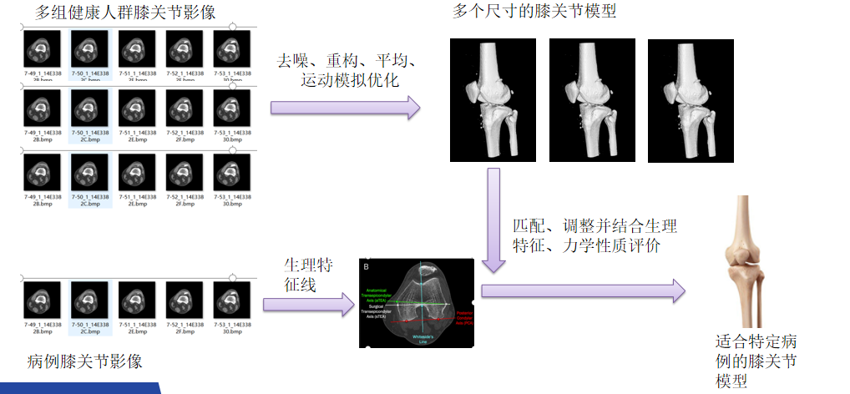

研究介绍:

1. 分组与去噪：

鉴于人体骨骼大小的差异性，首先将健康志愿者的CT数据其根据身高、体重等因素划分为若干组并对原数据做噪声处理。

1. 平均与运动模拟优化：

构建各组的平均模型从而避免健康志愿者这些个体自身特异性的影响，然后通过模拟膝关节的旋转运动从而对各个姿态下的模型进行优化。

1. 匹配、生成与评价：

提取病例的某个生理特征线，并与多个尺寸下的模型相比较，找出最匹配的模型，并根据生理特征线间较小的差异性进行微调整。

Research Topic：

Modeling of personalized knee prosthesis based on CT images

Research Objective：

Based on the CT image data sets of several groups of healthy volunteers' knee joints, the average knee joint model without individual differences was established, and then the closest average model was found and adjusted according to some physiological characteristics of specific patients.

Research Line：

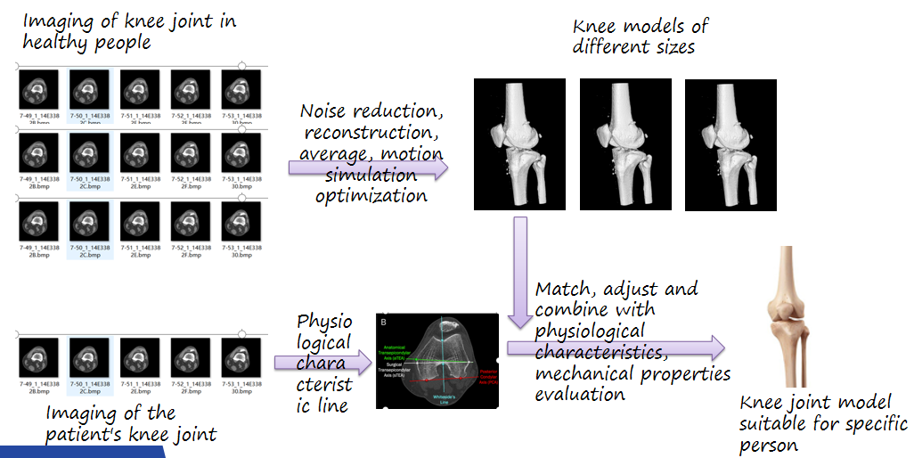

Research Introduction：

1. Grouping and denoising

In view of the difference of human bone size, the CT data of healthy volunteers were divided into several groups according to height, weight and other factors, and the original data were processed with noise.

2. Average and motion simulation optimization:

The average model of each group was constructed to avoid the influence of the individual specificity of healthy volunteers, and then the model was optimized by simulating the rotation of the knee joint.

3. Matching, generation and evaluation:

Extract a physiological characteristic line of the case, and compare it with the model of multiple sizes to find the most matching model, and make micro adjustment according to the small difference between the physiological characteristic lines.